Supporting Information

Journal of Environmental Science and Pollution Research

Photodegradation and Adsorption of Hexazinone in Aqueous Solutions: Removal Efficiencies, Kinetics, and Mechanisms

Tahereh Jasemizad¹ and Lokesh P. Padhye^{1,}*
¹Department of Civil and Environmental Engineering, The University of Auckland, Auckland, New Zealand

*Corresponding Author:
Phone: +64 9 923 2410; E-mail: l.padhye@auckland.ac.nz

Number of pages: 5
Number of Figures: 5

Fig S1. Effect of deionized water and secondary effluent matrices on degradation of hexazinone ([hexazinone]₀= 0.5 µM, pH=7, H₂O₂ dosage= 0.5 mM, UV intensity= 6.5 mJ cm⁻²)

Fig S2. Effect of scavengers in UV/H₂O₂ process on degradation of hexazinone ([hexazinone]₀= 0.5 µM, pH=7, H₂O₂ dosage= 0.5 mM, scavengers Conc.= 0.1 M, UV intensity= 6.5 mJ cm⁻²).

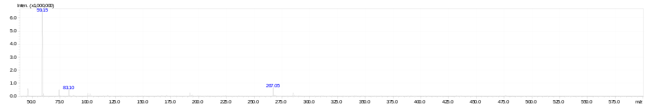

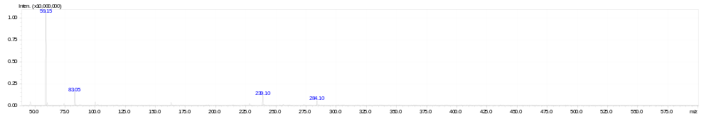

Fig S3. LC-MS/MS spectra of oxidation of hexazinone in UV/H₂O₂ process

Fig S4. The pseudo-first order (a) and pseudo-second order (b) kinetics for adsorption of hexazinone

Fig S5. The a) Freundlich, and b) Langmuir isotherms for adsorption of hexazinone onto CSGAC

