Supplementary material for: Facilitating maintenance of stormwater ponds: comparison of analytical methods for determination of metal pollution
Snežana Gavrić*, Kelsey Flanagan, Heléne Österlund, Godecke-Tobias Blecken, and Maria Viklander
Urban Water Engineering, Department of Civil, Environmental and Natural Resources Engineering, Luleå University of Technology, 971 87 Luleå, Sweden
Corresponding author: snezana.gavric@ltu.se

Table S1: General limits of quantification (LOQ) for the different metal analysis. The quantification limits were increased for some samples due to extra dilution of the sample, which was needed to reduce matrix effects such as signal suppression.
LOQ of different analysis | unit | Cd | Cr | Cu | Ni | Pb | Zn
Total metal concentrations | mg/kg DW | 0.1 | 0.25 | 0.1 | 1.0 | 0.5 | 1
Pore water metal concentrations | µg/L | 0.002 | 0.01 | 0.1 | 0.05 | 0.01 | 0.2
DGT labile concentrations* | µg | 0.0005 | 0.005 | 0.01 | 0.005 | 0.002 | 0.01
Fraction 1 | mg/kg DW | 0.003 | 0.03 | 0.05 | 0.03 | 0.009 | 0.09
Fraction 2 | mg/kg DW | 0.006 | 0.06 | 0.2 | 0.06 | 0.03 | 0.3
Fraction 3 | mg/kg DW | 0.002 | 0.02 | 0.03 | 0.02 | 0.006 | 0.06
Fraction 4 | mg/kg DW | 0.002 | 0.02 | 0.04 | 0.02 | 0.008 | 0.08
Fraction 5 | mg/kg DW | 0.003 | 0.03 | 0.05 | 0.03 | 0.01 | 0.1
*reporting limits for the metal mass of an unused DGT

Table S2: Description of the five-step sequential extraction analysis
 | Method | To remove and measure
Fraction 1 | Extraction of 1 g sample with 10 ml 1.0 M acetate buffer (pH 5) by shaking for 6 h at room temperature | adsorbed and exchangeable metals and carbonates
Fraction 2 | Extraction of the solid residue from Step 1 with 50 ml 0.1 M pyrophosphate solution (pH 9) by shaking for 1 h at room temperature | labile organic forms
Fraction 3 | Extraction of the solid residue from Step 2 with 10 ml 0.25 M hydroxylamine hydrochloride for 4 h at 50°C | amorphous Fe/Mn oxides
Fraction 4 | Extraction of the solid residue from Step 3 with 15 ml 1 M hydroxylamine hydrochloride in 25% acetic acid for 3 h at 90°C | crystalline Fe oxides
Fraction 5 | adding 0.75 g potassium chlorate to the solid residue from Step 4 followed by adding 15 ml 12 M hydrochloric acid for 30 min at room temperature and then 10 ml 4 M nitric acid for 20 min at 90°C | stable organic forms and sulphides

Table S3: Percent of censored data in 32 sediment samples for six metals in different analysis
Method | Zn | Cu | Pd | Ni | Cr | Cd
Total metal concentrations | 0 | 0 | 0 | 0 | 0 | 22
Pore water metal concentrations | 0 | 16 | 6 | 0 | 0 | 16
DGT labile concentrations | 0 | 0 | 0 | 0 | 3 | 6
Fraction 1 | 0 | 0 | 0 | 0 | 0 | 0
Fraction 2 | 3 | 16 | 6 | 44 | 31 | 84
Fraction 3 | 0 | 0 | 0 | 0 | 0 | 0
Fraction 4 | 0 | 0 | 0 | 0 | 0 | 0
Fraction 5 | 0 | 0 | 0 | 0 | 0 | 3

Guidelines included for the ranking of the total metal concentrations:
The Swedish EPA guideline includes values derived for two different types of land use i.e., sensitive (S) and less sensitive (LS) land use (Swedish EPA, 2016). These guidelines were chosen for this study, as they were developed to consider human health risks due to direct and indirect contact with the contaminated soil as well as protection of the soil ecosystem, groundwater, and surface water (SEPA, 2016). Exceeding the less sensitive limit means that the soil quality limits the choice of land use to industries and roads and this limit is used for the ranking. Norwegian guidelines (Miljødirektoratet, 2016) include five classes: background concentration (I), low concentration (II), moderate concentration (III), high concentration (IV), and very high concentration (V) (Miljødirektoratet, 2016). The classification system serves to determine the environmental status in different water bodies (Olsen et al., 2019). The Norwegian EQS for contaminated sediments is generally lower compared to SEPA’s and was used for the assessment of ecotoxicological effects. For the ranking table, sediment samples that do not have good status (Class III-V) received a rank. The Canadian guideline includes two values i.e., interim sediment quality guidelines (ISQGs) and probable effect levels (PELs) that are used to assess the degree to which adverse biological effects are likely to occur due to exposure to metal levels in sediments (CCME, 2001). The values refer to total concentrations in upper sediment layer (5 cm) and define three ranges: i) concentrations below ISQGs, ii) concentrations between the ISQGS and PELs and iii) concentrations above PEL that are rarely, occasionally, and frequently associated with the adverse biological effects respectively (CCME, 2001).
Method how the pore water and DGT concentrations are ranked based on the method described in HVMFS (2016):
According to the HVMFS (2016), annual average dissolved metal concentration is compared to: i) the lower regulation limit (Table 2) to assign “good” status if there is no exceedance and ii) the upper regulation limit (Table 2) to assign “moderate” status (for Cu and Zn) and “not good” status (for Ni and Pb) if there is exceedance. If annual average dissolved concentrations fall inside the range (Table 2), the bioavailable concentrations are calculated using Bio-met and the annual average bioavailable concentrations are compared against the lower regulation limit (Table 2) to assign “moderate” status (for Cu and Zn) and “not good” status (for Ni and Pb) if there is exceedance. Where local physicochemical parameters are outside of the validated ranges for Bio-met (Table S4 in the Supplementary material), the tool automatically assigns the most appropriate validated value to calculate bioavailable concentration with a display of a warning message. For the samples were water chemistry falls outside of the validated range for Bio-met in addition to comparing bioavailable metal concentration to the regulatory value, measured dissolved metal concentrations are also compared to the “generic values” (Table S4 in the Supplementary material) and the worse scenario is used for the classification (HVMFS, 2016). For one sample (Or2-O), the DOC value was missing and the value from Or2-I is used instead, as it is recommended to use the value from the similar site in such cases (HVMFS, 2016). For the samples that had Cu below the LOQ (< 1 µg/L), comparison to the lower limit (0.5 µg/L) is not done but rather status is assigned as “good”.

Table S4: Validated water chemistry ranges for Cu, Ni and Zn in Bio-met (Bio-met, 2015) and percentage of samples with pH lower and DOC and Ca higher than the validated ranges.
Parameter | Validation range Cu | [%] | Validation range Ni | [%] | Validation range Zn | [%]
pH | 6.0-8.5 | 25 | 6.5-8.7 | 31 | 6.0-8.5 | 25
DOC [mg/L] | 30 | 50 | 30 | 50 | 30 | 50
Ca [mg/L] | 3.1-129 | 9 | 2-88* | 28 | 5.0-160ª | 3
ªno increase in protective effect of calcium after this concentration (Bio-met, 2015)

Table S5: General parameters in 32 pond sediment samples

Sample | pH | Cond | DO | DOC | Cl | TOC | LOI | N | C/N | Clay+silt | Sand
 |  | μS/cm | mg/L | mg/L | mg/L | % DW | % DW | mg/kg DW
Os1-I | 7.50 | 814 | 0.36 | 14.5 | 12 | 5.07 | 4.7 | 920 | 55.1 | 0.63 | 0.37
Os1-O | 7.20 | 872 | 0.28 | 19.7 | 14.6 | 5.13 | 10.8 | 1600 | 32.1 | 0.86 | 0.14
Or1-I | 7.8 | 471 | 0.4 | 10.2 | 84.8 | 0.29 | 1.5 | 620 | 4.68 | 0.80 | 0.20
Or1-O | 6.7 | 645 | 0.163 | 24.2 | 98.9 | 0.6 | 2.1 | 1000 | 6.00 | 0.94 | 0.06
Or2-I | 5.8 | 426 | 0.019 | 36.5 | 82.8 | 1.58 | 4.7 | 4800 | 3.29 | 1.00 | 0.00
Or2-O | 5.9 | 618 | 0.101 | NA | NA | 1.86 | 4.1 | 3800 | 4.89 | 0.95 | 0.05
Or3-I | 7.1 | 615 | 0.175 | 27.1 | 57.4 | 0.82 | 3.2 | 430 | 19.1 | 0.94 | 0.06
Or3-O | 5.8 | 1481 | 0.233 | 31.9 | 51.5 | 1.86 | 5.8 | 2700 | 6.89 | 0.91 | 0.09
Or4-I | 6.9 | 608 | 0.036 | 40.7 | 47.2 | 1.71 | 4.7 | 1500 | 11.4 | 0.81 | 0.19
Or4-O | 6.5 | 53.8 | 0.262 | 47.7 | 47 | 1.42 | 6.5 | 1400 | 10.1 | 0.94 | 0.06
Or5-I | 6.7 | 536 | 0.272 | 93.2 | 169 | 1.36 | 6.7 | 270 | 50.4 | 0.98 | 0.02
Or5-O | 6.7 | 662 | 0.459 | 33.7 | 226 | 0.5 | 6.7 | 350 | 14.3 | 0.94 | 0.06
Or6-I | 7.1 | 358 | 0.049 | 33.2 | 72.9 | 0.62 | 7.1 | 220 | 28.2 | 0.62 | 0.38
Or6-O | 7.3 | 402 | 0.115 | 23 | 51 | 0.46 | 2.1 | 300 | 15.3 | 0.87 | 0.13
S1-I | 7.7 | 623 | 0.02 | 15.7 | 71.6 | 10.1 | 17 | 3700 | 27.3 | 0.62 | 0.38
S1-O | 7.9 | 566 | 0.02 | 7.99 | 79.2 | 13.4 | 20.6 | 5100 | 26.3 | 0.81 | 0.19
S2-I | 7.5 | 465 | 0.02 | 25.7 | 39.5 | 2.2 | 5.3 | 1100 | 20.0 | 0.64 | 0.36
S2-O | 6.6 | 618 | 0.027 | 57.2 | 48.3 | 6.43 | 12.6 | 4700 | 13.7 | 0.86 | 0.14
S3-I | 6.9 | 637 | 0.006 | 33.1 | 164 | 19.8 | 17.4 | 3700 | 53.5 | 0.38 | 0.62
S3-O | 6.7 | 474 | 0.011 | 50 | 149 | 22.1 | 35.9 | 8300 | 26.6 | 0.30 | 0.70
S4-I | 7.6 | 3690 | 0.035 | 58.7 | 1510 | 9.34 | 13.6 | 2000 | 46.7 | 0.97 | 0.03
S5-I | 6.9 | 540 | 4.19 | 124 | 144 | 3.28 | 6.4 | 930 | 35.3 | 0.22 | 0.72
S5-O | 6.7 | 6180 | 0.021 | 57.6 | 3420 | 3.45 | 4.7 | 1300 | 26.5 | 0.55 | 0.45
S6-I | 7.5 | 269 | 0.029 | 26.2 | 166 | 10.6 | 5.5 | 560 | 189 | 0.51 | 0.49
S6-O | 7.4 | 816 | 0.03 | 40.2 | 267 | 3.62 | 7.4 | 1300 | 27.8 | 0.87 | 0.13
V1-I | 6.1 | 777 | 0.035 | 23.2 | 275 | 10.2 | 11 | 1600 | 63.8 | 0.56 | 0.44
V1-O | 5.9 | 207 | 0.005 | 24.2 | 35.5 | 8.62 | 4.3 | 1100 | 78.4 | 0.76 | 0.24
V2-I | 6.0 | 255 | 0.026 | 18.6 | 58.1 | 5.36 | 7.3 | 1700 | 31.5 | 0.55 | 0.45
V3-I | 5.7 | 177.2 | 0.001 | 10.6 | 50.5 | 7.64 | 13.2 | 2400 | 31.8 | 0.65 | 0.35
V3-O | 5.9 | 371 | 0.037 | 9.6 | 85.4 | 14.2 | 23.8 | 16000 | 8.88 | 0.56 | 0.44
V4-I | 5.1 | 637 | 0.001 | 51.7 | 156 | 9.99 | 16.4 | 3400 | 29.4 | 0.77 | 0.23
V4-O | 5.8 | 825 | 0.001 | 127 | 198 | 8.45 | 14.9 | 3000 | 28.2 | 0.80 | 0.20

Table S6: Results of cendiff test. Test was run on total (T), pore water (PW) and DGT labile concentrations (DGT) for the two group of samples i.e., samples that had toxicity (EC20) reported and the rest.
Concentrations | p-value
Zn_{T} | 0.451
Cu_{T} | 0.125
Pb_{T} | 0.053
Ni_{T} | 0.231
Cr_{T} | 0.094
Cd_{T} | 0.480
Zn_{PW} | 0.506
Cu_{PW} | 0.801
Pb_{PW} | 0.731
Ni_{PW} | 0.702
Cr_{PW} | 0.371
Cd_{PW} | 0.775
Zn_{DGT} | 0.221
Cu_{DGT} | 0.403
Pb_{DGT} | 0.535
Ni_{DGT} | 0.033
Cr_{DGT} | 0.664
Cd_{DGT} | 0.707

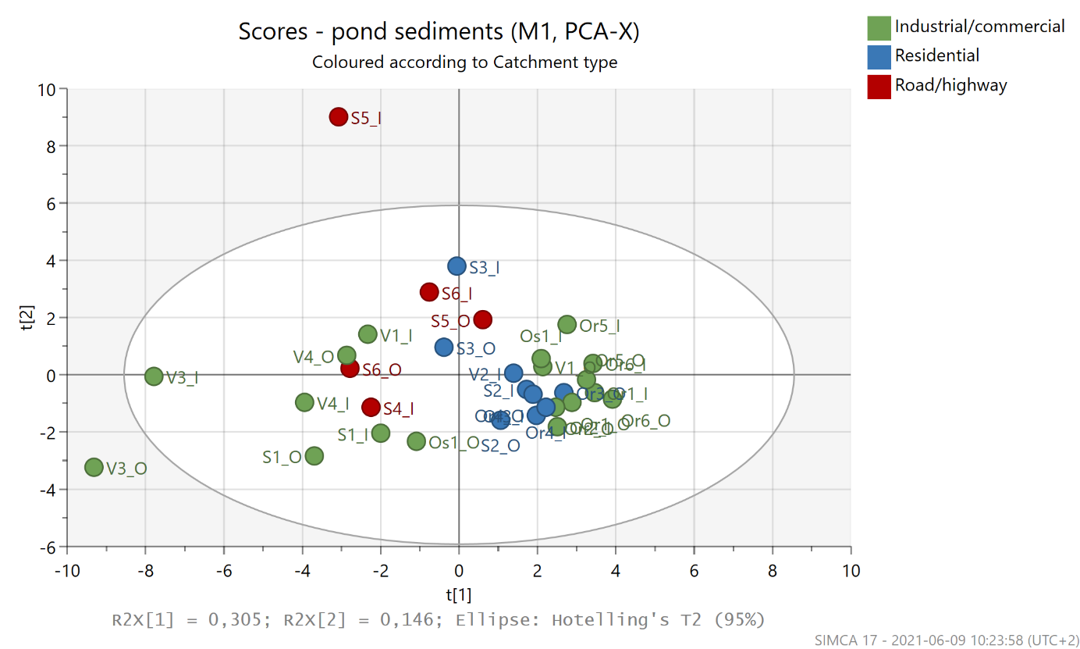
Fig. S1: Score plot for pond sediments where coloring indicates different catchment types and the labels sample names

Table S7: Results of Spearman rho correlation test between Fraction 1 of the sequential extraction (adsorbed and exchangeable metals and carbonates) and total metal concentration. Number of samples n=32.
Metal | rho | p-value
Zn | 0.92 | < 2.2E-16
Cu | 0.74 | 1.33E-06
Pb | 0.83 | 6.31E-09
Ni | 0.58 | 5.21E-04
Cr | 0.39 | 0.0275
Cd | 0.696* | 1.62E-08
* Kendall’s tau correlation (25% of the data was censored)

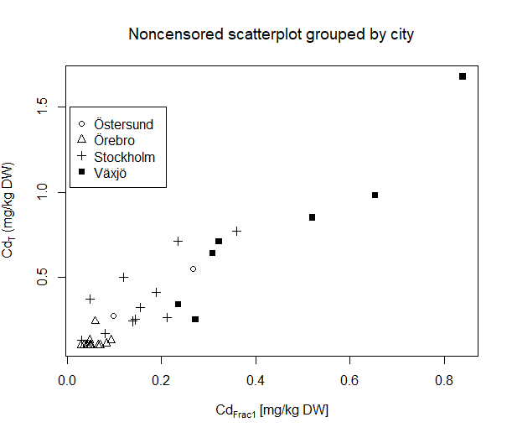
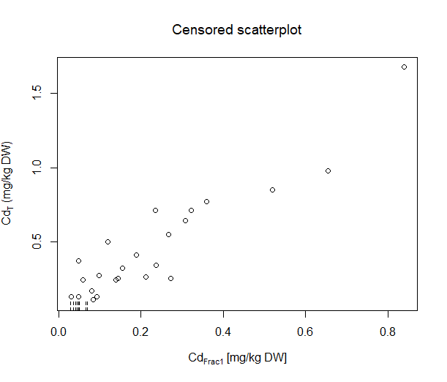
Fig. S3: Censored scatterplot shows total Cd concentration and Cd in Fraction 1 of sequential extraction

Fig. S2: Noncensored scatterplot shows total Cd concentration and Cd in Fraction 1 of sequential extraction where observations are grouped by city

Table S8: Correlation test results between total metal concentrations and different fractions of sequential extraction analysis. In case of censored values Kendall’s tau is calculated otherwise Spearman rho.
 | fcensored (%) | rho/tau | p-value
Zn_{T} | 0
Fraction 1 | 0 | 0.92 | < 2.2e-16
Fraction 2 | 3 | 0.718 | 8.05E-09
Fraction 3 | 0 | 0.97 | < 2.2E-16
Fraction 4 | 0 | 0.87 | 1.19E-10
Fraction 5 | 0 | 0.46 | 0.007455
Cu_{T} | 0
Fraction 1 | 0 | 0.74 | 1.33E-06
Fraction 2 | 16 | 0.65 | 1.29E-07
Fraction 3 | 0 | 0.92 | 4.48E-14
Fraction 4 | 0 | 0.95 | < 2.2E-16
Fraction 5 | 0 | 0.89 | 9.08E-12
Pb_{T} | 0
Fraction 1 | 0 | 0.83 | 6.31E-09
Fraction 2 | 6 | 0.631 | 4.07E-07
Fraction 3 | 0 | 0.88 | 5.62E-11
Fraction 4 | 0 | 0.72 | 3.04E-06
Fraction 5 | 0 | 0.39 | 0.02554
Ni_{T} | 0
Fraction 1 | 0 | 0.58 | 5.21E-04
Fraction 2 | 44 | 0.204 | 0.082047
Fraction 3 | 0 | 0.90 | 1.17E-12
Fraction 4 | 0 | 0.71 | 4.77E-06
Fraction 5 | 0 | 0.68 | 2.19E-05
Cr_{T} | 0
Fraction 1 | 0 | 0.39 | 0.0275
Fraction 2 | 31 | 0.274 | 0.023732
Fraction 3 | 0 | 0.78 | 1.07E-07
Fraction 4 | 0 | 0.75 | 9.92E-07
Fraction 5 | 0 | 0.77 | 3.02E-07
Cd_{T} | 25
Fraction 1 | 25 | 0.696 | 1.62E-08
Fraction 2 | 84 | 0.083 | 0.46669
Fraction 3 | 25 | 0.677 | 3.79E-08
Fraction 4 | 25 | 0.637 | 2.30E-07
Fraction 5 | 3 | 0.413 | 0.000795

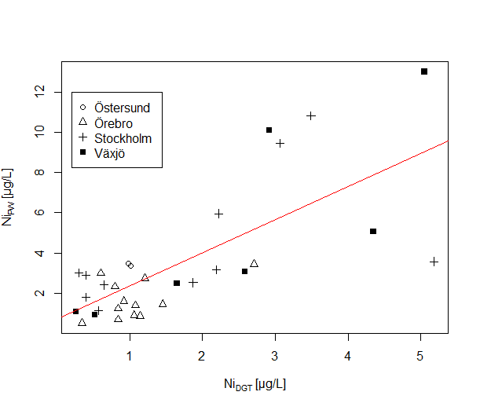

Fig. S4: All values were above LOQ. Noncensored scatterplot shows pore water Ni and DGT Ni concentration where observations are grouped by city

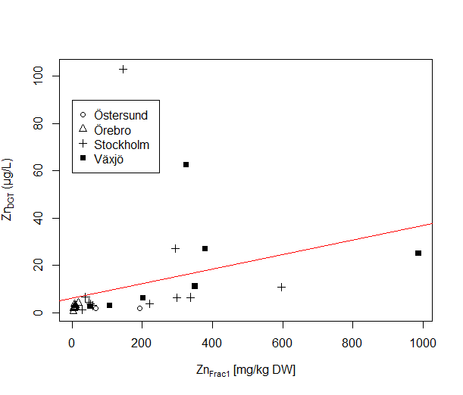

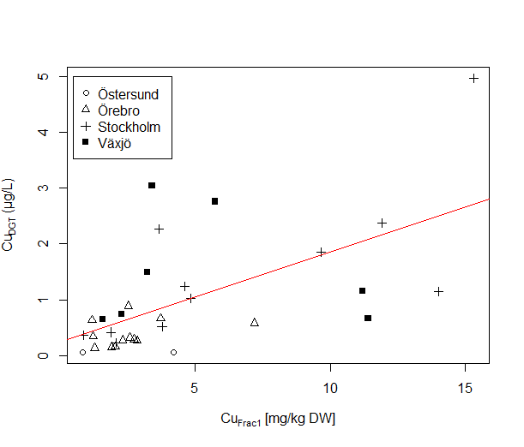

Fig. S5: All values were above LOQ. Noncensored scatterplot shows DGT Zn and Zn in Fraction 1 of sequential extraction (top graph), and DGT Cu and Cu in Fraction 1 of sequential extraction (bottom graph) where observations are grouped by city

Table S9: Correlation test results between LOI and total (T), pore water (PW) and DGT labile concentrations (DGT). In case of censored values Kendall’s tau is calculated otherwise Spearman rho.
Metal analysis | f-censored [%] | p-value | tau or rho
Zn_{T} | 0 | 2.95E-04* | 0.60
Zn_{PW} | 0 | 0.096 | 0.30
Zn_{DGT} | 0 | 0.028 | 0.39
Cu_{T} | 0 | 4.83E-04* | 0.58
Cu_{PW} | 16▲ | 0.279 | 0.135
Cu_{DGT} | 0 | 0.019 | 0.41
Pb_{T} | 0 | 0.017 | 0.42
Pb_{PW} | 6▲ | 0.337 | 0.121
Pb_{DGT} | 0 | 0.109 | 0.29
Ni_{T} | 0 | 0.071 | 0.32
DNi_{PW} | 0 | 0.017 | 0.42
Ni_{DGT} | 0 | 0.486 | 0.13
Cr_{T} | 0 | 0.083 | 0.31
Cr_{PW} | 0 | 4.73E-04* | 0.58
Cr_{DGT} | 3▲ | 0.961 | -0.008
Cd_{T} | 25▲ | 1.42E-05* | 0.534
Cd_{PW} | 16▲ | 0.341 | 0.119
Cd_{DGT} | 6▲ | 0.059 | 0.236
▲indicates % of censored data and that Kendall’s tau is calculated
* indicates statistical significance (p<0.01)

Table S10: Kendall’s tau correlation coefficient between TOC and Fraction 2 of sequential extraction analysis (labile organic forms).
Metal analysis | f-censored [%] | p-value | tau
Zn_{Frac2} | 3 | 7.31E-06* | 0.558
Cu_{Frac2} | 16 | 3.09E-04* | 0.446
Pb_{Frac2} | 6 | 8.24E-04* | 0.417
Ni_{Frac2} | 44 | 0.025 | 0.262
Cr_{Frac2} | 31 | 5.96E-04* | 0.415
Cd_{Frac2} | 84 | 0.397 | 0.097
* indicates statistical significance (p<0.01)

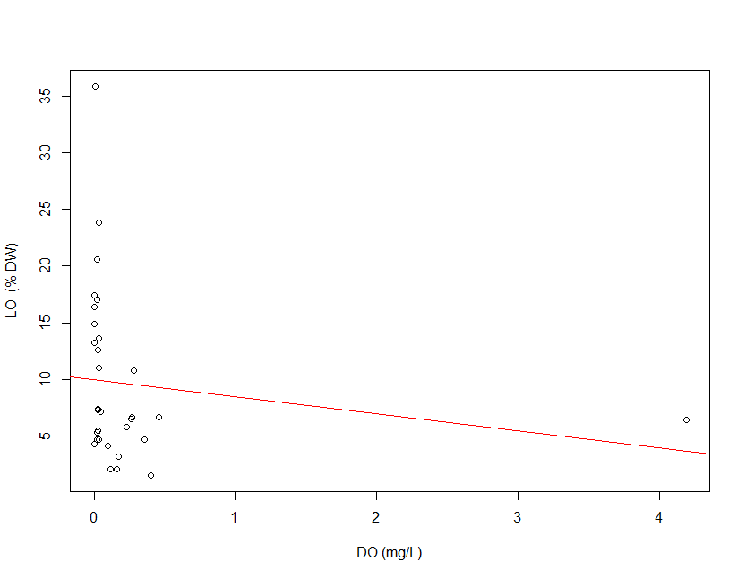
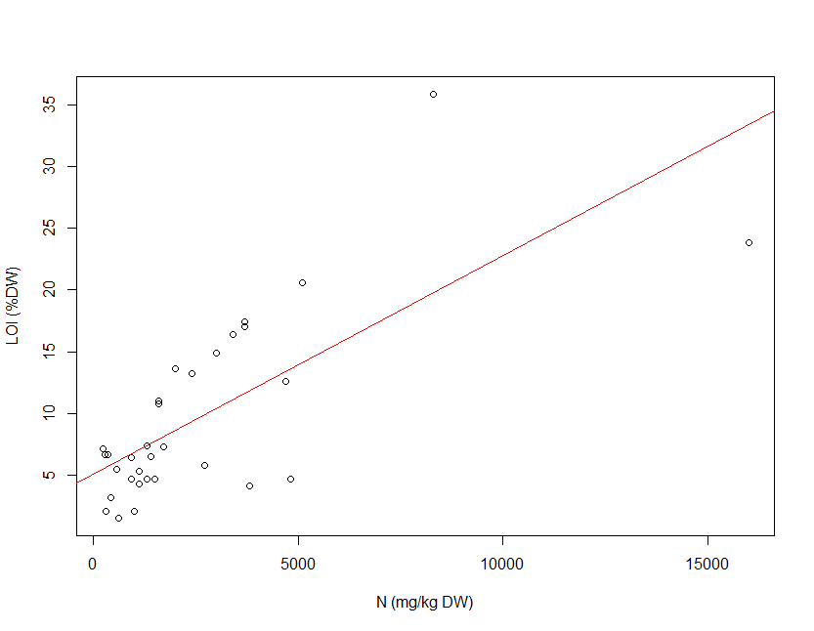
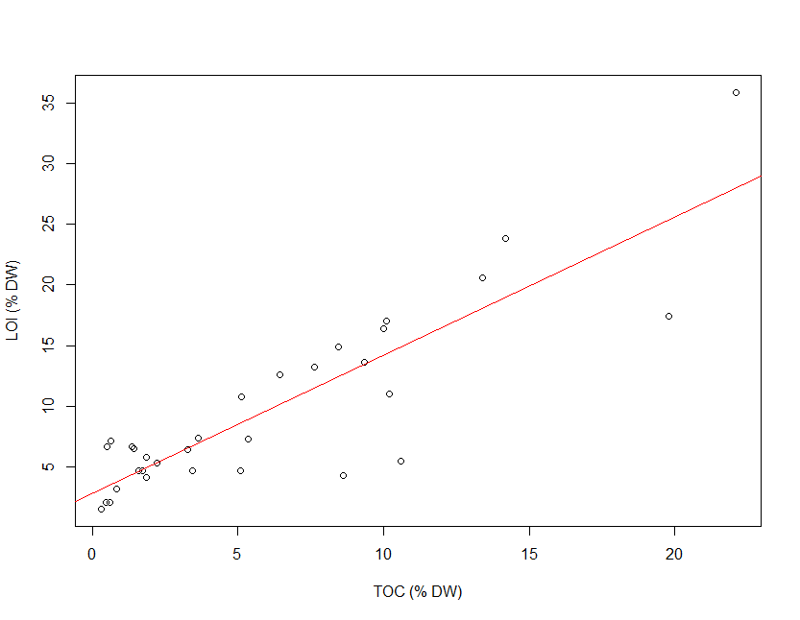

Fig. S6: Scatterplots between LOI and TOC (ρ=0.76, p= 4.46E-07), LOI and N (ρ=0.618, p=1.62E-04), and LOI and DO (ρ=-0.46, p= 0.008)

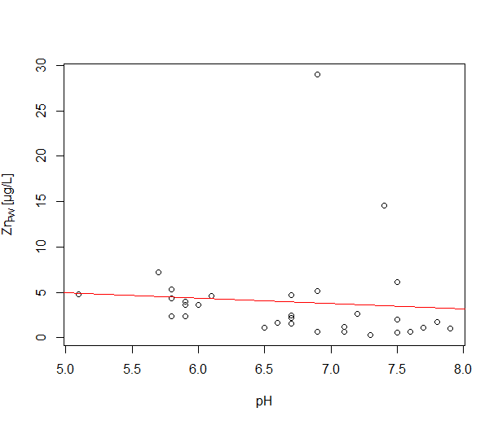

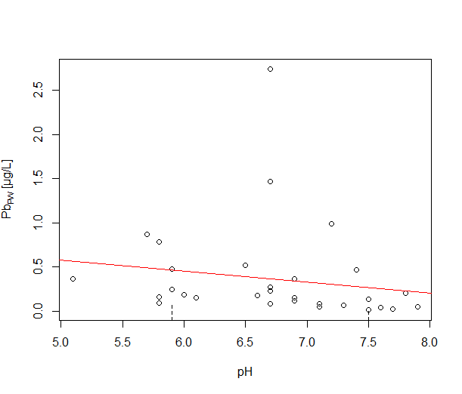

Fig. S7: Scatterplots between pH and pore water Zn concentration (ρ=-0.466, p= 0.007) and pH and pore water Pb concentration (tau=-0.337, p= 0.007)

Table S11: Total metal concentrations in stormwater pond sediments
 | Total Cd | Total Cr | Total Cu | Total Ni | Total Pb | Total Zn
Os1_In | 0.27 | 14.6 | 39.2 | 17.2 | 14.6 | 218
Os1_Out | 0.55 | 23.9 | 114 | 23.7 | 91.8 | 506
Or1_In | <0.1 | 19.8 | 18 | 11.5 | 15.9 | 51.2
Or1_Out | <0.1 | 23.2 | 26.1 | 13.4 | 18 | 75.2
Or2_In | 0.13 | 37.4 | 26.9 | 24.9 | 18.6 | 92
Or2_Out | <0.1 | 37.1 | 28.5 | 24.2 | 18 | 87.7
Or3_In | 0.24 | 46.8 | 43.7 | 30.6 | 25 | 102
Or3_Out | <0.1 | 22.9 | 19.4 | 19.4 | 12.4 | 59.4
Or4_In | 0.13 | 38.4 | 29.7 | 27.9 | 19.6 | 87.2
Or4_Out | 0.11 | 35.1 | 29.7 | 25.1 | 18.7 | 76.4
Or5_In | <0.1 | 16.8 | 14.5 | 9.3 | 15.1 | 51.8
Or5_Out | <0.1 | 14.4 | 13.4 | 8.8 | 13.2 | 43.6
Or6_In | <0.1 | 8.44 | 6.14 | 3.7 | 8.8 | 27.4
Or6_Out | <0.1 | 13.3 | 8.18 | 6.9 | 12.7 | 31.8
S1_In | 0.71 | 54.8 | 253 | 21.3 | 47.3 | 680
S1_Out | 0.77 | 71.9 | 319 | 27.2 | 54.4 | 886
S2_In | 0.24 | 26.2 | 36.1 | 17.9 | 17.4 | 129
S2_Out | 0.26 | 40.2 | 55.4 | 29.4 | 19.2 | 156
S3_In | 0.5 | 15.2 | 23.4 | 11.6 | 9 | 247
S3_Out | 0.41 | 18.4 | 32.8 | 15.5 | 9.4 | 69.8
S4_In | 0.32 | 58.2 | 172 | 24.9 | 35.3 | 477
S5_In | 0.37 | 28.7 | 63.6 | 12.3 | 13.4 | 255
S5_Out | 0.17 | 36.7 | 41.6 | 19.8 | 20.3 | 104
S6_In | 0.13 | 28.5 | 60.9 | 10.2 | 9.5 | 330
S6_Out | 0.25 | 54.2 | 210 | 22.9 | 30.2 | 1020
V1_In | 0.64 | 21.3 | 93 | 10.3 | 37.7 | 643
V1_Out | 0.25 | 8.44 | 10.9 | 3.4 | 7 | 122
V2_In | 0.34 | 13.6 | 33.3 | 6.7 | 29.6 | 127
V3_In | 0.98 | 34.6 | 104 | 28.7 | 63 | 603
V3_Out | 1.68 | 38.4 | 182 | 41.9 | 65.8 | 1380
V4_In | 0.85 | 43.4 | 99.9 | 43.6 | 51.5 | 726
V4_Out | 0.71 | 45 | 74.9 | 34.7 | 49.1 | 468

Table S12: Porewater metal concentrations in stormwater pond sediments
 | Cd porewater | Cr porewater | Cu porewater | Ni porewater | Pb porewater | Zn porewater
Os1_In | 0.02 | 0.367 | 0.302 | 3.46 | 0.138 | 2.01
Os1_Out | 0.017 | 0.291 | 0.643 | 3.34 | 0.992 | 2.62
Or1_In | 0.0049 | 0.0482 | 0.407 | 0.681 | 0.204 | 1.71
Or1_Out | 0.00424 | 0.327 | 0.382 | 0.864 | 0.232 | 2.19
Or2_In | 0.00318 | 0.951 | 0.299 | 0.897 | 0.0946 | 2.38
Or2_Out | 0.00954 | 0.705 | 1.09 | 2.98 | 0.478 | 3.97
Or3_In | 0.00319 | 0.357 | 1.82 | 1.61 | 0.087 | 0.685
Or3_Out | 0.00624 | 0.921 | 1.25 | 2.32 | 0.782 | 4.37
Or4_In | 0.00436 | 0.601 | 0.769 | 1.39 | 0.117 | 0.702
Or4_Out | 0.00347 | 0.99 | 3.08 | 3.44 | 0.519 | 1.11
Or5_In | 0.0249 | 2.71 | 3.55 | 2.74 | 2.74 | 4.71
Or5_Out | 0.00538 | 1.54 | 0.947 | 1.44 | 1.47 | 1.57
Or6_In | <0.002 | 0.292 | 0.626 | 1.24 | 0.0522 | 1.24
Or6_Out | <0.002 | 0.121 | 0.197 | 0.514 | 0.0656 | 0.318
S1_In | 0.00339 | 1.93 | 0.131 | 1.8 | 0.0256 | 1.09
S1_Out | 0.00766 | 1.55 | 0.382 | 1.14 | 0.0497 | 1.03
S2_In | 0.00328 | 0.359 | <0.1 | 2.52 | <0.01 | 0.542
S2_Out | 0.0041 | 0.592 | 0.504 | 2.4 | 0.175 | 1.63
S3_In | 0.0317 | 4.72 | 7.4 | 2.88 | 0.371 | 29
S3_Out | 0.00589 | 4.42 | 2.03 | 3.02 | 0.272 | 2.42
S4_In | 0.00506 | 2.77 | 0.309 | 3.57 | 0.0441 | 0.623
S5_In | 0.0383 | 5.58 | 1.6 | 10.8 | 0.151 | 5.15
S5_Out | 0.021 | 5.98 | <0.5 | 3.16 | 0.0883 | 2.41
S6_In | 0.00984 | 3.59 | 0.324 | 9.45 | 0.0133 | 6.12
S6_Out | 0.0212 | 4.39 | 3.36 | 5.95 | 0.468 | 14.6
V1_In | <0.02 | 0.517 | <1 | 2.47 | 0.152 | 4.58
V1_Out | <0.02 | 0.487 | <1 | 1.08 | <0.1 | 2.38
V2_In | 0.0047 | 0.524 | 0.535 | 0.917 | 0.188 | 3.64
V3_In | 0.0129 | 3.78 | 1.38 | 13 | 0.872 | 7.17
V3_Out | 0.005 | 3.07 | 0.779 | 3.06 | 0.245 | 3.58
V4_In | 0.00883 | 7.12 | 0.667 | 5.07 | 0.363 | 4.81
V4_Out | <0.02 | 11.1 | <1 | 10.1 | 0.164 | 5.32

Table S13: DGT metal concentrations in stormwater pond sediments
 | Cd DGT | Cr DGT | Cu DGT | Ni  DGT | Pb DGT | Zn DGT
Os1_In | <0.002 | 0.195 | 0.0598 | 0.978 | 0.0186 | 1.86
Os1_Out | <0.002 | <0.191 | 0.0592 | 1.01 | 0.0401 | 1.84
Or1_In | 0.00258 | 0.562 | 0.289 | 0.838 | 0.056 | 1.95
Or1_Out | 0.00302 | 0.479 | 0.667 | 1.14 | 0.204 | 4.15
Or2_In | 0.00223 | 0.417 | 0.132 | 1.06 | 0.0373 | 2.03
Or2_Out | 0.00094 | 0.492 | 0.161 | 0.605 | 0.0338 | 2.5
Or3_In | 0.00635 | 0.536 | 0.58 | 0.92 | 0.173 | 2.2
Or3_Out | 0.00158 | 0.477 | 0.338 | 0.798 | 0.051 | 2.35
Or4_In | 0.00331 | 0.561 | 0.319 | 1.08 | 0.0605 | 2.41
Or4_Out | 0.0113 | 0.609 | 0.261 | 2.71 | 0.0323 | 3.62
Or5_In | 0.0104 | 0.641 | 0.886 | 1.21 | 0.124 | 3.16
Or5_Out | 0.0109 | 0.671 | 0.27 | 1.45 | 0.0583 | 3.39
Or6_In | 0.00406 | 0.704 | 0.629 | 0.84 | 0.0836 | 2.51
Or6_Out | 0.00174 | 0.544 | 0.147 | 0.342 | 0.103 | 0.688
S1_In | 0.00441 | 0.504 | 1.02 | 0.396 | 0.0669 | 3.87
S1_Out | 0.00727 | 0.552 | 2.37 | 0.573 | 0.0608 | 6.53
S2_In | 0.00312 | 0.497 | 0.511 | 1.87 | 0.0901 | 4.32
S2_Out | 0.0023 | 0.473 | 0.226 | 0.643 | 0.0431 | 3.03
S3_In | 0.00529 | 0.451 | 0.416 | 0.4 | 0.0991 | 3.83
S3_Out | 0.00183 | 0.297 | 0.358 | 0.296 | 0.0361 | 1.36
S4_In | 0.00281 | 0.558 | 1.15 | 5.18 | 0.113 | 6.29
S5_In | 0.0407 | 0.393 | 4.97 | 3.49 | 0.0496 | 103
S5_Out | 0.00595 | 0.425 | 1.24 | 2.19 | 0.0498 | 6.56
S6_In | 0.00319 | 0.406 | 2.27 | 3.06 | 0.156 | 27.3
S6_Out | 0.00512 | 0.522 | 1.85 | 2.22 | 0.25 | 10.8
V1_In | 0.0621 | 0.363 | 1.49 | 1.65 | 0.315 | 62.5
V1_Out | 0.00548 | 0.333 | 0.648 | 0.261 | 0.0153 | 3.08
V2_In | 0.00826 | 0.33 | 0.741 | 0.525 | 0.125 | 2.73
V3_In | 0.0453 | 0.513 | 3.04 | 5.05 | 1.06 | 26.9
V3_Out | 0.0245 | 0.391 | 2.76 | 2.58 | 0.413 | 25
V4_In | 0.00901 | 0.713 | 1.15 | 4.35 | 0.264 | 11.2
V4_Out | 0.0114 | 0.856 | 0.668 | 2.92 | 0.162 | 6.21

Table S14: Metal concentrations in Fraction 1 of sequential extraction analysis
 | Cd  Frac 1 | Cr  Frac 1 | Cu  Frac 1 | Ni  Frac 1 | Pb  Frac 1 | Zn  Frac 1
Os1_In | 0.0973 | 1 | 0.859 | 1.88 | 7.33 | 66.3
Os1_Out | 0.266 | 2.35 | 4.19 | 4.28 | 59.2 | 193
Or1_In | 0.048 | 0.484 | 2.75 | 1.2 | 6.02 | 4.8
Or1_Out | 0.0652 | 0.441 | 3.72 | 1.71 | 6.43 | 18.1
Or2_In | 0.0475 | 0.537 | 1.28 | 2.24 | 4.5 | 8.54
Or2_Out | 0.07 | 0.613 | 2.06 | 2.28 | 3.81 | 9.16
Or3_In | 0.0595 | 0.525 | 7.2 | 1.43 | 8.15 | 5.46
Or3_Out | 0.044 | 1.02 | 1.24 | 3.78 | 4.32 | 6.28
Or4_In | 0.0934 | 0.516 | 2.59 | 3.7 | 5.82 | 5.86
Or4_Out | 0.0829 | 1.08 | 2.86 | 4.65 | 6.08 | 6.78
Or5_In | 0.0413 | 0.583 | 2.54 | 0.786 | 3.25 | 9.3
Or5_Out | 0.0505 | 0.658 | 2.32 | 1.42 | 3.58 | 8.36
Or6_In | 0.035 | 0.738 | 1.2 | 0.656 | 2.55 | 8.49
Or6_Out | 0.0294 | 0.51 | 1.91 | 0.806 | 3.84 | 3.54
S1_In | 0.235 | 4.89 | 4.85 | 5.72 | 12.7 | 220
S1_Out | 0.359 | 4.68 | 11.9 | 5.04 | 18.4 | 337
S2_In | 0.139 | 1.32 | 3.78 | 4.13 | 8.71 | 48.7
S2_Out | 0.211 | 1.43 | 2.07 | 5.05 | 7.2 | 59.2
S3_In | 0.119 | 1.33 | 1.89 | 2.91 | 2.21 | 52.2
S3_Out | 0.189 | 2.7 | 0.876 | 3.36 | 2.62 | 27.8
S4_In | 0.155 | 5.99 | 14 | 6.57 | 14.9 | 299
S5_In | 0.0475 | 2.69 | 15.3 | 3.97 | 3.16 | 145
S5_Out | 0.0808 | 2 | 4.63 | 3.4 | 5.73 | 38.2
S6_In | 0.0299 | 4.14 | 3.66 | 4.59 | 5.56 | 294
S6_Out | 0.144 | 5.28 | 9.67 | 5.48 | 15.3 | 597
V1_In | 0.308 | 2.87 | 3.25 | 4.25 | 13.5 | 326
V1_Out | 0.272 | 3.05 | 1.59 | 2.82 | 0.901 | 107
V2_In | 0.236 | 2.74 | 2.29 | 2.8 | 4.4 | 50.6
V3_In | 0.654 | 9.75 | 3.41 | 19.9 | 34.3 | 379
V3_Out | 0.839 | 6.24 | 5.74 | 19.1 | 29.4 | 987
V4_In | 0.52 | 2.78 | 11.2 | 4.54 | 10.1 | 350
V4_Out | 0.322 | 3.23 | 11.4 | 3.79 | 4.24 | 203

Table S15: Metal concentrations in Fraction 2 of sequential extraction analysis
 | Cd  Frac 2 | Cr  Frac 2 | Cu  Frac 2 | Ni  Frac 2 | Pb  Frac 2 | Zn  Frac 2
Os1_In | <0.3 | <3 | <5 | <3 | <1 | <11
Os1_Out | <0.3 | 2.91 | 6.19 | <3 | 7.02 | 25.2
Or1_In | <0.01 | 0.319 | 1.96 | 0.36 | 1.01 | 1.62
Or1_Out | <0.005 | 0.301 | 1.99 | 0.425 | 1.39 | 3.2
Or2_In | <0.006 | 0.633 | 1.94 | 0.604 | 2.01 | 2.3
Or2_Out | 0.00813 | 0.609 | 4.08 | 0.549 | 1.68 | 4.05
Or3_In | <0.006 | 0.556 | 5.51 | 0.364 | 2.71 | 3.15
Or3_Out | <0.005 | 0.821 | 3.24 | 1.16 | 1.81 | 2.08
Or4_In | 0.00922 | 0.491 | 5.13 | 1.03 | 2.48 | 3.14
Or4_Out | <0.005 | 0.607 | 3.67 | 0.833 | 1.63 | 1.86
Or5_In | <0.006 | 0.5 | 1.61 | 0.266 | 1.11 | 2.36
Or5_Out | <0.006 | 0.556 | 2.05 | 0.41 | 1.13 | 2.22
Or6_In | <0.006 | 0.431 | 1.12 | 0.215 | 0.632 | 1.2
Or6_Out | <0.006 | 0.36 | 1.21 | 0.294 | 0.712 | 5.08
S1_In | <0.3 | 3.62 | 11 | <3 | 7.02 | 28
S1_Out | <0.3 | 4.81 | 14.4 | <3 | 11.1 | 57.5
S2_In | 0.00791 | 0.879 | 4.02 | 0.609 | 1.54 | 12.1
S2_Out | 0.0419 | 1.01 | 8.46 | 1.78 | 4.18 | 18.9
S3_In | <0.1 | <1 | 3.75 | 1.75 | 1.18 | 9.93
S3_Out | <0.1 | 1.76 | 5.61 | 3.56 | 3.12 | 14.8
S4_In | <0.3 | <3 | 12.7 | <3 | 5.21 | 43.8
S5_In | <0.1 | <1 | 7.18 | <1 | 0.8 | 18.5
S5_Out | <0.1 | <1 | 5.14 | <1 | 1.5 | 6.65
S6_In | <0.3 | <3 | <5 | <3 | <1 | 20.2
S6_Out | <0.3 | <3 | 9.67 | <3 | 3.08 | 69.6
V1_In | <0.3 | <3 | <6 | <3 | 3.83 | 45.6
V1_Out | <0.3 | <3 | <6 | <3 | 2.75 | 26.7
V2_In | <0.3 | <3 | <6 | <3 | 1.59 | 14
V3_In | <0.3 | 4.71 | 8.69 | 4.19 | 12.2 | 59.4
V3_Out | 0.221 | 6.85 | 16.5 | 5.47 | 14.8 | 242
V4_In | <0.3 | 4.1 | 13.7 | <3 | 5.69 | 75.7
V4_Out | <0.3 | 4.55 | 12.2 | <3 | 7.08 | 54.6

Table S16: Metal concentrations in Fraction 3 of sequential extraction analysis
 | Cd  Frac 3 | Cr  Frac 3 | Cu  Frac 3 | Ni  Frac 3 | Pb  Frac 3 | Zn  Frac 3
Os1_In | 0.0675 | 2.56 | 15.9 | 2.96 | 3.99 | 51.7
Os1_Out | 0.181 | 4.8 | 51 | 5.51 | 23.8 | 149
Or1_In | 0.024 | 2.07 | 5.02 | 2.63 | 4.4 | 14.8
Or1_Out | 0.0403 | 2.38 | 8.52 | 3.04 | 6.42 | 22.8
Or2_In | 0.0236 | 3.21 | 6.7 | 5.12 | 6.52 | 25.4
Or2_Out | 0.0353 | 3.53 | 4.9 | 5.8 | 7.29 | 28.6
Or3_In | 0.0617 | 3.76 | 7.43 | 6.71 | 5.46 | 23.8
Or3_Out | 0.0174 | 3.68 | 4.94 | 4.44 | 4.12 | 21.3
Or4_In | 0.0343 | 4.05 | 5.32 | 6.83 | 6.53 | 27.4
Or4_Out | 0.0238 | 4.12 | 7.04 | 5.77 | 6.33 | 26.2
Or5_In | 0.0248 | 1.54 | 2.93 | 1.8 | 3.46 | 13.5
Or5_Out | 0.0313 | 1.52 | 2.78 | 1.95 | 3.88 | 12.1
Or6_In | 0.00717 | 0.975 | 1.23 | 0.651 | 2.76 | 7.28
Or6_Out | 0.0188 | 1.84 | 1.86 | 2.03 | 3.76 | 13.1
S1_In | 0.162 | 8.88 | 56.5 | 5 | 10.6 | 93.6
S1_Out | 0.158 | 7.81 | 68.1 | 4.2 | 9.85 | 176
S2_In | 0.0548 | 3.66 | 12.3 | 4.46 | 5.83 | 41.7
S2_Out | 0.0755 | 4.3 | 7.88 | 7.97 | 7.43 | 47.2
S3_In | 0.0577 | 2.65 | 3.26 | 4.72 | 2.09 | 40
S3_Out | 0.143 | 3.32 | 2.73 | 6.52 | 3.26 | 25.6
S4_In | 0.0608 | 9.47 | 58.4 | 5.3 | 12.3 | 172
S5_In | 0.0209 | 7.21 | 22.7 | 3.78 | 4.86 | 107
S5_Out | 0.0354 | 3.9 | 12.4 | 3.57 | 6.24 | 34.9
S6_In | 0.0246 | 6.23 | 56.5 | 2.89 | 4.1 | 106
S6_Out | 0.0837 | 9.42 | 106 | 5.38 | 11.9 | 363
V1_In | 0.263 | 7.14 | 49.1 | 4.4 | 15.7 | 222
V1_Out | 0.0775 | 2.32 | 5.03 | 1.51 | 3.93 | 36.9
V2_In | 0.0876 | 3.62 | 16.4 | 2.54 | 3.8 | 49.7
V3_In | 0.344 | 8.22 | 57.6 | 10 | 20.9 | 198
V3_Out | 0.825 | 8.88 | 106 | 14.1 | 25.9 | 408
V4_In | 0.202 | 7.71 | 39.9 | 14.7 | 26.4 | 271
V4_Out | 0.212 | 6.2 | 26.9 | 12.7 | 29.8 | 206

Table S17: Metal concentrations in Fraction 4 of sequential extraction analysis
 | Cd  Frac 4 | Cr  Frac 4 | Cu  Frac 4 | Ni  Frac 4 | Pb  Frac 4 | Zn  Frac 4
Os1_In | 0.0314 | 6.18 | 8.49 | 7.48 | 3.78 | 33.3
Os1_Out | 0.0708 | 13.5 | 47.4 | 12.9 | 7.15 | 96
Or1_In | 0.0122 | 3.34 | 2.64 | 2.45 | 2.22 | 11.7
Or1_Out | 0.0138 | 5.72 | 4.28 | 4.16 | 3.06 | 15.8
Or2_In | 0.0156 | 8.45 | 6.87 | 7.14 | 3.38 | 23.3
Or2_Out | 0.0139 | 8.41 | 2.18 | 5.78 | 4.02 | 22.9
Or3_In | 0.0325 | 7.24 | 4.89 | 5.13 | 2.28 | 19
Or3_Out | 0.00741 | 5.41 | 3.45 | 3.71 | 1.9 | 15.2
Or4_In | 0.0111 | 7.33 | 3.03 | 5.52 | 2.33 | 38.8
Or4_Out | 0.011 | 7.46 | 4.51 | 5.34 | 3.09 | 19.9
Or5_In | 0.0119 | 3.33 | 2.08 | 1.98 | 1.69 | 10.3
Or5_Out | 0.015 | 3.1 | 1.97 | 2.07 | 1.62 | 10.7
Or6_In | 0.00987 | 2.52 | 1.32 | 1.53 | 2.32 | 7.14
Or6_Out | 0.0111 | 3.52 | 1.57 | 1.94 | 2.79 | 8.3
S1_In | 0.0439 | 11.7 | 38.7 | 3.53 | 2.99 | 36.3
S1_Out | 0.0821 | 17 | 99.9 | 5.6 | 6.93 | 93.5
S2_In | 0.0198 | 8.49 | 10.4 | 5.56 | 2.53 | 23.5
S2_Out | 0.0171 | 10.4 | 13.2 | 7.6 | 3.18 | 34.8
S3_In | 0.0147 | 3.49 | 5.98 | 3.33 | 1.1 | 15.8
S3_Out | 0.0254 | 5.49 | 13.8 | 5.14 | 1.81 | 19.3
S4_In | 0.0371 | 18.2 | 60 | 7.27 | 6.71 | 67.9
S5_In | 0.0142 | 14.9 | 13.3 | 4.17 | 2.81 | 37
S5_Out | 0.0208 | 13.4 | 13.9 | 6.64 | 5.62 | 30.7
S6_In | 0.0195 | 16.7 | 16.7 | 4.64 | 3.87 | 30.2
S6_Out | 0.0453 | 17.9 | 74 | 6.47 | 4.84 | 79.8
V1_In | 0.0472 | 14.9 | 41.7 | 6.59 | 6.31 | 59.9
V1_Out | 0.0139 | 2.93 | 2.19 | 1.62 | 0.961 | 15
V2_In | 0.0218 | 4.59 | 6.98 | 2.25 | 1.63 | 22.5
V3_In | 0.0633 | 10.6 | 34.1 | 4.4 | 4.32 | 37.7
V3_Out | 0.054 | 11.8 | 46.1 | 5.36 | 3.97 | 57.2
V4_In | 0.0543 | 12.6 | 30.2 | 22 | 13.4 | 78
V4_Out | 0.0436 | 12.9 | 19.9 | 18.7 | 12.3 | 73.5

Table S18: Metal concentrations in Fraction 5 of sequential extraction analysis
 | Cd  Frac 5 | Cr  Frac 5 | Cu  Frac 5 | Ni  Frac 5 | Pb  Frac 5 | Zn  Frac 5
Os1_In | 0.0254 | 2.98 | 6.65 | 4.65 | 1.52 | 12.5
Os1_Out | 0.0463 | 6.62 | 24.1 | 4.89 | 0.958 | 16.5
Or1_In | 0.0139 | 5.37 | 2.1 | 2.64 | 1.15 | 15.5
Or1_Out | 0.0088 | 7.64 | 3.15 | 3.8 | 1.39 | 15.7
Or2_In | 0.0065 | 13.2 | 3.27 | 6.4 | 1.25 | 22.8
Or2_Out | 0.0198 | 14.5 | 10.2 | 9.06 | 3.61 | 26.4
Or3_In | 0.0081 | 14.1 | 4.74 | 7.41 | 1.22 | 25.1
Or3_Out | 0.00868 | 10 | 7.65 | 5.74 | 1.03 | 20.4
Or4_In | <0.01 | 14.3 | 6.31 | 8.92 | 2.23 | 26.6
Or4_Out | 0.0103 | 14.3 | 6.18 | 7.36 | 2.64 | 25.1
Or5_In | 0.0086 | 3.71 | 1.39 | 1.76 | 0.9 | 10.7
Or5_Out | 0.0101 | 2.98 | 1.21 | 1.53 | 0.93 | 7.91
Or6_In | 0.0043 | 1.95 | 1.47 | 1.04 | 0.917 | 4.55
Or6_Out | 0.00682 | 3.52 | 1.77 | 1.62 | 1.22 | 7.76
S1_In | 0.0312 | 15.1 | 25.3 | 7.53 | 1.27 | 25.2
S1_Out | 0.0311 | 31.9 | 42.6 | 13 | 2.09 | 41.1
S2_In | 0.0169 | 10.4 | 5.31 | 5.11 | 1.44 | 19.7
S2_Out | 0.0143 | 20.4 | 14.9 | 10.6 | 1.32 | 25.8
S3_In | 0.0189 | 11.9 | 7.37 | 5.33 | 0.647 | 20.3
S3_Out | 0.00973 | 15.3 | 13.1 | 5.78 | 0.716 | 12.7
S4_In | 0.0361 | 27.1 | 23.8 | 11.5 | 1.8 | 60.6
S5_In | 0.0284 | 14.5 | 12.9 | 6.6 | 0.943 | 24.8
S5_Out | 0.0175 | 25.1 | 11.7 | 14.9 | 3.13 | 39.7
S6_In | 0.032 | 13.1 | 10.3 | 5.37 | 1.2 | 20.8
S6_Out | 0.0394 | 22.2 | 30.5 | 10.7 | 1.78 | 45.2
V1_In | 0.0354 | 16.9 | 17 | 7.24 | 1.38 | 14
V1_Out | 0.00511 | 1.95 | 1.7 | 1.05 | 0.461 | 4.04
V2_In | 0.0175 | 3.08 | 4.51 | 1.69 | 0.457 | 11.4
V3_In | 0.0266 | 7.09 | 10.9 | 3.92 | 0.849 | 9.88
V3_Out | 0.0254 | 9.73 | 25.2 | 5.96 | 1.1 | 16.9
V4_In | 0.0312 | 13.3 | 12.5 | 7.87 | 1.94 | 31.5
V4_Out | 0.0319 | 14 | 8.04 | 5.64 | 1.48 | 29.6

