Supplementary Materials
Figure S1. FT-IR spectra of the five net mussels: Blue Net (BN), Green Net (GN), White Net (WN) and Yellow Net (YN). Absorbance in vertical axis, IR region cm⁻¹ in horizontal axis. The magnified region shows a range of the fingerprint region, where the main differences between the spectra were observed.
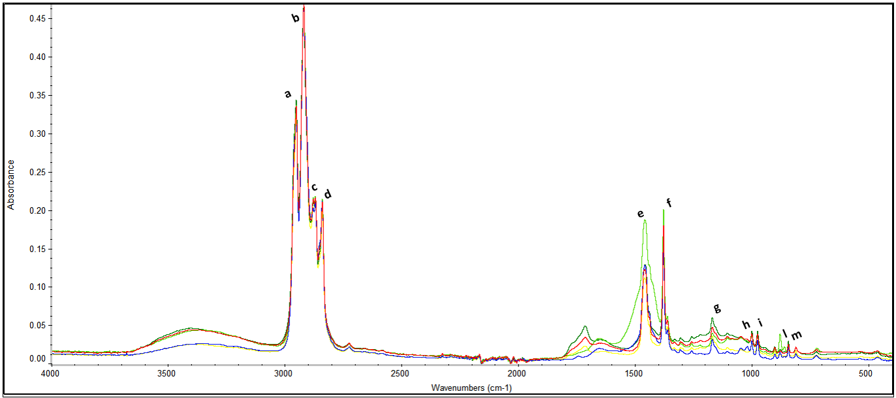

Table S1. Limit of detection (LOD) and limit of quantification (LOQ) for the detected elements.
Elements | LOD | LOQ
Elements | μg L⁻¹ | μg L⁻¹
Be | 1.3 | 5
B | 19.1 | 100
Al | 3.2 | 10
V | 0.9 | 5
Cr | 0.4 | 1
Mn | 0.2 | 1
Fe | 1.7 | 50
Co | 0.2 | 2
Ni | 2.1 | 10
Cu | 2.2 | 10
Zn | 0.9 | 10
As | 0.1 | 1
Mo | 0.8 | 3
Cd | 0.1 | 5
Sb | 0.1 | 2
Ba | 3.3 | 30
Hg | 0.1 | 0.5
Pb | 0.05 | 1
Se | 2.4 | 10

Table S2. Summary of experimental conditions of acute and sub-chronic test
 | Acute test | Sub-chronic test
Test type | Static | Semi-static
Stage of development | Nauplii (≤ 24 h) | Nauplii (≤ 24 h)
Luminosity | 500-1200 lx cool light | 500-1200 lx cool light
Light/dark photoperiod | 16 h:8 h | 16 h:8 h
Dilution water | Artificial Sea Water IO® (0.22 µm) | Artificial Sea Water IO® (0.22 µm)
Salinity PSU | 38 ± 2 | 38 ± 2
Temperature | 20 ± 2 | 20 ± 2
pH | 8 ± 0.3 | 8 ± 0.3
Chamber test | 12-well plates | 24-well plates
Test duration | 48 h | 5-9 d
Incubation volume (ml) | 3 | 1
N° organisms/replicate | 10 | 1
N° replicates | 3 | 10
N" run | 3 | 3
N° concentrations | 5 + 1 control | 3 + control
Solution renewal | Absent | Every 48 h
Feeding | Absent | T. suecica (1.0 x 10⁵ cell/mL)
Endpoint | Mortality rate | Moults number, larval development

Table S3. Physico-chemical parameters of microplastics aged mussel nets of different colours in artificial seawater (AFW, T = 25 °C). Polydispersity index (PDI), Volume-weighted diameter (D), relative percentage of each peak (%); n.a. = not available.
 |  | Time T= 0
 |  | Peak 1 | Peak 2 | Peak 3
Mussel Nets | PDI | D (nm) ± SD
Pink | 0.568 | 541 ± 39 (71%) | 1.020 ± 201 (20%) | 235 ± 22 (9%)
White | 0.748 | 540 ± 47 (67%) | 1123 ± 121 (23%) | 184 ± 11 (10%)
Green | 0.678 | 533 ± 58 (67%) | 925 ± 118 (33%) | n.a.
Blue | 0.595 | 622 ± 38 (32%) | 1112 ± 145 (53%) | 177± 8 (15%)
Yellow | 0.489 | 545 ± 63 (58%) | 1234 ± 169 (34%) | 223 ± 17 (8%)
 |  | Time T= 1 (48h)
 |  | Peak 1 | Peak 2 | Peak 3
Mussel Nets | PDI | D (nm) ± SD
Pink | 0.433 | 746 ± 118 (46%) | 1179 ± 286 (54%) | n.a.
White | 0.357 | 804 ± 315 (33%) | 1346 ± 362 (46%) | 367 ± 48 (22%)
Green | 0.646 | 947 ± 144 (100%) | n.a. | n.a.
Blue | 0.459 | 768 ± 142 (17%) | 1211 ± 256 (84%) | n.a.
Yellow | 0.324 | 676 ± 220 (68%) | 1375 ± 402 (31%) | n.a.

Table S4. ζ-potential (mV) of aged microplastc polypropylene tested.

Mussel nets colour | ζ-potential (mV)
Pink | −28.8 ± 7.5
White | −37.2± 8.0
Green | −25.8 ± 3.7
Blue | −18.3 ± 5.7
Yellow | −24.4 ± 3.9

Table S5 Theoretical toxicity units (TU) in elutriates attributable to each metal analysed (i.e., when the LC50 from the literature was available) according to Beiras et al. (2003)

Colour | ∑TU | TU_As* | TU_Cd* | TU_Hg** | TU_Ni** | TU_Cu** | TU_Zn**
Colour | ∑TU | (Forget et al. 1999) |  | (Pane et al. 2008) | (Wang et al. 2020) | (Rotini et al. 2018) | (Pane et al. 2008)
WN | 0.5793 | 0.3988 | 0.0052 | 0.0001 | 0.0041 | 0.1527 | 0.0181
GN | 0.3991 | 0.2801 | 0.0052 | 5.56E-05 | 0.0005 | 0.0989 | 0.0140
YN | 0.3242 | 0.1005 | 0.0146 | 0.0001 | 0.0008 | 0.1565 | 0.0515
BN | 0.3417 | 0.1010 | 0.0162 | 0.0002 | 0.0069 | 0.1291 | 0.0881
PN | 0.3512 | 0.2336 | 0.0052 | 5.56E-05 | 0.0021 | 0.0868 | 0.0232
*Tigriopus brevicornis; **T. fulvus

References
Beiras R, Fernández N, Bellas J, Besada V, González-Quijano A, Nunes T (2003): Integrative assessment of marine pollution in Galician estuaries using sediment chemistry, mussel bioaccumulation, and embryo-larval toxicity bioassays. Chemosphere 52, 1209-24
Forget J, Pavillon J-F, Beliaeff B, Bocquené G (1999): Joint action of pollutant combinations (pesticides and metals) on survival (LC50 values) and acetylcholinesterase activity of Tigriopus brevicornis (Copepoda, Harpacticoida). Environmental Toxicology and Chemistry 18, 912-918
Pane L, Mariottini GL, Lodi A, Giacco E (2008): Effects of heavy metals on laboratory reared Tigriopus fulvus Fischer (Copepoda: Harpacticoida). Heavy metal pollution. Hauppauge, NY: Nova Science Publ, 157-65
Rotini A, Gallo A, Parlapiano I, Berducci MT, Boni R, Tosti E, Prato E, Maggi C, Cicero AM, Migliore L, Manfra L (2018): Insights into the CuO nanoparticle ecotoxicity with suitable marine model species. Ecotoxicology and Environmental Safety 147, 852-860
Wang Z, Yeung KW, Zhou G-J, Yung MM, Schlekat CE, Garman ER, Gissi F, Stauber JL, Middleton ET, Wang YYL (2020): Acute and chronic toxicity of nickel on freshwater and marine tropical aquatic organisms. Ecotoxicology and Environmental Safety 206, 111373

