Submitted to Environmental Science and Pollution Research

Hydrocarbons removal from synthetic bilge water by adsorption onto biochars of dead Posidonia oceanica

Salvatore Cataldo^{a+}, Nicola Muratore^{a+}, Francesco Gianniciª, David Bongiorno^{b}, Vitaliano Chiodo^{c}, Susanna Maisano^{c} and Alberto Pettignano^{a*}

ª Dipartimento di Fisica e Chimica – Emilio Segrè, Università di Palermo, V.le delle Scienze, ed. 17, 90128 Palermo, Italy
^{b} Dipartimento di Scienze e Tecnologie Biologiche, Chimiche e Farmaceutiche (STEBICEF), Università di Palermo, V.le delle Scienze, ed. 17, 90128 Palermo, Italy
^{c} Istituto CNR-ITAE, via Salita S. Lucia sopra Contesse 5, I-98126 Messina, Italy

⁺ These authors contributed equally to this work.
* Corresponding author
tel: (+39)09123897959
E-mail: alberto.pettignano@unipa.it

Supplementary Material

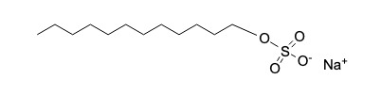 | 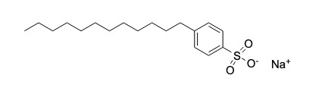
SLS | SDBS
Figure SM1. Molecular structure of SLS and SDBS

Figure SM2. TPH chromatogram of simulated bilge water after biochar (16.1 mg) treatment (top) and untreated simulated bilge water (bottom).

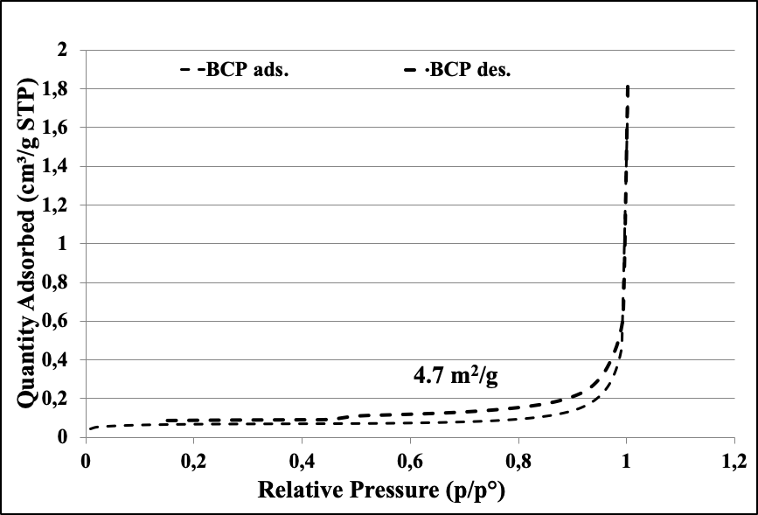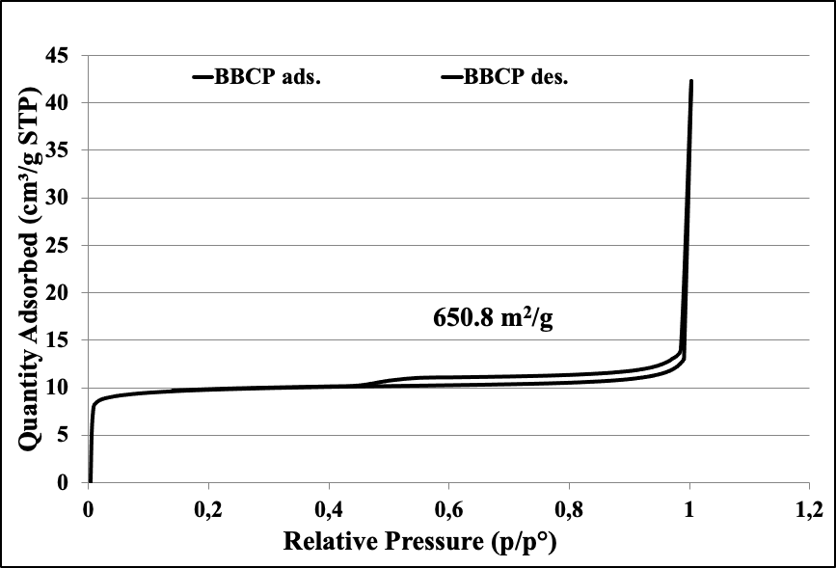
(b)
(a)
Figure SM3. BCP Adsorption N₂ isotherms (a) and BBCP Adsorption N₂ isotherms (b).

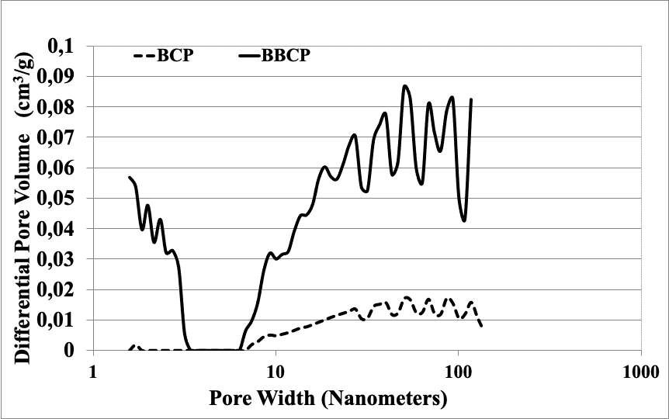
Figure SM4. BJH desorption pore size distribution.

Figure SM5. X-ray diffraction pattern of BCP. All peaks are due to the rhombohedral phase of calcite.
Figure SM6. Thermogravimetry differential curves of BCP (black), ABCP (red) and BBCP (blue).

Figure SM7. Effect of adsorbent dosage on the q_{e} () and on the removal efficiency () of hydrocarbons for the BBCP adsorbent. Experimental conditions: 20 mL of aqueous dispersions of DMA (c_{DMA} ≈ 200 mg L⁻¹) and SLS (c_{SLS} = 6 g L⁻¹) (a) or SDBS (c_{SDBS} = 2.5 g L⁻¹) (b) at pH =7 and at T = 25 °C.

Figure SM8. q_{e} values of DMA adsorption onto BBCP at different pH values in the range 4 - 9. Experimental details: amount of BBCP = 4.4 mg; DMA emulsion: 20 mL containing c_{DMA}≈ 200 mg L⁻¹, c_{SDBS} = 2.5 g L⁻¹, T = 25 °C

Table SM1. Calculated parameters values of Langmuir, Freundlich and Sips isotherm models for the hydrocarbons adsorption onto BCP, ABCP, FS400 and BBCP materials from dispersions containing DMA (c_{DMA} = 200 mg L⁻¹) and SLS (c_{SLS} = 6 g L⁻¹).
Adsorbent material | Model | q_{m} (mg g⁻¹) | K ^{a)} | n or s | R²
BCP | Langmuir | 11 ± 4 | 0.014 ± 0.014 |  | 0.7518
 | Freundlich |  | 0.9 ± 0.9 | 2 ± 1 | 0.7669
 | Sips | - | - | - | -
ABCP | Langmuir | 104 ± 23 | 0.014 ± 0.008 |  | 0.9364
 | Freundlich |  | 9 ± 3 | 2.4 ± 0.4 | 0.9712
 | Sips | - | - | - | -
FS400 | Langmuir | 240 ± 11 | 0.10 ± 0.02 |  | 0.9553
 | Freundlich |  | 47 ± 8 | 2.9 ± 0.4 | 0.9139
 | Sips | 246 ± 27 | 0.11 ± 0.03 | 1.0 ± 0.2 | 0.9515
BBCP | Langmuir | 883 ± 37 | 0.15 ± 0.02 |  | 0.9814
 | Freundlich |  | 174 ± 23 | 2.5 ± 0.2 | 0.9430
 | Sips | 918 ± 90 | 0.16 ± 0.02 | 1.1 ± 0.1 | 0.9798
^{a)} K_{L} (L mg⁻¹) or K_{F} (L^{1/n} g⁻¹ mg^{1–1/n}) or K_{S} (L^{1/s}·mg^{−1/s}).

Table SM2. Calculated parameters values of Langmuir, Freundlich and Sips isotherm models for the hydrocarbons adsorption onto BCP, ABCP, FS400 and BBCP materials from dispersions containing DMA (c_{DMA} = 200 mg L⁻¹) and SDBS (c_{SDBS} = 2.5 g L⁻¹).
Adsorbent material | Model | q_{m} (mg g⁻¹) | K ^{a)} | n or s | R²
ABCP | Langmuir | 184 ± 94 | 0.012 ± 0.021 |  | 0.5063
 | Freundlich
 | Sips
FS400 | Langmuir | 309 ± 18 | 0.04 ± 0.01 |  | 0.9640
 | Freundlich |  | 48 ± 12 | 3.0 ± 0.5 | 0.9480
 | Sips | 338 ± 71 | 0.05 ± 0.03 | 1.2 ± 0.4 | 0.9619
BBCP | Langmuir | 1106 ± 80 | 0.10 ± 0.02 |  | 0.9527
 | Freundlich |  | 241 ± 47 | 2.9 ± 0.5 | 0.9286
 | Sips | 1180 ± 280 | 0.11 ± 0.04 | 1.1 ± 0.4 | 0.9471
^{a)} K_{L} (L mg⁻¹) or K_{F} (L^{1/n} g⁻¹ mg^{1–1/n}) or K_{S} (L^{1/s}·mg^{−1/s}).

Table SM3. Calculated parameters values of Langmuir, Freundlich and Sips isotherm models for the hydrocarbons adsorption onto BBCP from dispersions containing DMA (c_{DMA} = 200 mg L⁻¹), SLS (c_{SLS} = 6 g L⁻¹) and NaCl (0 ≤ c_{NaCl} ≤ 0.5 mol L⁻¹).
I (mol L⁻¹) | Model | q_{m} (mg g⁻¹) | K ^{a)} | n or s | R²
0 | Langmuir | 883 ± 37 | 0.15 ± 0.02 |  | 0.9814
0 | Freundlich |  | 125 ± 17 | 2.0 ± 0.2 | 0.8974
0 | Sips | 940 ± 114 | 0.09 ± 0.02 | 0.9 ± 0.1 | 0.9358
0.1 | Langmuir | 1182 ± 108 | 0.05 ± 0.01 |  | 0.9523
0.1 | Freundlich |  | 122 ± 19 | 2.0 ± 0.2 | 0.9580
0.1 | Sips | 2108 ± 1259 | 0.05 ± 0.02 | 1.5 ± 0.3 | 0.9594
0.25 | Langmuir | 1489 ± 140 | 0.028 ± 0.005 |  | 0.9788
0.25 | Freundlich |  | 94 ± 5 | 1.77 ± 0.05 | 0.9965
0.25 | Sips | - | - | - | -
0.5 | Langmuir | 1857 ± 279 | 0.021 ± 0.006 |  | 0.9399
0.5 | Freundlich |  | 87 ± 19 | 1.7 ± 0.1 | 0.9478
0.5 | Sips | - | - | - | -
^{a)} K_{L} (L mg⁻¹), K_{F} (L^{1/n} g⁻¹ mg^{1–1/n}) or K_{S} (L^{1/s}·mg^{−1/s}).

