Supplementary Material

Time dependence of ¹³⁷Cs contamination in wild Japanese monkeys after the Fukushima Daiichi nuclear accident

Shin-ichi Hayama*, Aki Tanaka*, Setsuko Nakanishi*, Fumiharu Konno§, Yoshi Kawamoto*, Kazuhiko Ochiai*, Toshinori Omi*.

*: Faculty of Veterinary Medicine, Nippon Veterinary and Life Science University, Musashino, Tokyo, Japan;
§: Tohoku Wildlife Management Center, Sendai, Miyagi, Japan

Email: hayama@nvlu.ac.jp

Contents
Fig S1 Association between ¹³⁷Cs concentration in muscle and body weight (L:>5,000g, M: 5,000-10,000g, H: <10,000g).
Fig S2 Association between ¹³⁷Cs concentration in muscle and sex (Female and Male) /age class (Immature and Mature).
Fig S3 Association between ¹³⁷Cs concentration in muscle and season (Cold period from December to April and Warm period from May to November).
Fig S4 Association between ¹³⁷Cs concentration in muscle and soil contamination level (10,000–30,000, 30,000–60,000, 60,000–100,000, and 100,000–300,000 Bq/m²)

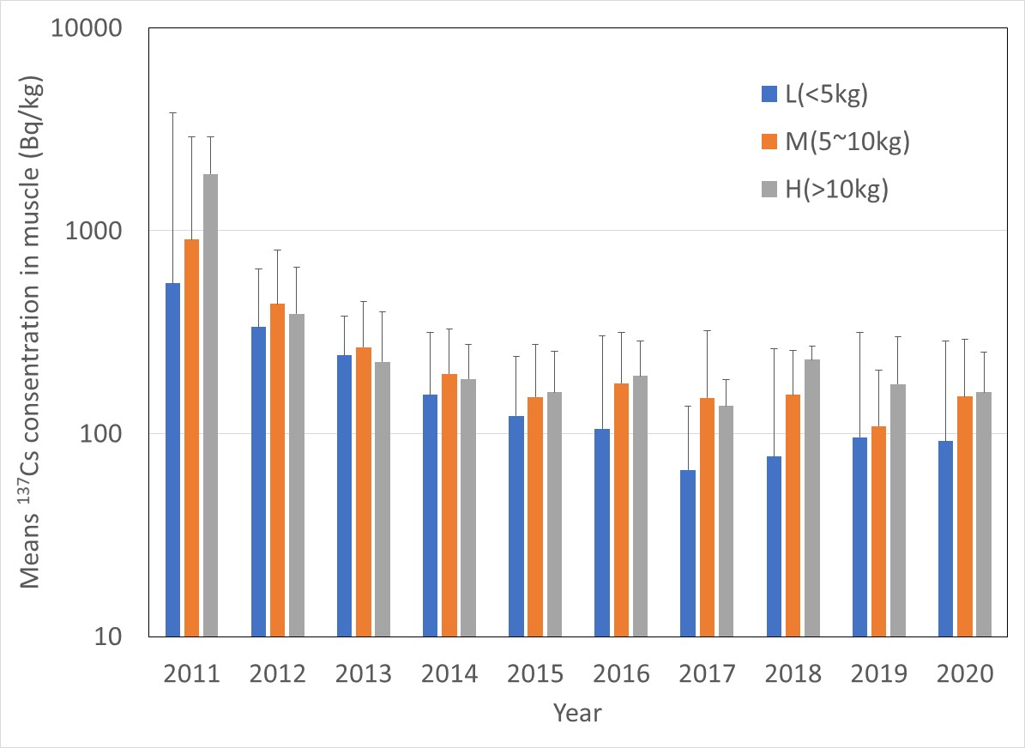

Fig S1 Association between ¹³⁷Cs concentration in muscle and body weight (L:>5,000g, M: 5,000-10,000g, H: <10,000g).
Error bar exhibit standard deviation.
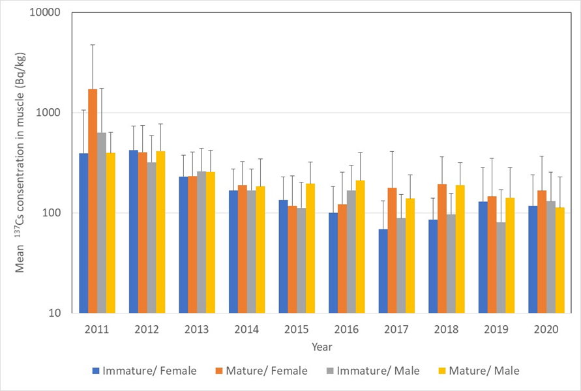
Fig S2 Association between ¹³⁷Cs concentration in muscle and sex (Female and Male) /age class (Immature and Mature).
Error bar exhibit standard deviation.

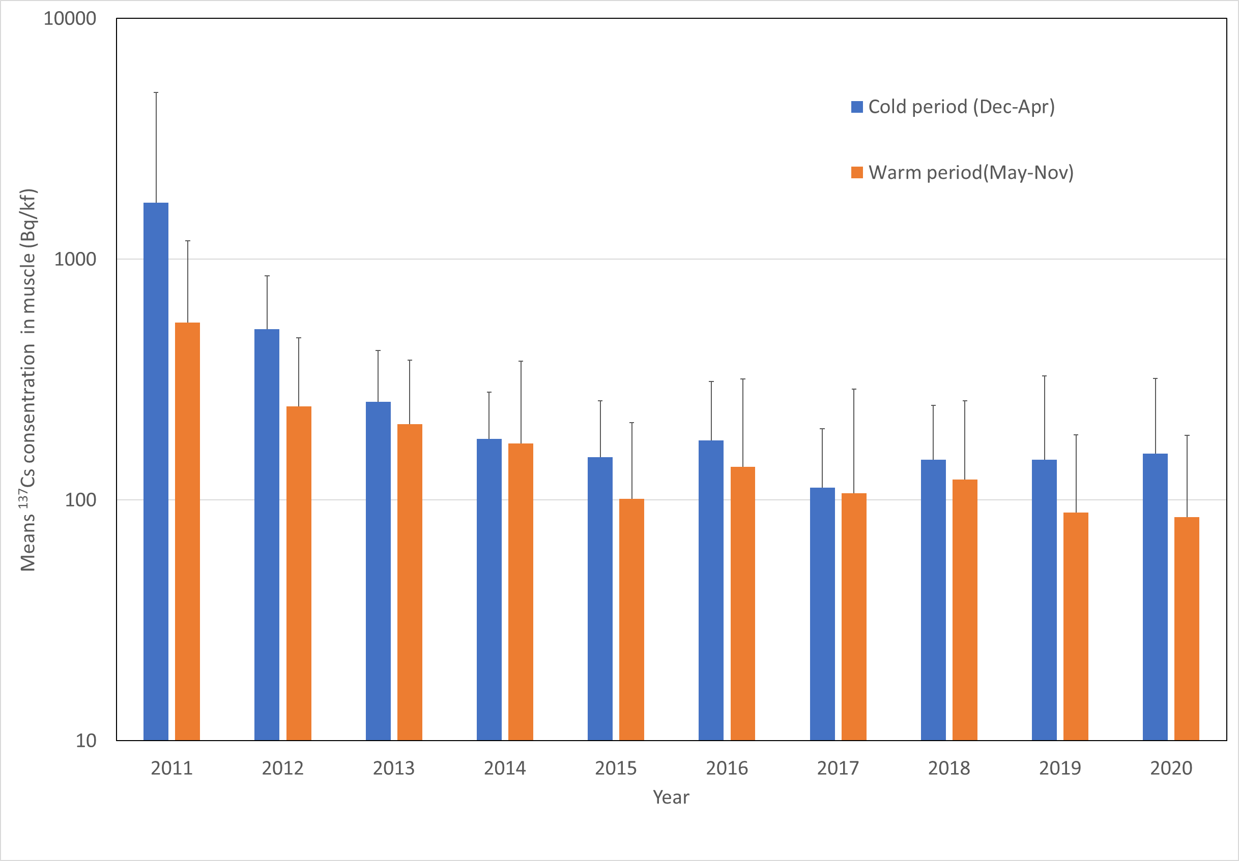
Fig S3 Association between ¹³⁷Cs concentration in muscle and season (Cold period from December to April and Warm period from May to November).
Error bar exhibit standard deviation.

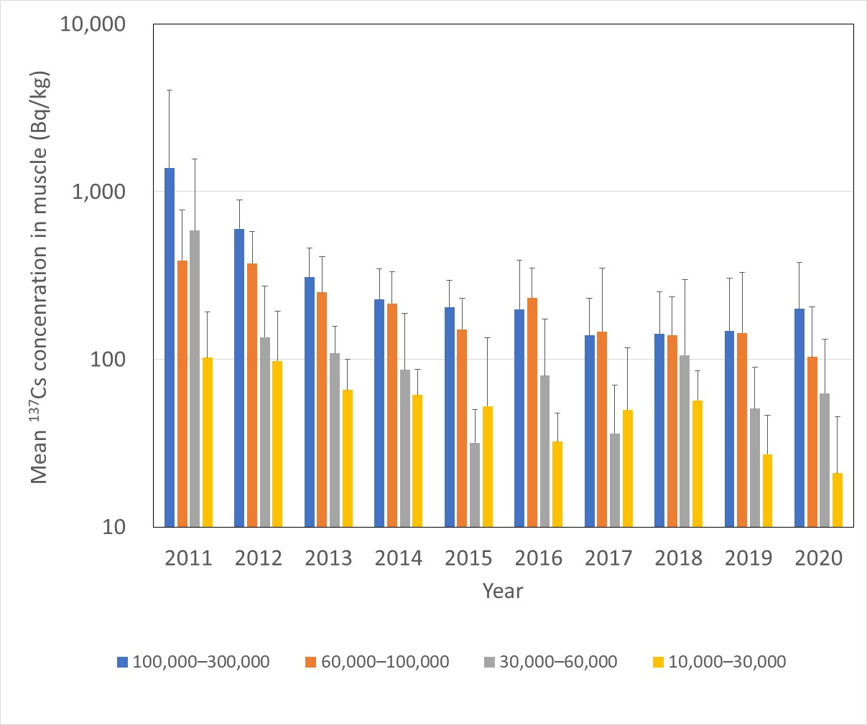
Soil contamination levels at capture sites (Bq/m²)
Fig S4 Association between ¹³⁷Cs concentration in muscle and soil contamination level (10,000–30,000, 30,000–60,000, 60,000–100,000, and 100,000–300,000 Bq/m²)
Error bar exhibit standard deviation.

