Supplementary material for
Influence of sanitation facilities on diarrhea prevalence among children aged below 5 years in flood-prone areas of Bangladesh: A multilevel analysis

Contents
Table S1: Flood prone area used in this study
Table S2: Sanitation facilities based on Containment type coded for Model I
Table S3: Sanitation facilities based on Excreta flow coded for Model II
Table S4: Sanitation facilities coded for analysis (comparison)
Table S5: Four types of floods in Bangladesh
Table S6: Independent variables used in this study
Table S7: Multilevel linear probability models (Model I and Model II)
Table S8: Sensitivity analysis including high population density areas
Fig. S1: Flood prone areas map (four levels)
Fig. S2: Severe drought risk area map (original from BARC)
Fig. S3: The diarrhea prevalence of children under five in 2011
Fig. S4: The diarrhea prevalence of children under five in 2014
Fig. S5: The diarrhea prevalence of children under five in 2017-2018
Fig. S6: The diarrhea prevalence of children under five, sum of DHS2011, 2014 and 2017-2018

Table S1: Flood prone area used in this study

Flood | Mechanism | Area:km² (%)
Severe | Occurs 5 times or more in 10 years with considerable loss/damage of standing crops | 23,621 (16.0)
Moderate | Occurs 3-4 times in 10 years with significant loss/damage of standing crops | 33,955 (23.0)
Low | Occurs at least twice in 10 years with loss/damage of standing crops | 34,250 (23.2)
Not flood prone | None in 10 years | 55,804 (37.8)
(Made by author, Source: BARC)

Table S2: Sanitation facilities based on Containment type coded for Model I

Containment type | Sanitation facilities
Improved | flush to piped sewer system
Improved | flush to septic tank
Improved | flush to pit latrine
Improved | ventilated improved pit latrine (VIP)
Improved | Pit latrine with slab
Improved | Composting toilet
Unimproved | flush to somewhere else
Unimproved | flush, don't know where
Unimproved | pit latrine without slab/open pit
Unimproved | bucket toilet
Unimproved | hanging toilet/latrine
Unimproved | no facility/bush/field
(made by author, source: DHS and UNICEF/WHO 2019)

Table S3: Sanitation facilities based on Excreta flow coded for Model II

Excreta flow | Sanitation facilities
Concentrated | pit latrine with slab
Concentrated | pit latrine without slab/open pit
Concentrated | ventilated improved pit latrine (VIP)
Concentrated | Flush to pit latrine
Concentrated | Flush to somewhere else
Concentrated | Flush, don’t know where
Concentrated | Flush to septic tank
Diffused | no facility/bush/field
Diffused | Bucket toilet
Diffused | Composting toilet
Diffused | Hanging toilet / latrine
transferred | flush to piped sewer system
(made by author, source: DHS and UNICEF/WHO 2019)

Table S4: Sanitation facilities coded for analysis (comparison)

kinds of sanitation facilities | Model I (containment type) | Model II (excreta flow)
flush to piped sewer system | Improved | Transferred
flush to septic tank | Improved | Concentrated
flush to pit latrine | Improved | Concentrated
flush to somewhere else | Not improved | Concentrated
flush, don't know where | Not improved | Concentrated
ventilated improved pit latrine (vip) | Improved | Concentrated
pit latrine with slab | Improved | Concentrated
pit latrine without slab/open pit | Not improved | Concentrated
no facility/bush/field | Not improved | Diffused
composting toilet | Improved | Diffused
bucket toilet | Not improved | Diffused
hanging toilet/latrine | Not improved | Diffused
(made by author, source: DHS and UNICEF/WHO 2019)

Table S5: Four types of floods in Bangladesh
Flood | Mechanism | season | Region | area: Mha (%)
River Flooding | Overtopping of the riverbanks in monsoon season | monsoon season  (June to September or October) | The catchment of Ganges, Brahmaputra and Meghna rivers | 5.62 (40.40)
Flash Flooding | Heavy run-off from the higher sites due to torrential rainfall in early monsoon season | early monsoon season  (April to May and September to November | Eastern and northern area | 1.47 (10.57)
Tidal Surge | generated mainly by wind stress and falling atmospheric pressure that produce a rise in water level in coastal area (Karim and Mimura, 2008) | early or late monsoon season | Southern coastal area | 1.18 (8.48)
Not flood prone |  |  |  | 5.64 (40.55)
(Made by author, Source: BARC; Karim and Mimura, 2008; BWDB)

Table S6: Independent variables used in this study

variables |  | measurement of variables
Outcome variable
 | Diarrhea incidence in the past two weeks | Categorized into “yes”, “no”
Explanatory variables
[Individual Level]
 | Child age | Categorized into “0-11month”, “12-23month”, “24-35month”, “36-47month”, “48-59month”
 | Sex of child | Categorized into “male” and “female”
 | JMP ladder only for Model I | Categorized into “improved” and “not improved”
 | Sanitation type only for Model II | Categorized into “transferred”, “concentrated” and “diffused”
 | Toilet shared or individual | Categorized into “shared“, “individual“ and “no facilities“
 | Type of water | Categorized into “improved” and “improved”
 | Mother’s age | Mother’s age at the survey
 | Mother’s education | Categorized into “high school”, “secondary school”, “primary school” and “no education”
 | Wealth index | Categorized into “richest”, “richer”, “middle”, “poorer” and “poorest”
 | Religion | Categorized into “Muslim” and “others”
[Community Level]
 | Residential area | Categorized into “rural”, and “urban”
 | Flood prone area | Categorized into “Severely flood-prone (SFP)”, “MFP Moderately flood-prone (MFP)”, “Low flood-prone (LFP)” and “Not flood prone (NFP)”
 | Population of under-five ages | Each survey year refers data obtained in every five years, for example DHS2011 refers 2010, DHS2014 refers 2015, and DHS2017-2018 refers 2020
(made by author, source: DHS)

Table S7: Multilevel linear probability models (Models I and II)
 |  | Model I: Containment type |  |  |  | Model II: Excreta flow
 |  | without interaction |  | with interaction |  | without interaction |  | with interaction
 |  | β | 95% CI | β | 95% CI | β | 95% CI | β | 95% CI
Containment type (Model I)
Improved |  | (reference) |  | (reference)
Unimproved |  | 0.003 | (–0.004, 0.011) | 0.015 | (–0.0004, 0.026)
Excreta flow (Model II)
Concentrated |  |  |  |  |  | (reference) |  | (reference)
Transferred |  |  |  |  |  | 0.023 | (–0.017, 0.064) | 0.030 | (–0.184, 0.079)
Diffused |  |  |  |  |  | 0.004 | (–0.012, 0.019) | 0.027 | (0.004, 0.053)
Flood type area
Not flood-prone (NFP) |  | (reference) |  | (reference) |  | (reference) |  | (reference)
Low (LFP) |  | –0.013 | (–0.023, –0.003) | –0.009 | (–0.023, 0.003) | –0.013 | (–0.023, –0.003) | –0.113 | (–0.024, –0.001)
Moderate (MFP) |  | 0.003 | (–0.005, 0.012) | 0.012 | (0.001, 0.024) | 0.003 | (–0.005, 0.012) | 0.005 | (–0.004, 0.014)
Severe (SFP) |  | 0.015 | (0.001, 0.027) | 0.024 | (–0.003, 0.030) | 0.015 | (0.002, 0.028) | 0.022 | (0.008, 0.035)
Interaction (Model I)
Unimproved * LFP area |  |  |  | –0.009 | (–0.029, 0.009)
Unimproved * MFP area |  |  |  | –0.022 | (–0.040, –0.004)
Unimproved * SFP area |  |  |  | 0.003 | (–0.019, 0.028)
Interaction (Model II)
Transferred * LFP area |  |  |  |  |  |  |  | –0.025 | (–0.121, 0.083)
Diffused * LFP area |  |  |  |  |  |  |  | –0.021 | (–0.057, 0.012)
Transferred * MFP area |  |  |  |  |  |  |  | –0.066 | (–0.224, 0.099)
Diffused * MFP area |  |  |  |  |  |  |  | –0.021 | (–0.055, 0.012)
Transferred * SFP area |  |  |  |  |  |  |  | 0.037 | (–0.145, 0.210)
Diffused * SFP area |  |  |  |  |  |  |  | –0.060 | (–0.095, –0.023)
Child age
0~11 months | (reference) |  |  | (reference) |  | (reference) |  | (reference)
12~23 months | 0.025 |  | (0.014, 0.101) | 0.025 | (0.014, 0.037) | 0.025 | (0.013, 0.037) | 0.025 | (0.014, 0.037)
24~35 months | –0.012 |  | (–0.024, –0.001) | –0.012 | (–0.024, –0.001) | –0.012 | (–0.023, –0.001) | –0.012 | (–0.023, –0.001)
36~47 months | –0.025 |  | (–0.036, –0.014) | –0.025 | (–0.036, –0.014) | –0.025 | (–0.036, –0.014) | –0.025 | (–0.036, –0.014)
48~59 months | –0.030 |  | (–0.042, –0.018) | –0.030 | (–0.041, –0.019) | –0.030 | (–0.042, –0.019) | –0.031 | (–0.042, –0.019)
Child sex
Female | (reference) |  |  | (reference) |  | (reference) |  | (reference)
Male | 0.009 |  | (0.002, 0.016) | 0.009 | (0.002, 0.016) | 0.009 | (0.001, 0.017) | 0.009 | (0.002, 0.016)
Mother’s age | –0.0007 |  | (-0.001, -0.0001) | –0.0007 | (–0.001, –0.0001) | –0.0007 | (–0.001, 0.0001) | –0.0007 | (–0.001, –0.0001)
Mother’s education
High school | (reference) |  |  | (reference) |  | (reference) |  | (reference)
Secondary | –0.002 |  | (–0.016, 0.013) | –0.002 | (–0.017, 0.010) | –0.018 | (–0.015, 0.010) | –0.002 | (–0.015, 0.011)
Primary | 0.011 |  | (–0.004, 0.026) | 0.010 | (–0.004, 0.026) | 0.011 | (–0.002, 0.025) | 0.011 | (–0.003, 0.027)
No education | 0.005 |  | (–0.012, 0.022) | 0.005 | (–0.011, 0.022) | 0.006 | (–0.009, 0.021) | 0.005 | (–0.011, 0.022)
Wealth index
Middle | (reference) |  |  | (reference) |  | (reference)
Poorest | –0.009 |  | (–0.021, 0.0008) | –0.009 | (–0.021, 0.002) | –0.009 | (–0.018, 0.002) | –0.008 | (–0.020, 0.002)
Poorer | –0.003 |  | (–0.014, 0.007) | –0.003 | (–0.013, 0.008) | –0.028 | (–0.014, 0.010) | –0.003 | (–0.014, 0.008)
Richer | –0.015 |  | (–0.026, –0.002) | –0.015 | (–0.027, –0.002) | –0.015 | (–0.025, –0.003) | –0.015 | (–0.027, –0.003)
Richest | 0.0003 |  | (–0.013, 0.015) | 0.0004 | (–0.011, 0.022) | –0.001 | (–0.013, 0.012) | –0.0008 | (–0.014, 0.013)
Religion
Islam | (reference) |  |  | (reference) |  | (reference) |  | (reference)
Other | –0.011 |  | (–0.022, 0.002) | –0.011 | (–0.024, 0.001) | –0.011 | (–0.024, 0.001) | –0.012 | (–0.025, 0.0005)
Residential area
Rural | (reference) |  |  | (reference) |  | (reference) |  | (reference)
Urban | 0.0007 |  | (–0.008, 0.009) | 0.003 | (–0.008, 0.010) | 0.0006 | (–0.008, 0.010) | 0.0007 | (–0.009, 0.010)
Population density¹⁾ | 0.0006 |  | (–0.016, 0.017) | 0.001 | (–0.016, 0.016) | –0.0005 | (–0.017, 0.017) | –0.0007 | (–0.016, 0.016)
Type of water
Improved | (reference) |  |  | (reference) |  | (reference) |  | (reference)
Unimproved | 0.003 |  | (–0.004, 0.012) | –0.015 | (–0.039, 0.006) | –0.016 | (–0.039, 0.007) | –0.017 | (–0.043, 0.004)
Toilet shared / private
Private | (reference) |  |  | (reference) |  | (reference) |  | (reference)
Shared | 0.009 |  | (0.0005, 0.016) | 0.009 | (0.002, 0.017) | 0.009 | (0.001, 0.016) | 0.009 | (0.0009, 0.016)
No facilities/bush | 0.008 |  | (–0.009, 0.025) | 0.007 | (-0.011, 0.028) | 0.005 | (–0.017, 0.027) | 0.0001 | (–0.023, 0.023)
1) scaled, 2) sani-: sanitation type
Dependent variable: diarrhea = yes, Model I: multilevel linear probability model of Containment type, Model II: multilevel linear probability model of Excreta flow
β: coefficient, CI: Confidence Interval
Table S8: Sensitivity analysis including high population density areas
 | Model I: Containment type |  |  |  | Model II: Excreta flow
 | without interaction |  | with interaction |  | without interaction |  | with interaction
 | β | 95% CI | β | 95% CI | β | 95% CI | β | 95% CI
Containment type (Model I)
Improved | (reference) |  | (reference)
Unimproved | 0.001 | (-0.006, 0.009) | 0.005 | (-0.006, 0.017)
Excreta flow (Model II)
Concentrated |  |  |  |  | (reference) |  | (reference)
Transferred |  |  |  |  | 0.034 | (0.008, 0.060) | 0.043 | (0.014, 0.071)
Diffused |  |  |  |  | 0.006 | (-0.011, 0.032) | 0.030 | (0.004, 0.055)
Flood type area
Not flood-prone (NFP) | (reference) |  | (reference) |  | (reference) |  | (reference)
Low (LFP) | -0.014 | (-0.024, -0.004) | -0.013 | (-0.026, -0.0005) | -0.014 | (-0.024, -0.045) | -0.011 | (-0.022, -0.001)
Moderate (MFP) | 0.002 | (-0.007, 0.011) | 0.008 | (-0.003, 0.020) | 0.002 | (-0.007, 0.011) | 0.004 | (-0.004, 0.014)
Severe (SFP) | 0.014 | (0.001, 0.027) | 0.008 | (-0.008, 0.025) | 0.014 | (0.001, 0.027) | 0.021 | (0.008, 0.034)
Interaction (Model I)
Unimproved * LFP area |  |  | -0.002 | (-0.021, 0.016)
Unimproved * MFP area |  |  | -0.015 | (-0.032, 0.002)
Unimproved * SFP area |  |  | 0.011 | (-0.012, 0.034)
Interaction (Model II)
Transferred * LFP area |  |  |  |  |  |  | -0.050 | (-0.011, 0.019)
Diffused * LFP area |  |  |  |  |  |  | -0.023 | (-0.057, 0.010)
Transferred * MFP area |  |  |  |  |  |  | -0.078 | (-0.208, 0.051)
Diffused * MFP area |  |  |  |  |  |  | -0.022 | (-0.053, 0.009)
Transferred * SFP area |  |  |  |  |  |  | 0.026 | (-0.136, 0.189)
Diffused * SFP area |  |  |  |  |  |  | -0.061 | (-0.099, -0.023)

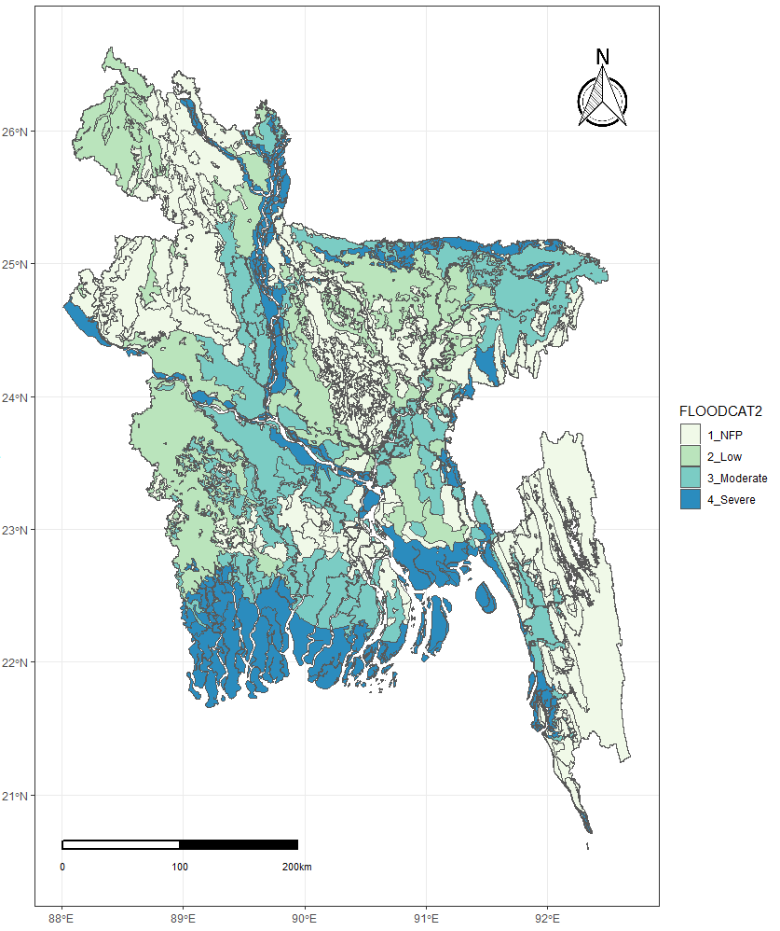
Not flood prone
Low
Moderate
Severe
Flood risk

Fig. S1: Flood prone area map (made by author, source: BARC)

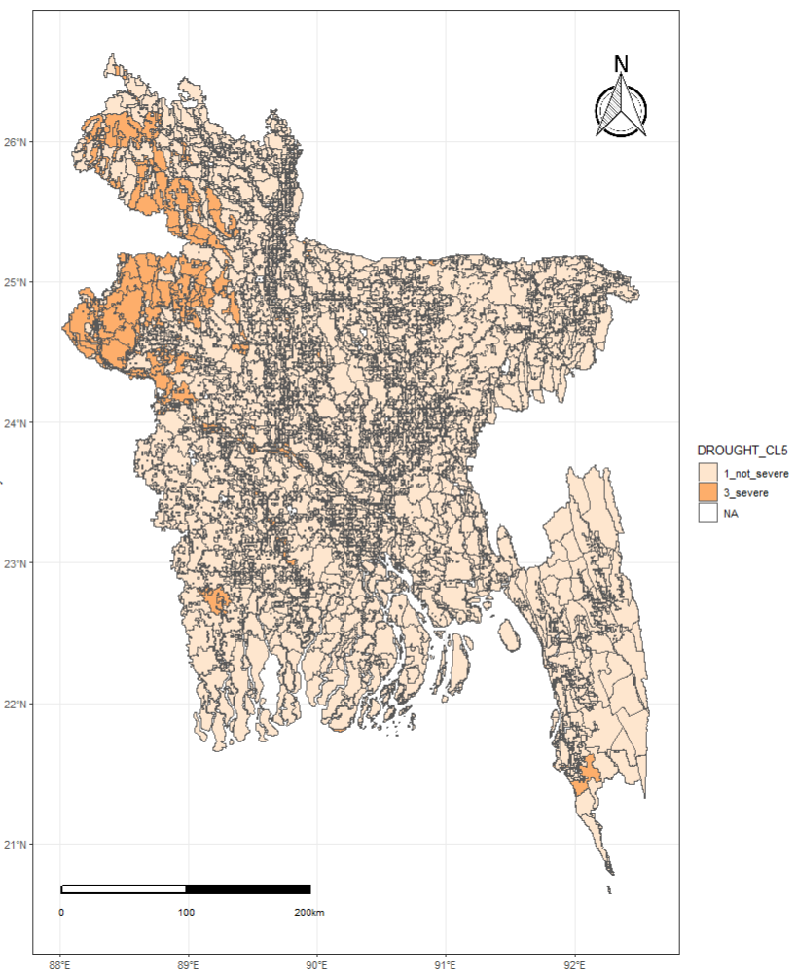
Not severe
Severe
No data
Drought risk area

Fig. S2: Severe drought areas of Bangladesh (Source: BARC)

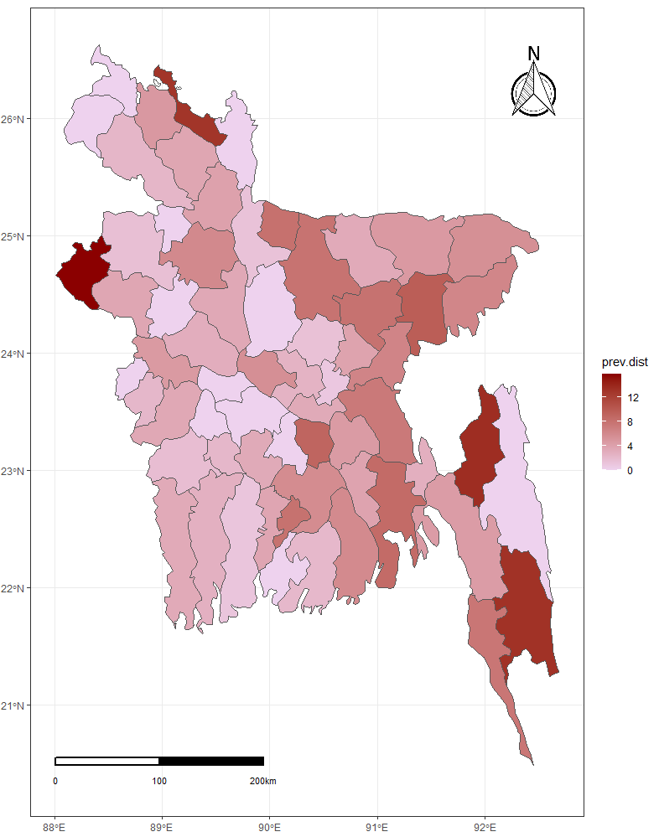
Prevalence
of diarrhea (%)

Fig. S3: The diarrhea prevalence of children under five in 2011
(made by author, Source: BDHS and BARC)

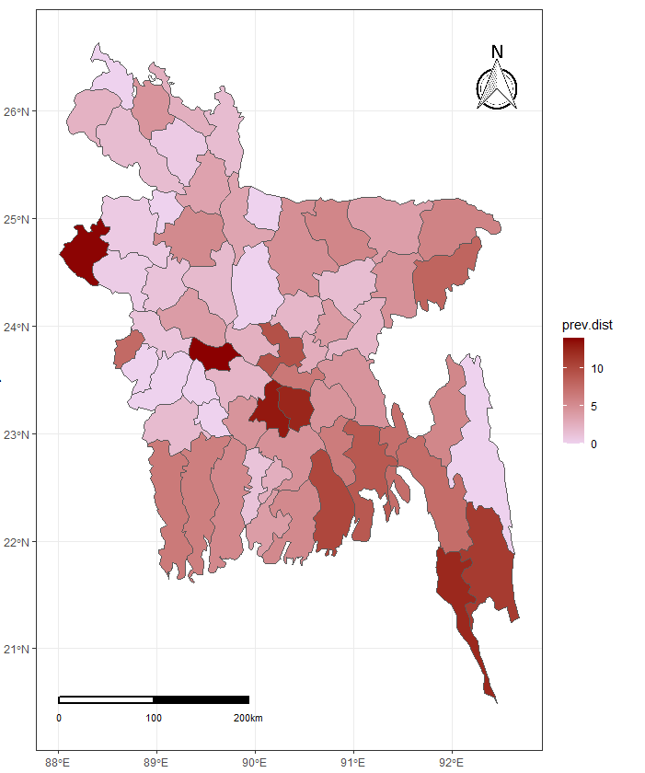
Prevalence
of diarrhea (%)

Fig. S4: The diarrhea prevalence of children under five in 2014
(made by author, Source: BDHS and BARC)

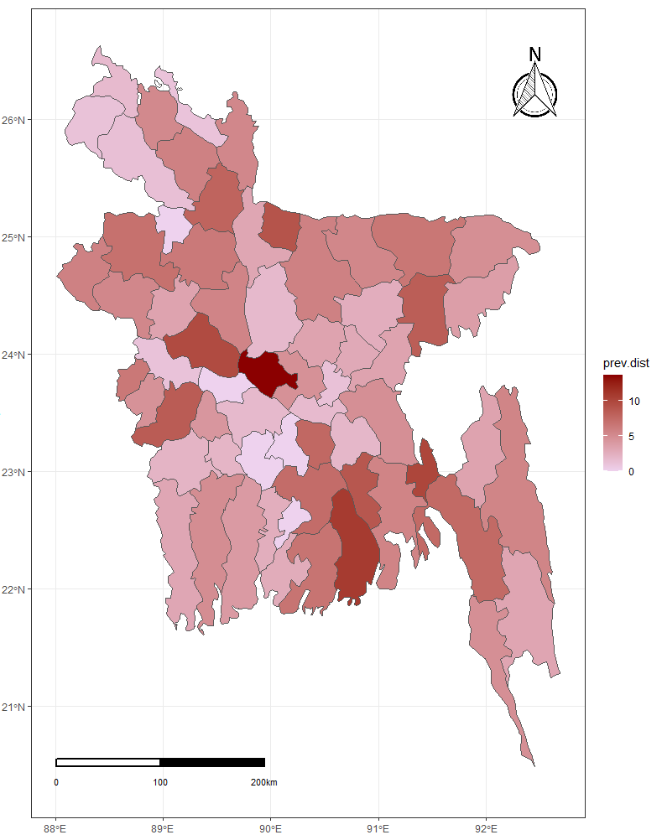
Prevalence
of diarrhea (%)

Fig. S5: The diarrhea prevalence of children under five in 2017-2018
(made by author, Source: BDHS and BARC)

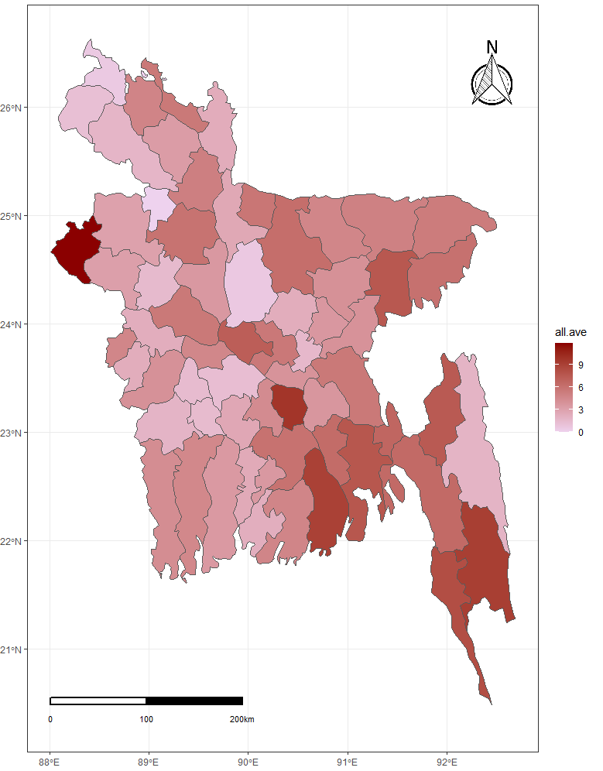
Prevalence
of diarrhea (%)

Fig. S6: The diarrhea prevalence of children under five, sum of DHS2011, 2014 and 2017-2018 (made by author, Source: BDHS and BARC)

