Supporting Information
Antibiotic resistances from slaughterhouse effluents and enhanced antimicrobial blue light technology for wastewater decontamionation.
Cong Xiaoyu¹, Krolla Peter¹, Khan Umer Zeb¹, Savin-Hoffmeyer Michael², Schwartz Thomas¹*
¹Karlsruhe Institute of Technology (KIT), Institute of Functional Interfaces (IFG), Hermann von Helmholtz Platz 1, 76344 Eggenstein-Leopoldshafen, Germany.
²University Clinic of Bonn, Institute of Hygiene and Public Health (IHPH), Venusberg-Campus 1, 53127 Bonn, Germany

SI Table 1: Primer sequences, calibaration line equation, efficiency values, detection limits, and correlation coefficientvalue oft he calibration lines, amplicon sizes, references. The table clustered he qPCR systems used for the quantification of facultative pathogenic bacteria and antibiotic resistence genes according to Hembach et al. (2017, 2022) and Alexander et al. (2020; 2022)

Target | Primer sequence | Equation of the calibration curve | Amplicon size | efficiency | R² | LOD | Control strain | reference
Facultative pathogenic bacteria
Enterococcus spp. | Fwd: AGAAATTCCAAACGAACTTG  Rev: CAGTGCTCTACCTCCATCATT | F(x)= -3,585x+35,283 | 93 bp | 90,1 % | 1,000 | 65 | E. faecium  DSM20477 | (Frahm und Obst 2003)
E. faecalis | Fwd: CACCTGAAGAAACAGGC  Rev: ATGGCTACTTCAATTTCACG | F(x)= -3,472x+35,447 | 475 bp | 94,1 % | 0,999 | 6 | E. faecalis  ATCC51299 | (Depardieu et al. 2004)
P. aeruginosa | Fwd: AGCGTTCGTCCTGCACAAGT  Rev: TCCACCATGCTCAGGGAGAT | F(x)= -3,282x+35,276 | 81 bp | 101,7 % | 0,999 | 3 | P. aeruginosa  DSM1117 | (Clifford et al. 2012)
K. pneumoniae | Fwd: ACGGCCGAATATGACGAATTC  Rev: AGAGTGATCTGCTCATGAA | F(x)= -3,387x+38,844 | 68 bp | 97,4 % | 0,998 | 18 | K. pneumoniae  DSM30104 | (Clifford et al. 2012)
A. baumannii | Fwd: GTTGTGGCTTTAGGTTTATTATACG  Rev: AAGTTACTCGACGCAATTCG | F(x)= -3,380x+35,679 | 94 bp | 97,6 % | 1,000 | 31 | A. baumannii  DSM30007 | (Clifford et al. 2012)
E. coli | Fwd: GCATCGTGACCACCTTGA  Rev: CAGCGTGGTGGCAAAA | F(x)= -3,361x+35,797 | 59 bp | 98,4 % | 0,994 | 4 | E. coli  DSM1103 | (Clifford et al. 2012)
Antibiotic resistance genes
ermB | Fwd: TGAATCGAGACTTGAGTGTGCAA  Rev: GGATTCTACAAGCGTACCTT | F(x)=-3,328x+35,901 | 71 bp | 100 % | 1,000 | 16 | S. hyointestinalis  DSM20770 | (Alexander et al. 2015)
IntI1 | Fwd: GCCTTGATGTTACCCGAGAG  Rev: GATCGGTCGAATGCGTGT | F(x)= -3,472x+34,720 | 196 bp | 94,1 % | 1,000 | 126 | E. coli pNORM | (Rocha et al. 2018)
tetM | Fwd:GGTTTCTCTTGGATACTTAAATCAATC  Rev: CCAACCATAAATCCTTGTTCRC | F(x)=-3,424x+38,747 | 88 bp | 95,9 % | 0,998 | 4 | E. coli DH5α | (Peak et al. 2007)
bla_{TEM} | Fwd: TTCCTGTTTTTGCTCACCCAG  Rev: CTCAAGGATCTTACCGCTGTTG | F(x)=-3,303x+38,559 | 112 bp | 100,8 % | 0,999 | 80 | E. coli pNORM | (Rocha et al. 2018)
sul1 | Fwd: CGCACCGGAAACATCGCTGCAC  Rev: TGAAGTTCCGCCGCAAGGCTCG | F(x) -3,387x+39,802 | 161 bp | 97,6 % | 0,999 | 80 | E. coli pNORM | (Rocha et al. 2018)
bla_{CTX-M} | Fwd: CGCTTTGCGATGTGCAG  Rev: ACCGCGATATCGTTGGT | F(x)= -3,504x+34,255 | 551 bp | 92,9 % | 1,000 | 93 | E. coli pNORM | ( Rocha et al. 2018)
bla_{CTX-M-32} | Fwd: CGTCACGCTGTTGTTAGGAA  Rev: CGCTCATCAGCACGATAAAG | F(x)= -3,517x+37,800 | 155 bp | 92,5 % | 1,000 | 235 | E. coli pNORM | (Rocha et al. 2018)
bla_{OXA-48} | Fwd: TGTTTTTGGTGGCATCGAT  Rev: GTAAMRATGCTTGGTTCGC | F(x)= -3,540x+36,913 | 177 bp | 91,6 % | 0,998 | 92 | K. pneumoniae  TGH Isolate 2 | (Monteiro et al. 2012)
vanA | Fwd: TCTGCAATAGAGATAGCCGC  Rev: GGAGTAGCTATCCCAGCATT | F(x)= -3,541x+33,078 | 376 bp | 91,6 % | 1,000 | 43 | E. faecium B7641 vanA | (Klein et al. 1998)
mecA | Fwd: CGCAACGTTCAATTTAATTTTGTTAA  Rev: TGGTCTTTCTGCATTCCTGGA | F(x)=-3,327x+34,887 | 91 bp | 99,8 % | 1,000 | 11 | S. Aureus A1 | (Volkmann et al. 2004)
mcr-1 | Fwd: GGGCCTGCGTATTTTAAGCG  Rev: CATAGGCATTGCTGTGCGTC | F(x)=-3,386x+35,349 | 183 bp | 97,4 % | 0,999 | 8 | E. coli NRZ-14408 | (Hembach et al. 2017)
bla_{NDM} | Fwd: TTGGCCTTGCTGTCCTTG  Rev: ACACCAGTGACAATATCACCG | F(x)= -3,293x+35,877 | 82 bp | 101,2 % | 0,999 | 66 | K. pneumoniae  ATCC BAA-2146 | (Monteiro et al. 2012)

SI Table 2: Water sample getting from poultry slaughterhouse. Abundance of facultative pathogenic bacteria (A), abundance of “commonly occurring resistance genes” (B), abundance of “intermediately occurring resistance genes” (C), and abundance of “rarely occurring resistance genes” (D). The data from each sampling campaign are listed together with the standard deviations SD.
A
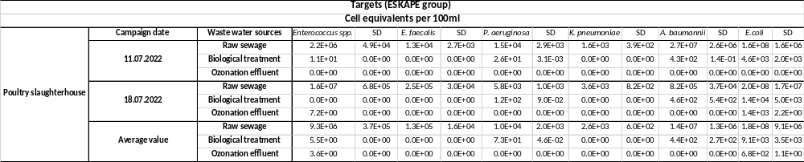

B
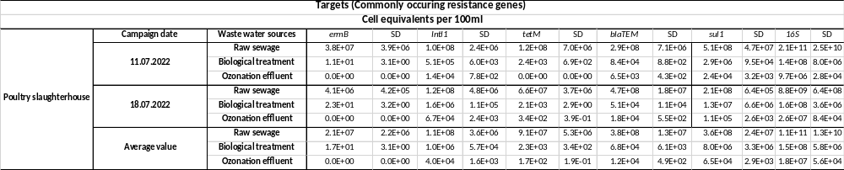

C
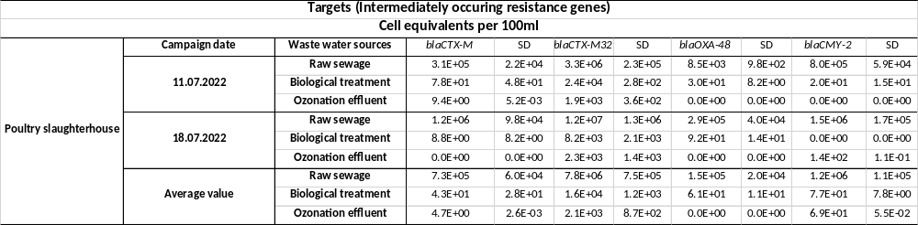

D)
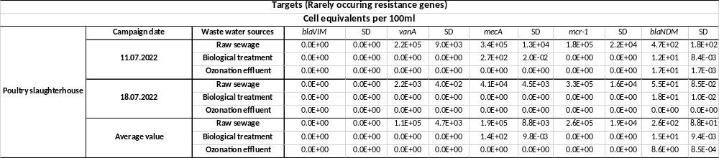
SI Table 3: Water sample getting from pig slaughterhouse. Abundance of facultative pathogenic bacteria (A), abundance of “commonly occurring resistance genes” (B), abundance of “intermediately occurring resistance genes” (C), and abundance of “rarely occurring resistance genes” (D). The data from each sampling campaign are listed together with the standard deviations SD.
A
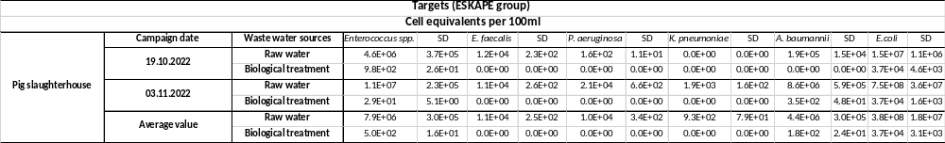

B
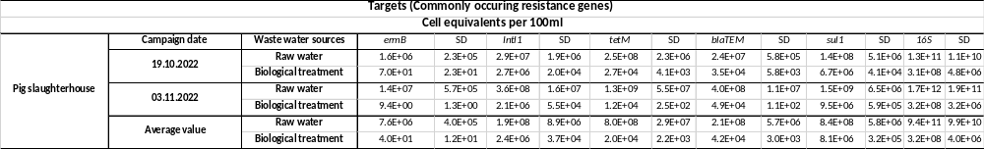

C
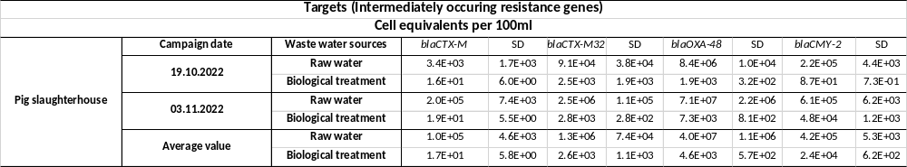
D
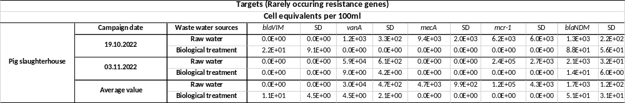

SI Table 4: Radiant intensity data were collected with a calibrated spectrophotometer (FLAME-S-XR1-ES, with optical fibre QP400-2-SR-BX; OceanInsight, Ostfildern, Germany) from the LED light source inside the incubator. Due to the fixed light emission of the LEDs, different light intensities, high and low, were performed by changing the light source – reaction vial distance.

Irradiation | High intensity | Low intensity
Radiant intensity [W/cm²] corresponds with J/s*cm² | 8,33E-02 | 5,43E-02
Irradiation time [h] | Time dependent energy input [J/cm²]
1 | 300 | 196
2 | 600 | 392
3 | 900 | 588
4 | 1200 | 784

Figure S1:
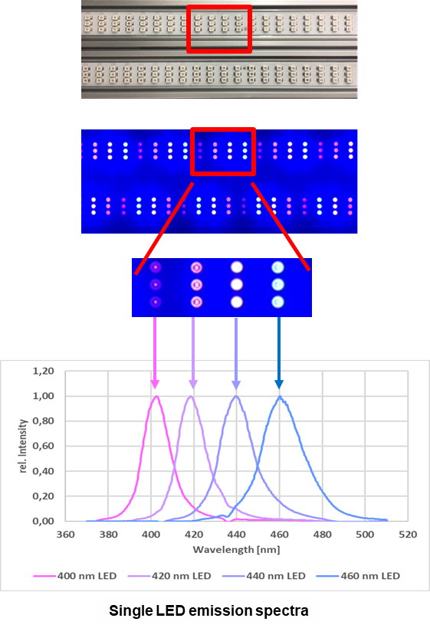
Figure S1: Exemplary: normalized entire emission spectrum of the LED bar (top); normalized emission spectra of each LED type on LED bar (bottom). A qualtitative characterization of the emitted spectrum was done with a spectrometer (FLAME-S-XR1-ES, OceanInsight, Ostfildern, Germany).

