Supplementary material

1. Spoon-based homogenisation approach:
Step one: Within each stainless tray where samples were collected, the sediment-water mixture was firstly well mixed with two spoons. The solid materials soon settled down and were divided into two rectangular zones (A, B, C and D in S 1). This step was done in both stainless-steel trays.
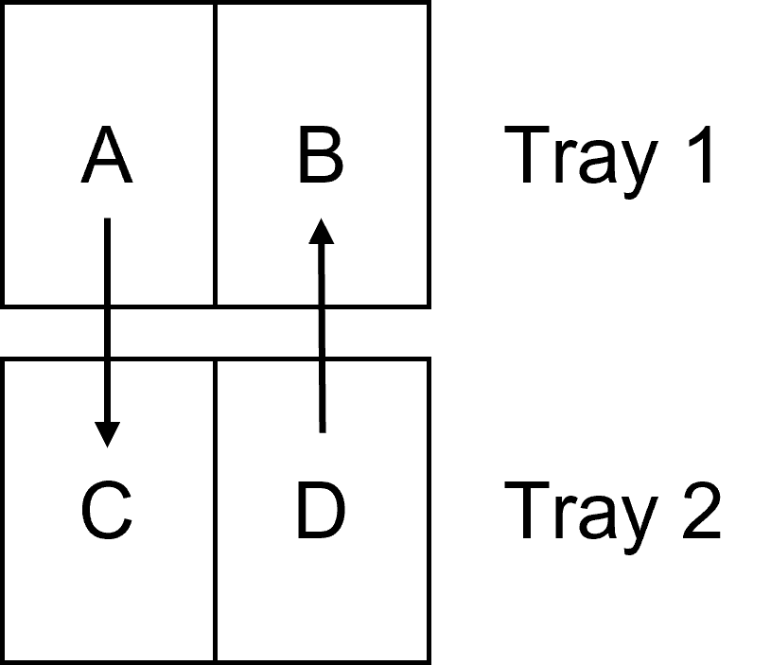
Figure S1. Explanatory sketch of spoon-based homogenisation approach for deriving representative sediment samples.
Step two: The second step commenced by exchanging the solid materials between two trays. An explanatory sketch is presented in S 1 where solids in A section of tray 1 is transferred to the C section on tray 2 and solids in B section of tray 2 is transferred to the B section on tray 1. After the transferring process, the sediment-water mixture in each tray is spoon-mixed again following the description in Step one. After a repetition of this step for twice, the sediment-water mixture in both trays is regarded as identical.
Step three: the sediment-water mixture is transferred to sample containers with the spoon in this step. All the sample containers are placed in a row with the lid removed. One spoon of the sediment-water mixture is consecutively transferred to each container for each round and a couple of rounds was taken until all sample jars were filled. When taking samples through the spoon, the spoon was firstly used to mix the sample so the sediments were in suspension.

2. Parameters and distributions used for the Monte Carlo uncertainty propagation for mass calculations

Table S1: Summary of distributions used for the Monte Carlo calculation of the mass of dry sieved sediment in each gully pot.
Term | Case | Stochastic component | Distribution type and parameters
$$A_{GP}$$ | GP with round cross-section | Diameter | Uniform, min=49.4 cm, max=50.6 cm
$$A_{GP}$$ | GP with rectangular cross-section | Width | Uniform, min=width- 1 cm, max= width+ 1 cm
$$A_{GP}$$ | GP with rectangular cross-section | Length | Uniform, min=length-1 cm, max= length + 1 cm
$$d_{GP}$$ | Always | Sediment depth | Uniform, min=depth-3 cm, max=depth+3 cm
$$ρ_{s}$$ | Always | Mass of empty jar | Uniform, min=mass-1 g, max=mass+1 g
$$ρ_{s}$$ | Always | Mass of jar with sediments | Uniform, min=mass-1 g, max=mass+1 g
$$ρ_{s}$$ | Always | Volume of sediment in jar | Uniform, min=vol-12.5 mL, max=vol+12.5 mL
DW | Always | Dry weight | Normal, μ=mean of six measurements for each sample, σ=standard deviation of six measurements for each sample
DW | Always | Percent error in dry weight due to sampling | Uniform, min= -20%, max=20%
$$f_{<2mm}$$ | Always | Error in weight in each size fraction | Normal, μ=0, σ=5%

Table S2: Summary of distributions used for the concentration of each metal in the Monte Carlo calculation of each
Metal | Case | Stochastic component | Distribution Analytical Error
Cd | Concentration quantified | Error in concentration | Normal, μ=0, σ=5.6%
Cd | Concentration below limit of quantification | Concentration | Uniform, min=0, max=0.1 mg/L
Cr | Always |  | Normal, μ=0, σ=5.1%
Cu | Always |  | Normal, μ=0, σ=5.1%
Ni | Always |  | Normal, μ=0, σ=5.1%
Pb | Always |  | Normal, μ=0, σ=5.1%
Zn | Always |  | Normal, μ=0, σ=5.1%

3. Data supporting analysis of correlations and significant differences with concentrations

(a)
 | Cr | Cu | Ni | Pb | Zn
Cr | 1 | 0.72* | 0.91* | 0.52* | 0.81*
Cu |  | 1 | 0.71* | 0.37 | 0.82*
Ni |  |  | 1 | 0.66* | 0.75*
Pb |  |  |  | 1 | 0.47
Zn |  |  |  |  | 1

(b)
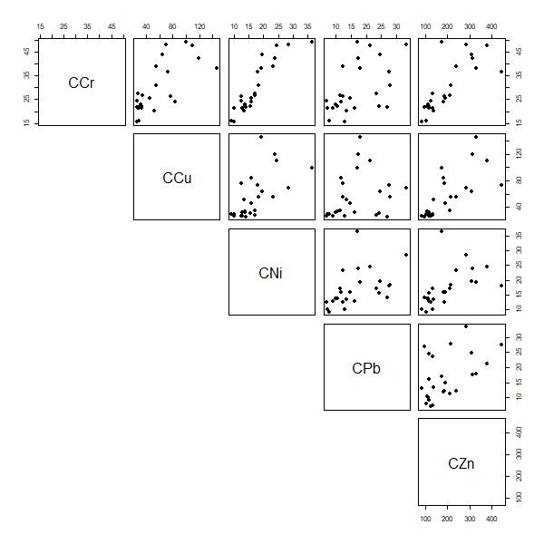
Figure S2: (a) Correlation matrix (Spearman rho coefficients) and (b) scatterplots for concentrations of metals detected in all GP sediments with all concentrations in mg/kg DW. Significant correlations (P<0.01) are indicated with *.

(a)
 | Cd
Cr | 0.37
Cu | 0.33
Ni | 0.52*
Pb | 0.72*
Zn | 0.40*

(b)
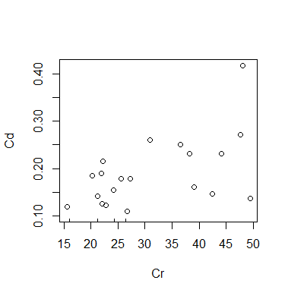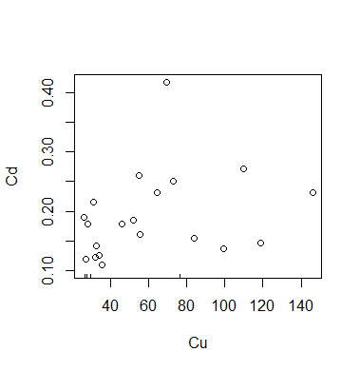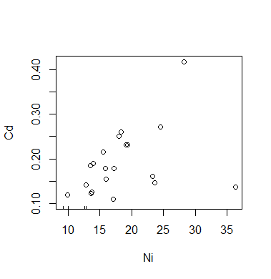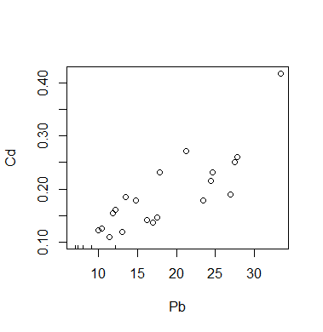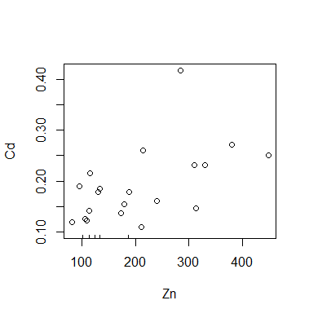
Figure S3: (a) Kendall’s tau correlation coefficient for concentrations of Cd (for which not all concentrations were detected and data is censored) with other metals and (b) scatterplots for concentration of Cd vs other metals with all concentrations in mg/kg DW.

Table S3: Significant difference between metal concentrations for different land use (PL, comm, res)
Metal conc [mg/kg DW] | p | Kruskal-Wallis chi-squared
Zn | 0.3146 | 2.3127
Cu | 0.05558 | 5.78
Pb | 0.4783 | 1.4752
Ni | 2.3223 | 0.3131
Cr | 0.4334 | 1.6724
 | p | tau
Cd and LOI | 0.00885 | 0.366154
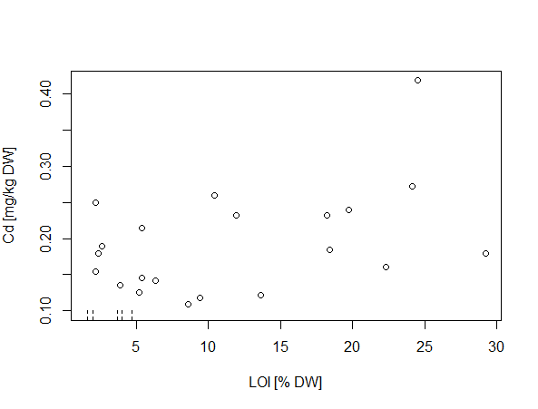

Figure S4: Censored scatterplot and Kendall’s tau results for concentrations Cd&LOI that had significant correlation.
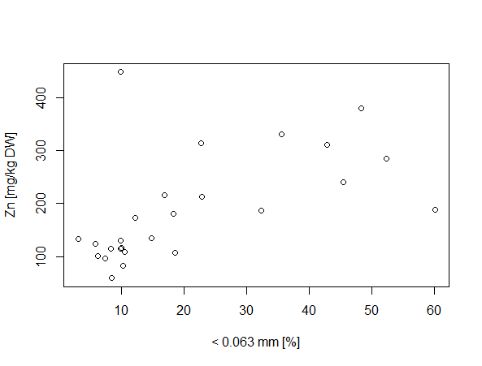
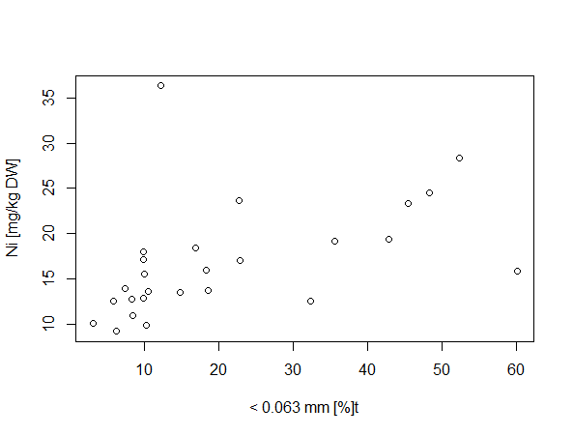

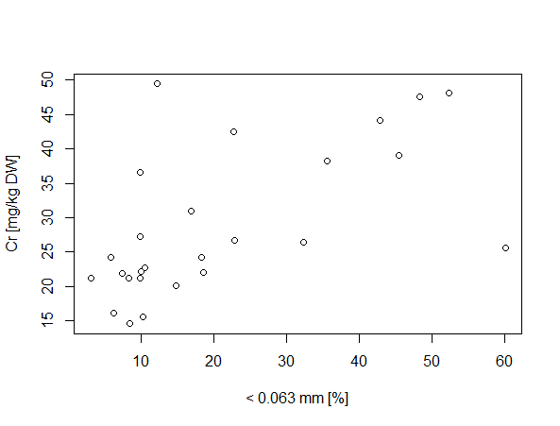
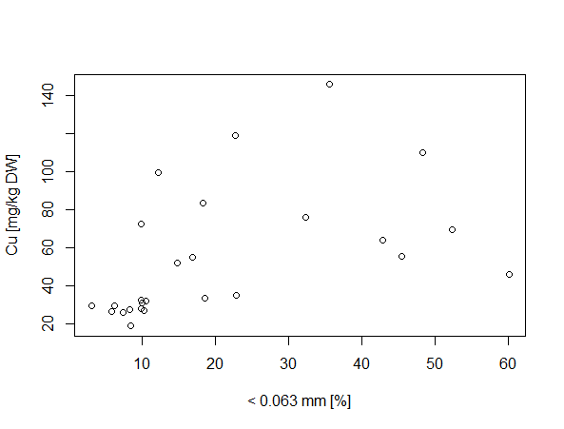

 | rho | p-value (calculate it in R)
Cr and Clay&Silt | 0.636 | 0.0005
Cu and Clay&Silt | 0.715 | 0.0000
Ni and Clay&Silt | 0.652 | 0.0003
Zn and Clay&Silt | 0.649 | 0.0003

Figure S5: Scatterplots and Spearman Rho test results for Cr, Cu, Ni and Zn

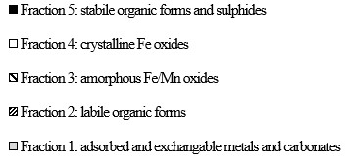
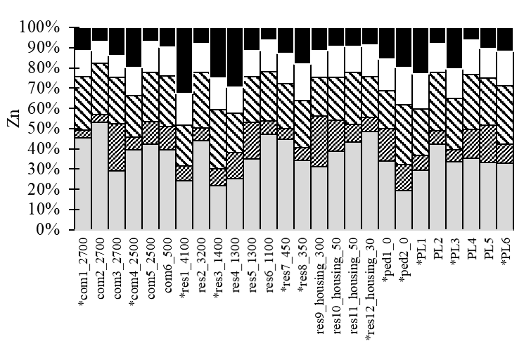
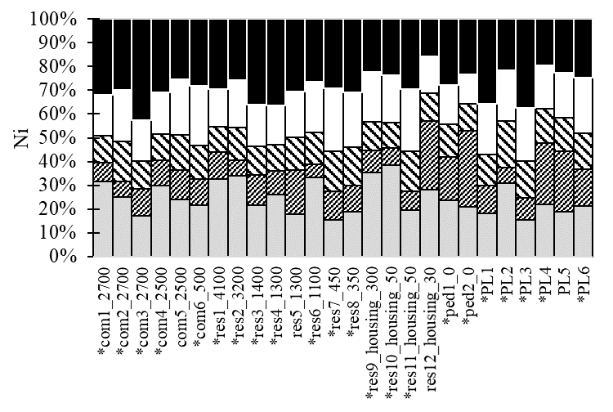
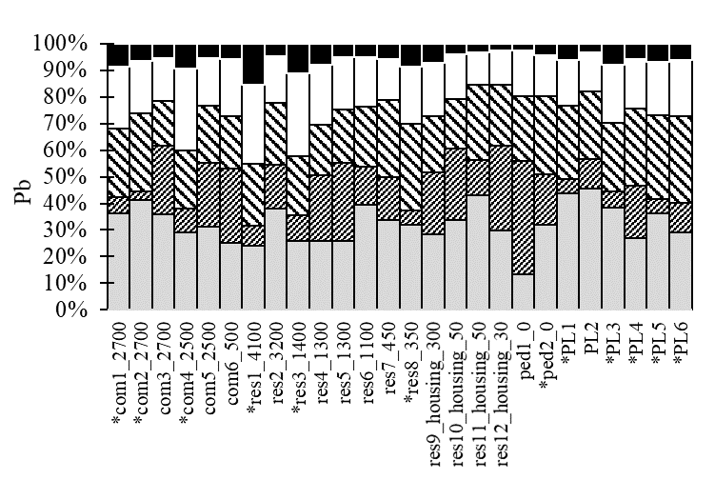
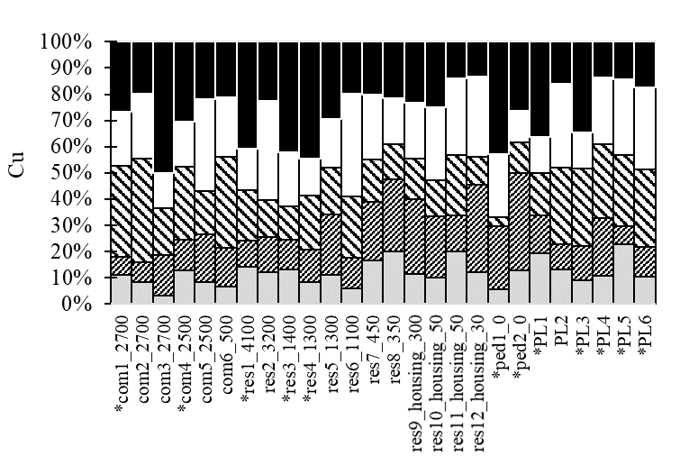
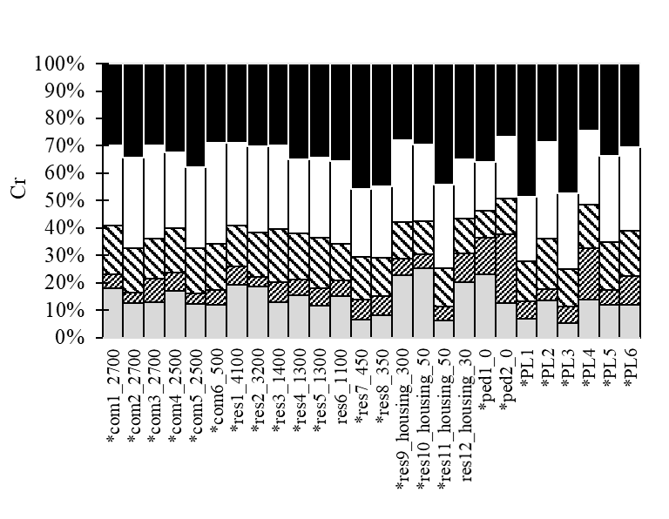
4. Graphs of proportional speciation of metals in GP sediments

Figure S6: Speciation graphs where in case metal is <LOQ, half of the LOQ is taken to make the graphs and calculate the sum of fractions.

5. Data supporting analysis of correlations and significant differences with metal loading rates
(a)
 | Cd | Cr | Cu | Ni | Pb | Zn
Cd | 1 | 0.83* | 0.81* | 0.84* | 0.93* | 0.82*
Cr |  | 1 | 0.9* | 0.99* | 0.93* | 0.92*
Cu |  |  | 1 | 0.88* | 0.86* | 0.89*
Ni |  |  |  | 1 | 0.93* | 0.88*
Pb |  |  |  |  | 1 | 0.9
Zn |  |  |  |  |  | 1

(b)
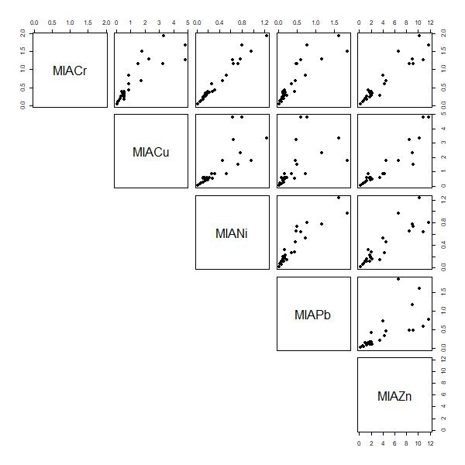
Figure S7: (a) Correlation matrix (Spearman rho coefficients) and (b) scatterplots for normalized mass-loading rates in mg/(m²yr). Significant correlations (P<0.01) are indicated with *.

Table S4: Significant difference between metal masses (normalized per impervious area and accumulation period) for different land use (PL, comm, res)
 | p | Kruskal-Wallis chi-squared
Zn | 0.3318 | 2.2067
Cu | 0.1098 | 4.4183
Pb | 0.3816 | 1.9267
Ni | 1.605 | 0.4482
Cr | 0.5134 | 1.3333
Cd | 0.6188 | 0.96

Table S5: Field observations
GP ID | Field observations
res1_4100 | sediments are gritty with few leaves and a bit greasy looking
res2_3200 | No standing water in GP  lots of leaves
res3_1400 | Lots of leaves  Sediment looked gravelly and not smelly
res4_1300 | /
res5_1300 | Lots of leaves
res6_1100 | /
res7_450 | Smelly sediments with many leaves and earthworms
res8_350 | Lots of leaves, earthworms and gravels
res9_housing_300 | Leaves on top layer
res10_housing_50 | Occurrence of one metal stick in the GP  Mainly leaves in the GP
res11_housing_50 | /
res12_housing_30 | Lots of leaves  Fine-sized sediment sludge
comm1_2700 | Lots of leaves in the sediments though no tree is around  Lots of gravels on the road surface around
comm2_2700 | Oily standing water
comm3_2700 | Near a bus stop  Lots of gravels and leaves
comm4_2500 | Oily sediments  Leaves on top, followed by gravelly sediments, followed by fine sediments
comm5_2500 | Near a construction site  Loose black sediment with oily film
comm6_500 | Smells like sewage  Oily standing water with floating of leaves
ped1_0 | Vegetation growing in the GP  very deep sediment layer with unknown elapsed time since last emptying
ped2_0 | Gravels on the top layer with fine-sized sediments at the bottom  Many earthworms
PL1 | Sediments are dry
PL2 | Many leaves and are smelly
PL3 | Really smelly sediments with lots of dead earthworms
PL4 | Liquidy, sandy and oily sediments  Grease floating on the surface of standing water
PL5 | Lots of leaves
PL6 | Lots of leaves  Greasy sediments

Table S6: Traffic and associated road maintenance activities
GP ID | Traffic and associated road maintenance activities
GP ID | Street layout  (I - receives runoff from intersection or turning point;  PL - parking along the same side of the street where the gully pot is;  Carwash- exposed to possible street car washing ) | Land use | AADT | Number of heavy duty vehicles | Number of lanes | Speed limit | Street Class | Street sweeping frequency
res1_4100 | I;PL | residential apartments | 4100 (y. 2014) | 8% | 2 | 50 | Class 6 (Brun) | 2 times/year
res2_3200 | I;PL | residential apartments | 3200 (y. 2014) | 8% | 2 | 50 | Class 6 (Brun) | 2 times/year
res3_1400 | High slope street | residential apartments | 200 (y. 2014) | 8% | 2 | 50 | Class 6 (Brun) | 2 times/year
res4_1300 | / | residential apartments | 1300 | NA | 2 | 30 | Class 6 (Brun) | 2 times/year
res5_1300 | / | residential apartments | 1300 | NA | 2 | 30 | Class 6 (Brun) | 2 times/year
res6_1100 | / | residential apartments | 1100 | NA | 2 | 30 (50) | Class 2 (blå) | 1 time/week
res7_450 | I; combined drainage | residential detached house | 200 (y. 2014) | 8% | 2 | 30 | Class 6 (Brun) | 2 times/year
res8_350 | before road narrowing; combined drainage | residential detached house | 200 (y. 2014) | 8% | 2 | 30 | Class 6 (Brun) | 2 times/year
res9_housing_300 | I;PL;carwash | residential detached house | 200 (y. 2014) | 8% | 2 | 30 | Class 6 (Brun) | 2 times/year
res10_housing_50 | at the entrance to the parking from a house; carwash | residential detached house | 200 (y. 2014) | 8% | 2 | 30 | Class 6 (Brun) | 2 times/year
res11_housing_50 | combined drainage; carwash | residential detached house | 50 | NA | 2 | 30 | Class 6 (Brun) | 2 times/year
res12_housing_30 | I;carwash | residential detached house | 30 | NA | 2 | 30 | Class 6 (Brun) | 2 times/year
comm1_2700 | I; | commercial | 2700 (y.1998) | na | 2 | 50 | Class 6 (Brun) | 2 times/year
comm2_2700 | I; | commercial | 2700 (y.1998) | na | 2 | 50 | Class 6 (Brun) | 2 times/year
comm3_2700 | I;PL;before bus stop | commercial | 2702 (y. 2014) | 10% | 2 | 50 | Class 6 (Brun) | 2 times/year
comm4_2500 | I; PL; before the road narrowing | commercial | 2500 (y. 2014) | 20% | 2 | 50 (30) | Class 6 (Brun) | 2 times/year
comm5_2500 | I;PL | commercial | 2500 | NA | 2 | 50 | Class 6 (Brun) | 2 times/year
comm6_500 | I; stop and go for loading and unloading | commercial | 200 (y. 2014) | 10% | 2 | 50 | Class 6 (Brun) | 2 times/year
ped1_0 | away from the high traffic road | pedestrian area | / | / | / | / | District administrations responsibilety | NA
ped2_0 | below high traffic road | pedestrian area | / | / | / | / | District administrations responsibilety | NA
PL1 | / | car park | 12848 visitors in October 2021 | NA | 2 | / | Class 6 (Brun) | 2 times/year
PL2 | / | car park | 12848 visitors in October 2021 | NA | 2 | / | Stockholm Parking | Once a year (spring) and if necessary
PL3 | / | car park | 12848 visitors in October 2021 | NA | 1 | / | Stockholm parking | Once a year (spring) and if necessary
PL4 | I;PL on the road | car park | 5 832 visitors in October 2021 | NA | 2 | / | Stockholm parking | Once a year (spring) and if necessary.
PL5 | / | car park | 5 832 visitors in October 2021 | NA | 2 | / | Stockholm parking | Once a year (spring) and if necessary
PL6 | at a curve | car park | 5 832 visitors in October 2021 | NA | 1 | / | Stockholm parking | Once a year (spring) and if necessary

Table S7: Sediment accumulation time
GP ID | Sediment accumulation
GP ID | Date of last emptying | Date of sampling | Number of accumulation days
res1_4100 | 01-03-2020 | 25-03-2021 | 389
res2_3200 | 01-03-2020 | 25-03-2021 | 389
res3_1400 | 01-03-2020 | 25-03-2021 | 389
res4_1300 | 01-03-2020 | 23-03-2021 | 387
res5_1300 | 01-03-2020 | 23-03-2021 | 387
res6_1100 | 01-03-2020 | 25-03-2021 | 389
res7_450 | 15-07-2020 | 25-05-2021 | 314
res8_350 | 15-07-2020 | 25-05-2021 | 314
res9_housing_300 | 01-03-2020 | 23-03-2021 | 387
res10_housing_50 | 01-03-2020 | 23-03-2021 | 387
res11_housing_50 | 15-07-2020 | 25-05-2021 | 314
res12_housing_30 | 01-03-2020 | 23-03-2021 | 387
comm1_2700 | 01-03-2020 | 25-03-2021 | 389
comm2_2700 | 01-03-2020 | 25-03-2021 | 389
comm3_2700 | 01-03-2020 | 24-03-2021 | 388
comm4_2500 | 01-03-2020 | 25-03-2021 | 389
comm5_2500 | 01-03-2020 | 24-03-2021 | 388
comm6_500 | 01-03-2020 | 24-03-2021 | 388
ped1_0 | 26-06-2020 | 27-05-2021 | 335
ped2_0 | 26-06-2020 | 27-05-2021 | 335
PL1 | 03-07-2020 | 25-05-2021 | NA
PL2 | 03-07-2020 | 25-05-2021 | 326
PL3 | 03-07-2020 | 25-05-2021 | 326
PL4 | 26-06-2020 | 27-05-2021 | 335
PL5 | 26-06-2020 | 25-05-2021 | 333
PL6 | 26-06-2020 | 27-05-2021 | 335

Table S8: Catchment delineation
GP ID | Catchment delineation
GP ID | Catchment area  total [m²] | Disconnected impervious surfaces [m²] | Perviousness land use type in Scalgo [m²] | Directly connected road [m²] | Directly connected roofs  [m²] | Parking lot and other impervious surfaces (pedestrian/bicycle pathways) directly connected [m²] | Impervious catchment area directly connected [m²]
res1_4100 | 8986.94 | 1476 | 4352.7 | 1425 | 0 | 1732.97 | 3160
res2_3200 | 681.55 | 0 | 212.77 | 268.64 | 0 | 200.14 | 469
res3_1400 | 902.33 | 0 | 111.1 | 402.98 | 0 | 388.25 | 791
res4_1300 | 995.36 | 0 | 167.06 | 468.34 | 0 | 356.95 | 825
res5_1300 | 1894.48 | 38.44 | 211.41 | 770.48 | 0 | 874.16 | 1640
res6_1100 | 617.61 | 0 | 43.02 | 289.84 | 0 | 284.75 | 575
res7_450 | 1567.91 | 0 | 1233.86 | 333.83 | 0 | 0 | 334
res8_350 | 945.88 | 15.95 | 682.62 | 247.30 | 0 | 0 | 247
res9_housing_300 | 6102.25 | 130.14 | 5043.52 | 440.28 | 3.05 | 485.27 | 929
res10_housing_50 | 1691.52 | 64.02 | 1146.31 | 197.56 | 63.05 | 220.16 | 481
res11_housing_50 | 3412.28 | 313.86 | 2481.36 | 255.50 | 102.03 | 259.98 | 618
res12_housing_30 | 2381.77 | 102.92 | 1527.73 | 473.75 | 0 | 277.49 | 751
comm1_2700 | 1166.05 | 0 | 8.24 | 716.77 | 0 | 441.05 | 1160
comm2_2700 | 873.17 | 0 | 0 | 356.86 | 0 | 516.31 | 873
comm3_2700 | 601.14 | 0 | 25.41 | 318.06 | 8.13 | 249.55 | 576
comm4_2500 | 2168.25 | 205.25 | 204.00 | 360.00 | 0 | 1399 | 1760
comm5_2500 | 3816 | 67.00 | 3329 | 283.00 | 28.00 | 109.00 | 420
comm6_500 | 427.5 | 0 | 0 | 287.61 | 0 | 139.89 | 428
ped1_0 | NA | NA | NA | NA | NA | NA | NA
ped2_0 | 11000 | 545.00 | 9706 | 0 | 0 | 780.00 | 780
PL1 | 70.97 | 0 | 0 | 0 | 0 | 70.97 | 71
PL2 | 758.75 | 0 | 0 | 0 | 0 | 756.75 | 766
PL3 | 270.3 | 0 | 0 | 0 | 0 | 270 | 270
PL4 | 514.36 | 0 | 0 | 401.69 | 0 | 112.67 | 514
PL5 | 866.98 | 0 | 59.28 | 0.2 | 0 | 807.50 | 808
PL6 | 1602.94 | 0 | 0 | 0 | 15.19 | 1588.16 | 1600

Table S9: Gully pot designs
GP ID | Gully pot designs
GP ID | H of the sediment [cm] | Gully pot inner diameter [cm] | Road surface to sediment surface [cm] | GP depth (road surface to GP bottom) [cm] | top of the road to top of the outlet pipe [cm] | outlet pipe diameter [mm] | Sump depth [cm]
res1_4100 | 12 | 50 | 167 | 179 | 128 | 200 | 31
res2_3200 | 19 | 50 | 153 | 172 | 140 | 225 | 9.5
res3_1400 | 17 | 50 | 126 | 143 | NA | 225 | NA
res4_1300 | 25 | 50 | 169 | 194 | 124 | 225 | 47.5
res5_1300 | 12 | 50 | 175 | 187 | 130 | 225 | 34.5
res6_1100 | 11 | 50 | 185 | 196 | 117 | 225 | 56.5
res7_450 | 45 | Rectangle  60*40 | 152 | 197 | Outlet invisible | 225 | NA
res8_350 | 4 | 40 | 56-46 |  | 48 | NA | NA
res9_housing_300 | 16 | 50 | 173 | NA | 150 | 225 | NA
res10_housing_50 | 11 | 50 | 185 | NA | 129 |  | NA
res11_housing_50 | 32 | 50 | 165 | 197 | 140 | 225 | 34.5
res12_housing_30 | 56 | 50 | NA | NA | NA | 225 | NA
comm1_2700 | 15, but still lots of water | 50 | 155, but still lots of water | 170 | 110 | 225 | 37.5
comm2_2700 | 32, very liquidy muddy sediment | 50 | 170 | 202 | 145 | 225 | 34.5
comm3_2700 | 17 | 50 | 128 | NA | 62 | NA | NA
comm4_2500 | 45 | 50 | 160 | 205 | 146 | 225 | 36.5
comm5_2500 | 27 | Rectangle  60*37 | 170 | NA | Outlet invisible | NA | NA
comm6_500 | 23 | 50 | 180 | 203 | 148 | 225 | 32.5
ped1_0 | > 125 cm but we only took top 20 cm layer | 50 | 65 | NA | Outlet invisible | 225 | NA
ped2_0 | 21 | 50 | 45-48 | NA | Outlet invisible | NA | NA
PL1 | 8 | 40 | 170-178 | 183 | NA | 160 | NA
PL2 | 11 | 40 | missing | NA | 270 | 150 | NA
PL3 | 10 | 40 | 230 | 240 | 210 | NA | NA
PL4 | 21 | 50 | 173 | 194 | 136 | 225 | 35.5
PL5 | 11 | 50 | 175 | 186 | 140 | NA | NA
PL6 | 19 | 50 | 170 | 189 | 137 | NA | NA

