Table (1. Supplementary file): Spatial variations of identified plant species (presence; ✔) and their relative vegetation cover (value %) at different industrial sites throughout the study period.
Scientific name | Family | Borg El-Arab
Scientific name | Family | Cont. | Ind. 1 | Ind. 2 | Ind. 3
Zilla spinosa | Brassicaceae | ✔ (15%) | ✔ (10%) | ✔ (20%) | ✔ (25%)
Calotropis Procera | Apocynaceae | ✔ (10%) |  |  | ✔ (5%)
Tamarixnilotica | Tamaricaceae | ✔ (10%) | ✔ (20%) | ✔ (15%) | ✔ (10%)
Anabasis articulata | Amaranthaceae | ✔ (10%) | ✔ (10%) | ✔ (10%) | ✔ (10%)
Salicornia fruticosa | Amaranthaceae | ✔ (10%) | ✔ (10%) | ✔ (20%) | ✔ (10%)
Deverratortuosa | Apiaceae | ✔ (10%) | ✔ (15%) | ✔ (20%) | ✔ (10%)
Echinops spinosa | Compositae | ✔ (10%) |  |  | ✔ (10%)
Nicotiana glauca | Solanaceae | ✔ (10%) | ✔ (10%) | ✔ (15%) | ✔ (10%)
Noeamurconata | Chenopodiaceae |  | ✔ (5%)
Zygophllum coccineum | Zygophyllaceae |  |  |  | ✔ (5%)
Eryngium ilicifolium | Apiaceae | ✔ (15%) | ✔ (10%) |  | ✔ (5%)
Cornulacamonacantha | Chenopodiaceae |  | ✔ (5%)
Hammada elegans | Amaranthaceae |  | ✔ (5%)

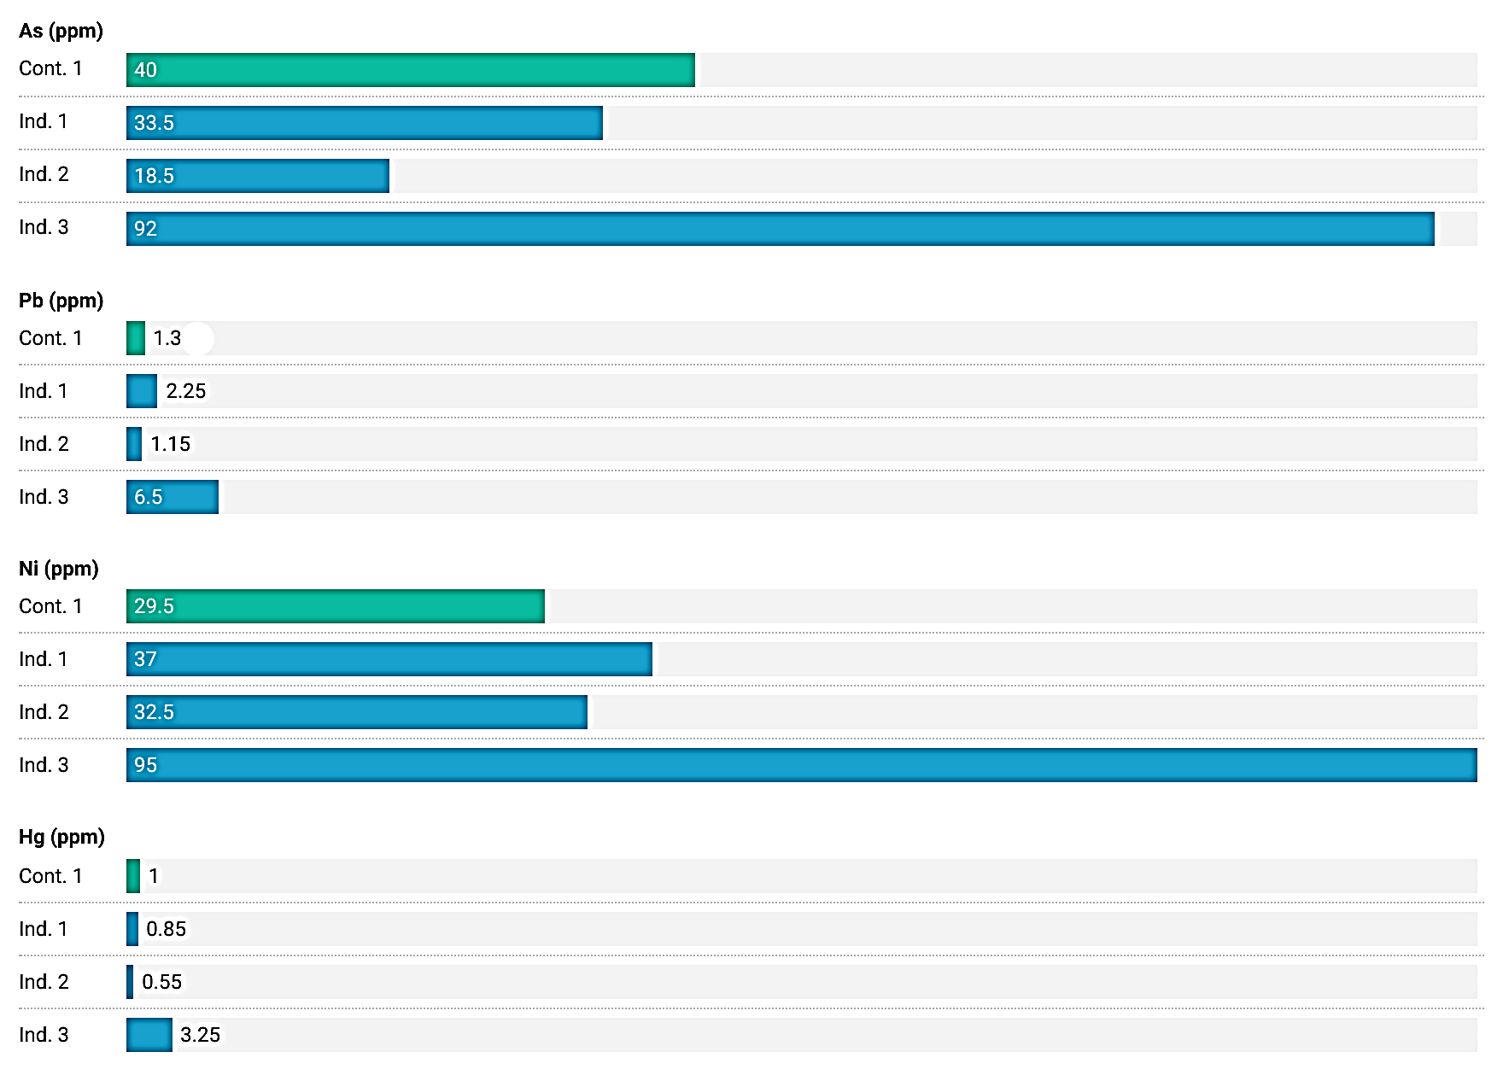
Fig (1. Supplementary file): Spatial variations in the values of heavy metals (ppm) of the soil samples collected from different industrial sites throughout the current study.

