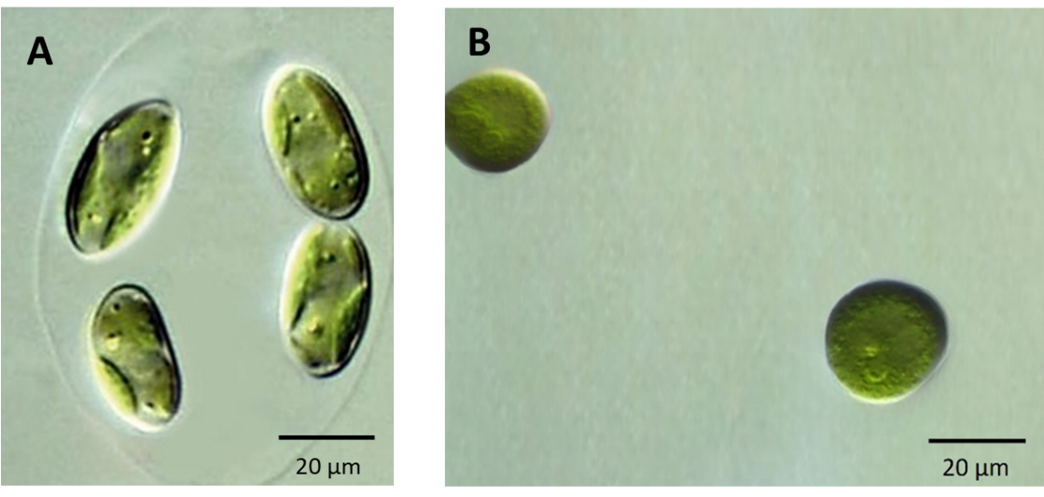
Fig. S1. Light microscopic images of cell morphology of the isolated alga O. pusilla (A). C. infusionum (B) (culture after 15 days), Scale bars: 20 μm.

