Supplementary files for:

Mercury accumulation efficiency of different biomonitors in indoor environments: the case study of the Central Italian Herbarium (Florence, Italy)

Francesco Ciani, Silvia Fornasaro, Renato Benesperi, Elisabetta Bianchi, Jacopo Cabassi, Luca Di Nuzzo, Lisa Grifoni, Stefania Venturi, Pilario Costagliola, Valentina Rimondi*

*Corresponding author at: Department of Earth Science, University of Florence, Via G. La Pira 4, 50121 Firenze, Italy, Tel.: +39-055-2757506, E-mail: valentina.rimondi@unifi.it (V. Rimondi)

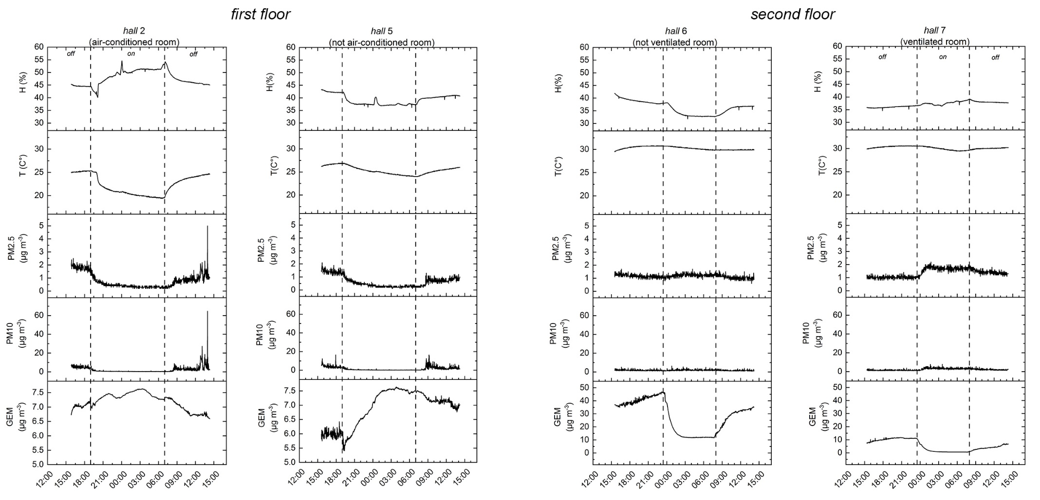

Figure S1: Results of the 24-h surveys carried out in the exposition halls (H= relative humidity; T= temperature; PM2.5 and PM10= particulate matter 2.5 and 10; GEM= gaseous elemental Hg).

barks | C_{Hg} (mean±SD, μg/kg) A(%) ª
 | hall 2 | hall 5 | hall 6 | hall 7 | mean ^{b}
E1-T0 | 24±2 | 31±7 | 25±4 | 37±14 | 29±6
E1-T1 | 60±10 +156% | 67±23 +128% | 70±15 +189% | 38±11 +3% | 59±14* +162%
E1-T2 | 107±15 +87% | 90±12 +51% | 87±9 +34% | 61±14 +33% | 86±19* +51%
net accumulation-E1  (T2-T0 in E1) | 84±16 +357% | 59±13 +192% | 62±9 +251% | 24±13 +65% | 57±25 +198%
E2-T0 | 23±2 | 21±4 | 18±1 | 25±4 | 22±3
E2-T1 | 59±9 +158% | 63±12 +213% | 211±15 +1047% | 57±11 +134% | 97±75* +388%
E2-T2 | 124±40 +114% | 102±16 +71% | 278±111 +33% | 75±27 +28% | 145±91* +61%
net accumulation at T2-E2  (T2-T0 in E2) | 101±52 +439% | 81±41 +386% | 260±135 +1444% | 50±25 +200% | 123±62 +559%
E2-T3 | 149±27 +26% | 136±30 +34% | 348±36 +37% | 75±13 +9% | 177±118 +27%
E2-T4 | 216±60 +50% | 181±67 +43% | 315±34 -10% | 99±43 +33% | 203±89 +29%
E2-T5 | 194±78 -12% | 208±31 +26% | 372±155 +16% | 86±22 -5% | 215±118 +6%
E2-T6 | 246±27 +44% | 176±26 -13% | 425±170 +32% | 124±35 +49% | 243±131 +28%
final net accumulation-E2  (T6-T0 in E2) | 223±26 +959% | 155±24 +743% | 407±170 +2207% | 99±21 +396% | 221±134 +1004%
E2-TY | 630±139 +156% | 523±83 +197% | 1130±201 166% | 293±45 +136% | 644±353* +165%
net accumulation-year  (TY-T0 in E2) | 607±26 +2615% | 502±24 +2409% | 1112±170 +6038% | 268±21 +1070% | 622±134 +2843%

Tab. S1: C_{Hg} and net accumulation (mean±SD μg/kg) recorded in barks during E1 and E2. ª = A(%) determined every three weeks of exposure and at the end of the experiment; ^{b} = mean C_{Hg} in all the halls at the same exposition time (T). * = Mann–Whitney test p < 0.05.
lichens | C_{Hg} (mean±SD, μg/kg) A (%)ª
 | hall 2 | hall 5 | hall 6 | hall 7 | mean^{b}
E1-T0 | 133±20 | 123±15 | 178±48 | 155±17 | 147±25
E1-T1 | 453±56 +252% | 261±19 +116% | 249±38 +47% | 182±8 +20% | 286±116* +108%
E1-T2 | 655±27 +47% | 353±13 +35% | 323±40 +30% | 232±19 +27% | 391±184* +35%
final net accumulation-E1  (T2-T0 in E1) | 523±21 +394% | 230±11 +187% | 145±54 +81% | 77±29 +50% | 243±196 +165%
E2-T0 | 116±6 | 121±7 | 147±14 | 129±4 | 128±12
E2-T1 | 570±69 +391% | 303±22 +151% | 333±6 +129% | 228±6 +76% | 358±128* +187%
E2-T2 | 1030±92 +81% | 419±27 +39% | 442±35 +33% | 251±12 +10% | 535±294* +41%
net accumulation at T2-E2  (T2-T0 in E2) | 914±457 +787% | 298±150 +246% | 295±149 +201% | 122±64 +95% | 407±204 +318%
E2-T3 | 1481±295 +43% | 615±28 +48% | 610±49 +40% | 352±50 +41% | 764±427* +43%
E2-T4 | 1815±119 +26% | 639±65 +4% | 524±71 -14% | 327±71 -7% | 827±581 +2%
E2-T5 | 1878±57 +4% | 609±40 -4% | 631±79 +21% | 374±19 +20% | 873±589 +10%
E2-T6 | 1928±201 +3% | 559±66 -8% | 585±37 -6% | 398±35 +6% | 867±617 -1%
final net accumulation-E2  (T6-T0) | 1812±196 +1562% | 438±68 +361% | 438±39 +299% | 268±37 +208% | 739±623 +577%
E2-TY | 3470±571 +80% | 1087±146 +94% | 1286±74 +120% | 648±40 +63% | 1623±1091* +87%
net accumulation-year  (TY-T0) | 3354±566 +2892% | 966±147 +797% | 1139±80 +776% | 519±40 +401% | 1495±1097 +1164%

Tab. S2: C_{Hg} and net accumulation (mean±SD μg/kg) recorded in barks during E1 and E2. ª = A(%) determined every three weeks of exposure and at the end of the experiment; ^{b} = mean C_{Hg} in all the halls at the same exposition time (T). * = Mann–Whitney test p < 0.05.

mosses | C_{Hg} (mean±SD, μg/kg) A(%)ª
 | hall 2 | hall 5 | hall 6 | hall 7 | mean ^{b}
E1-T0 | 104±33 | 121±10 | 95±7 | 100±31 | 105±11
E1-T1 | 494±140 +375% | 239±26 +99% | 186±22 +96% | 107±8 +16% | 257±167* +145%
E1-T2 | 533±61 +13% | 351±20 +49% | 303±24 +65% | 185±6 +74% | 343±145* +33%
final net accumulation-E1  (T2-T0 in E1) | 429±44 +412% | 230±23 +190% | 208±29 +218% | 85±30 +85% | 238±142 +227%
E2-T0 | 73±8 | 51±4 | 55±2 | 59±38 | 60±3
E2-T1 | 363±62 +409% | 254±23 +404% | 328±32 +496% | 150±25 +154% | 274±18* +357%
E2-T2 | 623±139 +72% | 359±26 +42% | 391±111 +19% | 209±38 +41% | 396±55* +45%
net accumulation at T2-E2  (T2-T0 in E2) | 550±275 +753% | 308±157 +604% | 336±178 +611% | 150±75 +254% | 336±170 +560%
E2-T3 | 858±89 +46% | 473±104 +31% | 556±95 +47% | 269±97 +28% | 539±6* +36%
E2-T4 | 1016±97 +19% | 471±62 +4% | 485±45 -9% | 268±46 +6% | 560±24 +4%
E2-T5 | 1101±221 +9% | 604±42 +31% | 446±54 -7% | 249±76 -9% | 600±83 +7%
E2-T6 | 1172±156 +8% | 606±56 +1% | 584±48 +33% | 296±35 +35% | 665±56 +11%
final net accumulation-E2  (T6-T0) | 1099±149 +1508% | 555±58 +1096% | 528±48 +955% | 237±34 +400% | 605±52 +1008%
E2-TY | 3052±483 +160% | 1350±207 +123% | 1474±194 +152% | 750±127 +153% | 1656±157* +149%
net accumulation-year  (TY-T0) | 2979±479 +4086% | 1299±210 +2563% | 1418±194 +2562% | 691±128 +1164% | 1597±155 +2680%

Tab. S3: C_{Hg} and net accumulation (mean±SD μg/kg) recorded in barks during E1 and E2. ª = A(%) determined every three weeks of exposure and at the end of the experiment; ^{b} = mean C_{Hg} in all the halls at the same exposition time (T). * = Mann–Whitney test p < 0.05.

 | GEM (μg/m3)
 | E1 |  |  |  |  | E2
 | E1-T0 | E1-T3 | E1-T6 | mean |  | E2-T0 | E2-T3 | E2-T6 | E2-T9 | E2-T12 | E2-T15 | E2-T18 | mean
hall 2 | 2.7 | 3.2 | 3.4 | 3.1 |  | 4.9 | 5 | 5.8 | 4.1 | 3.2 | 3.4 | 2.8 | 4.2
hall 5 | 3.1 | 3.5 | 4 | 3.5 |  | 4.7 | 4.1 | 5.3 | 3.7 | 3.5 | 3.4 | 3.9 | 3.9
hall 6 | 3.2 | 4 | 4.2 | 3.8 |  | 27.3 | 23 | 14.9 | 13.5 | 12.1 | 6.8 | 3.8 | 14.5
hall 7 | 0.8 | 1.5 | 1.4 | 1.2 |  | 4.9 | 4.8 | 3.1 | 3 | 1.4 | 0.8 | 0.5 | 2.6
 | T_{A} (C°)
 | E1 |  |  |  |  | E2
 | E1-T0 | E1-T3 | E1-T6 | mean |  | E2-T0 | E2-T3 | E2-T6 | E2-T9 | E2-T12 | E2-T15 | E2-T18 | mean
hall 2 | 19.3 | 19.5 | 19.7 | 19.5 |  | 20.3 | 20.6 | 20.8 | 19.6 | 19.2 | 18.7 | 18 | 19.6
hall 5 | 20.6 | 20.9 | 20.4 | 20.6 |  | 21.9 | 21.6 | 22.2 | 21 | 21.5 | 19 | 18.6 | 20.8
hall 6 | 17.8 | 17.6 | 19 | 18.1 |  | 29.5 | 29.4 | 27 | 27.4 | 26.8 | 23.1 | 19.5 | 26.1
hall 7 | 16.7 | 17.2 | 20.3 | 18 |  | 26.7 | 29.2 | 26.9 | 22.4 | 21 | 20.1 | 17.8 | 23.5

Table S4: mean GEM concentrations (μg/m³) and average temperatures (T_{A}) recorded during each exposure time of E1 and E2.

 |  | H (%) | T (C°) | PM2.5 (μg/m3) | PM10 (μg/m3) | GEM (μg/m3)
hall 2 | min | 40.1 | 19.4 | 0.2 | 0.2 | 6.6
 | max | 54.6 | 25.3 | 5.0 | 64.7 | 7.6
 | mean | 47.9 | 22.3 | 0.8 | 2.1 | 7.2
hall 5 | min | 36.0 | 24.0 | 0.1 | 0.1 | 5.4
 | max | 43.3 | 26.9 | 2.1 | 16.4 | 7.6
 | mean | 39.2 | 25.3 | 0.6 | 1.6 | 6.9
hall 6 | min | 31.8 | 29.5 | 0.6 | 0.6 | 11.5
 | max | 41.9 | 30.8 | 1.7 | 6.4 | 46.9
 | mean | 36.2 | 30.3 | 1.2 | 1.8 | 28.0
hall 7 | min | 34.6 | 29.4 | 0.8 | 0.8 | 0.5
 | max | 39.2 | 30.6 | 2.2 | 7.9 | 11.8
 | mean | 37.2 | 30.1 | 1.4 | 2.3 | 5.4
Table S5: results of 24h surveys of relative humidity (H), temperature (T), PM2.5, PM10 and GEM made in the Herbarium exposure halls.

