Intra-urban variability of long-term exposure to PM_{2.5} and NO₂ in five cities in Colombia

Supplementary material

Laura A. Rodriguez-Villamizar¹, Yurley Rojas², Sara Grisales³, Sonia C. Mangones⁴, Jhon J. Cáceres², Dayana M. Agudelo-Castañeda⁵, Víctor Herrera^{1,6}, Diana Marín⁷, Juan G. Piñeros Jiménez³, Luis C. Belalcázar-Ceron⁴, Oscar Alberto Rojas-Sánchez⁸, Jonathan Ochoa Villegas⁹, Leandro López¹, Oscar Mauricio Rojas¹⁰, María C. Vicini¹¹, Wilson Salas¹², Ana Zuleima Orrego¹³, Margarita Castillo¹⁴, Hugo Sáenz¹⁵, Luis Álvaro Hernández¹⁵, Scott Weichenthal¹⁶, Jill Baumgartner¹⁶, Néstor Y. Rojas⁴
¹ Departamento de Salud Pública, Universidad Industrial de Santander, Bucaramanga, Colombia; e-mail: laurovi@uis.edu.co; vicmaher@uis.edu.co
² Escuela de Ingeniería Civil, Industrial de Santander, Bucaramanga, Colombia; e-mail: yurleyrg18@gmail.com, jcaceres@uis.edu.co
³ Facultad Nacional de Salud Pública, Universidad de Antioquia, Medellín, Colombia; e-mail: sara.grisales@udea.edu.co; juan.pineros@udea.edu.co
⁴ Facultad de Ingeniería, Universidad Nacional de Colombia, Bogotá, Colombia; e-mail: scmangonesm@unal.edu.co; lcbelalcazarc@unal.edu.co; nyrojasr@unal.edu.co
⁵ Departamento de Ingeniería Civil y Ambiental, Universidad del Norte, Barranquilla, Colombia; e-mail: mdagudelo@uninorte.edu.co
⁶ Facultad de Ciencias de la Salud, Universidad Autónoma de Bucaramanga, Bucaramanga, Colombia
⁷ Escuela de Medicina, Universidad Pontificia Bolivariana, Medellín, Colombia; e-mail: dianamarcela.marin@upb.edu.co
⁸ División de Investigación en Salud Pública, Instituto Nacional de Salud, Bogotá, Colombia; e-mail: orojas@ins.gov.co
⁹ Facultad de Ingenierías, Universidad San Buenaventura, Medellín, Colombia; e-mail: jonathan.ochoa@usbmed.edu.co
¹⁰ Área Metropolitana de Bucaramanga, Bucaramanga, Colombia; e-mail: oscar.rojas@amb.gov.co
¹¹ Corporación para la defensa de la meseta de Bucaramanga, Bucaramanga, Colombia; e-mail: maría.vicini@cdmb.gov.co
¹² Departamento Administrativo de Gestión del Medio Ambiente, Alcaldía de Santiago de Cali; e-mail: calidadairedagma@cali.gov.co
¹³ Área Metropolitana del Valle de Aburrá, Medellín, Colombia; e-mail: ana.orrego@metropol.gov.co
¹⁴ EPA Barranquilla Verde, Barranquilla, Colombia; e-mail: margarita.castillo@barranquillaverde.gov.co
¹⁵ Secretaría Distrital de Ambiente, Alcaldía de Bogotá, Bogotá, Colombia; e-mail: hugo.saenz@ambientebogota.gov.co; alvaro.hernandez@ambientebogota.gov.co
16 Department of Epidemiology, Biostatistics & Occupational Health, McGill University, Montreal, Canada; e-mail: scottandrew.weichenthal@mcgill.ca; jill.baumgartner@mcgill.ca

Table S1. Characteristics of the cities and sampling campaigns
Characteristics | Barranquilla | Bogotá | Bucaramanga | Cali | Medellín
Population 2021¹ | 1,297,082 | 7,834,167 | 614,269 | 2,264,748 | 2,573,220
Urban extension coverage (Km²)² | 92 | 349 | 31 | 139 | 142
Altitude (masl) | 24 | 2,640 | 950 | 926 | 1,405
Temperature ºC (anual mean) | 26.61 | 14.84 | 22.70 | 23.32 | 22.73
Dry season sampling period | PM_{2.5} and NO₂: April 19 – May 5 | PM_{2.5}: March 17 – 29 (week 1) April 5-14 (week 2)³  NO₂: April 20 -May 10 | PM_{2.5}: Februray 24 – March 15. NO₂: April 19-May 7 | PM_{2.5} and NO₂: August 5-20 | PM_{2.5}: August 20 -September 3 NO₂: August 27-September 13
PM_{2.5} mean concentration during dry season (μg/m³) | 16.71 | 17.33 | 13.85 | 15.38 | 16.21
NO₂ mean concentration during dry season (μg/m³) | 20.09 | 35.26 | 32.44 | 38.10 | 49.15
Rainy season sampling period | PM_{2.5} and NO₂: September 10 -24 | PM_{2.5} and NO₂: July 14 - 30 | PM_{2.5} and NO₂: June 15-30 | PM_{2.5} and NO₂: September 30 - October 15 | PM_{2.5} and NO₂: April 28 - Mayo 14
PM_{2.5} mean concentration during rainy season (μg/m³) | 15.11 | 10.43 | 12.02 | 16.20 | 15.79
NO₂ mean concentration during rainy season (μg/m³) | 29.97 | 34.00 | 37.40 | 40.14 | 54.49
1 Estimations of population based on national census 2018. Source: DANE Colombia
2 Area delimited manually including the city urban area using Google Earth ®.
3 The first sampling campaign in cities, particularly in Bogotá, was delayed because of social protests. In Bogotá the first sampling campaign excluded the holy week as these days usually correspond to holiday season.

Figure S1. Agreement between PM2.5 measurements from sampling low-cost devices and local monitoring stations in cities
- Dry season campaign (C1)
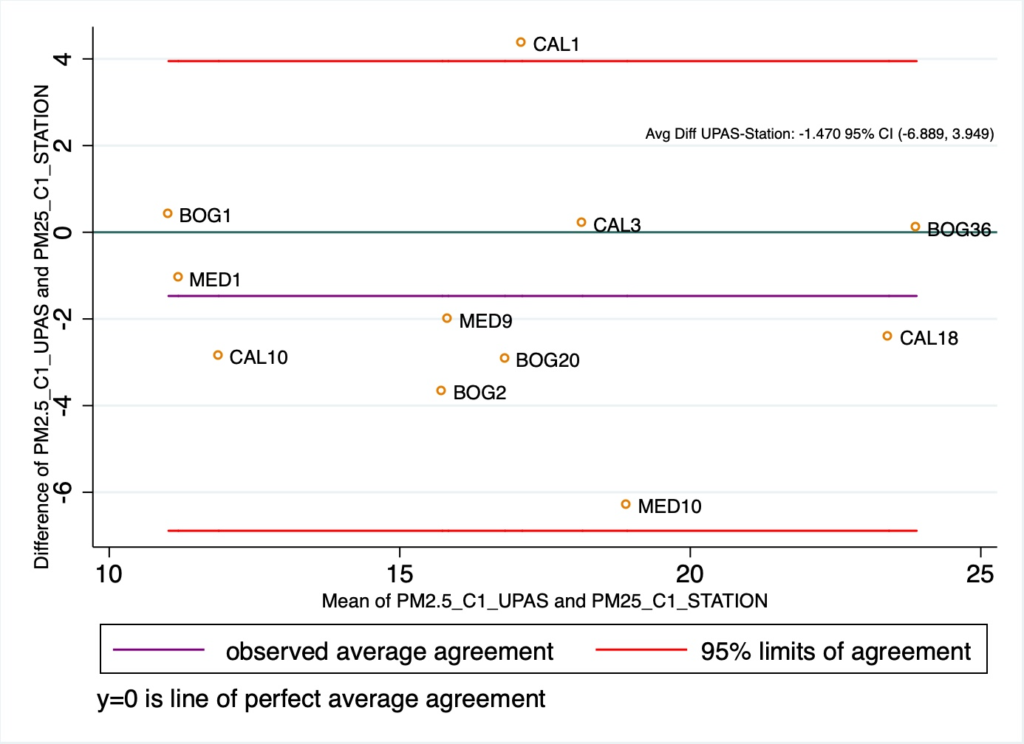

- Rainy season campaign (C2)
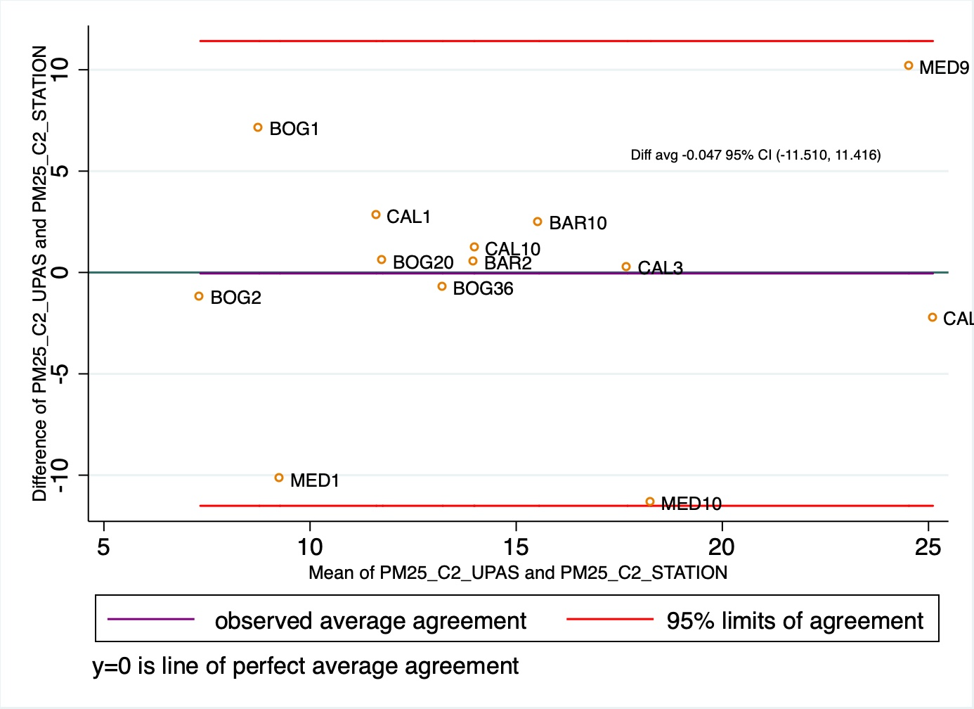

Figure S2. Measured versus predicted PM_{2.5} concentrations (μg/m³) for LUR annual models for five cities in Colombia
Barranquilla  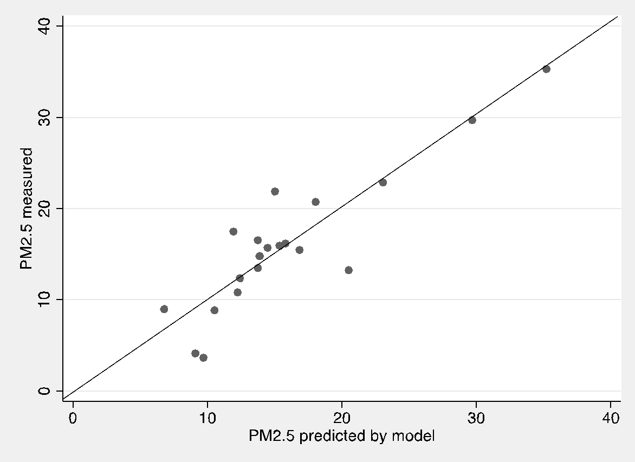 | Bogotá  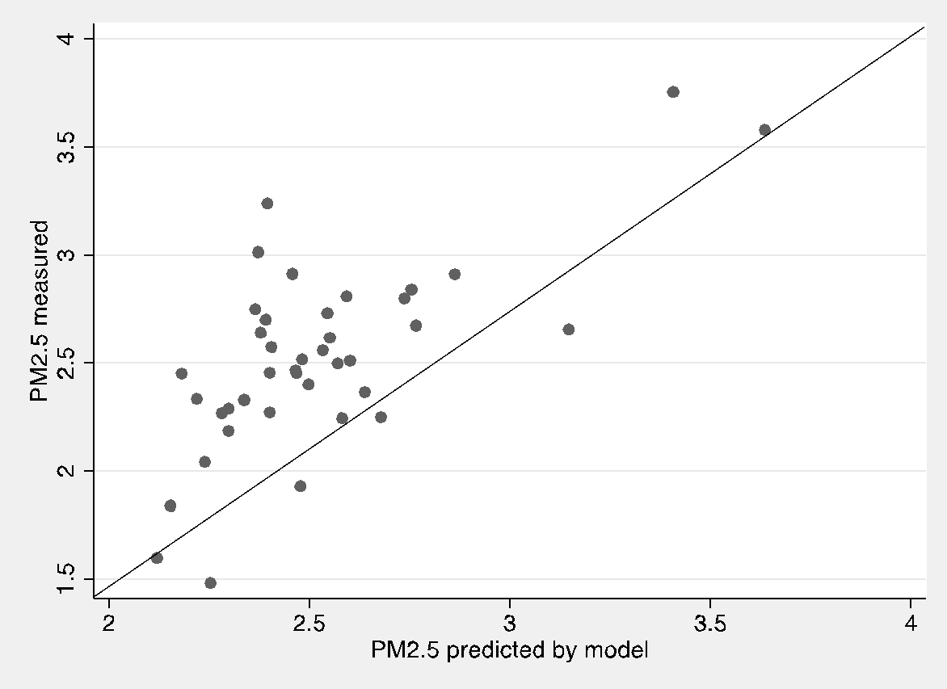
Bucaramanga  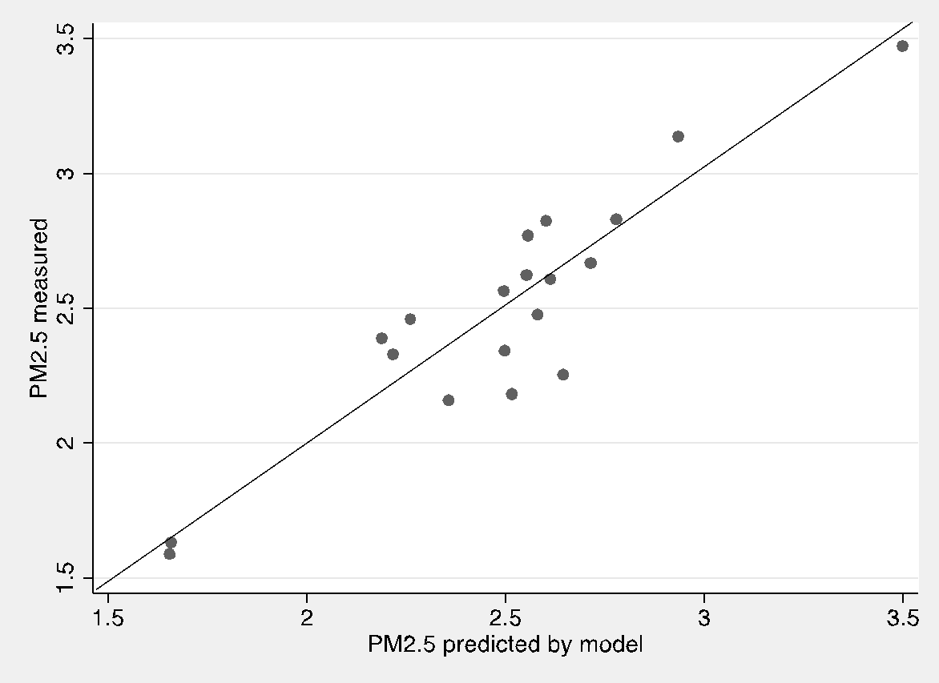 | Cali  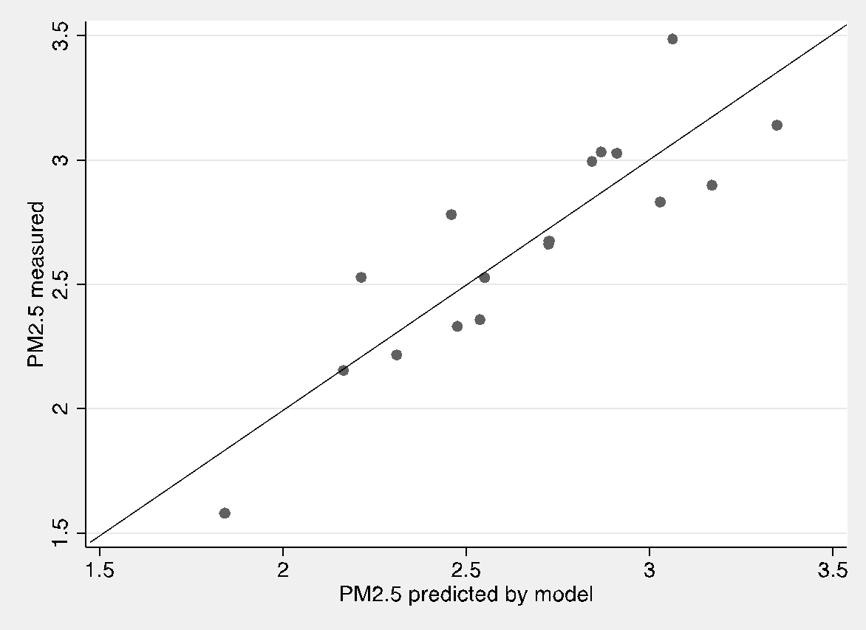
Medellín
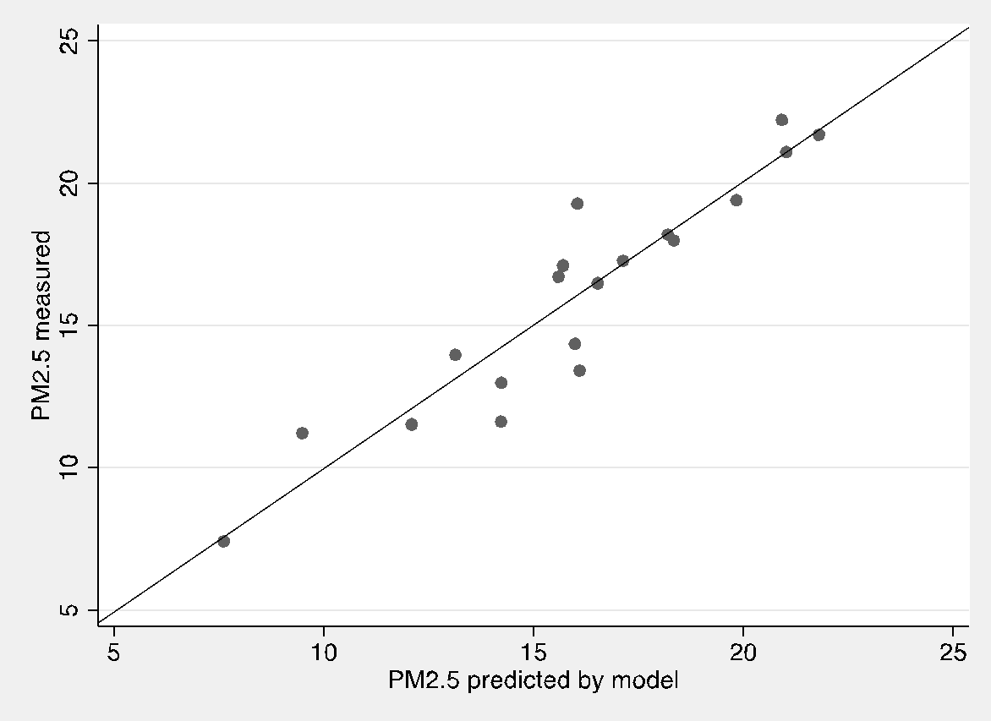

Figure S3. Measured versus predicted NO₂ concentrations (μg/m³) for LUR annual models for five cities in Colombia
Barranquilla  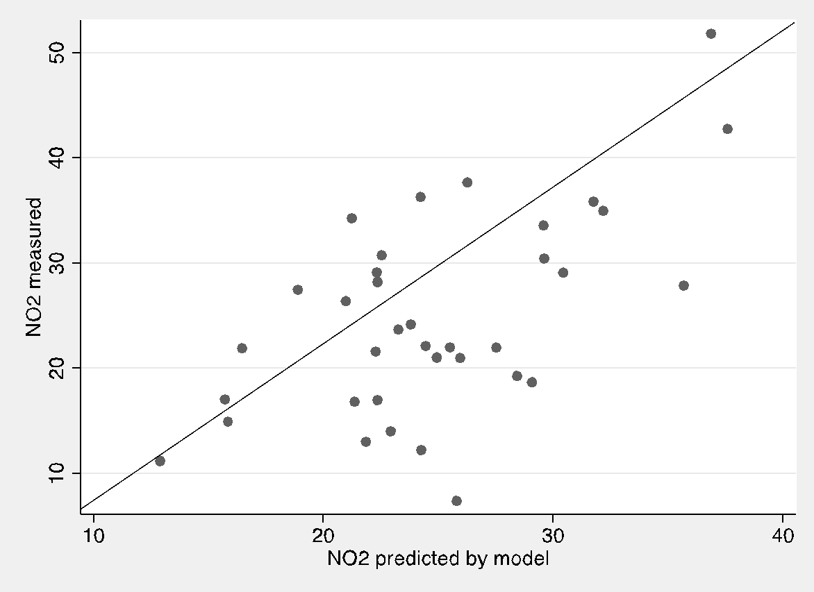 | Bogotá  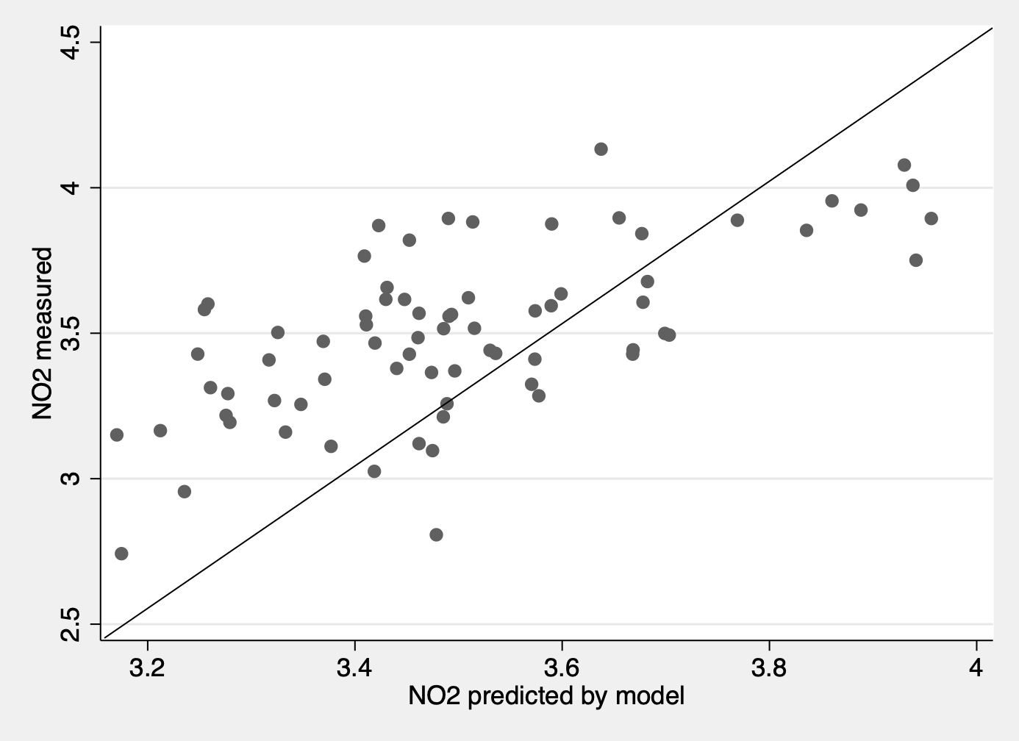
Bucaramanga  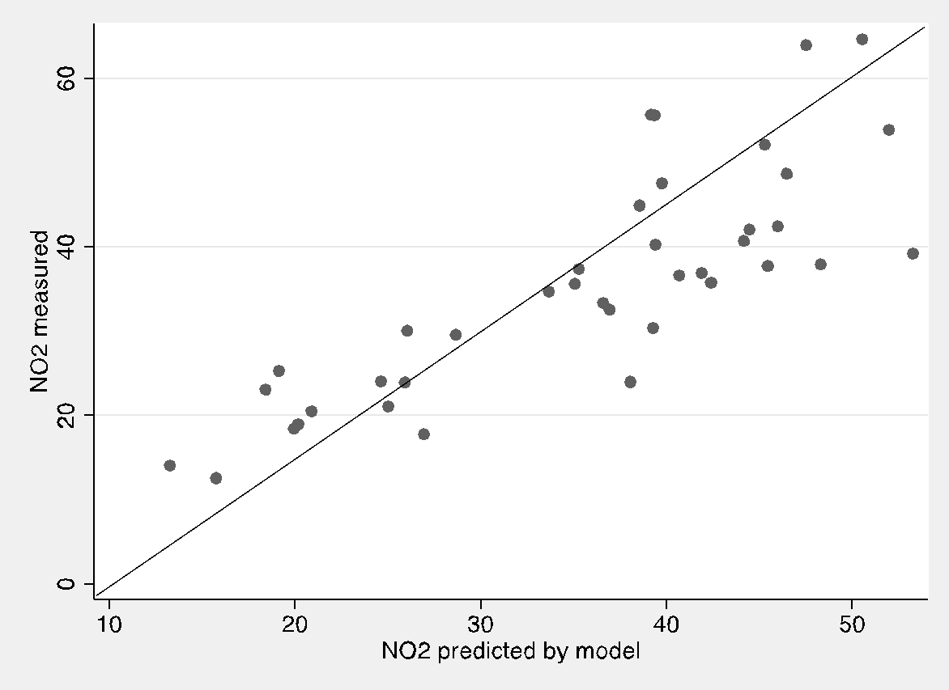 | Cali  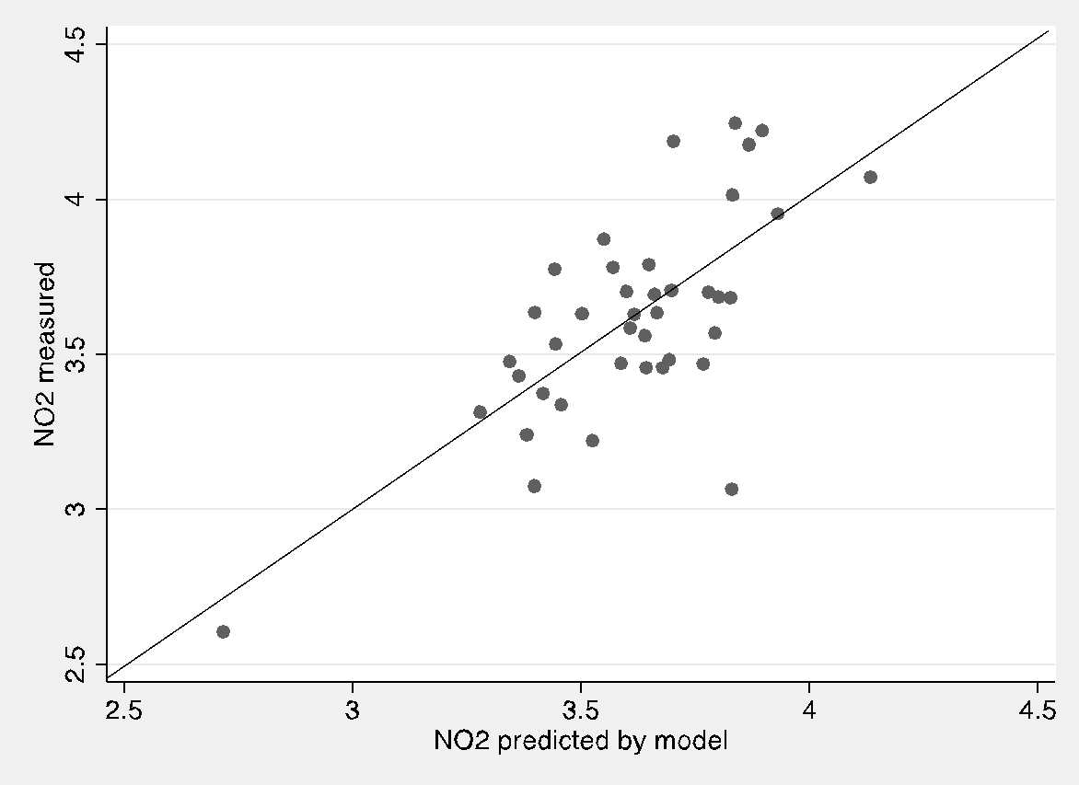
Medellín
