Excess secondary sludge reuse: H₂O₂ treatment - thermal adsorbent synthesis
Ana Udaondo^{1,2}, Vicente Montes^{*,2}, Olga Gimeno¹, Francisco Javier Rivas¹
¹ Department of Chemical Engineering and Physical Chemistry, university institute of water, climate change and sustainability, University of Extremadura, Badajoz, Spain
² Department of Organic and Inorganic Chemistry, university institute of water, climate change and sustainability, University of Extremadura, Badajoz, Spain
SUPLEMENTARY INFORMATION

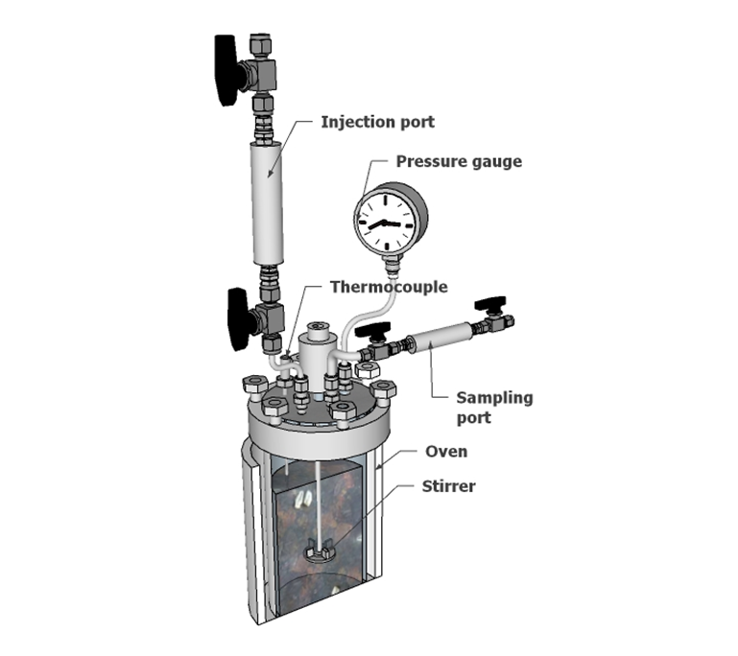
Fig. S1. Reactor used in the H₂O₂ treatment of secondary sludge.

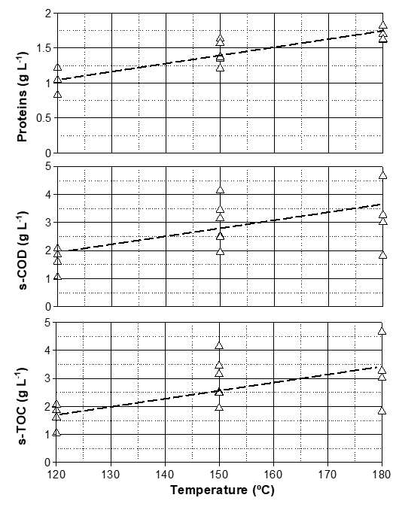
Fig. S2. Thermal sewage sludge treatment in the presence of hydrogen peroxide. Influence of temperature on the final concentration of up: Proteins. Middle: Soluble Chemical oxygen demand (s-COD). Bottom: Soluble Total Organic Carbon (s-TOC)

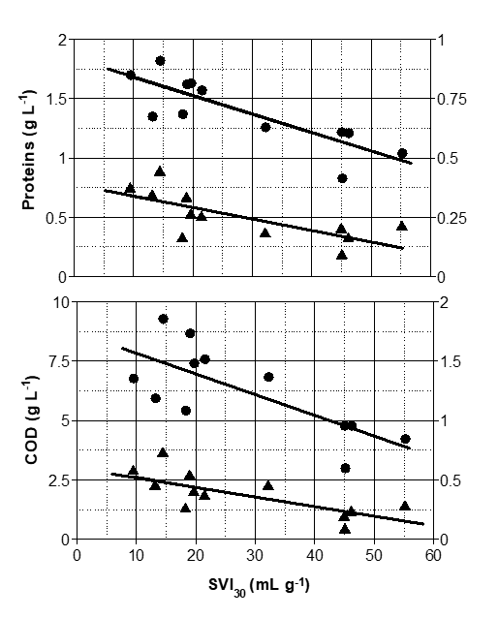
Fig. S3. Thermal sewage sludge treatment in the presence of hydrogen peroxide. Linear correlation between proteins and COD extracellular polymeric substances with sludge volumetric index after 30 min. ▲, s-EPS ●, l-EPS

Table S1. Elemental and XRF analysis pf synthetized adsorbents. Data in weight percentage
 | C | H | N | P | Fe | Al | Si | Ca | Mg | Ni
DS | 29.7 | 3.96 | 2.93 | 4.49 | 4.34 | 3.87 | 3.35 | 2.29 | 1.00 | -
S₄₀₀ | 25.9 | 2.03 | 2.11 | 4.65 | 4.24 | 4.17 | 3.90 | 2.41 | 1.23 | 0.02
S₇₀₀ | 15.2 | 0.06 | 0.36 | 7.20 | 7.44 | 6.87 | 5.54 | 3.84 | 1.91 | -
S_{KOH} | 6.5 | 1.96 | - | 1.15 | 8.44 | 6.62 | 8.30 | 5.04 | 2.46 | -
S_{NN} | 10.1 | 0.18 | 1.19 | 6.36 | 7.27 | 5.79 | 5.87 | 3.46 | 1.51 | 0.02
 | K | S | Ti | Cl | Zn | Mn | Cu | Sr | Cr
DS | 0.58 | 0.49 | 0.21 | 0.10 | 0.07 | 0.06 | 0.03 | 0.01 | -
S₄₀₀ | 0.64 | 0.18 | 0.19 | - | 0.06 | 0.06 | 0.02 | 0.004 | 0.02
S₇₀₀ | 0.87 | 0.24 | 0.29 | - | 0.09 | 0.10 | 0.05 | 0.02 | 0.03
S_{KOH} | 2.27 | 0.34 | 0.39 | - | 0.08 | 0.11 | 0.09 | 0.02 | 0.04
S_{NN} | 1.06 | 0.10 | 0.31 | - | 0.13 | 0.07 | 0.05 | 0.02 | 0.02
DS=Dehydrated sludge

