Trajectories of trace element accumulation in seagrass (Posidonia oceanica) over a decade reveal the footprint of fish farming

Victoria Litsi-Mizan ^{1,2}, Ioanna Kalantzi ², Manolis Tsapakis ², Spiros A. Pergantis ³, Ioannis Karakassis ¹, Eugenia T. Apostolaki ^{2 *}

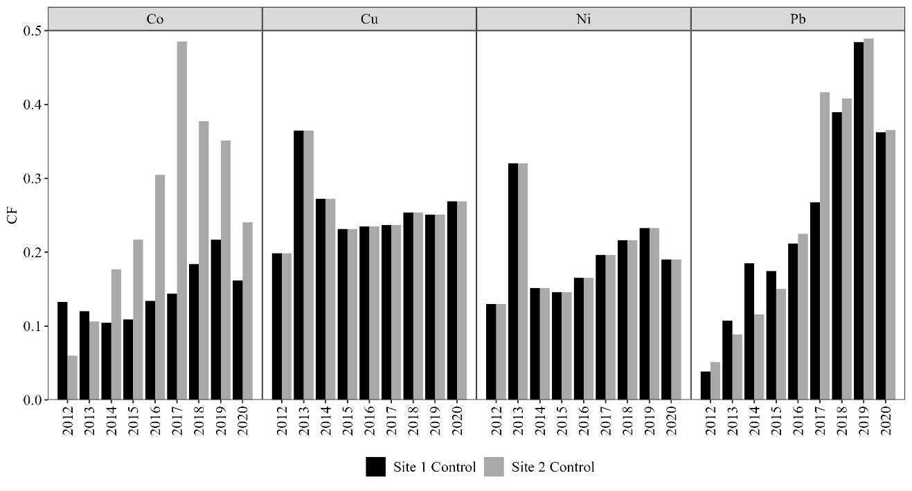

Fig. S1. Contamination levels of the selected ‘Control’ stations based on the contamination factor (CF) calculated by applying the MaLE method (Malea et al. 2019b). The levels of contamination were characterized as follows: CF < 1: low contamination; CF < 3: moderate contamination, CF < 6: considerable contamination, CF.6: very high contamination.

