Enhanced adsorption of phenolic compounds using biomass-derived high surface area activated carbon: Isotherms, Kinetics and Thermodynamics
Praveengouda Patil¹, Gautham Jeppu¹, Manjunath Singanodi Vallabha², Chikmagalur Raju Girish^{1*}
¹Department of Chemical Engineering, Manipal Institute of Technology,
Manipal Academy of Higher Education, Manipal-576104, Karnataka, India
²Department of Civil Engineering, BMS College of Engineering, Bengaluru-560019, India
*Corresponding author email id: cr.girish@manipal.edu

SUPPLEMENTARY FILE

List of Tables

Table S1. Impacts of phenolic compounds on human being.

Table S2. List of Isotherms used in the present investigation.

Table S3. Kinetic models: linear and non-linear forms.

Table S4. Proximate and Ultimate analysis.

Table S5. Elemental composition before and after adsorption from EDS.

Table S6. Optimum operational conditions for isotherm studies.

Table S7. Thermodynamic parameters for adsorption of Phenol and 2,4-DCP on CFPAC.

Table S8. Isosteric heat of adsorption parameters for phenol and 2,4-DCP.

Table S9. Cost analysis for preparation of CFPAC.

Table S1. Impacts of phenolic compounds on human being.
Exposure | Hazards
Inhalation | Irritation in respiratory system
Oral | Fatal death
Eyes | Severe damage and blindness
Skin | Irritation and corrosive damage to skin, burns are developed on skin
Chronic exposure | Headache, nausea, issue in swallowing, vomit, and diarrhoea. The phenol can also damage liver and kidney

Table S2. List of Isotherms used in the present investigation
Isotherm | Equation |  | Ref.
Isotherm | Linear Form | Non-Linear form | Ref.
Langmuir Isotherm | $$\frac{C_{e}}{q_{m}}=\frac{1}{K_{L}*q_{m}}+\frac{C_{e}}{q_{m}}$$ | $$q_{e}=\frac{q_{m}*K_{L}*C_{e}}{1+K_{L}*C_{e}}$$ | (Girish and Ramachandra Murty 2014)
Freundlich Isotherm | $${lnq}_{e}=\frac{1}{n}{lnC}_{e}+{lnK}_{F}$$ | $$q_{e}=K_{F}*C_{e}^{\left(\frac{1}{n}\right)}$$ | (Karri, Sahu, and Jayakumar 2017)
Redlich-Peterson model | $$ln\left(\frac{C_{e}}{q_{e}}\right)=β{lnC}_{e}-{lnA}_{RP}$$ | $$q_{e}=\frac{A_{RP}*C_{e}}{1+K_{RP}*C_{e}^{β}}$$ | (Dehmani et al. 2022)
Temkin model | $$q_{e}=\frac{RT}{b_{T}}*ln\left(A_{T}\right)+\frac{RT}{b_{T}}*ln\left(C_{e}\right)$$ | $$q_{e}=\frac{RT}{b_{T}}*ln\left(A_{T}*C_{e}\right)$$ | (Gama et al. 2022)
where, q_{m} is maximum quantity of phenol/2,4-DCP on unit mass of CFPAC, C_{e} is aqueous concentration of pollutant (phenol/2,4-DCP) at equilibrium, K_{L}, K_{F,} A_{RP,} K_{RP}, $β$, A_{T}, b_{T} are constants of Langmuir, Freundlich, RP isotherm and Temkin isotherm.

Table S3. Kinetic models: linear and non-linear forms
Types of equation | Linear form | Non-linear form | References
Pseudo-first-order | $$ln\left(q_{e}-q_{t}\right)=ln\left(q_{e}\right)-k_{1}*t$$ | $${ q}_{t}=q_{e}*\left(1-e^{-k_{1}t}\right)$$ | (Sriramoju, Dash, and Majumdar 2021)
Pseudo-second-order | $$\frac{t}{q}=\frac{1}{k_{2}*q_{e}^{2}}+\frac{1}{q_{e}}t$$ | $$q_{t}=\left(\frac{k_{2}*q_{e}^{2}*t}{1+k_{2}*q_{e}*t}\right)$$ | (Mohammadi, Darijani, and Karimi 2020)
Intraparticle diffusion | $$q_{t}=K_{pi}*t^{0.5}+C_{i}$$ | - | (Lütke et al. 2019)

Where, q_{t} is adsorption capacity (mg/g) of pollutant at a given time “t”, q_{e} is experimental adsorption capacity of pollutant at equilibrium, k₁ (min⁻¹) and k₂ (g/mg/min) is rate constant of pseudo-first-order and pseudo-second-order model respectively (Yu et al. 2021). Further, K_{pi} is diffusion constant (mg/g/min^{1/2}) and C_{i} is thickness of boundary layer (Kuśmierek, Szala, and Światkowski 2016).

Table S4. Proximate and Ultimate analysis
Proximate Analysis | % Moisture | %Volatile matter | % Ash | %Fixed Carbon
Value (%) | 8.495 | 32.995 | 3.385 | 55.125
Ultimate Analysis | Carbon | Hydrogen | Nitrogen | Sulphur
Value (%) | 49 | 7.41 | 0.86 | 0.07

Table S5. Elemental composition before and after adsorption from EDS
Condition | Element | C | O | Na | P | K | Cl
Before adsorption | wt/% | 90.65 | 7.735 | 0.28 | 1.19 | 0.145 | 0
After adsorption: Phenol | wt/% | 90.03 | 8.19 | 0.285 | 1.22 | 0.28 | 0
After adsorption :2,4-Dichlorophenol | wt/% | 87.28 | 8.5 | 0.21 | 0.785 | 0.17 | 3.04

Table S6. Optimum operational conditions for isotherm studies
Conditions | Phenol | 2,4-DCP
Concentration (mg/L) | 25 | 50
pH | 2 | 2
Temperature (ºC) | 20 | 20
Agitation speed (rpm) | 150 | 120
Adsorbent dosage (g/L) | 1.6 | 0.6

Table S7. Thermodynamic parameters for adsorption of Phenol and 2,4-DCP on CFPAC
Adsorbate | Co (mg/L) | ∆G kJ/mol |  |  |  |  | ∆H kJ/mol | ∆S kJ/mol/K
Adsorbate | Co (mg/L) | 283K | 293K | 303K | 313K | 323K | ∆H kJ/mol | ∆S kJ/mol/K
PHENOL | 25 | -3.395 | -3.653 | -1.117 | -0.673 | -1.685 | -22.161 | -0.066
PHENOL | 50 | -2.081 | -2.437 | -0.801 | -0.509 | -0.850 | -14.872 | -0.045
PHENOL | 100 | -0.756 | -1.170 | 0.087 | 0.715 | 0.167 | -11.642 | -0.038
PHENOL | 150 | -0.084 | -0.596 | 0.883 | 1.096 | 0.896 | -10.721 | -0.037
PHENOL | 200 | 0.180 | -0.297 | 1.011 | 1.487 | 1.316 | -11.565 | -0.041
PHENOL | 300 | 0.819 | 0.209 | 1.624 | 1.726 | 1.014 | -4.967 | -0.020
PHENOL | 400 | 1.067 | 0.640 | 2.301 | 2.267 | 1.413 | -5.967 | -0.025
PHENOL | 500 | 1.386 | 1.232 | 2.426 | 2.782 | 1.177 | -2.335 | -0.014
PHENOL | 600 | 1.534 | 1.429 | 2.334 | 2.636 | 3.159 | -11.148 | -0.111
2,4-DICHLOROPHENOL | 25 | -7.835 | -7.203 | -6.571 | -5.939 | -5.307 | -25.72 | -0.063
2,4-DICHLOROPHENOL | 50 | -7.060 | -6.489 | -5.918 | -5.347 | -4.776 | -23.22 | -0.057
2,4-DICHLOROPHENOL | 100 | -4.887 | -4.459 | -4.030 | -3.602 | -3.173 | -17.01 | -0.043
2,4-DICHLOROPHENOL | 150 | -3.506 | -3.127 | -2.748 | -2.369 | -1.990 | -14.23 | -0.038
2,4-DICHLOROPHENOL | 200 | -2.518 | -2.257 | -1.995 | -1.734 | -1.472 | -9.92 | -0.026
2,4-DICHLOROPHENOL | 300 | -1.239 | -0.937 | -0.636 | -0.335 | -0.034 | -9.76 | -0.030
2,4-DICHLOROPHENOL | 400 | -0.551 | -0.143 | 0.265 | 0.673 | 1.081 | -12.09 | -0.041
2,4-DICHLOROPHENOL | 500 | 0.261 | 0.513 | 0.765 | 1.018 | 1.270 | -6.88 | -0.025
2,4-DICHLOROPHENOL | 600 | 0.247 | 0.715 | 1.183 | 1.652 | 2.120 | -13.01 | -0.047

Table S8. Isosteric heat of adsorption parameters for phenol and 2,4-DCP
Pollutant | q_{e} (mg/g) | ΔH_{x} (kJ/mol)
Phenol | 10 | 15.953
Phenol | 20 | 9.576
Phenol | 30 | 6.151
Phenol | 40 | 5.034
Phenol | 50 | 5.045
Phenol | 70 | 2.018
Phenol | 90 | 2.172
Phenol | 100 | 0.596
2,4-DICHLOROPHENOL | 40 | 24.146
2,4-DICHLOROPHENOL | 80 | 21.406
2,4-DICHLOROPHENOL | 140 | 14.257
2,4-DICHLOROPHENOL | 190 | 10.754
2,4-DICHLOROPHENOL | 230 | 6.821
2,4-DICHLOROPHENOL | 280 | 5.626
2,4-DICHLOROPHENOL | 320 | 5.887
2,4-DICHLOROPHENOL | 360 | 3.122
2,4-DICHLOROPHENOL | 390 | 5.210

Table S9. Cost analysis for preparation of CFPAC
Description of item |  | Unit cost | No. of Units |  | Price  (INR) |  | Price  (USD)
For 1Kg of CFPAC
1. | Biomass | 0 |  |  |  | 0 | 0
2. | Electricity | 7.5 |  | 4 |  | 30 | 0.36
3. | Chemicals |  |  |  |  | 380 | 4.59
4. | DI Water |  |  |  |  | 24 | 0.29
Total |  |  |  |  |  | 434 | 5.24

List of Figures

Fig. S1 Nitrogen adsorption/ desorption isotherms of CFPAC

Fig. S2 Non-linear model fit of isotherms for phenol (a), (b) and 2,4-DCP (c), (d) at pH 2 and pH 5

Fig. S3 Influence of initial concentration on the separation factor (R_{L})

Fig. S4 Langmuir isotherm at different temperatures a) Phenol and b) 2,4-DCP

Fig. S5 Pseudo-First-Order (a) and (c), Pseudo-Second-Order (b) and (d) non-linear kinetics for phenol, 2,4-DCP

Fig. S6 Pseudo first order and Pseudo second order model fit for Phenol (a) and (b) and 2,4-DCP (c) and (d)

Fig. S7 Plot of ln(k₂) vs 1/T for determining activation energy

Fig. S8 Intraparticle diffusion plot of a) Phenol b) 2,4-DCP

Fig. S9 Isosteric heat of adsorption for (a) phenol (b) 2,4-DCP on CFPAC and plot of ΔH_{x} vs Loading for phenol (c) and (d) 2,4-DCP

Fig S10 SEM-EDS after adsorption of phenol and 2,4-DCP

Fig. S11 FTIR spectra before and after adsorption of phenol and 2,4-DCP

Fig. S1 Nitrogen adsorption/ desorption isotherms of CFPAC

Fig. S2 Non-linear model fit of isotherms for phenol (a), (b) and 2,4-DCP (c), (d) at pH 2 and pH 5

Fig. S3 Influence of initial concentration on the separation factor (R_{L})

Fig. S4 Langmuir isotherm at different temperatures a) Phenol and b) 2,4-DCP

Fig. S5 Pseudo-First-Order (a) and (c), Pseudo-Second-Order (b) and (d) non-linear kinetics for phenol, 2,4-DCP

Fig. S6 Pseudo first order and Pseudo second order model fit for Phenol (a) and (b) and 2,4-DCP (c) and (d)

Fig. S7 Plot of ln(k₂) vs 1/T for determining activation energy
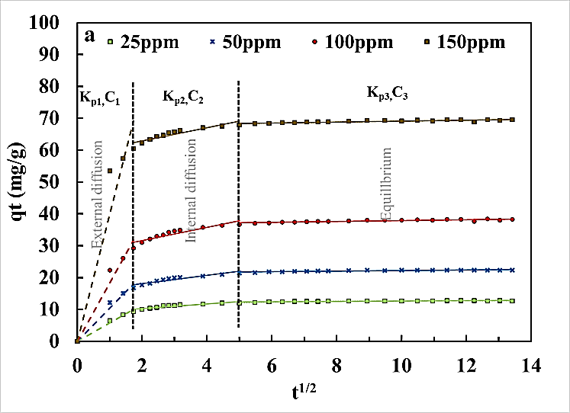
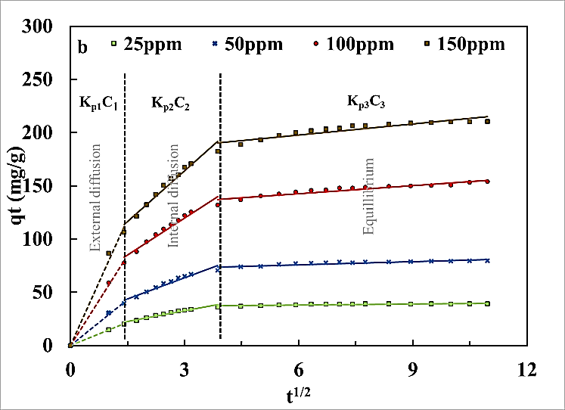

Fig. S8 Intraparticle diffusion plot of a) Phenol b) 2,4-DCP

Fig. S9. Isosteric heat of adsorption for (a) phenol (b) 2,4-DCP on CFPAC and plot of ΔH_{x} vs Loading for phenol (c) and (d) 2,4-DCP

- (b)

Fig S10 SEM-EDS after adsorption of (a) phenol and (b) 2,4-DCP

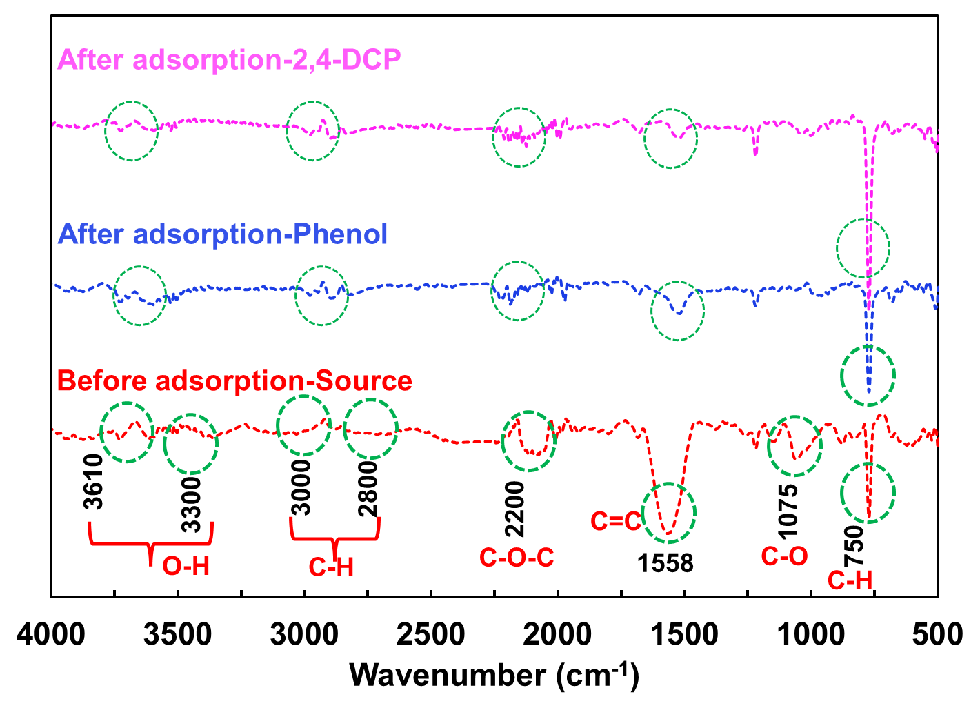

Fig. S11 FTIR spectra before and after adsorption of phenol and 2,4-DCP

