Sequestration of Pb(II) using channel-like porous spheres of carboxylated graphene oxide-incorporated cellulose acetate@iminodiacetic acid: optimization and mechanism study
Eman M. Abd El-Monaem¹, Hassanien Gomaa², Ahmed M. Omer^{3,}*, Gehan M. El-Subruiti¹, Abdelazeem S. Eltaweil¹
¹Chemistry Department, Faculty of Science, Alexandria University, Alexandria, Egypt.
²Department of Chemistry, Faculty of Science, Al-Azhar University, Assiut 71524, Egypt.
³Polymer Materials Research Department, Advanced Technology and New Materials Research Institute (ATNMRI), City of Scientific Research and Technological Applications (SRTA-City), P. O. Box: 21934, New Borg El-Arab City, Alexandria, Egypt.

*Corresponding authors: Ahmed M. Omer (ahmedomer_81@yahoo.com)

Text S1
Cellulose acetate (Mwt = 30,000 g/mol, 39.8 wt% acetyl) and graphite powder (<20 µm, purity 99.99%) was provided from Alfa-Aesar Co. (UK). Lead nitrate (Pb(NO₃)₂), sulfuric acid (assay 95-98%), and potassium permanganate (assay >99%) were brought from Aladdin Industrial Corporation (China). Hydrochloric acid (assay 37%), iminodiacetic acid, and hydrogen peroxide (assay 30%) were purchased from Loba Chemie (India).

Text S2
The fabricated samples were characterized by fourier transforms infrared spectroscopy (FTIR- Bruker vector-22), thermogravimetric analyzer (TGA- LINSEIS L40/2052), scanning electron microscope (SEM- Hitachi S4800), X-ray photoelectron spectroscopy (XPS- Thermo-Fisher Sci.), X-ray diffraction (XRD- VG ESCALAB 210), and Zeta potential (ZP- Malvern).

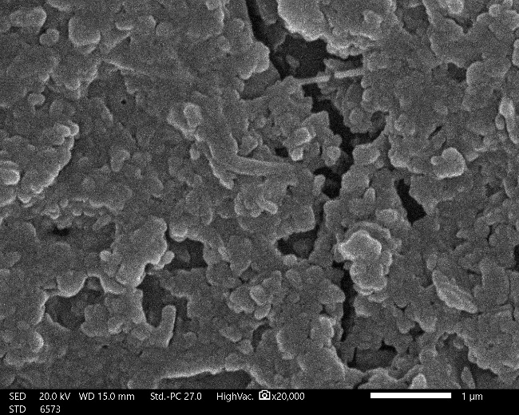
Figure S1. SEM image of COOH-GO sample.

Table S1. Non-linear equations of the applied adsorption isotherm models
Model | Equation
Langmuir | $q_{e}=\frac{q_{max}K_{L}C_{e}}{1+ K_{L} C_{e}}$ (3)
Freundlich | $q_{e}=k_{F }C_{e}^{1/n}$ (4)
Temkin | $q_{e}=\frac{R T}{b_{T}}\ln{k_{T}}C_{e}$ (5)

Where, q_{e} and C_{e} are the adsorption capacity and the concentration of the un-adsorbed Pb(II) at equilibrium, respectively. q_{max} and k_{L} are the monolayer adsorption capacity and Langmuir constant, respectively. n and k_{F} are Freundlich constants. k_{T} is the equilibrium binding constant and b is Temkin constant related to heat of adsorption.

Table S2. The calculated R_{L} values at varied concentrations of Pb(II).
C_{o} (mg/L) | R_{L}
50 | 1.98x10⁻⁴
100 | 9.9x10⁻⁵
250 | 3.96x10⁻⁵
350 | 2.83x10⁻⁵

Table S3. Equations of the applied adsorption kinetic models
Kinetic Model | Equation
Pseudo 1st order | $$q_{t}=q_{e}\left(1-e^{-k_{1 }t}\right) (7)$$
Pseudo 2nd order | $$q_{t}=\frac{t{ k}_{2 }q_{e}^{2}}{1+t k_{2}q_{e}} (8)$$
Elovich model | $q_{t}= \frac{1}{β}ln(αβt+1)$ (9)
Intraparticle diffusion | $q_{t}=K_{p }t^{0.5}+C$ (10)

Where, q_{t} and q_{e} are amounts of Pb(II) uptakes at time t and equilibrium, respectively. k₁ and k₂ are the rate constants of Pseudo-1st order and Pseudo-2nd order, respectively. Furthermore, α and β are Elovich coefficients that represent the initial adsorption rate and the desorption coefficient, respectively, also related to the extent of surface coverage and activation energy for chemisorption. K_{p} is the intraparticle diffusion constant and C provides an idea about the thickness of the boundary layer.

Table S4. XPS data of COOH-GO@CA@IDA spheres (before and after Pb²⁺-adsorption).
 | C 1s |  |  | O 1s | Pb 4f
Before Pb²⁺-adsorption | Survey data |  | 62.43 C (%)  287.5 eV | 37.57 O (%)  533.7 eV | 0 Pb (%)  ----
Before Pb²⁺-adsorption | Peak positions | 288.8 eV  286.5 eV  284.8 eV |  | 533.8 eV  533 eV  532.3 eV | ----
After Pb²⁺-adsorption | Survey data |  | 62.12 C (%)  287.4 eV | 37.72 O (%)  533.9 eV | 0.16 Pb (%)  139.8 eV
After Pb²⁺-adsorption | Peak positions | 288.8 eV  286.5 eV  284.8 eV |  | 533.5 eV  532.9 eV  532 eV  530.3 eV | 138.75 eV  143.56 eV

