Supplementary Data
LC-MS analysis of polar and highly polar organic pollutants in Barcelona urban groundwater using orthogonal LC separation modes
Francesc Labad¹, Sandra Pérez^{1*}
¹ONHEALTH, Department of Environmental Chemistry, Institute of Environmental Assessment and Water Research (IDAEA), CSIC, Jordi Girona 18-26, 08034 Barcelona (Spain)

*Corresponding author:
Sandra Pérez
IDAEA-CSIC
ONHEALTH Research Group
Jordi Girona 18-26
Barcelona 08034, Spain
E-mail: spsqam@idaea.csic.es
Phone: +34-93 400 6100
Fax: +34-93 204 5904
Table of contents
Table S1. List of the 96 target compounds sorted by logD¹ 23
Table S2. In situ parameters of the seven GW samples. 37
Figure S1. Flow-chart for enrichment by VAE followed by HILIC (left) and C18 (right) chromatographic separation before HPLC-MS/MS analysis. 38
Figure S2. Retention differences between columns and compounds polarities. 39
Figure S3. A: Chromatograms of diclofenac, atorvastatin and gabapentin; B: Chromatograms of melamine, metformin and methenamine. A shows great performance using the HSS T3 column (Upper) while B shows great BEH Amide column (Lower) performance for the selected compounds shown. 40
Table S3. Parameters of the optimised gradients. 41
Table S4. MS parameters, chromatographic retention times (RT) and retention factors (RFK) of target compounds sorted by alphabetical order. The t₀ for the HSS T3 column was 0.90 min. 42
Table S5. Validation parameters of the target compounds enriched by the VAE approach at 1, 50 and 200 µg/L (n = 3), sorted by alphabetical order. 48
Table S6. Sample location in coordinates. 53
Table S7. Limits of detection (LOD) and quantification (LOQ) of the target analytes, sorted by alphabetical order. 54
Table S8. Results of the seven wells samples studied sorted by Log D (pH 7.4). The concentration values shown are in ng L⁻¹. 57
Table S9. Quality Score for each compound in both columns, sorted by log D. 60

Table S1. List of the 96 target compounds sorted by logD
Compound | Main use | CAS | Molecular formula | Molecular weight | Water Solubility¹  (mg mL⁻¹) | Boiling point¹  (°C) | Log D¹ at pH 7.4 | Structure
Zanamivir | Antiviral | 1391180-80-8 | C₁₂H₂₀N₄O₇ | 332.31 | 18 | - | -6.0 | 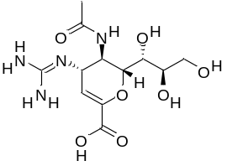
Oxytetracycline | Antibiotic | 79-57-2 | C₂₂H₂₄N₂O₉ | 460.40 | 31 | 840 | -4.3 | 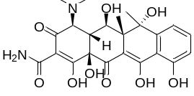
Pipemidic acid | Antibiotic | 51940-44-4 | C₁₄H₁₇N₅O₃ | 303.32 | 0.32 | 535 | -3.6 | 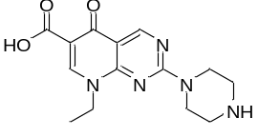
Cyclamate | Sweetener | 100-88-9 (cyclamic acid) | C₆H₁₃NO₃S | 179.24 | 133 | - | -3.5 | 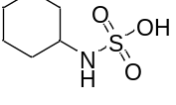
Sulisobenzone (BP4) | UV-Filter | 4065-45-6 | C₁₄H₁₂O₆S | 308.31 | 250 | 498 | -3.5 | 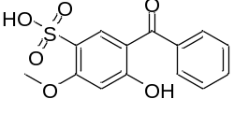
Metformin | Diabetes type 2 treatment agent | 657-24-9 | C₄H₁₁N₅ | 129.16 | 300 | 173 | -3.4 | 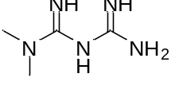
Iodixanol | Iodinated contrast media | 92339-11-2 | C₃₅H₄₄I₆N₆O₁₅ | 1550.20 | 0.19 | 1251 | -3.4 | 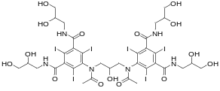
Tetracycline | Antibiotic | 60-54-8 | C₂₂H₂₄N₂O₈ | 444.40 | 0.23 | 738 | -3.2 | 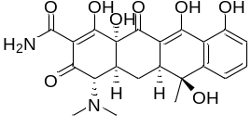
Iohexol | Iodinated contrast media | 66108-95-0 | C₁₉H₂₆I₃N₃O₉ | 821.14 | 350 | 892 | -3.2 | 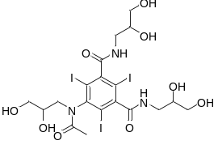
Eflornithine | Facial hirsutism treatment drug | 70052-12-9 | C₆H₁₂F₂N₂O₂ | 182.17 | 10 | 347 | -3.0 | 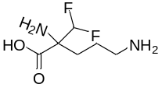
Amoxicillin | Antibiotic | 26787-78-0 | C₁₆H₁₉N₃O₅S | 365.40 | 0.96 | 743 | -2.7 | 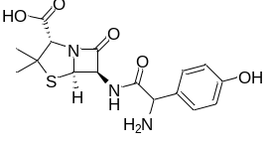
Ciprofloxacin | Antibiotic | 85721-33-1 | C₁₇H₁₈FN₃O₃ | 331.35 | 1.4 | 582 | -2.2 | 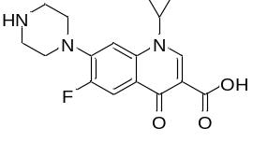
Levofloxacin | Antibiotic | 100986-85-4 | C₁₈H₂₀FN₃O₄ | 361.40 | 0.05 | 572 | -2.1 | 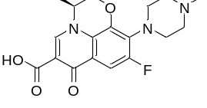
Iopromide | Iodinated contrast media | 73334-07-3 | C₁₈H₂₄I₃N₃O₈ | 791.11 | 0.37 | 841 | -2.1 | 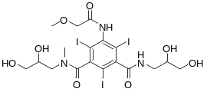
Atenolol | β-blocker  agent | 29122-68-7 | C₁₄H₂₂N₂O₃ | 266.34 | 13 | 508 | -1.9 | 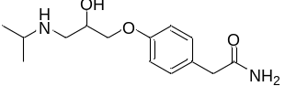
Aspartame | Sweetener | 22839-47-0 | C₁₄H₁₈N₂O₅ | 294.30 | 10 | 536 | -1.8 | 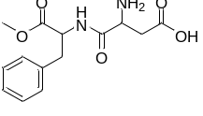
Meprobamate | Anxiolytic | 57-53-4 | C₉H₁₈N₂O₄ | 218.25 | 2.5 | 334 | -1.8 | 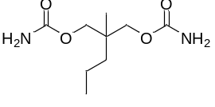
Sotalol | β-blocker  agent | 3930-20-9 | C₁₂H₂₀N₂O₃S | 272.36 | 0.78 | 443 | -1.6 | 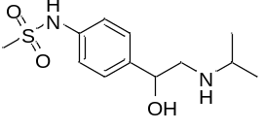
5-Fluorouracil | Antineoplastic agent | 51-21-8 | C₄H₃FN₂O₂ | 130.08 | 5.9 | 367 | -1.6 | 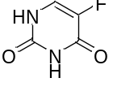
Acyclovir | Antiviral | 59277-89-3 | C₈H₁₁N₅O₃ | 225.20 | 9.1 | 500 | -1.5 | 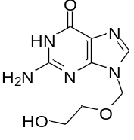
Gabapentin | Anticonvulsant | 60142-96-3 | C9H17NO2 | 171.24 | 4.5 | 314 | -1.4 | 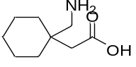
Pregabalin | Anticonvulsant | 148553-50-8 | C₈H₁₇NO₂ | 159.23 | 11 | 274 | -1.3 | 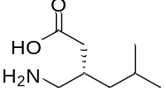
Saccharin | Sweetener | 81-07-2 | C₇H₅NO₃S | 183.18 | 4.0 | 389 | -1.3 | 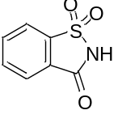
Melamine | Industrial compound | 108-78-1 | C₃H₆N₆ | 126.12 | 3.2 | 558 | -1.2 | 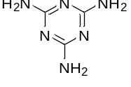
Trimethoprim | Antibiotic | 738-70-5 | C₁₄H₁₈N₄O₃ | 290.32 | 0.62 | 405 | -1.2 | 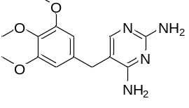
Sulfamethizole | Antibiotic | 144-82-1 | C₉H₁₀N₄O₂S₂ | 270.33 | 0.61 | 505 | -1.1 | 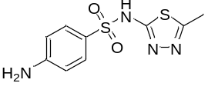
Diatrizoic acid | Iodinated contrast media | 117-96-4 | C₁₁H₉I₃N₂O₄ | 613.91 | 0.11 | 614 | -1.0 | 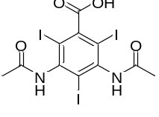
Sulfaguanidine | Antibiotic | 57-67-0 | C₇H₁₀N₄O₂S | 214.25 | 0.81 | 426 | -1.0 | 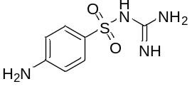
Phenytoin | Anticonvulsant | 57-41-0 | C₁₅H₁₂N₂O₂ | 252.27 | 0.07 | 464 | -1.0 | 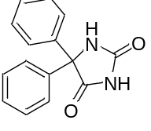
Clofibric acid | Lipid-lowering agent | 882-09-7 | C₁₀H₁₁ClO₃ | 214.64 | - | 324 | -0.9 | 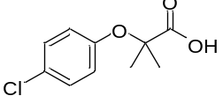
Enrofloxacin | Antibiotic | 93106-60-6 | C₁₉H₂₂FN₃O₃ | 359.40 | 0.05 | 561 | -0.9 | 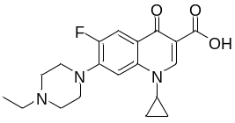
Valsartan | Antihypertensive | 137862-53-4 | C₂₄H₂₉N₅O₃ | 435.52 | 0.02 | 685 | -0.9 | 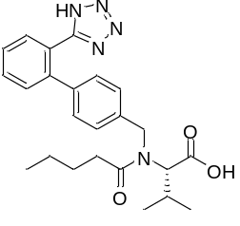
Furosemide | Antihypertensive | 54-31-9 | C₁₂H₁₁ClN₂O₅S | 330.74 | 0.07 | 582 | -0.8 | 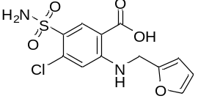
Salicylic acid | Antibacterial | 69-72-7 | C₇H₆O₃ | 138.12 | 2.24 | 336 | -0.8 | 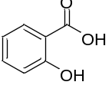
Sulfadiazine | Antibiotic | 68-35-9 | C₁₀H₁₀N₄O₂S | 250.28 | 0.6 | 513 | -0.8 | 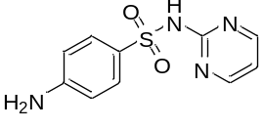
Flumequine | Antibiotic | 42835-25-6 | C₁₄H₁₂FNO₃ | 261.25 | <1.0 | 440 | -0.7 | 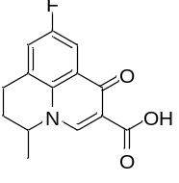
Primidone | Anticonvulsant | 125-33-7 | C₁₂H₁₄N₂O₂ | 218.25 | 1.0 | 443 | -0.7 | 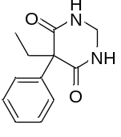
Sulfamethoxazole | Antibiotic | 723-46-6 | C₁₀H₁₁N₃O₃S | 253.28 | 0.46 | 482 | -0.6 | 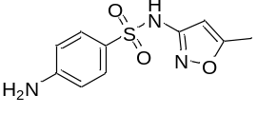
Sulfadimethoxine | Antibiotic | 122-11-2 | C₁₂H₁₄N₄O₄S | 310.33 | 0.34 | 549 | -0.5 | 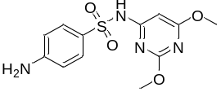
Amantadine | Antiviral | 768-94-5 | C₁₀H₁₇N | 151.14 | 6.3 | 226 | -0.4 | 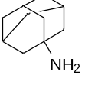
Lincomycin | Antibiotic | 154-21-2 | C₁₈H₃₄N₂O₆S | 406.54 | - | 647 | -0.4 | 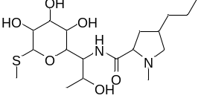
Metoprolol | β-blocker  agent | 37350-58-6 | C₁₅H₂₅NO₃ | 267.36 | >1000 | 399 | -0.3 | 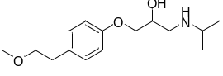
Nalidixic acid | Antibiotics | 389-08-2 | C₁₂H₁₂N₂O₃ | 232.24 | 2.3 | 413 | -0.3 | 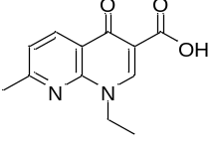
Sucralose | Sweetener | 56038-13-2 | C₁₂H₁₉Cl₃O₈ | 397.63 | >1000 | 669 | -0.2 | 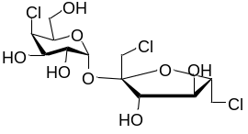
Morphine | Analgesic | 57-27-2 | C₁₇H₁₉NO₃ | 285.34 | 10 | 476 | -0.1 | 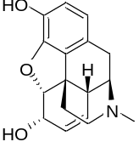
Bezafibrate | Lipid-lowering agent | 41859-67-0 | C₁₉H₂₀ClNO₄ | 361.82 | 2*10⁻³ | 572 | -0.1 | 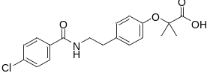
Hydrochlorothiazide | Antihypertensive | 58-93-5 | C₇H₈ClN₃O₄S₂ | 297.74 | 0.72 | 577 | 0.0 | 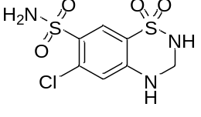
Sulfathiazole | Antibiotic | 72-14-0 | C₉H₉N₃O₂S₂ | 255.32 | 0.37 | 480 | 0.0 | 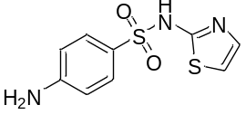
Sulfamerazine | Antibiotic | 127-79-7 | C₁₁H₁₂N₄O₂S | 264.30 | 0.20 | 519 | 0.0 | 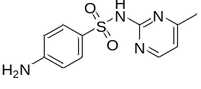
Metronidazole | Antibacterial | 443-48-1 | C₆H₉N₃O₃ | 171.15 | 5.9 | 405 | 0.1 | 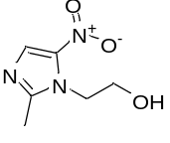
Ketoprofen | NSAID | 22071-15-4 | C₁₆H₁₄O₃ | 254.28 | 0.02 | 431 | 0.1 | 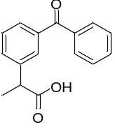
Cotinine | Stimulant | 486-56-6 | C₁₀H₁₂N₂O | 176.22 | - | 329 | 0.2 | 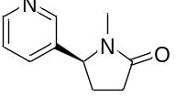
Sulfamethazine | Antibiotics | 57-68-1 | C₁₂H₁₄N₄O₂S | 278.33 | 0.23 | 526 | 0.2 | 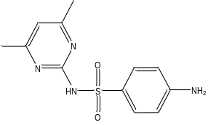
Hyoscine | Anticholinergic | 149-64-4 | C₂₁H₂₉NO₄ | 359.46 | 100 | 460 | 0.3 | 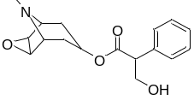
Caffeine | Stimulant | 58-08-2 | C₈H₁₀N₄O₂ | 194.19 | 22 | 417 | 0.3 | 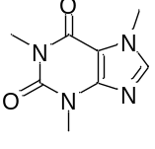
Codeine | Analgesic | 76-57-3 | C₁₈H₂₁NO₃ | 299.36 | 0.58 | 462 | 0.3 | 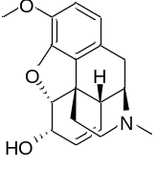
Warfarin | Anticoagulant | 81-81-2 | C₁₉H₁₆O₄ | 308.30 | 0.02 | 515 | 0.3 | 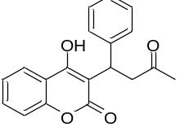
Sulfapyridine | Antibiotic | 144-83-2 | C₁₁H₁₁N₃O₂S | 249.29 | 0.27 | 474 | 0.4 | 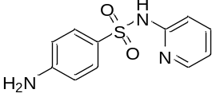
Florfenicol | Antibiotic | 73231-34-2 | C₁₂H₁₄C_{l2}FNO₄S | 358.21 | - | - | 0.4 | 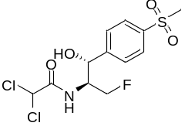
Acetaminophen | Analgesic | 103-90-2 | C₈H₉NO₂ | 151.16 | 14 | 388 | 0.4 | 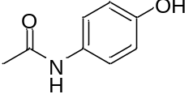
Furazolidone | Antibiotics | 67-45-8 | C₈H₇N₃O₅ | 225.16 | 0.36 | 353 | 0.4 | 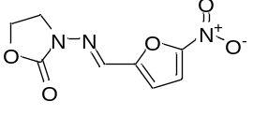
Naproxen | NSAID | 22204-53-1 | C₁₄H₁₄O₃ | 230.26 | 0.02 | 404 | 0.5 | 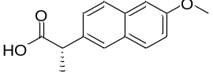
Zonisamide | Anticonvulsant | 68291-97-4 | C₈H₈N₂O₃S | 212.23 | 2.1 | 457 | 0.5 | 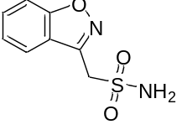
Ibuprofen | NSAID | 15687-27-1 | C₁₃H₁₈O₂ | 206.28 | 0.02 | 320 | 0.5 | 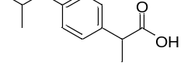
Tramadol | Analgesic | 3715-90-0 | C₁₃H₁₈ClN₃ | 251.75 | 0.75 | 388 | 0.5 | 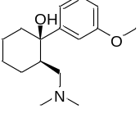
Oseltamivir | Antiviral | 196618-13-0 | C₁₆H₂₈N₂O₄ | 312.40 | 0.69 | 473 | 0.6 | 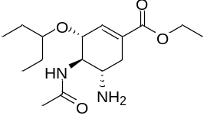
Neotame | Sweetener | 165450-17-9 | C₂₀H₃₀N₂O₅ | 378.46 | 0.01 | 572 | 0.6 | 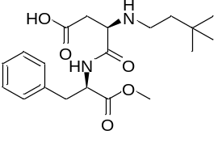
Fluconazole | Antifugals | 86386-73-4 | C₁₃H₁₂F₂N₆O | 306.27 | 1.4 | 580 | 0.7 | 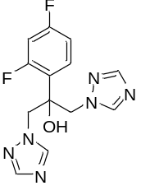
Indomethacin | NSAID | 53-86-1 | C₁₉H₁₆ClNO₄ | 357.79 | 0.9*10⁻³ | 499 | 0.8 | 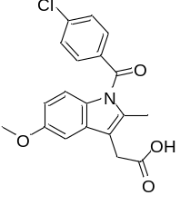
Rosuvastatin | NSAID | 287714-41-4 | C₂₂H₂₈FN₃O₆S | 481.54 | 0.09 | 746 | 1.0 | 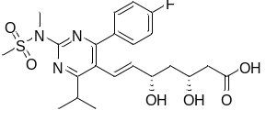
Chloramphenicol | Antibiotic | 56-75-7 | C₁₁H₁₂Cl₂N₂O₅ | 323.13 | 2.5 | 645 | 1.0 | 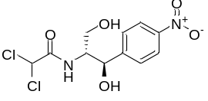
Methenamine | Antibacterial | 100-97-0 | C₆H₁₂N₄ | 140.19 | 449 | 253 | 1.0 | 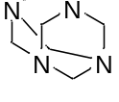
Sitagliptin | Diabetes type 2 treatment | 486460-32-6 | C₁₆H₁₅F₆N₅O | 407.31 | 0.03 | 530 | 1.1 | 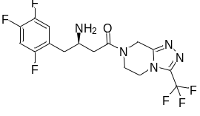
Carazolol | β-blocker  agent | 57775-29-8 | C₁₈H₂₂N₂O₂ | 298.38 | 0.01 | 469 | 1.1 | 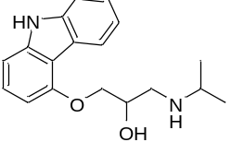
Propranolol | β-blocker  agent | 525-66-6 | C₁₆H₂₁NO₂ | 259.34 | 0.06 | 435 | 1.2 | 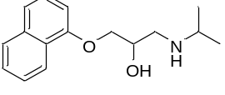
Cocaine | Stimulant | 50-36-2 | C₁₇H₂₁NO₄ | 303.35 | 1.8 | 395 | 1.2 | 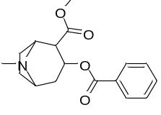
Irbesartan | Antihypertensive | 138402-11-6 | C₂₅H₂₈N₆O | 428.53 | 0.01 | 649 | 1.2 | 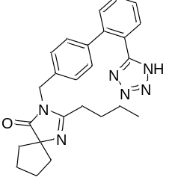
Atorvastatin | Lipid-lowering agent | 134523-00-5 | C₃₃H₃₅FN₂O₅ | 558.60 | <1 | 722 | 1.3 | 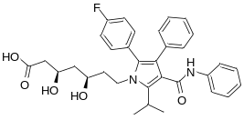
Citalopram | Antidepressant | 59729-33-8 | C₂₀H₂₁FN₂O | 324.16 | 0.02 | 352 | 1.3 | 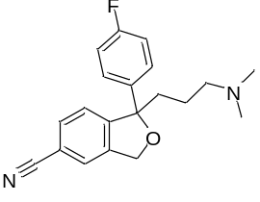
Lidocaine | Anesthetic | 137-58-6 | C₁₄H₂₂N₂O | 234.34 | 0.59 | 373 | 1.3 | 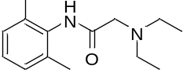
Azithromycin | Antibiotic | 83905-01-5 | C₃₈H₇₂N₂O₁₂ | 748.98 | - | 822 | 1.4 | 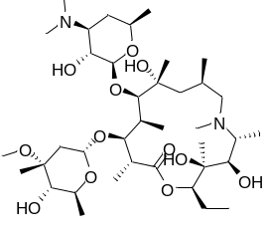
Venlafaxine | Antidepressant | 93413-69-5 | C₁₇H₂₇NO₂ | 277.40 | 572 | 398 | 1.4 | 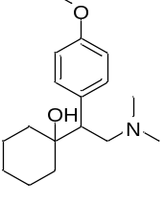
Diclofenac | NSAID | 15307-86-5 | C₁₄H₁₁Cl₂NO₂ | 296.15 | 2.3*10⁻³ | 412 | 1.4 | 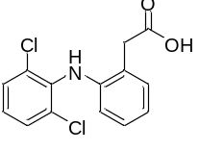
2.2'.4.4'-Tetrahydroxybenzophenone (BP2) | UV-Filter | 131-55-5 | C₁₃H₁₀O₅ | 246.22 | 0.01 | 559 | 1.4 | 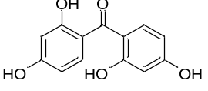
1H-Benzotriazole | Industrial compound | 95-14-7 | C₆H₅N₃ | 119.12 | 20 | 359 | 1.5 | 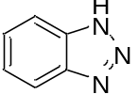
Oxazepam | Antidepressant | 604-75-1 | C₁₅H₁₁N₂O₂Cl | 286.71 | 0.02 | 517 | 1.5 | 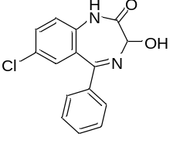
Paroxetine | Antidepressant | 61869-08-7 | C₁₉H₂₀FNO₃ | 329.37 | 1.1*10⁻³ | 452 | 1.5 | 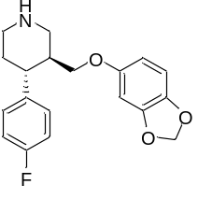
Gemfibrozil | Lipid-lowering drug | 25812-30-0 | C₁₅H₂₂O₃ | 250.33 | 0.03 | 395 | 1.6 | 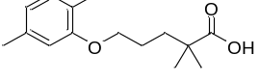
Erythromycin | Antibiotic | 114-07-8 | C₃₇H₆₇NO₁₃ | 733.93 | 2.0 | 720 | 1.7 | 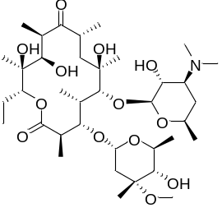
5-Methyl-1H-benzotriazole | Industrial compound | 136-85-6 | C₇H₇N₃ | 133.15 | 3.1 | 211 | 1.7 | 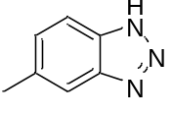
Lamotrigine | Antidepressant | 84057-84-1 | C₉H₇Cl₂N₅ | 256.09 | 0.17 | 503 | 1.7 | 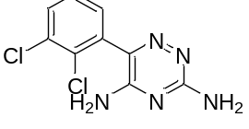
Carisoprodol | Muscle relaxant | 78-44-4 | C₁₂H₂₄N₂O₄ | 260.33 | 0.30 | 423 | 1.9 | 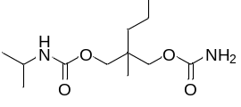
Pentobarbital | Sedative | 76-74-4 | C₁₁H₁₈N₂O₃ | 226.28 | 0.68 | - | 1.9 | 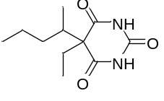
Lorazepam | Anxiolytic | 846-49-1 | C₁₅H₁₀Cl₂N₂O₂ | 321.20 | 0.08 | 534 | 1.9 | 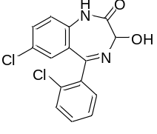
Hydroxychloroquine | Antimalarial drug | 118-42-3 | C₁₈H₂₆ClN₃O | 335.87 | 0.03 | 517 | 2.0 | 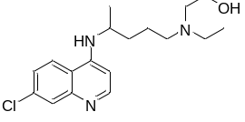
6∝-Methylprednisolone | Antiinflammatory | 83-43-2 | C₂₂H₃₀O₅ | 374.47 | 0.12 | 572 | 2.0 | 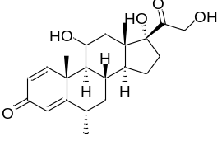
¹Log D, solubility and boiling point values were obtained from the ChemSpider database http://www.chemspider.com/.

Table S2. In situ parameters of the seven GW samples.
Site | pH | EC¹ (μS cm⁻¹) | T (⁰C) | Hardness (mg L⁻¹)
HBAV | 6.7 | 1163 | 25.0 | 305.2
DXSA | 6.9 | 1270 | 19.7 | 291.2
RBOP | 5.5 | 580 | 21.8 | 201.2
URB1 | 6.7 | 1422 | 19.7 | 375.2
SAP2b | 6.9 | 2541 | 21.3 | 537.6
DTA2 | 6.8 | 1730 | 20.1 | 479.2
FTAU | 6.6 | 1699 | 21.5 | 429.6
¹Electric conductivity.

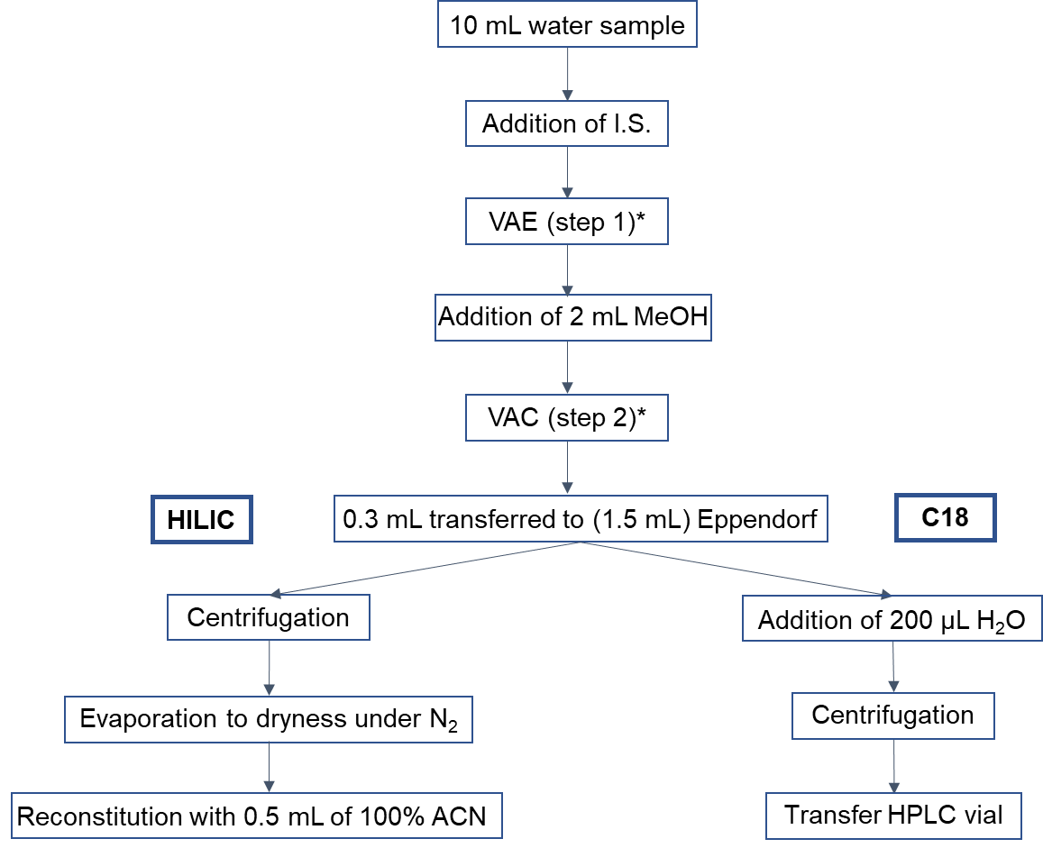
* For further information see Mechelke et al. (Mechelke et al., 2019).

Figure S1. Flow-chart for enrichment by VAE followed by HILIC (left) and C18 (right) chromatographic separation before HPLC-MS/MS analysis.

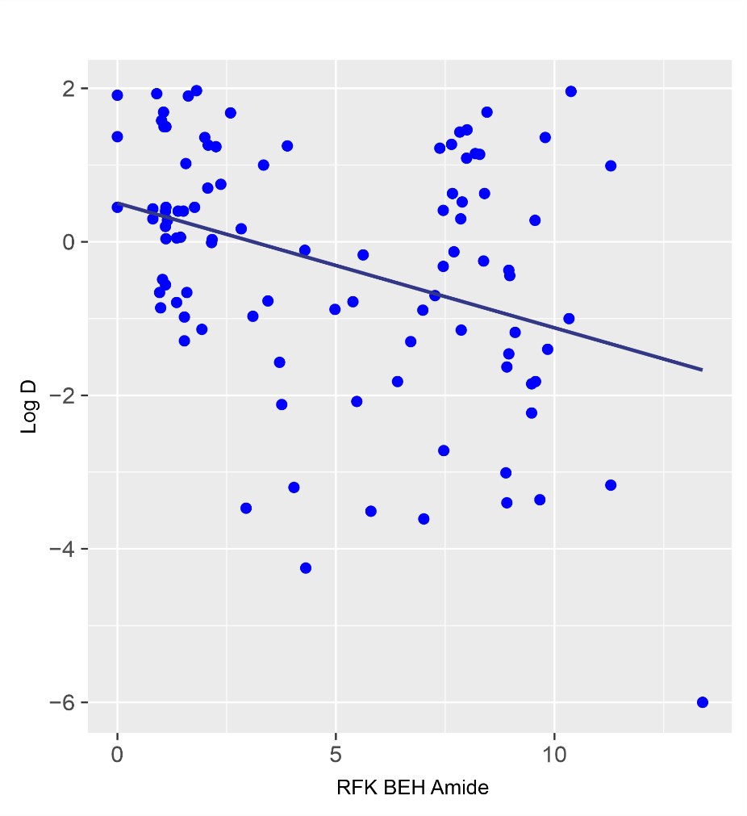
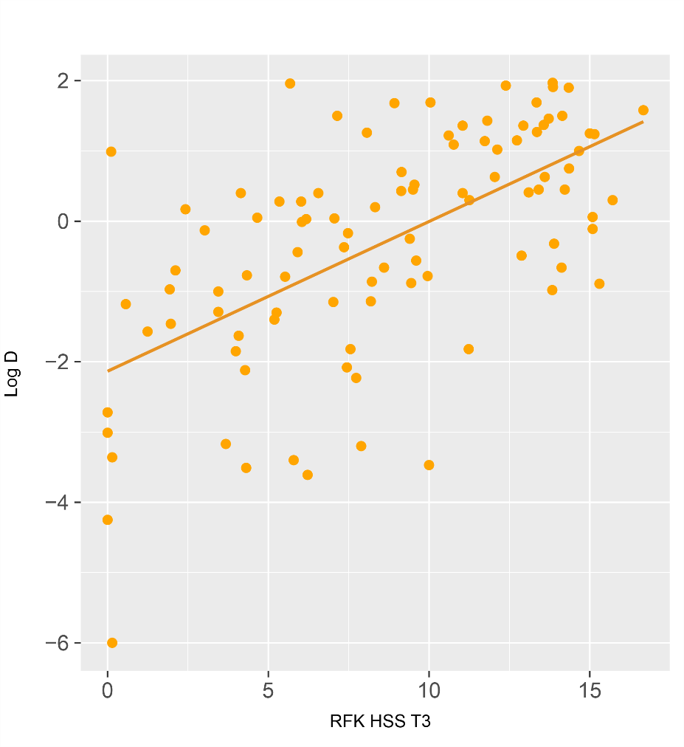
Figure S2. Retention differences between columns and compounds polarities.
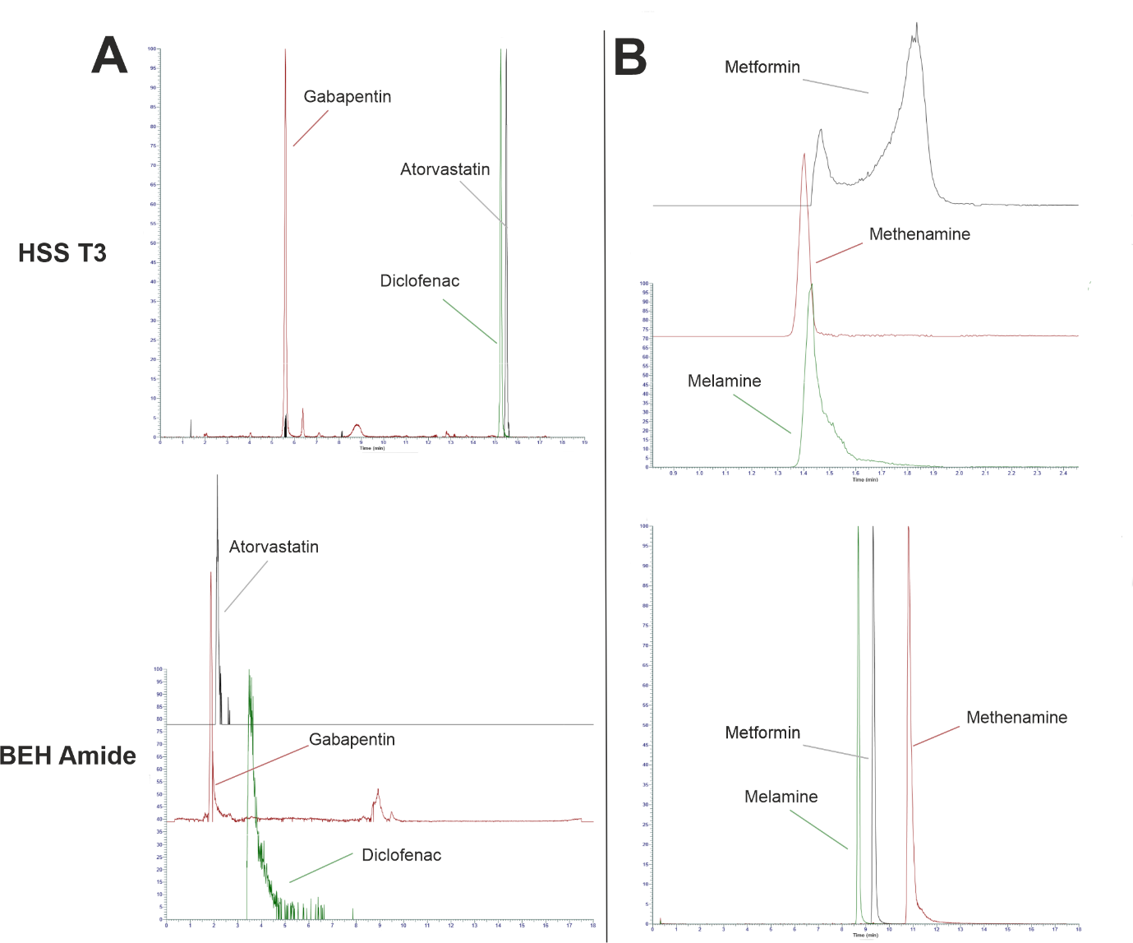

Figure S3. A: Chromatograms of diclofenac, atorvastatin and gabapentin; B: Chromatograms of melamine, metformin and methenamine. A shows great performance using the HSS T3 column (Upper) while B shows great BEH Amide column (Lower) performance for the selected compounds shown.

Table S3. Parameters of the optimised gradients.
Optimised Gradient HSS T3
Flow (mL/min) | Time (min) | Solvent A* (%) | Solvent B* (%)
0.2 | 0 | 5 | 95
0.2 | 0.3 | 5 | 95
0.2 | 10 | 30 | 70
0.2 | 13.3 | 65 | 35
0.2 | 15.5 | 100 | 0
0.2 | 17.3 | 100 | 0
0.2 | 17.7 | 5 | 95
0.2 | 19 | 5 | 95

Optimised Gradient HILIC
Flow (mL/min) | Time (min) | Solvent A** (%) | Solvent B** (%)
0.2 | 0 | 100 | 0
0.2 | 1 | 100 | 0
0.2 | 8 | 50 | 50
0.2 | 11 | 50 | 50
0.2 | 12 | 100 | 0
0.2 | 15 | 100 | 0
* A (ESI+): H₂O 5mM ammonium formate 0.1% formic acid
A (ESI-): H₂O 2mM ammonium fluoride
B (ESI+/-): 100% ACN
** A (ESI+/-): H₂O 5mM ammonium formate
B (ESI+/-): H₂O:ACN (2:98, v/v) 5mM ammonium formate

Table S4. MS parameters, chromatographic retention times (RT) and retention factors (RFK) of target compounds sorted by alphabetical order. The t₀ for the HSS T3 column was 0.90 min.
Analyte | ESI mode | Precursor (m/z) | Product Ion (m/z) | CE (eV) | RT (min) | RFK | Internal Standard
1H-Benzotriazole | + | 120.0557 | 65.0387 | 20 | 7.33 | 7.14 | Benzotriazole D4
2,2',4,4'-Tetrahydroxybenzophenone (BP2) | - | 245.0454 | 109.0294 | 19 | 12.54 | 12.93 | Irbesartan D6
5-Fluorouracil | - | 129.0106 | 85.0290 | 37 | 2.02 | 1.24 | Gabapentin D10
5-methyl-1H-benzotriazole | + | 134.0712 | 79.0542 | 25 | 9.94 | 10.04 | Cotinine D3
6αmethylprednisolone | + | 375.2162 | 357.2063 | 22 | 13.36 | 13.84 | Paroxetine D4
Acetaminophen | + | 152.0706 | 110.0602 | 20 | 4.63 | 4.14 | Acetaminophen D4
Acyclovir | - | 224.0789 | 150.0419 | 35 | 2.67 | 1.97 | Gabapentin D10
Amantadine | + | 152.1431 | 135.1167 | 15 | 7.52 | 7.36 | Aspartame D5
Amoxicillin | + | 366.1118 | 114.0008 | 12 | 3.45 | 2.83 | Cotinine D3
Aspartame | + | 295.1292 | 180.1019 | 25 | 7.70 | 7.56 | Sotalol D6
Atenolol | + | 267.1701 | 190.0861 | 25 | 4.49 | 3.99 | Propranolol D7
Atorvastatin | + | 559.2603 | 440.2248 | 38 | 14.40 | 15.00 | Climbazole D4
Azithromycin | + | 749.5146 | 591.4214 | 44 | 10.84 | 11.04 | Ciprofloxacin D8
Bezafibrate | + | 362.1147 | 316.1096 | 14 | 14.48 | 15.09 | Bezafibrate D4
Caffeine | + | 195.0877 | 138.0664 | 27 | 6.32 | 6.02 | Caffeine 13C3
Carazolol | + | 299.1754 | 116.1068 | 40 | 11.46 | 11.73 | Propranolol D7
Carisoprodol | + | 261.1805 | 62.0238 | 20 | 12.05 | 12.39 | Carisoprodol D7
Chloramphenicol | - | 321.0045 | 152.0352 | 13 | 11.81 | 12.12 | Irbesartan D6
Ciprofloxacin | + | 332.1403 | 288.1508 | 19 | 7.86 | 7.73 | Ciprofloxacin D8
Citalopram | + | 325.1706 | 109.0446 | 26 | 12.92 | 13.36 | Midazolam 13C6
Clofibric acid | - | 213.0323 | 126.9956 | 10 | 9.40 | 9.44 | Bezafibrate D4
Cocaine | + | 304.1538 | 182.1174 | 30 | 10.45 | 10.61 | Cocaine D5
Codeine | + | 300.1597 | 165.0697 | 42 | 5.71 | 5.34 | Codeine D3
Cotinine | + | 177.1021 | 80.0494 | 28 | 3.08 | 2.42 | Cotinine D3
Cyclamate | - | 178.0543 | 79.9577 | 34 | 4.78 | 4.31 | Acetaminophen D4
Diatrizoic acid | + | 631.8031 | 360.9680 | 25 | 4.00 | 3.44 | Metronidazole D4
Diclofenac | + | 296.0245 | 215.0496 | 30 | 13.11 | 13.57 | Diclofenac 13C6
Eflornithine | + | 183.0940 | 120.1000 | 25 | 0.90 | 0.00 | Cotinine D3
Enrofloxacin | + | 360.1723 | 316.1824 | 28 | 8.30 | 8.22 | Lamotrigine 13C3
Erythromycin | + | 734.4666 | 158.1174 | 29 | 12.91 | 13.34 | Ciprofloxacin D8
Florfenicol | - | 355.9927 | 119.0501 | 14 | 10.84 | 11.04 | Sulfamethoxazole 13C6
Fluconazole | - | 305.0966 | 68.0252 | 12 | 9.13 | 9.14 | Fluconazole 13C3
Flumequine | + | 262.0874 | 244.0766 | 30 | 13.61 | 14.12 | Carbamazepine D10
Furazolidone | + | 226.0458 | 95.0366 | 18 | 9.12 | 9.13 | Fluconazole 13C3
Furosemide | - | 329.0004 | 204.9823 | 30 | 9.86 | 9.96 | Valsartan D3
Gabapentin | + | 172.1337 | 154.1226 | 17 | 5.57 | 5.19 | Gabapentin D10
Gemfibrozil | - | 249.1496 | 121.0659 | 14 | 15.90 | 16.67 | Gemfibrozil D6
Hydrochlorothiazide | - | 295.9568 | 268.9457 | 29 | 6.34 | 6.04 | Hydrochlorothiazide 13CD2
Hydroxychloroquine | + | 336.1835 | 247.0996 | 30 | 6.01 | 5.68 | Chlorpromazine D3
Hyoscine | + | 360.2164 | 138.0913 | 30 | 11.03 | 11.26 | Cocaine D5
Ibuprofen | - | 205.1234 | 159.1172 | 10 | 13.70 | 14.22 | Gemfibrozil D6
Indomethacin | - | 356.0689 | 297.0560 | 30 | 13.82 | 14.36 | Indomethacin D4
Iodixanol | - | 773.8494 | 126.9042 | 50 | 6.11 | 5.79 | Sulfadiazine D4
Iohexol | + | 821.8868 | 803.8744 | 21 | 3.39 | 2.77 | Acetaminophen D4
Iopromide | + | 791.8755 | 372.9690 | 50 | 4.75 | 4.28 | Acetaminophen D4
Irbesartan | + | 429.2392 | 207.0914 | 25 | 14.53 | 15.14 | Irbesartan D6
Ketoprofen | + | 255.1012 | 105.0334 | 25 | 14.48 | 15.09 | Valsartan D3
Lamotrigine | + | 256.0151 | 172.9667 | 40 | 8.93 | 8.92 | Lamotrigine 13C3
Levofloxacin | + | 362.1511 | 216.1042 | 21 | 7.60 | 7.44 | Ofloxacin D8
Lidocaine | + | 235.1803 | 86.0963 | 18 | 8.16 | 8.07 | Lamotrigine 13C3
Lincomycin | + | 407.2206 | 126.1276 | 24 | 6.22 | 5.91 | Caffeine 13C3
Lorazepam | - | 319.0040 | 283.0274 | 19 | 13.81 | 14.34 | Lorazepam D4
Melamine | + | 127.0727 | 85.0515 | 20 | 1.41 | 0.57 | Cotinine D3
Meprobamate | + | 219.1339 | 158.1175 | 13 | 11.01 | 11.23 | Carisoprodol D7
Metformin | + | 130.1087 | 60.0559 | 15 | 1.83 | 1.03 | Lamotrigine 13C3
Methenamine | + | 141.1135 | 112.0870 | 16 | 1.00 | 0.11 | Cotinine D3
Metoprolol | + | 268.1906 | 116.1068 | 21 | 9.36 | 9.40 | Metoprolol D7
Metronidazole | + | 172.0716 | 128.0453 | 17 | 5.09 | 4.66 | Metronidazole D4
Morphine | + | 286.1436 | 201.0909 | 40 | 3.62 | 3.02 | Gabapentin D10
Nalidixic acid | + | 233.0920 | 205.0606 | 32 | 13.40 | 13.89 | Carbamazepine D10
Naproxen | - | 229.0864 | 158.0373 | 13 | 12.97 | 13.41 | Naproxen D3
Neotame | + | 379.2226 | 172.1330 | 30 | 13.14 | 13.60 | Midazolam 13C6
Oseltamivir | + | 313.2116 | 166.0861 | 18 | 11.74 | 12.04 | Oseltamivir D3
Oxazepam | + | 287.0581 | 241.0524 | 25 | 13.63 | 14.14 | Lorazepam D4
Oxytetracycline | + | 461.1555 | 426.1183 | 25 | 7.40 | 7.22 | Ofloxacin D8
Paroxetine | + | 330.1502 | 192.1183 | 33 | 13.25 | 13.72 | Paroxetine D4
Pentobarbital | - | 225.1242 | 122.0975 | 60 | 13.37 | 13.86 | Irbesartan D6
Phenytoin | - | 251.0821 | 102.0349 | 25 | 13.35 | 13.83 | Irbesartan D6
Pipemidic acid | + | 304.1409 | 217.1084 | 25 | 6.50 | 6.22 | Caffeine 13C3
Pregabalin | + | 160.1337 | 142.1227 | 12 | 5.63 | 5.26 | Sulfadiazine D4
Primidone | + | 219.1128 | 162.0912 | 19 | 8.64 | 8.60 | Acetaminophen D4
Propranolol | + | 260.1642 | 116.1068 | 23 | 12.36 | 12.73 | Propranolol D7
Rosuvastatin | + | 482.1755 | 258.1400 | 43 | 14.10 | 14.67 | Bezafibrate D4
Saccharin | - | 181.9917 | 61.9703 | 36 | 4.00 | 3.44 | Hydrochlorothiazide 13CD2
Salicylic acid | - | 137.0244 | 93.0350 | 16 | 4.80 | 4.33 | Acetaminophen D4
Sitagliptin | + | 408.1253 | 174.0524 | 24 | 10.59 | 10.77 | Fluconazole 13C3
Sotalol | + | 273.1265 | 213.0690 | 24 | 4.57 | 4.08 | Sotalol D6
Sucralose | - | 395.0066 | 59.0134 | 22 | 7.63 | 7.48 | Gemfibrozil D6
Sulfadiazine | + | 251.0596 | 156.0111 | 20 | 5.87 | 5.52 | Sulfadiazine D4
Sulfadimethoxine | + | 311.0801 | 156.0766 | 35 | 12.49 | 12.88 | Sulfamethoxazole 13C6
Sulfaguanidine | + | 214.0524 | 156.0115 | 41 | 2.64 | 1.93 | Valsartan D3
Sulfamerazine | + | 265.0753 | 156.0113 | 21 | 7.25 | 7.06 | Sulfamethazine D4
Sulfamethazine | + | 279.0908 | 204.0436 | 22 | 8.39 | 8.32 | Sulfamethazine D4
Sulfamethizole | + | 271.0319 | 156.0113 | 16 | 8.27 | 8.19 | Sulfamethoxazole 13C6
Sulfamethoxazole | - | 252.0445 | 156.0124 | 15 | 9.54 | 9.60 | Sulfamethoxazole 13C6
Sulfapyridine | + | 250.0644 | 156.0112 | 22 | 6.80 | 6.56 | Sulfamethoxazole 13C6
Sulfathiazole | - | 254.0062 | 156.0124 | 20 | 6.46 | 6.18 | Sulfamethoxazole 13C6
Sulisobenzone (BP4) | - | 307.0279 | 211.0398 | 34 | 9.90 | 10.00 | Sulfamethoxazole 13C6
Tetracycline | + | 445.1605 | 410.1234 | 25 | 8.00 | 7.89 | Sulfamethazine D4
Tramadol | + | 264.1956 | 58.0654 | 15 | 9.49 | 9.54 | Tramadol 13C3D3
Trimethoprim | + | 291.1450 | 230.1161 | 29 | 7.22 | 7.02 | Trimethoprim D9
Valsartan | + | 436.2332 | 207.0915 | 17 | 14.67 | 15.30 | Valsartan D3
Venlafaxine | + | 278.2113 | 58.0654 | 27 | 11.53 | 11.81 | Venlafaxine D6
Warfarin | + | 309.1117 | 163.0388 | 18 | 15.04 | 15.71 | Carbamazepine D10
Zanamivir | + | 333.1405 | 60.2418 | 22 | 1.39 | 0.54 | Cotinine D3
Zonisamide | + | 213.0325 | 150.0549 | 12 | 9.45 | 9.50 | Zonisamide 13C6

Table S5. Validation parameters of the target compounds enriched by the VAE approach at 1, 50 and 200 µg/L (n = 3), sorted by alphabetical order.
Compound | Low Level 1 µg L⁻¹ |  |  | Intermediate Level 50 µg L⁻¹ |  |  | High Level 200 µg L⁻¹
Compound | RR (%) | RSD (%) | ME (%) | RR (%) | RSD (%) | ME (%) | RR (%) | RSD (%) | ME (%)
1H-Benzotriazole | 93 | 19 | 17 | 100 | 3.0 | 5.3 | 89 | 1.8 | 8.0
2,2',4,4'-Tetrahydroxybenzophenone (BP2) | 73 | 3.1 | 518 | 138 | 42 | 34 | 89 | 15 | 101
5-Fluorouracil | 114 | 5.6 | 55 | 100 | 3.3 | 5.3 | 111 | 3.3 | 107
5-methyl-1-H-benzotriazole | 69 | 8.2 | 323 | 84 | 9.3 | 5.3 | 79 | 7.6 | -13
6αmethylprednisolone | 37 | 8.0 | 333 | 101 | 4.7 | 7.4 | 107 | 5.0 | 3.9
Acetaminophen | 99 | 4.3 | 1.2 | 103 | 0.6 | 7.8 | 104 | 1.8 | -4.8
Acyclovir | 103 | 6.0 | 68 | 108 | 3.2 | -8.6 | 108 | 3.5 | 156
Amantadine | 59 | 11 | 371 | 85 | 9.1 | 2.9 | 96 | 7.0 | -10
Amoxicillin | 0 | 0.0 | 0 | 0 | 0 | -69 | 0 | 0 | -64
Aspartame | 0 | 0.0 | 0 | 0 | 0 | -92 | 0 | 0 | -92
Atenolol | 54 | 6.1 | 209 | 107 | 4.1 | 0.9 | 106 | 7.2 | 4.1
Atorvastatin | 31 | 40 | 343 | 102 | 4.9 | 10 | 47 | 3.9 | 114
Azithromycin | 0 | 0 | 0 | 118 | 48 | 1637 | 49 | 48 | -47
Bezafibrate | 71 | 7.7 | 205 | 100 | 2.1 | 6.0 | 108 | 1.7 | -5.6
Caffeine | 8.7 | 503 | 79 | 114 | 5.8 | 4.5 | 102 | 1.2 | -0.2
Carazolol | 70 | 13 | 376 | 190 | 55 | 1128 | 92 | 0.6 | 5.2
Carisoprodol | 37 | 5.3 | 416 | 108 | 0.9 | 0.4 | 88 | 1.6 | 14
Chloramphenicol | 127 | 2.3 | 73 | 115 | 53 | 13 | 121 | 26 | 189
Ciprofloxacin | 1085 | 117 | 0 | 104 | 4.4 | 10 | 73 | 3.8 | 26
Citalopram | 47 | 17 | 665 | 100 | 4.3 | 18 | 92 | 4.5 | 49
Clofibric acid | 108 | 4.4 | 86 | 94 | 6.3 | 15 | 122 | 3.2 | 133
Cocaine | 19 | 9.3 | 1270 | 107 | 2.6 | 5.4 | 34 | 2.5 | 208
Codeine | 0 | 0.0 | 0 | 0 | 0 | 0 | 0 | 0 | 0
Cotinine | 43 | 13 | 684 | 104 | 1.4 | 5.5 | 106 | 1.0 | -5.1
Cyclamate | 78 | 11 | 109 | 106 | 1.7 | 3.5 | 110 | 6.0 | 186
Diatrizoic acid | 112 | 1.8 | 189 | 101 | 2.7 | -1.7 | 99 | 4.9 | -0.2
Diclofenac | 0 | 0.0 | 0 | 105 | 0.5 | 4.6 | 138 | 1.5 | -29
Eflornithine | 0 | 0.0 | 0 | 79 | 8.0 | -49 | 142 | 4.2 | -96
Enrofloxacin | 627 | 108 | 93 | 81 | 5.2 | 375 | 78 | 20 | 128
Erythromycin | 17 | 36 | -89 | 73 | 21 | -2.4 | 63 | 42 | -23
Florfenicol | 69 | 12 | 257 | 159 | 11 | -38 | 116 | 3.0 | 212
Fluconazole | 118 | 4.0 | 85 | 87 | 3.3 | -7.0 | 110 | 1.3 | 177
Flumequine | 120 | 72 | 412 | 113 | 3.8 | -4.0 | 102 | 0.8 | 14
Furazolidone | 60 | 6.1 | 238 | 90 | 3.1 | 6.1 | 105 | 7.1 | 2.4
Furosemide | 102 | 3.5 | 73 | 73 | 62 | -43 | 97 | 15 | 141
Gabapentin | 49 | 19 | 409 | 105 | 1.9 | 4.3 | 104 | 1.6 | -7.5
Gemfibrozil | 65 | 8.1 | 225 | 105 | 1.0 | 1.1 | 89 | 2.1 | 244
Hydrochlorothiazide | 100 | 3.9 | 101 | 88 | 6.0 | -1.6 | 103 | 1.4 | 180
Hydroxychloroquine | 2695 | 88 | 0 | 56 | 16 | 104077 | 58 | 34 | 335
Hyoscine | 39 | 9.6 | 3305 | 82 | 11 | -11 | 98 | 18 | 552
Ibuprofen | 89 | 26 | 5557 | 115 | 1.5 | 1.0 | 103 | 5.9 | 124
Indomethacin | 182 | 0.4 | 7.5 | 130 | 8.5 | -20 | 83 | 4.3 | 165
Iodixanol | 181 | 0.9 | 13 | 107 | 5.0 | 2.4 | 112 | 5.1 | 146
Iohexol | 159 | 1.9 | 42 | 99 | 6.6 | 4.5 | 94 | 5.8 | -17
Iopromide | 0 | 0.0 | 0 | 96 | 18 | -1.4 | 104 | 4.4 | -23
Irbesartan | 28 | 51 | 1832 | 107 | 0 | 2.8 | 66 | 1.1 | 51
Ketoprofen | 54 | 17 | 108 | 103 | 1.2 | -0.1 | 100 | 16 | -12
Lamotrigine | 69 | 12 | 230 | 102 | 2.5 | 1.9 | 109 | 1.1 | -6.0
Levofloxacin | 355 | 44 | 5720 | 103 | 3.2 | 0.1 | 74 | 7.9 | 24
Lidocaine | 45 | 5.9 | 182 | 105 | 12 | -76 | 102 | 2.2 | -17
Lincomycin | 51 | 14 | 211 | 92 | 5.6 | 6.5 | 103 | 3.6 | -4.2
Lorazepam | 101 | 8.6 | 82 | 97 | 15 | -0.4 | 95 | 1.5 | 224
Melamine | 112 | 0.1 | 3618 | 116 | 5.5 | 0.0 | 130 | 3.7 | 26
Meprobamate | 0 | 0.0 | 0 | 0 | 0 | 0 | 0 | 0 | 0
Metformin | 63 | 8.1 | 234 | 94 | 11 | 2.6 | 124 | 1.6 | -3.8
Methenamine | 59 | 8.6 | -91 | 112 | 4.8 | 341 | 69 | 3.4 | 2.8
Metoprolol | 53 | 3.5 | 291 | 115 | 3.3 | 8.0 | 111 | 3.1 | -7.3
Metronidazole | 97 | 8.2 | 43 | 102 | 7.3 | 1.4 | 107 | 2.0 | -4.4
Morphine | 0 | 0.0 | 0 | 0 | 0 | 0 | 0 | 0 | 0
Nalidixic Acid | 87 | 47 | 358 | 108 | 1.0 | 0.2 | 111 | 2.4 | 1.7
Naproxen | 201 | 1.1 | -7.1 | 0 | 4.1 | 0.0 | 112 | 8.2 | 84
Neotame | 0 | 0.0 | 188 | 100 | 15.5 | -69 | 25 | 25 | -19
Oseltamivir | 41 | 5.1 | 424 | 105 | 3.8 | 4.5 | 99 | 0.7 | 2.1
Oxazepam | 0 | 0.0 | 0 | 96 | 3.7 | -2.9 | 100 | 2.1 | -1.0
Oxytetracycline | 0 | 0.0 | 0 | 56 | 4.3 | -6.7 | 75 | 18 | -47
Paroxetine | 162 | 1.4 | 23 | 103 | 1.1 | 2.8 | 50 | 25 | -38
Pentobarbital | 0 | 0.0 | 0 | 105 | 5.3 | 3.1 | 106 | 4.9 | 2.9
Phenytoin | 67 | 12 | 346 | 129 | 5.6 | 12 | 115 | 29 | 194
Pipemidic acid | 600 | 102 | 68 | 101 | 5.1 | 136 | 83 | 5.2 | 46
Pregabalin | 178 | 22 | 30 | 103 | 3.2 | 6.3 | 121 | 4.5 | -15
Primidone | 0 | 0.0 | 0 | 90 | 7.7 | 5.3 | 101 | 6.3 | -18
Propranolol | 53 | 6.2 | 296 | 105 | 2.7 | 7.6 | 99 | 3.3 | 1.9
Rosuvastatin | 80 | 5.3 | 160 | 126 | 2.6 | 1.7 | 111 | 2.9 | 0.9
Saccharin | 93 | 5.7 | 279 | 110 | 4.2 | 4.2 | 101 | 2.6 | 183
Salicylic acid | 83 | 3.9 | 347 | 107 | 0.9 | 15 | 108 | 5.7 | 195
Sitagliptin | 68 | 8.4 | 162 | 106 | 3.4 | 1.6 | 104 | 1.4 | -10
Sotalol | 58 | 2.3 | 252 | 105 | 3.2 | 1.8 | 103 | 0.5 | -4.2
Sucralose | 186 | 1.8 | 160 | 91 | 7.0 | 8.4 | 124 | 7.9 | 82
Sulfadiazine | 63 | 1.7 | 223 | 104 | 5.4 | 1.8 | 111 | 1.8 | -7.9
Sulfadimethoxine | 59 | 3.1 | 368 | 101 | 5.8 | 17 | 120 | 0.8 | -6.0
Sulfaguanidine | 0 | 0.0 | 0 | 0 | 0 | 0 | 0 | 0 | 0
Sulfamerazine | 66 | 3.5 | 184 | 107 | 6.4 | 2.0 | 102 | 5.3 | -5.8
Sulfamethazine | 51 | 11 | 295 | 137 | 9.3 | 48 | 109 | 3.2 | -2.3
Sulfamethizole | 43 | 17 | 217 | 102 | 6.6 | 10 | 116 | 6.0 | -8.9
Sulfamethoxazole | 63 | 4.6 | 168 | 107 | 1.5 | 1.8 | 111 | 7.5 | 179
Sulfapyridine | 59 | 7.6 | 308 | 100 | 4.0 | 5.4 | 107 | 12 | -2.2
Sulfathiazole | 75 | 13 | 138 | 111 | 5.2 | 2.2 | 109 | 3.0 | 210
Sulisobenzone (BP4) | 97 | 1.9 | 121 | 91 | 10 | 13 | 114 | 2.1 | 214
Tetracycline | 0 | 0.0 | 0 | 26 | 14 | -31 | 42 | 30 | -25
Tramadol | 30 | 26 | 687 | 109 | 2.8 | 5.6 | 112 | 4.2 | -9.4
Trimethoprim | 55 | 3.9 | 257 | 105 | 2.8 | 4.7 | 119 | 3.3 | -4.2
Valsartan | 82 | 13 | 365 | 105 | 0.9 | 3.3 | 93 | 1.9 | 11
Venlafaxine | 46 | 5.9 | 361 | 103 | 4.9 | 7.3 | 105 | 1.6 | -5.0
Warfarin | 40 | 15 | 536 | 110 | 1.8 | -1.8 | 109 | 3.3 | 5.6
Zanamivir | 0 | 0.0 | 0 | 103 | 2.8 | -3.5 | 92 | 12 | -94
Zonisamide | 0 | 0.0 | 0 | 103 | 2.8 | -3.5 | 118 | 3.1 | -17

Table S6. Sample location in coordinates.
Sample name | Latitude (UTM) | Longitude (UTM)
SAP2bis | 41.42999 | 2.215175
HBAV | 41.45036842 | 2.19982326
DXSA | 41.44558850 | 2.20261138
RBOP | 41.43877969 | 2.20583093
URB1 | 41.43283058 | 2.20366017
DTA2 | 41.42092226 | 2.21613223
FTAU | 41.41963968 | 2.22703186

Table S7. Limits of detection (LOD) and quantification (LOQ) of the target analytes, sorted by alphabetical order.
Compounds | LOD (ng L⁻¹) | LOQ (ng L⁻¹)
1H-Benzotriazole | 0.07 | 0.21
2,2',4,4'-Tetrahydroxybenzophenone (BP2) | 0.16 | 0.50
5-Fluorouracil | 0.45 | 1.34
5-methyl-1-H-benzotriazole | 0.12 | 0.37
6α-methylprednisolone | 0.14 | 0.43
Acetaminophen | 0.16 | 0.49
Acyclovir | 0.16 | 0.48
Amantadine | 0.15 | 0.45
Amoxicillin | 0.00 | 0.00
Aspartame | 0.10 | 0.30
Atenolol | 0.03 | 0.09
Atorvastatin | 0.16 | 0.47
Azithromycin | 0.15 | 0.44
Bezafibrate | 0.13 | 0.40
Caffeine | 0.16 | 0.47
Carazolol | 0.07 | 0.21
Carisoprodol | 0.12 | 0.37
Chloramphenicol | 0.07 | 0.20
Ciprofloxacin | 0.16 | 0.48
Citalopram | 0.14 | 0.41
Clofibric acid | 0.17 | 0.49
Cocaine | 0.12 | 0.36
Codeine | 0.14 | 0.43
Cotinine | 0.09 | 0.26
Cyclamate | 0.09 | 0.27
Diatrizoic acid | 0.31 | 0.92
Diclofenac | 0.10 | 0.29
Eflornithine | 0.44 | 1.20
Enrofloxacin | 0.09 | 0.26
Erythromycin | 0.27 | 0.82
Florfenicol | 0.10 | 0.31
Fluconazole | 0.13 | 0.38
Flumequine | 0.13 | 0.39
Furazolidone | 0.11 | 0.35
Furosemide | 0.10 | 0.29
Gabapentin | 0.09 | 0.28
Gemfibrozil | 0.11 | 0.32
Hydrochlorothiazide | 0.11 | 0.33
Hydroxychloroquine | 0.15 | 0.44
Hyoscine | 0.13 | 0.40
Ibuprofen | 0.26 | 0.77
Indomethacin | 0.06 | 0.19
Iodixanol | 0.11 | 0.32
Iohexol | 0.22 | 0.67
Iopromide | 0.23 | 0.72
Irbesartan | 0.12 | 0.35
Ketoprofen | 0.13 | 0.38
Lamotrigine | 0.11 | 0.33
Levofloxacin | 0.10 | 0.30
Lidocaine | 0.11 | 0.33
Lincomycin | 0.13 | 0.39
Lorazepam | 0.14 | 0.42
Melamine | 0.34 | 1.00
Meprobamate | 0.08 | 0.23
Metformin | 0.29 | 0.86
Methenamine | 0.17 | 0.50
Metoprolol | 0.10 | 0.31
Metronidazole | 0.14 | 0.43
Morphine | 0.11 | 0.33
Nadixilic Acid | 0.14 | 0.42
Naproxen | 0.11 | 0.32
Neotame | 0.14 | 0.42
Oseltamivir | 0.09 | 0.28
Oxazepam | 0.13 | 0.40
Oxytetracycline | 0.12 | 0.36
Paroxetine | 0.15 | 0.44
Pentobarbital | 0.13 | 0.39
Phenytoin | 0.13 | 0.39
Pipemidic acid | 0.19 | 0.58
Pregabalin | 0.16 | 0.49
Primidone | 0.04 | 0.12
Propranolol | 0.15 | 0.46
Rosuvastatin | 0.14 | 0.43
Saccharin | 0.14 | 0.41
Salicylic acid | 0.41 | 1.23
Sitagliptin | 0.16 | 0.49
Sotalol | 0.14 | 0.42
Sucralose | 0.12 | 0.36
Sulfadiazine | 0.12 | 0.36
Sulfadimethoxine | 0.06 | 0.17
Sulfaguanidine | 0.17 | 0.52
Sulfamerazine | 0.09 | 0.26
Sulfamethazine | 0.10 | 0.29
Sulfamethizole | 0.16 | 0.48
Sulfamethoxazole | 0.11 | 0.32
Sulfapyridine | 0.12 | 0.37
Sulfathiazole | 0.13 | 0.40
Sulisobenzone (BP4) | 0.06 | 0.18
Tetracycline | 0.40 | 1.19
Tramadol | 0.11 | 0.33
Trimethoprim | 0.11 | 0.35
Valsartan | 0.10 | 0.29
Venlafaxine | 0.10 | 0.30
Warfarin | 0.15 | 0.45
Zanamivir | 0.22 | 0.65
Zonisamide | 0.28 | 0.84

Table S8. Results of the seven wells samples studied sorted by Log D (pH 7.4). The concentration values shown are in ng L⁻¹.
Compounds | SAP2bis | HBAV | DXSA | RBOP | URB1 | DTA2 | FTAU
1H-Benzotriazole | 1100 | 326 | 275 | <LOQ | 207 | 124 | 95.1
2,2',4,4'-Tetrahydroxybenzophenone (BP2) | <LOQ | <LOQ | N/F | N/F | N/F | N/F | N/F
5-Fluorouracil | N/F | N/F | N/F | N/F | N/F | N/F | N/F
5-Methylbenzotriazole | 2122 | 768 | 602 | 5.5 | 427 | 137 | 142
6α-Methylprednisolone | 86.6 | <LOQ | <LOQ | N/F | N/F | <LOQ | <LOQ
Acetaminophen | N/F | N/F | N/F | N/F | N/F | N/F | N/F
Acyclovir | N/F | N/F | N/F | N/F | N/F | N/F | N/F
Amantadine | 99.0 | 113 | 124 | <LOQ | 15.0 | 6.5 | 5.4
Atenolol | 3.7 | 0.1 | <LOQ | <LOQ | 0.1 | 0.1 | N/F
Atorvastatin | N/F | N/F | N/F | N/F | N/F | N/F | N/F
Azithromycin | N/F | N/F | N/F | N/F | N/F | N/F | N/F
Bezafibrate | 1.6 | N/F | N/F | N/F | 8.7 | <LOQ | N/F
Caffeine | <LOQ | <LOQ | <LOQ | <LOQ | <LOQ | <LOQ | <LOQ
Carazolol | N/F | N/F | N/F | N/F | N/F | N/F | N/F
Carisoprodol | N/F | N/F | N/F | N/F | N/F | N/F | N/F
Chloramphenicol | N/F | N/F | N/F | N/F | N/F | N/F | N/F
Ciprofloxacin | <LOQ | 5.1 | 2.1 | 0.5 | 7.0 | <LOQ | 0.7
Citalopram | N/F | N/F | N/F | N/F | N/F | N/F | N/F
Clofibric acid | N/F | <LOQ | N/F | N/F | <LOQ | <LOQ | N/F
Cocaine | <LOQ | <LOQ | <LOQ | <LOQ | <LOQ | N/F | <LOQ
Cotinine | 13.8 | <LOQ | 2.0 | <LOQ | 0.2 | <LOQ | <LOQ
Cyclamate | N/F | N/F | N/F | N/F | N/F | N/F | N/F
Diatrizoic acid | N/F | 0.5 | N/F | 0.9 | N/F | N/F | N/F
Diclofenac | 13.5 | 23.2 | 25.6 | N/F | N/F | N/F | N/F
Eflornithine | N/F | N/F | N/F | N/F | N/F | N/F | N/F
Enrofloxacin | <LOQ | 4.4 | 1.8 | 0.8 | 4.6 | 0.4 | 0.8
Erythromycin | N/F | N/F | <LOQ | N/F | <LOQ | <LOQ | 20.9
Florfenicol | N/F | 6.1 | 1.4 | N/F | N/F | N/F | N/F
Fluconazole | 108 | 46.1 | 49.2 | 4.2 | 28.6 | 5.6 | 6.3
Flumenquine | N/F | <LOQ | <LOQ | N/F | N/F | <LOQ | <LOQ
Furazolidone | N/F | N/F | N/F | N/F | N/F | N/F | N/F
Furosemide | 3.292 | N/F | N/F | N/F | N/F | N/F | N/F
Gabapentin | <LOQ | <LOQ | N/F | N/F | N/F | N/F | N/F
Gemfibrozil | 3.404 | <LOQ | N/F | N/F | N/F | N/F | N/F
Hydrochlorothiazide | 1179 | 104 | 133 | 29.2 | 44.4 | 2.3 | 35.9
Hydroxychloroquine | N/F | N/F | N/F | <LOQ | N/F | N/F | N/F
Hyoscine | <LOQ | N/F | N/F | N/F | N/F | N/F | N/F
Ibuprofen | N/F | N/F | N/F | <LOQ | N/F | N/F | N/F
Indomethacin | N/F | N/F | N/F | N/F | N/F | N/F | N/F
Iodixanol | N/F | N/F | N/F | N/F | N/F | N/F | N/F
Iohexol | N/F | N/F | 4148 | 576 | N/F | N/F | N/F
Iopromide | N/F | N/F | N/F | N/F | N/F | N/F | N/F
Irbersartan | 104 | 7.9 | 8.9 | N/F | N/F | N/F | N/F
Ketoprofen | 104 | <LOQ | <LOQ | <LOQ | <LOQ | <LOQ | <LOQ
Lamotrigine | 784 | 276 | 296 | 23.0 | 146 | 14.1 | 17.6
Levofloxacin | <LOQ | 2.8 | 1.1 | 0.3 | 3.7 | <LOQ | 0.3
Lidocaine | 965 | 56.5 | 61.7 | <LOQ | 12.3 | 15.8 | 16.6
Lincomycin | 36.0 | 88.0 | N/F | N/F | N/F | N/F | N/F
Lorazepam | 72.9 | <LOQ | 1.8 | N/F | N/F | N/F | N/F
Melamine | <LOQ | 53.1 | 40.8 | 2.3 | 53.7 | 5.6 | 5.2
Metformin | <LOQ | N/F | <LOQ | N/F | N/F | N/F | N/F
Methenamine | <LOQ | N/F | N/F | N/F | N/F | N/F | N/F
Metoprolol | 109 | 12.2 | 23.1 | N/F | 16.5 | 2.1 | 1.4
Metronidazole | N/F | N/F | N/F | <LOQ | N/F | N/F | N/F
Nalidixic acid | 1.3 | N/F | 0.1 | <LOQ | 0.2 | 0.1 | 0.1
Neotame | N/F | N/F | N/F | N/F | N/F | N/F | N/F
Oseltamivir | N/F | N/F | N/F | N/F | N/F | N/F | N/F
Oxazepam | 58.6 | 1.1 | 1.7 | N/F | N/F | N/F | N/F
Oxytetracycline | N/F | N/F | N/F | N/F | N/F | N/F | N/F
Paroxetine | N/F | N/F | N/F | N/F | N/F | N/F | N/F
Pentobarbital | 18.0 | 1.4 | 2.6 | N/F | 1.4 | 3.8 | 4.7
Phenytoin | 95.8 | 5.6 | 16.7 | 0.8 | 3.7 | 5.3 | 7.1
Pipemidic acid | N/F | 6.9 | 3.1 | 1.2 | 9.8 | 0.5 | 1.3
Pregabalin | <LOQ | <LOQ | <LOQ | N/F | <LOQ | <LOQ | <LOQ
Primidone | <LOQ | <LOQ | <LOQ | <LOQ | <LOQ | <LOQ | <LOQ
Propranolol | 9.8 | N/F | N/F | N/F | N/F | N/F | N/F
Rosuvastatin | N/F | N/F | N/F | N/F | N/F | N/F | N/F
Saccharin | 16.7 | N/F | <LOQ | <LOQ | <LOQ | N/F | <LOQ
Salicylic acid | N/F | N/F | N/F | N/F | N/F | N/F | N/F
Sitagliptin | N/F | N/F | N/F | N/F | N/F | N/F | N/F
Sotalol | 24.6 | 2.2 | 4.3 | N/F | N/F | N/F | N/F
Sucralose | 34099 | N/F | 9021 | 666 | 3775 | 1342 | 1626
Sulfadiazine | 81.6 | 11.4 | 11.9 | <LOQ | 2.4 | 6.5 | 5.7
Sulfadimethoxine | N/F | 0.7 | N/F | N/F | 0.8 | <LOQ | N/F
Sulfamerazine | <LOQ | 0.1 | 0.3 | <LOQ | 0.3 | 2.3 | 1.5
Sulfamethazine | 37.6 | 13.3 | 7.8 | N/F | 4.1 | 5.9 | 4.5
Sulfamethizole | N/F | 0.4 | N/F | 0.2 | 0.4 | 0.7 | 0.4
Sulfamethoxazole | <LOQ | 15.0 | <LOQ | <LOQ | 8.3 | <LOQ | <LOQ
Sulfapyridine | 42.3 | 21.0 | 11.0 | 0.7 | 2.7 | 1.3 | 0.5
Sulfathiazole | 99.3 | 3.3 | 2.7 | N/F | N/F | N/F | <LOQ
Sulisobenzone (BP4) | N/F | N/F | N/F | N/F | N/F | N/F | N/F
Tetracycline | N/F | <LOQ | N/F | N/F | <LOQ | N/F | N/F
Tramadol | 30.0 | 49.3 | 28.3 | 0.1 | 4.3 | 1.1 | 0.5
Trimethoprim | N/F | N/F | 1.9 | 0.1 | 0.8 | <LOQ | 0.1
Valsartan | 1266 | 10.4 | 24.4 | N/F | 2.1 | 3.0 | N/F
Venlafaxine | <LOQ | 0.1 | <LOQ | <LOQ | 0.1 | <LOQ | <LOQ
Warfarin | <LOQ | <LOQ | <LOQ | N/F | 13.5 | <LOQ | <LOQ
Zanamivir | N/F | N/F | N/F | N/F | N/F | N/F | N/F
Zonisamide | N/F | N/F | N/F | N/F | N/F | N/F | N/F

Table S9. Quality Score for each compound in both columns, sorted by log D.
Compound | QS HSST3 | QS BEH Amide | Log D (pH 7.4)
Zanamivir | 5 | 10 | -6,0
Oxytetracycline | 0 | 10 | -4,3
Pipemidic acid | 10 | 10 | -3,6
Cyclamate | 7 | 10 | -3,5
Sulisobenzone (BP4) | 10 | 10 | -3,5
Iodixanol | 7 | 7 | -3,4
Metformin | 2 | 10 | -3,4
Tetracycline | 10 | 10 | -3,2
Iohexol | 7 | 7 | -3,2
Eflornithine | 0 | 10 | -3,0
Amoxicillin | 0 | 10 | -2,7
Ciprofloxacin | 10 | 10 | -2,2
Iopromide | 4 | 7 | -2,1
Levofloxacin | 7 | 9 | -2,1
Atenolol | 10 | 10 | -1,9
Aspartame | 4 | 7 | -1,8
Meprobamate | 10 | 7 | -1,8
Sotalol | 10 | 10 | -1,6
5-Fluorouracil | 9 | 10 | -1,6
Acyclovir | 9 | 4 | -1,5
Gabapentin | 10 | 3 | -1,4
Pregabalin | 10 | 4 | -1,3
Saccharin | 10 | 9 | -1,3
Melamine | 5 | 10 | -1,2
Trimethoprim | 10 | 10 | -1,2
Sulfamethizole | 10 | 6 | -1,1
Diatrizoic acid | 7 | 4 | -1,0
Phenytoin | 10 | 9 | -1,0
Sulfaguanidine | 9 | 10 | -1,0
Valsartan | 10 | 4 | -0,9
Clofibric acid | 7 | 10 | -0,9
Enrofloxacin | 10 | 8 | -0,9
Sulfadiazine | 10 | 6 | -0,8
Furosemide | 10 | 10 | -0,8
Salicylic acid | 10 | 10 | -0,8
Flumequine | 10 | 8 | -0,7
Primidone | 7 | 3 | -0,7
Sulfamethoxazole | 10 | 8 | -0,6
Sulfadimethoxine | 10 | 8 | -0,5
Lincomycin | 4 | 7 | -0,4
Amantadine | 10 | 10 | -0,4
Nalidixic acid | 10 | 10 | -0,3
Metoprolol | 4 | 10 | -0,3
Sucralose | 10 | 4 | -0,2
Morphine | 10 | 4 | -0,1
Bezafibrate | 10 | 4 | -0,1
Hydrochlorothiazide | 10 | 9 | 0,0
Sulfathiazole | 10 | 9 | 0,0
Sulfamerazine | 10 | 9 | 0,0
Metronidazole | 10 | 9 | 0,1
Ketoprofen | 7 | 3 | 0,1
Cotinine | 10 | 10 | 0,2
Sulfamethazine | 10 | 9 | 0,2
Caffeine | 10 | 3 | 0,3
Codeine | 10 | 7 | 0,3
Hyoscine | 10 | 10 | 0,3
Warfarin | 10 | 5 | 0,3
Acetaminophen | 10 | 3 | 0,4
Florfenicol | 10 | 9 | 0,4
Sulfapyridine | 10 | 9 | 0,4
Furazolidone | 10 | 2 | 0,4
Ibuprofen | 10 | 6 | 0,5
Naproxen | 7 | 3 | 0,5
Zonisamide | 7 | 0 | 0,5
Tramadol | 10 | 10 | 0,5
Neotame | 10 | 4 | 0,6
Oseltamivir | 10 | 7 | 0,6
Fluconazole | 10 | 9 | 0,7
Indomethacin | 10 | 3 | 0,8
Methenamine | 5 | 7 | 1,0
Rosuvastatin | 10 | 4 | 1,0
Chloramphenicol | 10 | 9 | 1,0
Sitagliptin | 10 | 4 | 1,1
Carazolol | 10 | 10 | 1,1
Propranolol | 10 | 10 | 1,2
Cocaine | 10 | 10 | 1,2
Irbesartan | 10 | 10 | 1,2
Atorvastatin | 10 | 4 | 1,3
Lidocaine | 10 | 9 | 1,3
Citalopram | 10 | 10 | 1,3
2.2'.4.4'-Tetrahydroxybenzophenone (BP2) | 10 | 9 | 1,4
Azithromycin | 10 | 4 | 1,4
Diclofenac | 10 | 1 | 1,4
Venlafaxine | 10 | 10 | 1,4
Paroxetine | 10 | 10 | 1,5
1H-Benzotriazole | 10 | 9 | 1,5
Oxazepam | 10 | 6 | 1,5
Gemfibrozil | 10 | 8 | 1,6
Lamotrigine | 10 | 10 | 1,7
5-Methyl-1H-benzotriazole | 10 | 9 | 1,7
Erythromycin | 10 | 4 | 1,7
Lorazepam | 10 | 9 | 1,9
Pentobarbital | 10 | 8 | 1,9
Carisoprodol | 10 | 5 | 1,9
Hydroxychloroquine | 10 | 7 | 2,0
6∝-Methylprednisolone | 10 | 6 | 2,0

References
Mechelke, J., Longrée, P., Singer, H., & Hollender, J. (2019). Vacuum-assisted evaporative concentration combined with LC-HRMS/MS for ultra-trace-level screening of organic micropollutants in environmental water samples. Analytical and Bioanalytical Chemistry, 411(12), 2555–2567. https://doi.org/10.1007/S00216-019-01696-3/

