Electronic Supporting Information (ESI)

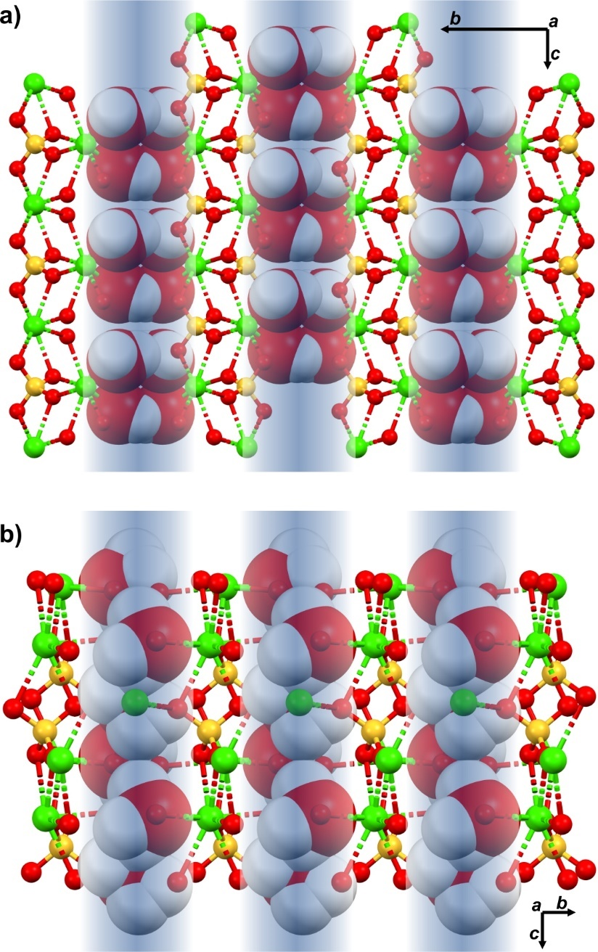
Figure S1. Packing of the water molecules in the channels formed by the CaO₈ units in the crystal network of gypsum (a), and subhydrate of calcium sulfate CaSO₄·0.69H₂O (b). Water channels are highlighted in blue.

Table S1. Unit cell parameters of investigated crystals selected from the surface of A. maritima leaves and the SEM images illustrating their morphology.
Population | Sample | Type of experiment | Bravais lattice type | Unit cell parameters  a, b, c, α, β, γ [Å,°] | Compound | An image of the spot from the crystal was selected.
Metal tolerant (control) | B_K_1_1_1-1 | pre | mC | 6.29(6)  15.16(14)  5.65(7)  90.4(9)  114(1)  89.7(7) | Gypsum | 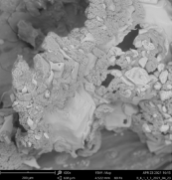
Metal tolerant (control) | B_K_2_1_1-1 | pre | mC | 6.266(17)  15.16(5)  5.679(10)  90.0  114.3(3)  90.0 | Gypsum | 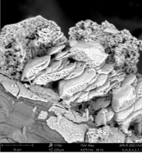
Metal tolerant (control) | B_K_2_1_1-2 | pre | mC | 6.266(15)  15.25(3)  5.66(3)  90.0  114.4(4)  90.0 | Gypsum
Metal tolerant (control) | B_K_2_1_1-3 | pre | mC | 6.29(2)  15.11(3)  5.695(15)  90.0  114.2(4)  90.0 | Gypsum
Metal tolerant (control) | B_K_4_1_4-3 | pre | mP | 6.205(13)  7.237(9)  9.42(2)  90.0  102.5(3)  90.0 | Syngenite | 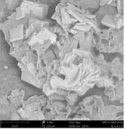
Metal tolerant (control) | B_K_4_1_4-4 | full | mP | 6.2246(4)  7.1218(4)  9.7273(7)  90  104.138(7)  90 | Syngenite
Metal tolerant (control) | B_K_4_1_8-3 | pre | mP | 6.2(2)  7.1(5)  9.72(10)  90(2)  104(2)  90(4) | Syngenite | 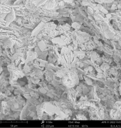
Metal tolerant (control) | B_K_5_1_6-2 | Pre | mC | 6.24(6)  15.3(3)  5.65(3)  90.0  114.2(9)  90.0 | Gypsum | 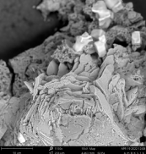
Metal tolerant (control) | B_K_5_1_6-3 | Full | mC | 6.265(2)  15.138(3)  5.6774(14)  90  114.35(4)  90 | Gypsum
Metal tolerant (control) | B_K_5_1_8-1 | pre | mP | 6.25(5)  7.18(4)  9.73(8)  87.7(6)  102.8(7)  89.9(6) | Syngenite | 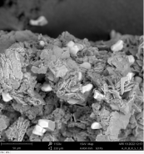
Metal tolerant (control) | B_K_5_1_8-4 | pre | mP | 6.249(6)  7.135(7)  9.778(10)  90.0  103.97(10)  90.0 | Syngenite
Metal tolerant (control) | B_K_5_1_8-6 | pre | mP | 6.219(13)  7.083(18)  9.714(17)  89.8(3)  104.5(3)  90.3(4) | Syngenite
Metal tolerant (control) | B_K_5_1_8-7 | pre | mP | 6.220(7)  7.144(9)  9.725(12)  90.0  104.25(13)  90.0 | Syngenite
Metal tolerant (control) | B_K_5_1_10-2 | pre | mC | 6.250(2)  15.110(9)  5.6600(18)  90.00(4)  114.39(4)  90.00(4) | Gypsum | 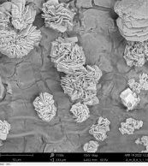
Metal tolerant (control) | B_K_6_1_9-1 | pre | mC | 6.30(8)  15.3(2)  5.72(6)  89(1)  113(1)  89(1) | Gypsum | 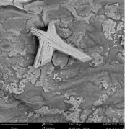
Metal tolerant (control) | B_K_6_1_9-2 | pre | mC | 6.27(3)  15.12(6)  5.66(3)  89.8(4)  114.0(4)  89.9(4) | Gypsum
Metal tolerant (control) | B_K_6_2_6-1 | full | mP | 6.11490(14)  12.1502(2)  9.0272(2)  90  104.507(3)  90 | Picromerite | 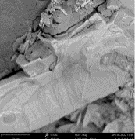
Metal tolerant (control) | B_K_6_2_6-2 | pre | mP | 6.101(13)  12.123(16)  9.002(16)  89.85(19)  104.3(2)  89.94(15) | Picromerite
Metal tolerant (control) | B_K_6_2_6-3 | pre | mP | 6.14(2)  12.17(4)  9.03(3)  90.2(3)  104.9(3)  90.4(3) | Picromerite
Metal tolerant (control) | B_K_6_2_13-1 | pre | mP | 6.10(2)  12.116(6)  9.001(19)  89.8(2)  104.3(3)  90.13(15) | Picromerite | 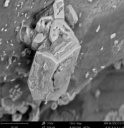
Metal tolerant (control) | B_K_8_1_2-1 | pre | mC | 6.3(2)  15.07(14)  5.6(2)  89(3)  116(6)  89(3) | Gypsum | 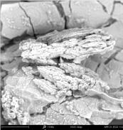
Metal tolerant (control) | B_K_8_1_2-2 | pre | mC | 6.260(5)  15.125(6)  5.668(4)  90.0  114.37(8)  90.0 | Gypsum
Metal tolerant (control) | B_K_8_2_4-1 | pre | mP | 6.202(9)  7.079(12)  9.71(2)  90.0  104.1(2)  90.0 | Syngenite | 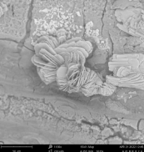
Metal tolerant (control) | B_K_8_2_9-3 | pre | mP | 6.38(3)  7.29(5)  9.7(2)  91.0(8)  105(1)  90.0(5) | Syngenite | 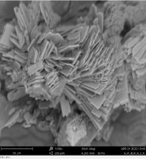
Metal intolerant (control) | L_K_10_1_2-1 | full | mC | 6.2598(5)  15.1329(8)  5.6732(5)  90  114.335(10)  90 | Gypsum | 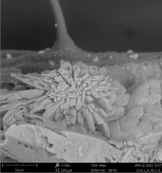
Metal intolerant (control) | L_K_10_1_2-3 | pre | mC | 6.24(15)  15.11(12)  5.66(5)  90.3(7)  114.6(8)  89.8(7) | Gypsum
Metal intolerant (control) | L_K_10_1_4-1 | pre | mC | 6.28(4)  15.16(3)  5.69(2)  90.0  114.6(5)  90.0 | Gypsum | 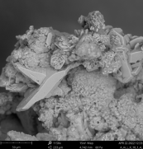
Metal intolerant (control) | L_K_10_1_4-2 | pre | mC | 6.29(5)  14.99(7)  5.69(6)  91.2(6)  114.5(9)  88.6(5) | Gypsum
Metal intolerant (control) | L_K_10_1_4-3 | pre | mC | 6.25(12)  15.1(2)  5.66(5)  90(1)  114(1)  90(2) | Gypsum
Metal intolerant (control) | L_K_10_1_5-1 | pre | mC | 6.289(19)  15.12(8)  5.684(14)  89.8(3)  114.2(3)  90.1(3) | Gypsum | 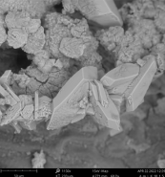
Metal intolerant (control) | L_K_10_1_5-3 | pre | mC | 6.23(10)  14.9(3)  5.66(10)  90.8(10)  114(2)  89(1) | Gypsum
Metal intolerant (control) | L_K_10_2_5-1 | pre | mC | 6.25(2)  15.16(6)  5.71(3)  89.8(4)  114.4(4)  90.1(3) | Gypsum | 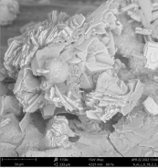
Metal intolerant (control) | L_K_10_2_9-1 | pre | mP | 6.23(3)  7.18(6)  9.54(7)  90.4(6)  104.2(5)  90.2(5) | Syngenite | 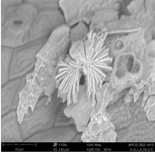
Metal intolerant (control) | L_K_11_1_5-3 | pre | mC | 6.25(7)  15.30(14)  5.68(10)  90.0  115(2)  90.0 | Gypsum | 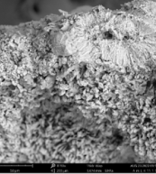
Metal intolerant (control) | L_K_12_1_1-1 | pre | mC | 6.31(7)  15.17(7)  5.71(3)  90.0  114.4(9)  90.0 | Gypsum | 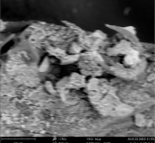
Metal intolerant (control) | L_K_12_1_8-1 | pre | mC | 6.306(18)  15.08(8)  5.72(3)  90.0  114.5(5)  90.0 | Gypsum | 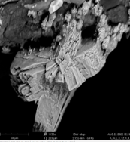
Metal intolerant (control) | L_K_12_1_8-2 | pre | mC | 6.26(7)  15.19(7)  5.65(4)  90.1(5)  113.9(9)  91.0(7) | Gypsum
Metal intolerant (control) | L_K_12_1_8-3 | pre | mC | 6.26(2)  15.172(15)  5.669(16)  90.0  114.2(3)  90.0 | Gypsum
Metal intolerant (control) | L_K_12_2_2-2 | pre | mP | 6.26(2)  7.12(2)  9.71(2)  90.0  105.0(6)  90.0 | Syngenite | 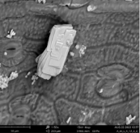
Metal intolerant (control) | L_K_13_2_6-1 | pre | mC | 6.27(2)  15.12(5)  5.675(13)  90.0  114.4(3)  90.0 | Gypsum | 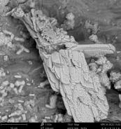
Metal intolerant (control) | L_K_13_2_7-1 | pre | mC | 6.27(4)  15.11(9)  5.70(3)  90.0  114.3(7)  90.0 | Gypsum | 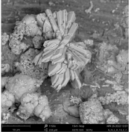
Metal intolerant (control) | L_K_14_1_9-1 | pre | mC | 6.257(9)  15.126(16)  5.674(10)  90.0  114.30(18)  90.0 | Gypsum | 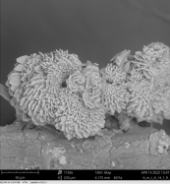
Metal intolerant (control) | L_K_14_1_9-3 | pre | mC | 6.16(9)  15.12(15)  5.88(11)  91(1)  114(2)  90(1) | Gypsum
Metal intolerant (control) | L_K_14_1_10-1 | pre | mC | 6.26(2)  15.14(5)  5.69(2)  89.9(3)  114.6(4)  90.0(3) | Gypsum | 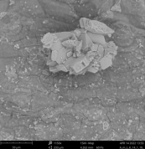
Metal intolerant (control) | L_K_14_1_10-2 | pre | mC | 6.26(2)  15.14(5)  5.69(2)  89.9(3)  114.6(4)  90.0(3) | Gypsum
Metal intolerant (control) | L_K_14_2_6+7-3 | pre | mC | 6.24(6)  15.15(3)  5.70(3)  90.0  114.2(7)  90.0 | Gypsum | 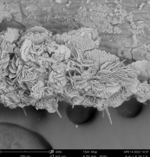
Metal intolerant (control) | L_K_14_2_9-1 | pre | mC | 6.23(6)  15.05(6)  5.646(18)  90.0  114.3(7)  90.0 | Gypsum | 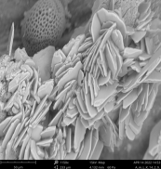
Metal intolerant (control) | L_K_15_1_12-2 | pre | mP | 6.241(7)  7.097(14)  9.728(15)  90.0  104.9(3)  90.0 | Syngenite | 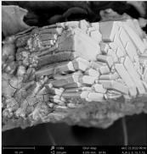
Metal intolerant (control) | L_K_15_1_12-3 | pre | mP | 6.218(8)  7.100(14)  9.73(2)  90.0  104.48(14)  90.0 | Syngenite
Metal intolerant (control) | L_K_15_1_13-1 | pre | mP | 6.225(12)  7.11(2)  9.72(3)  90.0  104.14(19)  90.0 | Syngenite | 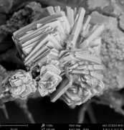
Metal intolerant (control) | L_K_15_1_13-2 | pre | mP | 6.20(2)  7.115(15)  9.72(2)  90.0  104.0(3)  90.0 | Syngenite
Metal intolerant (control) | L_K_15_1_15-1 | pre | mP | 6.219(10)  7.120(17)  9.71(6)  90.0  103.9(3)  90.0 | Syngenite | 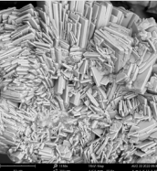
Metal intolerant (control) | L_K_15_1_15-2 | pre | mP | 6.22(4)  7.11(2)  9.73(2)  90.0  104.6(3)  90.0 | Syngenite
Metal intolerant (control) | L_K_16_1_3-3 | pre | mC | 6.29(8)  15.18(17)  5.69(5)  89.9(8)  114.6(10)  88.2(9) | Gypsum | 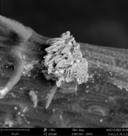
Metal intolerant (control) | L_K_16_1_9-1 | pre | mC | 6.29(18)  15.09(6)  5.67(10)  90.0  115(3)  90.0 | Gypsum | 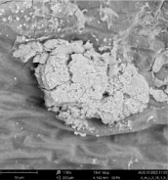
Metal tolerant (+ Pb) | B_Pb_17_2-1 | pre | oP | 6.48(2)  5.391(10)  9.24(2)  90.0  90.0  90.0 | Niter | 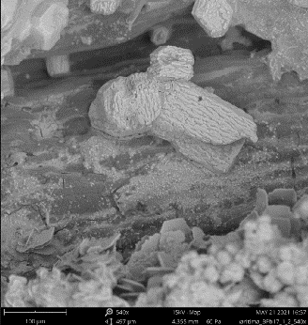
Metal tolerant (+ Pb) | B_Pb_17_2-2 | pre | oP | 6.425(14)  5.425(12)  9.20(2)  89.70(18)  89.90(18)  89.92(18) | Niter
Metal tolerant (+ Pb) | B_Pb_17_2-3 | pre | oP | 6.422(8)  5.413(5)  9.165(12)  90.0 90.0  90.0  318.6(6) | Niter
Metal tolerant (+ Pb) | B_Pb_17_1_6-1 | pre | oP | 6.44(2)  5.400(8)  9.206(14)  90.0  90.0  90.0 | Niter | 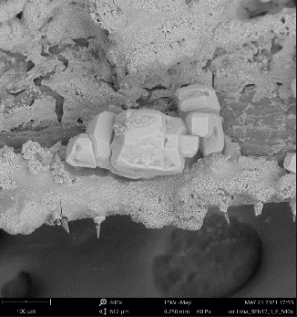
Metal tolerant (+ Pb) | B_Pb_17_1_6-2 | pre | oP | 6.426(4)  5.4197(14)  9.169(3)  90.0  90.0  90.0 | Niter
Metal tolerant (+ Pb) | B_Pb_17_1_6-3 | pre | oP | 6.420(7)  5.416(5)  9.159(3)  90.0  90.0  90.0 | Niter
Metal tolerant (+ Pb) | B_Pb_17_1_6-4 | pre | oP | 6.428(3)  5.422(3)  9.169(3)  90.0  90.0  90.0 | Niter
Metal tolerant (+ Pb) | B_Pb_17_1_6-5 | pre | oP | 6.441(2)  5.4278(18)  9.150(11)  90.0  90.0  90.0 | Niter
Metal tolerant (+ Pb) | B_Pb_17_1_4_1 | pre | oP | 6.425(6)  5.417(5)  9.164(5)  90.0  90.0  90.0 | Niter | 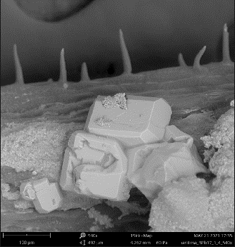
Metal tolerant (+ Pb) | B_Pb_17_1_4-2 | full | oP | 6.27222)  5.39305(16)  9.1392(3)  90  90  90 | Niter
Metal tolerant (+ Pb) | B_Pb_17_1_4-3 | pre | oP | 6.43(2)  5.397(9)  9.194(12)  90.0  90.0  90.0 | Niter
Metal tolerant (+ Pb) | B_Pb_20_2_6-1 | full | hP | 6.9332(4)  6.9332(4)  6.3460(4)  90  90  120 | CaSO₄·0.69H₂O | 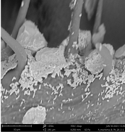
Metal tolerant (+ Pb) | B_Pb_20_2_6-2 | pre | hP | 6.934(16)  6.934(16)  6.35(2)  90.0  90.0  120.0 | CaSO₄·0.69H₂O
Metal tolerant (+ Pb) | B_Pb_21_1_2-2 | pre | mC | 6.270(12)  15.22(3)  5.682(15)  90.09(18)  114.4(2)  89.74(17) | Gypsum | 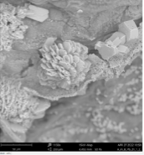
Metal tolerant (+ Pb) | B_Pb_21_1_2-3 | pre | mC | 6.31(12)  15.13(10)  5.67(17)  90.0  115(4)  90.0 | Gypsum
Metal tolerant (+ Pb) | B_Pb_21_1_3-1 | pre | mC | 6.34(4)  15.26(2)  5.71(3)  90.0  114.6(7)  90.0 | Gypsum | 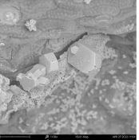
Metal tolerant (+ Pb) | B_Pb_21_1_9-1 | pre | mC | 6.272(17)  15.21(5)  5.70(4)  90.0  114.8(6)  90.0 | Gypsum | 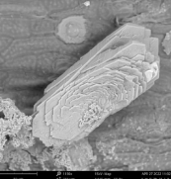
Metal tolerant (+ Pb) | B_Pb_21_1_9-2 | pre | mC | 6.216(15)  15.13(3)  5.660(16)  90.0  113.9(4)  90.0 | Gypsum
Metal tolerant (+ Pb) | B_Pb_21_1_9-3 | pre | mC | 6.28(6)  14.97(17)  5.68(4)  90.0  114(1)  90.0 | Gypsum
Metal tolerant (+ Pb) | B_Pb_21_1_10-1 | pre | mC | 6.32(4)  15.26(4)  5.67(7)  90.0  115(1)  90.0 | Gypsum | 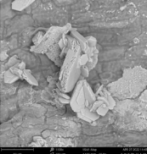
Metal tolerant (+ Pb) | B_Pb_21_1_10-2 | pre | mC | 6.1(7)  15.4(3)  5.5(5)  90.0  112(14)  90.0 | Gypsum
Metal tolerant (+ Pb) | B_Pb_22_1_7-1 | pre | mC | 6.31(6)  15.23(5)  5.67(5)  90.0  114(1)  90.0 | Gypsum | 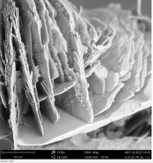
Metal tolerant (+ Pb) | B_Pb_22_1_7-2 | pre | mC | 6.23(2)  15.09(4)  5.647(19)  90.0  114.2(4)  90.0 | Gypsum
Metal tolerant (+ Pb) | B_Pb_22_1_7-3 | pre | mC | 6.04(17)  15.2(2)  5.8(3)  88(2)  111(4)  92(2) | Gypsum
Metal tolerant (+ Pb) | B_Pb_23_1-1 | pre | mC | 6.32(4)  15.05(8)  5.71(3)  90.0(4)  115.5(6)  89.0(5) | Gypsum | 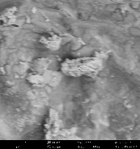
Metal tolerant (+ Pb) | B_Pb_23_1-5 | pre | mC | 6.18(5)  15.36(11)  5.64(3)  90.1(5)  113.6(6)  88.8(6) | Gypsum | 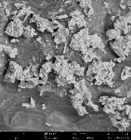
Metal tolerant (+ Pb) | B_Pb_23_2-1 | pre | mC | 6.250(14)  15.210(17)  5.700(17)  89.3(2)  113.9(3)  90.36(15) | Gypsum | 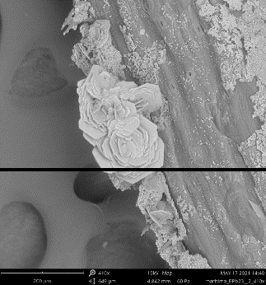
Metal tolerant (+ Pb) | B_Pb_23_2-3 | pre | mC | 6.26(2)  15.23(2)  5.680(10)  90.0  114.5(3)  90.0 | Gypsum
Metal tolerant (+ Pb) | B_Pb_23_2-6 | full | mC | 6.2783(15)  15.217(3)  5.6738(13)  90  114.21(3)  90 | Gypsum
Metal tolerant (+ Pb) | B_Pb_24_1_3-1 | pre | oP | 6.426(10)  5.416(5)  9.192(9)  90.0  90.0  90.0 | Niter | 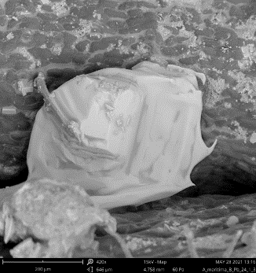
Metal tolerant (+ Pb) | B_Pb_24_1_3-2 | pre | oP | 6.428(18)  5.388(12)  9.162(12)  90.0  90.0  90.0 | Niter
Metal tolerant (+ Pb) | B_Pb_24_1_3-3 | pre | oP | 6.4351(17)  5.423(3)  9.159(4)  90.0  90.0  90.0 | Niter
Metal tolerant (+ Pb) | B_Pb_24_1_1-2 | pre | oP | 6.4(4)  5.4(2)  9(1)  90.0  92(7)  90.0 | Niter | 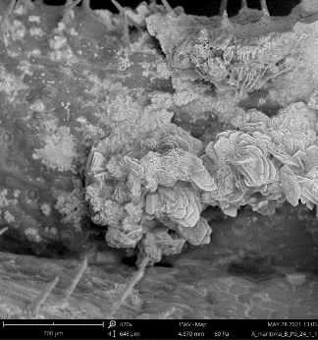
Metal intolerant (+ Pb) | L_Pb_26_2_10-3 | pre | mC | 6.45(11)  14.9(2)  5.9(2)  90.0  114(4)  90.0 | Gypsum | 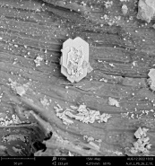
Metal intolerant (+ Pb) | L_Pb_26_2_13-4 | pre | mC | 6.25(4)  15.1(5)  5.66(3)  90(1)  114.4(6)  90(1) | Gypsum | 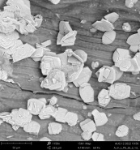
Metal intolerant (+ Pb) | L_Pb_26_2-12 | pre | mC | 6.20(9)  15.18(4)  5.67(3)  89.8(3)  114.3(9)  90.0(6) | Gypsum | 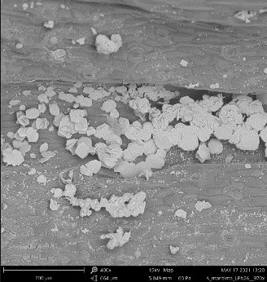
Metal intolerant (+ Pb) | L_Pb_26_2-15 | pre | mC | 6.28(4)  15.14(10)  5.69(3)  91.0(5)  114.8(6)  89.1(5) | Gypsum
Metal intolerant (+ Pb) | L_Pb_27_1_3-2 | pre | mC | 6.282(7)  15.26(2)  5.697(9)  90.0  114.07(17)  90.0 | Gypsum | 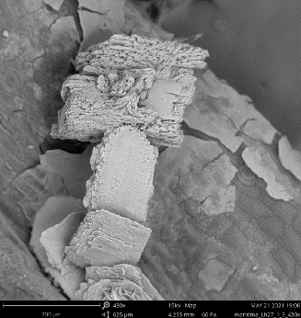
Metal intolerant (+ Pb) | L_Pb_27_1_3-3 | pre | mC | 6.277(9)  15.270(16)  5.664(9)  90.0  114.09(17)  90.0 | Gypsum
Metal intolerant (+ Pb) | L_Pb_27_1_3-4 | pre | mC | 6.25(3)  15.27(13)  5.65(2)  90.1(5)  114.1(5)  89.6(5) | Gypsum
Metal intolerant (+ Pb) | L_Pb_27_1_2-1 | pre | oP | 6.439(11)  5.439(16)  9.19(2)  90.0  90.0  90.0 | Niter | 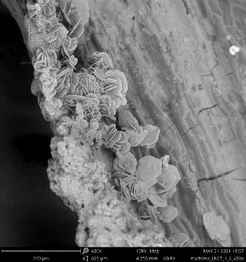
Metal intolerant (+ Pb) | L_Pb_27_1_2-2 | pre | mC | 6.43(6)  15.08(2)  5.62(5)  90.0  113(1)  90.0 | Gypsum
Metal intolerant (+ Pb) | L_Pb_27_1_2-3 | pre | mC | 6.28(2)  15.19(3)  5.674(13)  90.0  113.9(4)  90.0 | Gypsum
Metal intolerant (+ Pb) | L_Pb_27_1_2-5 | pre | oP | 6.438(11)  5.409(12)  9.21(3)  90.0  90.0  90.0 | Niter
Metal intolerant (+ Pb) | L_Pb_27_1_1-1 | pre | oP | 6.275(16)  5.362(11)  9.206(14)  90.0  90.0  90.0 | Niter | 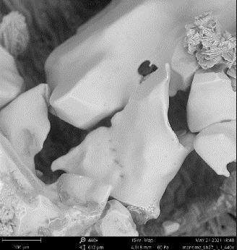
Metal intolerant (+ Pb) | L_Pb_27_1_1-2 | pre | oP | 6.388(10)  5.446(5)  9.216(17)  90.0  90.0  90.0 | Niter
Metal intolerant (+ Pb) | L_Pb_27_1_1-3 | pre | oP | 6.431(7)  5.404(5)  9.207(10)  90.0  90.0  90.0 | Niter
Metal intolerant (+ Pb) | L_Pb_27_1_1-4 | pre | oP | 6.432(11)  5.403(12)  9.219(19)  90.0  90.4(2)  90.0 | Niter
Metal intolerant (+ Pb) | L_Pb_28_1_5-3 | pre | mC | 6.3(3)  15.1(4)  5.66(16)  90(2)  114(4)  90(3) | Gypsum | 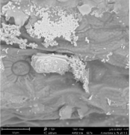
Metal intolerant (+ Pb) | L_Pb_28_1_9-1 | full | mC | 6.2562(14)  15.1356(15)  5.6698(10)  90  114.43(3)  90 | Gypsum | 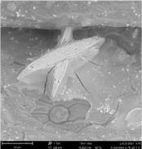
Metal intolerant (+ Pb) | L_Pb_28_1_9-2 | pre | mC | 6.25(4)  15.1(5)  5.66(3)  90(1)  114.4(6)  90(1) | Gypsum
Metal intolerant (+ Pb) | L_Pb_28_1_9-3 | pre | mC | 6.26(6)  15.10(3)  5.66(4)  90.0  114.5(8)  90.0, | Gypsum
Metal intolerant (+ Pb) | L_Pb_29_1_8-1 | pre | mC | 6.272(12)  15.14(3)  5.672(10)  90.0  114.8(3)  90.0 | Gypsum | 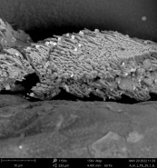
Metal intolerant (+ Pb) | L_Pb_29_1_9-1 | pre | mC | 6.20(13)  15.14(10)  5.75(19)  90.0  115(3)  90.0 | Gypsum | 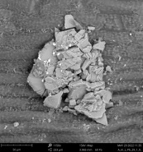
Metal intolerant (+ Pb) | L_Pb_29_1_9-2 | pre | mC | 6.27(6)  15.10(5)  5.67(3)  90.0  114.6(10)  90.0 | Gypsum
Metal intolerant (+ Pb) | L_Pb_29_1_9-3 | pre | mC | 6.22(6)  15.1(2)  5.68(6)  90.0  114(1)  90.0 | Gypsum
Metal intolerant (+ Pb) | L_Pb_30_1_1-1 | pre | mC | 6.24(7)  15.28(5)  5.70(5)  90.0  115(1)  90.0 | Gypsum | 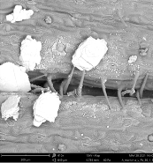
Metal intolerant (+ Pb) | L_Pb_30_1_1-3 | pre | mC | 6.19(5)  15.16(7)  5.85(5)  90.2(5)  113.7(8)  89.3(5) | Gypsum
Metal intolerant (+ Pb) | L_Pb_30_1_5-2 | pre | mC | 6.291(5)  15.226(14)  5.656(4)  90.0  114.17(8)  90.0 | Gypsum | 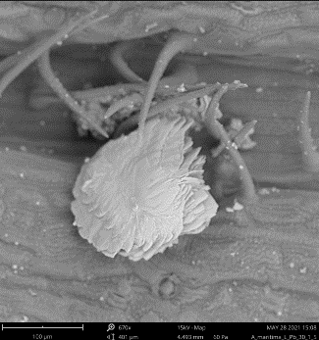
Metal intolerant (+ Pb) | L_Pb_30_1_5-3 | pre | mC | 6.329(19)  15.21(4)  5.700(13)  90.0  114.5(3)  90.0 | Gypsum
Metal intolerant (+ Pb) | L_Pb_30_1-2 | pre | mC | 6.286(7)  15.305(11)  5.690(6)  90.0  114.23(13)  90.0 | Gypsum | 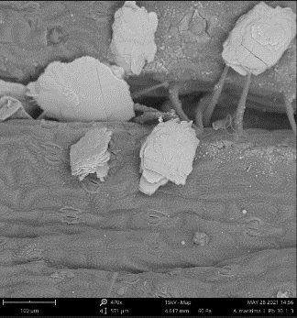
Metal intolerant (+ Pb) | L_Pb_30_1-3 | pre | mC | 6.310(7)  15.245(10)  5.692(7)  90.0  114.28(15)  90.0 | Gypsum
Metal intolerant (+ Pb) | L_Pb_30_1_2-2 | pre | mC | 6.28(3)  15.24(3)  5.71(3)  90.0  114.5(6)  90.0 | Gypsum | 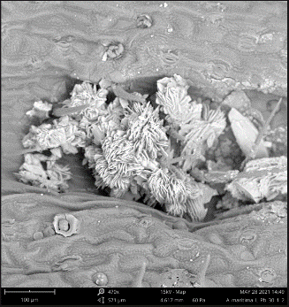
Metal intolerant (+ Pb) | L_Pb_31_1_12-3 | pre | oP | 6.28(4)  5.40(5)  9.14(5)  90.0  90.0  90.0 | Niter | 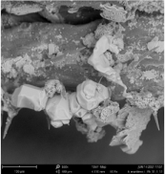
Metal intolerant (+ Pb) | L_Pb_31_2_13-2 | pre | oP | 6.24(3)  5.352(15)  9.27(2)  90.0  90.0  90.0 | Niter | 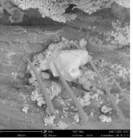
Metal intolerant (+ Pb) | L_Pb_31_2_14-1 | pre | mC | 6.286(9)  15.207(17)  5.700(6)  90.02(11)  114.44(16)  90.02(9) | Gypsum | 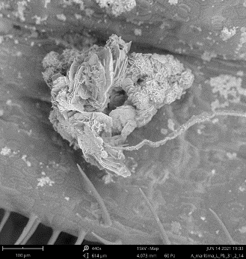
Metal intolerant (+ Pb) | L_Pb_31_2_14-2 | pre | mC | 6.277(15)  15.181(16)  5.687(8)  90.0  114.4(2)  90.0 | Gypsum
Metal intolerant (+ Pb) | L_Pb_31_2_10-3 | pre | mC | 6.265(7)  15.13(3)  5.659(5)  90.0  114.35(13)  90.0 | Gypsum | 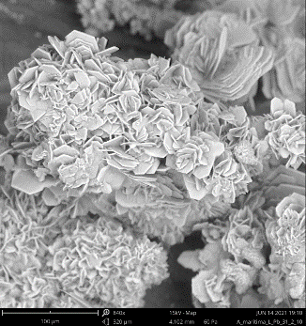
Metal intolerant (+ Pb) | L_Pb_31_1_9-1 | pre | oP | 6.281(3)  5.400(4)  9.126(8)  90.0  90.0  90.0 | Niter | 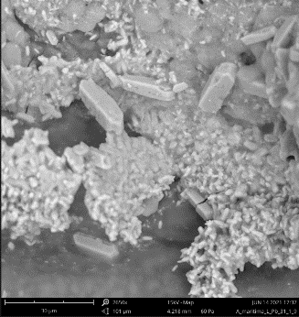
Metal intolerant (+ Pb) | L_Pb_31_1_12-1 | pre | oP | 6.26(2)  5.375(7)  9.192(12)  90.0  90.0  90.0 | Niter | 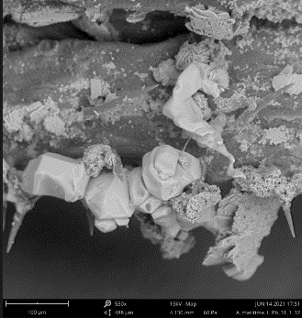
Metal intolerant (+ Pb) | L_Pb_31_1_12-2 | pre | oP | 6.268(3)  5.393(5)  9.142(3)  90.0  90.0  90.0 | Niter
Metal intolerant (+ Pb) | L_Pb_31_1_12-3 | pre | oP | 6.266(7)  5.370(7)  9.171(9)  90.0  90.0  90.0 | Niter
Metal intolerant (+ Pb) | L_Pb_31_1_13-1 | full | oP | 6.2730(4)  5.3930(3)  9.1408(7)  90.0  90.0  90.0 | Niter | 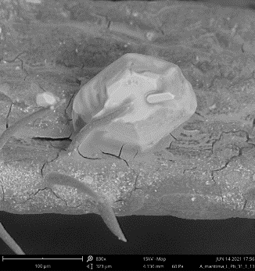
Metal intolerant (+ Pb) | L_Pb_31_2_4-1 | pre | oP | 6.278(14)  5.38(2)  9.191(16)  90.0  90.0  90.0 | Niter | 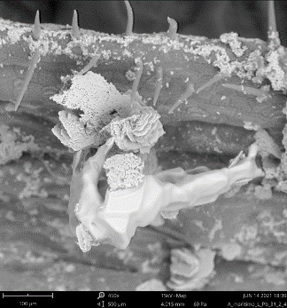
Metal intolerant (+ Pb) | L_Pb_31_2_4-2 | pre | oP | 6.271(11)  5.327(8)  9.285(19)  90.0  90.0  90.0 | Niter
Where: pre – X-Ray diffraction screening; full – complete X-Ray diffraction measurement.

Table S2. Bond lengths for gypsum [Å].
Atom | Atom | Length/Å |  | Atom | Atom | Length/Å
Ca1 | Ca1¹ | 4.0415(14) |  | Ca1 | O2² | 2.542(2)
Ca1 | Ca1² | 4.0415(14) |  | Ca1 | O2⁵ | 2.542(2)
Ca1 | S1³ | 3.1283(7) |  | S1 | Ca1² | 3.1283(7)
Ca1 | S1² | 3.1283(7) |  | S1 | Ca1³ | 3.1283(7)
Ca1 | O1² | 2.531(2) |  | S1 | O1⁶ | 1.475(2)
Ca1 | O1⁴ | 2.360(2) |  | S1 | O1 | 1.475(2)
Ca1 | O1⁵ | 2.531(2) |  | S1 | O2⁶ | 1.478(2)
Ca1 | O1 | 2.360(2) |  | S1 | O2 | 1.478(2)
Ca1 | O1W | 2.362(2) |  | O1 | Ca1² | 2.531(2)
Ca1 | O1W⁴ | 2.362(2) |  | O2 | Ca1² | 2.542(2)
¹3/2-X,1/2-Y,2-Z; ²1/2-X,1/2-Y,1-Z; ³3/2-X,1/2-Y,1-Z; ⁴1-X,+Y,3/2-Z; ⁵1/2+X,1/2-Y,1/2+Z; ⁶1-X,+Y,1/2-Z

Table S3. Values of valence angles for gypsum [ º].
Atom | Atom | Atom | Angle/˚ |  | Atom | Atom | Atom | Angle/˚
Ca1¹ | Ca1 | Ca1² | 106.51(4) |  | O1W | Ca1 | Ca1² | 79.67(6)
S1³ | Ca1 | Ca1² | 60.602(19) |  | O1W⁴ | Ca1 | S1³ | 104.04(6)
S1³ | Ca1 | Ca1¹ | 118.49(2) |  | O1W | Ca1 | S1¹ | 104.04(6)
S1¹ | Ca1 | Ca1² | 118.49(2) |  | O1W⁴ | Ca1 | S1¹ | 76.86(6)
S1¹ | Ca1 | Ca1¹ | 60.602(19) |  | O1W | Ca1 | S1³ | 76.86(6)
S1¹ | Ca1 | S1³ | 178.67(4) |  | O1W | Ca1 | O1⁵ | 77.74(8)
O1 | Ca1 | Ca1¹ | 35.66(5) |  | O1W⁴ | Ca1 | O1⁵ | 131.69(8)
O1¹ | Ca1 | Ca1¹ | 32.94(5) |  | O1W | Ca1 | O1¹ | 131.69(8)
O1⁴ | Ca1 | Ca1¹ | 91.70(6) |  | O1W⁴ | Ca1 | O1¹ | 77.74(8)
O1 | Ca1 | Ca1² | 91.70(6) |  | O1W⁴ | Ca1 | O1W | 98.01(13)
O1⁵ | Ca1 | Ca1¹ | 115.23(6) |  | O1W⁴ | Ca1 | O2¹ | 80.01(8)
O1¹ | Ca1 | Ca1² | 115.23(6) |  | O1W | Ca1 | O2¹ | 76.20(8)
O1⁵ | Ca1 | Ca1² | 32.94(5) |  | O1W | Ca1 | O2⁵ | 80.01(8)
O1⁴ | Ca1 | Ca1² | 35.66(5) |  | O1W⁴ | Ca1 | O2⁵ | 76.20(8)
O1¹ | Ca1 | S1¹ | 27.73(5) |  | O2¹ | Ca1 | Ca1² | 113.76(5)
O1⁴ | Ca1 | S1¹ | 82.89(5) |  | O2¹ | Ca1 | Ca1¹ | 88.45(5)
O1¹ | Ca1 | S1³ | 151.30(5) |  | O2⁵ | Ca1 | Ca1¹ | 113.76(5)
O1⁵ | Ca1 | S1³ | 27.73(5) |  | O2⁵ | Ca1 | Ca1² | 88.45(5)
O1⁴ | Ca1 | S1³ | 96.23(5) |  | O2¹ | Ca1 | S1³ | 153.06(5)
O1 | Ca1 | S1¹ | 96.23(5) |  | O2⁵ | Ca1 | S1³ | 27.85(5)
O1⁵ | Ca1 | S1¹ | 151.30(5) |  | O2⁵ | Ca1 | S1¹ | 153.06(5)
O1 | Ca1 | S1³ | 82.89(5) |  | O2¹ | Ca1 | S1¹ | 27.85(5)
O1¹ | Ca1 | O1⁵ | 139.61(10) |  | O2⁵ | Ca1 | O2¹ | 143.39(11)
O1 | Ca1 | O1⁴ | 98.26(11) |  | Ca1³ | S1 | Ca1¹ | 178.67(4)
O1 | Ca1 | O1¹ | 68.60(8) |  | O1 | S1 | Ca1¹ | 52.97(8)
O1⁴ | Ca1 | O1⁵ | 68.60(8) |  | O1⁶ | S1 | Ca1³ | 52.97(8)
O1 | Ca1 | O1⁵ | 85.02(5) |  | O1⁶ | S1 | Ca1¹ | 127.99(9)
O1⁴ | Ca1 | O1¹ | 85.02(5) |  | O1 | S1 | Ca1³ | 127.99(9)
O1⁴ | Ca1 | O1W | 85.44(8) |  | O1⁶ | S1 | O1 | 110.84(17)
O1 | Ca1 | O1W | 159.71(7) |  | O1 | S1 | O2⁶ | 111.03(11)
O1⁴ | Ca1 | O1W⁴ | 159.71(7) |  | O1 | S1 | O2 | 106.38(11)
O1 | Ca1 | O1W⁴ | 85.44(8) |  | O1⁶ | S1 | O2⁶ | 106.38(11)
O1⁵ | Ca1 | O2¹ | 141.46(6) |  | O1⁶ | S1 | O2 | 111.03(11)
O1 | Ca1 | O2⁵ | 81.44(7) |  | O2 | S1 | Ca1³ | 125.63(8)
O1 | Ca1 | O2¹ | 124.04(7) |  | O2⁶ | S1 | Ca1¹ | 125.63(8)
O1⁵ | Ca1 | O2⁵ | 55.57(6) |  | O2 | S1 | Ca1¹ | 53.44(8)
O1⁴ | Ca1 | O2⁵ | 124.04(7) |  | O2⁶ | S1 | Ca1³ | 53.44(8)
O1⁴ | Ca1 | O2¹ | 81.44(7) |  | O2 | S1 | O2⁶ | 111.25(18)
O1¹ | Ca1 | O2⁵ | 141.46(6) |  | Ca1 | O1 | Ca1¹ | 111.40(8)
O1¹ | Ca1 | O2¹ | 55.57(6) |  | S1 | O1 | Ca1¹ | 99.30(11)
O1W⁴ | Ca1 | Ca1¹ | 79.67(6) |  | S1 | O1 | Ca1 | 148.89(12)
O1W | Ca1 | Ca1¹ | 164.63(6) |  | S1 | O2 | Ca1¹ | 98.71(10)
O1W⁴ | Ca1 | Ca1² | 164.63(6)
¹1/2-X,1/2-Y,1-Z; ²3/2-X,1/2-Y,2-Z; ³3/2-X,1/2-Y,1-Z; ⁴1-X,+Y,3/2-Z; ⁵1/2+X,1/2-Y,1/2+Z; ⁶1-X,+Y,1/2-Z

Table S4. Values of torsion angles for gypsum [ º].
A | B | C | D | Angle/˚ |  | A | B | C | D | Angle/˚
Ca1¹ | S1 | O1 | Ca1 | 170.8(3) |  | O1³ | S1 | O2 | Ca1¹ | -122.40(11)
Ca1² | S1 | O1 | Ca1 | -8.0(3) |  | O2 | S1 | O1 | Ca1 | 172.5(2)
Ca1² | S1 | O1 | Ca1¹ | -178.83(4) |  | O2³ | S1 | O1 | Ca1¹ | -119.45(11)
Ca1² | S1 | O2 | Ca1¹ | 178.82(4) |  | O2³ | S1 | O1 | Ca1 | 51.3(3)
O1³ | S1 | O1 | Ca1¹ | 122.53(11) |  | O2 | S1 | O1 | Ca1¹ | 1.73(14)
O1³ | S1 | O1 | Ca1 | -66.7(2) |  | O2³ | S1 | O2 | Ca1¹ | 119.32(10)
O1 | S1 | O2 | Ca1¹ | -1.72(14)
¹1/2-X,1/2-Y,1-Z; ²3/2-X,1/2-Y,1-Z; ³1-X,+Y,1/2-Z

Table S5. Bond lengths for niter [Å].
Atom | Atom | Length/Å |  | Atom | Atom | Length/Å
O2 | K1¹ | 2.8031(12) |  | K1 | O1⁵ | 2.8464(8)
O2 | K1² | 2.8879(5) |  | K1 | O1⁴ | 2.8094(9)
O2 | K1³ | 2.8879(5) |  | K1 | O1⁸ | 2.8464(8)
O2 | N1 | 1.2568(19) |  | K1 | O1⁹ | 2.8094(9)
O1 | K1 | 2.8601(8) |  | K1 | O1¹⁰ | 2.8602(8)
O1 | K1² | 2.8465(8) |  | K1 | N1 | 3.2363(14)
O1 | K1⁴ | 2.8094(9) |  | K1 | N1⁵ | 3.2471(8)
O1 | N1 | 1.2544(11) |  | K1 | N1⁷ | 3.2471(8)
K1 | O2⁵ | 2.8879(5) |  | N1 | O1¹⁰ | 1.2544(11)
K1 | O2⁶ | 2.8031(12) |  | N1 | K1² | 3.2471(8)
K1 | O2⁷ | 2.8879(5) |  | N1 | K1³ | 3.2471(8)
¹1/2+X,+Y,1/2-Z; ²3/2-X,1-Y,-1/2+Z; ³3/2-X,-Y,-1/2+Z; ⁴2-X,1-Y,1-Z; ⁵3/2-X,1-Y,1/2+Z; ⁶-1/2+X,+Y,1/2-Z; ⁷3/2-X,-Y,1/2+Z; ⁸3/2-X,-1/2+Y,1/2+Z; ⁹2-X,-1/2+Y,1-Z; ¹⁰+X,1/2-Y,+Z

Table S6. Values of valence angles for niter [ º].
Atom | Atom | Atom | Angle/˚ |  | Atom | Atom | Atom | Angle/˚
K1¹ | O2 | K1² | 102.92(2) |  | O1⁷ | K1 | O1⁹ | 167.28(3)
K1¹ | O2 | K1³ | 102.92(2) |  | O1⁴ | K1 | O1 | 79.32(3)
K1² | O2 | K1³ | 138.05(5) |  | O1⁸ | K1 | O1¹⁰ | 72.592(18)
N1 | O2 | K1¹ | 127.45(9) |  | O1⁷ | K1 | O1 | 123.067(8)
N1 | O2 | K1³ | 94.93(4) |  | O1⁸ | K1 | O1 | 104.491(18)
N1 | O2 | K1² | 94.93(4) |  | O1⁷ | K1 | O1¹⁰ | 68.85(3)
K1⁴ | O1 | K1 | 100.68(3) |  | O1¹⁰ | K1 | O1 | 167.28(3)
K1⁴ | O1 | K1³ | 101.22(3) |  | O1⁴ | K1 | O1⁷ | 72.592(18)
K1³ | O1 | K1 | 136.82(3) |  | O1⁴ | K1 | O1⁸ | 69.89(4)
N1 | O1 | K1³ | 96.98(7) |  | O1 | K1 | O1⁹ | 44.69(3)
N1 | O1 | K1⁴ | 131.36(8) |  | O1⁷ | K1 | N1 | 144.654(18)
N1 | O1 | K1 | 95.76(7) |  | O1⁹ | K1 | N1 | 22.684(17)
O2⁵ | K1 | O2⁶ | 77.08(2) |  | O1⁹ | K1 | N1⁷ | 144.79(3)
O2⁶ | K1 | O2⁷ | 138.05(5) |  | O1 | K1 | N1 | 22.684(17)
O2⁵ | K1 | O2⁷ | 77.08(2) |  | O1 | K1 | N1⁷ | 100.70(3)
O2⁵ | K1 | O1⁸ | 142.462(19) |  | O1 | K1 | N1⁶ | 144.79(3)
O2⁵ | K1 | O1⁹ | 74.19(3) |  | O1¹⁰ | K1 | N1 | 144.654(18)
O2⁵ | K1 | O1⁴ | 142.462(19) |  | O1⁸ | K1 | N1 | 95.30(3)
O2⁵ | K1 | O1 | 74.19(3) |  | O1⁴ | K1 | N1⁶ | 124.21(3)
O2⁵ | K1 | O1¹⁰ | 100.36(3) |  | O1⁷ | K1 | N1⁶ | 90.88(3)
O2⁵ | K1 | O1⁷ | 100.36(3) |  | O1⁸ | K1 | N1⁷ | 124.21(3)
O2⁷ | K1 | N1⁶ | 128.92(3) |  | O1¹⁰ | K1 | N1⁶ | 22.55(3)
O2⁷ | K1 | N1⁷ | 22.68(3) |  | O1⁹ | K1 | N1⁶ | 100.70(3)
O2⁶ | K1 | N1 | 100.37(2) |  | O1⁴ | K1 | N1 | 95.30(3)
O2⁷ | K1 | N1 | 100.37(2) |  | O1⁷ | K1 | N1⁷ | 22.55(3)
O2⁵ | K1 | N1⁷ | 92.09(3) |  | O1⁴ | K1 | N1⁷ | 67.10(3)
O2⁶ | K1 | N1⁷ | 128.92(3) |  | O1¹⁰ | K1 | N1⁷ | 90.88(3)
O2⁶ | K1 | N1⁶ | 22.68(3) |  | O1⁸ | K1 | N1⁶ | 67.10(3)
O2⁵ | K1 | N1 | 68.85(4) |  | N1 | K1 | N1⁶ | 122.12(2)
O2⁵ | K1 | N1⁶ | 92.09(3) |  | N1⁷ | K1 | N1⁶ | 112.29(4)
O1 | K1 | O2⁷ | 80.28(3) |  | N1 | K1 | N1⁷ | 122.12(2)
O1⁴ | K1 | O2⁶ | 140.37(3) |  | O2 | N1 | K1 | 161.26(10)
O1⁹ | K1 | O2⁶ | 80.28(3) |  | O2 | N1 | K1² | 62.39(3)
O1¹⁰ | K1 | O2⁶ | 44.54(3) |  | O2 | N1 | K1³ | 62.39(3)
O1 | K1 | O2⁶ | 122.76(3) |  | O1⁹ | N1 | O2 | 119.90(7)
O1⁷ | K1 | O2⁷ | 44.54(3) |  | O1 | N1 | O2 | 119.90(7)
O1⁹ | K1 | O2⁷ | 122.76(3) |  | O1 | N1 | O1⁹ | 120.18(13)
O1¹⁰ | K1 | O2⁷ | 110.06(3) |  | O1 | N1 | K1² | 161.24(9)
O1⁴ | K1 | O2⁷ | 72.57(3) |  | O1 | N1 | K1 | 61.56(7)
O1⁸ | K1 | O2⁶ | 72.57(3) |  | O1⁹ | N1 | K1 | 61.56(7)
O1⁸ | K1 | O2⁷ | 140.37(3) |  | O1 | N1 | K1³ | 60.47(5)
O1⁷ | K1 | O2⁶ | 110.06(3) |  | O1⁹ | N1 | K1² | 60.47(5)
O1⁸ | K1 | O1⁷ | 110.39(2) |  | O1⁹ | N1 | K1³ | 161.24(9)
O1⁸ | K1 | O1⁹ | 79.32(3) |  | K1² | N1 | K1³ | 112.29(4)
O1⁴ | K1 | O1⁹ | 104.491(18) |  | K1 | N1 | K1² | 109.86(3)
O1¹⁰ | K1 | O1⁹ | 123.067(8) |  | K1 | N1 | K1³ | 109.86(3)
O1⁴ | K1 | O1¹⁰ | 110.39(2)
¹1/2+X,+Y,1/2-Z; ²3/2-X,-Y,-1/2+Z; ³3/2-X,1-Y,-1/2+Z; ⁴2-X,1-Y,1-Z; ⁵-1/2+X,+Y,1/2-Z; ⁶3/2-X,-Y,1/2+Z; ⁷3/2-X,1-Y,1/2+Z; ⁸2-X,-1/2+Y,1-Z; ⁹+X,1/2-Y,+Z; ¹⁰3/2-X,-1/2+Y,1/2+Z

Table S7. Values of torsion angles for niter [ º].
A | B | C | D | Angle/˚ |  | A | B | C | D | Angle/˚
K1¹ | O2 | N1 | O1 | 90.86(12) |  | K1 | O1 | N1 | O2 | 158.58(12)
K1¹ | O2 | N1 | O1² | -90.86(12) |  | K1³ | O1 | N1 | O2 | 19.92(13)
K1³ | O2 | N1 | O1² | 158.72(11) |  | K1⁵ | O1 | N1 | O2 | -91.73(14)
K1³ | O2 | N1 | O1 | -19.55(13) |  | K1 | O1 | N1 | O1² | -19.69(13)
K1⁴ | O2 | N1 | O1 | -158.73(11) |  | K1³ | O1 | N1 | O1² | -158.35(11)
K1⁴ | O2 | N1 | O1² | 19.55(13) |  | K1⁵ | O1 | N1 | O1² | 89.99(14)
K1¹ | O2 | N1 | K1³ | 110.41(3) |  | K1³ | O1 | N1 | K1 | -138.65(4)
K1⁴ | O2 | N1 | K1 | -69.59(3) |  | K1⁵ | O1 | N1 | K1 | 109.69(8)
K1¹ | O2 | N1 | K1⁴ | -110.41(3) |  | K1⁵ | O1 | N1 | K1³ | -111.66(8)
K1³ | O2 | N1 | K1⁴ | 139.17(6) |  | K1³ | O1 | N1 | K1⁴ | -71.8(3)
K1³ | O2 | N1 | K1 | 69.59(3) |  | K1 | O1 | N1 | K1⁴ | 66.8(3)
K1¹ | O2 | N1 | K1 | 180.0 |  | K1⁵ | O1 | N1 | K1⁴ | 176.53(18)
K1⁴ | O2 | N1 | K1³ | -139.17(6) |  | K1 | O1 | N1 | K1³ | 138.65(4)
¹1/2+X,+Y,1/2-Z; ²+X,1/2-Y,+Z; ³3/2-X,1-Y,-1/2+Z; ⁴3/2-X,-Y,-1/2+Z; ⁵2-X,1-Y,1-Z

Table S8. Bond lengths for syngenite [Å].
Atom | Atom | Length/Å |  | Atom | Atom | Length/Å
Ca1 | O1¹ | 2.5457(19) |  | O2 | K1¹¹ | 2.858(2)
Ca1 | O1 | 2.5458(19) |  | O2 | S1 | 1.480(3)
Ca1 | O1W | 2.461(3) |  | O3 | K1¹² | 2.850(2)
Ca1 | O4 | 2.5185(18) |  | O3 | K1¹¹ | 2.955(2)
Ca1 | O4² | 2.4427(18) |  | O3 | K1¹⁰ | 2.955(2)
Ca1 | O4³ | 2.4427(18) |  | O3 | K1⁸ | 2.850(2)
Ca1 | O4¹ | 2.5185(18) |  | O3 | S1 | 1.480(3)
Ca1 | O5⁴ | 2.401(3) |  | O4 | Ca1² | 2.4427(18)
Ca1 | O6⁴ | 2.703(3) |  | O4 | K1¹² | 3.3844(19)
Ca1 | S1 | 3.1441(11) |  | O4 | S2 | 1.4780(18)
Ca1 | S2 | 3.1105(10) |  | O5 | Ca1¹³ | 2.401(3)
Ca1 | S2⁴ | 3.1267(10) |  | O5 | K1⁸ | 2.671(2)
K1 | K1¹ | 3.4591(11) |  | O5 | K1¹² | 2.671(2)
K1 | O1⁵ | 2.9452(19) |  | O5 | S2 | 1.479(3)
K1 | O1W | 2.962(2) |  | O6 | Ca1¹³ | 2.703(3)
K1 | O2⁶ | 2.900(2) |  | O6 | K1¹³ | 2.745(2)
K1 | O2⁷ | 2.858(2) |  | O6 | K1¹⁴ | 2.745(2)
K1 | O3⁷ | 2.955(2) |  | O6 | S2 | 1.470(3)
K1 | O3⁸ | 2.850(2) |  | S1 | K1¹¹ | 3.3371(9)
K1 | O4³ | 3.3844(19) |  | S1 | K1¹² | 3.7717(9)
K1 | O5⁸ | 2.671(2) |  | S1 | K1⁶ | 3.4703(9)
K1 | O6⁴ | 2.745(2) |  | S1 | K1¹⁰ | 3.3371(9)
K1 | S1⁷ | 3.3371(9) |  | S1 | K1⁹ | 3.4703(9)
K1 | S1⁶ | 3.4703(9) |  | S1 | K1⁸ | 3.7717(10)
O1 | K1⁹ | 2.9452(19) |  | S1 | O1¹ | 1.4814(18)
O1 | S1 | 1.4814(18) |  | S2 | Ca1¹³ | 3.1267(10)
O1W | K1¹ | 2.962(2) |  | S2 | K1⁸ | 3.6156(9)
O2 | K1¹⁰ | 2.858(2) |  | S2 | K1¹² | 3.6156(9)
O2 | K1⁶ | 2.900(2) |  | S2 | O4¹ | 1.4780(18)
O2 | K1⁹ | 2.900(2)
¹+X,1/2-Y,+Z; ²1-X,1-Y,1-Z; ³1-X,-1/2+Y,1-Z; ⁴1+X,+Y,+Z; ⁵2-X,-1/2+Y,1-Z; ⁶2-X,-Y,1-Z; ⁷+X,+Y,-1+Z; ⁸1-X,-Y,1-Z; ⁹2-X,1/2+Y,1-Z; ¹⁰+X,+Y,1+Z; ¹¹+X,1/2-Y,1+Z; ¹²1-X,1/2+Y,1-Z; ¹³-1+X,+Y,+Z; ¹⁴-1+X,1/2-Y,+Z

Table S9. Values of valence angles for syngenite [ º].
Atom | Atom | Atom | Angle/˚ |  | Atom | Atom | Atom | Angle/˚
O1¹ | Ca1 | O1 | 55.41(8) |  | S1⁷ | K1 | O4⁴ | 152.57(4)
O1 | Ca1 | O6² | 122.82(6) |  | S1⁷ | K1 | S1⁵ | 98.11(2)
O1¹ | Ca1 | O6² | 122.82(6) |  | Ca1 | O1 | K1⁹ | 101.56(6)
O1 | Ca1 | S1 | 27.71(4) |  | S1 | O1 | Ca1 | 99.23(9)
O1¹ | Ca1 | S1 | 27.71(4) |  | S1 | O1 | K1⁹ | 97.74(9)
O1¹ | Ca1 | S2 | 87.83(5) |  | Ca1 | O1W | K1¹ | 102.62(8)
O1¹ | Ca1 | S2² | 98.61(5) |  | Ca1 | O1W | K1 | 102.62(8)
O1 | Ca1 | S2 | 87.83(5) |  | K1¹ | O1W | K1 | 71.46(6)
O1 | Ca1 | S2² | 98.61(5) |  | K1⁹ | O2 | K1⁵ | 78.31(7)
O1W | Ca1 | O1¹ | 148.16(5) |  | K1¹⁰ | O2 | K1⁵ | 101.60(2)
O1W | Ca1 | O1 | 148.16(5) |  | K1¹¹ | O2 | K1⁹ | 101.60(2)
O1W | Ca1 | O4¹ | 78.15(7) |  | K1¹¹ | O2 | K1⁵ | 164.88(10)
O1W | Ca1 | O4 | 78.15(7) |  | K1¹¹ | O2 | K1¹⁰ | 74.48(7)
O1W | Ca1 | O6² | 68.61(8) |  | K1¹⁰ | O2 | K1⁹ | 164.88(10)
O1W | Ca1 | S1 | 162.93(7) |  | S1 | O2 | K1⁹ | 99.66(11)
O1W | Ca1 | S2 | 76.09(6) |  | S1 | O2 | K1¹¹ | 95.27(11)
O1W | Ca1 | S2² | 96.63(6) |  | S1 | O2 | K1⁵ | 99.66(11)
O4³ | Ca1 | O1¹ | 129.48(6) |  | S1 | O2 | K1¹⁰ | 95.27(11)
O4¹ | Ca1 | O1¹ | 75.05(6) |  | K1⁸ | O3 | K1¹⁰ | 96.08(3)
O4 | Ca1 | O1 | 75.05(6) |  | K1¹¹ | O3 | K1¹⁰ | 71.66(7)
O4¹ | Ca1 | O1 | 100.28(6) |  | K1⁸ | O3 | K1¹² | 79.98(7)
O4⁴ | Ca1 | O1 | 129.48(6) |  | K1⁸ | O3 | K1¹¹ | 149.14(10)
O4 | Ca1 | O1¹ | 100.28(6) |  | K1¹² | O3 | K1¹⁰ | 149.14(10)
O4³ | Ca1 | O1 | 74.35(6) |  | K1¹² | O3 | K1¹¹ | 96.08(3)
O4⁴ | Ca1 | O1¹ | 74.35(6) |  | S1 | O3 | K1¹² | 117.68(11)
O4³ | Ca1 | O1W | 80.12(5) |  | S1 | O3 | K1¹⁰ | 91.43(11)
O4⁴ | Ca1 | O1W | 80.12(5) |  | S1 | O3 | K1¹¹ | 91.43(11)
O4³ | Ca1 | O4 | 68.65(7) |  | S1 | O3 | K1⁸ | 117.68(11)
O4⁴ | Ca1 | O4¹ | 68.65(7) |  | Ca1³ | O4 | Ca1 | 111.35(7)
O4¹ | Ca1 | O4 | 56.00(8) |  | Ca1³ | O4 | K1¹² | 92.04(5)
O4⁴ | Ca1 | O4³ | 153.70(9) |  | Ca1 | O4 | K1¹² | 114.95(6)
O4⁴ | Ca1 | O4 | 123.38(5) |  | S2 | O4 | Ca1³ | 147.00(11)
O4³ | Ca1 | O4¹ | 123.38(5) |  | S2 | O4 | Ca1 | 98.87(9)
O4⁴ | Ca1 | O6² | 78.36(4) |  | S2 | O4 | K1¹² | 86.76(8)
O4 | Ca1 | O6² | 136.45(6) |  | Ca1¹³ | O5 | K1⁸ | 114.24(7)
O4¹ | Ca1 | O6² | 136.45(6) |  | Ca1¹³ | O5 | K1¹² | 114.24(7)
O4³ | Ca1 | O6² | 78.36(4) |  | K1¹² | O5 | K1⁸ | 86.59(8)
O4³ | Ca1 | S1 | 102.00(4) |  | S2 | O5 | Ca1¹³ | 104.90(14)
O4 | Ca1 | S1 | 86.80(5) |  | S2 | O5 | K1¹² | 118.37(9)
O4⁴ | Ca1 | S1 | 102.00(4) |  | S2 | O5 | K1⁸ | 118.37(9)
O4¹ | Ca1 | S1 | 86.80(5) |  | Ca1¹³ | O6 | K1¹⁴ | 102.34(7)
O4³ | Ca1 | S2 | 95.96(4) |  | Ca1¹³ | O6 | K1¹³ | 102.34(7)
O4¹ | Ca1 | S2² | 151.25(4) |  | K1¹³ | O6 | K1¹⁴ | 78.11(7)
O4³ | Ca1 | S2² | 82.61(4) |  | S2 | O6 | Ca1¹³ | 92.24(13)
O4 | Ca1 | S2 | 28.00(4) |  | S2 | O6 | K1¹⁴ | 137.53(6)
O4 | Ca1 | S2² | 151.25(4) |  | S2 | O6 | K1¹³ | 137.53(6)
O4⁴ | Ca1 | S2² | 82.61(4) |  | Ca1 | S1 | K1⁸ | 92.12(2)
O4⁴ | Ca1 | S2 | 95.96(4) |  | Ca1 | S1 | K1⁵ | 80.06(2)
O4¹ | Ca1 | S2 | 28.00(4) |  | Ca1 | S1 | K1¹⁰ | 148.762(12)
O5² | Ca1 | O1¹ | 74.59(7) |  | Ca1 | S1 | K1¹¹ | 148.762(12)
O5² | Ca1 | O1 | 74.59(7) |  | Ca1 | S1 | K1¹² | 92.12(2)
O5² | Ca1 | O1W | 123.83(9) |  | Ca1 | S1 | K1⁹ | 80.06(2)
O5² | Ca1 | O4⁴ | 88.36(5) |  | K1¹¹ | S1 | K1¹⁰ | 62.43(2)
O5² | Ca1 | O4 | 145.86(6) |  | K1⁹ | S1 | K1⁸ | 171.51(3)
O5² | Ca1 | O4¹ | 145.86(6) |  | K1⁵ | S1 | K1¹² | 171.51(3)
O5² | Ca1 | O4³ | 88.36(5) |  | K1¹¹ | S1 | K1⁵ | 113.95(3)
O5² | Ca1 | O6² | 55.22(8) |  | K1¹¹ | S1 | K1⁹ | 81.89(2)
O5² | Ca1 | S1 | 73.25(6) |  | K1⁹ | S1 | K1¹² | 118.462(16)
O5² | Ca1 | S2² | 27.20(6) |  | K1⁸ | S1 | K1¹² | 58.10(2)
O5² | Ca1 | S2 | 160.08(7) |  | K1¹¹ | S1 | K1⁸ | 103.65(2)
O6² | Ca1 | S1 | 128.46(6) |  | K1¹⁰ | S1 | K1¹² | 103.65(2)
O6² | Ca1 | S2 | 144.70(6) |  | K1¹⁰ | S1 | K1⁵ | 81.89(2)
O6² | Ca1 | S2² | 28.02(6) |  | K1⁹ | S1 | K1⁵ | 63.70(2)
S2 | Ca1 | S1 | 86.84(3) |  | K1¹¹ | S1 | K1¹² | 74.495(19)
S2² | Ca1 | S1 | 100.44(3) |  | K1¹⁰ | S1 | K1⁸ | 74.495(19)
S2 | Ca1 | S2² | 172.72(4) |  | K1¹⁰ | S1 | K1⁹ | 113.95(3)
K1¹ | K1 | S1⁵ | 121.851(12) |  | K1⁵ | S1 | K1⁸ | 118.462(16)
O1⁶ | K1 | K1¹ | 102.70(4) |  | O1 | S1 | Ca1 | 53.06(8)
O1⁶ | K1 | O1W | 138.43(6) |  | O1¹ | S1 | Ca1 | 53.05(8)
O1⁶ | K1 | O3⁷ | 128.20(6) |  | O1 | S1 | K1⁹ | 57.24(8)
O1⁶ | K1 | O4⁴ | 100.04(5) |  | O1¹ | S1 | K1¹¹ | 158.07(8)
O1⁶ | K1 | S1⁵ | 25.02(4) |  | O1¹ | S1 | K1¹⁰ | 95.71(8)
O1⁶ | K1 | S1⁷ | 102.49(4) |  | O1 | S1 | K1⁵ | 107.59(8)
O1W | K1 | K1¹ | 54.27(3) |  | O1¹ | S1 | K1⁵ | 57.24(8)
O1W | K1 | O4⁴ | 59.19(5) |  | O1 | S1 | K1⁸ | 115.26(8)
O1W | K1 | S1⁵ | 162.19(6) |  | O1¹ | S1 | K1⁸ | 69.56(8)
O1W | K1 | S1⁷ | 93.42(5) |  | O1 | S1 | K1¹² | 69.56(8)
O2⁵ | K1 | K1¹ | 129.16(3) |  | O1¹ | S1 | K1¹² | 115.26(8)
O2⁷ | K1 | K1¹ | 52.76(3) |  | O1¹ | S1 | K1⁹ | 107.59(8)
O2⁵ | K1 | O1⁶ | 49.03(6) |  | O1 | S1 | K1¹⁰ | 158.07(8)
O2⁷ | K1 | O1⁶ | 79.49(6) |  | O1 | S1 | K1¹¹ | 95.71(8)
O2⁵ | K1 | O1W | 172.51(7) |  | O1 | S1 | O1¹ | 106.07(15)
O2⁷ | K1 | O1W | 102.69(5) |  | O2 | S1 | Ca1 | 126.42(12)
O2⁷ | K1 | O2⁵ | 78.40(2) |  | O2 | S1 | K1¹⁰ | 58.52(9)
O2⁷ | K1 | O3⁷ | 49.08(7) |  | O2 | S1 | K1¹² | 132.91(9)
O2⁵ | K1 | O3⁷ | 105.96(7) |  | O2 | S1 | K1⁹ | 55.47(8)
O2⁷ | K1 | O4⁴ | 152.04(5) |  | O2 | S1 | K1¹¹ | 58.52(9)
O2⁵ | K1 | O4⁴ | 122.53(5) |  | O2 | S1 | K1⁸ | 132.91(9)
O2⁵ | K1 | S1⁵ | 24.87(5) |  | O2 | S1 | K1⁵ | 55.47(8)
O2⁷ | K1 | S1⁷ | 26.21(5) |  | O2 | S1 | O1 | 109.98(10)
O2⁷ | K1 | S1⁵ | 82.59(5) |  | O2 | S1 | O1¹ | 109.98(10)
O2⁵ | K1 | S1⁷ | 84.39(5) |  | O3 | S1 | Ca1 | 124.20(12)
O3⁷ | K1 | K1¹ | 54.17(3) |  | O3 | S1 | K1¹¹ | 62.26(9)
O3⁸ | K1 | K1¹ | 129.99(4) |  | O3 | S1 | K1⁸ | 41.99(8)
O3⁸ | K1 | O1⁶ | 126.00(5) |  | O3 | S1 | K1⁹ | 141.72(6)
O3⁸ | K1 | O1W | 89.16(6) |  | O3 | S1 | K1¹⁰ | 62.26(9)
O3⁷ | K1 | O1W | 70.19(7) |  | O3 | S1 | K1¹² | 41.99(8)
O3⁸ | K1 | O2⁵ | 83.98(6) |  | O3 | S1 | K1⁵ | 141.72(6)
O3⁸ | K1 | O2⁷ | 120.57(7) |  | O3 | S1 | O1¹ | 110.70(10)
O3⁸ | K1 | O3⁷ | 83.92(3) |  | O3 | S1 | O1 | 110.70(10)
O3⁷ | K1 | O4⁴ | 127.56(6) |  | O3 | S1 | O2 | 109.39(16)
O3⁸ | K1 | O4⁴ | 82.62(6) |  | Ca1 | S2 | Ca1¹³ | 172.72(4)
O3⁸ | K1 | S1⁵ | 102.90(4) |  | Ca1 | S2 | K1⁸ | 95.72(2)
O3⁷ | K1 | S1⁷ | 26.31(5) |  | Ca1¹³ | S2 | K1⁸ | 78.03(2)
O3⁷ | K1 | S1⁵ | 123.53(5) |  | Ca1 | S2 | K1¹² | 95.72(2)
O3⁸ | K1 | S1⁷ | 96.44(5) |  | Ca1¹³ | S2 | K1¹² | 78.03(2)
O4⁴ | K1 | K1¹ | 101.06(3) |  | K1¹² | S2 | K1⁸ | 60.86(2)
O4⁴ | K1 | S1⁵ | 108.86(4) |  | O4 | S2 | Ca1 | 53.13(7)
O5⁸ | K1 | K1¹ | 133.29(4) |  | O4¹ | S2 | Ca1¹³ | 126.42(7)
O5⁸ | K1 | O1⁶ | 64.35(6) |  | O4¹ | S2 | Ca1 | 53.13(7)
O5⁸ | K1 | O1W | 104.27(7) |  | O4 | S2 | Ca1¹³ | 126.42(7)
O5⁸ | K1 | O2⁵ | 78.00(7) |  | O4¹ | S2 | K1¹² | 117.03(8)
O5⁸ | K1 | O2⁷ | 143.84(7) |  | O4¹ | S2 | K1⁸ | 69.16(8)
O5⁸ | K1 | O3⁷ | 166.37(7) |  | O4 | S2 | K1¹² | 69.16(8)
O5⁸ | K1 | O3⁸ | 83.55(7) |  | O4 | S2 | K1⁸ | 117.03(8)
O5⁸ | K1 | O4⁴ | 45.09(6) |  | O4¹ | S2 | O4 | 106.24(14)
O5⁸ | K1 | O6² | 82.47(5) |  | O4¹ | S2 | O5 | 109.42(10)
O5⁸ | K1 | S1⁷ | 162.30(5) |  | O4 | S2 | O5 | 109.42(10)
O5⁸ | K1 | S1⁵ | 64.85(5) |  | O5 | S2 | Ca1 | 124.82(11)
O6² | K1 | K1¹ | 50.94(4) |  | O5 | S2 | Ca1¹³ | 47.90(10)
O6² | K1 | O1⁶ | 77.25(6) |  | O5 | S2 | K1⁸ | 40.53(7)
O6² | K1 | O1W | 61.34(7) |  | O5 | S2 | K1¹² | 40.53(7)
O6² | K1 | O2⁷ | 89.82(6) |  | O6 | S2 | Ca1 | 127.54(11)
O6² | K1 | O2⁵ | 126.15(7) |  | O6 | S2 | Ca1¹³ | 59.74(11)
O6² | K1 | O3⁸ | 142.66(8) |  | O6 | S2 | K1⁸ | 128.20(9)
O6² | K1 | O3⁷ | 104.55(5) |  | O6 | S2 | K1¹² | 128.20(9)
O6² | K1 | O4⁴ | 63.19(6) |  | O6 | S2 | O4 | 112.04(10)
O6² | K1 | S1⁷ | 107.00(4) |  | O6 | S2 | O4¹ | 112.04(10)
O6² | K1 | S1⁵ | 102.08(5) |  | O6 | S2 | O5 | 107.64(15)
S1⁷ | K1 | K1¹ | 58.783(12)
¹+X,1/2-Y,+Z; ²1+X,+Y,+Z; ³1-X,1-Y,1-Z; ⁴1-X,-1/2+Y,1-Z; ⁵2-X,-Y,1-Z; ⁶2-X,-1/2+Y,1-Z; ⁷+X,+Y,-1+Z; ⁸1-X,-Y,1-Z; ⁹2-X,1/2+Y,1-Z; ¹⁰+X,+Y,1+Z; ¹¹+X,1/2-Y,1+Z; ¹²1-X,1/2+Y,1-Z; ¹³-1+X,+Y,+Z; ¹⁴-1+X,1/2-Y,+Z

Table S10. Values of torsion angles for syngenite [ º].
A | B | C | D | Angle/˚ |  | A | B | C | D | Angle/˚
Ca1 | O1 | S1 | K1¹ | 179.66(5) |  | K1⁶ | O2 | S1 | O1 | 159.20(9)
Ca1 | O1 | S1 | K1² | -72.32(8) |  | K1¹ | O2 | S1 | O3 | -37.43(4)
Ca1 | O1 | S1 | K1³ | -109.25(7) |  | K1⁵ | O2 | S1 | O3 | -140.17(5)
Ca1 | O1 | S1 | K1⁴ | 62.29(7) |  | K1⁶ | O2 | S1 | O3 | 37.43(4)
Ca1 | O1 | S1 | K1⁵ | 103.12(8) |  | K1⁴ | O2 | S1 | O3 | 140.17(5)
Ca1 | O1 | S1 | K1⁶ | 175.32(17) |  | K1¹ | O3 | S1 | Ca1 | -144.16(3)
Ca1 | O1 | S1 | O1⁷ | 2.25(15) |  | K1⁶ | O3 | S1 | Ca1 | 144.16(4)
Ca1 | O1 | S1 | O2 | 121.13(11) |  | K1² | O3 | S1 | Ca1 | 46.53(9)
Ca1 | O1 | S1 | O3 | -117.88(12) |  | K1³ | O3 | S1 | Ca1 | -46.53(9)
Ca1⁸ | O4 | S2 | Ca1 | 156.5(2) |  | K1³ | O3 | S1 | K1⁵ | 75.1(2)
Ca1⁸ | O4 | S2 | Ca1⁹ | -32.6(2) |  | K1² | O3 | S1 | K1⁵ | 168.13(6)
Ca1 | O4 | S2 | Ca1⁹ | 170.94(5) |  | K1³ | O3 | S1 | K1⁴ | -168.13(6)
Ca1 | O4 | S2 | K1² | 75.94(8) |  | K1⁶ | O3 | S1 | K1⁴ | 22.56(16)
Ca1⁸ | O4 | S2 | K1² | -127.57(17) |  | K1¹ | O3 | S1 | K1⁴ | 94.25(10)
Ca1 | O4 | S2 | K1³ | 114.76(7) |  | K1¹ | O3 | S1 | K1⁵ | -22.56(16)
Ca1⁸ | O4 | S2 | K1³ | -88.76(19) |  | K1⁶ | O3 | S1 | K1⁵ | -94.25(10)
Ca1⁸ | O4 | S2 | O4⁷ | 157.94(11) |  | K1³ | O3 | S1 | K1² | -93.06(18)
Ca1 | O4 | S2 | O4⁷ | 1.45(16) |  | K1³ | O3 | S1 | K1¹ | 97.63(6)
Ca1 | O4 | S2 | O5 | 119.49(11) |  | K1¹ | O3 | S1 | K1⁶ | 71.69(7)
Ca1⁸ | O4 | S2 | O5 | -84.0(2) |  | K1² | O3 | S1 | K1¹ | -169.32(12)
Ca1⁸ | O4 | S2 | O6 | 35.3(2) |  | K1⁶ | O3 | S1 | K1¹ | -71.69(7)
Ca1 | O4 | S2 | O6 | -121.20(11) |  | K1⁶ | O3 | S1 | K1³ | -169.32(12)
Ca1⁹ | O5 | S2 | Ca1 | 180.000(0) |  | K1² | O3 | S1 | K1³ | 93.06(18)
Ca1⁹ | O5 | S2 | K1³ | 128.80(9) |  | K1² | O3 | S1 | K1⁶ | -97.63(6)
Ca1⁹ | O5 | S2 | K1² | -128.80(9) |  | K1¹ | O3 | S1 | K1² | 169.32(12)
Ca1⁹ | O5 | S2 | O4 | 121.99(9) |  | K1² | O3 | S1 | K1⁴ | -75.1(2)
Ca1⁹ | O5 | S2 | O4⁷ | -121.99(9) |  | K1³ | O3 | S1 | K1⁶ | 169.32(12)
Ca1⁹ | O5 | S2 | O6 | 0.000(1) |  | K1⁶ | O3 | S1 | K1² | 97.63(6)
Ca1⁹ | O6 | S2 | Ca1 | 180.000(0) |  | K1¹ | O3 | S1 | K1³ | -97.63(6)
Ca1⁹ | O6 | S2 | K1³ | -40.13(6) |  | K1² | O3 | S1 | O1 | 105.19(10)
Ca1⁹ | O6 | S2 | K1² | 40.13(6) |  | K1¹ | O3 | S1 | O1 | -85.49(11)
Ca1⁹ | O6 | S2 | O4⁷ | 120.35(9) |  | K1³ | O3 | S1 | O1 | 12.13(15)
Ca1⁹ | O6 | S2 | O4 | -120.35(9) |  | K1¹ | O3 | S1 | O1⁷ | 157.18(9)
Ca1⁹ | O6 | S2 | O5 | 0.000(1) |  | K1⁶ | O3 | S1 | O1⁷ | 85.49(11)
K1⁵ | O1 | S1 | Ca1 | -103.12(8) |  | K1⁶ | O3 | S1 | O1 | -157.18(9)
K1⁵ | O1 | S1 | K1¹ | 76.53(5) |  | K1² | O3 | S1 | O1⁷ | -12.13(15)
K1⁵ | O1 | S1 | K1⁶ | 72.2(2) |  | K1³ | O3 | S1 | O1⁷ | -105.19(10)
K1⁵ | O1 | S1 | K1⁴ | -40.83(7) |  | K1³ | O3 | S1 | O2 | 133.47(9)
K1⁵ | O1 | S1 | K1² | -175.45(3) |  | K1¹ | O3 | S1 | O2 | 35.84(3)
K1⁵ | O1 | S1 | K1³ | 147.63(7) |  | K1² | O3 | S1 | O2 | -133.47(9)
K1⁵ | O1 | S1 | O1⁷ | -100.87(11) |  | K1⁶ | O3 | S1 | O2 | -35.84(4)
K1⁵ | O1 | S1 | O2 | 18.01(13) |  | K1³ | O4 | S2 | Ca1⁹ | 56.18(8)
K1⁵ | O1 | S1 | O3 | 139.00(11) |  | K1³ | O4 | S2 | Ca1 | -114.76(7)
K1⁴ | O2 | S1 | Ca1 | -39.83(5) |  | K1³ | O4 | S2 | K1² | -38.82(6)
K1⁶ | O2 | S1 | Ca1 | -142.57(4) |  | K1³ | O4 | S2 | O4⁷ | -113.30(10)
K1¹ | O2 | S1 | Ca1 | 142.57(4) |  | K1³ | O4 | S2 | O5 | 4.73(11)
K1⁵ | O2 | S1 | Ca1 | 39.83(5) |  | K1³ | O4 | S2 | O6 | 124.04(11)
K1¹ | O2 | S1 | K1⁵ | 102.742(16) |  | K1² | O5 | S2 | Ca1⁹ | 128.80(9)
K1⁶ | O2 | S1 | K1³ | 78.95(4) |  | K1³ | O5 | S2 | Ca1⁹ | -128.80(9)
K1¹ | O2 | S1 | K1⁶ | -74.85(8) |  | K1³ | O5 | S2 | Ca1 | 51.20(9)
K1⁵ | O2 | S1 | K1⁶ | -177.60(8) |  | K1² | O5 | S2 | Ca1 | -51.20(9)
K1¹ | O2 | S1 | K1⁴ | -177.60(9) |  | K1² | O5 | S2 | K1³ | -102.40(19)
K1⁵ | O2 | S1 | K1³ | -98.64(12) |  | K1³ | O5 | S2 | K1² | 102.40(18)
K1⁴ | O2 | S1 | K1⁵ | -79.66(9) |  | K1³ | O5 | S2 | O4⁷ | 109.22(10)
K1⁶ | O2 | S1 | K1⁵ | 177.60(9) |  | K1³ | O5 | S2 | O4 | -6.81(15)
K1⁵ | O2 | S1 | K1⁴ | 79.66(9) |  | K1² | O5 | S2 | O4⁷ | 6.81(15)
K1⁵ | O2 | S1 | K1² | 178.30(4) |  | K1² | O5 | S2 | O4 | -109.22(10)
K1⁴ | O2 | S1 | K1⁶ | 102.742(16) |  | K1³ | O5 | S2 | O6 | -128.80(9)
K1⁵ | O2 | S1 | K1¹ | -102.742(16) |  | K1² | O5 | S2 | O6 | 128.80(9)
K1⁴ | O2 | S1 | K1¹ | 177.60(9) |  | K1⁹ | O6 | S2 | Ca1⁹ | -111.07(18)
K1⁴ | O2 | S1 | K1² | 98.64(12) |  | K1¹⁰ | O6 | S2 | Ca1 | -68.93(18)
K1⁶ | O2 | S1 | K1¹ | 74.85(8) |  | K1⁹ | O6 | S2 | Ca1 | 68.93(18)
K1⁶ | O2 | S1 | K1⁴ | -102.742(16) |  | K1¹⁰ | O6 | S2 | Ca1⁹ | 111.07(18)
K1¹ | O2 | S1 | K1³ | 4.10(11) |  | K1¹⁰ | O6 | S2 | K1³ | 70.9(2)
K1¹ | O2 | S1 | K1² | -78.95(4) |  | K1⁹ | O6 | S2 | K1² | -70.9(2)
K1⁴ | O2 | S1 | K1³ | -178.30(4) |  | K1⁹ | O6 | S2 | K1³ | -151.20(13)
K1⁶ | O2 | S1 | K1² | -4.10(11) |  | K1¹⁰ | O6 | S2 | K1² | 151.20(13)
K1¹ | O2 | S1 | O1 | 84.35(11) |  | K1⁹ | O6 | S2 | O4⁷ | 9.3(2)
K1⁵ | O2 | S1 | O1 | -18.40(12) |  | K1⁹ | O6 | S2 | O4 | 128.58(17)
K1⁴ | O2 | S1 | O1 | -98.06(9) |  | K1¹⁰ | O6 | S2 | O4 | -9.3(2)
K1⁶ | O2 | S1 | O1⁷ | -84.35(11) |  | K1¹⁰ | O6 | S2 | O4⁷ | -128.58(17)
K1⁵ | O2 | S1 | O1⁷ | 98.06(9) |  | K1⁹ | O6 | S2 | O5 | -111.07(18)
K1⁴ | O2 | S1 | O1⁷ | 18.39(12) |  | K1¹⁰ | O6 | S2 | O5 | 111.07(18)
K1¹ | O2 | S1 | O1⁷ | -159.20(9)
¹+X,1/2-Y,1+Z; ²1-X,-Y,1-Z; ³1-X,1/2+Y,1-Z; ⁴2-X,-Y,1-Z; ⁵2-X,1/2+Y,1-Z; ⁶+X,+Y,1+Z; ⁷+X,1/2-Y,+Z; ⁸1-X,1-Y,1-Z; ⁹-1+X,+Y,+Z; ¹⁰-1+X,1/2-Y,+Z

Table S11. Bond lengths for picromerite [Å].
Atom | Atom | Length/Å |  | Atom | Atom | Length/Å
Mg1 | O1W¹ | 2.1007(12) |  | K1 | O3⁷ | 2.8485(14)
Mg1 | O1W | 2.1007(12) |  | K1 | O4⁸ | 2.8016(13)
Mg1 | O2W¹ | 2.0172(13) |  | K1 | S1⁶ | 3.4343(6)
Mg1 | O2W | 2.0172(13) |  | K1 | S1 | 3.5743(5)
Mg1 | O3W¹ | 2.0912(12) |  | O1 | S1 | 1.4800(13)
Mg1 | O3W | 2.0912(12) |  | O2 | K1⁶ | 2.8981(14)
O1W | K1² | 2.9718(13) |  | O2 | S1 | 1.4697(13)
O3W | K1³ | 3.0850(13) |  | O3 | K1⁹ | 2.8485(14)
K1 | O1W⁴ | 2.9717(13) |  | O3 | K1⁶ | 2.9028(13)
K1 | O3W⁵ | 3.0850(13) |  | O3 | S1 | 1.4827(13)
K1 | O1 | 2.7045(13) |  | O4 | K1⁸ | 2.8016(13)
K1 | O2 | 3.3091(14) |  | O4 | S1 | 1.4843(12)
K1 | O2⁶ | 2.8981(14) |  | S1 | K1⁶ | 3.4343(6)
K1 | O3⁶ | 2.9028(13)
¹1-X,2-Y,1-Z; ²1-X,1/2+Y,1/2-Z; ³+X,1+Y,+Z; ⁴1-X,-1/2+Y,1/2-Z; ⁵+X,-1+Y,+Z; ⁶-X,1-Y,1-Z; ⁷-X,-1/2+Y,1/2-Z; ⁸1-X,1-Y,1-Z; ⁹-X,1/2+Y,1/2-Z

Table S12. Values of valence angles for picromerite [ º].
Atom | Atom | Atom | Angle/˚ |  | Atom | Atom | Atom | Angle/˚
O1W | Mg1 | O1W¹ | 180.00(9) |  | O3⁷ | K1 | O3W⁵ | 64.49(3)
O2W | Mg1 | O1W | 89.39(5) |  | O3⁶ | K1 | O3W⁵ | 92.47(4)
O2W | Mg1 | O1W¹ | 90.61(5) |  | O3⁷ | K1 | O2⁶ | 95.43(4)
O2W¹ | Mg1 | O1W¹ | 89.39(5) |  | O3⁷ | K1 | O2 | 147.77(4)
O2W¹ | Mg1 | O1W | 90.61(5) |  | O3⁶ | K1 | O2 | 86.12(3)
O2W | Mg1 | O2W¹ | 180.0 |  | O3⁷ | K1 | O3⁶ | 104.27(3)
O2W | Mg1 | O3W | 90.44(5) |  | O3⁶ | K1 | S1⁶ | 25.32(3)
O2W¹ | Mg1 | O3W¹ | 90.44(5) |  | O3⁷ | K1 | S1⁶ | 106.26(3)
O2W | Mg1 | O3W¹ | 89.56(5) |  | O3⁷ | K1 | S1 | 126.22(3)
O2W¹ | Mg1 | O3W | 89.56(5) |  | O3⁶ | K1 | S1 | 106.03(3)
O3W¹ | Mg1 | O1W¹ | 90.35(5) |  | O4⁸ | K1 | O1W⁴ | 85.19(4)
O3W | Mg1 | O1W¹ | 89.65(5) |  | O4⁸ | K1 | O3W⁵ | 76.88(4)
O3W¹ | Mg1 | O1W | 89.65(5) |  | O4⁸ | K1 | O2 | 69.83(4)
O3W | Mg1 | O1W | 90.35(5) |  | O4⁸ | K1 | O2⁶ | 118.14(4)
O3W | Mg1 | O3W¹ | 180.0 |  | O4⁸ | K1 | O3⁶ | 85.16(4)
Mg1 | O1W | K1² | 137.71(5) |  | O4⁸ | K1 | O3⁷ | 140.37(4)
Mg1 | O3W | K1³ | 128.09(5) |  | O4⁸ | K1 | S1⁶ | 98.30(3)
O1W⁴ | K1 | O3W⁵ | 78.52(3) |  | O4⁸ | K1 | S1 | 85.67(3)
O1W⁴ | K1 | O2 | 97.08(3) |  | S1⁶ | K1 | S1 | 85.511(13)
O1W⁴ | K1 | S1⁶ | 164.99(3) |  | S1 | O1 | K1 | 114.12(7)
O1W⁴ | K1 | S1 | 80.18(3) |  | K1⁶ | O2 | K1 | 111.86(4)
O3W⁵ | K1 | O2 | 146.68(4) |  | S1 | O2 | K1⁶ | 98.34(7)
O3W⁵ | K1 | S1⁶ | 116.48(3) |  | S1 | O2 | K1 | 88.03(6)
O3W⁵ | K1 | S1 | 153.41(3) |  | K1⁹ | O3 | K1⁶ | 122.48(5)
O1 | K1 | O1W⁴ | 72.32(4) |  | S1 | O3 | K1⁶ | 97.81(6)
O1 | K1 | O3W⁵ | 150.36(4) |  | S1 | O3 | K1⁹ | 126.12(7)
O1 | K1 | O2 | 45.69(4) |  | S1 | O4 | K1⁸ | 122.95(7)
O1 | K1 | O2⁶ | 73.23(4) |  | K1⁶ | S1 | K1 | 94.489(13)
O1 | K1 | O3⁶ | 117.14(4) |  | O1 | S1 | K1⁶ | 105.96(5)
O1 | K1 | O3⁷ | 104.02(4) |  | O1 | S1 | K1 | 43.68(5)
O1 | K1 | O4⁸ | 105.39(4) |  | O1 | S1 | O3 | 108.11(7)
O1 | K1 | S1⁶ | 92.70(3) |  | O1 | S1 | O4 | 110.06(7)
O1 | K1 | S1 | 22.21(3) |  | O2 | S1 | K1 | 67.71(6)
O2⁶ | K1 | O1W⁴ | 142.51(4) |  | O2 | S1 | K1⁶ | 56.61(6)
O2⁶ | K1 | O3W⁵ | 132.62(4) |  | O2 | S1 | O1 | 108.93(8)
O2⁶ | K1 | O2 | 68.14(4) |  | O2 | S1 | O3 | 109.77(8)
O2⁶ | K1 | O3⁶ | 49.20(4) |  | O2 | S1 | O4 | 110.22(8)
O2⁶ | K1 | S1 | 73.43(3) |  | O3 | S1 | K1 | 136.21(5)
O2 | K1 | S1⁶ | 70.79(2) |  | O3 | S1 | K1⁶ | 56.87(5)
O2⁶ | K1 | S1⁶ | 25.05(3) |  | O3 | S1 | O4 | 109.72(7)
O2 | K1 | S1 | 24.26(2) |  | O4 | S1 | K1⁶ | 143.97(5)
O3⁶ | K1 | O1W⁴ | 168.07(4) |  | O4 | S1 | K1 | 111.80(5)
O3⁷ | K1 | O1W⁴ | 79.06(4)
¹1-X,2-Y,1-Z; ²1-X,1/2+Y,1/2-Z; ³+X,1+Y,+Z; ⁴1-X,-1/2+Y,1/2-Z; ⁵+X,-1+Y,+Z; ⁶-X,1-Y,1-Z; ⁷-X,-1/2+Y,1/2-Z; ⁸1-X,1-Y,1-Z; ⁹-X,1/2+Y,1/2-Z

Table S13. Values of torsion angles for picromerite [ º].
A | B | C | D | Angle/˚ |  | A | B | C | D | Angle/˚
K1 | O1 | S1 | K1¹ | -79.53(6) |  | K1² | O3 | S1 | K1¹ | -140.45(9)
K1 | O1 | S1 | O2 | -20.00(9) |  | K1¹ | O3 | S1 | K1 | 56.91(8)
K1 | O1 | S1 | O3 | -139.23(7) |  | K1² | O3 | S1 | O1 | -42.86(10)
K1 | O1 | S1 | O4 | 100.95(8) |  | K1¹ | O3 | S1 | O1 | 97.59(7)
K1¹ | O2 | S1 | K1 | -111.81(5) |  | K1² | O3 | S1 | O2 | -161.56(8)
K1 | O2 | S1 | K1¹ | 111.81(5) |  | K1¹ | O3 | S1 | O2 | -21.11(8)
K1 | O2 | S1 | O1 | 14.79(7) |  | K1¹ | O3 | S1 | O4 | -142.37(6)
K1¹ | O2 | S1 | O1 | -97.02(7) |  | K1² | O3 | S1 | O4 | 77.18(9)
K1 | O2 | S1 | O3 | 132.98(6) |  | K1³ | O4 | S1 | K1 | -80.66(7)
K1¹ | O2 | S1 | O3 | 21.17(8) |  | K1³ | O4 | S1 | K1¹ | 53.22(12)
K1¹ | O2 | S1 | O4 | 142.13(6) |  | K1³ | O4 | S1 | O1 | -127.57(8)
K1 | O2 | S1 | O4 | -106.06(6) |  | K1³ | O4 | S1 | O2 | -7.40(10)
K1² | O3 | S1 | K1 | -83.54(9) |  | K1³ | O4 | S1 | O3 | 113.59(8)
¹-X,1-Y,1-Z; ²-X,1/2+Y,1/2-Z; ³1-X,1-Y,1-Z

Table S14. Bond lengths for subhydrate CaSO₄·0.69H₂O [Å].
Atom | Atom | Length/Å |  | Atom | Atom | Length/Å
Ca1 | Ca1¹ | 4.0958(4) |  | Ca1 | S1⁷ | 3.17317(18)
Ca1 | O1² | 2.503(3) |  | O1 | Ca1¹ | 2.503(3)
Ca1 | O1³ | 2.423(4) |  | O1 | S1 | 1.456(3)
Ca1 | O1 | 2.423(4) |  | O2 | Ca1⁸ | 2.442(4)
Ca1 | O1⁴ | 2.503(3) |  | O2 | Ca1¹ | 2.645(4)
Ca1 | O1W | 2.503(9) |  | O2 | S1 | 1.466(3)
Ca1 | O2⁵ | 2.442(4) |  | S1 | Ca1¹ | 3.17317(17)
Ca1 | O2² | 2.645(4) |  | S1 | Ca1⁹ | 3.17321(17)
Ca1 | O2⁶ | 2.442(4) |  | S1 | O1¹⁰ | 1.456(3)
Ca1 | O2⁴ | 2.645(4) |  | S1 | O2¹⁰ | 1.466(3)
Ca1 | S1² | 3.17321(17)
¹1+Y-X,1-X,1/3+Z; ²1-Y,+X-Y,-1/3+Z; ³-Y+X,-Y,4/3-Z; ⁴1-X,-X+Y,5/3-Z; ⁵1-Y+X,1-Y,4/3-Z; ⁶+X,-1+Y,+Z; ⁷1-Y,+X-Y,2/3+Z; ⁸+X,1+Y,+Z; ⁹1+Y-X,1-X,-2/3+Z; ¹⁰+Y,+X,1-Z

Table S15. Values of valence angles for CaSO₄·0.69H₂O [ º].
Atom | Atom | Atom | Angle/˚ |  | Atom | Atom | Atom | Angle/˚
O1 | Ca1 | Ca1¹ | 34.38(7) |  | O2⁵ | Ca1 | O1⁴ | 69.37(12)
O1² | Ca1 | Ca1¹ | 108.34(8) |  | O2⁵ | Ca1 | O1² | 82.67(13)
O1³ | Ca1 | Ca1¹ | 124.78(12) |  | O2⁶ | Ca1 | O1⁴ | 82.67(13)
O1⁴ | Ca1 | Ca1¹ | 83.06(7) |  | O2⁶ | Ca1 | O1W | 140.23(8)
O1³ | Ca1 | O1² | 117.30(9) |  | O2⁵ | Ca1 | O1W | 140.23(8)
O1 | Ca1 | O1² | 78.32(13) |  | O2⁵ | Ca1 | O2² | 87.89(13)
O1⁴ | Ca1 | O1² | 143.6(2) |  | O2⁶ | Ca1 | O2⁵ | 79.55(16)
O1 | Ca1 | O1⁴ | 117.30(9) |  | O2⁶ | Ca1 | O2⁴ | 87.89(13)
O1³ | Ca1 | O1⁴ | 78.32(13) |  | O2⁵ | Ca1 | O2⁴ | 122.91(10)
O1³ | Ca1 | O1 | 131.6(2) |  | O2⁶ | Ca1 | O2² | 122.91(10)
O1 | Ca1 | O1W | 65.78(11) |  | O2⁴ | Ca1 | O2² | 141.52(16)
O1³ | Ca1 | O1W | 65.78(11) |  | O2⁴ | Ca1 | S1⁷ | 27.30(7)
O1 | Ca1 | O2² | 96.63(11) |  | O2⁶ | Ca1 | S1⁷ | 85.20(9)
O1 | Ca1 | O2⁵ | 152.43(14) |  | O2² | Ca1 | S1⁷ | 151.78(9)
O1⁴ | Ca1 | O2² | 142.79(10) |  | O2² | Ca1 | S1² | 27.29(7)
O1 | Ca1 | O2⁶ | 75.18(13) |  | O2⁴ | Ca1 | S1² | 151.78(9)
O1³ | Ca1 | O2⁴ | 96.63(11) |  | O2⁵ | Ca1 | S1⁷ | 95.81(9)
O1³ | Ca1 | O2⁶ | 152.43(14) |  | O2⁶ | Ca1 | S1² | 95.81(9)
O1 | Ca1 | O2⁴ | 67.30(11) |  | O2⁵ | Ca1 | S1² | 85.20(9)
O1³ | Ca1 | O2⁵ | 75.18(13) |  | S1⁷ | Ca1 | Ca1¹ | 58.669(17)
O1⁴ | Ca1 | O2⁴ | 53.80(11) |  | S1² | Ca1 | Ca1¹ | 120.855(13)
O1³ | Ca1 | O2² | 67.30(11) |  | S1⁷ | Ca1 | S1² | 178.69(8)
O1² | Ca1 | O2² | 53.80(11) |  | Ca1 | O1 | Ca1¹ | 112.50(12)
O1² | Ca1 | O2⁴ | 142.79(10) |  | S1 | O1 | Ca1¹ | 103.35(19)
O1³ | Ca1 | S1⁷ | 86.56(7) |  | S1 | O1 | Ca1 | 142.45(19)
O1⁴ | Ca1 | S1⁷ | 26.51(8) |  | Ca1⁸ | O2 | Ca1¹ | 107.18(11)
O1² | Ca1 | S1⁷ | 154.42(9) |  | S1 | O2 | Ca1¹ | 96.84(19)
O1 | Ca1 | S1² | 86.56(7) |  | S1 | O2 | Ca1⁸ | 136.8(2)
O1³ | Ca1 | S1² | 92.90(7) |  | Ca1¹ | S1 | Ca1⁹ | 178.69(8)
O1² | Ca1 | S1² | 26.51(8) |  | O1 | S1 | Ca1¹ | 50.14(14)
O1 | Ca1 | S1⁷ | 92.90(7) |  | O1¹⁰ | S1 | Ca1¹ | 128.91(15)
O1⁴ | Ca1 | S1² | 154.42(9) |  | O1¹⁰ | S1 | Ca1⁹ | 50.14(14)
O1W | Ca1 | Ca1¹ | 71.91(4) |  | O1 | S1 | Ca1⁹ | 128.91(15)
O1W | Ca1 | O1⁴ | 108.20(10) |  | O1 | S1 | O1¹⁰ | 111.6(3)
O1W | Ca1 | O1² | 108.20(10) |  | O1 | S1 | O2¹⁰ | 111.43(18)
O1W | Ca1 | O2² | 70.76(8) |  | O1¹⁰ | S1 | O2¹⁰ | 106.0(2)
O1W | Ca1 | O2⁴ | 70.76(8) |  | O1¹⁰ | S1 | O2 | 111.43(18)
O1W | Ca1 | S1² | 89.34(4) |  | O1 | S1 | O2 | 106.0(2)
O1W | Ca1 | S1⁷ | 89.34(4) |  | O2 | S1 | Ca1¹ | 55.86(15)
O2² | Ca1 | Ca1¹ | 128.12(8) |  | O2 | S1 | Ca1⁹ | 125.04(16)
O2⁴ | Ca1 | Ca1¹ | 34.72(8) |  | O2¹⁰ | S1 | Ca1⁹ | 55.86(15)
O2⁶ | Ca1 | Ca1¹ | 71.69(8) |  | O2¹⁰ | S1 | Ca1¹ | 125.04(16)
O2⁵ | Ca1 | Ca1¹ | 142.34(9) |  | O2 | S1 | O2¹⁰ | 110.5(3)
O2⁶ | Ca1 | O1² | 69.37(12)
¹1+Y-X,1-X,1/3+Z; ²1-Y,+X-Y,-1/3+Z; ³-Y+X,-Y,4/3-Z; ⁴1-X,-X+Y,5/3-Z; ⁵+X,-1+Y,+Z; ⁶1-Y+X,1-Y,4/3-Z; ⁷1-Y,+X-Y,2/3+Z; ⁸+X,1+Y,+Z; ⁹1+Y-X,1-X,-2/3+Z; ¹⁰+Y,+X,1-Z

Table S16. Values of torsion angles for CaSO₄·069H₂O [ º].
A | B | C | D | Angle/˚ |  | A | B | C | D | Angle/˚
Ca1 | O1 | S1 | Ca1¹ | -162.5(5) |  | Ca1⁴ | O2 | S1 | Ca1² | 54.6(3)
Ca1 | O1 | S1 | Ca1² | 18.6(5) |  | Ca1⁴ | O2 | S1 | Ca1¹ | -124.2(3)
Ca1¹ | O1 | S1 | Ca1² | -178.84(7) |  | Ca1¹ | O2 | S1 | Ca1² | 178.85(7)
Ca1¹ | O1 | S1 | O1³ | -123.31(19) |  | Ca1¹ | O2 | S1 | O1 | 1.7(2)
Ca1 | O1 | S1 | O1³ | 74.1(4) |  | Ca1¹ | O2 | S1 | O1³ | 123.31(19)
Ca1¹ | O1 | S1 | O2³ | 118.41(19) |  | Ca1⁴ | O2 | S1 | O1 | -122.6(3)
Ca1¹ | O1 | S1 | O2 | -1.8(2) |  | Ca1⁴ | O2 | S1 | O1³ | -0.9(4)
Ca1 | O1 | S1 | O2³ | -44.1(5) |  | Ca1¹ | O2 | S1 | O2³ | -119.16(17)
Ca1 | O1 | S1 | O2 | -164.4(4) |  | Ca1⁴ | O2 | S1 | O2³ | 116.6(3)
¹1+Y-X,1-X,1/3+Z; ²1+Y-X,1-X,-2/3+Z; ³+Y,+X,1-Z; ⁴+X,1+Y,+Z

