SUPPORTING INFORMATION
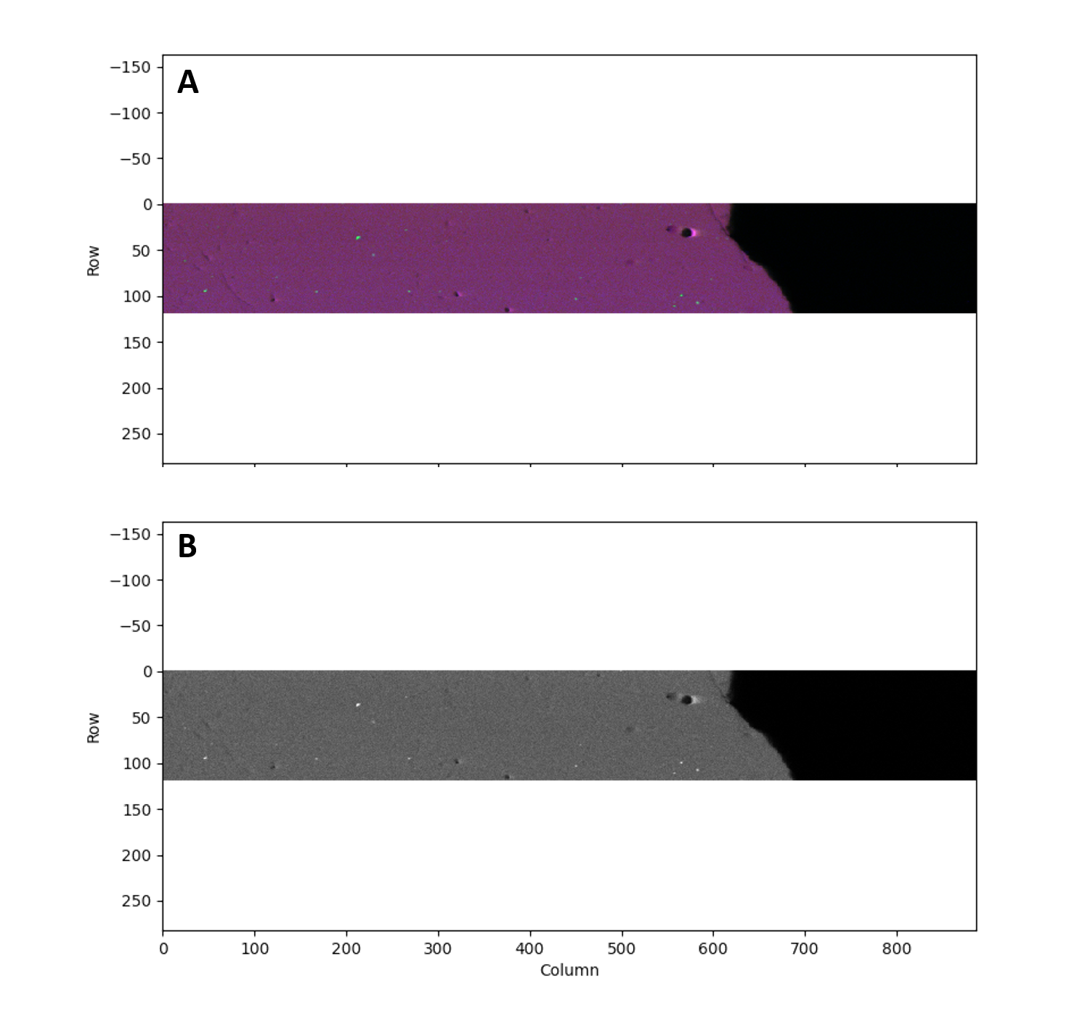
SI Figure 1: µXRF-generated elemental maps of ULV sample showing; A) hotspots of Cr (red = Ca, blue = Si, green = Cr), and B) hotspots of V (white spots). Axes values are pixels, with each pixel representing a 5x5 µm area on the sample.

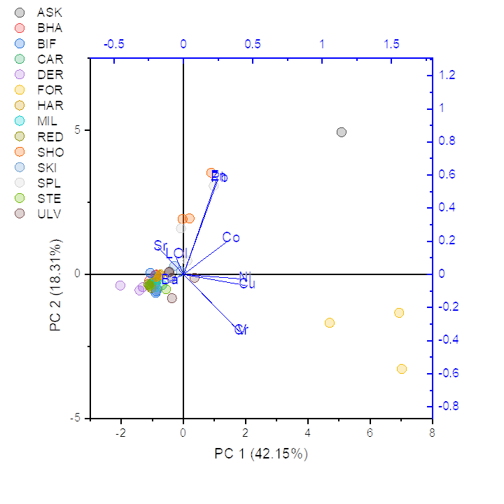
SI Figure 2: Principal component analysis (PCA) of slag composition by site.
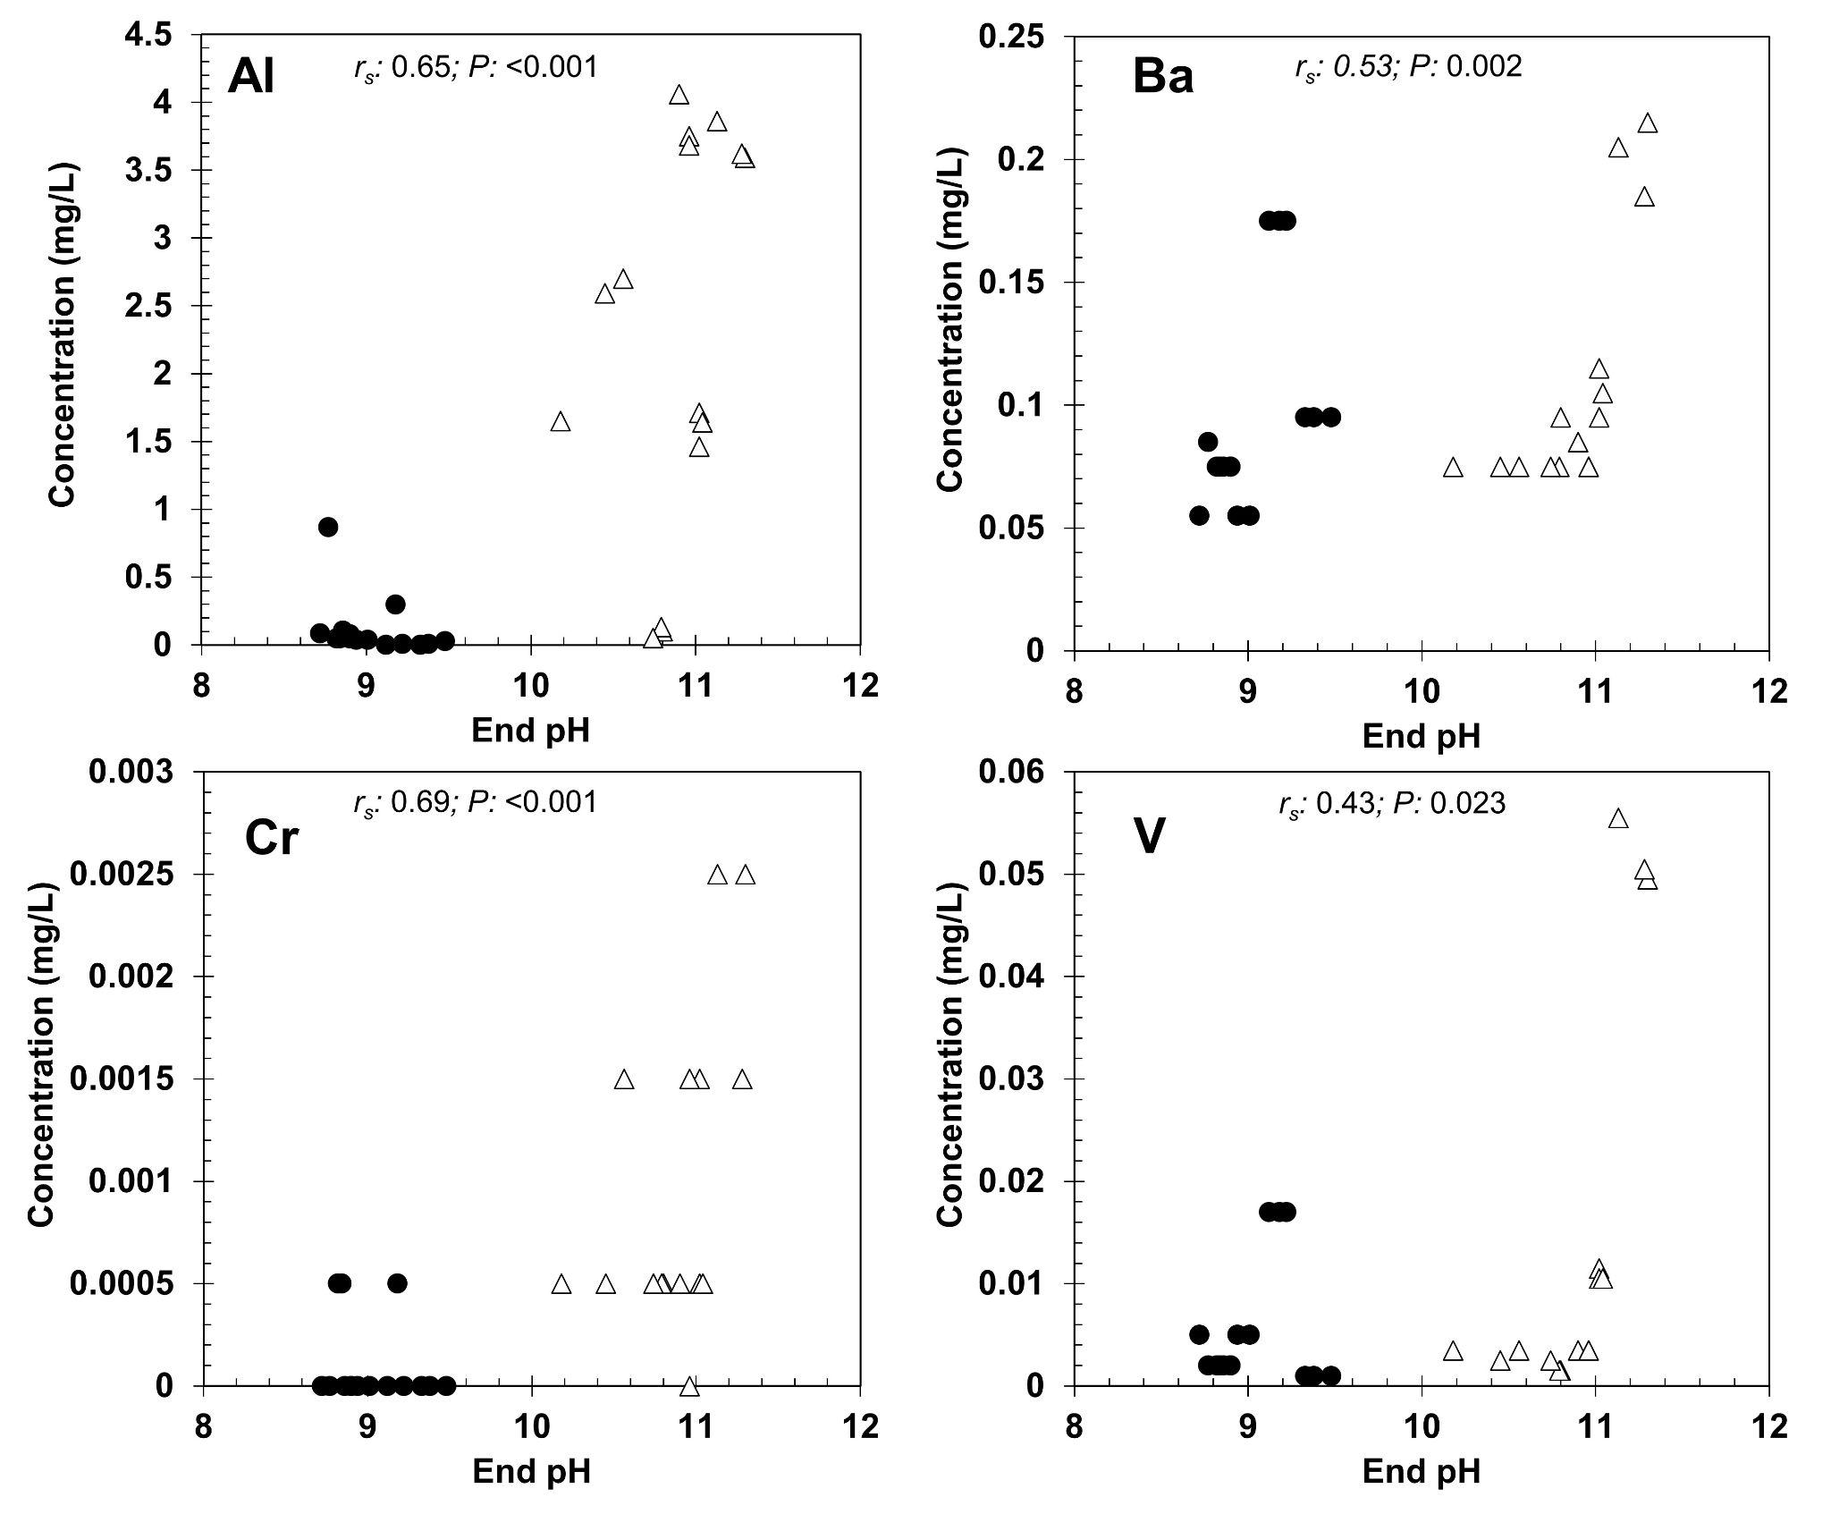

SI Figure 3: Relationship between final leaching test pH and selected elements. Closed circles show seawater treatments, open triangles show deionised water treatments. Spearman correlation coefficient and P value shown on each plot (degrees of freedom: 28 for each).
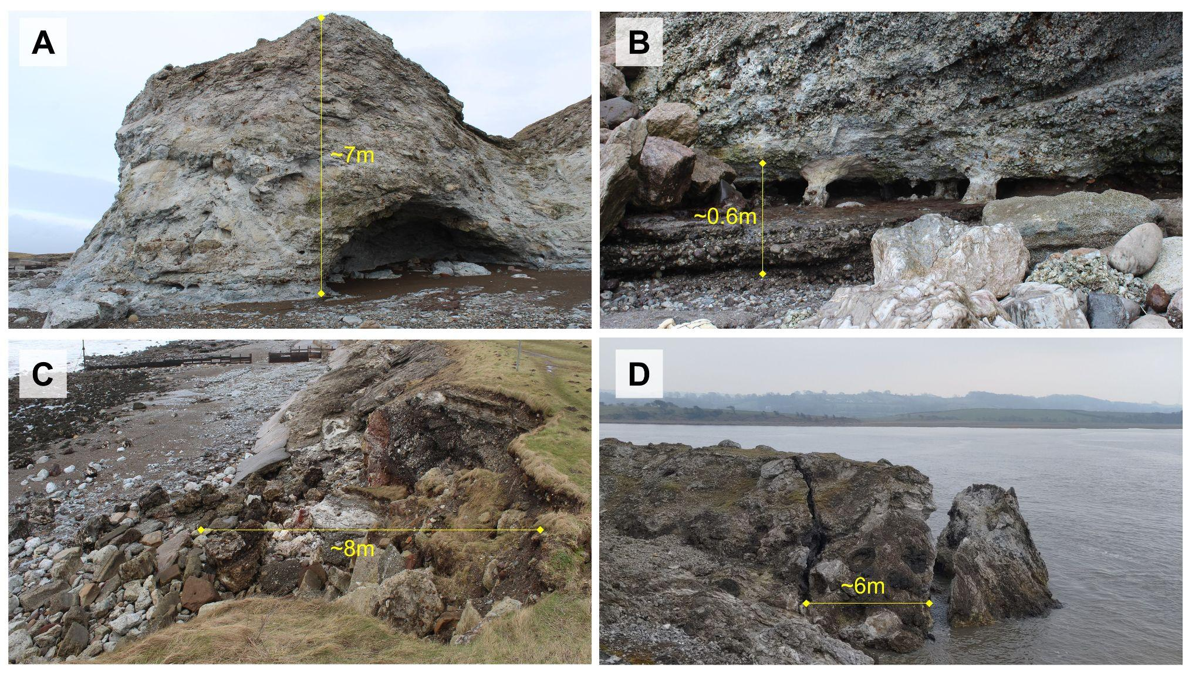
SI Figure 4: Example site photos showing: A: Major erosional feature developing in weathered slag at Harrington, Cumbria; B: Wave-cut platform and notch in slag at Derwent Howe, Cumbria (note also extensive secondary surface minerals); C: Erosion of slag cliff (and auxiliary concrete defence at base), Harrington, Cumbria; D: Tension crack and large block failure of slag bank at Carnforth, Lancashire, likely due to undermining of tidal flat deposits.

SI Table 1: SEM-EDS spot analysis used to identify phases present in XRD analysis and false-colour elemental maps in Figure 4. Elements present are shown as Atomic% and have been normalised to 100%.

Element  (Atomic %) | Melilite  (Ca,Na)₂(Al,Mg)[(Al,Si)SiO₇] | Larnite  Ca₂SiO₄ | Ca-Sulfide  CaS | CSiH  Ca-Si-Hydrate | Calcite  CaCO₃ | Thaumasite  Ca₃Si(OH)₆(CO₃)(SO₄).12H₂O
O | 57.7 ∓ 0.4 | 58.6 ∓ 0.6 | 27.9 ∓ 4.7 | 68.9 | 72.5 ∓ 1.0 | 70.9 ∓ 1.1
Na | 0.7 ∓ 0.1 | n.d. | n.d. | 0.2 | 0.3 ∓ 0.1 | 0.1 ∓ 0.2
Mg | 2.9 ∓ 0.5 | 0.1 ∓ 0.02 | n.d. | 2.63 | 0.2 ∓ 0.4 | 0.1 ∓ 0.1
Al | 10.0 ∓ 0.9 | n.d. | 0.3 ∓ 0.1 | n.d. | n.d. | 0.2 ∓ 0.1
Si | 12.5 ∓ 0.3 | 16.1 ∓ 1.0 | 1.9 ∓ 1.8 | 14.5 | 0.9 ∓ 1.6 | 5.8 ∓ 0.4
S | 0.1 ∓ 0.02 | n.d. | 33.7 ∓ 5.1 | 0.7 | 0.3 ∓ 0.3 | 8.7 ∓ 0.5
Ca | 16.5 ∓ 0.4 | 25.1 ∓ 1.7 | 35.9 ∓ 1.7 | 13.0 | 25.4 ∓ 2.6 | 13.7 ∓ 1.1
Ca/Si | 1.3 | 1.6 | - | 0.9 | - | 2.4
Ca/S | - | - | 1.1 | - | - | 1.6
N.d. = not detected; - = elemental ratio >10 (i.e. non-stoichiometric)

