Supplementary Information_1 (SI_1)

Energy from waste biomass: an LCA study on a bio-fuel cell at early design stage
Eleonora Rossi^{a,b}, Daniele Cespi^{a,b,*}, Irene Maggioreª, Leonardo Setti^{a,b} , Fabrizio Passarini^{a,b}
ª- Industrial Chemistry Deparment “Toso Montanari”, Alma Mater - Università di Bologna, Via Piero Gobetti, 85, 40136 Bologna (BO), Italy
^{b}- Interdepartmental Center for Industrial Research Renewable Sources, Environment, Sea and Energy, University of Bologna, via Angherà 22, 47922 Rimini (RN), Italy
Corresponding author: daniele.cespi2@unibo.it

Life Cycle Inventory

LCI Cell manufacturing

Table S 1: BFC set-up, material inventory.
Material | Quantity (g) | Process | Database
ABS (Acrylonitrile butadiene styrene) | 50 | Acrylonitrile-butadiene-styrene copolymer {RER}| acrylonitrile-butadiene-styrene copolymer production | APOS, U | ecoinvent 3
H₂O | 50 | Water, deionised {Europe without Switzerland} | market for water, deionised | APOS, U | ecoinvent 3
KCl | 10 | Potassium chloride, industrial grade {GLO}| market for potassium chloride, industrial grade | APOS, U | ecoinvent 3
Agar | 1.35 | Seaweed, agar, raw, processed in FR | Ambient (long) | LDPE | No preparation | at consumer/FR [Ciqual code: 11084] | AGRIBALYSE

Table S 2: LCI energy of BFC set-up (FU = 1p).
Step | Quantity (Wh) | Process | Database
Printer | 1270 | Electricity, medium voltage {IT}| electricity voltage transformation from high to medium voltage | APOS, U | ecoinvent 3
Freezer | 0.0045 | Electricity, medium voltage {IT}| electricity voltage transformation from high to medium voltage | APOS, U | ecoinvent 3
Heating magnetic stirrer | 8.86 | Electricity, medium voltage {IT}| electricity voltage transformation from high to medium voltage | APOS, U | ecoinvent 3

LCI Cell Use

Table S 3: LCI material of BFC system (FU = 9.08g treated biomass).
Material | Quantity (g) | Process | Database
INPUT
H₂O | 50.00 | Water, deionised {RoW}| market for water, deionised | APOS, U | ecoinvent 3
NaOH | xx* | Sodium hydroxide, without water, in 50% solution state {GLO}| market for | APOS, U | ecoinvent 3
PAN | xx* | Polyacrylonitrile fibres (PAN), from acrylonitrile and methacrylate, prod. mix, PAN w/o additives EU-27 S | ecoinvent 3
Electron acceptor | xx* | xx* | xx*
H₃PO₄ | xx* | Phosphoric acid, industrial grade, without water, in 85% solution state {RoW}| purification of wet-process phosphoric acid to industrial grade, product in 85% solution state | APOS, U | ecoinvent 3
AVOIDED PRODUCT
P₂O₅ fertilizer (from H₃PO₄) | 3.40 | Organic phosphorus fertiliser, as P₂O₅ {GLO}| inorganic phosphorus, as P₂O₅ to generic market for organic phosphorus, as P₂O₅ | APOS, U | ecoinvent 3
N fertilizer | 0.09 | Organic nitrogen fertiliser, as N {GLO}| inorganic nitrogen fertiliser, as N to generic market for organic nitrogen fertiliser, as N | APOS, U | ecoinvent 3
P₂O₅ fertilizer | 0.003 | Organic phosphorus fertiliser, as P₂O₅ {GLO}| inorganic phosphorus, as P₂O₅ to generic market for organic phosphorus, as P₂O₅ | APOS, U | ecoinvent 3
K₂O fertilizer | 0.03 | Organic potassium fertiliser, as K₂O {GLO}| inorganic potassium fertiliser, as K₂O to generic market for organic potassium fertiliser, as K₂O | APOS, U | ecoinvent 3

*: these data cannot be disclosed as they are present in the patent-pending Setti L, Maggiore I (2022) "Abiotic biofuel cell": European patent pending PCT/EP2023/083563 by ALMA MATER STUDIORUM - UNIVERSITY OF BOLOGNA

Table S 4: LCI energy of the BFC system (FU = 9.08g treated biomass) .
Step | Quantity (Wh) | Process | Database
INPUT
Heating magnetic stirrer (hydrolysis) | 11.97 | Electricity, medium voltage {IT}| electricity voltage transformation from high to medium voltage | APOS, U | ecoinvent 3
Heater | 0.06 | Electricity, medium voltage {IT}| electricity voltage transformation from high to medium voltage | APOS, U | ecoinvent 3
Heating magnetic stirrer (reaction) | 4.50 | Electricity, medium voltage {IT}| electricity voltage transformation from high to medium voltage | APOS, U | ecoinvent 3
Pump | 11.25 | Electricity, medium voltage {IT}| electricity voltage transformation from high to medium voltage | APOS, U | ecoinvent 3
AVOIDED PRODUCT
Produced energy | 5.40 | Electricity, medium voltage {IT}| electricity voltage transformation from high to medium voltage | APOS, U | ecoinvent 3

LCI Energy Optimization

Table S 5: Energy LCI of the baseline (Scenario 1) and the energy optimized configuration (Scenario 4)
Input | Scenario 1 (baseline) amount (Wh) | Scenario 4 energy optimized  amount (Wh)
Heating Magnetic Stirrer (Hydrolysis) | 11.96 | 0.00
Heater | 0.06 | 0.00
Heating Magnetic Stirrer (Reaction) | 4.50 | 0.00
Pump | 11.25 | 2.81

Life Cycle Impact Assessment

BFC Set-up
Table S 6: LCIA for the BFC set-up (FU = 1p), Cumulative Energy Demand V1.11.
Impact category | Unit | Total | Acrylonitrile-butadiene-styrene copolymer, ABS, at plant/RER U | water, deionised {Europe without Switzerland} | market for water, deionised | APOS, U | potassium chloride, industrial grade {GLO}| market for potassium chloride, industrial grade | APOS, U | Seaweed, agar, raw, processed in FR | Ambient (long) | LDPE | No preparation | at consumer/FR | _ Printer _ Electricity, medium voltage {IT}| electricity voltage transformation from high to medium voltage | APOS, U | _Freezer _ Electricity, medium voltage {IT}| electricity voltage transformation from high to medium voltage | APOS, U | _ Heating_plate _ Electricity, medium voltage {IT}| electricity voltage transformation from high to medium voltage | APOS, U
Total | MJ | 1.69E+01 | 5.17E+00 | 2.39E-04 | 6.13E-02 | 4.95E-01 | 1.11E+01 | 3.93E-05 | 7.74E-02
Non renewable, fossil | MJ | 1.33E+01 | 4.92E+00 | 1.96E-04 | 5.14E-02 | 1.39E-01 | 8.13E+00 | 2.88E-05 | 5.66E-02
Non-renewable, nuclear | MJ | 1.77E+00 | 2.24E-01 | 2.61E-05 | 5.44E-03 | 3.32E-01 | 1.20E+00 | 4.25E-06 | 8.35E-03
Non-renewable, biomass | MJ | 1.09E-03 | 1.80E-07 | 1.02E-08 | 2.03E-06 | 1.00E-06 | 1.08E-03 | 3.83E-09 | 7.52E-06
Renewable, biomass | MJ | 2.74E-01 | 8.89E-03 | 4.15E-06 | 8.25E-04 | 2.72E-03 | 2.59E-01 | 9.19E-07 | 1.81E-03
Renewable, wind, solar, geothe | MJ | 5.61E-01 | 4.42E-04 | 3.67E-06 | 8.61E-04 | 4.47E-03 | 5.52E-01 | 1.96E-06 | 3.85E-03
Renewable, water | MJ | 1.01E+00 | 1.42E-02 | 9.38E-06 | 2.76E-03 | 1.70E-02 | 9.65E-01 | 3.42E-06 | 6.72E-03

Table S 7: LCIA for the BFC set-up (FU = 1p), ReCiPe 2016 Endpoint (H) V1.08 / World (2010) H/A.
Damage category | Unit | Total | Acrylonitrile-butadiene-styrene copolymer, ABS, at plant/RER U | water, deionised {Europe without Switzerland}| market for water, deionised | APOS, U | potassium chloride, industrial grade {GLO}| market for potassium chloride, industrial grade | APOS, U | Seaweed, agar, raw, processed in FR | Ambient (long) | LDPE | No preparation | at consumer/FR | _ Printer _ Electricity, medium voltage {IT}| electricity voltage transformation from high to medium voltage | APOS, U | _Freezer _ Electricity, medium voltage {IT}| electricity voltage transformation from high to medium voltage | APOS, U | _ Heating_plate _ Electricity, medium voltage {IT}| electricity voltage transformation from high to medium voltage | APOS, U
Total | mPt | 2.58E+01 | 7.87E+00 | 2.15E-03 | 2.82E-01 | 5.15E-01 | 1.70E+01 | 6.02E-05 | 1.18E-01
Human health | mPt | 2.38E+01 | 7.20E+00 | 2.00E-03 | 2.20E-01 | 4.94E-01 | 1.57E+01 | 5.58E-05 | 1.10E-01
Ecosystems | mPt | 1.31E+00 | 3.63E-01 | 1.49E-04 | 5.91E-02 | 1.44E-02 | 8.63E-01 | 3.06E-06 | 6.01E-03
Resources | mPt | 6.94E-01 | 3.01E-01 | 8.53E-06 | 2.30E-03 | 7.08E-03 | 3.80E-01 | 1.35E-06 | 2.65E-03

BFC base scenario

Table S 8: LCIA for the BFC system (FU = 9.08g treated biomass), Cumulative Energy Demand V1.11.
Impact category | Unit | Total | water, deionised {RoW}| market for water, deionised | APOS, U | Sodium hydroxide, without water, in 50% solution state {GLO}| market for | APOS, U | Phosphoric acid, industrial grade, without water, in 85% solution state {RoW}| purification of wet-process phosphoric acid to industrial grade, product in 85% solution state | APOS, U | Electron aceptor | Polyacrylonitrile fibres (PAN), from acrylonitrile and methacrylate, prod. mix, PAN w/o additives EU-27 S | _ Heating_plate _Hydolysis_ Electricity, medium voltage {IT}| electricity voltage transformation from high to medium voltage | APOS, U | _ Heating_plate _Reaction_ Electricity, medium voltage {IT}| electricity voltage transformation from high to medium voltage | APOS, U | _Heater_ Electricity, medium voltage {IT}| electricity voltage transformation from high to medium voltage | APOS, U | _Pump _ Electricity, medium voltage {IT}| electricity voltage transformation from high to medium voltage | APOS, U | _Produced _ Electricity, medium voltage {IT}| electricity voltage transformation from high to medium voltage | APOS, U | organic phosphorus fertiliser, as P2O5 {GLO}| inorganic phosphorus, as P2O5 to generic market for organic phosphorus, as P2O5 | APOS, U | fertilizer from bio-fuel cell from biomass per kg bio-genic waste
Non renewable, fossil | MJ | 1.69E+00 | 2.00E-04 | 2.41E-02 | 9.02E-02 | 1.57E-02 | 2.05E-01 | 7.65E-02 | 2.88E-02 | 3.71E-04 | 7.20E-02 | -3.45E-02 | -1.14E-01 | -3.09E-03
Non-renewable, nuclear | MJ | 2.22E-01 | 2.06E-05 | 4.30E-03 | 4.43E-03 | 2.17E-03 | 1.85E-02 | 1.13E-02 | 4.25E-03 | 5.47E-05 | 1.06E-02 | -5.10E-03 | -4.93E-03 | -9.43E-05
Non-renewable, biomass | MJ | 1.30E-04 | 1.09E-08 | 1.86E-06 | 3.23E-05 | 2.50E-06 | 0.00E+00 | 1.02E-05 | 3.83E-06 | 4.93E-08 | 9.56E-06 | -4.59E-06 | -3.43E-05 | -3.57E-07
Renewable, biomass | MJ | 3.34E-02 | 4.75E-06 | 7.07E-04 | 2.66E-03 | 8.31E-04 | 5.34E-07 | 2.44E-03 | 9.19E-04 | 1.18E-05 | 2.30E-03 | -1.10E-03 | -2.73E-03 | -5.64E-05
Renewable, wind, solar, geothe | MJ | 6.64E-02 | 3.06E-06 | 5.88E-04 | 6.17E-04 | 2.90E-04 | 9.22E-05 | 5.20E-03 | 1.96E-03 | 2.52E-05 | 4.89E-03 | -2.35E-03 | -9.89E-04 | -1.65E-05
Renewable, water | MJ | 1.22E-01 | 1.06E-05 | 1.81E-03 | 3.47E-03 | 1.14E-03 | 2.28E-03 | 9.08E-03 | 3.42E-03 | 4.40E-05 | 8.54E-03 | -4.10E-03 | -4.14E-03 | -6.92E-05

Table 9: LCIA for the BFC system (FU = 9.08g treated biomass), ReCiPe 2016 Endpoint (H) V1.08 / World (2010) H/A.
Damage category | Unit | Total | water, deionised {RoW}| market for water, deionised | APOS, U | Sodium hydroxide, without water, in 50% solution state {GLO}| market for | APOS, U | Phosphoric acid, industrial grade, without water, in 85% solution state {RoW}| purification of wet-process phosphoric acid to industrial grade, product in 85% solution state | APOS, U | Electron Acceptor | Polyacrylonitrile fibres (PAN), from acrylonitrile and methacrylate, prod. mix, PAN w/o additives EU-27 S | _ Heating_plate _Hydolysis_ Electricity, medium voltage {IT}| electricity voltage transformation from high to medium voltage | APOS, U | _ Heating_plate _Reaction_ Electricity, medium voltage {IT}| electricity voltage transformation from high to medium voltage | APOS, U | _Heater_ Electricity, medium voltage {IT}| electricity voltage transformation from high to medium voltage | APOS, U | _Pump _ Electricity, medium voltage {IT}| electricity voltage transformation from high to medium voltage | APOS, U | _Produced _ Electricity, medium voltage {IT}| electricity voltage transformation from high to medium voltage | APOS, U | organic phosphorus fertiliser, as P2O5 {GLO}| inorganic phosphorus, as P2O5 to generic market for organic phosphorus, as P2O5 | APOS, U | fertilizer from bio-fuel cell from biomass per kg bio-genic waste
Total | mPt | 3.40E+00 | 2.18E-03 | 8.98E-02 | 5.11E-01 | 6.40E-02 | 2.58E-01 | 1.60E-01 | 6.02E-02 | 7.76E-04 | 1.51E-01 | -7.22E-02 | -3.96E-01 | -8.70E-03
Human health | mPt | 3.15E+00 | 2.02E-03 | 8.62E-02 | 4.90E-01 | 6.14E-02 | 2.37E-01 | 1.48E-01 | 5.58E-02 | 7.19E-04 | 1.40E-01 | -6.70E-02 | -3.76E-01 | -8.22E-03
Ecosystems | mPt | 1.63E-01 | 1.49E-04 | 2.78E-03 | 1.65E-02 | 2.07E-03 | 9.74E-03 | 8.13E-03 | 3.06E-03 | 3.94E-05 | 7.64E-03 | -3.67E-03 | -1.41E-02 | -3.27E-04
Resources | mPt | 8.76E-02 | 8.55E-06 | 7.71E-04 | 5.00E-03 | 5.53E-04 | 1.11E-02 | 3.58E-03 | 1.35E-03 | 1.74E-05 | 3.37E-03 | -1.62E-03 | -5.71E-03 | -1.47E-04

Table S 10: LCIA for the BFC system (FU = 9.08g treated biomass), ReCiPe 2016 Midpoint (H) V1.08 / World (2010) H/A.
Impact category | Unit | Total | water, deionised {RoW}| market for water, deionised | APOS, U | Sodium hydroxide, without water, in 50% solution state {GLO}| market for | APOS, U | Phosphoric acid, industrial grade, without water, in 85% solution state {RoW}| purification of wet-process phosphoric acid to industrial grade, product in 85% solution state | APOS, U | Electron Acceptor | Polyacrylonitrile fibres (PAN), from acrylonitrile and methacrylate, prod. mix, PAN w/o additives EU-27 S | _ Heating_plate _Hydolysis_ Electricity, medium voltage {IT}| electricity voltage transformation from high to medium voltage | APOS, U | _ Heating_plate _Reaction_ Electricity, medium voltage {IT}| electricity voltage transformation from high to medium voltage | APOS, U | _Heater_ Electricity, medium voltage {IT}| electricity voltage transformation from high to medium voltage | APOS, U | _Pump _ Electricity, medium voltage {IT}| electricity voltage transformation from high to medium voltage | APOS, U | _Produced _ Electricity, medium voltage {IT}| electricity voltage transformation from high to medium voltage | APOS, U | organic phosphorus fertiliser, as P2O5 {GLO}| inorganic phosphorus, as P2O5 to generic market for organic phosphorus, as P2O5 | APOS, U | fertilizer from bio-fuel cell from biomass per kg bio-genic waste
Global warming | kg CO₂ _{eq} | 1.03E-01 | 1.63E-05 | 2.10E-03 | 6.50E-03 | 1.37E-03 | 9.67E-03 | 5.39E-03 | 2.03E-03 | 2.61E-05 | 5.07E-03 | -2.43E-03 | -1.03E-02 | -2.60E-04
Stratospheric ozone depletion | kg CFC11 _{eq} | 1.65E-08 | 1.50E-11 | 2.27E-09 | 2.51E-09 | 1.23E-09 | 1.33E-08 | 4.16E-09 | 1.57E-09 | 2.02E-11 | 3.91E-09 | -1.88E-09 | -5.52E-08 | -1.50E-09
Ionizing radiation | kBq Co-60 _{eq} | 9.80E-04 | 1.05E-07 | 2.05E-05 | 5.14E-05 | 1.11E-05 | 3.11E-04 | 4.11E-05 | 1.55E-05 | 2.00E-07 | 3.87E-05 | -1.86E-05 | -3.71E-05 | -6.88E-07
Ozone formation, Human health | kg NOx _{eq} | 1.86E-04 | 3.72E-08 | 5.53E-06 | 1.99E-05 | 4.02E-06 | 2.50E-05 | 9.33E-06 | 3.51E-06 | 4.52E-08 | 8.78E-06 | -4.21E-06 | -2.60E-05 | -5.33E-07
Fine particulate matter formation | kg PM2.5_{eq} | 1.13E-04 | 3.89E-08 | 4.53E-06 | 2.35E-05 | 3.09E-06 | 8.22E-06 | 5.47E-06 | 2.06E-06 | 2.65E-08 | 5.14E-06 | -2.47E-06 | -1.78E-05 | -3.37E-07
Ozone formation, Terrestrial ecosystems | kg NOx_{eq} | 1.91E-04 | 3.78E-08 | 5.58E-06 | 2.03E-05 | 4.07E-06 | 2.54E-05 | 9.49E-06 | 3.57E-06 | 4.60E-08 | 8.93E-06 | -4.28E-06 | -2.65E-05 | -5.45E-07
Terrestrial acidification | kg SO_{2eq} | 3.26E-04 | 9.06E-08 | 7.66E-06 | 6.48E-05 | 5.43E-06 | 2.67E-05 | 1.63E-05 | 6.12E-06 | 7.89E-08 | 1.53E-05 | -7.35E-06 | -4.76E-05 | -9.97E-07
Freshwater eutrophication | kg P _{eq} | 1.60E-06 | 6.50E-10 | 1.16E-07 | 3.89E-07 | 8.07E-08 | 7.89E-09 | 1.43E-07 | 5.37E-08 | 6.92E-10 | 1.34E-07 | -6.44E-08 | -1.21E-06 | -9.32E-09
Marine eutrophication | kg N _{eq} | 1.64E-06 | 2.68E-10 | 4.27E-08 | 1.09E-07 | 2.91E-08 | 3.44E-07 | 5.05E-08 | 1.90E-08 | 2.45E-10 | 4.75E-08 | -2.28E-08 | -1.67E-07 | -8.83E-09
Terrestrial ecotoxicity | kg 1,4-DCB | 7.11E-02 | 5.67E-05 | 3.92E-03 | 4.32E-02 | 4.62E-03 | 1.65E-03 | 2.98E-03 | 1.12E-03 | 1.45E-05 | 2.80E-03 | -1.35E-03 | -2.71E-02 | -6.08E-04
Freshwater ecotoxicity | kg 1,4-DCB | 7.03E-05 | 6.48E-08 | 1.74E-06 | 4.24E-05 | 2.55E-06 | 7.15E-07 | 1.39E-06 | 5.24E-07 | 6.76E-09 | 1.31E-06 | -6.29E-07 | -1.88E-05 | -3.92E-07
Marine ecotoxicity | kg 1,4-DCB | 1.81E-04 | 1.27E-07 | 4.96E-06 | 1.02E-04 | 7.05E-06 | 6.41E-06 | 5.31E-06 | 2.00E-06 | 2.58E-08 | 5.00E-06 | -2.40E-06 | -4.43E-05 | -8.41E-07
Human carcinogenic toxicity | kg 1,4-DCB | 1.95E-03 | 6.21E-07 | 3.76E-05 | 1.39E-03 | 6.58E-05 | 4.60E-06 | 3.52E-05 | 1.33E-05 | 1.71E-07 | 3.31E-05 | -1.59E-05 | -1.95E-04 | -4.63E-06
Human non-carcinogenic toxicity | kg 1,4-DCB | 1.86E-02 | 8.85E-06 | 5.86E-04 | 1.21E-02 | 8.16E-04 | 1.19E-04 | 5.98E-04 | 2.25E-04 | 2.90E-06 | 5.63E-04 | -2.70E-04 | -3.52E-03 | -5.93E-05
Land use | m²a crop _{eq} | 1.72E-02 | 9.35E-07 | 1.45E-04 | 2.05E-03 | 1.91E-04 | 0.00E+00 | 1.06E-03 | 4.00E-04 | 5.16E-06 | 1.00E-03 | -4.80E-04 | -7.85E-04 | -1.41E-05
Mineral resource scarcity | kg Cu _{eq} | 7.43E-05 | 1.44E-07 | 6.69E-06 | 2.86E-04 | 1.49E-05 | 7.88E-07 | 3.54E-06 | 1.33E-06 | 1.72E-08 | 3.33E-06 | -1.60E-06 | -2.95E-04 | -3.42E-06
Fossil resource scarcity | kg oil _{eq} | 3.65E-02 | 4.37E-06 | 5.25E-04 | 1.97E-03 | 3.41E-04 | 4.00E-03 | 1.67E-03 | 6.29E-04 | 8.11E-06 | 1.57E-03 | -7.55E-04 | -2.49E-03 | -6.76E-05
Water consumption | m³ | 5.49E-03 | 3.49E-05 | 5.60E-05 | 6.02E-04 | 2.89E-05 | 1.66E-07 | 1.05E-04 | 3.93E-05 | 5.07E-07 | 9.83E-05 | -4.72E-05 | -1.46E-04 | -5.33E-06

Table S 11: LCIA for the BFC system (FU = 9.08g treated biomass) Scenario 1 comparison: 10c (cycles), 237c and 4750c, Cumulative Energy Demand V1.11.
Impact category | Unit | 10c | 237c | 4750c
Non renewable, fossil | MJ | 1.33E+00 | 5.61E-02 | 2.80E-03
Non-renewable, nuclear | MJ | 1.77E-01 | 7.46E-03 | 3.72E-04
Non-renewable, biomass | MJ | 1.09E-04 | 4.60E-06 | 2.30E-07
Renewable, biomass | MJ | 2.74E-02 | 1.15E-03 | 5.76E-05
Renewable, wind, solar, geothe | MJ | 5.61E-02 | 2.37E-03 | 1.18E-04
Renewable, water | MJ | 1.01E-01 | 4.24E-03 | 2.12E-04
Table S 12: LCIA for the BFC system (FU = 9.08g treated biomass) Scenario 1 comparison: 10c (cycles), 237c and 4750c, ReCiPe 2016 Endpoint (H) V1.08 / World (2010) H/A.
Damage category | Unit | 10c | 237c | 4750c
Total | mPt | 2.58E+00 | 1.09E-01 | 5.43E-03
Human health | mPt | 2.38E+00 | 1.00E-01 | 5.01E-03
Ecosystems | mPt | 1.31E-01 | 5.51E-03 | 2.75E-04
Resources | mPt | 6.94E-02 | 2.93E-03 | 1.46E-04

Table S 13: LCIA for the BFC system (FU = 9.08g treated biomass) Scenario 1 comparison: 10c (cycles), 237c and 4750c, ReCiPe 2016 Midpoint (H) V1.08 / World (2010) H/A.
Impact category | Unit | 10c | 237c | 4750c
Global warming | kg CO₂ _{eq} | 8.36E-02 | 3.53E-03 | 2.08E-04
Stratospheric ozone depletion | kg CFC11 _{eq} | 4.61E-08 | 1.95E-09 | 8.43E-11
Ionizing radiation | kBq Co-60 _{eq} | 5.47E-04 | 2.31E-05 | 8.49E-07
Ozone formation, Human health | kg NOx _{eq} | 1.40E-04 | 5.92E-06 | 2.95E-07
Fine particulate matter formation | kg PM2.5_{eq} | 8.14E-05 | 3.43E-06 | 2.53E-08
Ozone formation, Terrestrial ecosystems | kg NOx_{eq} | 1.45E-04 | 6.12E-06 | 3.06E-07
Terrestrial acidification | kg SO_{2eq} | 2.40E-04 | 1.01E-05 | 5.05E-07
Freshwater eutrophication | kg P _{eq} | 1.96E-06 | 8.26E-08 | 4.12E-09
Marine eutrophication | kg N _{eq} | 1.19E-06 | 5.03E-08 | 2.51E-09
Terrestrial ecotoxicity | kg 1,4-DCB | 3.98E-02 | 1.68E-03 | 3.58E-05
Freshwater ecotoxicity | kg 1,4-DCB | 3.94E-05 | 1.66E-06 | 6.38E-08
Marine ecotoxicity | kg 1,4-DCB | 9.53E-05 | 4.02E-06 | 4.51E-08
Human carcinogenic toxicity | kg 1,4-DCB | 5.93E-04 | 2.50E-05 | 1.37E-08
Human non-carcinogenic toxicity | kg 1,4-DCB | 7.46E-03 | 3.15E-04 | 6.56E-07
Land use | m²a crop _{eq} | 1.36E-02 | 5.75E-04 | 2.87E-05
Mineral resource scarcity | kg Cu _{eq} | 5.75E-05 | 2.43E-06 | 9.85E-08
Fossil resource scarcity | kg oil _{eq} | 2.91E-02 | 1.23E-03 | 6.12E-05
Water consumption | m³ | 4.73E-03 | 1.99E-04 | 9.95E-06

Reagents changing (Scenario 2) and uncertainty analysis

Table S 14: LCIA for the BFC system (FU = 9.08g treated biomass), Scenario 2 (III) HNO3+KOH, Cumulative Energy Demand V1.11.
Impact category | Unit | Potassium hydroxide {GLO}| market for | APOS, U | Nitric acid, without water, in 50% solution state {RoW}| nitric acid production, product in 50% solution state | APOS, U | organic nitrogen fertiliser, as N {GLO}| inorganic nitrogen fertiliser, as N to generic market for organic nitrogen fertiliser, as N | APOS, U | organic potassium fertiliser, as K2O {GLO}| inorganic potassium fertiliser, as K2O to generic market for organic potassium fertiliser, as K2O | APOS, U
Non renewable, fossil | MJ | 7.50E-02 | 3.53E-02 | -5.37E-02 | -7.02E-02
Non-renewable, nuclear | MJ | 8.85E-03 | 7.89E-04 | -1.56E-03 | -2.63E-03
Non-renewable, biomass | MJ | 4.49E-06 | 8.43E-07 | -6.02E-06 | -8.43E-06
Renewable, biomass | MJ | 2.18E-03 | 7.08E-04 | -9.44E-04 | -1.51E-03
Renewable, wind, solar, geothe | MJ | 1.21E-03 | 9.86E-05 | -2.76E-04 | -4.45E-04
Renewable, water | MJ | 3.87E-03 | 4.07E-04 | -1.15E-03 | -1.87E-03

Table S 15: LCIA for the BFC system (FU = 9.08g treated biomass), Scenario 2 (III) HNO3+KOH, ReCiPe 2016 Endpoint (H) V1.08 / World (2010) H/A.
Damage category | Unit | Potassium hydroxide {GLO}| market for | APOS, U | Nitric acid, without water, in 50% solution state {RoW}| nitric acid production, product in 50% solution state | APOS, U | organic nitrogen fertiliser, as N {GLO}| inorganic nitrogen fertiliser, as N to generic market for organic nitrogen fertiliser, as N | APOS, U | organic potassium fertiliser, as K2O {GLO}| inorganic potassium fertiliser, as K2O to generic market for organic potassium fertiliser, as K2O | APOS, U
Total | mPt | 2.39E-01 | 1.60E-01 | -1.46E-01 | -2.35E-01
Human health | mPt | 2.28E-01 | 1.51E-01 | -1.38E-01 | -2.22E-01
Ecosystems | mPt | 7.83E-03 | 6.79E-03 | -5.46E-03 | -8.91E-03
Resources | mPt | 2.96E-03 | 1.50E-03 | -2.55E-03 | -3.36E-03
Table S 15: LCIA for the BFC system (FU = 9.08g treated biomass), Scenario 2 (III) HNO3+KOH, ReCiPe 2016 Endpoint (H) V1.08 / World (2010) H/A.

Table S 16: LCIA for the BFC system (FU = 9.08g treated biomass), Scenario 3 comparison of traditional Italian energy mix, 50%PV and 100%PV, Cumulative Energy Demand V1.11.
Impact category | Unit | 50%PV |  | 100%PV
Impact category | Unit | Electricity, medium voltage {IT}| electricity voltage transformation from high to medium voltage | APOS, U | Electricity, low voltage, label-certified {CH}| electricity production, photovoltaic, 3kWp slanted-roof installation, single-Si, panel, mounted, label-certified | APOS, U | Electricity, low voltage, label-certified {CH}| electricity production, photovoltaic, 3kWp slanted-roof installation, single-Si, panel, mounted, label-certified | APOS, U
Non renewable, fossil | MJ | 8.88E-02 | 1.55E-02 | 3.10E-02
Non-renewable, nuclear | MJ | 1.31E-02 | 2.04E-03 | 4.09E-03
Renewable, water | MJ | 1.05E-02 | 1.91E-03 | 3.89E-06
Renewable, wind, solar, geothe | MJ | 6.03E-03 | 5.37E-02 | 1.10E-03
Renewable, biomass | MJ | 2.84E-03 | 5.52E-04 | 1.07E-01
Non-renewable, biomass | MJ | 1.18E-05 | 1.94E-06 | 3.81E-03

Table S 17: LCIA for the BFC system (FU = 9.08g treated biomass), Scenario 3 comparison of traditional Italian energy mix, 50%PV and 100%PV, ReCiPe 2016 Endpoint (H) V1.08 / World (2010) H/A.
Damage category | Unit | 50%PVr |  | 100%PVr
Damage category | Unit | Electricity, medium voltage {IT}| electricity voltage transformation from high to medium voltage | APOS, U | Electricity, low voltage, label-certified {CH}| electricity production, photovoltaic, 3kWp slanted-roof installation, single-Si, panel, mounted, label-certified | APOS, U | Electricity, low voltage, label-certified {CH}| electricity production, photovoltaic, 3kWp slanted-roof installation, single-Si, panel, mounted, label-certified | APOS, U
Total | mPt | 1.86E-01 | 5.84E-02 | 1.17E-01
Human health | mPt | 1.72E-01 | 5.59E-02 | 1.12E-01
Ecosystems | mPt | 9.43E-03 | 1.88E-03 | 3.77E-03
Resources | mPt | 4.16E-03 | 5.87E-04 | 1.17E-03

Energy Optimization

  - Comparison with traditional biomass treatment scenarios
Table S 18: LCIA for the BFC system (FU = 9.08g treated biomass), comparison between the BFCs and the traditional alternatives for the treatment of biowaste, Cumulative Energy Demand v1.11.
Impact category | Unit | AD 10km | AD 50km | AD 100km | COM 10km | COM 50km | COM 100km | BFC 4750c (0) H₃PO₄+NaOH | BFC 4750c (0) H₃PO₄+NaOH_50%PV | BFC 4750c (III) HNO₃+KOH | BFC 4750c (0) H₃PO₄+NaOH_En.Opt.
Non renewable, fossil | MJ | -1.83E-03 | 2.82E-05 | 2.35E-03 | 1.52E-03 | 3.42E-03 | 5.79E-03 | 1.54E-01 | 8.09E-02 | 1.58E-01 | -7.90E-04
Non-renewable, nuclear | MJ | -1.22E-02 | -1.22E-02 | -1.21E-02 | 4.06E-04 | 4.31E-04 | 4.62E-04 | 2.72E-02 | 1.62E-02 | 2.96E-02 | 3.83E-03
Non-renewable, biomass | MJ | -6.05E-05 | -6.05E-05 | -6.04E-05 | -3.55E-07 | -3.09E-07 | -2.50E-07 | 2.07E-05 | 1.09E-05 | 1.68E-05 | 4.41E-08
Renewable, biomass | MJ | -5.79E-03 | -5.79E-03 | -5.78E-03 | 5.95E-04 | 6.01E-04 | 6.08E-04 | 5.96E-03 | 3.68E-03 | 5.99E-03 | 9.48E-04
Renewable, wind, solar, geothe | MJ | -6.69E-05 | -6.22E-05 | -5.64E-05 | 6.47E-05 | 6.79E-05 | 7.19E-05 | 1.03E-02 | 5.80E-02 | 1.08E-02 | -5.14E-04
Renewable, water | MJ | -2.91E-04 | -2.77E-04 | -2.60E-04 | 1.07E-04 | 1.19E-04 | 1.35E-04 | 1.93E-02 | 1.07E-02 | 2.02E-02 | 4.67E-04

Table S 19: LCIA for the BFC system (FU = 9.08g treated biomass), comparison between the BFCs and the traditional alternatives for the treatment of biowaste, ReCiPe 2016 Endpoint (H) V1.08 / World (2010) H/A.
Damage category | Unit | AD 10km | AD 50km | AD 100km | COM 10km | COM 50km | COM 100km | BFC 4750c (0) H₃PO₄+NaOH | BFC 4750c (0) H₃PO₄+NaOH_50%PV | BFC 4750c (III) HNO₃+KOH | BFC 4750c (0) H₃PO₄+NaOH_En.Opt.
Total | mPt | 1.69E-02 | 2.08E-02 | 2.56E-02 | 6.04E-02 | 6.44E-02 | 6.95E-02 | 5.54E-01 | 4.27E-01 | 3.54E-01 | 1.69E-02
Human health | mPt | 2.32E-02 | 2.67E-02 | 3.12E-02 | 5.76E-02 | 6.13E-02 | 6.60E-02 | 5.25E-01 | 4.09E-01 | 3.31E-01 | 2.32E-02
Ecosystems | mPt | -6.05E-03 | -5.89E-03 | -5.70E-03 | 2.70E-03 | 2.85E-03 | 3.05E-03 | 2.20E-02 | 1.45E-02 | 1.58E-02 | -6.05E-03
Resources | mPt | -1.90E-04 | -6.43E-05 | 9.24E-05 | 1.38E-04 | 2.63E-04 | 4.20E-04 | 7.09E-03 | 3.53E-03 | 6.61E-03 | -1.90E-04

Supplementary Figures – Monte Carlo analysis

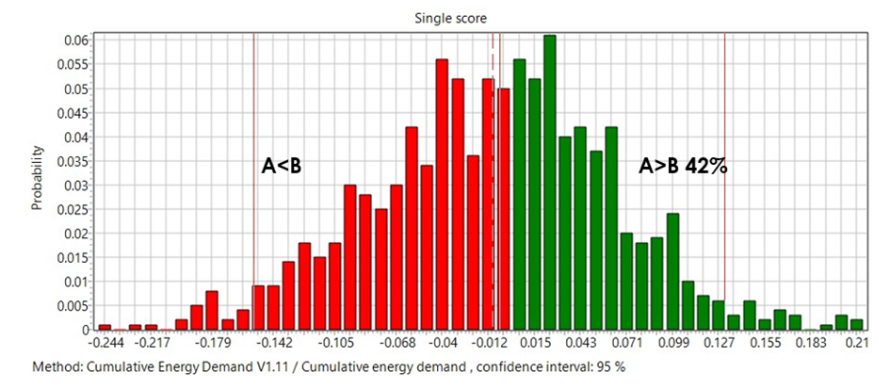
Fig. S 1: Monte Carlo analysis fuel cell use 4750c Scen A= (baseline, 0) H₃PO₄+NaOH and Scen B= (III) HNO₃+KOH; method: Cumulative Energy Demand V1.11.
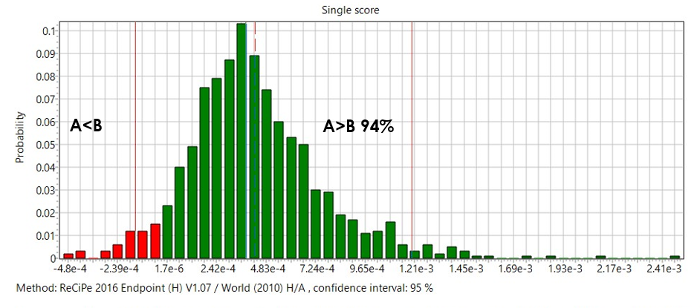
Fig. S 2: Monte Carlo analysis fuel cell use 4750c Scen A= (baseline, 0) H₃PO₄+NaOH and Scen B= (III) HNO₃+KOH; method: ReCiPe 2016 Endpoint (H) V1.08/ World (2010) H/A.

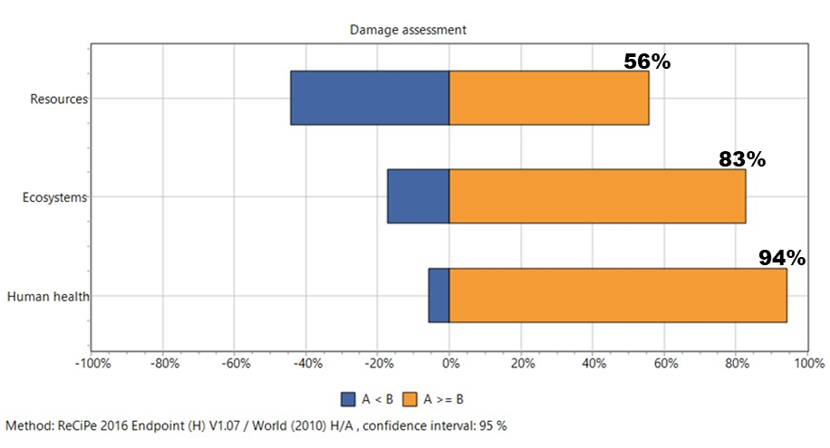
Fig. S 3: Monte Carlo analysis fuel cell use 4750c Scen A= (baseline, 0) H₃PO₄+NaOH and Scen B= (III) HNO₃+KOH; method: ReCiPe 2016 Endpoint (H) V1.08 / World (2010) H/A, Damage assessment.

Supplementary Figures – Energy substitution and optimization
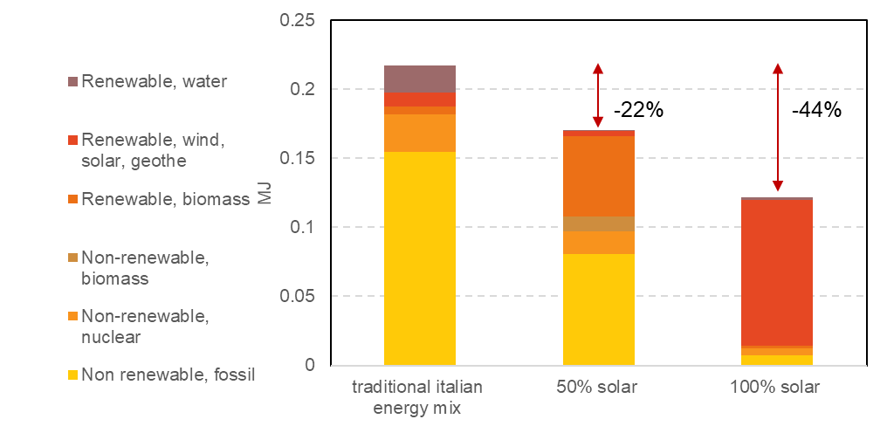
Fig. S 4: LCIA for the BFC system (FU = 9.08g treated biomass), Scenario 3 comparison of traditional Italian energy mix, 50%PV and 100%PV, Cumulative Energy Demand V1.11.
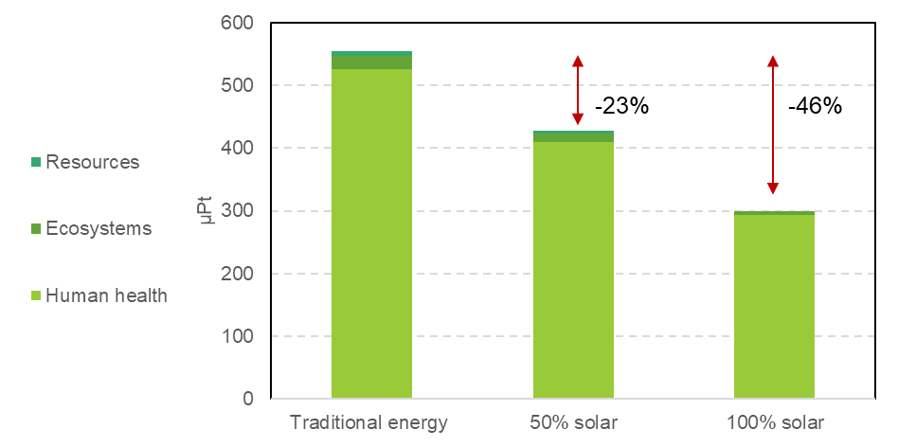
Fig. S 5: LCIA for the BFC system (FU = 9.08g treated biomass), Scenario 3 comparison of traditional Italian energy mix, 50%PV and 100%PV, ReCiPe 2016 Endpoint (H) V1.08 / World (2010) H/A.

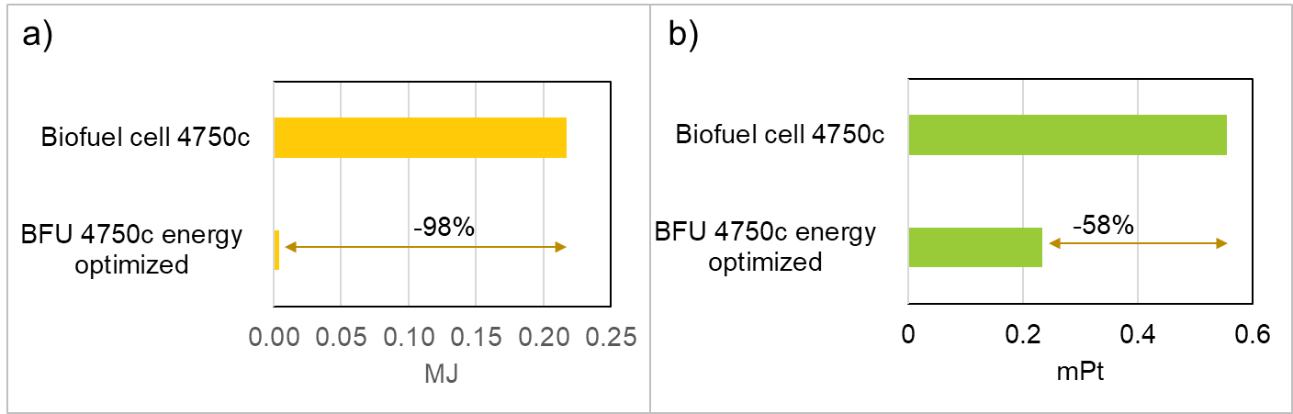
Fig. S 6: LCIA for the BFC system (FU = 9.08g treated biomass), Scenario 4 comparison between baseline and the energy optimized configuration in terms of a) Cumulative Energy Demand v1.11 and b) ReCiPe 2016 Endpoint (H) v1.08 / World (2010) H/A.

