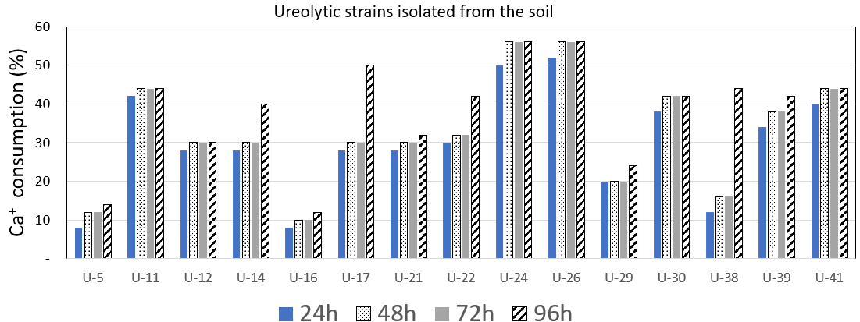
(a)
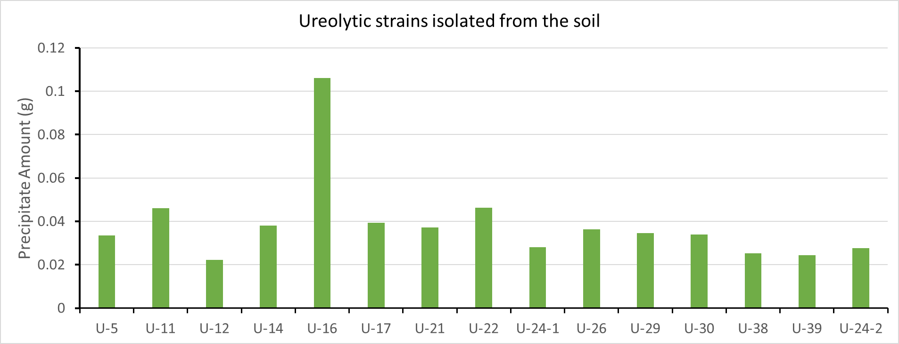
(b)
Figure S3. Study of ureolytic strains isolated from the soil: (a)Calcium ion consumption in time; (b) Precipitate amount.

