Supplementary Information (SI)
Resources recovery from domestic wastewater by a combined process: anaerobic digestion and membrane photobioreactor
Environmental Science and Pollution Research
Elvira Ferrera¹, Ignacio Ruigómez¹, Carolina Vela-Bastos^{2,3}, Alice Ferreira², Luisa Gouveia^{2,3}, Luisa Vera^{1*}
¹ Departamento de Ingeniería Química y Tecnología Farmacéutica, Facultad de Ciencias, Universidad de La Laguna, Avenida Astrofísico Francisco Sánchez s/n, 38206 La Laguna, Spain. E-mail: eferrera@ull.es ; isempere@ull.es; luvera@ull.edu.es
² LNEG - UBB - National Laboratory of Energy and Geology I.P., Bioenergy and Biorefineries Unit, Estrada do Paço do Lumiar 22, 1649-038 Lisbon, Portugal. E-mail: alice.ferreira@lneg.pt; luisa.gouveia@lneg.pt
³ GreenCoLab - Green Ocean Technologies and Products Collaborative Laboratory, CCMAR, Algarve University, Portugal. E-mail: carolinabastos@greencolab.com
*Corresponding author. E-mail address: luvera@ull.edu.es

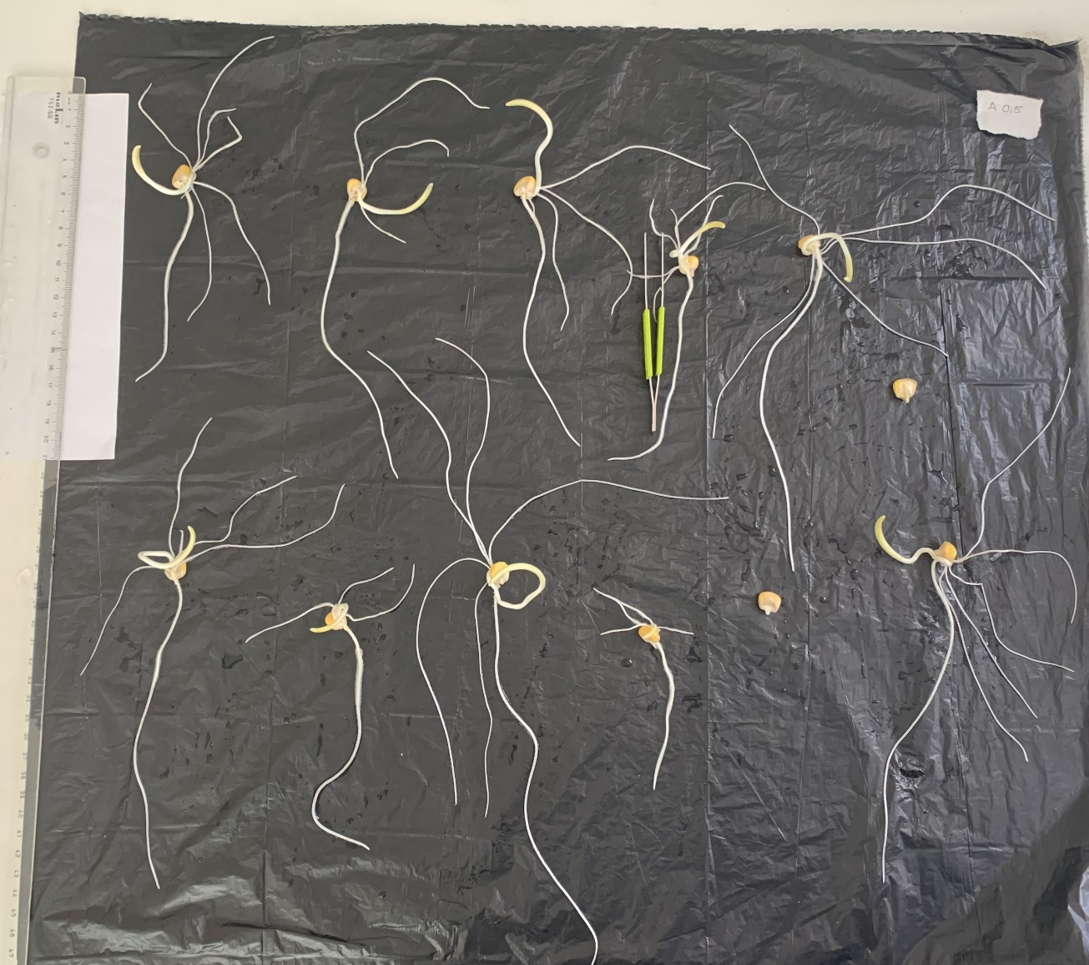
Figure S2. Germinated seeds.

