Comparative Analysis of Bacterial Populations in Sulfonylurea-Sensitive and -Resistant Weeds: Insights into Community Composition and Catabolic Gene Dynamics

Jan Homa^{a*}, Wiktoria Wilms^{a,b}, Katarzyna Marcinkowska^{c}, Paweł Cyplik^{d}, Łukasz Ławniczakª, Marta Woźniak-Karczewskaª, Michał Niemczakª, Łukasz Chrzanowskiª

ªDepartment of Chemical Technology, Poznan University of Technology, 60-965 Poznan, Poland
^{b}Institute for Environmental Studies, Faculty of Science, Charles University in Prague, 128 01 Prague, Czech Republic
^{c}Department of Weed Science, Institute of Plant Protection – National Research Institute, 60-318 Poznan, Poland
^{d}Department of Food Technology of Plant Origin, Poznan University of Life Sciences, 60-624 Poznan, Poland
*corresponding author: jan.j.homa@doctorate.put.poznan.pl; Department of Chemical Technology, Poznan University of Technology, Berdychowo 4, 60-965 Poznań, Poland

Table S1 Genes, primer names, and primer sequences used for PCR analysis.
Gene name | Primer name | Primer Sequence | Ref.
sulE | sulEF1 | 5’-CTGATTGCATATGGAAACTGACAACGTGGAGCT-3’ | [1]
sulE | sulER1 | 5’-TACAAGCTTGCTTTCGTTCTGATCTAAGC-3’ | [1]
vegetative  catalase 1 | veg2F | 5’-GGAATTCATGAGTTCAAATAAACTGACAAC-3’ | [1]
vegetative  catalase 1 | veg2R | 5’-CCGCTCGAGTTAAGAATCTTTTTTAATCGGC-3’; | [1]
Acetoin  dehydrogenase E1 | adE2F | 5’-CGGGATCCATGGCGAGAGTCATAAGCATGTC-3’ | [1]
Acetoin  dehydrogenase E1 | adE2R | 5’-CCGCTCGAGTTAATTCAATGCCGGCTCGC-3’ | [1]
manganese  ABC transporter | mABCtF | 5’-CATGCATATGAAAAGCGCTGATCAGCAA-3’ | [2]
manganese  ABC transporter | mABCtR | 5’-CATGCTCGAGTTATTTAGTAATCG-3’ | [2]
Vegetative  catalase 1 | veg1F | 5’-CATGCATATGAGTTCAAATAAACTGACA-3’ | [2]
Vegetative  catalase 1 | veg1R | 5’-CATGCTCGAGTTAAGAATCTTTTTTAATCGGCAA-3’ | [2]
acetoin dehydrogenase E1 | adE1F | 5’-CATGCATATGGCGAGAGTCATAAGC-3’ | [2]
acetoin dehydrogenase E1 | adE1R | 5’-CATGCTCGAGTTAGGCTCGC-3’ | [2]
P450SU1 and its adjacent ferredoxin, Fd1 (CYP 105A1 gene) | P450SU1-Fd1F | 5’-GTCATATGACCGATACCGCCACGACG-3’ | [3]
P450SU1 and its adjacent ferredoxin, Fd1 (CYP 105A1 gene) | P450SU1-Fd1R | 5’-CTGGATCCTATTCCGTGTCCTCGACG-3’ | [3]

Table S2 Primers and corresponding temperatures optimised for PCR use.
Primer pair name | Temperature [°C]
Sul E1 | 56
mABCt-1 | 65
Veg-1 | 58
Veg-2 | 56
AdE1 | 58
adE2 | 65
P450 SU-1 | 65

Table S3 Genes, primer names, and primer sequences used for qPCR analysis.
Target Gene | Primer name | Forward sequence | Reverse sequence
sulE | Hz-sulE | 5’-CGACGGCCTGAAAAGAGGAT-3’ | 5’-AGGAACAGAGGGCCGATACT-3’
manganese  ABC transporter | Bs-ABC | 5’-CTGCTGCATCGGCAATTTGA-3’ | 5’-TGGCAGCAGTACTTTTTGCG-3’
Vegetative  catalase 1 | Bs-vegcat | 5’-CGATTTGGCGCAGCTTGATT-3’ | 5’-TCAAGCCGGCGATCTGTATC-3’
acetoin dehydrogenase E1 | Bs-Actdh | 5’-GAAAGAGCAAGAAACGGCGG-3’ | 5’-AGGTGCTCAACTCTTTCATCC-3’
16 S rRNA | F968 Forward R1401 Reverse | 5’-AACGCGAAGAACCTTAC-3’ | 5’-CGGTGTGTACAAGACCC-3’

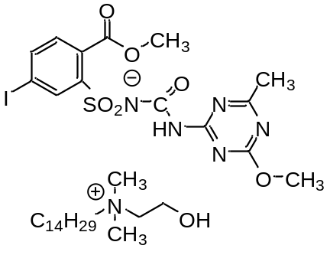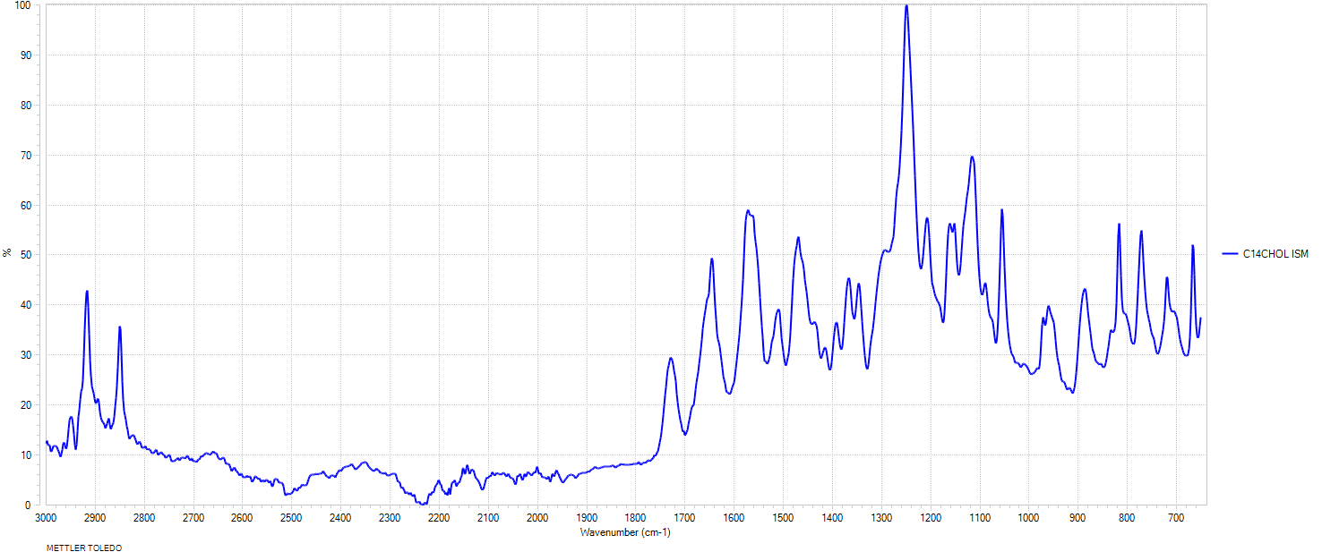
IR υ_{max} [cm⁻¹] = 2953, 2915, 2850, 1729, 1646, 1571, 1510, 1468, 1392, 1366, 1348, 1249, 1206, 1161, 1152, 1114, 1090, 1055, 971, 960, 885, 816, 772, 720, 667.

Fig. S1 FTIR spectrum of N-tetradecylcholine iodosulfuron-methyl [C₁₄CHOL][ISM].

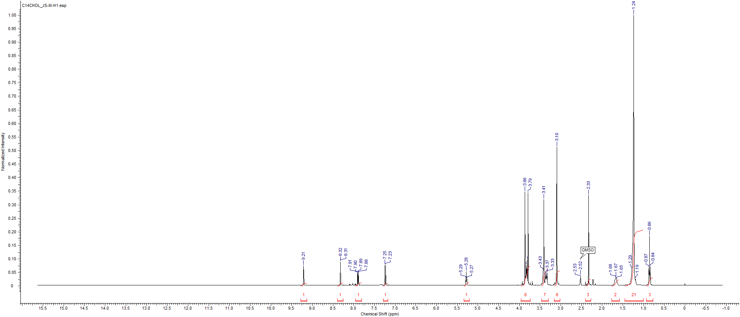
¹H NMR (400 MHz, DMSO-d₆) δ [ppm] = 0.86 (3H, t, J = 6.8 Hz); 1.24 (21H, m); 1.67 (2H, m); 2.33 (3H, s); 3.10 (6H, s); 3.41 (7H, m); 3.83 (8H, m); 5.28 (1H, m); 7.24 (1H, d, J = 8.1 Hz); 7.90 (1H, dd, J₁₂ = 8.0 Hz, J₁₃ = 1.7 Hz); 8.31 (1H, d, J = 1.8 Hz), 9.21 (1H, s).

Fig. S2 ¹H NMR spectrum of N-tetradecylcholine iodosulfuron-methyl [C₁₄CHOL][ISM].

¹³C NMR (100 MHz, CD₃OD) δ [ppm] = 13.9, 21.8, 22.1, 25.1, 25.8, 28.7, 29.0, 31.3, 50.8, 52.7, 54.3, 54.9, 64.1, 64.5, 96.3, 129.3, 130.8, 137.3; 138.6, 144.4, 155.0, 165.5, 168.3, 170.6, 177.7.

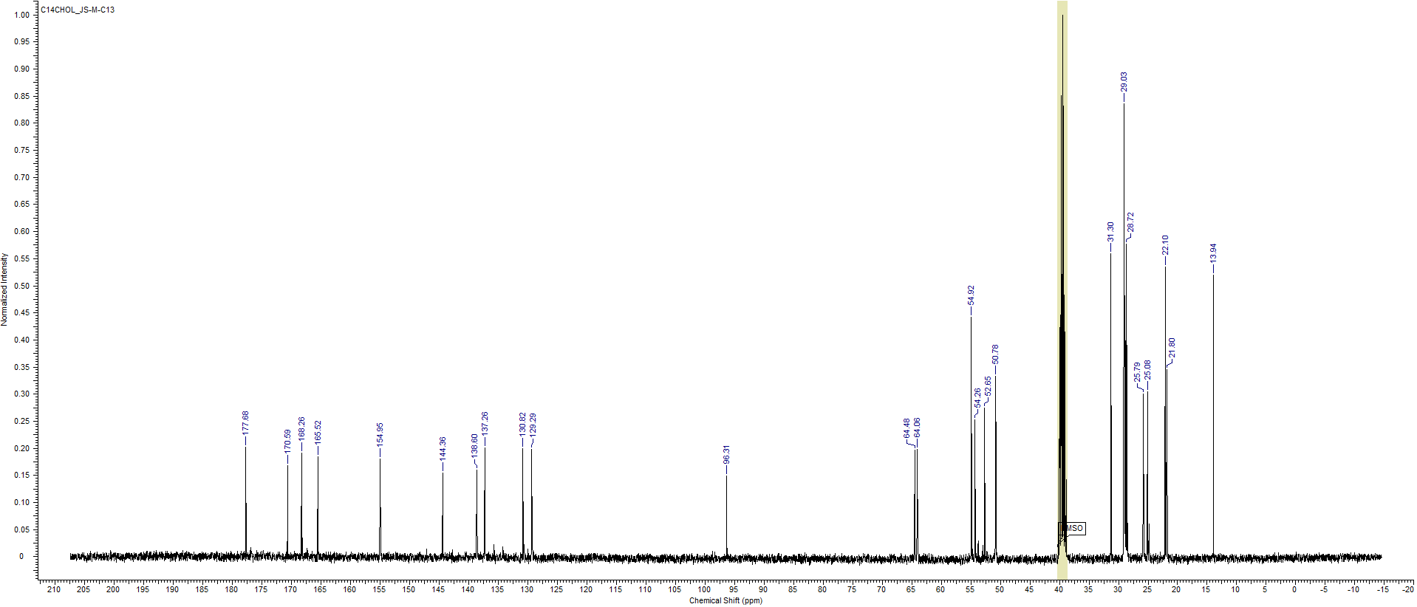
Fig. S3 ¹³C NMR spectrum of N-tetradecylcholine iodosulfuron-methyl [C₁₄CHOL][ISM].

Fig. S4 The influence of the tested HILs and reference herbicide on the cornflower biotypes resistant (R) and sensitive (S) to ALS inhibitors.

Fig. S5 Analysis of the root surface microbiome composition of susceptible and herbicide-resistant cornflower. C – untreated control; H – herbicide treatment; HILs – herbicidal ionic liquid treatment.

Table S4 C_{T} target/C_{T} 16 S values and SEM values obtained from qPCR analysis of gene abundance in the environment.
Suscceptible Biotype
Root Surface | ABC | Vegecat | ACTH | SulE
Control | 2.40 ± 0.2 | - | - | 3.36 ± 0.16
Herbicide | 3.54 ± 0.36 | 4.36 ± 0.35 | - | 4.46 ± 0,45
HILs | 2.70 ± 0.02 | 4.64 ± 0.16 | - | 2.55 ± 0.12
Root Tissue | ABC | Vegecat | ACTH | SulE
Control | 3.70 ± 0.07 | - | 3.94 ± 0.11 | -
Herbicide | 4.52 ± 0.2 | 4.36 ± 0.18 | -
HILs | 2.50 ± 0.11 | 4.89 ± 0.09 | - | 3.80 ± 0.23
Stem Surface | ABC | Vegecat | ACTH | SulE
Control | - | - | - | -
Herbicide | 2.46 ± 0.11 | 2.39 ± 0.12 | - | 2.30 ± 0.18
HILs | - | - | - | -
Stem Tissue | ABC | Vegecat | ACTH | SulE
Control | - | - | - | -
Herbicide | - | 4.41 ± 0.18 | - | 2.27 ± 0.13
HILs | - | - | - | -
Resistant Biotype
Root Surface | ABC | Vegecat | ACTH | SulE
Control | 2.45 ± 0.08 | - | - | 2.37 ± 0.12
Herbicide | - | - | - | -
HILs | 4.64 ± 0.07 | - | - | -
Root Tissue | ABC | Vegecat | ACTH | SulE
Control | - | - | - | -
Herbicide | 4.00 ±0.26 | - | - | -
HILs | - | - | - | -
Stem Surface | ABC | Vegecat | ACTH | SulE
Control | 3.76 ± 0.13 | 3.87 ± 0.07 | - | -
Herbicide | 3.64 ± 0.17 | 4.40 ± 0.12 | 2.15 ±0.03 | -
HILs | 2.24 ± 0.13 | - | 3.96 ±0.07 | -
Stem Tissue | ABC | Vegecat | ACTH | SulE
Control | - | 2.63 ±0.05 | 2.39 ±0.08 | -
Herbicide | 2.72 ±0.12 | 6.03 ±0.43 | 4.91 ±0.3 | -
HILs | - | - | - | -

References:
[1] B.J. Hang, Q. Hong, X.T. Xie, X. Huang, C.H. Wang, J. He, S.P. Li, SulE, a sulfonylurea herbicide de-esterification esterase from Hansschlegelia zhihuaiae S113, Appl. Environ. Microbiol. 78 (2012) 1962–1968. https://doi.org/10.1128/AEM.07440-11.
[2] Z. Zhang, Y. Zhang, D.C. Yang, J.L. Zhang, Expression and functional analysis of three nicosulfuron-degrading enzymes from Bacillus subtilis YB1, J. Environ. Sci. Heal. - Part B Pestic. Food Contam. Agric. Wastes. 53 (2018) 476–485. https://doi.org/10.1080/03601234.2018.1455344.
[3] H.A. Hussain, J.M. Ward, Enhanced heterologous expression of two Streptomyces griseolus cytochrome P450s and Streptomyces coelicolor ferredoxin reductase as potentially efficient hydroxylation catalysts, Appl. Environ. Microbiol. 69 (2003) 373–382. https://doi.org/10.1128/AEM.69.1.373-382.2003.

