Research Article
An assessment of latrine front-end characteristics and associated surface E. coli indicated faecal contamination in rural Fiji
Sabita Adhikari ¹*, Shylett Anthony ², Ponipate Baleinamau ² Jeremaia Coriakula ², Thompson Daurewa ², Rachel Devi ², Sikeli Gavidi ², Pierre Horwitz ³, Erin C. Hunter ⁴, Aaron Jenkins ^{3,5}, Stacy Jupiter ⁶, Maria Lalamacuata ², Kinikoto Mailautoka ², Sangeeta Mangubhai ^{7,8}, Kelera Naivalu ², Timoci Naivalulevu ², Vilisi Naivalulevu ², Nabeela Nasim¹, Sikeli Naucunivanua ⁷, Joel Negin ⁵, Paul van Nimwegen ⁷, Anaseini Ratu ⁵, Mereia Ravoka ⁷, Andrew Tukana ⁷, Jack van de Vossenberg ⁹ , Donald Wilson ², and Jacqueline Thomas ¹
- School of Civil Engineering, The University of Sydney, Darlington, NSW 2006, Australia (sabita.adhikari@sydney.edu.au, nabeela.nasim@sydney.edu.au, jacqueline.thomas@sydney.edu.au)
- Fiji Institute of Pacific Health Research, College of Medicine, Nursing & Health Sciences, Fiji National University, Hoodless House, Suva, Fiji (shylettanthony@gmail.com, ponipate.baleinamau@fnu.ac.fj, jeremaiacoriakula@gmail.com daurewathompson@gmail.com, gavidisikeli1@gmail.com, lalamacuatasia@gmail.com, mailautoka.kinikoto@gmail.com, kelera.tuisova@gmail.com, timoci.naivalulevu@fnu.ac.fj, vratukalou@gmail.com, donald.wilson@fnu.ac.fj)
- Centre for People, Place, and Planet, Edith Cowan University, Joondalup, WA, Australia (p.horwitz@ecu.edu.au, aaron.jenkins@ecu.edu.au)
- Department of Public Health Sciences, College of Behavioural, Social and Health Sciences, Clemson University, United States (hunter9@clemson.edu)
- School of Public Health, Faculty of Medicine and Health, The University of Sydney, Camperdown, NSW 2006, Australia (erin.hunter@sydney.edu.au, aaron.jenkins@sydney.edu.au, joel.negin@sydney.edu.au, anaseini.ratu@sydney.edu.au)
- Wildlife Conservation Society, Melanesia Program, Suva, Fiji (sjupiter@wcs.org)
- Wildlife Conservation Society, Fiji Program, Suva, Fiji (smangubhai@gmail.com, sikelinaucunivanua@adra.org.fj, pvannimwegen@wcs.org, mravoka@wcs.org, andrewtukana15@gmail.com)
- Talanoa Consulting, 28 Disraeli Road, Suva, Fiji (smangubhai@gmail.com)
- Water Supply, Sanitation and Environmental Engineering Department, IHE Delft Institute of Water Education, Delft, The Netherlands (j.vandevossenberg@un-ihe.org)
* Correspondence: Sabita Adhikari; Email: sabita.adhikari@sydney.edu.au; Tel.: +61 293512136

Supplementary materials
Table S1: Sanitation and household survey questionaries and observation checklists for in-depth front-end study
Table S2: Details of the sampling locations and the area swabbed in the latrine front-end for in-depth front-end study.
Table S3: Latrine front-end characteristics, household sanitation and hygiene behaviours within the five catchments including the baseline (311 households) and endline survey (259 households).
Table S4: E. coli density (CFU/25 cm²) on latrine floor with latrine front-end characteristics in baseline and endline sampling with a total of 142 latrine swab samples.
Table S5: E. coli density (CFU/25 cm²) on various sampling locations in 12 latrines of in-depth front-end study with types of latrine front-end flush systems (cistern flush, pour-flush and hole).
Fig. S1 Categories for visual assessment of moisture on the latrine floor in rural Fiji
Fig. S2 E. coli density (CFU/25 cm²) on the latrine floor from baseline (n = 96) and endline (n = 46) study
Fig. S3 E. coli density (CFU/25 cm²) on overall sampling surfaces in 12 latrines of in-depth front-end study with latrine front-end maintenance
Fig. S4 Latrine usage behaviour observed in rural Fiji. a) Cistern flush latrine used as pour-flush after the cistern is broken; b) Cistern flush latrine with the washable floor (concrete) moist toilet mat; c) Latrine front-end used as storage for agricultural tools and jerry cans

Table S1: Sanitation and household survey questionaries and observation checklists for in-depth front-end study

Household sanitation survey questionaries
√ Tick in the box provided
- Name of village: Date:
- Household code:
- Community type: ☐ Village (registered) ☐ Fijian settlement ☐Indo- Fijian settlement ☐Mixed ☐Others
- Household location: GPS (Lat): GPS (Long):
- Weather (today): ☐ Sunny ☐ Rainy ☐ Cloudy

Part A – Household survey
- Interviewee name:
- Interviewee sex: ☐ Male ☐Female ☐ Other
- What is the highest education level in the household? ☐ No formal education ☐ Primary (elementary) ☐Secondary (high school) ☐Tertiary (university or technical school)
- What is the main occupation of the household? (specify):
- Total family members (number): Male: Female: Others:
- How many children and their ages? Number: Ages:
- What is the kind of household ownership? ☐ Owned ☐ Rented ☐ Rent-free ☐ Squatter ☐ Other (specify)
- What kind of animals do you have at home and how many? ☐ Dog ( )
☐ Cat ( ) ☐ Goat ( ) ☐ Pig ( ) ☐ Horse ( ) ☐Cow( )
☐ Chicken ( ) ☐ Duck ( ) ☐None ☐ Others (specify)
(Mention number in brackets)
- Has any family member suffered from any of any diseases in the past two years? ☐ Yes ☐ No
- If yes, which diseases? ☐Diarrhea ☐Dysentery ☐Typhoid ☐Helminths ☐Leptospirosis ☐Dengue ☐Others(specify)
10a. Detail of the family members who suffered.
Relation: Age: Gender: Name of the disease: Time of infection:

10b: If more, detail of the family members who suffered
Relation: Age: Gender: Name of the disease: Time of infection

10c: If more, detail of the family members who suffered
Relation: Age: Gender: Name of the disease: Time of infection

Part B – Sanitation Survey
- When was the toilet built? ☐………Years ☐ Don’t know
- How many households use this toilet? Number:
- How many people use this toilet? ☐ Number:
- How often do you use a latrine? ☐Always ☐Usually ☐Sometimes ☐Never
- What do you use to clean after defaecation? ☐ Only toilet paper ☐ Only water ☐ Both water and toilet paper ☐ Newspaper ☐ Leaves ☐ Others (Specify)
- How do you manage the anal cleansing material? ☐ Flush in toilet ☐ store in bin inside toilet ☐ store in bin outside toilet ☐ Others (specify):
- Where do children defecate? ☐ Use Potty ☐Use diapers ☐Household yard ☐Others (specify)
- How do you dispose of children’s faeces? ☐ In toilet ☐ with solid waste (rubbish) ☐throw in the bush ☐leave it (do nothing) ☐ others (specify)
- How often do you normally wash your hands after using toilets? ☐ Always ☐ Only after defecation ☐ Usually ☐ Sometimes ☐ Rarely ☐ Never
- Do you normally wash your hand in these conditions? ☐ Before cooking ☐ before eating ☐ before feeding children ☐ after urinating ☐after defecating ☐ after working in the garden ☐after handling children’s faeces ☐ After handling animals
(Tick multiple as applicable)
- Is soap used to wash your hands? ☐ Always ☐Usually ☐Sometimes ☐ Rarely ☐Never
- What other material do you use to wash your hands? ☐ Ash ☐ Only water ☐Other (specify)
- Do you use the toilet without slippers/shoes? ☐ Always ☐ Usually ☐Sometimes ☐ Rarely ☐Never
- Do you use separate slippers/shoes for the toilet? ☐ Yes ☐No
- How frequently do you clean your toilet? ☐ Daily ☐ Once in a week ☐Twice a week ☐ Once in two weeks ☐ Other (specify)
- What do you use to clean the toilet? ☐ Toilet cleaners ☐ Disinfectant ☐ Lime
☐ Ash ☐ Only water ☐Others (specify)
- Have you ever repaired your toilet? ☐ Yes ☐ No
- If yes, when was the repair done? Time:
- If yes, what kind of repair? ☐ Flush handle ☐ Cistern ☐ Floor ☐Toilet seat ☐Wall ☐Floor ☐Door ☐ Tap ☐Other(specify)
Menstrual hygiene management.
- What is the common material used by females during menstrual hygiene management? ☐ Commercial/disposable pads ☐ tampons ☐ reusable cotton pads
☐ folded cloth ☐ others (specify)
- Where do females in the house dispose the menstrual hygiene management materials? ☐ Flush in the toilet ☐together in the rubbish bin ☐ dispose of in a separate bin ☐ Throw it away in river ☐ Throw it away in bush ☐ Others (specify)
- If reusable menstrual hygiene materials (cotton pads or cloths) are used, where are they washed? ☐In toilets ☐ in shower ☐ in handwashing station ☐ in the river
☐ others (specify)

Sanitation Observation Checklists

Part C (Toilet front-end features)
- Latrine code: Time:
- Location of Toilet: GPS (Lat): GPS (Long):
- Location of toilet reference to the household? ☐Outside ☐ Inside
- If outside, what is the distance between the toilet and the house? ………… meters
- What is the toilet backend (connection)? ☐Municipal sewerage ☐Septic tank ☐Pit ☐Environment ☐Can’t observe
- Photo taken? (Toilet door from outside)
- Is the entry to the toilet through the door? ☐ Yes ☐ No (open entry)
- If yes, what is the door made up of? ☐ CGI sheet ☐Wooden ☐Cloth curtain ☐ Plastic ☐ Others (specify)
- Are the door handles present on both sides of the door? ☐Both sides ☐ Only outside ☐ Only inside ☐ Not present
- What is the door handle made of? ☐ Wooden ☐ Steel ☐ Iron ☐ Others (specify)
- Are the door locks present on both sides of the door? ☐ Both sides ☐ Only outside ☐Only inside ☐ Not present
- What is the door lock (out) made of? ☐Wooden ☐ Iron ☐Steel ☐Others(specify):
- What is the door lock (inside) made of? ☐Wooden ☐ Iron ☐Steel ☐ Others(specify):
- Photo taken? (Toilet door from the inside)
- What is the flush mechanism? ☐ Cistern flush ☐ Pour flush ☐ Dry toilet (hole) ☐Others
- What is the type of toilet seat (based on sitting position)? ☐ Pedestal ☐ Squat ☐Others (Specify)
- If pedestal, what is the type of pedestal base? ☐ Porcelain ☐Plastic ☐Concrete ☐ Wooden ☐Seat covered with plastic ☐ Others (specify)
- If pedestal, what is the type of toilet seat? ☐ Porcelain ☐Plastic ☐Concrete
☐ Wooden seat ☐Seat covered with plastic ☐ Others (specify)
- If squat, what is the type of toilet pan? ☐ Porcelain ☐Plastic ☐ just hole (in ground) ☐ Others (specify)
- Photo taken? (Toilet seat)
- What kind of anal cleansing material are present? ☐ Toilet paper ☐ Water ☐Newspaper ☐Leaves ☐None ☐Others(specify)
- Is there water stored in a container inside the toilet? ☐ Yes ☐ No
- Is there a bin for the disposal of sanitary products? ☐Yes ☐ No
- Is there a separate slipper used for the toilet? ☐Yes ☐No
- What is the floor around the footrest area made of (just below the toilet seat)? ☐Tiles ☐Concrete ☐Wood ☐Dirt ☐others (specify)
- What is the floor made of in other areas (besides footrest? ☐Tiles ☐ Concrete ☐Wood ☐Dirt ☐ others (specify)
- Is the floor around the footrest area covered? ☐ Yes ☐No
- If yes, what is the floor covered with? ☐ Plastic sheet ☐Toilet mat ☐cloth ☐ others (specify)
- Photo taken? (Toilet floor)
- What is the lower wall (just 10 cm above the floor) made of? ☐Concrete ☐ Tile ☐ Wooden ☐ CGI sheets ☐Brick wall ☐Others
- What is the upper wall (above 10cm above the floor) made of? ☐ Concrete ☐ Tile ☐Wooden ☐CGI sheets ☐Brick wall ☐Others(specify)
- What is the toilet roof made of? ☐ CGI sheet ☐ Concrete ☐ Plastic sheet ☐Wood/bamboo ☐Leaves ☐ No roof ☐Others (specify)
- Does sunlight enter inside the toilet? ☐ Yes ☐ No
- If yes, which part? ☐ Floor ☐Wall ☐Other (specify)
- Photo taken? (Toilet wall)
- Is there a running water (piped) tap inside the latrine? ☐Yes (functional) ☐Yes (non-functional) ☐No
- Is there a handwashing facility present inside (within the same door) the toilet? ☐ Yes ☐No
- Is there a handwashing facility present within the vicinity the toilet outside? ☐ Yes ☐No
- If yes, what is the distance between the handwashing facility and the latrine? ……meters
- Are handwashing facilities present elsewhere in the household? ☐ Yes ☐No
- If yes, where? Specify:
- What kind of handwashing facilities are present? ☐ Tap with running water and sink ☐ Bucket with tap ☐ Bucket of water with ladle ☐ Others (specify)
- Is hand cleaning material present in the handwashing station? ☐ Yes ☐No
- If yes, what type of material is present? ☐Liquid soap ☐ Bar of soap ☐ Ash ☐Others
- Picture taken?

Part D (Toilet maintenance)
- Is the toilet broken? ☐ Yes ☐ No
- What is broken? ☐ Seat ☐ Flush ☐ Floor ☐ Pipes ☐Wall ☐Roof ☐other (specify)
- Is faeces observed inside the toilet? ☐ Yes ☐ No
- If yes, where? ☐ In toilet bowl ☐Floor ☐Wall ☐Toilet seat ☐Others(specify)
- Is dirt observed in the toilet? ☐Yes ☐ No
- Is the toilet floor moist? ☐ Yes ☐ No
- If yes, where is it moist? ☐ All floor ☐Around the footrest ☐Towards toilet corners ☐Other(specify)
- Any water pooling occurring on the floor? ☐ Yes ☐ No
- Is the lower wall (10cm above the floor) moist? ☐Yes ☐No
- Is there toilet cleansing material present in the toilet? ☐Yes ☐ No
- If yes, what kind of cleaning material is present? ☐ Brush ☐ Mob ☐Toilet cleaner ☐ None ☐Others
- Is there a smell in the toilet front-end? ☐Yes ☐ No
- Is faeces observed in the vicinity of the toilet? ☐ Yes ☐No
- If yes, what type? ☐Adult ☐Child ☐ Animal
- Is the backend receptacle broken? ☐ Yes ☐ No ☐ Can’t observed
- What is broken? ☐Container ☐ Connection ☐ Effluent pipe ☐ Others (specify)
- Is the toilet leaking or overflowing? ☐ Leaking ☐overflowing ☐No ☐ Can’t observed
- Are crops grown in the vicinity of the of toilet? ☐ Yes ☐No ☐ Can’t observe
- If yes, what types? ☐ Taro ☐ Cassava ☐Leafy greens ☐ Fruit ☐ Other(specify)
- If yes, where are the crops relative to the toilet? ☐ Uphill ☐ Downhill ☐ Same level
- Are crops grown in the vicinity of the effluent discharge zone? ☐ Yes ☐ No ☐Can’t observe
- If yes, what types?☐ Taro ☐ Cassava ☐ Leafy greens ☐Fruit ☐Other(specify)
If yes, where are the crops relative to the toilet? ☐ Uphill ☐ Downhill ☐Same level

Table S2: Details of the sampling locations and the area swabbed in the latrine front-end for in-depth front-end study.
SN | Sampling points | Sampling area | Details of sampling location
1 | Outside door | 5 cm × 5 cm | Door handle on the outside of latrine door. If no door handle was present outside, a potential area on the outside of the door likely to be touched during latrine usage was swabbed
2 | Inside door | 5 cm × 5 cm | Door handle on inside of latrine door. If no door handle was present inside, a potential area on the inside of the door likely to be touched while using the latrine was swabbed.
3 | Outside lock | whole surface | Lock handle on the outside of the latrine door.
4 | Inside lock | whole surface | Lock handle on the inside of latrine door.
5 | Latrine floor | 5 cm × 5 cm | Floor area around the pedestal where the user would place the feet during latrine usage.
6 | Latrine cover | 5 cm × 5 cm | The potential area around the tip of the cover where the user would touch.
7 | Latrine seat | 5 cm × 5 cm | An area where the user would be seated during latrine usage.
8 | Flush button | 5 cm × 5 cm | The flush buttons of cistern flush latrines.
9 | Mid-wall | 5 cm × 5 cm | The potential wall area around the pedestal that is likely to be touched during latrine usage. Usually, the side of the wall where anal cleaning materials (toilet paper or newspaper) were stored.
10 | Lower wall | 5 cm × 5 cm | Latrine wall 10 cm above the latrine floor (control).

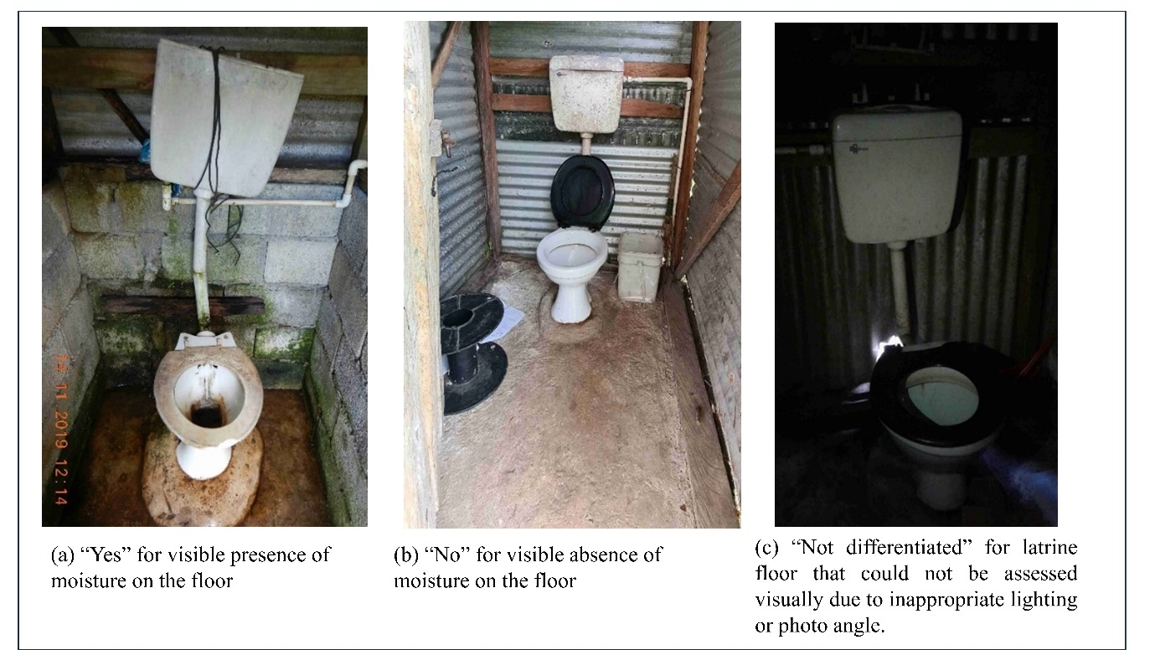
Fig. S1 Categories for visual assessment of moisture on the latrine floor in rural Fiji

Table S3: Latrine front-end characteristics, household sanitation and hygiene behaviours within the five catchments including the baseline (311 households) and endline survey (259 households).
Catchments | Bureta |  |  | Dama |  |  | Dawasamu |  |  | Upper Navua |  |  | Waibula |  |  | Total
Sampling rounds | Baseline | Endline | % change | Baseline | Endline | % change | Baseline | Endline | % change | Baseline | Endline | % change | Baseline | Endline | % change | Baseline | Endline | % change
No of households | 55 HHs | 41 HHs |  | 65 HHs | 53 HHs |  | 56 HHs | 52 HHs |  | 65 HHs | 53 HHs |  | 70 HHs | 60 HHs |  | 311 HHs | 259 HHs
Latrine locations
Inside | 23  (42%) | 18 (44%) | 2% | 19 (29%) | 19 (36%) | 7% | 6  (11%) | 9  (17%) | 6% | 15 (23%) | 17 (32%) | 9% | 32 (46%) | 31 (52%) | 6% | 95 (31%) | 94 (36%) | 5%
Outside | 32  (58%) | 23 (56%) | 2% | 46 (71%) | 33 (62%) | 9% | 50  (89%) | 42  (81%) | 8% | 50 (77%) | 36 (68%) | 9% | 38 (54%) | 29 (48%) | 6% | 216 (69%) | 163 (63%) | 6%
Latrine ownership
Private | 43  (78%) | 33 (80%) | 2% | 58 (89%) | 51 (96%) | 7% | 39  (70%) | 33  (63%) | 7% | 59 (91%) | 49 (92%) | 1% | 66 (94%) | 51 (85%) | 9% | 265 (85%) | 217 (84%) | 1%
Shared | 12  (22%) | 8 (20%) | 2% | 7  (11%) | 2  (4%) | 7% | 17  (30%) | 18  (35%) | 5% | 6  (9%) | 4  (8%) | 1% | 4  (6%) | 8 (13%) | 7% | 46 (15%) | 40 (15%) | 0%
Latrine user number ¹
1 to 5 | 37  (67%) | 26  (63%) | 4% | 37 (57%) | 30  (57%) | 0% | 30  (54%) | 21  (40%) | 14% | 47 (72%) | 34  (64%) | 8% | 46 (66%) | 35  (58%) | 8% | 197 (63%) | 146  (56%) | 7%
6 to 10 | 17  (31%) | 12  (29%) | 2% | 23 (35%) | 19  (36%) | 1% | 16  (29%) | 23  (44%) | 15% | 17 (26%) | 18  (34%) | 2% | 20 (29%) | 19  (32%) | 3% | 93 (30%) | 91 (35%) | 5%
more than 10 | 1  (2%) | 3  (7%) | 5% | 5  (8%) | 4  (8%) | 0% | 10  (18%) | 7  (13%) | 5% | 1  (2%) | 1  (2%) | 0% | 4  (6%) | 5  (8%) | 2% | 21  (7%) | 20  (8%) | 1%
Front-end flush type
Cistern Flush | 53  (96%) | 38 (93%) | 3% | 38 (58%) | 33 (62%) | 4% | 43  (77%) | 38  (73%) | 4% | 64 (98%) | 50 (94%) | 4% | 61 (87%) | 54 (90%) | 3% | 260 (83%) | 213 (82%) | 1%
Pour flush | 0  (0%) | 2  (5%) | 5% | 23 (35%) | 18 (34%) | 1% | 10  (18%) | 7  (13%) | 5% | 0  (0%) | 0  (0%) |  | 6  (9%) | 2  (3%) | 7% | 39 (13%) | 29 (11%) | 2%
Hole (non-flush) | 1  (2%) | 1  (2%) | 0% | 4 (6%) | 1 (2%) | 4% | 3  (5%) | 6  (12%) | 7% | 1  (2%) | 0  (0%) |  | 3  (4%) | 4  (7%) | 3% | 12  (4%) | 12 (5%) | 1%
Latrine floor type
Washable floor | 52  (95%) | 39 (95%) | 0  (0%) | 61  (94%) | 47 (89%) | 5% | 50  (89%) | 45  (87%) | 2% | 63  (97%) | 53 (100%) | 3% | 61  (87%) | 53 (88%) | 1% | 287  (92%) | 235 (91%) | 1%
Non-washable floor | 3  (5%) | 2  (5%) | 0  (0%) | 4  (6%) | 5  (9%) | 3% | 6  (11%) | 6  (12%) | 1% | 2  (3%) | 0  (0%) | 3% | 9  (13%) | 7 (12%) | 1% | 24  (8%) | 20 (8%) | 0%
Overall latrine front-end broken
Yes | 22  (40%) | 15 (37%) | 3% | 26 (40%) | 7 (13%) | 27% | 30  (54%) | 22  (42%) | 12% | 23 (35%) | 9 (17%) | 18% | 20 (29%) | 16 (27%) | 2% | 121 (39%) | 69 (27%) | 12%
No | 33  (60%) | 25 (61%) | 8% | 39 (60%) | 42 (79%) | 3% | 26  (46%) | 29  (56%) | 10% | 42 (65%) | 43 (81%) | 1% | 50 (71%) | 44 (73%) | 2% | 190 (60%) | 183 (71%) | 11%
Observation of faeces in or around latrine²
Yes | 2  (4%) | 0  (0%) | 4% | 2  (3%) | 1  (2%) | 1% | 7  (13%) | 2  (4%) | 9% | 1  (2%) | 4  (8%) | 6% | 1  (1%) | 2  (3%) | 2% | 13  (4%) | 9  (3%) | 1 %
No | 53  (96%) | 40 (98%) | 2% | 62 (95%) | 47  (89%) | 6% | 49  (88%) | 49  (94%) | 6% | 64 (98%) | 49 (92%) | 6% | 69  (99%) | 58 (97%) | 2% | 297 (95%) | 243 (94%) | 1 %
Visible moisture on latrine floor ³
Yes | 18  (33%) | 19 (46%) | 13% | 35 (54%) | 23 (43%) | 11% | 31  (55%) | 32  (62%) | 7% | 30 (46%) | 19 (36%) | 10% | 16 (23%) | 22 (37%) | 14% | 130  (42%) | 115 (44%) | 3 %
No | 15  (27%) | 2  (5%) | 22% | 11 (17%) | 1  (2%) | 15% | 18  (32%) | 6  (12%) | 20% | 18 (28%) | 16 (30%) | 2% | 29 (41%) | 8 (13%) | 28% | 91 (29%) | 33 (13%) | 16%
Not differentiated | 22  (40%) | 10 (24%) | 16% | 18 (28%) | 11 (21%) | 7% | 7  (13%) | 7  (13%) | 0% | 17 (26%) | 13 (25%) | 1% | 25 (36%) | 22 (37%) | 1% | 89 (29%) | 63 (24%) | 5%
Visible dirt on latrine floor ³
Yes | 26  (47%) | 12 (29%) | 18% | 36 (55%) | 20 (38%) | 17% | 30  (54%) | 25  (48%) | 6% | 31 (48%) | 25 (47%) | 6% | 23 (33%) | 24 (40%) | 7% | 146 (47%) | 95 (37%) | 10%
No | 15  (27%) | 17 (41%) | 14% | 20  (31%) | 14 (26%) | 5% | 21  (38%) | 15  (29%) | 9% | 23 (35%) | 0 |  | 39 (56%) | 17 (28%) | 28% | 118 (38%) | 88 (34%) | 4%
Not differentiated | 14  (25%) | 2  (5%) | 20% | 8  (12%) | 1  (2%) | 10% | 5  (9%) | 5  (10%) | 5% | 11  (17%) | 14 (26%) | 9% | 8  (11%) | 11 (18%) | 7% | 46 (15%) | 28 (11%) | 4%
Latrine used as storage ³
Yes | 7  (13%) | 4  (10%) | 3% | 12  (18%) | 6  (11%) | 7% | 5  (9%) | 11  (21%) | 12% | 14 (22%) | 10  (19%) | 3% | 5  (7%) | 6  (10%) | 3% | 43 (14%) | 37  (14%) | 0
No | 48  (87%) | 27  (66%) | 21% | 52 (80%) | 29  (55%) | 25% | 51  (91%) | 35  (67%) | 24% | 51 (78%) | 38  (72%) | 6% | 65 (93%) | 46  (77%) | 16% | 267  (86%) | 175 (68%) | 18%
Observation of anal cleansing materials inside latrine ⁴
Yes | 48  (87%) | 39  (95%) | 8% | 55  (85%) | 47  (89%) | 4% | 45  (80%) | 51  (98%) | 18% | 63  (97%) | 48  (91%) | 6% | 63  (90%) | 58  (97%) | 7% | 274  (88%) | 243  (94%)
No | 7  (13%) | 1  (2%) | 11% | 10  (15%) | 5  (9%) | 6% | 11  (20%) | 0  (0%) | 20% | 2  (3%) | 5  (9%) | 6% | 7  (10%) | 2  (3%) | 7% | 37  (12%) | 13  (5%)
Type of anal cleansing material used reported by households ⁵
Toilet paper | 29  (53%) | 27  (66%) | 13% | 16  (25%) | 30  (57%) |  | 38  (68%) | 29  (56%) | 12% | 28  (43%) | 30  (57%) | 14% | 57  (81%) | 50  (83%) | 2% | 168  (54%) | 166  (64%) | 10%
Newspaper | 0  (0%) | 4  (10%) | 10% | 1  (2%) | 4  (8%) | 6% | 7  (13%) | 1  (2%) | 11% | 0 | 0 | 0 | 1  (1%) | 0 | 1% | 9  (3%) | 9  (3%) | 0
Toilet paper and newspaper | 24  (44%) | 5  (12%) | 32% | 24  (37%) | 4  (8%) | 29% | 11  (20%) | 12  (23%) | 3% | 37  (57%) | 12  (23%) | 34% | 9  (13%) | 6  (10%) | 3% | 105  (34%) | 39  (15%) | 19%
Toilet paper and water | 0  (0%) | 3  (7%) | 7% | 23  (35%) | 9  (17%) | 18% | 0  (0%) | 1  (2%) | 2% | 0  (0%) | 4  (8%) | 8% | 3  (4%) | 3  (5%) | 1% | 26  (8%) | 20  (8%) | 0%
Newspaper and water | 0  (0%) | 0  (0%) | 0  (0%) | 0  (0%) | 2  (4%) | 4% | 0  (0%) | 1  (2%) | 2% | 0  (0%) | 0  (0%) | 0% | 0  (0%) | 0  (0%) | 0% | 0  (0%) | 3  (1%) | 1%
Toilet paper, newspaper, and water | 0  (0%) | 2  (5%) | 5% | 0  (0%) | 3  (6%) | 6% | 0  (0%) | 7  (13%) | 13% | 0  (0%) | 6  (11%) | 11% | 0  (0%) | 0  (0%) | 0% | 0  (0%) | 18  (7%) | 7%
Water | 0  (0%) | 0  (0%) | 0  (0%) | 1  (2%) | 1  (2%) | 2% | 0  (0%) | 0  (0%) | 0% | 0  (0%) | 1  (2%) | 2% | 0  (0%) | 0  (0%) | 0% | 0  (0%) | 2  (1%) | 1%
How do you dispose of your child faeces? ^{6, 7}
In the toilet | 16  (29%) | 4  (10%) | 19% | 39  (60%) | 2  (4%) | 56% | 41  (73%) | 9  (17%) | 56% | 32  (49%) | 11  (21%) | 28% | 45  (64%) | 16  (27%) | 37% | 173  (56%) | 42  (16%) | 40%
Thrown or washed in the river | 0  (0%) | 0  (0%) | 0% | 4  (6%) | 0  (0%) | 6% | 1  (2%) | 0  (0%) | 2% | 2  (3%) | 0  (0%) | 3% | 0  (0%) | 0  (0%) | 0% | 7  (2%) | 0  (0%) | 2%
Thrown in bushes | 0  (0%) | 0  (0%) | 0% | 0  (0%) | 1  (2%) | 2% | 1  (2%) | 3  (6%) | 4% | 1  (2%) | 3  (6%) | 4% | 1  (1%) | 2  (3%) | 2% | 3  (1%) | 9  (3%) | 2%
Disposed together with solid waste | 12  (22%) | 7  (17%) | 5% | 5  (8%) | 13  (25%) | 17% | 4  (7%) | 13  (25%) | 18% | 8  (12%) | 7  (13%) | 1% | 9  (13%) | 21  (35%) | 22% | 38  (12%) | 61  (24%) | 12%
Buried in pit | 0  (0%) | 3  (7%) | 7% | 1  (2%) | 2  (4%) | 1% | 1  (2%) | 1  (2%) | 0% | 0  (0%) | 1  (2%) | 2% | 0  (0%) | 0  (0%) | 0% | 2  (1%) | 7  (3%) | 2%
Cleaned and burned to ignite firewood | 0  (0%) | 0  (0%) | 0% | 0  (0%) | 0  (0%) | 0% | 0  (0%) | 2  (4%) | 4% | 1  (2%) | 2  (4%) | 2% | 0  (0%) | 0  (0%) | 0% | 0  (0%) | 4  (2%) | 2%
Observation of handwashing facilities inside latrine ⁸
Yes | 5  (9%) | 1  (2%) | 7% | 9  (14%) | 3  (6%) | 8% | 1  (2%) | 4  (8%) | 6% | 5  (8%) | 3  (6%) | 2% | 4  (6%) | 5  (8%) | 2% | 24  (8%) | 16 (6%) | 2%
No | 49  (89%) | 38  (93%) | 4% | 56  (86%) | 49  (92%) | 6% | 55  (98%) | 46  (88%) | 10% | 60  (92%) | 50  (94%) | 2% | 66  (94%) | 55  (92%) | 2% | 286 (92%) | 238 (92%) | 0%
Observation of handwashing facilities elsewhere in household ⁹
Yes | 53  (96%) | 27  (66%) | 30% | 50  (77%) | 40  (75%) | 2% | 41  (73%) | 26  (50%) | 23% | 57  (88%) | 40  (75%) | 13% | 65  (93%) | 55  (92%) | 1% | 266 (86%) | 188  (73%) | 13%
No | 2  (4%) | 8  (20%) | 16% | 15  (23%) | 9  (17%) | 6% | 15  (27%) | 24  (46%) | 19% | 8  (12%) | 13  (25%) | 13% | 5  (7%) | 4  (7%) | 0% | 45 (14%) | 58  (22%) | 8%
Type of handwashing facilities observed elsewhere in the household
Tap with running water and sink | 35  (66%) | 17  (63%) | 3% | 28  (56%) | 29  (73%) | 17% | 7  (17%) | 6  (23%) | 6% | 39  (68%) | 26  (65%) | 3% | 35  (54%) | 43  (78%) | 24% | 144  (54%) | 116  (64%) | 10%
Bucket of water | 9  (17%) | 3  (11%) | 6% | 20  (40%) | 4  (10%) | 30% | 12  (29%) | 0  (0%) | 29% | 13  (23%) | 0  (0%) | 23% | 17  (26%) | 4  (7%) | 19% | 71 (27%) | 11  (6%) | 21%
Bucket with tap | 7  (13%) | 7  (26%) | 13% | 2  (4%) | 7  (18%) | 14% | 3  (7%) | 19  (73%) | 66% | 3  (5%) | 8  (20%) | 15% | 5  (8%) | 6  (11%) | 3% | 20  (8%) | 47  (25%) | 17%
Others | 2  (4%) | 0  (0%) | 4% | 0  (0%) | 0  (0%) | 0% | 19  (46%) | 1  (4%) | 42% | 2  (4%) | 6  (15%) | 11% | 8  (12%) | 2  (4%) | 8% | 31  (12%) | 9  (5%) | 7%
Do you normally wash your hand after defecation? ¹⁰
Yes | 51  (93%) | 40  (98%) | 5% | 63  (97%) | 52  (98%) | 1% | 55  (98%) | 51  (98%) | 0% | 63  (97%) | 52  (98%) | 1% | 70  (100%) | 58  (97%) | 3% | 302  (97%) | 253  (98%) | 1%
No | 4  (7%) | 1  (2%) | 5% | 2  (3%) | 1  (2%) | 1% | 1  (2%) | 0  (0%) | 2% | 2  (3%) | 0 | 3% | 0  (0%) | 1  (2%) | 2% | 9  (3%) | 3  (1%) | 2%
Is soap used for handwashing?¹¹
Always | 19  (35%) | 10  (24%) | 11% | 43  (66%) | 22  (42%) | 24% | 17  (30%) | 21  (40%) | 10% | 28  (43%) | 19  (36%) | 7% | 36  (51%) | 40  (67%) | 16% | 142 (46%) | 112  (43%) | 3%
Usually | 10  (18%) | 12  (29%) | 11% | 0  (0%) | 10  (19%) | 19% | 12  (21%) | 14  (27%) | 6% | 8  (12%) | 22  (42%) | 30% | 16  (23%) | 5  (17%) | 6% | 46 (15%) | 63  (24%) | 9%
Sometimes | 26  (47%) | 19  (46%) | 1% | 21  (32%) | 18  (34%) | 2% | 25  (45%) | 14  (27%) | 18% | 24  (37%) | 11  (21%) | 16% | 18  (26%) | 10  (17%) | 9% | 114 (37%) | 72  (28%) | 9%
Rarely | 0  (0%) | 1  (2%) | 2% | 1  (2%) | 2  (4%) | 2% | 2  (4%) | 0 | 4% | 5  (8%) | 0  (0%) | 8% | 0  (0%) | 0  (0%) | 0% | 8  (3%) | 3  (1%) | 2%
Never | 0  (0%) | 0  (0%) | 0  (0%) | 0  (0%) | 0  (0%) | 0  (0%) | 0  (0%) | 1  (2%) | 2% | 0  (0%) | 1  (2%) | 2% | 0  (0%) | 0  (0%) | 0% | 0  (0%) | 2  (1%) | 1%
Walking outdoor without shoes – interviewee ¹²
Always | 0  (0%) | 10  (24%) | 24% | 5  (8%) | 8  (15%) | 7% | 10  (18%) | 14  (27%) | 9% | 7  (11%) | 26  (49%) | 38% | 13  (19%) | 18  (30%) | 11% | 35  (11%) | 76  (29%) | 18%
Usually | 5  (9%) | 2  (5%) | 4% | 14  (22%) | 3  (6%) | 16% | 10  (18%) | 4  (8%) | 10% | 17  (26%) | 9  (17%) | 9% | 12  (17%) | 6  (10%) | 7% | 58  (19%) | 24  (9%) | 10%
Sometimes | 12  (25%) | 20  (49%) | 24% | 24  (37%) | 25  (47%) | 10% | 31  (55%) | 20  (38%) | 17% | 32  (49%) | 11  (21%) | 28% | 29  (41%) | 8  (13%) | 28% | 130  (42%) | 84  (32%) | 10%
Rarely | 12  (22%) | 4  (10%) | 12% | 4  (17%) | 6  (11%) | 6% | 0  (0%) | 1  (2%) | 2% | 4  (6%) | 0  (0%) | 6% | 6  (9%) | 2  (3%) | 6% | 26  (8%) | 13  (5%) | 3%
Never | 24  (44%) | 5  (12%) | 32% | 18  (8%) | 10  (19%) | 11% | 5  (9%) | 12  (23%) | 14% | 5  (8%) | 7  (13%) | 5% | 10  (14%) | 25  (42%) | 28% | 62  (20%) | 59  (23%) | 3%
Walking outdoor without shoes – other family members ¹³
Always | 1  (2%) | 10  (24%) | 22% | 4  (6%) | 8  (15%) | 9% | 9  (16%) | 14  (27%) | 11% | 7  (11%) | 25  (47%) | 36% | 14  (20%) | 15  (25%) | 5% | 35  (11%) | 72  (28%) | 17%
Usually | 5  (9%) | 2  (5%) | 4% | 13  (20%) | 2  (4%) | 16% | 10  (18%) | 5  (10%) | 8% | 18  (28%) | 8  (15%) | 13% | 9  (13%) | 7  (12%) | 1% | 55  (18%) | 24 (9%) | 9%
Sometimes | 16  (20%) | 21  (51%) | 31% | 25  (38%) | 27  (51%) | 13% | 29  (52%) | 19  (37%) | 15% | 29  (45%) | 13  (25%) | 20% | 34  (49%) | 12  (20%) | 29% | 133 (43%) | 92  (36%) | 7%
Rarely | 11  (20%) | 3  (7%) | 13% | 4  (6%) | 6  (11%) | 5% | 3  (5%) | 0  (0%) | 5% | 5  (8%) | 1  (2%) | 6% | 2  (3%) | 1  (2%) | 1% | 25  (8%) | 11  (4%) | 4%
Never | 22  (40%) | 5  (12%) | 32% | 19  (29%) | 10  (19%) | 10% | 5  (9%) | 13  (25%) | 16% | 6  (9%) | 6  (11%) | 2% | 11  (16%) | 24  (40%) | 24% | 63  (20%) | 58 (22%) | 2%
Reported diarrhoea in past month by households¹⁴
Yes | 4  (7%) | 8  (20%) | 13% | 10  (15%) | 6  (11%) | 4% | 17  (30%) | 10  (19%) | 11% | 8  (12%) | 7  (13%) | 1% | 9  (13%) | 8 (13%) | 0% | 48  (15%) | 39  (15%) | 0%
No | 51  (93%) | 33  (80%) | 13% | 55  (85%) | 46  (87%) | 2% | 39  (70%) | 41  (79%) | 9% | 57  (88%) | 46  (87%) | 1% | 61  (87%) | 49  (82%) | 5% | 263  (85%) | 215  (83%) | 2%
Reported household members diagnosed with typhoid ¹⁵
Yes | 0  (0%) | 0  (0%) | 0% | 0  (0%) | 0  (0%) | 0% | 1  (2%) | 1  (2%) | 0% | 3  (5%) | 0  (0%) | 5 % | 2  (3%) | 1  (2%) | 1% | 6  (2%) | 2  (1%) | 1%
No | 55  (100%) | 41  (100%) | 0% | 65  (100%) | 52  (98%) | 2% | 55  (98%) | 51  (98%) | 0% | 62  (95%) | 53  (100%) | 5% | 68  (97%) | 57  (95%) | 2% | 305  (98%) | 254  (98%) | 0%
¹ two missing data in endline, ² One missing data in baseline and seven in endline, ³one missing data in baseline and 46 in endline, ⁴three missing data in endline, ⁵two missing data in baseline and three in endline, ⁶ the sample size was smaller for child-faeces disposal as in baseline 82 households did not have any children at home and 95 households in endline, ⁷ 28 missing data in endline, ⁸one missing data in baseline and five in endline, ⁹ 13 missing data in endline, ¹⁰ three missing data in endline, ¹¹ seven missing data in endline, ¹² two missing data in endline, ¹³ five missing data in endline, ¹⁴ five missing data in endline , ¹⁵ three missing data in endline

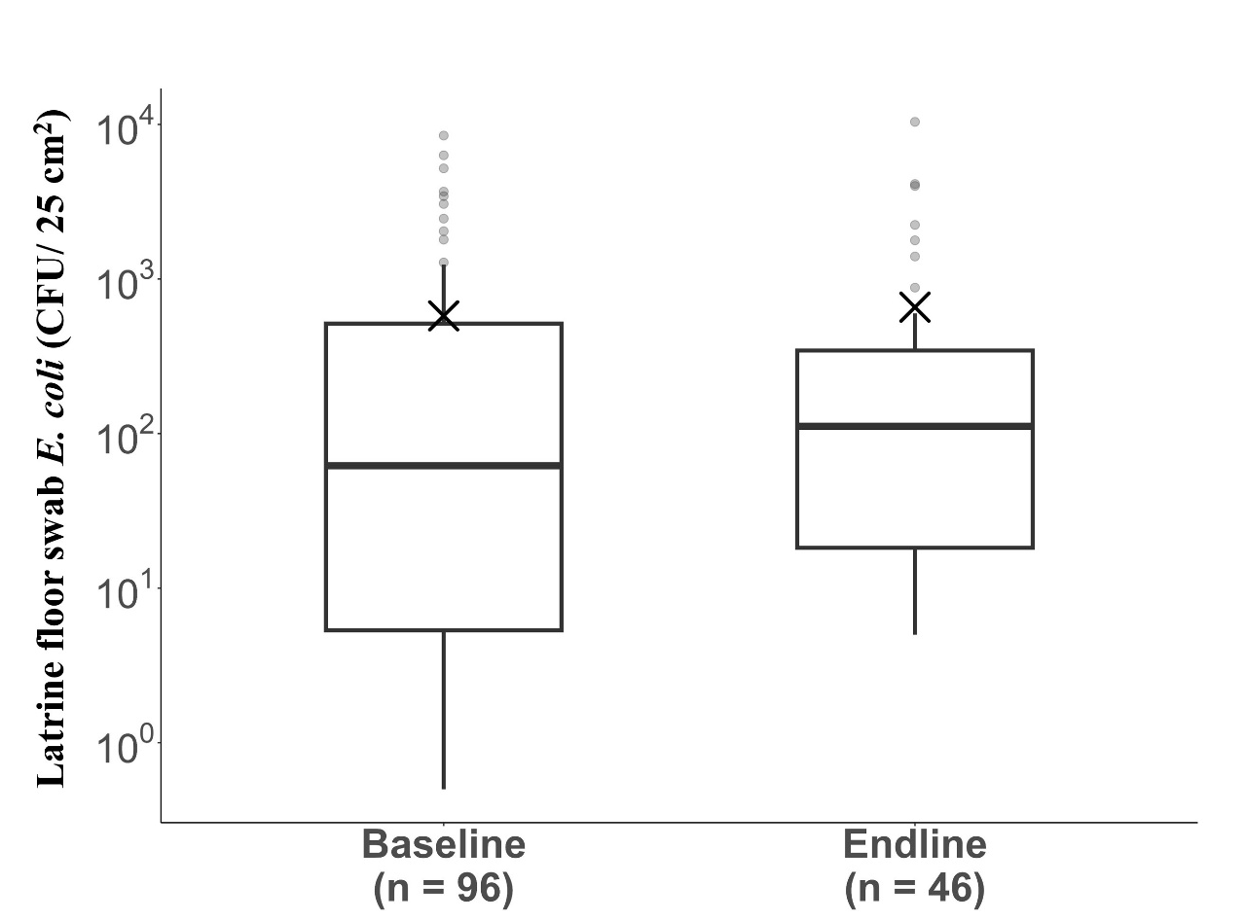
Fig. S2 E. coli density (CFU/ 25 cm²) on the latrine floor from baseline (n = 96) and endline (n = 46). The box plot represents the median, quartiles, outlier (grey, round shape) and mean (×). The lower limit of detection is 1.0 CFU/25 cm². Non-detects were substituted with half of the lower limit of detection values. The E. coli densities data presented are raw continuous data.

Table S4: E. coli density (CFU/25 cm²) on latrine floor with latrine front-end characteristics in baseline and endline sampling with a total of 142 latrines swab samples.
Description of categories | Categories | Sample size (n) | Mean E. coli (CFU/25 cm²) on latrine floor | p-value
Household and latrine front-end characteristics
Latrine floor type¹ | Washable floor | 125 | 6.7 ×10² | 0.05
 | Non-washable floor | 17 | 1.3 ×10²
Latrine front-end type ² | Cistern flush | 102 | 5.6 ×10² | 0.77
 | Pour-flush | 28 | 8.4 ×10²
 | Hole -type | 12 | 4.3 ×10²
Latrine ownership¹ | Private | 106 | 4.8 ×10² | 0.463
 | Shared | 35 | 9.9 ×10²
Latrine location in reference to household ¹ | Outside | 111 | 6.6 ×10² | 0.82
 | Inside | 30 | 4.2 ×10²
No. of latrine users ² | One to five users | 84 | 5.0 ×10² | 0.81
 | Six to ten users | 40 | 3.8 ×10²
 | More than 10 users | 17 | 1.6 ×10³
Reported diarrhoea in households in the past month¹
 | Yes | 20 | 8.7 ×10² | 0.83
 | No | 120 | 5.7 ×10²
Highest education levels attended by household ² | Primary level | 28 | 9.0 ×10² | 0.07
 | Secondary level | 85 | 5.3 ×10²
 | Tertiary level | 27 | 5.4 ×10²
Latrine front-end maintenance
Latrine front-end broken^{1,3} | Yes | 68 | 5.5 ×10² | 0.60
 | No | 72 | 6.7 ×10²
Latrine flush broken^{1, 4, 5} | Yes | 22 | 5.0 ×10² | 0.26
 | No | 77 | 8.2 ×10²
Observation faeces in or around latrine ^{1, 3} | Yes | 10 | 5.6 ×10² | 0.25
 | No | 130 | 6.2 ×10²
Visual moisture on latrine floor^{1, 5} | Yes | 71 | 7.1 ×10² | 0.14
 | No | 34 | 4.0 ×10²
 | Not differentiated | 25 | 5.1 ×10²
Visual dirt on latrine floor^{1,6} | Yes | 86 | 6.6 ×10² | 0.19
 | No | 31 | 5.8 ×10²
 | Not differentiated | 13 | 1.9 ×10²
¹ Mann-Whitney U Test , ² Kruskal-Wallis Test, ³ two missing data, ⁴within cistern flush latrines (n = 102), ⁵three missing data, ⁶12 missing data

Table S5: E. coli density (CFU/25 cm²) on various sampling locations in 12 latrines of in-depth front-end study with types of latrine front-end flush systems (cistern flush, pour-flush and hole).
Sampling locations | Sample number(n) | % of positive E. coli samples within each sampling location² | Number of non-detects in each sampling location | Overall mean E. coli within sampling location (CFU/25 cm²) | Overall E. coli range within each sampling location (CFU/25 cm²) | Cistern-flush latrines (n = 6) |  |  | Pour-flush latrines (n = 3) |  |  | Hole-type latrines (n = 3)
 |  |  |  |  |  | n | mean | range | n | mean | range | n | mean | range
Outside door | 12 | 0 | 12 | ND | ND | 6 | ND | ND | 3 | ND | ND | 3 | 0 | 0
Outside lock¹ | 5 | 20 | 1 | 1.2 | ND to 6.0 | 4 | 1.5 | ND to 6.0 | 1 | ND | ND | NA | NA | NA
Inside door | 12 | 8 | 11 | 4.3 | ND to 50.0 | 6 | ND | ND | 3 | 16.7 | ND to 50.0 | 3 | 0 | 0
Inside lock¹ | 5 | 0 | 5 | ND | ND | 4 | ND | ND | 1 | ND | ND | NA | NA | NA
Latrine floor | 12 | 83 | 2 | 1.0 × 10³ | ND to 6.0 × 10³ | 6 | 94.4 | ND to 4.2 × 10² | 3 | 3.8 × 10³ | 2.1 × 10² to 6.0 × 10³ | 3 | 91.3 | 36.0 to 1.8 × 10²
Latrine cover | 9 | 44 | 5 | 7.8 | ND to 52.5 | 6 | 11.6 | ND to 52.5 | 2 | ND | ND | 1 | ND | ND
Latrine seat | 12 | 58 | 5 | 60.0 | ND to 5.6 × 10² | 6 | 97.5 | ND to 5.6 × 10² | 3 | 18.5 | 0 to 55.6 | 3 | 26.0 | 15.0 to 37.0
Flush button | 6 | 33 | 4 | 0.6 | ND to 2.0 | 6 | 0.6 | ND to 2.0 | NA | NA | NA | NA | NA | NA
Mid wall | 12 | 75 | 3 | 7.8 | ND to 22.0 | 6 | 10 | ND to 22.0 | 3 | 9.7 | 3.0 to 20.0 | 3 | 1.4 | ND to 4.0
Lower wall | 12 | 17 | 10 | 4.0 | ND to 35.0 | 6 | 8.0 | ND to 35.0 | 3 | ND | ND | 3 | ND | ND
Total | 97
¹ outside and inside lock expressed as CFU per swab, ²percentage calculated with total sample number for each surface (n), NA = Not applicable, ND = Not detected

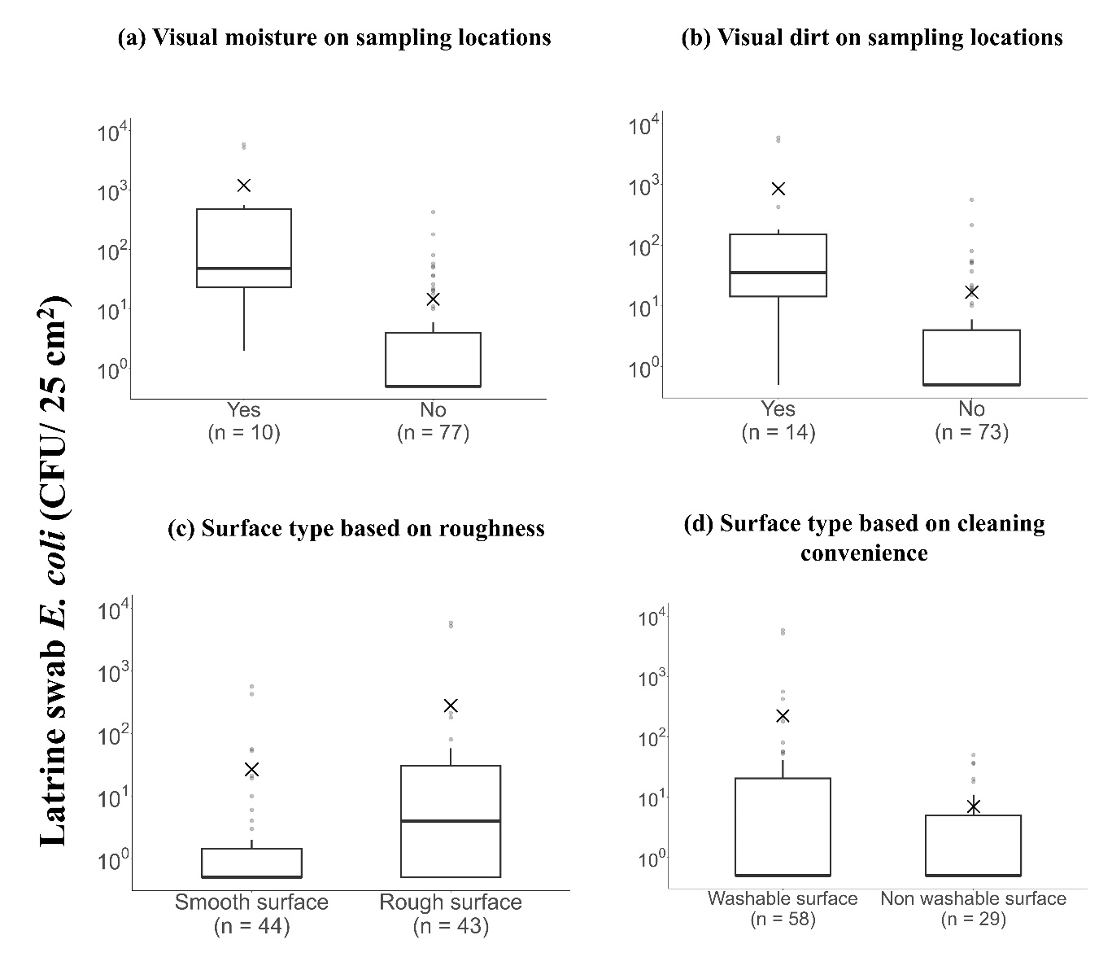
Fig. S3 E. coli density (CFU/ 25 cm²) on overall sampling surfaces (excluding the inside and outside lock) in 12 latrines of in-depth front-end study with latrine front-end maintenance (87 surfaces, excluding outside and inside lock). The box plot represents the median, quartiles, outlier (grey dots) and mean (×). a) E. coli and visual presence of moisture observed on the surfaces during sampling; b) E. coli and visual presence of dirt observed on the surfaces during sampling; c) E. coli and type of surface based on visual surface roughness; d) E. coli and type of surface based on cleaning convenience. The lower limit of detection is 1.0 CFU/25 cm². Non-detects were substituted with half of the lower limit of detection value. The E. coli densities data presented are raw continuous data.

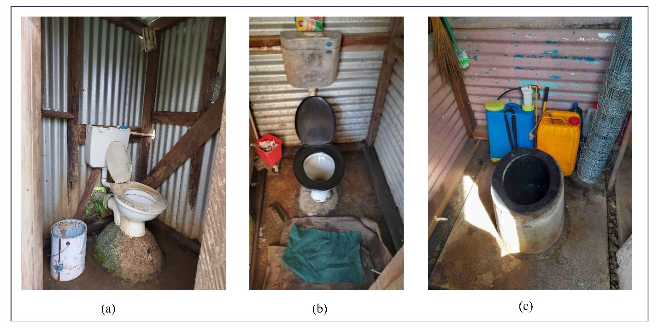
Fig. S4 Latrine usage behaviour observed in rural Fiji: (a) Cistern flush latrine used as pour-flush after the cistern is broken; (b) Cistern flush latrine with the washable floor made of course concrete with moist floor and toilet mat; c) Latrine front-end used as storage for agricultural tools and jerry cans

