Supplementary Material

Metal(loid) tolerance, accumulation, and phytoremediation potential of wetland macrophytes for multi-metal(loid)s polluted water.
Aqib Hassan Ali Khanª, Blanca Velasco-Arroyo^{b}, Carlos Rad^{c}, Sandra Curiel-Alegre^{ac}, Carlos Rumboª, Herwig De Wilde^{d}, Alfredo Pérez-de-Mora^{e}, Sonia Martel-Martínª, Rocío Barros^{a*}
ªInternational Research Center in Critical Raw Materials for Advanced Industrial Technologies (ICCRAM), University of Burgos, Centro de I+D+I. Plaza Misael Bañuelos s/n. 09001, Burgos, Spain
^{b}Department of Biotechnology and Food Science, University of Burgos, Plaza Misael Bañuelos, s/n. 09001, Burgos, Spain
^{c}Research Group in Composting (UBUCOMP), University of Burgos, Faculty of Sciences, Plaza Misael Bañuelos s/n, 09001, Burgos, Spain
^{d}TAUW België nv, Dept. of Soil and Groundwater, Waaslandlaan 8A3, 9160 Lokeren, Belgium
^{e}TAUW GmbH, Dept. of Soil and Groundwater, Landsbergerstr. 404, 81241 Munich, Germany

*Corresponding authors: rbarros@ubu.es

Supplementary Table 1. Initial concentrations for the target elements (expressed in mg L⁻¹) in the original groundwater extracted from different collected wells located at the polluted site.
Metal(loid) | mg L⁻¹
As | 0.300 – 0.500
Cd | 2.000 – 2.500
Cu | 160 – 1000
Fe | 250 – 400
Ni | 130 – 150
Pb | 0.200 – 0.350
Zn | 70 – 320

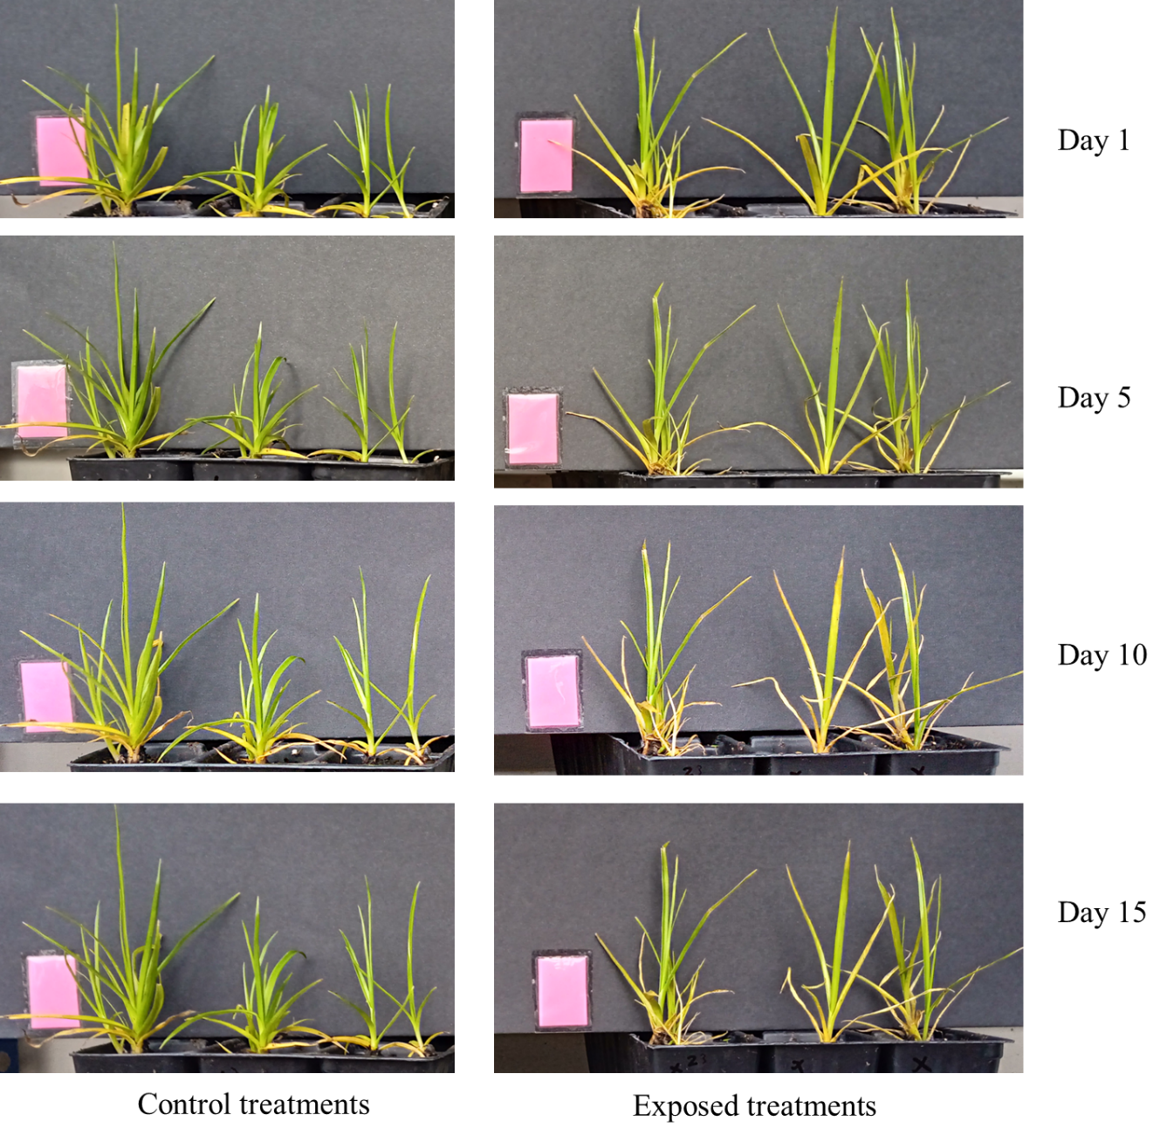
Supplementry Figure 1. Changes in growth of Carex riparia at 1, 5, 10, and 15 days.

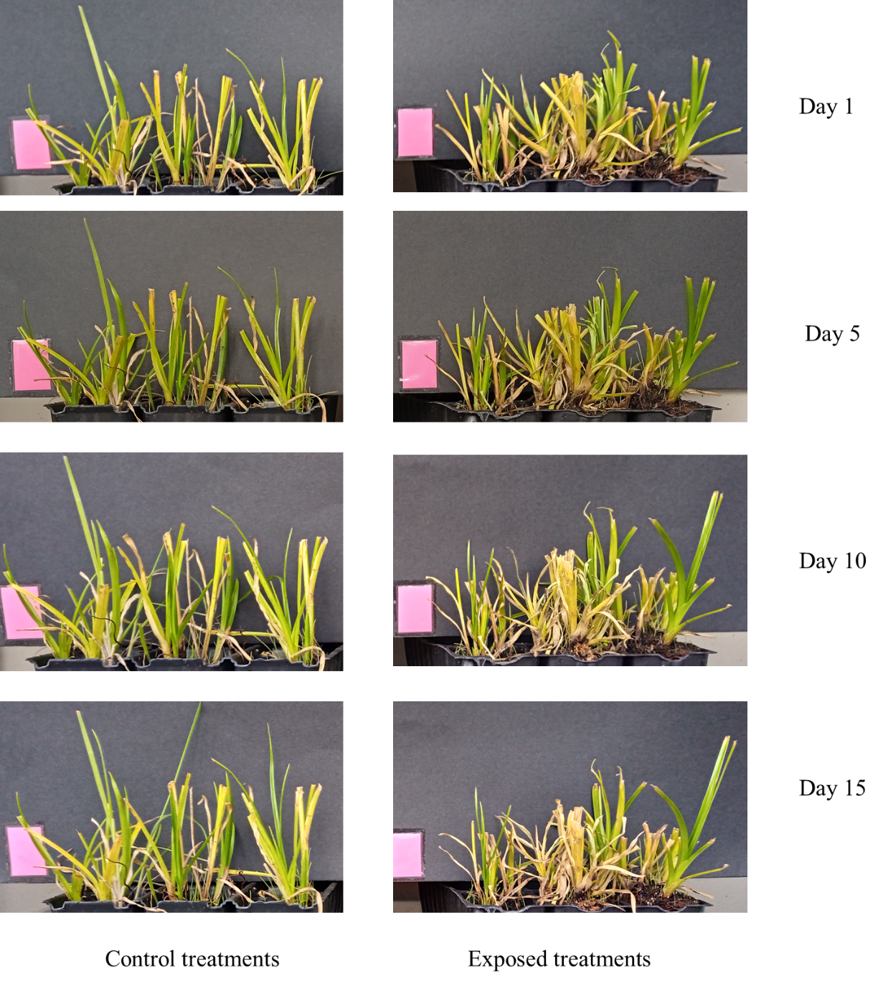
Supplementry Figure 2. Changes in growth of Cyperus longus at 1, 5, 10 and 15 days.

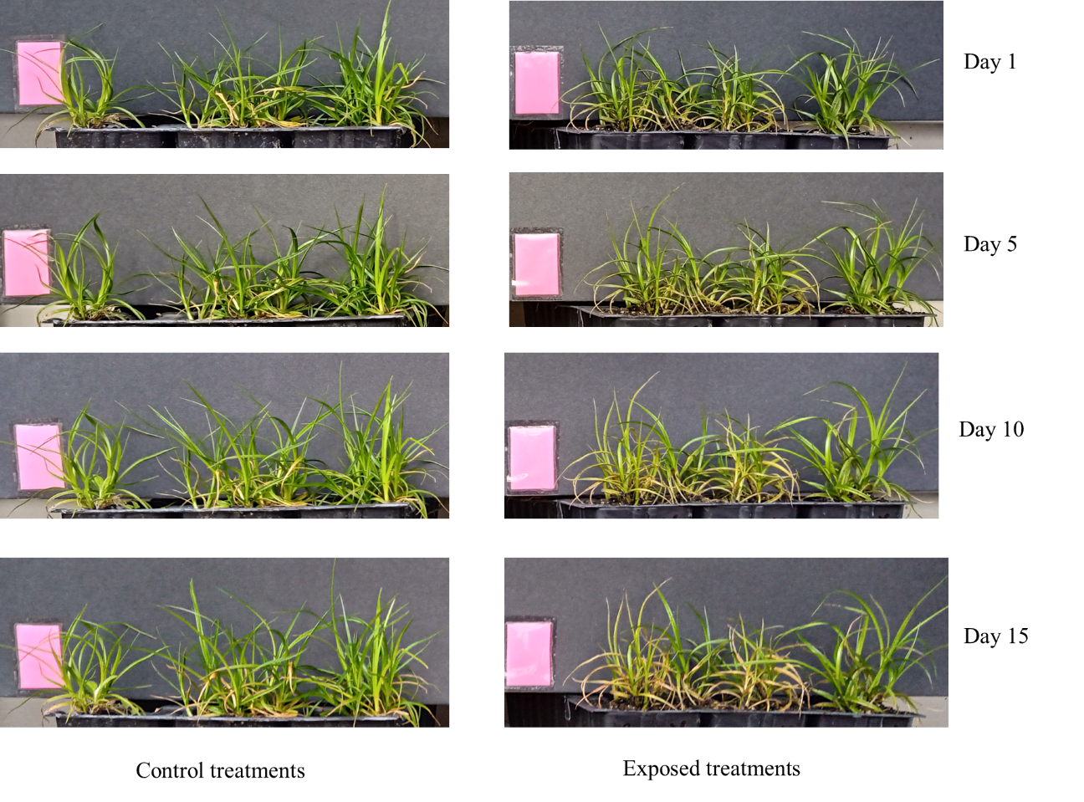
Supplementry Figure 3. Changes in growth of Cyperus rotundus at 1, 5, 10, and 15 days.

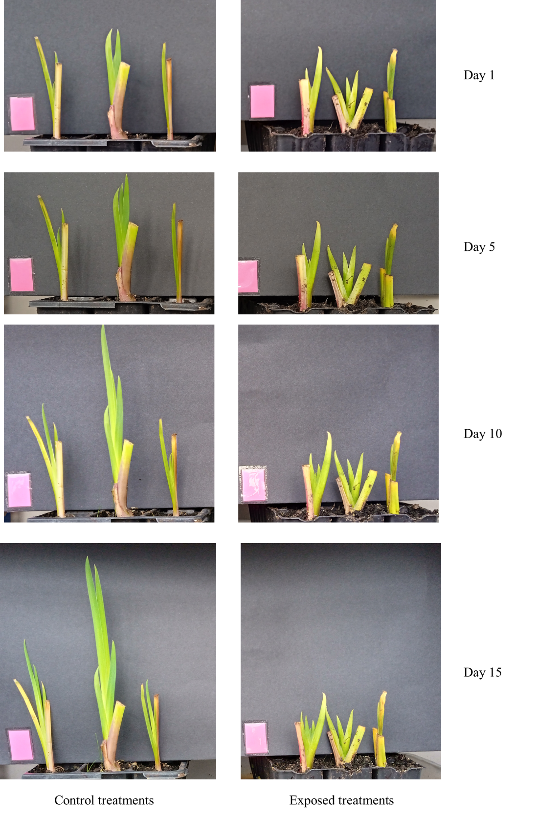
Supplementry Figure 4. Changes in growth of Iris pseudacorus at 0, 5, 10, and 15 days.

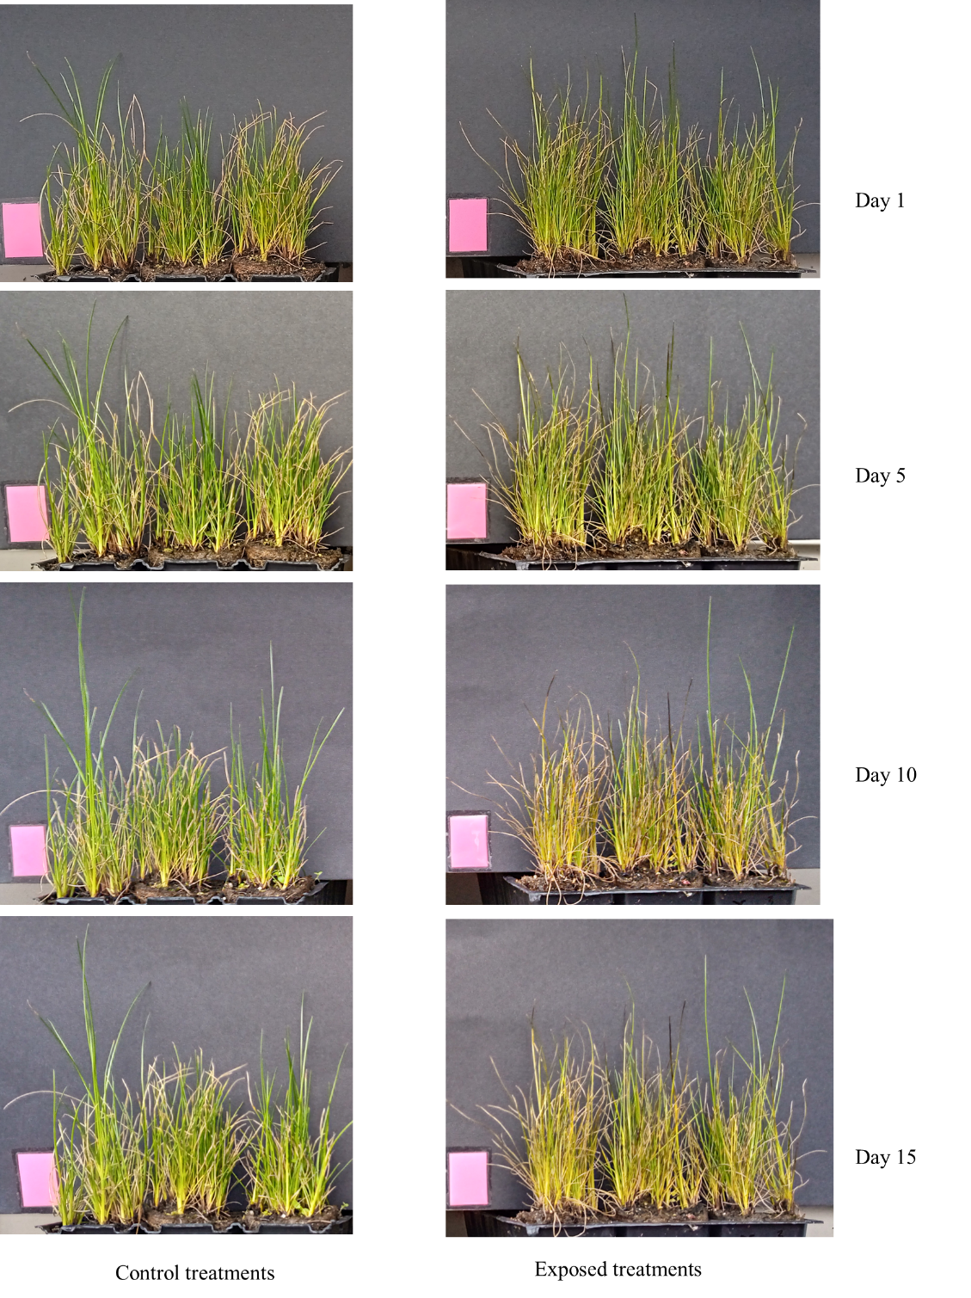
Supplementry Figure 5. Changes in growth of Juncus effusus at 1, 5, 10, and 15 days.

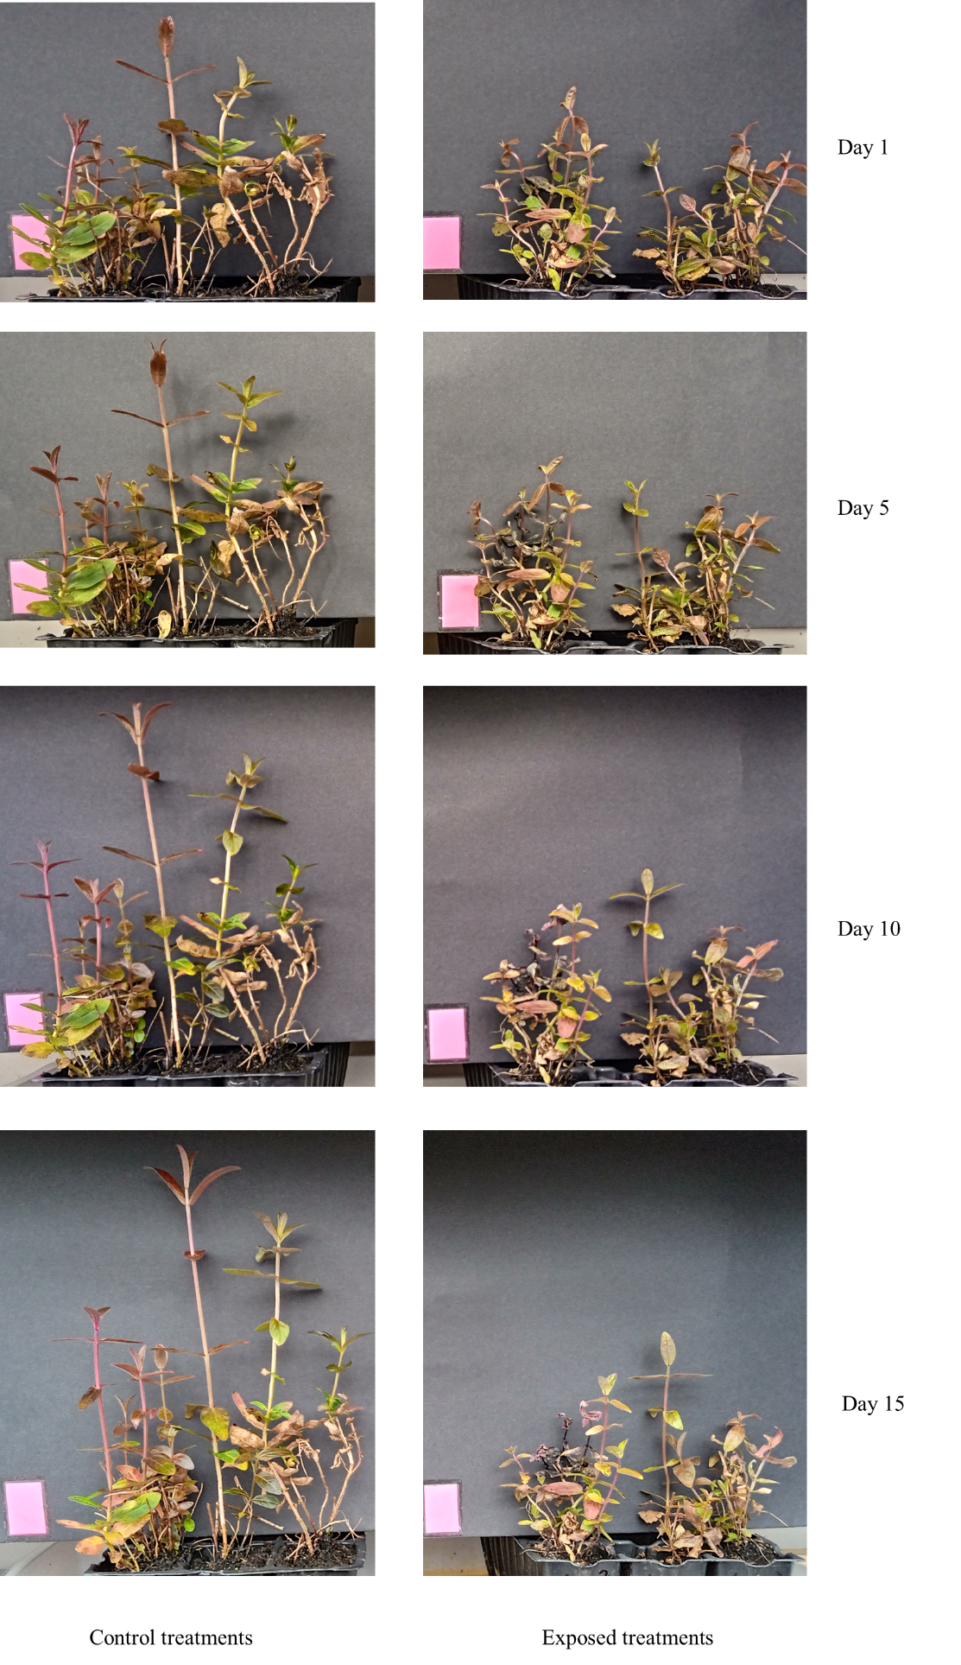
Supplementry Figure 6. Changes in growth of Lythrum salicaria at 1, 5, 10, and 15 days.

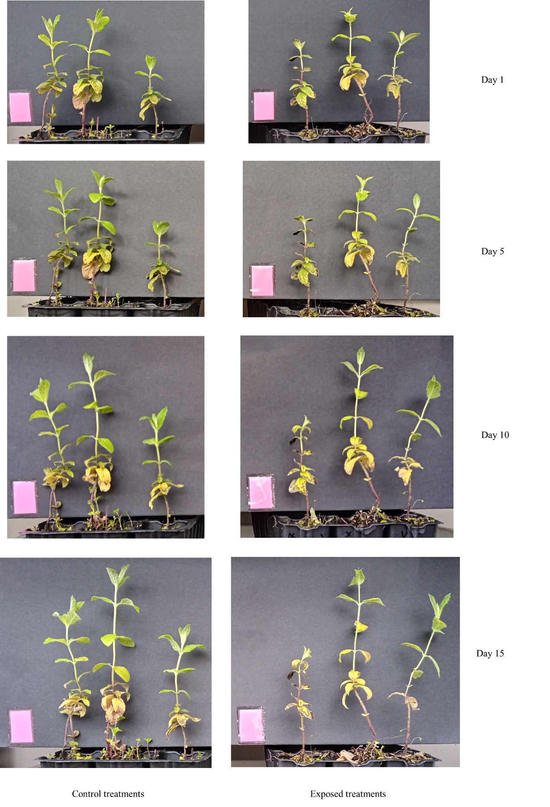
Supplementry Figure 7. Changes in growth of Mentha aquatica at 1, 5, 10, and 15 days.

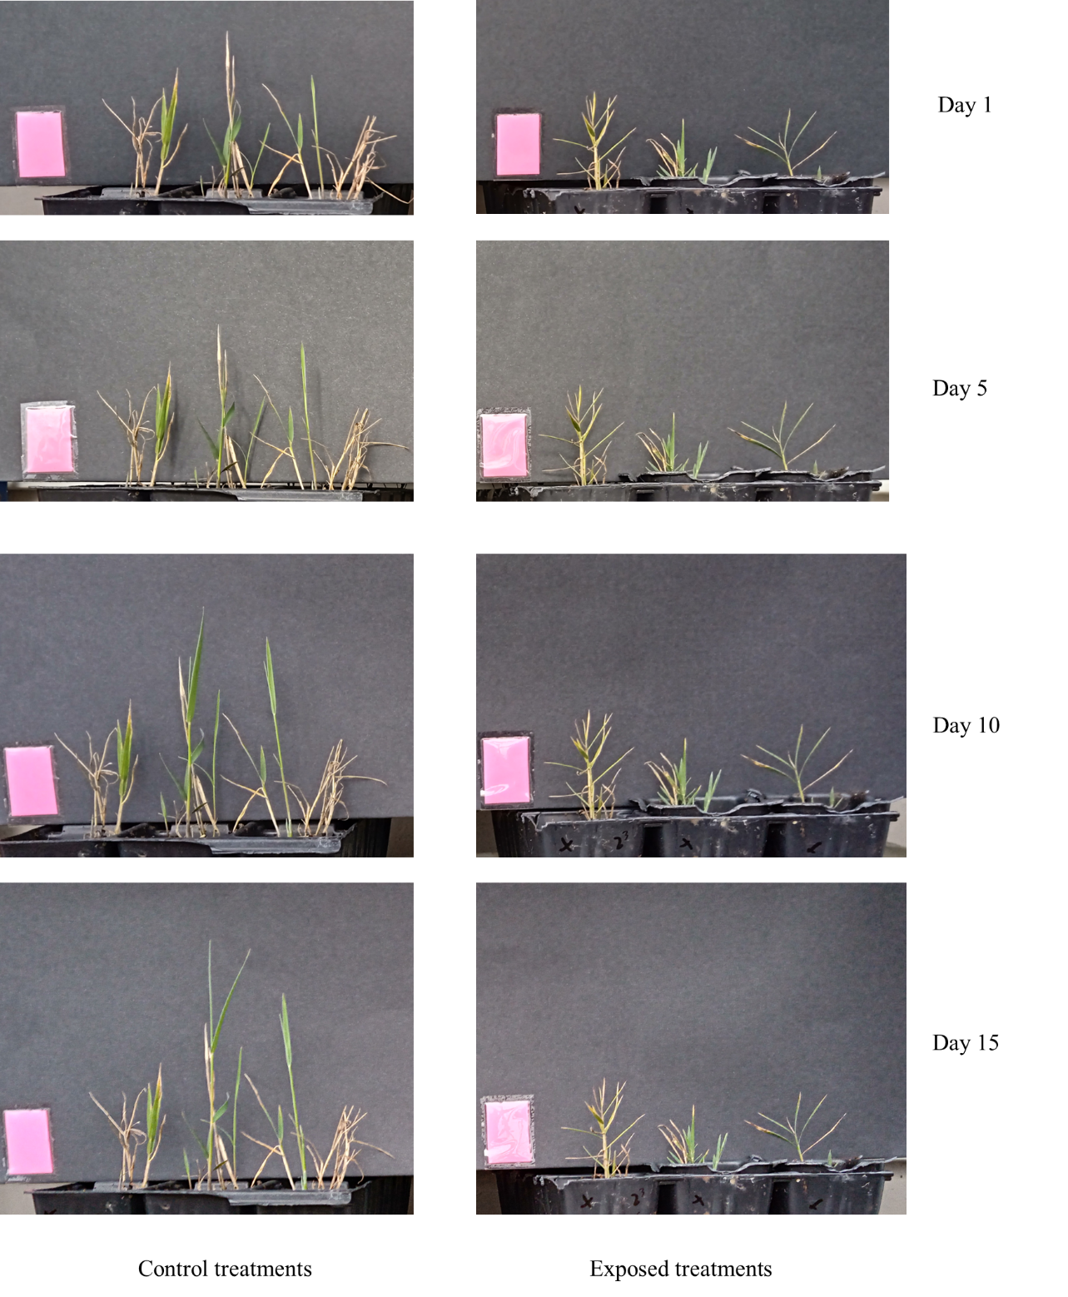
Supplementry Figure 8. Changes in growth of Phragmites australis at 1, 5, 10, and 15 days.

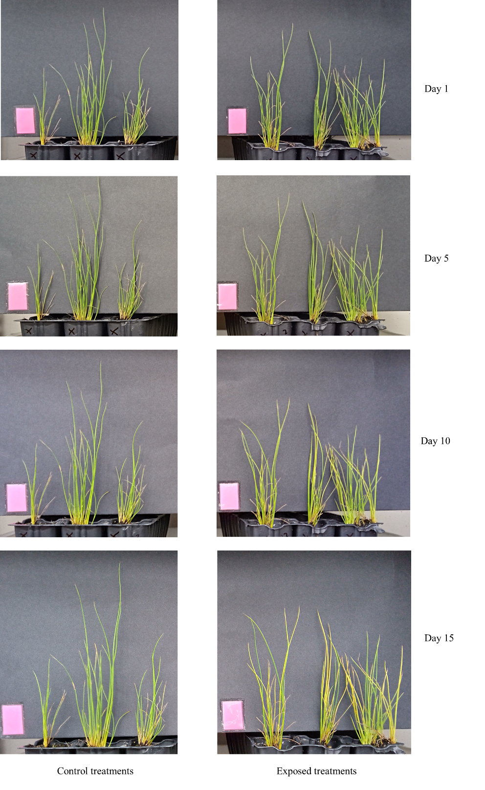
Supplementry Figure 9. Changes in growth of Scirpus holoschoenus at 1, 5, 10, and 15 days.

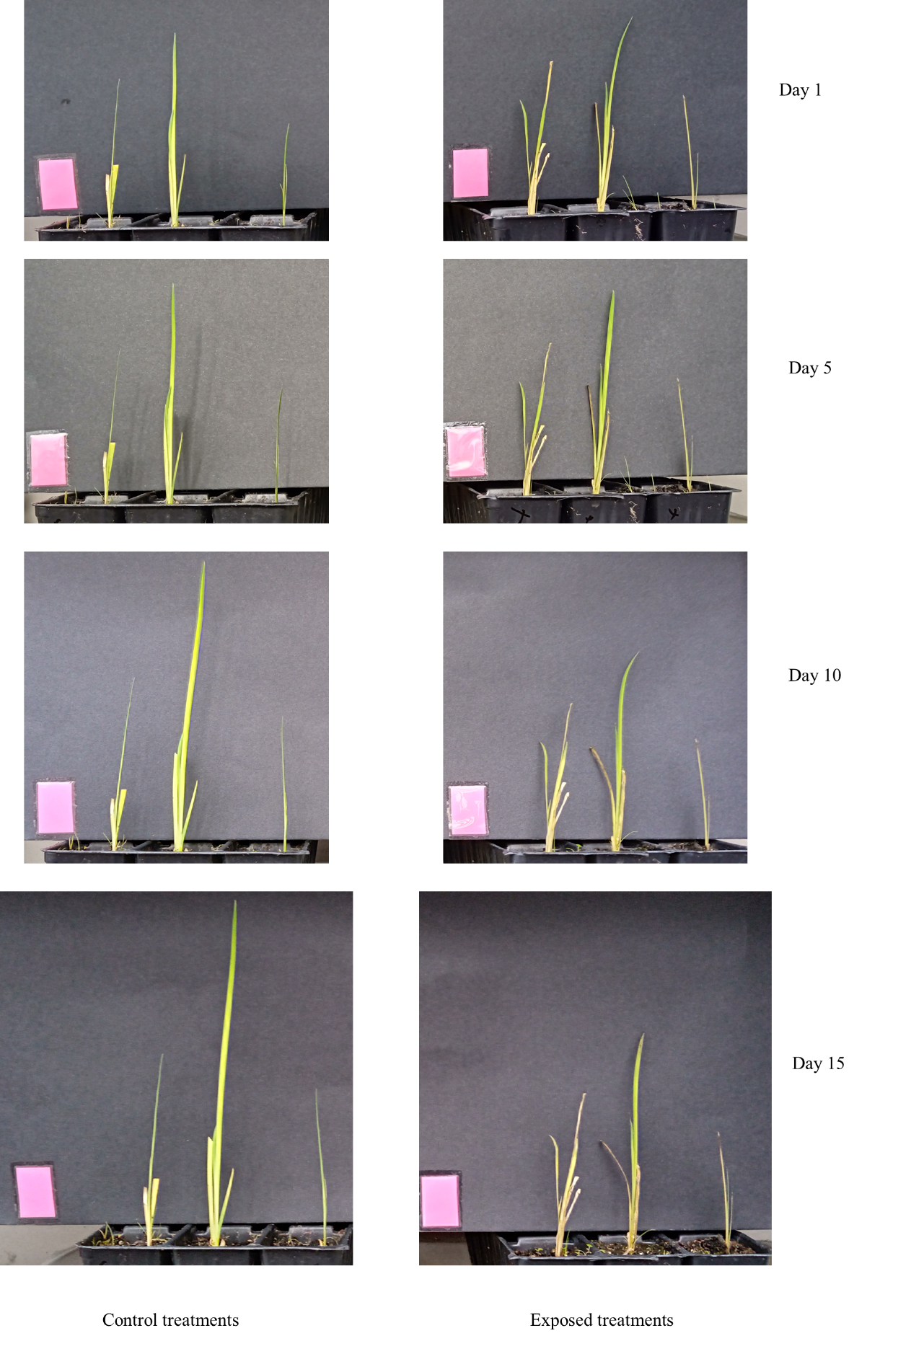
Supplementry Figure 10. Changes in growth of Typha angustifolia at 1, 5, 10, and 15 days.

Supplementary Table 2. Metal(loid)s content recovery certified and obtained values in comparison with standard reference material used.
Metal(loid)s studied | Certified value* | Obtained value | Recovery | RSD
Metal(loid)s studied | mg kg⁻¹ | mg kg⁻¹ | % | %
As | 0.042 ±0.010 | 0.04 ±0.001 | 95.32 | 4.95
Cd | 0.120 ±0.007 | 0.116 ±0.003 | 96.94 | 3.18
Cu | 10.200 ±0.500 | 9.949 ±0.226 | 97.54 | 2.56
Ni | 15.200 ±0.600 | 14.517 ±0.486 | 95.5 | 4.78
Pb | 1.670 ±0.110 | 1.621 ±0.045 | 97.07 | 3.08
Zn | 30.500 ±1.100 | 29.945 ±0.412 | 98.18 | 1.87
*Certified values for ERM-CD281 Rye grass certified material

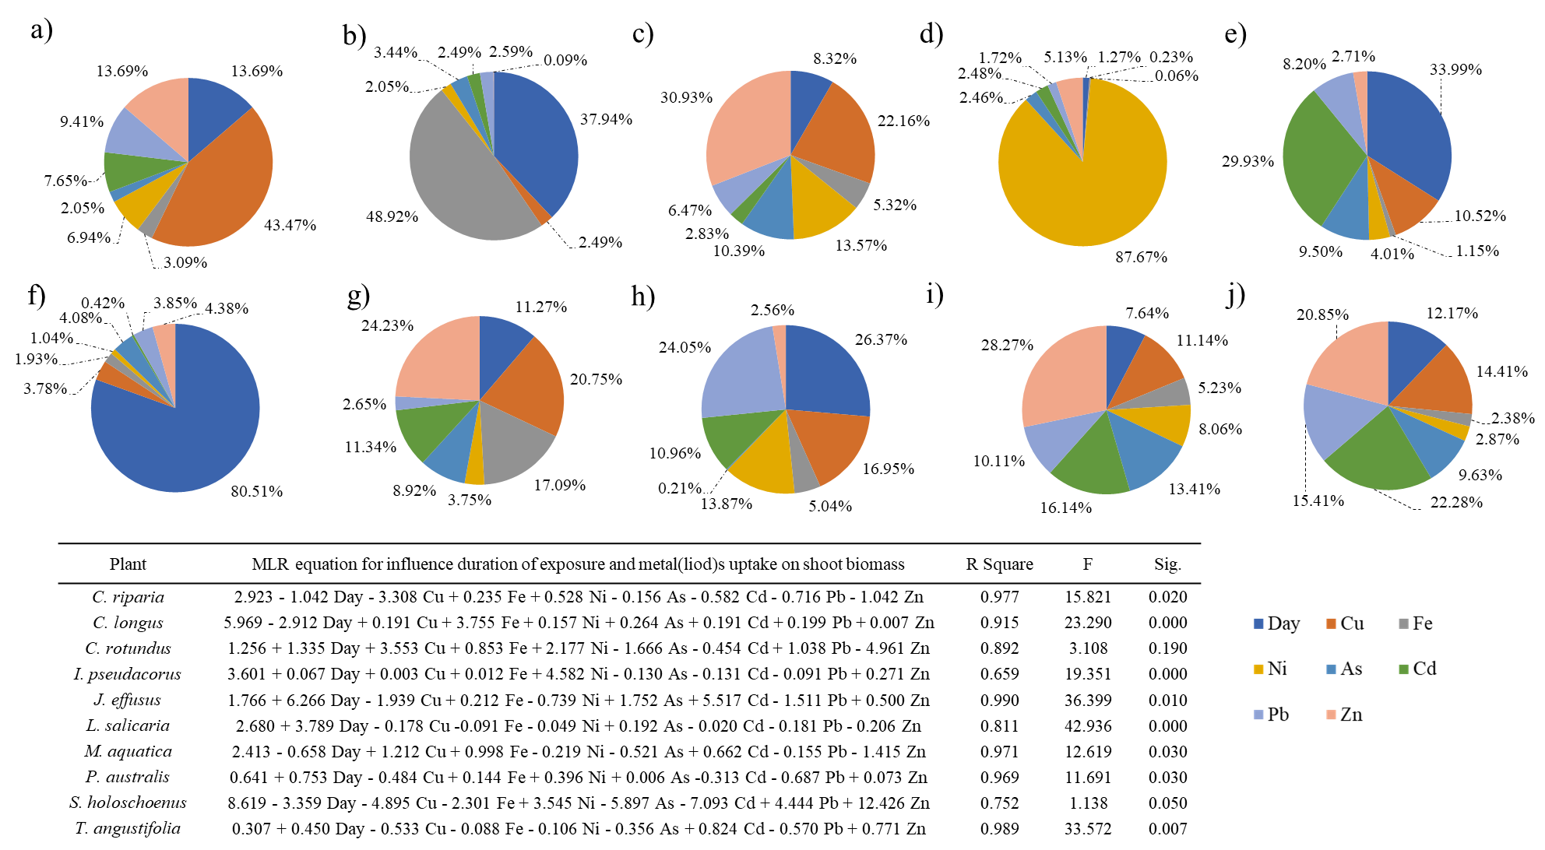
Supplementry Figure 11. MLR analysis to assess the effects of exposure time to polluted groundwater and metal(loid) uptake on the shoot biomass production of the studied plants. Pie charts indicate the relative contributions of exposure time and individual metal(loid) concentrations to the total model variability in the following order: a) C. riparia, b) C. longus, c) C. rotundus, d) I. pseudacorus, e) J. effusus, f) L. salicaria, g) M. aquatica, h) P. australis, i) S. holoschoenus, and j) T. angustifolia.

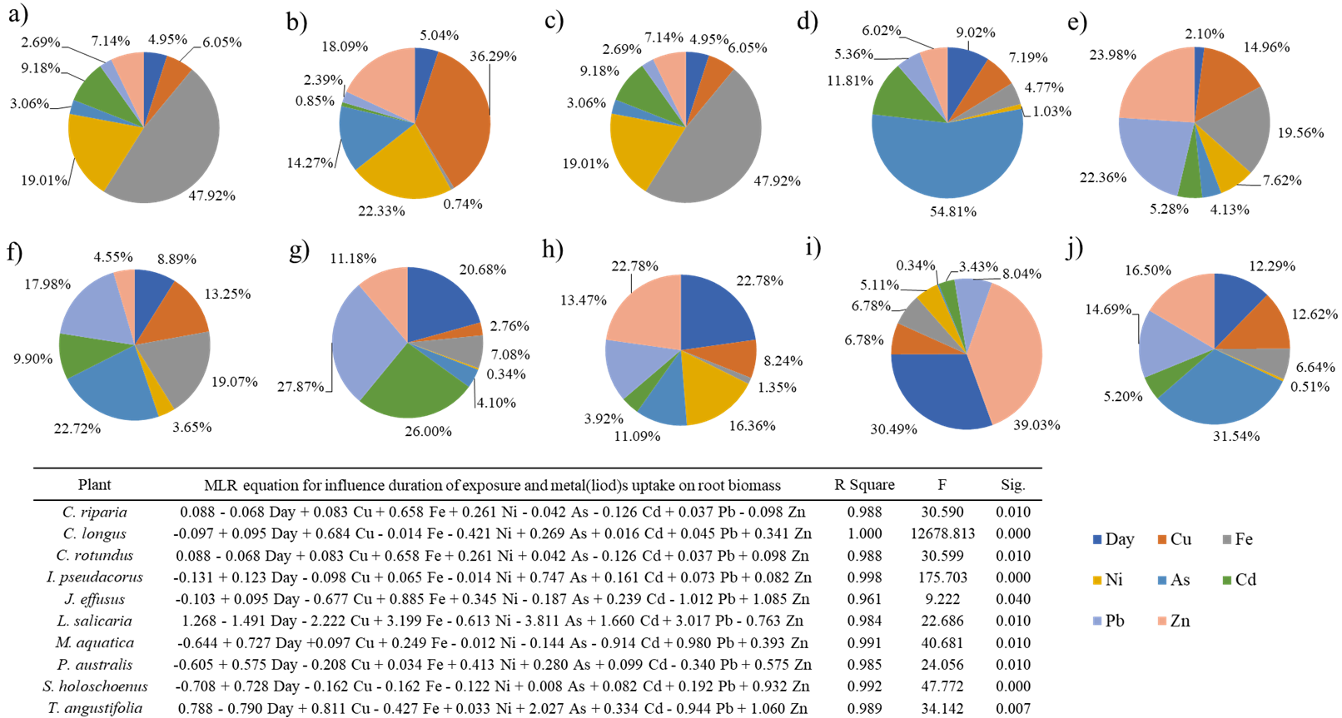
Supplementry Figure 12. MLR analysis to assess the effects of exposure time to polluted groundwater and metal(loid) uptake on the root biomass production of the studied plants. Pie charts indicate the relative contributions of exposure time and individual metal(loid) concentrations to the total model variability in the following order: a) C. riparia, b) C. longus, c) C. rotundus, d) I. pseudacorus, e) J. effusus, f) L. salicaria, g) M. aquatica, h) P. australis, i) S. holoschoenus, and j) T. angustifolia.

Supplementary Table 3. Metal(loid) concentrations in the shoots of the studied aquatic plants grown in polluted groundwater.
Plant | Days ⁺ | As¹ | Cd¹ | Cu² | Fe² | Ni¹ | Pb¹ | Zn²
Carex riparia | 5 | 2.96 ±0.11ª | 1.06 ±0.03ª | 86.08 ±4.49^{b} | 833.38 ±52.7^{b} | 67.44 ±1.86^{b} | 0.38 ±0.04^{b} | 56.48 ±3.76^{b}
Carex riparia | 10 | 3.17 ±0.10ª | 1.22 ±0.07ª | 116.12 ±8.15ª | 859.03 ±8.36^{b} | 217.07 ±15.27ª | 0.52 ±0.02ª | 74.95 ±2.31ª
Carex riparia | 15 | 1.95 ±0.02^{b} | 0.83 ±0.02^{b} | 65.47 ±1.47^{b} | 1138.30 ±113.53ª | 62.73 ±1.98^{b} | 0.54 ±0.02ª | 56.99 ±4.98^{b}
Cyperus longus | 5 | 0.23 ±0.01^{b} | 0.81 ±0.10^{b} | 20.93 ±1.15^{b} | 123.25 ±6.53^{c} | 53.16 ±3.77^{b} | 0.38 ±0.02ª | 40.16 ±19.70^{b}
Cyperus longus | 10 | 0.26 ±0.03^{b} | 1.73 ±0.10ª | 90.58 ±3.10ª | 272.72 ±9.34^{b} | 118.47 ±4.43ª | 0.30 ±0.02^{ab} | 76.77 ±3.52ª
Cyperus longus | 15 | 0.41 ±0.01ª | 1.90 ±0.06ª | 102.28 ±6.88ª | 399.87 ±9.84ª | 72.73 ±3.99^{b} | 0.20 ±0.02^{b} | 60.28 ±2.76ª
Cyperus rotundus | 5 | 1.91 ±0.09^{b} | 0.83 ±0.05ª | 65.64 ±0.77ª | 937.13 ±29.74^{c} | 70.94 ±6.53ª | 0.33 ±0.01ª | 46.88 ±2.32^{b}
Cyperus rotundus | 10 | 2.55 ±0.21^{ab} | 0.50 ±0.04^{b} | 66.63 ±2.21ª | 2273.51 ±141.77^{b} | 40.26 ±3.04^{b} | 0.52 ±0.03^{b} | 51.19 ±2.00^{b}
Cyperus rotundus | 15 | 3.72 ±0.27ª | 0.62 ±0.03^{b} | 69.32 ±3.21ª | 3297.38 ±125.00^{a*} | 31.63 ±1.17^{b} | 0.53 ±0.06^{b} | 67.15 ±4.48ª
Iris pseudacorus | 5 | 0.34 ±0.01ª | 0.02 ±0.00ª | 8.95 ±0.35^{b} | 10.00 ±0.87^{b} | 0.10 ±0.00^{b} | 0.15 ±0.01ª | 15.45 ±0.50^{b}
Iris pseudacorus | 10 | 0.35 ±0.03ª | 0.02 ±0.00ª | 9.04 ±0.59^{b} | 30.01 ±0.02ª | 0.11 ±0.01^{b} | 0.17 ±0.00ª | 22.18 ±2.26^{b}
Iris pseudacorus | 15 | 0.53 ±0.02ª | 0.06 ±0.01ª | 12.31 ±1.44ª | 41.15 ±0.43ª | 6.28 ±1.00ª | 0.22 ±0.01ª | 39.53 ±1.38ª
Juncus effusus | 5 | 1.44 ±0.03^{b} | 0.73 ±0.18^{b} | 58.39 ±6.08^{c} | 666.79 ±1.56^{b} | 35.03 ±4.08^{c} | 0.24 ±0.01^{b} | 35.08 ±3.05^{c}
Juncus effusus | 10 | 2.07 ±0.39ª | 1.67 ±0.22^{b} | 153.59 ±6.59^{b} | 1984.45 ±132.12ª | 133.32 ±24.69^{b} | 0.38 ±0.01ª | 94.73 ±5.52^{b}
Juncus effusus | 15 | 2.06 ±0.25ª | 3.85 ±0.02^{a*} | 347.07 ±44.63^{a*} | 2082.25 ±65.37ª | 313.50 ±2.19^{a*} | 0.41 ±0.01ª | 212.27 ±8.02^{a*}
Lythrum salicaria | 5 | 4.00 ±0.76^{a*} | 0.75 ±0.10^{b} | 81.96 ±3.22^{b} | 551.39 ±6.76^{b} | 16.55 ±1.99^{b} | 0.45 ±0.04ª | 92.29 ±1.56^{a*}
Lythrum salicaria | 10 | 1.61 ±0.20^{b} | 0.13 ±0.01^{c} | 84.44 ±3.82^{b} | 987.05 ±68.89ª | 19.86 ±0.76^{b} | 0.45 ±0.04ª | 96.04 ±2.89ª
Lythrum salicaria | 15 | 1.46 ±0.19^{b} | 1.09 ±0.02ª | 175.53 ±15.93ª | 1284.89 ±28.20ª | 131.88 ±8.75ª | 0.46 ±0.04ª | 103.15 ±10.88ª
Mentha aquatica | 5 | 2.51 ±0.01^{b} | 1.66 ±0.13^{a*} | 58.92 ±3.90^{b} | 1378.92 ±158.95^{a*} | 102.51 ±0.64^{b} | 0.58 ±0.07ª | 62.83 ±4.91^{b}
Mentha aquatica | 10 | 2.66 ±0.09^{b} | 1.42 ±0.21ª | 67.05 ±6.89^{b} | 861.05 ±35.20^{b} | 126.46 ±7.88^{ab} | 0.58 ±0.15ª | 63.84 ±2.13^{b}
Mentha aquatica | 15 | 4.66 ±0.01ª | 1.43 ±0.05ª | 108.95 ±7.53ª | 838.90 ±56.40^{b} | 143.72 ±6.02ª | 0.65 ±0.02ª | 87.42 ±8.52ª
Phragmites australis | 5 | 3.95 ±0.12^{b*} | 0.01 ±0.00ª | 49.67 ±4.20^{b} | 831.46 ±30.38^{c} | 7.43 ±0.22^{b} | 0.98 ±0.07^{a*} | 42.38 ±2.61^{b}
Phragmites australis | 10 | 4.15 ±0.23^{ab*} | 0.02 ±0.00ª | 55.67 ±1.63^{ab} | 1352.89 ±54.94^{b} | 16.76 ±1.82^{ab} | 1.11 ±0.11^{a*} | 62.28 ±0.81ª
Phragmites australis | 15 | 5.05 ±0.46^{a*} | 0.03 ±0.00ª | 62.57 ±4.93ª | 2068.19 ±26.61ª | 19.92 ±2.62ª | 1.48 ±0.38^{a*} | 68.68 ±0.33ª
Scirpus holoschoenus | 5 | 2.06 ±0.08ª | 0.47 ±0.04ª | 41.51 ±1.47^{b} | 1243.57 ±61.80^{b*} | 23.83 ±4.32^{b} | 0.55 ±0.04^{b} | 48.58 ±2.51^{b}
Scirpus holoschoenus | 10 | 2.35 ±0.28ª | 0.45 ±0.01ª | 47.94 ±17.69^{b} | 1443.83 ±299.24^{b*} | 25.67 ±2.90^{b} | 0.68 ±0.00ª | 58.81 ±2.23^{b}
Scirpus holoschoenus | 15 | 2.89 ±0.18ª | 0.45 ±0.02ª | 69.34 ±7.18ª | 2841.99 ±112.62^{a*} | 33.14 ±1.41ª | 0.72 ±0.07ª | 74.57 ±4.34ª
Typha angustifolia | 5 | 0.22 ±0.01^{b} | 0.66 ±0.01^{c} | 125.40 ±0.96^{b*} | 495.64 ±42.69^{c} | 115.85 ±9.94^{b*} | 1.20 ±0.03^{b*} | 68.32 ±0.57^{c}
Typha angustifolia | 10 | 1.44 ±0.26ª | 6.18 ±0.12^{a*} | 244.36 ±0.42^{a*} | 1132.43 ±54.48^{b} | 426.20 ±12.47^{a*} | 0.69 ±0.03ª | 229.19 ±6.34^{a*}
Typha angustifolia | 15 | 0.65 ±0.00^{b} | 2.95 ±0.19^{b} | 303.09 ±5.43^{a*} | 2760.43 ±188.91^{a*} | 173.90 ±1.21^{b} | 0.57 ±0.01ª | 168.76 ±7.35^{b}
⁺Days of Exposure. In super script alphabets indicate significant difference between different exposure duration (5, 10, or 15 days) of the specified aquatic plant’s shoot with “a” being highest followed by later alphabets, while “*” indicate significant highest metal(loid)s’ uptake among different aquatic plant within the same duration of exposure (5, 10, & 15 days).
¹The values of As, Cd, Ni, and Pb were presented in μg kg⁻¹ of the plant dried biomass.
²For Cu, Fe, and Zn the values were presented in mg kg⁻¹ of the plant dried biomass.

Supplementary Table 4. Metal(loid) concentrations in the roots of the studied aquatic plants grown in polluted groundwater.
Plant | Days ⁺ | As¹ | Cd¹ | Cu² | Fe² | Ni¹ | Pb¹ | Zn²
Carex riparia | 5 | 36.11 ±1.48^{b} | 3.34 ±0.29^{b*} | 809.00 ±12.59^{a*} | 5917.89 ±203.44^{c} | 196.43 ±2.12^{b*} | 0.74 ±0.07ª | 150.69 ±3.95^{b*}
Carex riparia | 10 | 47.10 ±0.45^{a*} | 5.31 ±0.30^{a*} | 838.40 ±3.35ª | 9988.41 ±177.72^{b} | 305.22 ±11.31^{a*} | 1.10 ±0.08ª | 212.69 ±8.41^{a*}
Carex riparia | 15 | 33.61 ±2.40^{b} | 2.79 ±0.13^{b} | 944.63 ±6.22ª | 18521.65 ±703.85ª | 359.94 ±34.25^{a*} | 1.20 ±0.11ª | 218.04 ±10.99^{a*}
Cyperus longus | 5 | 30.74 ±1.16^{b} | 2.22 ±0.33^{b} | 391.06 ±9.21^{b} | 4055.53 ±203.90^{c} | 142.24 ±7.75^{b} | 0.44 ±0.03^{b} | 90.78 ±1.24^{c}
Cyperus longus | 10 | 39.03 ±3.84^{b} | 3.55 ±0.15^{ab} | 761.44 ±7.95ª | 8615.95 ±551.33^{b} | 215.33 ±14.46^{ab} | 0.85 ±0.01ª | 130.21 ±11.96^{b}
Cyperus longus | 15 | 65.95 ±0.33^{a*} | 4.73 ±0.04^{a*} | 822.40 ±29.48ª | 21859.01 ±784.53^{a*} | 364.78 ±67.56^{a*} | 0.88 ±0.06ª | 232.75 ±12.08^{a*}
Cyperus rotundus | 5 | 13.09 ±2.16^{b} | 1.53 ±0.06^{b} | 332.04 ±27.11^{b} | 2574.41 ±242.31^{b} | 110.85 ±6.40^{b} | 0.68 ±0.04^{b} | 94.29 ±5.50ª
Cyperus rotundus | 10 | 24.25 ±1.46^{ab} | 1.97 ±0.31^{ab} | 363.30 ±30.13^{ab} | 3236.00 ±191.06^{ab} | 130.01 ±5.45ª | 1.14 ±0.14ª | 82.67 ±1.66ª
Cyperus rotundus | 15 | 30.97 ±0.41ª | 2.57 ±0.29ª | 445.16 ±6.72ª | 4877.00 ±118.66ª | 146.80 ±5.84ª | 1.07 ±0.04ª | 99.01 ±25.87ª
Iris pseudacorus | 5 | 2.47 ±0.51^{b} | 0.02 ±0.00^{c} | 15.85 ±6.62^{b} | 243.71 ±75.01^{b} | 2.88 ±0.35^{c} | 0.25 ±0.00^{b} | 14.52 ±6.08^{c}
Iris pseudacorus | 10 | 10.37 ±1.35ª | 0.31 ±0.14^{b} | 15.81 ±3.39ª | 1185.89 ±671.99ª | 47.20 ±0.80^{b} | 0.45 ±0.03ª | 53.33 ±3.33^{b}
Iris pseudacorus | 15 | 9.15 ±2.83ª | 4.21 ±1.24^{a*} | 30.27 ±4.86ª | 1000.72 ±119.73ª | 214.90 ±7.04ª | 0.40 ±0.04ª | 192.90 ±46.56ª
Juncus effusus | 5 | 9.36 ±0.66^{b} | 0.48 ±0.17^{c} | 136.57 ±33.78^{b} | 9757.91 ±3224.46^{ab*} | 78.09 ±5.66 ª | 0.78 ±0.05^{b} | 49.11 ±1.76^{b}
Juncus effusus | 10 | 10.06 ±2.41^{b} | 1.29 ±0.31^{b} | 184.05 ±7.22^{b} | 12132.04 ±617.66 ^{a*} | 102.20 ±8.11 ª | 1.24 ±0.05ª | 81.29 ±7.63ª
Juncus effusus | 15 | 29.48 ±0.72ª | 2.09 ±0.95ª | 494.53 ±9.35ª | 8668.55 ±534.60^{b} | 124.22 ±5.26 ª | 1.72 ±0.04ª | 95.19 ±3.80ª
Lythrum salicaria | 5 | 1.73 ±0.65^{b} | 0.44 ±0.29^{c} | 45.99 ±19.97^{c} | 1880.43 ±11.80^{b} | 31.71 ±9.40^{c} | 1.31 ±0.05^{b} | 34.71 ±7.50c
Lythrum salicaria | 10 | 6.73 ±1.74ª | 1.08 ±0.10^{b} | 220.25 ±9.81^{b} | 4849.68 ±608.88ª | 85.84 ±8.00^{b} | 3.95 ±0.85ª | 119.36 ±9.01^{ab}
Lythrum salicaria | 15 | 7.39 ±0.90ª | 3.12 ±1.56ª | 651.28 ±6.47ª | 4924.79 ±979.43ª | 169.63 ±26.22ª | 4.26 ±0.07ª | 168.99 ±56.15ª
Mentha aquatica | 5 | 8.15 ±0.81^{b} | 1.55 ±0.11^{b} | 399.20 ±55.39^{c} | 3059.64 ±46.42^{c} | 85.02 ±1.31^{b} | 0.83 ±0.01^{c} | 61.29 ±4.51^{b}
Mentha aquatica | 10 | 15.87 ±0.69ª | 2.05 ±0.18^{ab} | 575.52 ±46.12^{b} | 5034.99 ±481.51^{b} | 76.93 ±1.01^{b} | 1.61 ±0.13^{b} | 66.70 ±2.89^{b}
Mentha aquatica | 15 | 19.35 ±1.42ª | 3.34 ±0.57ª | 1199.43 ±27.77^{a*} | 18022.02 ±1508.76ª | 266.92 ±13.78ª | 3.14 ±0.29ª | 131.63 ±13.64ª
Phragmites australis | 5 | 42.30 ±2.92^{a*} | 0.72 ±0.02^{c} | 134.42 ±7.76^{b} | 1935.65 ±124.36^{b} | 32.06 ±0.79^{c} | 0.25 ±0.03ª | 46.14 ±4.89^{c}
Phragmites australis | 10 | 43.73 ±1.71^{a*} | 2.20 ±0.36^{b} | 213.89 ±1.37ª | 4240.53 ±156.04ª | 112.13 ±6.40^{b} | 0.72 ±0.03^{b} | 108.19 ±6.96 ^{ab}
Phragmites australis | 15 | 31.37 ±2.88^{b} | 5.53 ±0.18^{a*} | 138.04 ±6.08^{b} | 4629.78 ±571.81ª | 259.60 ±29.62ª | 0.81 ±0.10^{b} | 131.43 ±4.28ª
Scirpus holoschoenus | 5 | 26.02 ±4.65^{b} | 2.13 ±0.40^{b} | 299.50 ±28.45^{b} | 3680.55 ±423.89^{c} | 78.17 ±5.43^{c} | 2.50 ±0.11^{c*} | 103.74 ±1.92^{b}
Scirpus holoschoenus | 10 | 29.61 ±3.52^{b} | 3.34 ±0.03ª | 664.06 ±12.83ª | 6988.08 ±299.24^{b} | 259.00 ±3.21^{b} | 4.85 ±0.16^{ab*} | 201.09 ±6.69^{a*}
Scirpus holoschoenus | 15 | 52.94 ±5.80ª | 3.71 ±0.33ª | 671.77 ±23.65ª | 16029.59 ±1438.71ª | 335.66 ±3.49ª | 6.12 ±0.47^{a*} | 208.96 ±14.89^{a*}
Typha angustifolia | 5 | 8.40 ±0.55^{c} | 1.31 ±0.26^{b} | 308.09 ±21.83^{c} | 2427.03 ±206.66^{b} | 86.55 ±3.12^{b} | 0.48 ±0.03^{b} | 79.27 ±3.89^{c}
Typha angustifolia | 10 | 32.77 ±0.35ª | 4.24 ±0.21ª | 937.20 ±31.52^{a*} | 4349.55 ±99.48ª | 250.13 ±1.18ª | 1.69 ±0.08ª | 214.64 ±6.33^{a*}
Typha angustifolia | 15 | 18.15 ±1.69^{b} | 3.09 ±0.19ª | 535.39 ±34.04^{b} | 5657.43 ±327.22 ª | 292.95 ±9.03ª | 1.88 ±0.11ª | 156.09 ±24.25^{b}
⁺Days of Exposure. In super script alphabets indicate significant difference between different exposure duration (5, 10, or 15 days) of the specified aquatic plant’s root with “a” being highest followed by later alphabets, while “*” indicate significant highest metal(loid)s’ uptake among different aquatic plant within the same duration of exposure (5, 10, & 15 days).
¹The values of As, Cd, Ni, and Pb were presented in μg kg⁻¹ of the plant dried biomass.
²For Cu, Fe, and Zn the values were presented in mg kg⁻¹ of the plant dried biomass.

