SUPPLEMENTARY INFORMATION
Table S1: Latent construct construction and distribution of responses for specific items (shares of respondents)
Latent construct | Item specification | Strongly disagree | Disagree | Neutral or undecided | Agree | Strongly agree
Perceived usefulness | I found ROTS useful and efficient in improving the sanitation of my community | 0.20 | 0.30 | 0.11 | 0.30 | 0.09
Perceived usefulness | Using the ROTS would motivate me to improve the sanitation in my community | 0.25 | 0.30 | 0.12 | 0.23 | 0.10
Perceived ease of use | My interaction with the ROTS would be clear and understandable | 0.06 | 0.15 | 0.12 | 0.49 | 0.18
Perceived ease of use | It is easy for me to learn and become skilful at using the ROTS | 0.06 | 0.15 | 0.09 | 0.49 | 0.21
Attitudes | Using the ROTS is a good idea | 0.04 | 0.09 | 0.08 | 0.51 | 0.28
Attitudes | Using the ROTS can be a source of income generation | 0.02 | 0.10 | 0.10 | 0.51 | 0.27
Attitudes | The ROTS can make my lifestyle more interesting | 0.04 | 0.10 | 0.10 | 0.49 | 0.27
Attitudes | I like to use the ROTS | 0.07 | 0.09 | 0.08 | 0.34 | 0.42
Social norms | People who are important to me would think that using the ROTS is good for me | 0.25 | 0.31 | 0.13 | 0.22 | 0.09
Social norms | People who influence my behaviour would think that I should use the ROTS | 0.28 | 0.31 | 0.14 | 0.22 | 0.05
Social norms | In general, my community has supported the use of the ROTS | 0.25 | 0.33 | 0.15 | 0.20 | 0.07
Perceived control | I have the resource necessary to use the ROTS (Money, space, etc.) | 0.31 | 0.24 | 0.13 | 0.23 | 0.09
Perceived control | I know the benefit of using the ROTS | 0.14 | 0.25 | 0.20 | 0.29 | 0.12
Perceived control | A specific body is available for assistance in case of difficulties using the ROTS. | 0.27 | 0.35 | 0.16 | 0.18 | 0.04
Perceived political support | The community leaders will support the IOM of the ROTS | 0.31 | 0.20 | 0.05 | 0.28 | 0.16
Perceived political support | The local government will support the IOM of the ROTS | 0.30 | 0.18 | 0.05 | 0.35 | 0.12
Excreta use knowledge | Human excreta are a resource for the soil* |  | 0.08 | 0.12 | 0.80
Excreta use knowledge | Sanitized human excreta can be used as fertilizer* |  | 0.10 | 0.15 | 0.75
Excreta use knowledge | Crops fertilized with human excreta are good for consumption* |  | 0.17 | 0.22 | 0.62
Excreta handling anxiety | Handling excreta is a great health risk | 0.07 | 0.09 | 0.02 | 0.35 | 0.47
Excreta handling anxiety | Human excreta should not be handled in any way | 0.08 | 0.22 | 0.04 | 0.25 | 0.41
Excreta handling anxiety | Human urine has no benefit to humans | 0.17 | 0.29 | 0.07 | 0.24 | 0.23
Excreta handling anxiety | It is a taboo to handle urine | 0.12 | 0.12 | 0.05 | 0.32 | 0.39
Excreta handling anxiety | Human faeces have no benefit to humans | 0.20 | 0.29 | 0.07 | 0.17 | 0.27
Excreta handling anxiety | It is a taboo to touch faeces | 0.12 | 0.12 | 0.05 | 0.33 | 0.38
Excreta handling anxiety | It is a taboo to touch treated faeces | 0.14 | 0.16 | 0.05 | 0.28 | 0.37
Notes: *Measured on a 3-point scale: Disagree – Don’t know – Agree; ROTS – resource-oriented toilet system

Table S2: Descriptive characteristics of respondents and their households
Variables used in the analysis: | Statistics
Age of household head in years, mean (SD) | 45 (13)
Sex of household head (share of households with male heads) | 0.63
Size of household, mean (SD) | 5.03 (2.04)
Education of household head (shares of: illiterate – can write and read – primary school – secondary school – college and above | 0.57 – 0.22 – 0.13 – 0.06 – 0.02
Household income – annual, both in-cash and in-kind, from various sources in Ethiopian Birrs, mean (SD); values transformed by square root used in the analysis | 22653 (19536)
Farmland size in timads (SD) | 6.44 (6.17)
Livestock ownership in tropical livestock units (weights: large cattle 0.8; smaller cattle 0.6; sheep and goats 0.1; donkeys 0.4; hens and chickens 0.01), (SD) | 4.53 (2.57)
Shares of households having mobile phones – TVs – radios (used for the construction of media sources availability index by factor analysis) | 0.44 – 0.15 – 0.40
Other descriptive characteristics of the sample | Statistics
Share of households with children below 10 years | 0.91
Share of households with people above 60 years | 0.30
Marital status of household head: shares of married – single – widowed – divorced | 0.84 – 0.07 – 0.06 – 0.03
Occupation of household head – share of farmers | 0.89
Ethnicity – share of Oromo | 0.99
Religion – share of Ethiopian Orthodox | 0.97

Figure S1: Estimates for the model informed by TAM
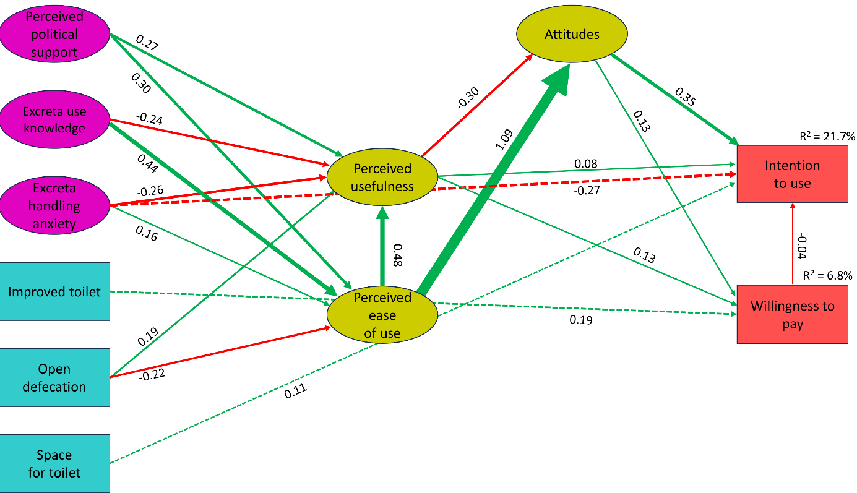

Figure S2: Estimates for the model informed by C-TAM-TPB
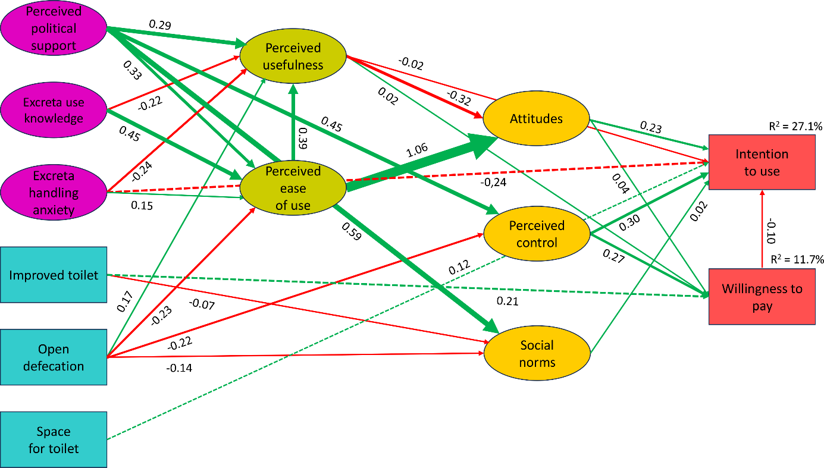

Table S3: Standardized direct, indirect, and total effects on intention to use ROTS
 | Direct effect |  |  | Indirect effect |  |  | Total effect
 | TAM | TPB | C-TAM-TPB | TAM | TPB | C-TAM-TPB | TAM | TPB | C-TAM-TPB
Perceived ease of use | . | . | . | 0.368 | . | 0.199 | 0.368 | . | 0.199
Perceived usefulness | 0.082 | . | -0.025 | -0.109 | . | -0.074 | -0.027 | . | -0.099
Attitudes | 0.352 | 0.194 | 0.228 | -0.003 | -0.001 | -0.003 | 0.349 | 0.193 | 0.225
Perceived control | . | 0.349 | 0.295 | . | -0.026 | -0.021 | . | 0.323 | 0.274
Social norms | . | -0.013 | 0.025 | . | . | . | . | -0.013 | 0.025
Perceived political support | . | . | . | 0.102 | 0.174 | 0.176 | 0.102 | 0.174 | 0.176
Excreta use knowledge | . | . | . | 0.168 | 0.098 | 0.111 | 0.168 | 0.098 | 0.111
Excreta handling anxiety | -0.269 | -0.232 | -0.243 | 0.065 | 0.041 | 0.055 | -0.204 | -0.191 | -0.188
Improved toilet | . | . | . | -0.004 | -0.016 | -0.018 | -0.004 | -0.016 | -0.018
Open defecation | . | . | . | -0.087 | -0.119 | -0.125 | -0.087 | -0.119 | -0.125
Space for toilet | 0.114 | 0.117 | 0.118 | . | . | . | 0.114 | 0.117 | 0.018

Table S4: Standardized direct, indirect, and total effects on WTP for ROTS
 | Direct effect |  |  | Indirect effect |  |  | Total effect
 | TAM | TPB | C-TAM-TPB | TAM | TPB | C-TAM-TPB | TAM | TPB | C-TAM-TPB
Perceived ease of use | . | . | . | 0.184 | . | 0.047 | 0.184 | . | 0.047
Perceived usefulness | 0.126 | . | 0.023 | -0.040 | . | -0.013 | 0.086 | . | 0.010
Attitudes | 0.131 | 0.016 | 0.041 | . | . | . | 0.131 | 0.016 | 0.041
Perceived control | . | 0.306 | 0.275 | . | . | . | . | 0.306 | 0.275
Perceived political support | . | . | . | 0.078 | 0.138 | 0.143 | 0.078 | 0.138 | 0.143
Excreta use knowledge | . | . | . | 0.060 | 0.008 | 0.019 | 0.060 | 0.008 | 0.019
Excreta handling anxiety | . | . | . | 0.006 | 0.003 | 0.005 | 0.006 | 0.003 | 0.005
Improved toilet | 0.194 | 0.205 | 0.206 | . | . | . | 0.194 | 0.205 | 0.206
Open defecation | . | . | . | -0.025 | -0.071 | -0.068 | -0.025 | -0.071 | -0.068
Space for toilet | . | . | . | . | . | . | . | . | .

