Supplementary Material
Comparison of three different zeolites to activate peroxymonosulfate for the degradation of the pharmaceutical ciprofloxacin in water

Efraím A. Serna-Galvis^{a,b}, Carlos Mendoza-Merlano^{b}, Johana Arboleda-Echavarría^{b,c}, Ricardo A. Torres-Palmaª, Adriana Echavarría-Isaza^{b,*}

ª Grupo de Investigación en Remediación Ambiental y Biocatálisis (GIRAB), Instituto de Química, Facultad de Ciencias Exactas y Naturales, Universidad de Antioquia UdeA, Calle 70 # 52-21, Medellín, Colombia

^{b} Grupo de Catalizadores y Adsorbentes (CATALAD), Instituto de Química, Facultad de Ciencias Exactas y Naturales, Universidad de Antioquia UdeA, Calle 70 # 52-21, Medellín, Colombia
^{c} Escuela de Microbiología, Universidad de Antioquia UdeA, Calle 70 # 52-21, Medellín, Colombia

*Corresponding author: adriana.echavarria@udea.edu.co

Supplementary figures
A
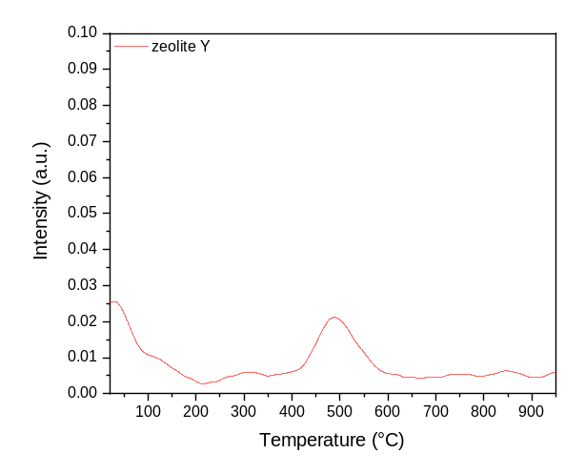
B
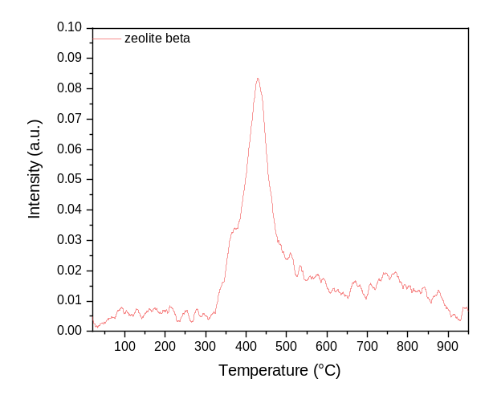

C
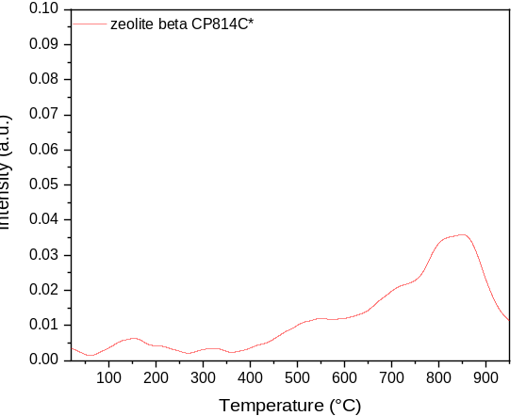
Fig. S1. Determination of the basicity of the considered zeolites by CO₂ adsorption (TPD-CO₂ results). A. ZY, B. ZB, and C. CP814C*.

A
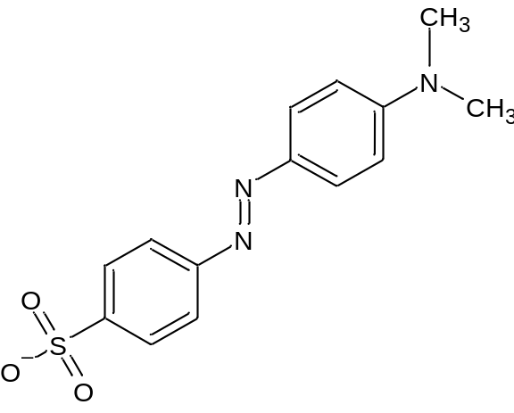
B
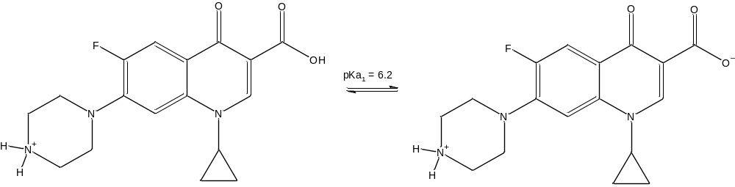
Fig. S2. Structures of the target pollutants A. Methyl Orange (MO).
B. Ciprofloxacin (CIP) and its pKa₁.

Supplementary tables
Table S1. Elemental composition of ZY.
Element | Si | Al | Na | O
Weight Composition  (%) | 20.7 | 8.3 | 14.1 | 56.9

Table S2. Oxygen surface composition (percentage) for the basic groups on the ZY surface before and after interaction with PMS.
Zeolite* | Al-O⁻ | Si-O⁻
ZY before interaction | 40.0 | 20.7
ZY after  interaction | 33.4 | 8.8
*Before the interaction with PMS, the AlO⁻ and SiO⁻
moieties on ZY have Na⁺ as compensation cations.

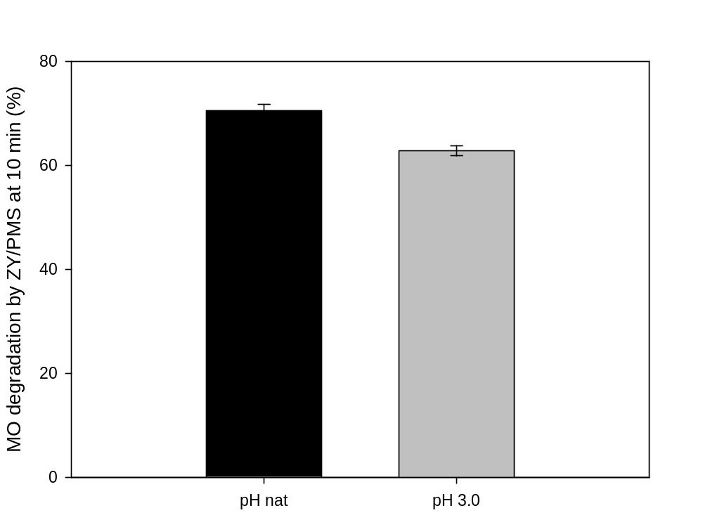
Fig. S3. Degradation of MO by the ZY/PMS system at different initial pHs. Experimental conditions: [Zeolite]= 0.2 g L⁻¹, [PMS]= 500 µmol L⁻¹, and [MO]= 30.6 µmol L⁻¹, pH nat: 5.6.

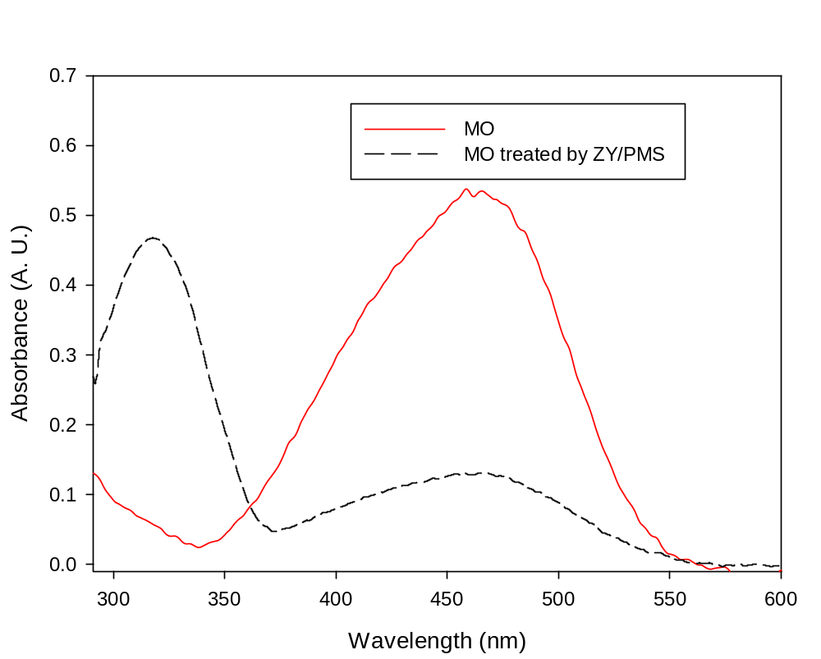
Fig. S4. Spectra of methyl orange solution without treatment (MO) and after 10 min of the treatment using the ZY/PMS system (MO treated by ZY/PMS).

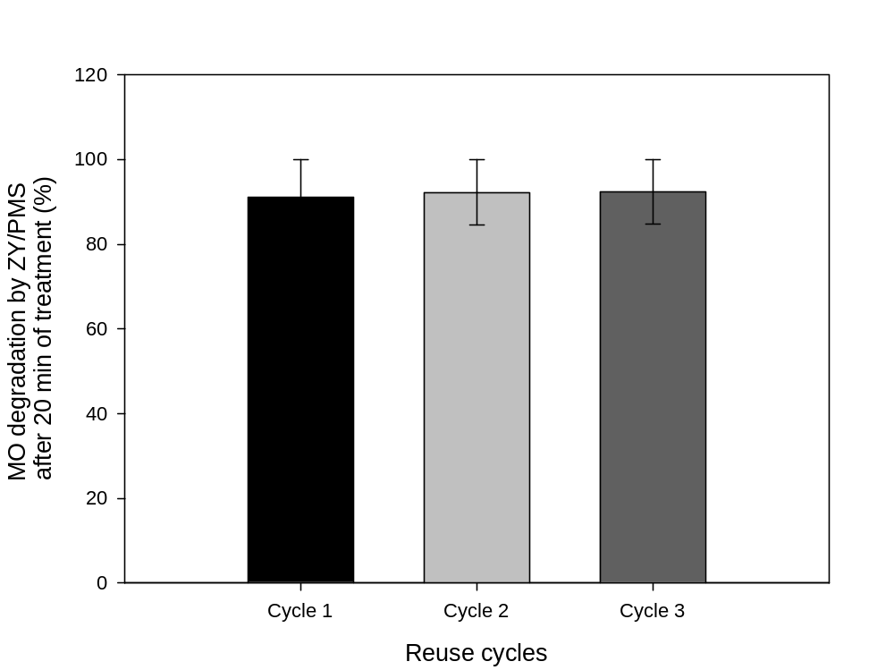
Fig. S5. Reuse cycles for the MO treatment by ZY/PMS. Experimental conditions: [Z4A]= 0.2 g L⁻¹, [PMS]= 500 µmol L⁻¹, and [MO]= 30.6 µmol L⁻¹.

Table S3. Composition of the simulated hospital wastewater (HWW).
Component | Concentration (mg L⁻¹) |  | Concentration (µmol L⁻¹)
NaCl |  | 76 |  | 1300
NH₄Cl |  | 50 |  | 940
Na₂SO₄ |  | 100.5 |  | 710
KCl |  | 100 |  | 1340
KH₂PO₄ |  | 50 |  | 370
CaCl₂-2H₂O |  | 50 |  | 340
Urea |  | 1260 |  | 2100
pH |  | 6.5

