Supplementary information for
Enhanced Micropollutant Degradation over Catalyst-Free Synergistic Activation of Periodate and Persulfate under Solar Light
Zexiao Zhengª, Justin H.K. Manª, Xiaoying Wangª, Alvin S.K. Kwanª, Kwan To Yimª, Irene M.C. Lo^{a, b*}
ª Department of Civil and Environmental Engineering, The Hong Kong University of Science and Technology, Hong Kong, China
^{b} Institute for Advanced Study, The Hong Kong University of Science and Technology, Hong Kong, China
* Corresponding author. Email address: cemclo@ust.hk; (Chair Professor Irene M. C. Lo); Tel.: +852 2358 7157; Fax: +852 2358 1534.

The Supplementary materials include 10 Pages, 5 Figures, and 2 Tables.

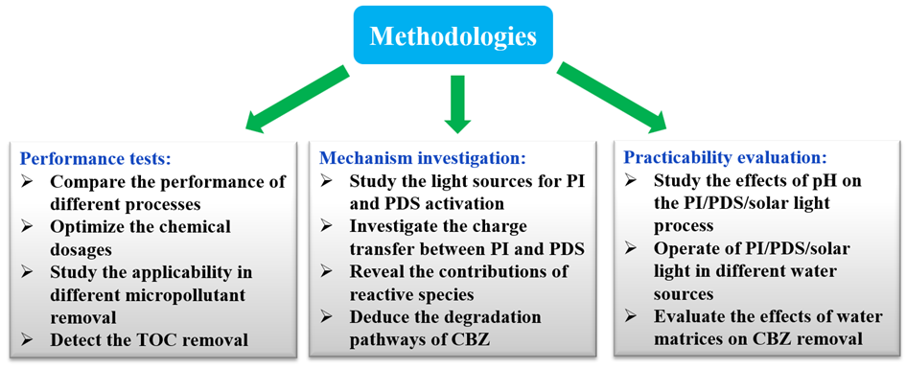
Figure S1. The methodological flow diagram of the research work

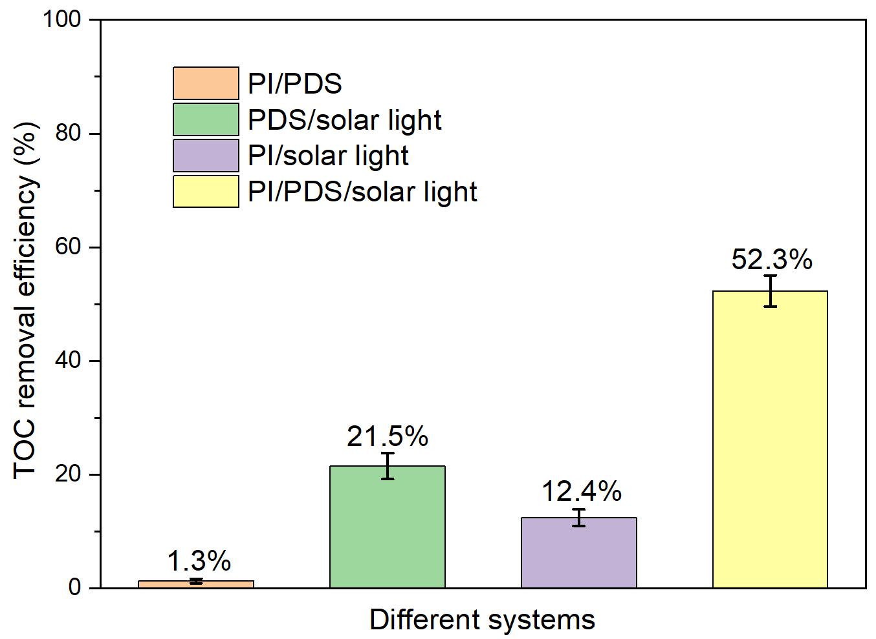
Figure S2. TOC removal efficiencies during the CBZ degradation by different processes. Experimental conditions: [CBZ]₀ = 1 ppm; [NaBrO₃]₀ = 0.1 mM; [PDS]₀ = 0.25 mM; [PI]₀ = 0.5 mM; pH = 7.0 ± 0.1

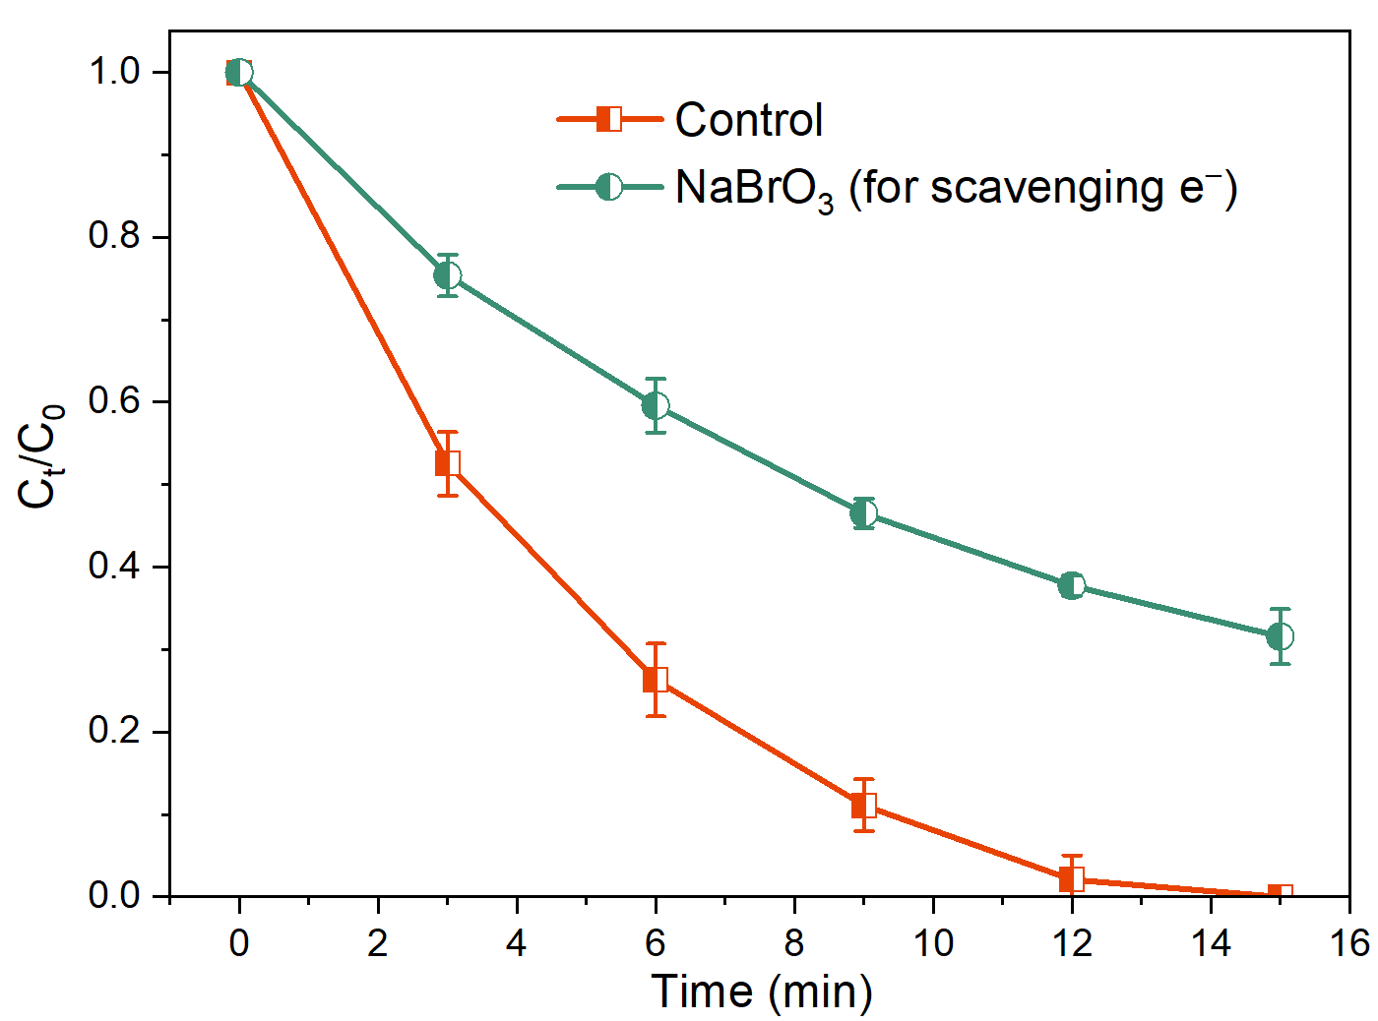
Figure S3. Effect of scavenging electrons on CBZ degradation by the PI/PDS/solar light process. Experimental conditions: [CBZ]₀ = 1 ppm; [NaBrO₃]₀ = 0.1 mM; [PDS]₀ = 0.25 mM; [PI]₀ = 0.5 mM; pH = 7.0 ± 0.1

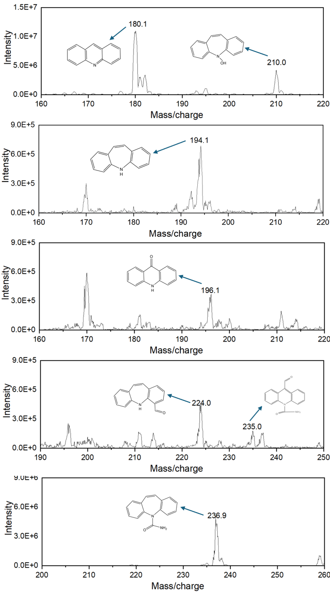
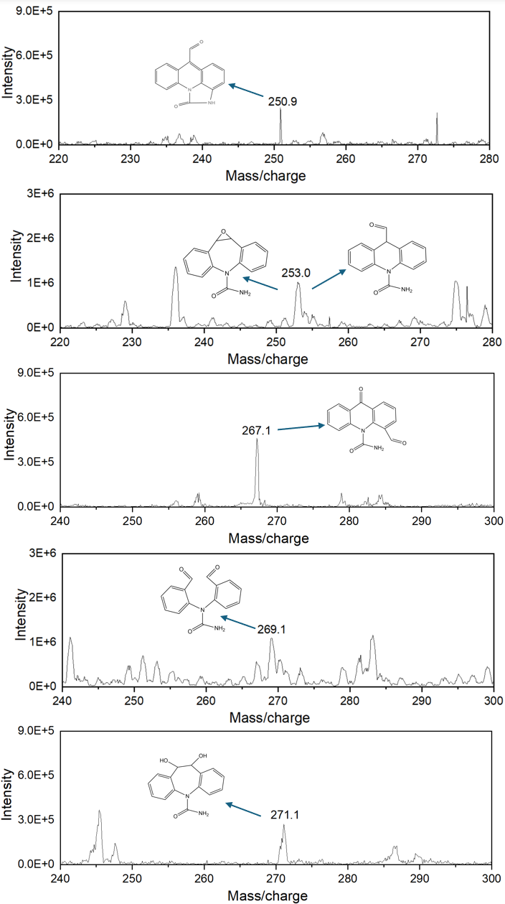
Figure S4. LC-MS patterns of intermediates during CBZ degradation by the PI/PDS/solar light process
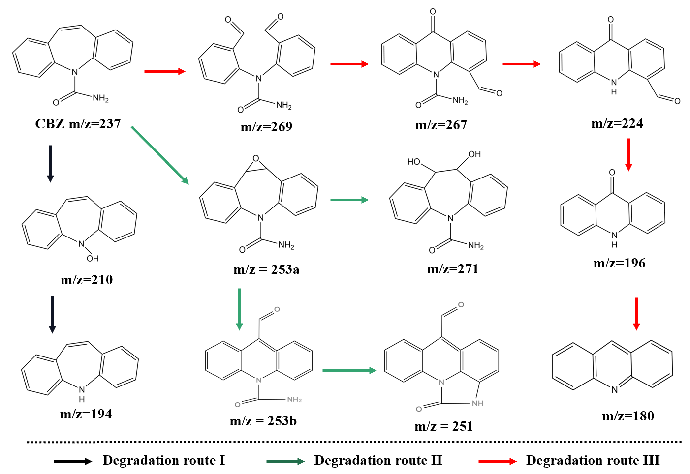
Figure S5. Degradation pathways of CBZ by the PI/PDS/solar light process

Table S1. Detailed experimental conditions of different processes
Processes | PI dosage | PDS dosage | Light intensity | Solution volume | Solution pH | Temp.  (°C) | Pollutant Conc.
PI/solar light | 0.5 mM | - | 1008 ± 24  W/m² | 50 mL | 7.0 ± 0.1 | 20.1 ± 0.5 | 1 ppm
PDS/solar light | - | 0.25 mM | 1008 ± 24  W/m² | 50 mL | 7.0 ± 0.1 | 20.1 ± 0.5 | 1 ppm
PI/PDS solar light | 0.5 mM | 0.25 mM | 1008 ± 24  W/m² | 50 mL | 7.0 ± 0.1 | 20.1 ± 0.5 | 1 ppm

Processes | Materials | Pollutant conc. | Working conditions |  |  | Removal efficiency | Energy consumption | Ref.
Processes | Materials | Pollutant conc. | Chemical & conc. | Light source | Time (min) | Removal efficiency | Energy consumption | Ref.
UV/PMS | - | 5 ppm | 1 mM PMS | UV lamp | 90 | 76.2% | 4.67 kWh m⁻³ | Deng et al., 2013
UV/H₂O₂ | - | 5 ppm | 1 mM H₂O₂ | UV lamp | 90 | 96.22% | 1.98 kWh m⁻³ | Deng et al., 2013
UV/PDS | - | 5 ppm | 1 mM PDS | UV lamp | 90 | 98.91% | 1.49 kWh m⁻³ | Deng et al., 2013
UV/IO₃⁻ | - | 5 ppm | 0.3 mM IO₃⁻ | UV lamp | 30 | 92.47% | 9 kWh m⁻³ | Zhang et al., 2022
Photocatalysis/PDS | MoS₂/rGO/WO₃ | 2.4 ppm | 0.25 mM PDS | AM 1.5 G solar light | 20 | 88.25% | - | Cui et al., 2021
UV/TiO₂/PI | TiO₂ | 5 ppm | 0.05 mM PI | UV lamp | 30 | 87% | 5.57 kWh m⁻³ | Zhang et al., 2022
UV/PDS |  | 4.8 ppm | 0.2 mM PDS | UV lamp | 60 | 100% | - | Zhang et al., 2015
PI/PDS/solar light |  | 1 ppm | 0.5 mM PI, 0.5 mM PDS | AM 1.5 G solar light | 15 | 100% | - | This study
Table S2. Comparison of different processes in CBZ degradation

References
Cui J, Zhang Y, Zheng Y, Pei Y, He X, Xi B (2021) Catalytic degradation of carbamazepine by a novel granular visible-light-driven photocatalyst activating the peroxydisulfate system. Chemical Engineering Journal 421: 127867.
Deng J, Shao Y, Gao N, Xia S, Tan C, Zhou S, Hu X (2013) Degradation of the antiepileptic drug carbamazepine upon different UV-based advanced oxidation processes in water. Chemical Engineering Journal 222: 150-158.
Zhang X, Kamali M, Uleners T, Symus J, Zhang S, Liu Z, Costa MEV, Appels L, Cabooter D, Dewil R (2022) UV/TiO₂/periodate system for the degradation of organic pollutants–Kinetics, mechanisms and toxicity study. Chemical Engineering Journal 449: 137680.
Zhang X, Kamali M, Yu X, Costa MEV, Appels L, Cabooter D, Dewil R (2022) Kinetics and mechanisms of the carbamazepine degradation in aqueous media using novel iodate-assisted photochemical and photocatalytic systems. Science of The Total Environment 825: 153871.

