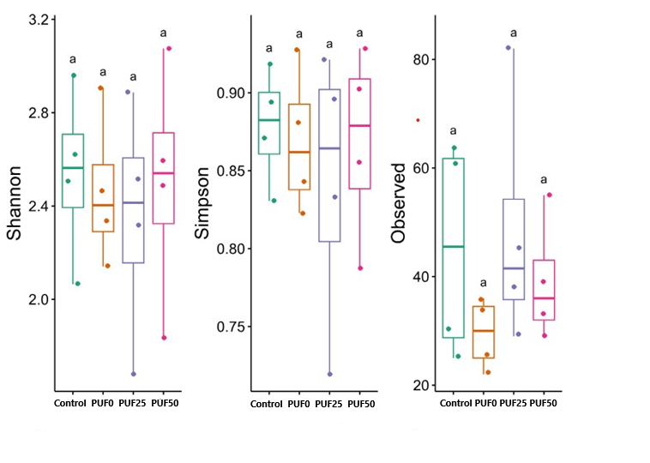

Fig. S1. Alpha diversity index of microbial gut of different feeds

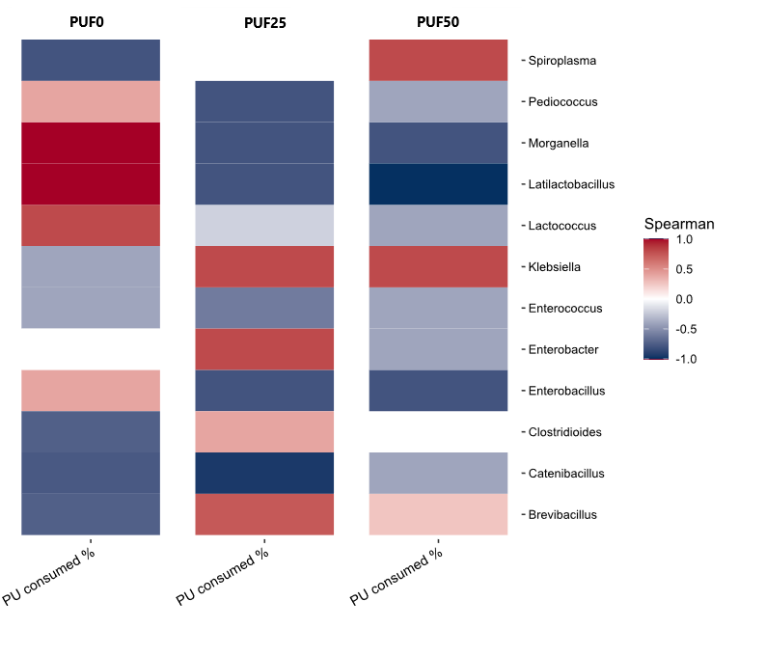

Fig. S2 Spearman correlation of different genera with the total % of PU consumed for each type of PU foam.

Frass from mealworms fed with bran
100x | 250x | 1500x
Frass from mealworms fed with PU foam
100x | 250x | 1500x

Fig. S3. SEM images of frass from mealworms fed with bran and fed with PU foam

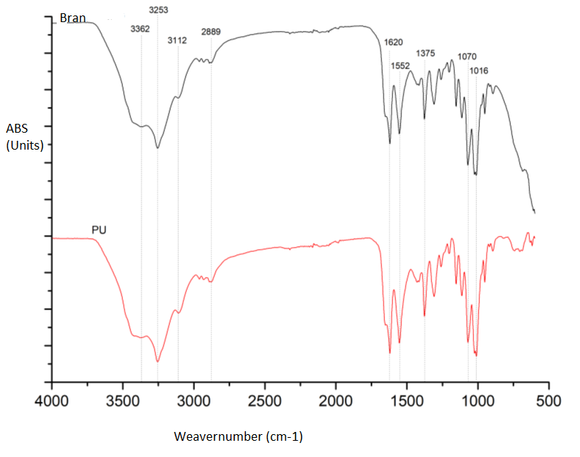

Fig. S4. FTIR spectra of chitin from bran (black line) and PU (red line)

Table S1. The degree of acetylation calculated from the elemental analysis.
Chitin | %N | %C | %DA
Bran | 2.25 ± 0.05 | 15.55 ± 0.45 | 104 ± 2.7
PU foam | 1.91 ± 0.08 | 13.48 ± 0.41 | 115.5 ± 1.4

