Journal: Environmental Science and Pollution Research
Occurrence of microplastics in Russell's snapper (Lutjanus russellii) and associated prey species in the Central Gulf of Thailand
Wanlada Klangnurak¹, Siriluk Prachumwong¹, María Belén Alfonso^{2,3}, Haruka Nakano^{2,3},
Suchana Chavanich^{4,5}, Voranop Viyakarn^{4,5} and Suppakarn Jandang^{2,3*}

¹ Department of Animal Production Technology and Fishery, School of Agricultural Technology, King Mongkut's Institute of Technology Ladkrabang, Bangkok 10520, Thailand
² Research Institute for Applied Mechanics, Kyushu University, Kasuga-Koen, Kasuga 816-8580, Japan
³ Center for Ocean Plastic Studies, Research Institute for Applied Mechanics, Kyushu University, CU Research Building 14th floor, Bangkok, 10330, Thailand
⁴ Reef Biology Research Group, Department of Marine Science, Faculty of Science, Chulalongkorn University, Pathumwan, Bangkok, 10330, Thailand
⁵ Aquatic Resources Research Institute, Chulalongkorn University, Institute Building No.3, 9th floor, Bangkok, 10330, Thailand

*Corresponding Author: Suppakarn Jandang
Email address: suppakarn.j@riam.kyushu-u.ac.jp

Supplementary material
Table S1 The library used for Fourier-transform infrared (µFT-IR) analysis in this study
1 | Food Additives
2 | Inorganic
3 | Organic
4 | Polymer
5 | Trans Food Additives
6 | Trans Inorganic
7 | Trans Organic
8 | Trans Polymer
9 | Thermal damaged
10 | UV damaged

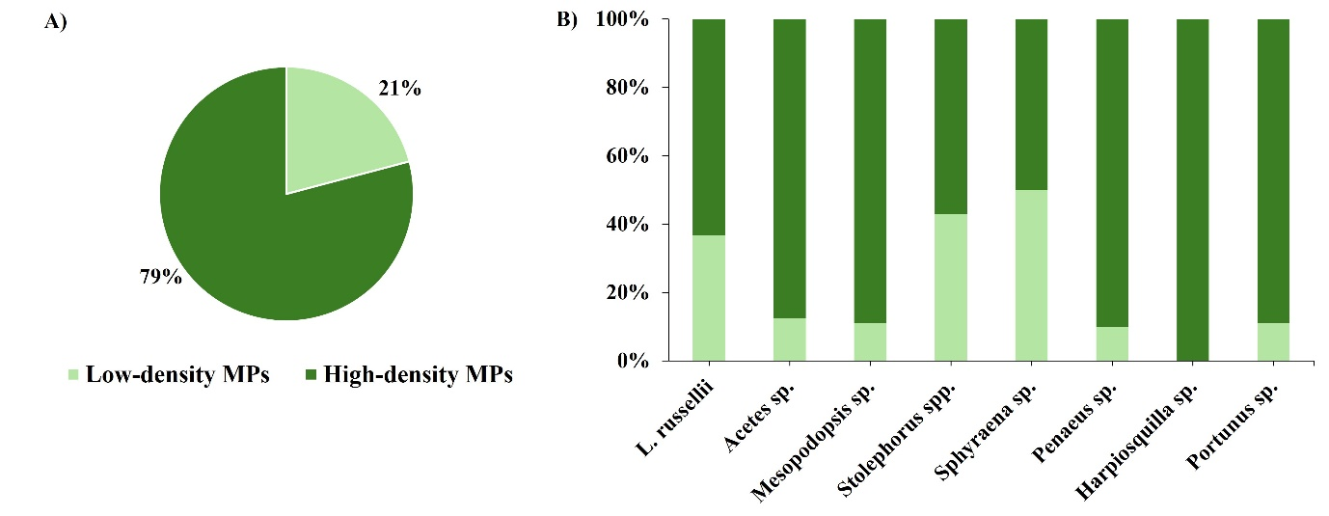
Fig S1 Proportion of low- and high-density microplastics (MPs) with respect to (A) all organism species and (B) individual species
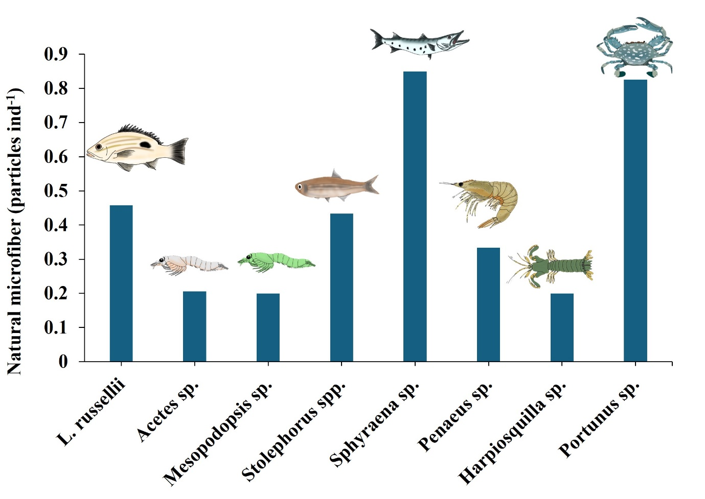
Fig S2 Mean abundance of natural microfiber per individual in studies of predator fish Lutjanus russellii and associated prey

Table S2 The Mann-Whitney U test was employed to assess potential differences in the presence of microplastics (MPs) between predator (Lutjanus russellii) and each prey
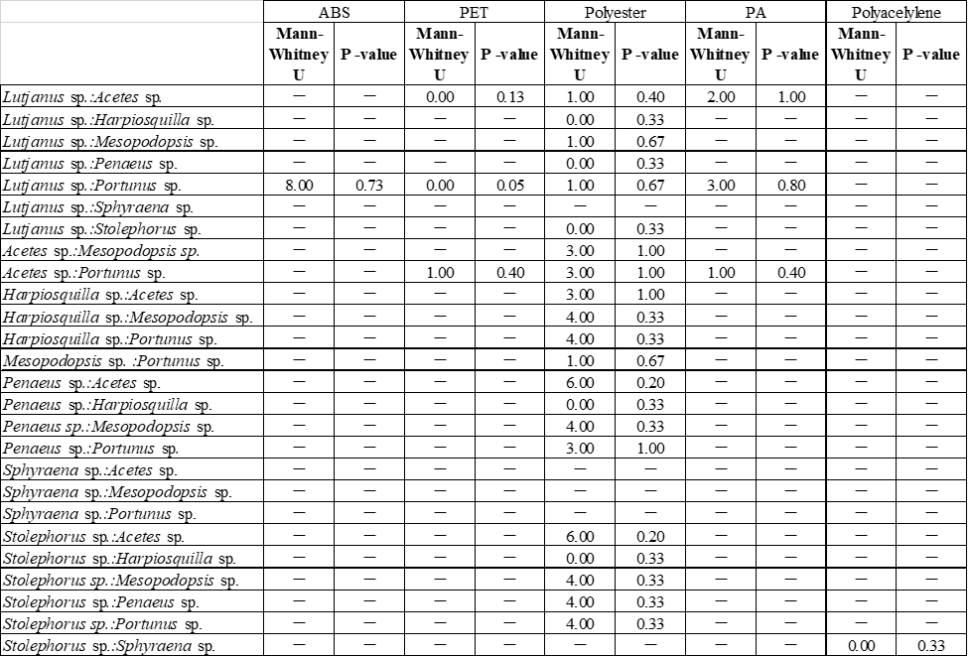

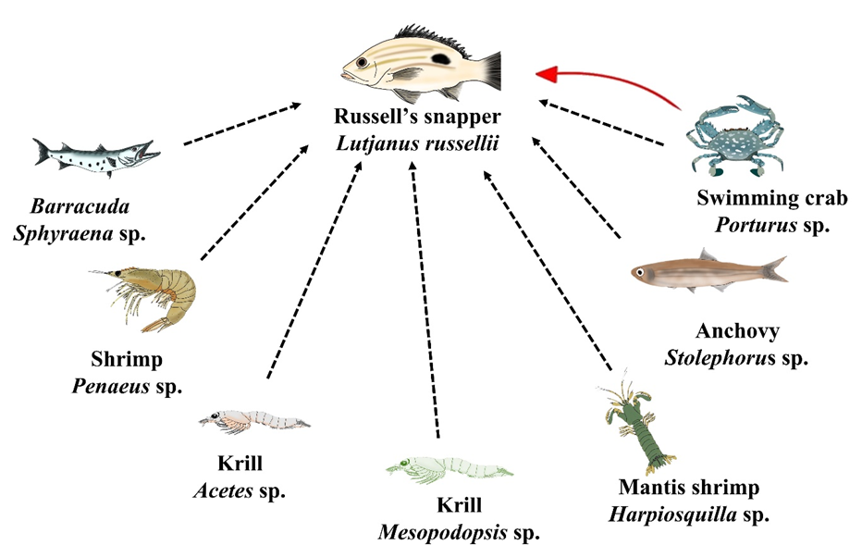
Fig S3 Diagram illustrating the food web of Lutjanus russellii in Pathio, Chumphon, located in the lower Gulf of Thailand. Each organism represents the food consumed by L. russellii. The red arrow indicates the potential transfer of the Polyethylene Terephthalate (PET) fibers from the crab, Portunus sp. to Russell’s snapper L. russellii (Mann–Whitney U test, p ≤ 0.05)

