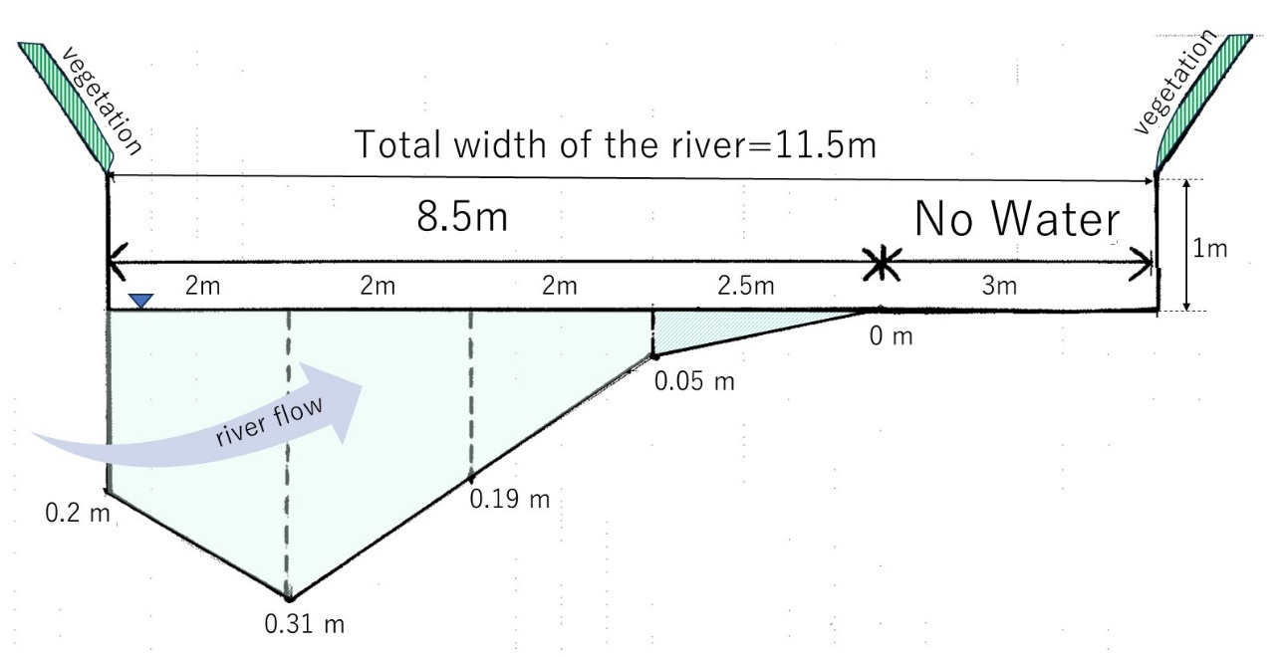
Supplementary Fig. Cross-sectional diagram of the Hamada River, as viewed facing the direction of water flow. The riverbed depths are indicated for the date of October 19, 2022.

