Online Resource

Tailoring selectivity and efficiency: pyrazolyl-1H-1,2,4-triazole MCM-41 and silica hybrid materials for efficient Cadmium(II) removal from water

Youssef Draoui ª, Smaail Radi ª, Amal El Mahdaoui ª, Mohamed El Massaoudi ª, Aurelian Rotaru ^{b}, Yann Garcia ^{c}, Maria do Amparo F. Faustino ^{d}, Maria da Graça P. M. S. Neves ^{d}, Nuno M. M. Moura ^{d,*}

ª LCAE, Department of Chemistry, Faculty of Science, University Mohamed I , P.O. Box 524, Oujda 60 000, Morocco.
^{b} Department of Electrical Engineering and Computer Science & Research Center MANSiD, “Stefan cel Mare” University, University Street, No. 13, Suceava 720229, Romania.
^{c} Institute of Condensed Matter and Nanosciences, Molecular Chemistry, Materials and Catalysis (IMCN/MOST), Université Catholique de Louvain, Place L. Pasteur 1, 1348 Louvain-la-Neuve, Belgium.
^{d} LAQV-REQUIMTE, Department of Chemistry, University of Aveiro, 3810-193 Aveiro, Portugal.
* Corresponding authors: nmoura@ua.pt

Content:
Equipments…………………………………………………………………………………...S2
Figure OR1. Top: ATR-FTIR spectra of M1 (A) and M2 (B) and of the corresponding precursors. Bottom: the region between 1600 and 1200 cm⁻¹ is zoomed (A` for M1 and B` for M2) for detailed comparison………………………………………………….………S3
Figure OR2. Top: Solid state ¹³C NMR spectrum of precursors Si-Cl (left) and MCM-41-Cl(right).
Bottom: Solid state ¹³C NMR spectrum of M1 (left) and M2 (right)……………………….S4
Figure OR3. Thermogravimetric plots of M1 (left), M2 (right) and of the corresponding precursors……………………………………………………………………………………...S5

Equipments
The characterization of silica particles was performed using scanning electron microscopy (SEM) with a Hitachi S4100 equipped with energy-dispersive spectroscopy. The specific surface area and pore size distribution were determined using the Brunauer-Emmett-Teller (BET) and Barrett-Joyner-Halenda (BJH) methods on a Micromeritics Gemini 2380 surface area analyzer, with a sample weight of approximately 50 mg. Solid-state ¹³C Nuclear Magnetic Resonance (NMR) spectra were recorded on a Bruker Avance III 400 spectrometer. Elemental analysis was conducted using a LECO CHNS-932 apparatus. Attenuated Total Reflectance Fourier Transform Infrared (ATR-FTIR) spectra were obtained using a FT Mattson 7000 Galaxy series spectrophotometer. Nitrogen adsorption-desorption measurements were carried out with a Thermoquest Sorpsomatic 1990 analyzer. Mass loss determinations were performed in a 90:10 oxygen/nitrogen atmosphere using a TGA Q50 V6.7 Build 203 instrument at a heating rate of 10 °C/min. Atomic absorption measurements were conducted using a Spectra Varian A.A. 400 spectrophotometer. Calibration curves were prepared using commercially pure 1000 ppm metal standard solutions in 2% nitric acid.
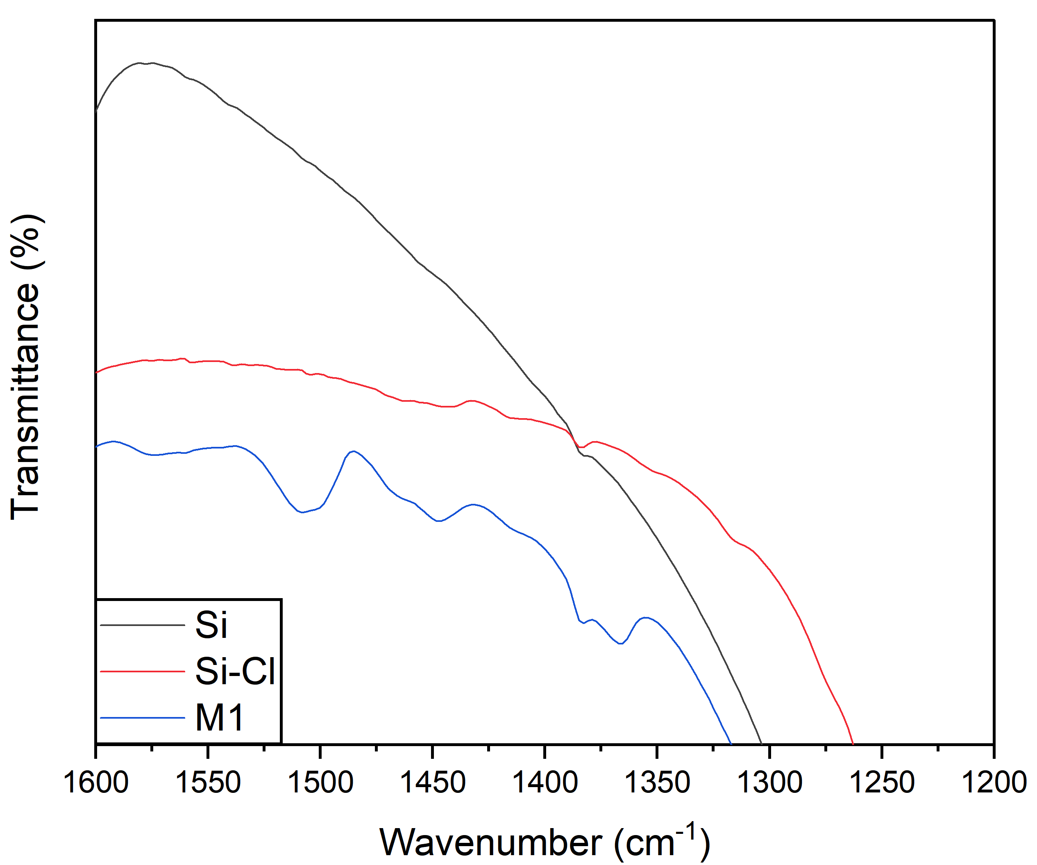
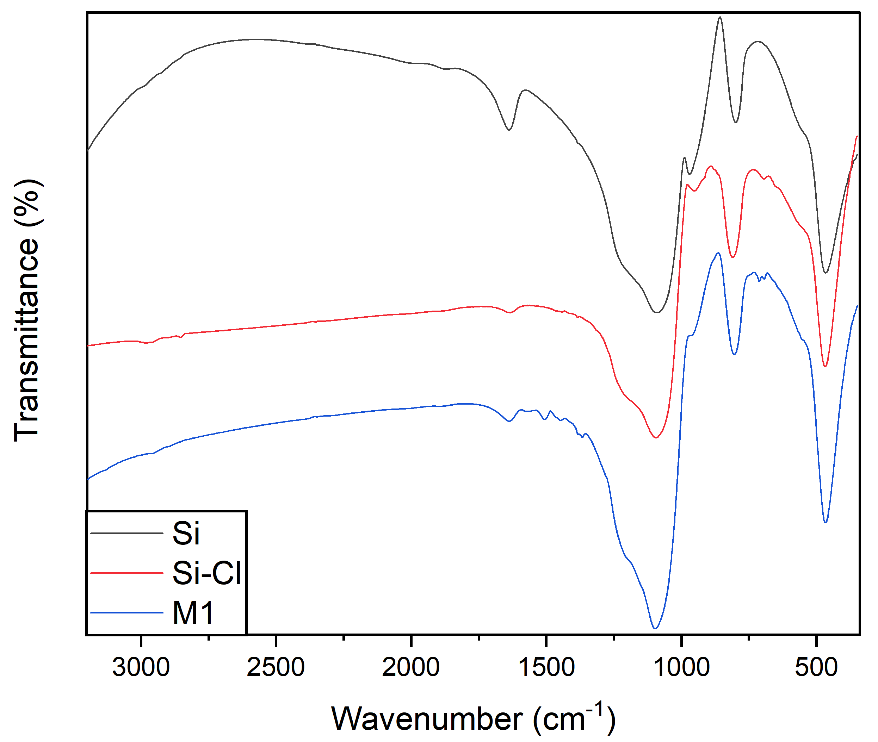
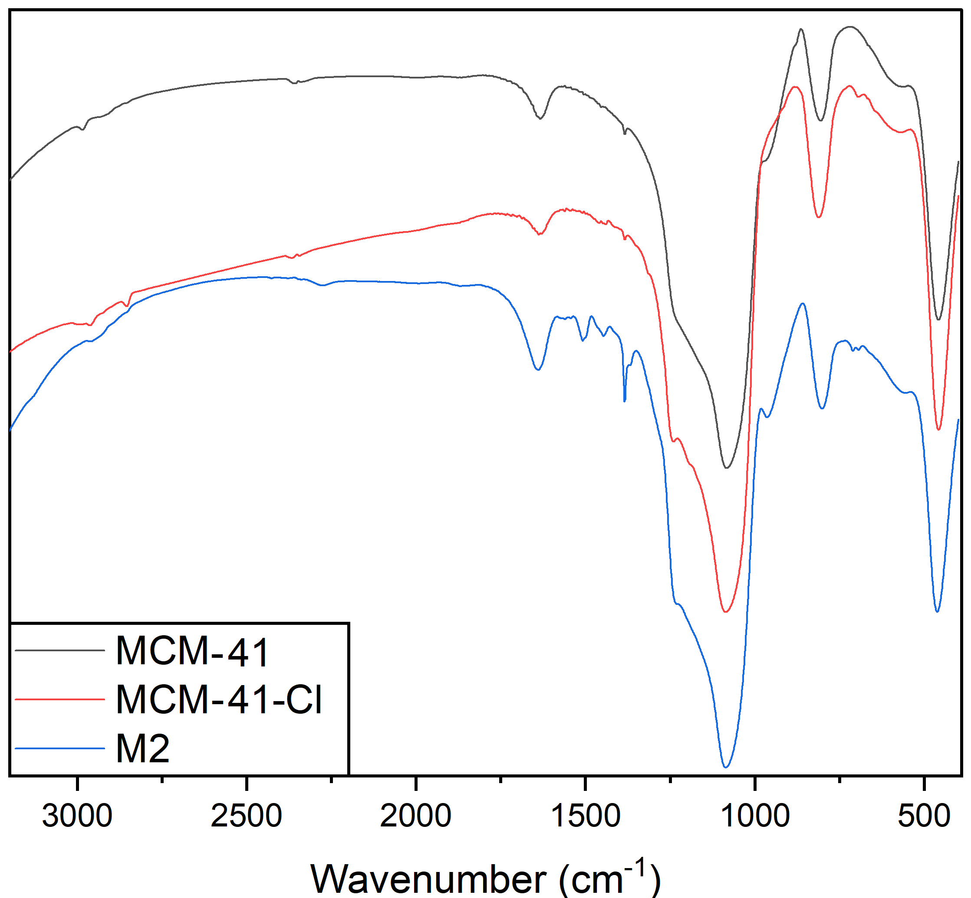
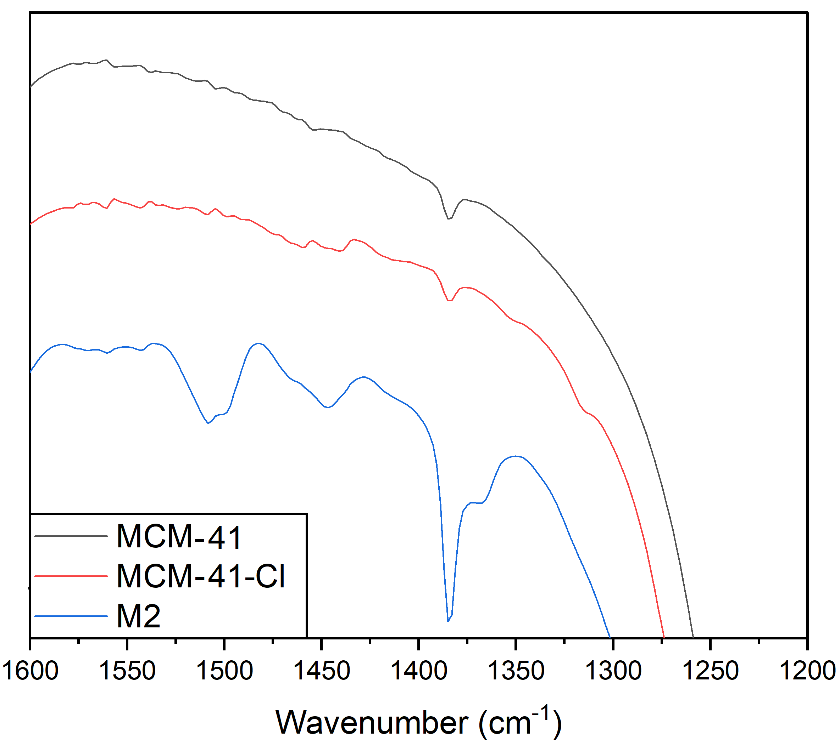
Zoomed
Zoomed
(B´)
(A´)
(A)
(B)

Figure OR1. Top: ATR-FTIR spectra of M1 (A) and M2 (B) and of the corresponding precursors. Bottom: the region between 1600 and 1200 cm⁻¹ is zoomed (A` for M1 and B` for M2) for detailed comparison.

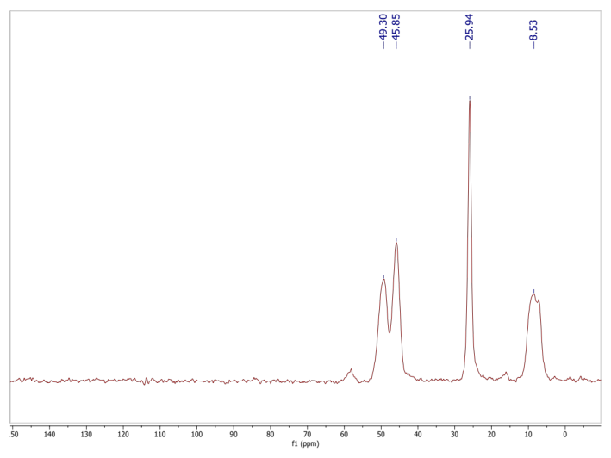
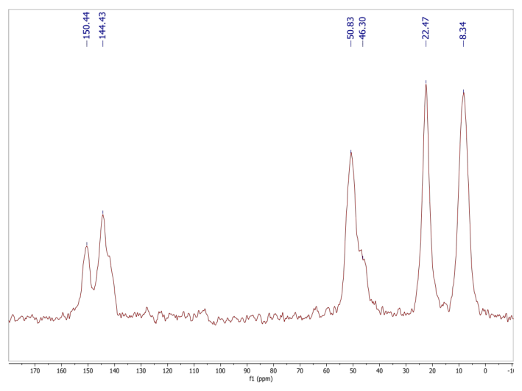
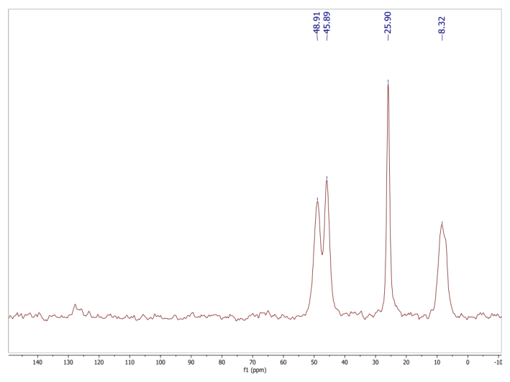
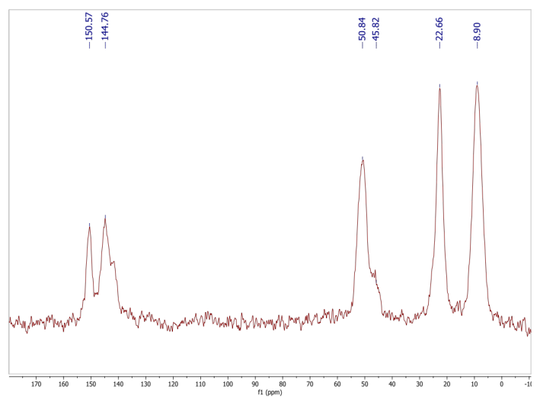
Si-Cl
MCM-41-Cl
M1
M2
Figure OR2. Top: Solid state ¹³C NMR spectrum of precursors Si-Cl (left) and MCM-41-Cl (right). Bottom: Solid state ¹³C NMR spectrum of M1 (left) and M2 (right).

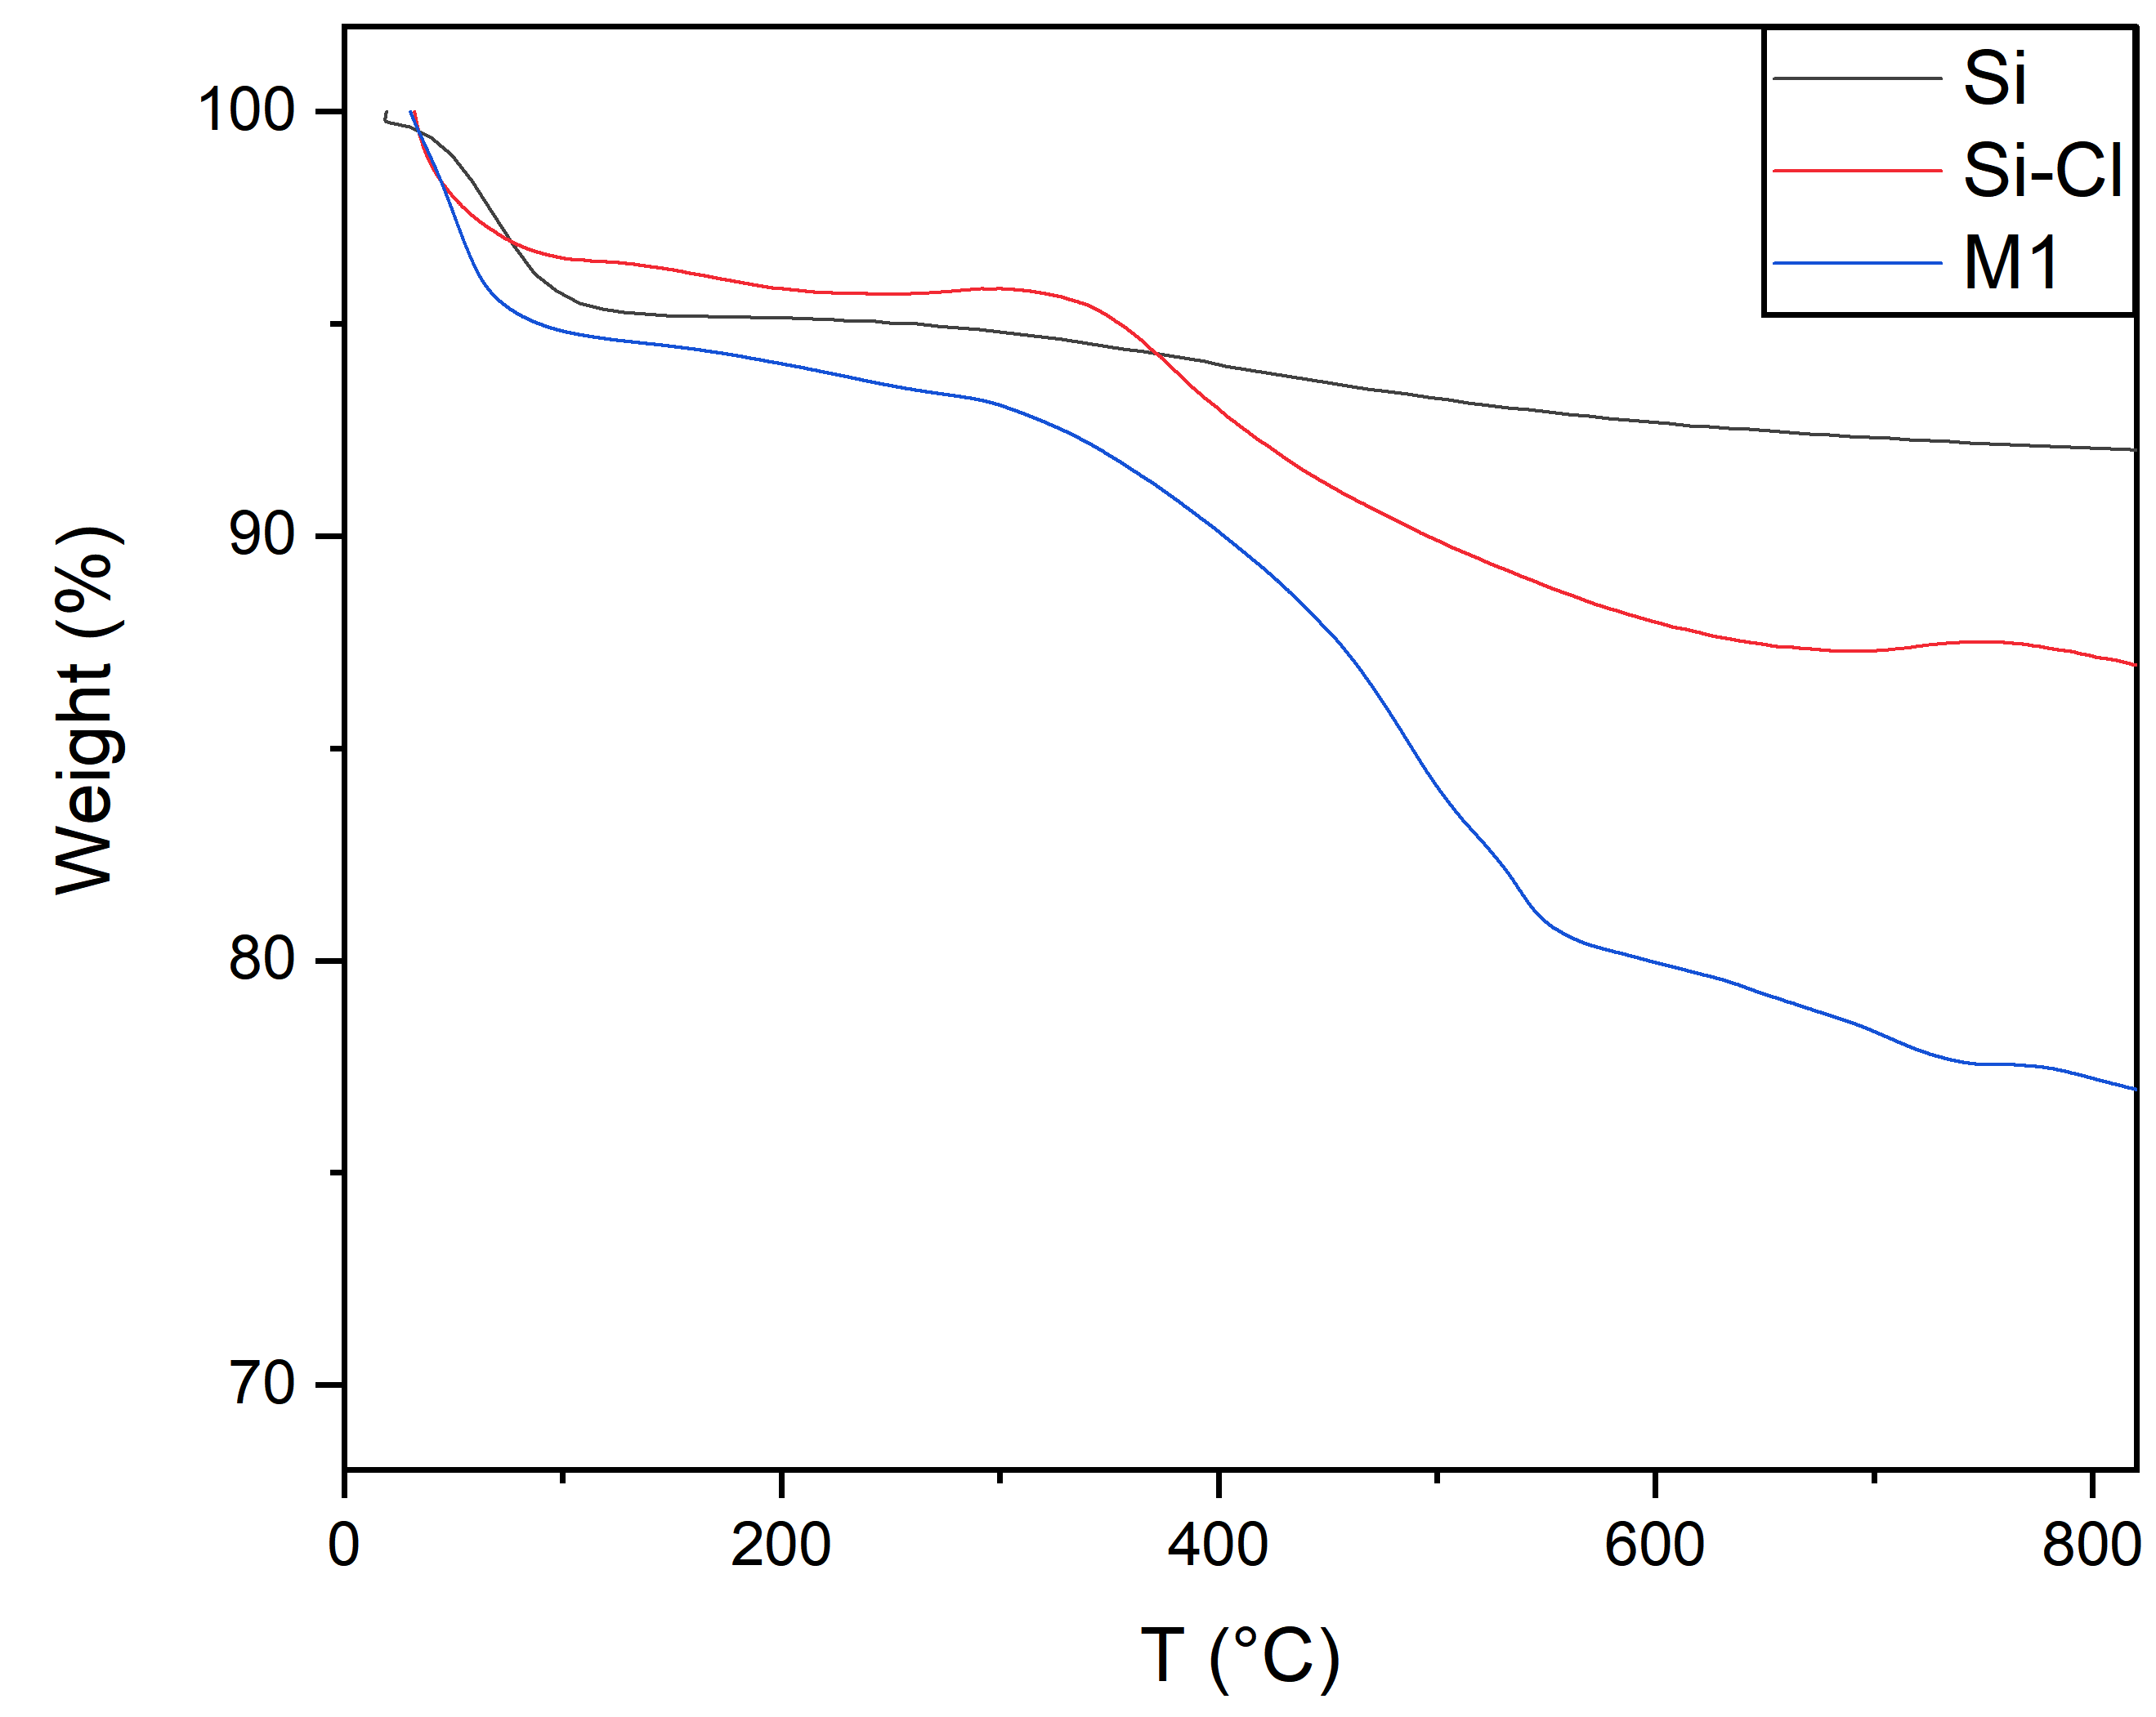
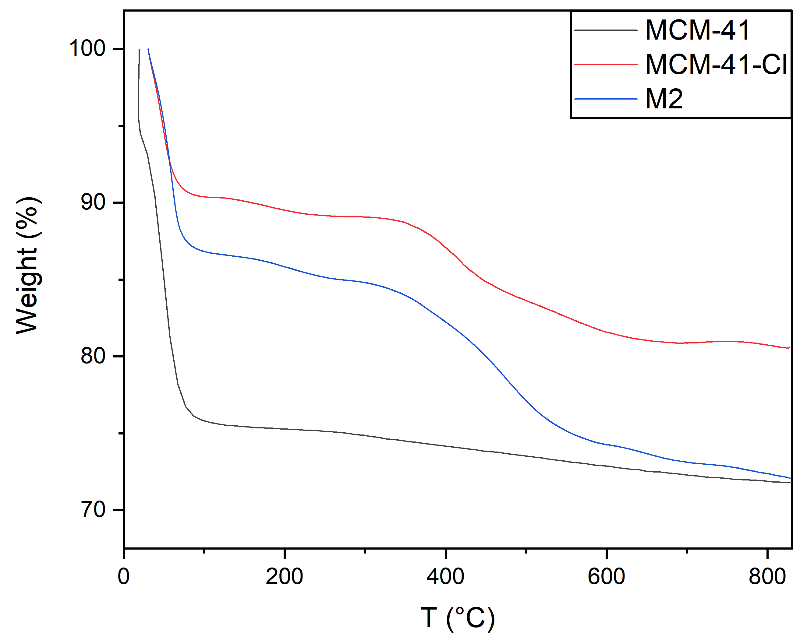

Figure OR3. Thermogravimetric plots of M1 (left), M2 (right) and of the corresponding precursors.

