Ultrasound-Assisted Extraction of Biosurfactants from Water Hyacinth for Enhanced Soil Washing of Diesel-Contaminated Soils: Performance Evaluation and Phytotoxicity Assessment
Witchaya Rongsayamanontª and Naphatsarnan Phasukarratchaiª*
ªFaculty of Environment and Resource Studies, Mahidol University, Salaya, Phutthamonthon, Nakhon Pathom, 73170, Thailand
*Corresponding author. E-mail: naphatsarnan.pha@mahidol.ac.th

Supplementary Information

1. Extract WH composition analysis by GCMS
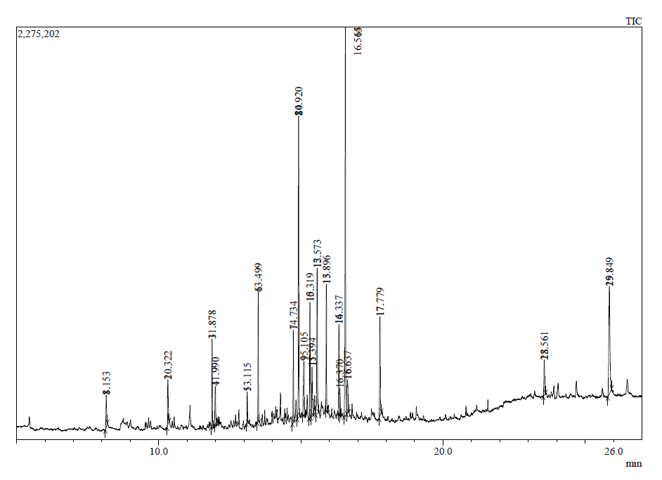
Fig.S1 GCMS chromatogram of water-soluble extract WH
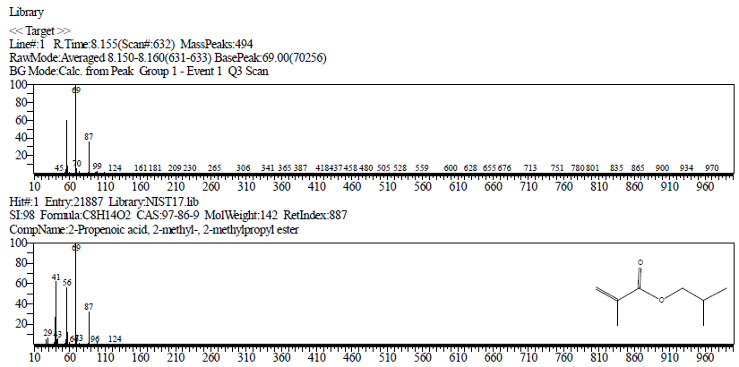
Fig.S2 GCMS of the water-soluble extract WH compounds compared with reference libraries at RT 8.155 min

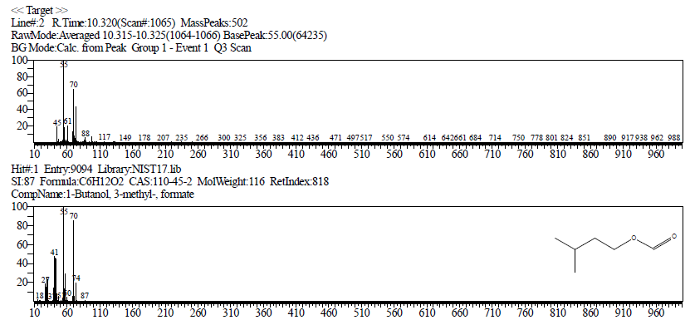
Fig.S3 GCMS of the water-soluble extract WH compounds compared with reference libraries at RT 10.320 min

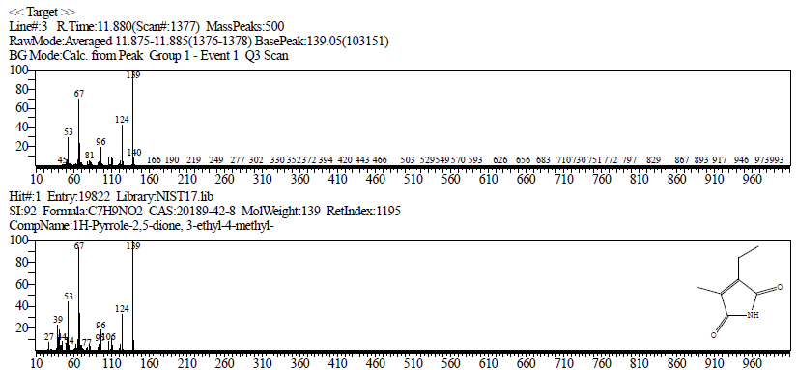
Fig.S4 GCMS of the water-soluble extract WH compounds compared with reference libraries at RT 11.880 min

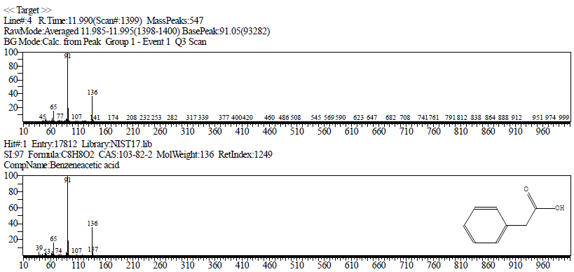
Fig.S5 GCMS of the water-soluble extract WH compounds compared with reference libraries at RT 11.990 min

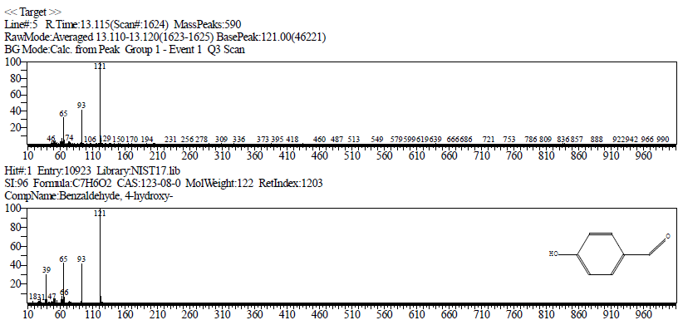
Fig.S6 GCMS of the water-soluble extract WH compounds compared with reference libraries at RT 13.115 min

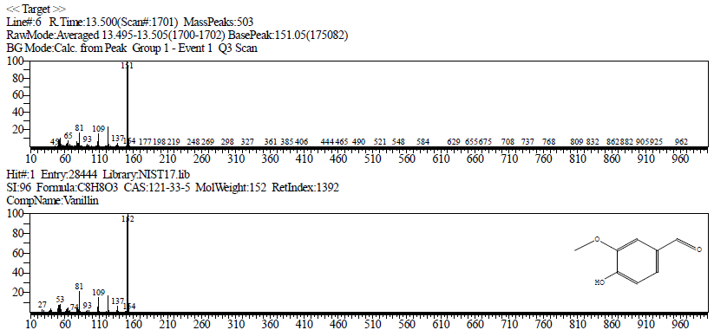
Fig.S7 GCMS of the water-soluble extract WH compounds compared with reference libraries at RT 13.500 min

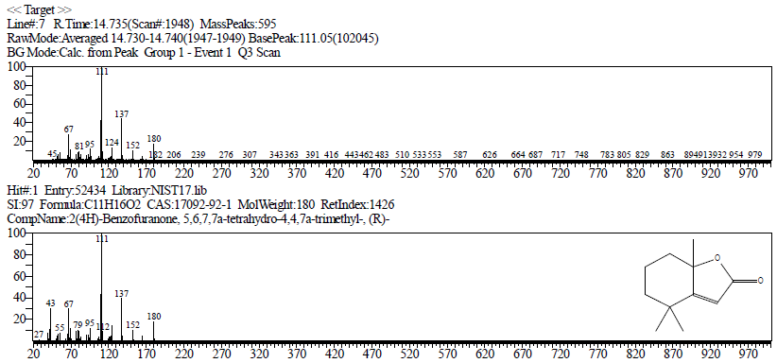
Fig.S8 GCMS of the water-soluble extract WH compounds compared with reference libraries at RT 14.735 min

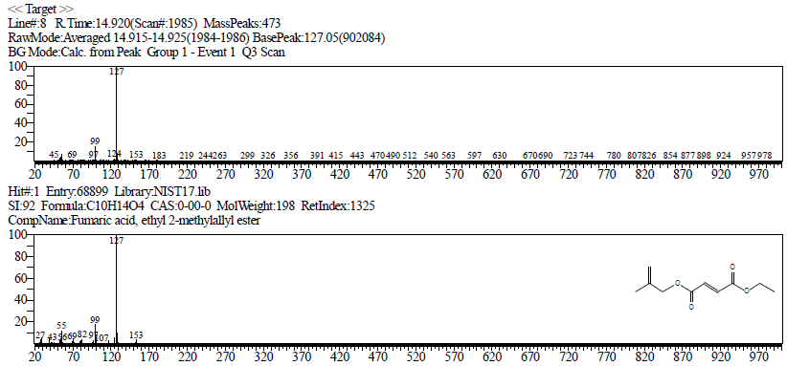
Fig.S9 GCMS of the water-soluble extract WH compounds compared with reference libraries at RT 14.920 min

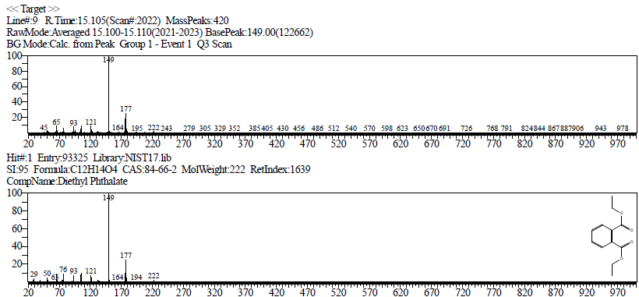
Fig.S10 GCMS of the water-soluble extract WH compounds compared with reference libraries at RT15.105 min

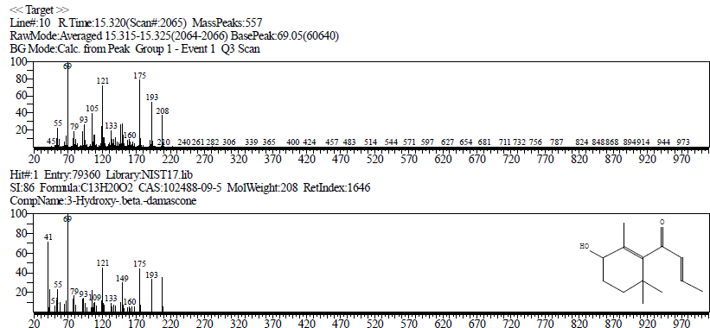
Fig.S11 GCMS of the water-soluble extract WH compounds compared with reference libraries at RT 15.320 min

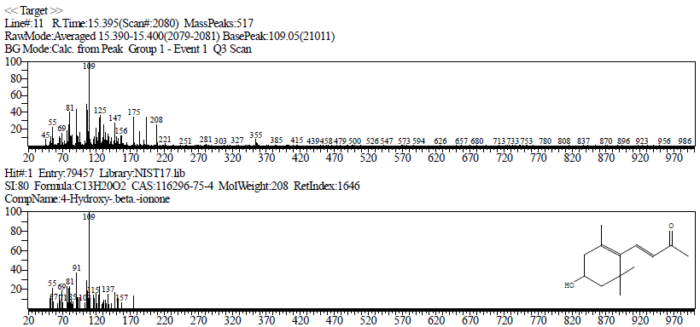
Fig.S12 GCMS of the water-soluble extract WH compounds compared with reference libraries at RT 15.395 min

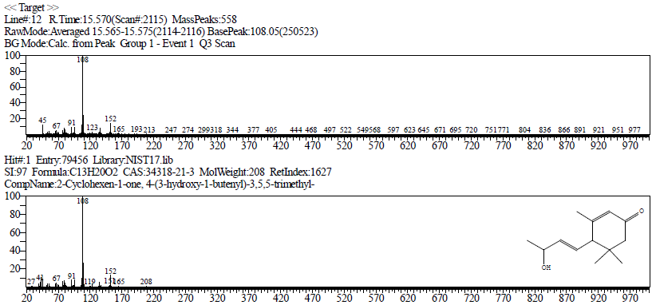
Fig.S13 GCMS of the water-soluble extract WH compounds compared with reference libraries at RT 15.570 min

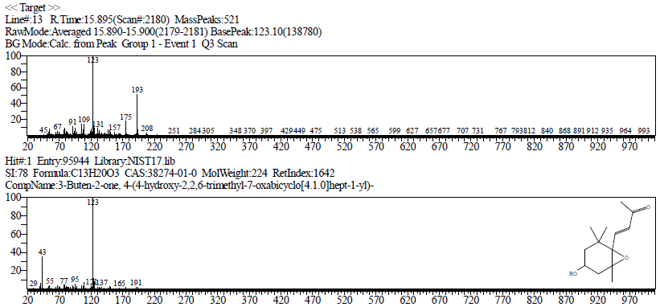
Fig.S14 GCMS of the water-soluble extract WH compounds compared with reference libraries at RT 15.895 min

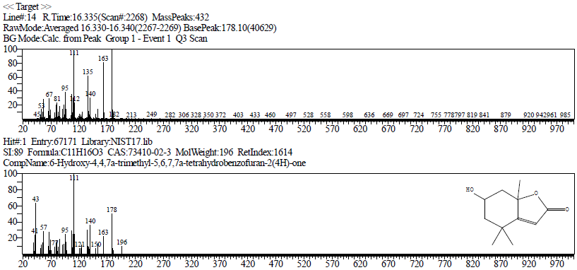
Fig.S15 GCMS of the water-soluble extract WH compounds compared with reference libraries at RT 16.335 min

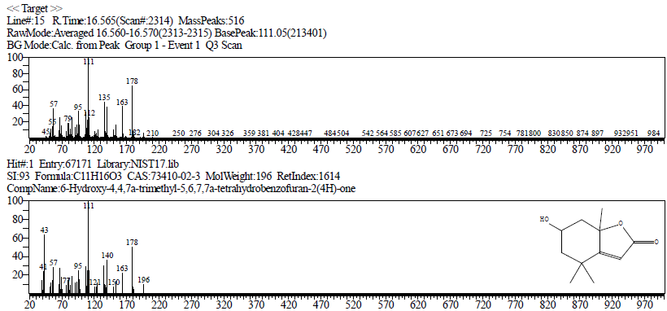
Fig.S16 GCMS of the water-soluble extract WH compounds compared with reference libraries at RT 16.565 min

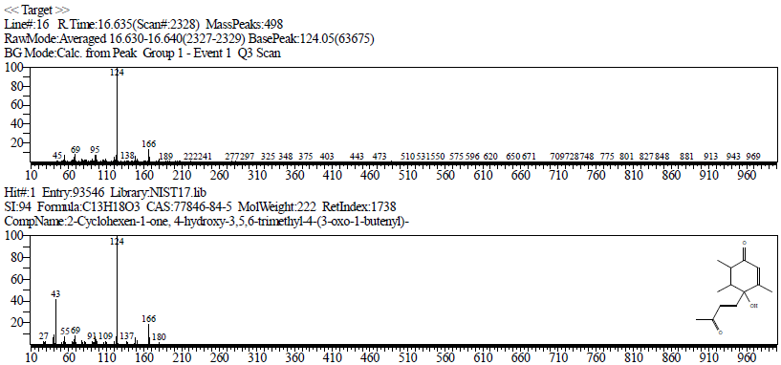
Fig.S17 GCMS of the water-soluble extract WH compounds compared with reference libraries at RT 16.635 min

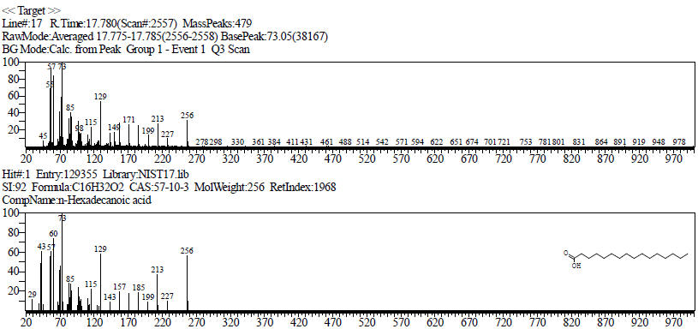
Fig.S18 GCMS of the water-soluble extract WH compounds compared with reference libraries at RT 17.780 min

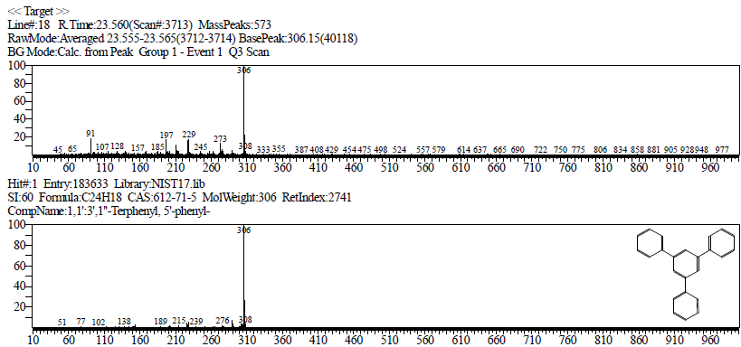
Fig.S19 GCMS of the water-soluble extract WH compounds compared with reference libraries at RT 23.560 min

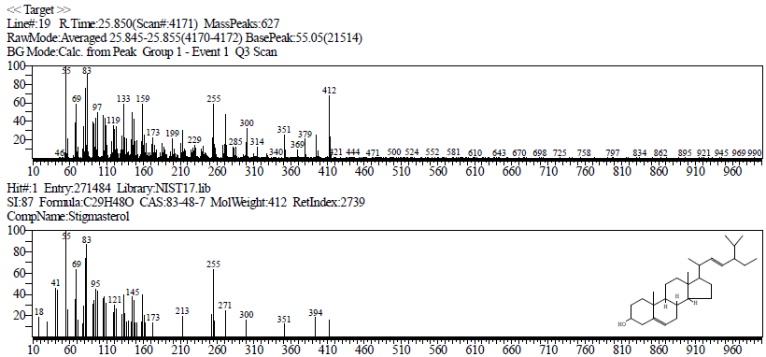
Fig.S20 GCMS of the water-soluble extract WH compounds compared with reference libraries at RT 25.850 min

2. Extract WH composition analysis by LCMSMS

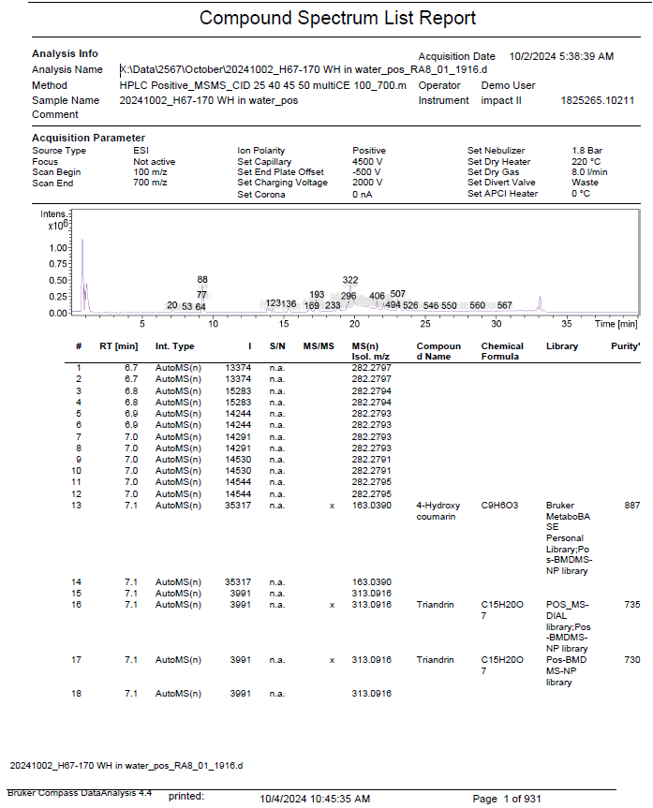
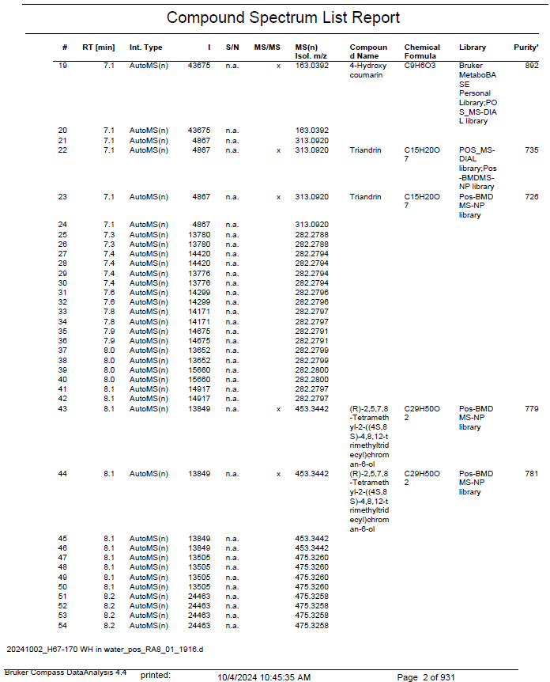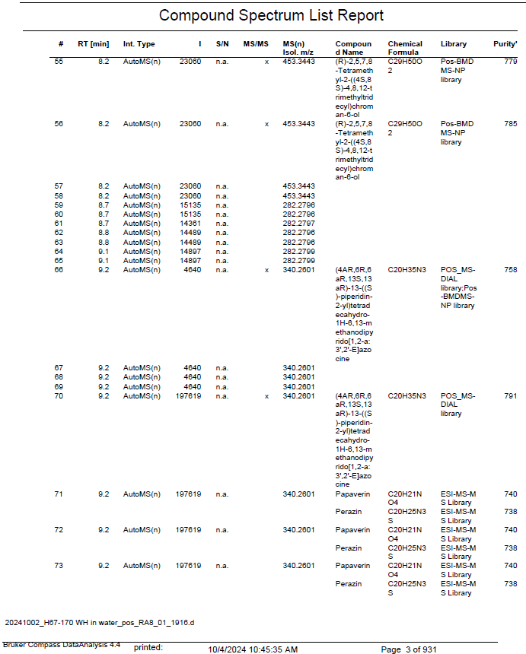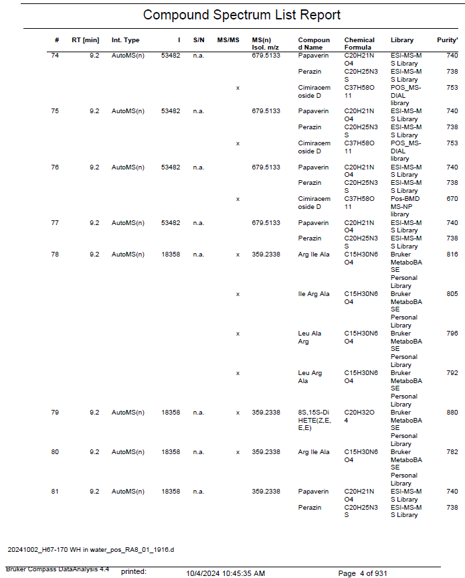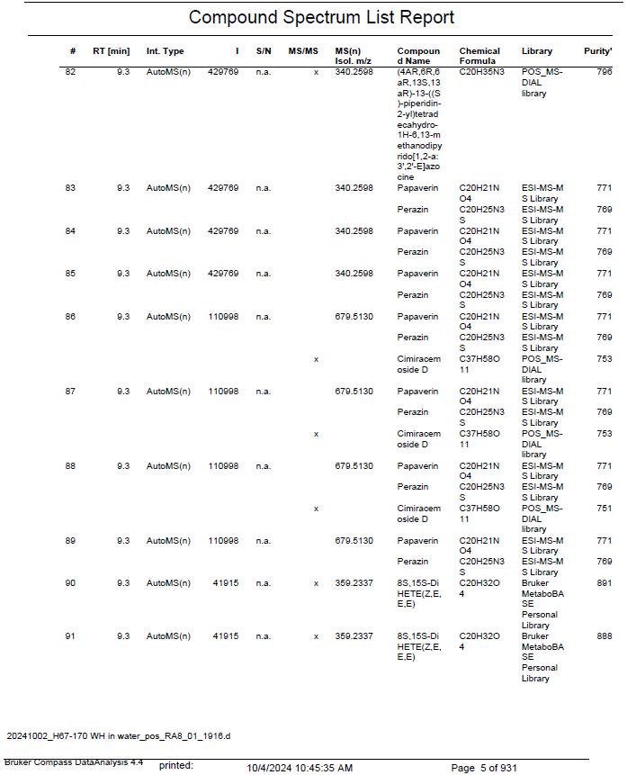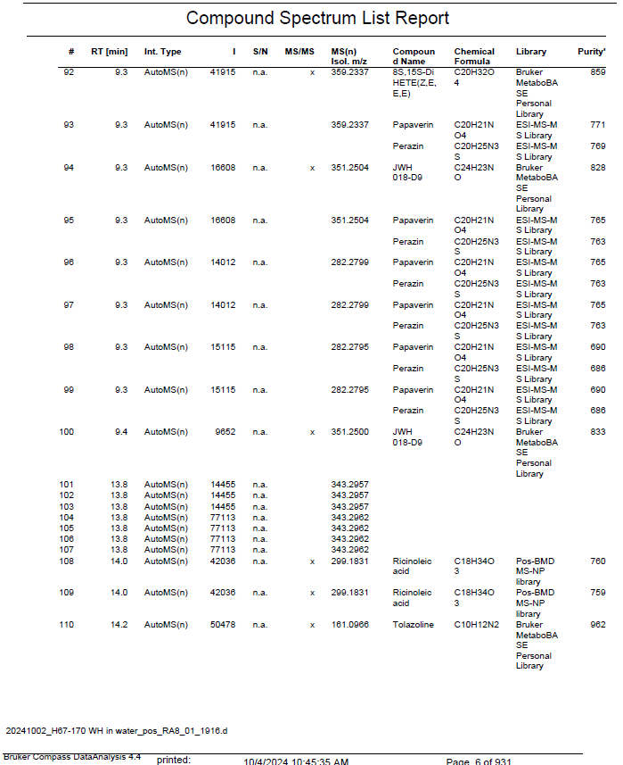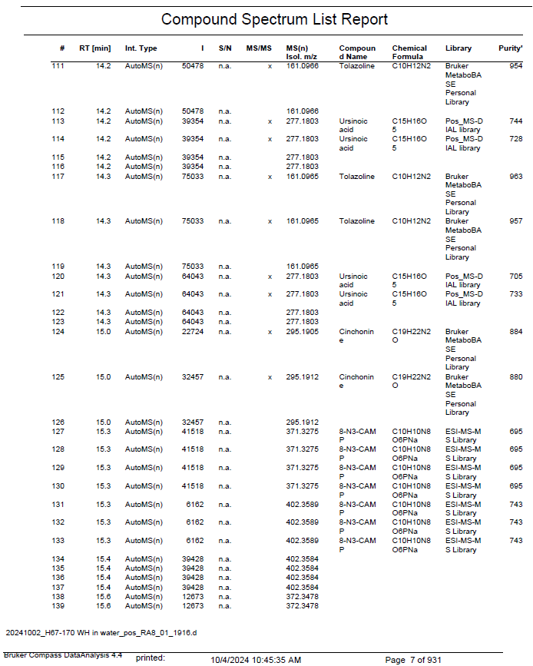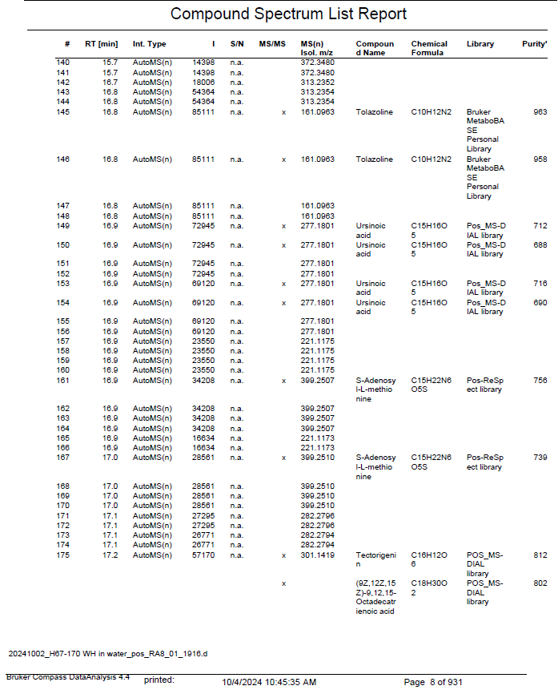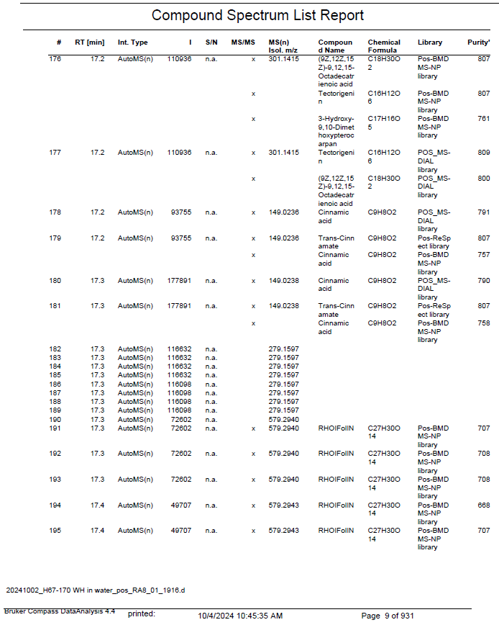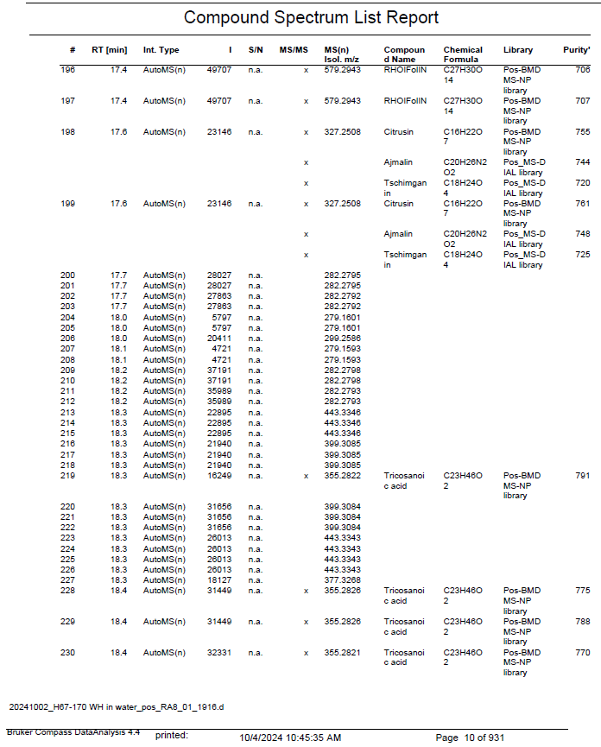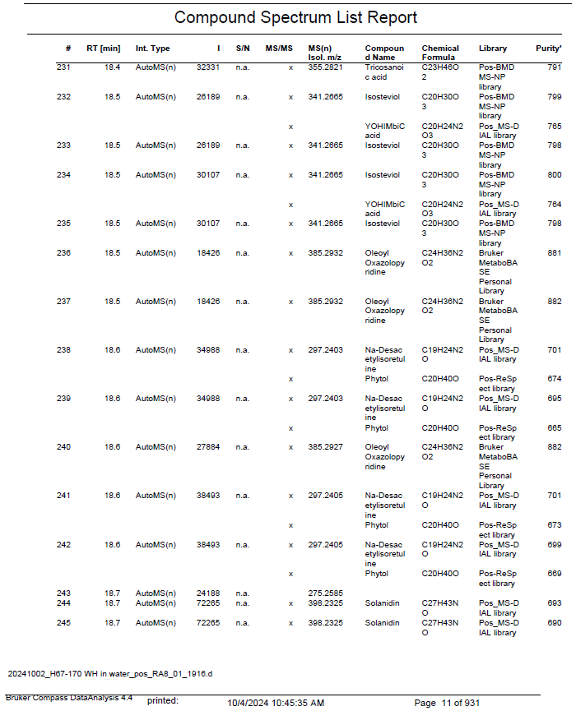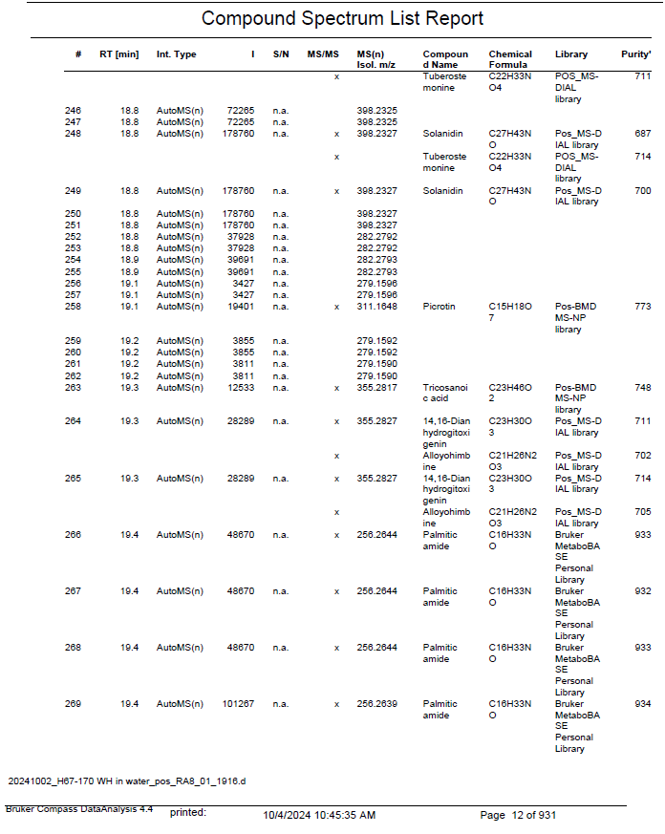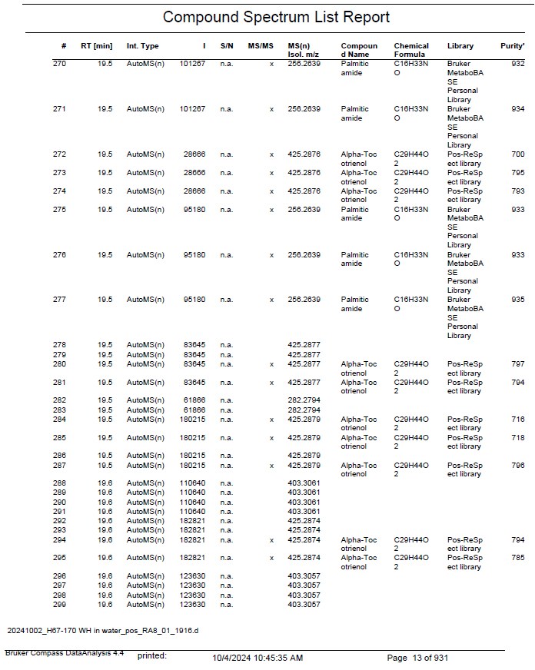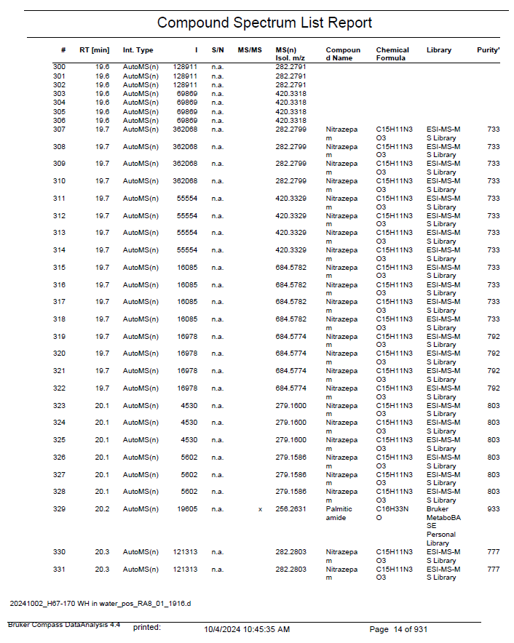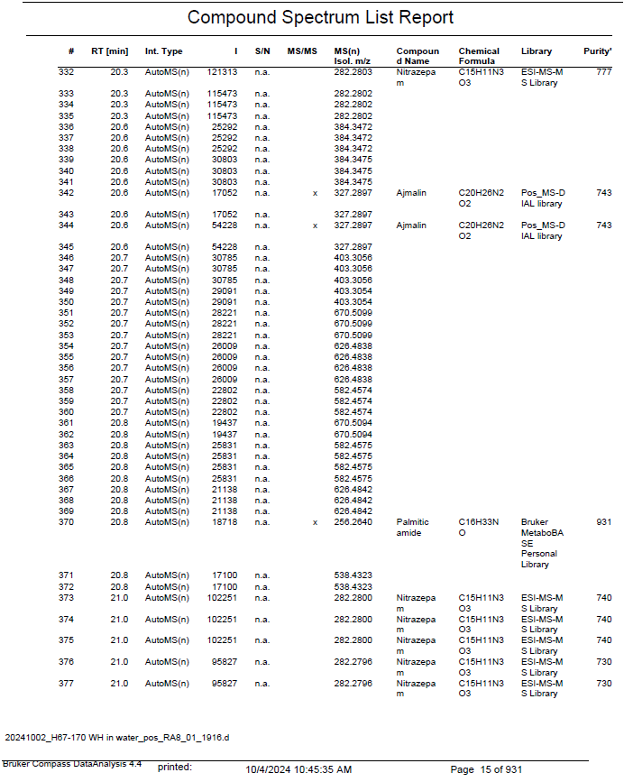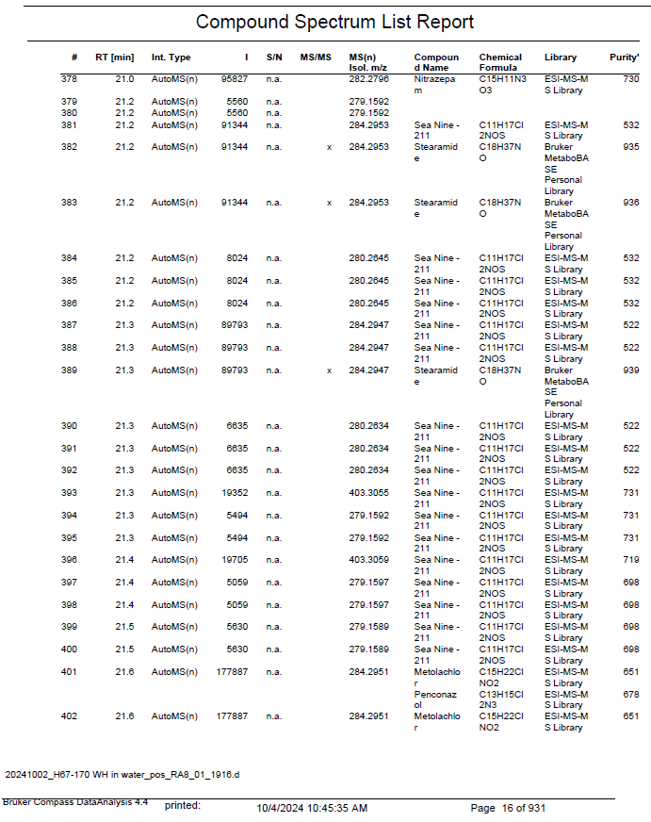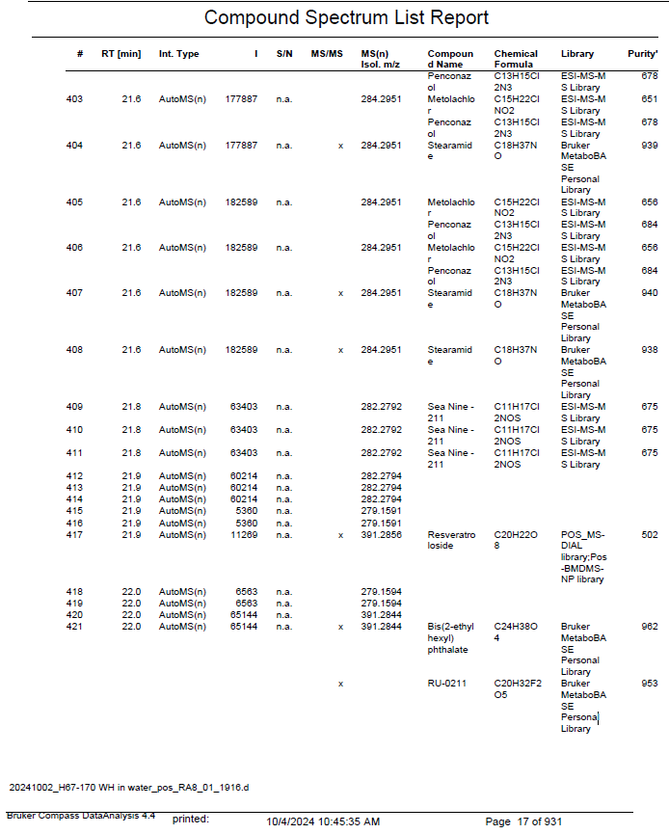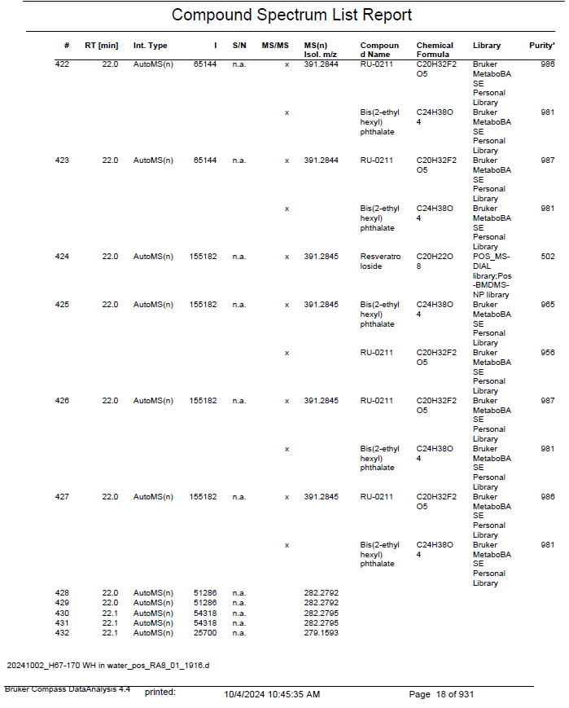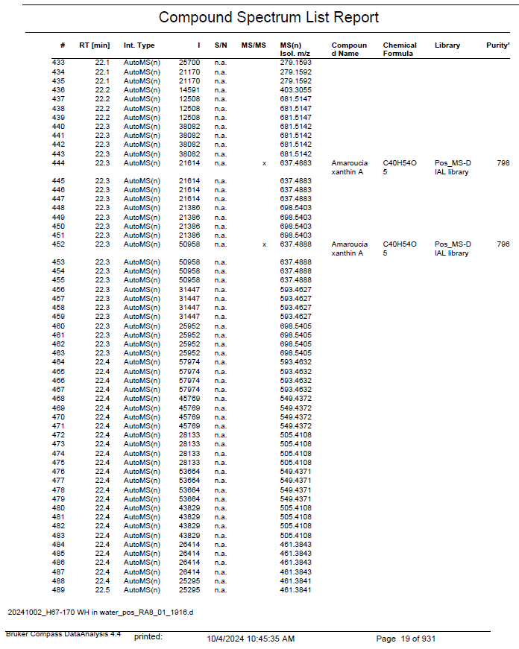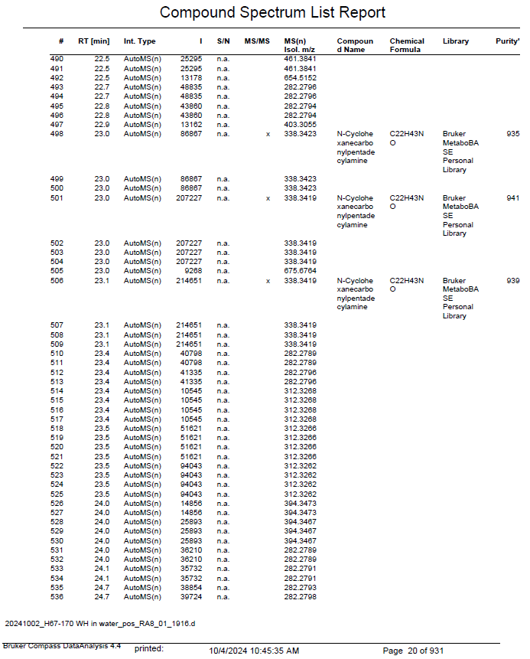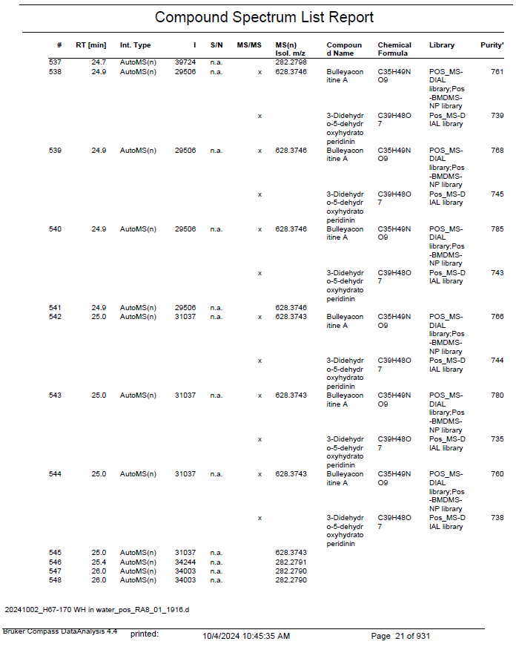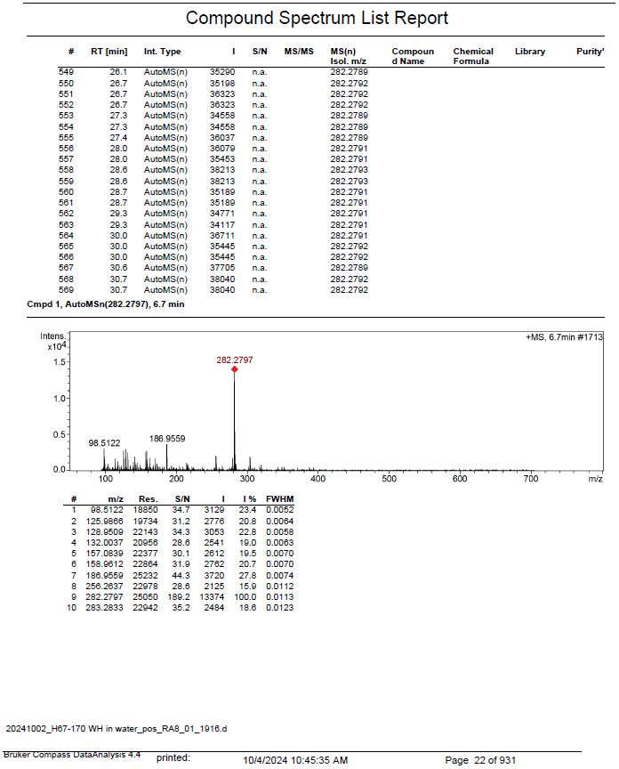

3. Mixture Design Results
Table S1 Diesel-contaminated soil washing efficiency using 2% mixed surfactant solutions at various mixing ratios
Sample Run | Washing solution concentration |  |  | Diesel removal (%)
Sample Run | Dehydol LS9 (%) | Extract WH (%) | NaCl (%) | Rep 1 | Rep 2 | AVG | SD | %RSD
1 | 2.00 | 0.00 | 0.00 | 80.53 | 83.93 | 82.23 e | 2.40 | 2.92
2 | 0.00 | 2.00 | 0.00 | 32.58 | 41.33 | 36.96 ª | 6.19 | 16.75
3 | 0.00 | 0.00 | 2.00 | 51.08 | 51.73 | 51.40 ^{b} | 0.46 | 0.89
4 | 1.00 | 1.00 | 0.00 | 71.28 | 59.30 | 65.29 ^{c} | 8.47 | 12.98
5 | 1.00 | 0.00 | 1.00 | 75.01 | 66.41 | 70.71 ^{c,d} | 6.08 | 8.60
6 | 0.00 | 1.00 | 1.00 | 36.74 | 46.69 | 41.72 ^{a,b} | 7.03 | 16.86
7 | 1.33 | 0.33 | 0.33 | 69.13 | 66.19 | 67.66 ^{c} | 2.08 | 3.07
8 | 0.33 | 1.33 | 0.33 | 65.48 | 71.77 | 68.63 ^{c} | 4.45 | 6.49
9 | 0.33 | 0.33 | 1.33 | 72.10 | 71.25 | 71.67 ^{c,d,e} | 0.60 | 0.83
10 | 0.67 | 0.67 | 0.67 | 80.33 | 81.54 | 80.94 ^{d,e} | 0.86 | 1.06
DI water | - | - | - | 7.59 | 9.86 | 8.73 | 1.61 | 18.43
Note: a, b, c, d, and e indicate statistically significant differences based on ANOVA at p = 0.05.

Table S2 Statistical analysis results of diesel removal efficiency using surfactant mixtures from the mixture design, expressed in the form of a regression equation
Model | F | p | R-Sqr | Adjust R-Sqr
Linear | 10.06936 | 0.001304 | 0.542257 | 0.488404
Quadratic | 1.90026 | 0.175983 | 0.674713 | 0.558539
Special Cubic | 9.12748 | 0.009830 | 0.808892 | 0.720689
Cubic | 15.31165 | 0.000663 | 0.949495 | 0.912764
Total Adjusted

Table S3 Model adequacy analysis of the cubic regression equation for predicting diesel removal efficiency using surfactant mixtures from the mixture design
 | SS | df | MS | F | p
Model | 4290.123 | 8 | 536.2654 | 25.85006 | 0.000004
Total Error | 228.198 | 11 | 20.7452 | - | -
Lack of Fit | 0.438 | 1 | 0.4383 | 0.01925 | 0.892420
Pure Error | 227.759 | 10 | 22.7759 | - | -
Total Adjusted | 4518.321 | 19 | 237.8064 | - | -

The cubic regression equation for predicting diesel removal efficiency using surfactant mixtures from the mixture design is following equation.
v = 82.20x + 36.92y + 51.37z + 22.65xy + 15.45xz - 9.98yz + 558.55xyz - 175.77xy(x-y) - 111.42xz(x-z)
Here, v, x, y, and z represent diesel removal (%), Dehydol LS9 (%), Extract WH (%), and NaCl (%), respectively.

4. Concentration and Time Optimization for soil washing
Table S4 Diesel removal efficiency in CCRD experiment
Sample Run | Conc. (%) | Time (min) | Diesel removal (%)
Sample Run | Conc. (%) | Time (min) | Rep1 | Rep 2 | AVG | SD
1 | 0.50 | 15.00 | 52.2 | 53.8 | 53.0 | 1.09
2 | 0.50 | 45.00 | 58.4 | 58.0 | 58.2 | 0.22
3 | 1.50 | 15.00 | 61.8 | 61.0 | 61.4 | 0.55
4 | 1.50 | 45.00 | 61.2 | 61.0 | 61.1 | 0.14
5 | 0.29 | 30.00 | 46.7 | 54.3 | 50.5 | 5.39
6 | 1.71 | 30.00 | 70.3 | 72.0 | 71.2 | 1.15
7 | 1.00 | 8.79 | 55.7 | 62.1 | 58.9 | 4.57
8 | 1.00 | 51.21 | 61.0 | 69.5 | 65.2 | 6.01
9 (C) | 1.00 | 30.00 | 80.3 | 68.9 | 74.6 | 8.08
10 (C) | 1.00 | 30.00 | 60.5 | 61.1 | 60.8 | 0.42

Table S5 Model adequacy analysis of the regression equation for predicting diesel removal efficiency from CCRD
