Supplementary Material
Chemical Components of Electric Vehicle and Internal Combustion Engine Vehicle Fire Smoke and Their Mutagenic Effects

Yong Ho Kim^{1*}, Adam Nored¹, Gavin P. Horn², Richard M. Kesler², Adam Barowy², Alex Schraiber³, Benjamin Gaudet³, Alexander C. Mayer⁴, Micah Niemeier-Walsh⁴, Kenneth W. Fent⁴, Kasey Kovalcik¹, Joseph Patrick Pancras¹, Ian Gilmour¹

¹Center for Public Health and Environmental Assessment, United States Environmental Protection Agency, Research Triangle Park, North Carolina, United States of America
²Fire Safety Research Institute, UL Research Institutes, Columbia, Maryland, United States of America
³UL Solutions, Northbrook, Illinois, United States of America
⁴National Institute for Occupational Safety and Health, Cincinnati, Ohio, United States of America

*Corresponding Author
Yong Ho Kim, kim.yongho@epa.gov, https://orcid.org/0000-0001-7527-0134

Table of Contents
Table S1. Specifications of EVs and ICEVs utilized in full-scale fire testing ……………...…. S2
Table S2. Chemical components (µg/g) of the smoke PM collected from EV and ICEV fires … S3
Table S3. Mass balance (%) of major chemical components of smoke PM samples from EV and ICEV fires ……………………………………………………………………………………… S4
Table S4. Mutagenic potency of EOM from EV and ICEV fire smoke samples in the TA98 ±S9 and TA100 +S9 Salmonella strains …………………………………………………………………… S4
Figure S1. Mass balance of major chemical components of smoke PM samples collected from two different locations (plume vs. ground) during the EV6 fire ………………………………. S5

Table S1. Specifications of EVs and ICEVs utilized in full-scale fire testing.
Vehicle ID | Year | Curb Weight | Battery Pack Charge
EV1 | 2022 | 1631 kg | 65 kWh
EV2 | 2019 | 1596 kg | 40 kWh
EV3 | 2019 | 1448 kg | 28 kWh
EV4 | 2023 | 1825 kg | 82 kWh
EV5 | 2022 | 2256 kg | 91 kWh
EV6 | 2020 | 1689 kg | 65 kWh
ICEV1 | 2020 | 1318 kg | Gasoline
ICEV2 | 2019 | 1536 kg | Gasoline
EV6 and ICEV1 were the same vehicle model but with different propulsion systems.

Table S2. Chemical components (µg/g) of the smoke PM collected from EV and ICEV fires.
 | EV1 | EV2 | EV3 | EV4 | EV5 | EV6 | ICEV1 | ICEV2
Al | 5430.7 | 4332.2 | 2025.6 | 3862.3 | 1543.0 | 4536.0 | 416.8 | 4295.5
As | ND | 5.0 | 1.9 | 108.2 | 57.9 | 4.3 | 0.4 | 9.1
Ba | 22.1 | 76.0 | 73.2 | 136.0 | 75.9 | 288.0 | 271.1 | 2607.3
Bi | 433.2 | 42.0 | 466.3 | 551.9 | 333.9 | 615.8 | 862.3 | 402.3
Ca | 1667.4 | 801.1 | 764.7 | 3873.3 | 1349.4 | 3474.0 | 3078.6 | 21198.8
Co | 43577.9 | 44717.2 | 47790.2 | 3879.1 | 8959.1 | 23119.8 | 48.1 | 2843.9
Cu | 374.6 | 917.1 | 487.0 | 975.1 | 1171.6 | 1236.6 | 857.3 | 935.1
Fe | 238.3 | 399.0 | 196.8 | 302.8 | 540.7 | 206.0 | 319.3 | 1558.5
K | 155.3 | 287.8 | ND | 580.0 | 135.7 | 268.9 | 287.5 | 1282.5
Li | 28995.6 | 17202.2 | 14422.7 | 8184.0 | 8113.5 | 16645.7 | 44.7 | 430.9
Mg | 967.4 | 851.9 | 1589.0 | 1758.3 | 1618.4 | 2932.9 | 1361.3 | 4144.2
Mn | 31657.5 | 51002.9 | 46333.6 | 2299.3 | 11776.2 | 28886.5 | 60.6 | 2527.1
Na | 1894.0 | 2799.4 | 2156.2 | 4432.4 | 1806.2 | 2096.4 | 2283.8 | 4002.8
Ni | 140821.4 | 86425.2 | 142529.2 | 38509.1 | 38535.3 | 101182.8 | 157.1 | 9902.9
Pb | 67.2 | 67.6 | 99.8 | 59.3 | 81.9 | 421.9 | 231.9 | 690.1
Sb | 566.5 | 2463.9 | 1421.9 | 928.2 | 1344.9 | 1279.9 | 800.1 | 1269.7
Si | 1624.3 | 2678.5 | 1832.6 | 2929.2 | 2022.4 | 2084.4 | 2187.6 | 2885.8
Sn | 116.3 | 626.5 | 148.7 | 226.1 | 494.3 | 190.1 | 234.7 | 318.5
Sr | 6.6 | 19.6 | 14.0 | 29.5 | 8.4 | 15.4 | 29.3 | 108.8
Ti | 50.7 | 69.5 | 106.5 | 44.3 | 42.6 | 65.1 | 99.8 | 258.8
W | 878.2 | 26.7 | 5.7 | 68.7 | 579.0 | 1370.0 | ND | 37.6
Zn | 15438.6 | 16730.4 | 10915.1 | 10250.1 | 24141.2 | 10930.9 | 26699.3 | 26577.8
Fluoride | 10436.7 | 3290.6 | 12626.1 | 8264.6 | 13915.4 | 17689.1 | 891.8 | 1987.1
Chloride | 50440.6 | 34030.8 | 43605.3 | 13798.7 | 31392.6 | 24555.9 | 27841.6 | 46101.4
Bromide | 3096.4 | 6324.7 | 8311.6 | 3780.5 | 4118.0 | 4960.2 | 5553.9 | 2998.6
Sulfate | 24760.1 | 3329.8 | 3050.9 | 1480.2 | 1815.2 | 13993.3 | 1497.8 | 3074.8
Nitrate | 1734.7 | 688.6 | 2193.1 | 1781.4 | 589.9 | 7114.9 | 576.2 | 18220.3
Phosphate | 518.3 | 934.4 | 2815.0 | 7146.6 | 15553.8 | 6804.4 | 1981.0 | 839.7
OC | 154282.4 | 152673.9 | 280525.2 | 205862.1 | 396648.8 | 162890.4 | 148018.6 | 149906.2
EC | 210428.9 | 319740.4 | 92341.4 | 319310.3 | 293050.0 | 427272.4 | 469697.0 | 559273.3
Values that are below the detection limit are listed as not detected (ND)

Table S3. Mass balance (%) of major chemical components of smoke PM samples from EV and ICEV fires.
 | EV1 | EV2 | EV3 | EV4 | EV5 | EV6 | ICEV1 | ICEV2
Organic Carbon | 15.43 | 15.27 | 28.05 | 20.59 | 39.66 | 16.29 | 14.80 | 14.99
Elemental Carbon | 21.04 | 31.97 | 9.23 | 31.93 | 29.31 | 42.73 | 46.97 | 55.93
Fluoride | 1.00 | 0.30 | 1.30 | 0.80 | 1.40 | 1.80 | 0.10 | 0.20
Chloride | 5.00 | 3.40 | 4.40 | 1.40 | 3.10 | 2.50 | 2.80 | 4.60
Phosphate | 0.10 | 0.10 | 0.30 | 0.70 | 1.60 | 0.70 | 0.20 | 0.10
Sulfate | 2.50 | 0.30 | 0.30 | 0.10 | 0.20 | 1.40 | 0.10 | 0.30
Nitrate | 0.20 | 0.10 | 0.20 | 0.20 | 0.10 | 0.70 | 0.10 | 1.80
Bromide | 0.30 | 0.60 | 0.80 | 0.40 | 0.40 | 0.50 | 0.60 | 0.30
Inorganic Element | 27.50 | 23.25 | 27.34 | 8.40 | 10.47 | 20.18 | 4.03 | 8.82
Unknown | 26.93 | 24.71 | 28.08 | 35.48 | 13.76 | 13.20 | 30.30 | 12.96
Unknown: unquantified oxygen and hydrogen derivatives. EV6 and ICEV1 were the same vehicle model but with different propulsion systems.

Table S4. Mutagenic potency of EOM from EV and ICEV fire smoke samples in the TA98 ±S9 and TA100 +S9 Salmonella strains.
 | EV1 | EV2 | EV3 | EV4 | EV5 | EV6 | ICEV1
TA98 +S9 | 2.98±0.14 | 2.64±0.36 | *1.17±0.08 | 2.52±0.16 | 2.84±0.14 | *6.30±0.13 | 2.26±0.27
TA98 -S9 | 0.95±0.07 | *1.99±0.05 | *0.14±0.03 | *1.79±0.04 | *1.87±0.06 | *1.61±0.04 | 0.78±0.06
TA100 +S9 | 2.57±0.11 | *3.79±0.17 | *1.47±0.07 | 3.04±0.17 | *3.98±0.10 | *3.75±0.19 | 2.42±0.09
EV6 and ICEV1 were the same vehicle model but with different propulsion systems. Data are presented as mean ± SEM. *p<0.05 compared with the ICEV1.

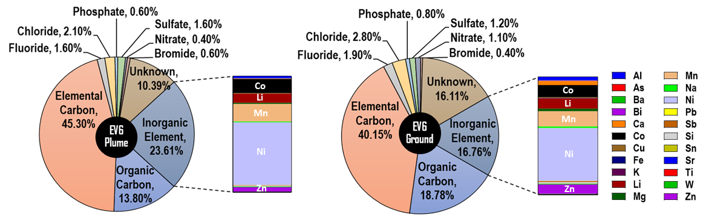
Figure S1. Mass balance of major chemical components of smoke PM samples collected from two different locations (plume vs. ground) during the EV6 fire. Unknown: unquantified oxygen and hydrogen derivatives.

