Supplementary information
Determination of Per- and Polyfluoroalkyl Substances in air samples from urban areas close to industrial complexes and human risk assessment
Reyes García-Garcinuño¹, Massimo Picardo², Josepa Fabregas², Laura Vallecillos¹, Francesc Borrull¹*, Rosa Maria Marcé¹
¹ Universitat Rovira i Virgili, Department of Analytical Chemistry and Organic Chemistry, Campus Sescelades, Marcel·lí Domingo, 1, Tarragona 43007, Spain
² Consorci d’Aigües Tarragona, Ctra. Nacional 340, Km.1094, L’Ampolla 43895, Tarragona, Spain
* e-mail: francesc.borrull@urv.cat

TABLES
Table 1S. Acronyms and full chemical names of the target compounds.
Compounds | Acronyms
Perfluoro-n-butanoic acid | PFBA
Perfluoro-n-(¹³C₄)butanoic acid | ¹³C PFBA
Perfluoro-n-pentanoic acid | PFPA
Perfluoro-n-(¹³C₅)pentanoic acid | ¹³C PFPA
Perfluoro-n-hexanoic acid | PFHxA
Perfluoro-n-(1,2,3,4,6-¹³C₅)hexanoic acid | ¹³C PFHxA
Sodium perfluoro-1-(2,3,4-¹³C₃)butanesulfonate | ¹³C PFBS
Potassium perfluoro-1-butanesulfonate | PFBS
Perfluoro-n-heptanoic acid | PFHpA
Perfluoro-n-(1,2.3.4-¹³C₄)heptanoic acid | ¹³C PFHpA
Sodium perfluoro-1-pentanesulfonate | PFPS^{b}
Perfluoro-n-octanoic acid | PFOA
Perfluoro-n-(¹³C₈)octanoic acid | ¹³C PFOA
Sodium perfluoro-1-hexanesulfonate | PFHxS
Sodium perfluoro-1-(1,2,3-¹³C₃)hexanesulfonate | ¹³C PFHxS
Perfluoro-n-nonanoic acid | PFNA
Perfluoro-n-(¹³C₉)nonanoic acid | ¹³C PFNA
Sodium perfluoro-1-heptanesulfonate | PFHpS^{b}
Perfluoro-n-decanoic acid | PFDA
Perfluoro-n-(1,2,3,4,5,6-¹³C₆)decanoic acid | ¹³C PFDA
Sodium perfluoro-1-octanesulfonate | PFOS
Sodium perfluoro-1-(¹³C₈)octanesulfonate | ¹³C PFOS
Sodium perfluoro-1-nonanesulfonate | PFNSª
Perfluoro-n-undecanoic acid | PFUnDA
Perfluoro-n-(1,2,3,4,5,6,7-¹³C₇)undecanoic acid | ¹³C PFUnDA
Sodium perfluoro-1-decanesulfonate | PFDSª
Perfluoro-n-dodecanoic acid | PFDoA
Perfluoro-n-(1,2-¹³C₂)dodecanoic acid | ¹³C PFDoA
Sodium perfluoro-1-undecanesulfonate | PFUnSª
Sodium perfluoro-1-dodecanesulfonate | PFDoS
Perfluoro-n-tridecanoic acid | PFTrA^{c}
Sodium perfluoro-1-tridecanesulfonate | PFTrS^{d}
Perfluoro-n-(1,2-¹³C₂)tetradecanoic acid | ¹³C PFTeDA

Table 2S. Acronyms, retention time (tR, min), MRM mass transitions with the collision energy, instrumental limit of detection (ILOD) and instrumental limit of quantification (ILOQ) of target and isotopically labelled PFAS standards of the target compounds determined in this study.
Compounds | t_{R} (min) | Transitions  Quantifier ion Qualifier ion  (Collision energy, eV) |  | ILOD  (µg L⁻¹) | ILOQ  (µg L⁻¹)
PFBA | 6.9 | 213169 (4) | - | 0.10 | 0.50
¹³C PFBA | 7.0 | 217172 (4)
PFPA | 7.8 | 263219 (4) | - | 0.09 | 0.50
¹³C PFPA | 7.8 | 268223 (4)
PFHxA | 8.6 | 313269 (4) | 313119 (18) | 0.17 | 0.50
¹³C PFHxA | 8.6 | 318273 (4)
¹³C PFBS | 9.1 | 30280 (40)
PFBS | 9.2 | 29999 (30) | 29980 (40) | 0.08 | 0.50
PFHpA | 9.2 | 363319 (6) | 363169 (18) | 0.17 | 0.50
¹³C PFHpA | 9.3 | 367322 (6)
PFPS^{b} | 9.7 | 34999 (35) | 34980 (39) | 0.08 | 0.50
PFOA | 9.9 | 413369 (6) | 431169 (16) | 0.07 | 0.50
¹³C PFOA | 10.0 | 421376 (6)
PFHxS | 10.3 | 399119 (48) | 39999 (42) | 0.08 | 0.50
¹³C PFHxS | 10.3 | 40280 (42)
PFNA | 10.5 | 463419 (6) | 463219 (14) | 0.10 | 0.50
¹³C PFNA | 10.5 | 472427 (6)
PFHpS^{b} | 10.8 | 449169 (46) | 44980 (50) | 0.17 | 1.0
PFDA | 11.1 | 513469 (8) | 513219 (16) | 0.10 | 0.50
¹³C PFDA | 11.1 | 519474 (8)
PFOS | 11.3 | 49999 (46) | 49950 (50) | 0.08 | 0.50
¹³C PFOS | 11.3 | 50780 (50)
PFNSª | 11.6 | 54999 (56) | 54980 (53) | 0.08 | 0.50
PFUnDA | 11.7 | 563519 (6) | 563319 (15) | 0.08 | 0.50
¹³C PFUnDA | 11.7 | 570525 (6)
PFDSª | 12.0 | 59999 (57) | 59980 (54) | 0.07 | 0.50
PFDoA | 12.2 | 613569 (8) | 613169 (26) | 0.08 | 0.50
¹³C PFDoA | 12.2 | 615570 (8)
PFUnSª | 12.3 | 64999 (80) | 64980 (120) | 0.09 | 0.50
PFDoS | 12.6 | 69999 (40) | 69980 (100) | 0.08 | 0.50
PFTrA^{c} | 12.7 | 663619 (9) | 663169 (86) | 0.09 | 0.50
PFTrS^{d} | 13.0 | 74999 (95) | 74980 (200) | 0.20 | 1.0
¹³C PFTeDA | 13.1 | 715670 (10)
The compounds with super index do not have analogue ISTD and the following were used for quantification: ª: ¹³C PFOS; ^{b}: ¹³C PFHxS; ^{c}: ¹³C PFDA; ^{d}: ¹³C PFTeDA

Table 3S. Values used to calculate EDI (Eq 1) (Asante-Duah, 2002).
 | Infants  (1-6 years) | Children  (6-12 years) | Adults
IR (m^{3·}h⁻¹) | 0.25 | 0.46 | 0.83
RR (%) | 1 | 1 | 1
ET (h day⁻¹) | 12 | 12 | 12
EF (day year⁻¹) | 365 | 365 | 365
ED (years) | 5 | 6 | 58
BW (kg) | 16 | 29 | 70
AT (days) | 1,825 | 2,190 | 21,170

Table 4S. Table with oral chronic reference dose (RfD) and oral slope factor (SfO) values for PFASs (RAIS, 2025).
Compounds | RfD (mg kg_{bw}⁻¹ day⁻¹) | Source | SfO (mg kg_{bw}⁻¹ day⁻¹)⁻¹ | Source
PFBA | 1.00E-03 | IRISª current
PFHxA | 5.00E-04 | IRIS current
PFBS | 3.00E-04 | PPRTV^{b} Current
PFOA | 3.00E-08 | DWSHA^{c} | 2.93E+04 | DWSHA
PFHxS | 2.00E-05 | ATSDR^{d} Final
PFNA | 3.00E-06 | ATSDR Final
PFDA | 2.00E-09 | IRIS current
PFOS | 1.00E-07 | DWSHA | 3.95E+01 | DWSHA
PFUnDA | 3.00E-04 | WIe Current
PFDoA | 5.00E-05 | WI Current
ªIntegrated Risk Information System
^{b}Provisional Peer-Reviewed Toxicity Value
^{c}Drinking Water Standards and Health Advisores
^{d}Agency for Toxic Substances and Disease Registry
^{e}Weight of Evidence

Table 5S. Extraction recoveries to MeOH and ACN as a solvent extraction and temperatures of 70 ºC and 100 ºC (RSD %; n = 3).
Compounds | MeOH |  |  | ACN
Compounds | 70 ºC | 100 ºC |  | 70 ºC | 100 ºC
PFBA | 85 (5) | 84 (7) |  | 77 (1) | 73 (10)
PFPA | 102 (5) | 91 (6) |  | 97 (3) | 89 (10)
PFHxA | 113 (5) | 94 (4) |  | 107 (3) | 100 (8)
PFBS | 85 (5) | 87 (8) |  | 84 (6) | 79 (12)
PFHpA | 126 (4) | 102 (5) |  | 122 (4) | 114 (8)
PFPS | 79 (9) | 79 (6) |  | 70 (6) | 64 (10)
PFOA | 116 (5) | 96 (4) |  | 111 (5) | 104 (8)
PFHxS | 79 (7) | 87 (7) |  | 74 (6) | 70 (12)
PFNA | 97 (6) | 87 (6) |  | 92 (6) | 85 (9)
PFHpS | 79 (6) | 80 (9) |  | 76 (8) | 71 (11)
PFDA | 94 (6) | 88 (5) |  | 88 (5) | 80 (9)
PFOS | 74 (5) | 80 (9) |  | 73 (8) | 71 (13)
PFNS | 72 (5) | 77 (11) |  | 71 (9) | 67 (11)
PFUnDA | 81 (6) | 83 (9) |  | 76 (8) | 72 (10)
PFDS | 86 (4) | 85 (8) |  | 84 (8) | 77 (13)
PFDoA | 93 (9) | 94 (7) |  | 87 (3) | 80 (14)
PFUnS | 83 (1) | 90 (9) |  | 82 (8) | 74 (5)
PFDoS | 106 (27) | 76 (5) |  | 72 (17) | 57 (11)
PFTrA | 137 (29) | 94 (2) |  | 89 (17) | 70 (15)
PFTrS | 138 (30) | 113 (5) |  | 80 (22) | 66 (11)

Table 6S. EDIs (pg kg_{bw}⁻¹ day⁻¹) calculated for each target compound in two different exposure scenarios for three populations groups and in two sites.
Compounds | Estimated Daily Intake (pg kg_{bw}⁻¹ day⁻¹)
Compounds | El Serrallo |  |  |  |  |  |  | Constantí
Compounds | Low scenario |  |  |  | High scenario |  |  | Low scenario |  |  |  | High scenario
Compounds | Infants | Children | Adults |  | Infants | Children | Adults | Infants | Children | Adults |  | Infants | Children | Adults
PFBA | 4.3E+00 | 4.3E+00 | 1.5E+00 |  | 3.0E+01 | 3.1E+01 | 1.1E+01 | 9.6E+00 | 9.7E+00 | 3.4E+00 |  | 3.7E+01 | 3.7E+01 | 1.3E+01
PFOS | 2.5E+00 | 2.5E+00 | 8.9E-01 |  | 1.3E+01 | 1.3E+01 | 4.7E+00 | 2.2E+00 | 2.2E+00 | 7.8E-01 |  | 2.0E+01 | 2.1E+01 | 7.3E+00
PFPA | 4.5E-01 | 4.5E-01 | 1.6E-01 |  | 7.0E+00 | 7.1E+00 | 2.5E+00 | 2.7E+00 | 2.7E+00 | 9.6E-01 |  | 3.1E+01 | 3.1E+01 | 1.1E+01
PFBS | 3.0E-01 | 3.0E-01 | 1.1E-01 |  | 7.9E+00 | 8.0E+00 | 2.9E+00 | 1.3E-01 | 1.3E-01 | 4.7E-02 |  | 2.0E+00 | 2.0E+00 | 7.1E-01
PFTrS | 3.3E-01 | 3.3E-01 | 1.2E-01 |  | 6.5E+00 | 6.6E+00 | 2.4E+00 | 1.7E-01 | 1.7E-01 | 6.0E-02 |  | 1.3E+00 | 1.3E+00 | 4.5E-01
PFHxS | 2.4E-01 | 2.4E-01 | 8.5E-02 |  | 2.9E+00 | 2.9E+00 | 1.0E+00 | 1.4E-01 | 1.4E-01 | 4.9E-02 |  | 1.4E+00 | 1.4E+00 | 5.1E-01
PFPS | 2.5E-01 | 2.5E-01 | 8.9E-02 |  | 2.1E+00 | 2.2E+00 | 7.7E-01 | 9.5E-02 | 9.7E-02 | 3.4E-02 |  | 9.0E-01 | 9.2E-01 | 3.3E-01
PFOA | 1.1E-01 | 1.1E-01 | 4.0E-02 |  | 1.2E+00 | 1.3E+00 | 4.4E-01 | 1.1E-01 | 1.1E-01 | 3.9E-02 |  | 7.8E-01 | 8.0E-01 | 2.8E-01
PFHpS | 7.3E-02 | 7.4E-02 | 2.6E-02 |  | 6.1E-01 | 6.2E-01 | 2.2E-01 | 4.3E-02 | 4.4E-02 | 1.5E-02 |  | 3.9E-01 | 3.9E-01 | 1.4E-01
PFDoS | 4.8E-02 | 4.9E-02 | 1.7E-02 |  | 7.2E-01 | 7.3E-01 | 2.6E-01 | 4.5E-02 | 4.6E-02 | 1.6E-02 |  | 4.6E-01 | 4.6E-01 | 1.6E-01
PFHxA | 9.5E-02 | 9.6E-02 | 3.4E-02 |  | 4.3E-01 | 4.3E-01 | 1.5E-01 | 2.6E-01 | 2.7E-01 | 9.4E-02 |  | 1.6E+00 | 1.7E+00 | 5.9E-01
PFDA | 1.2E-01 | 1.2E-01 | 4.2E-02 |  | 7.5E-01 | 7.6E-01 | 2.7E-01 | 1.6E-01 | 1.6E-01 | 5.7E-02 |  | 5.7E-01 | 5.8E-01 | 2.1E-01
PFDoA | 4.0E-03 | 4.1E-03 | 1.4E-03 |  | 4.4E-01 | 4.4E-01 | 1.6E-01 | 7.5E-02 | 7.6E-02 | 2.7E-02 |  | 3.0E-01 | 3.1E-01 | 1.1E-01
PFUnS | 4.5E-02 | 4.6E-02 | 1.6E-02 |  | 5.2E-01 | 5.3E-01 | 1.9E-01 | 7.8E-02 | 7.9E-02 | 2.8E-02 |  | 1.1E+00 | 1.2E+00 | 4.1E-01
PFDS | 2.1E-02 | 2.1E-02 | 7.5E-03 |  | 3.1E-01 | 3.1E-01 | 1.1E-01 | 4.5E-02 | 4.6E-02 | 1.6E-02 |  | 5.5E-01 | 5.5E-01 | 2.0E-01
PFNS | 1.1E-02 | 1.1E-02 | 3.9E-03 |  | 5.1E-01 | 5.1E-01 | 1.8E-01 | 1.2E-02 | 1.2E-02 | 4.3E-03 |  | 2.2E-01 | 2.2E-01 | 7.8E-02
PFTrA | 2.1E-02 | 2.1E-02 | 7.6E-03 |  | 2.8E-01 | 2.8E-01 | 9.9E-02 | 4.6E-02 | 4.6E-02 | 1.6E-02 |  | 1.3E-01 | 1.4E-01 | 4.9E-02
PFUnDA | 2.0E-02 | 2.0E-02 | 7.2E-03 |  | 2.4E-01 | 2.4E-01 | 8.5E-02 | 4.1E-02 | 4.2E-02 | 1.5E-02 |  | 1.6E-01 | 1.6E-01 | 5.6E-02
PFHpA | 7.1E-02 | 7.2E-02 | 2.6E-02 |  | 4.3E-01 | 4.4E-01 | 1.6E-01 | 4.1E-02 | 4.2E-02 | 1.5E-02 |  | 1.2E-01 | 1.2E-01 | 4.3E-02
PFNA | 5.2E-02 | 5.2E-02 | 1.9E-02 |  | 8.9E-02 | 9.1E-02 | 3.2E-02 | 2.9E-02 | 2.9E-02 | 1.0E-02 |  | 8.9E-02 | 9.1E-02 | 3.2E-02
∑PFASs | 8.9E+00 | 9.0E+00 | 3.2E+00 |  | 7.6E+01 | 7.7E+01 | 2.8E+01 | 1.6E+01 | 1.6E+01 | 5.7E+00 |  | 1.0E+02 | 1.0E+02 | 3.6E+01

FIGURES
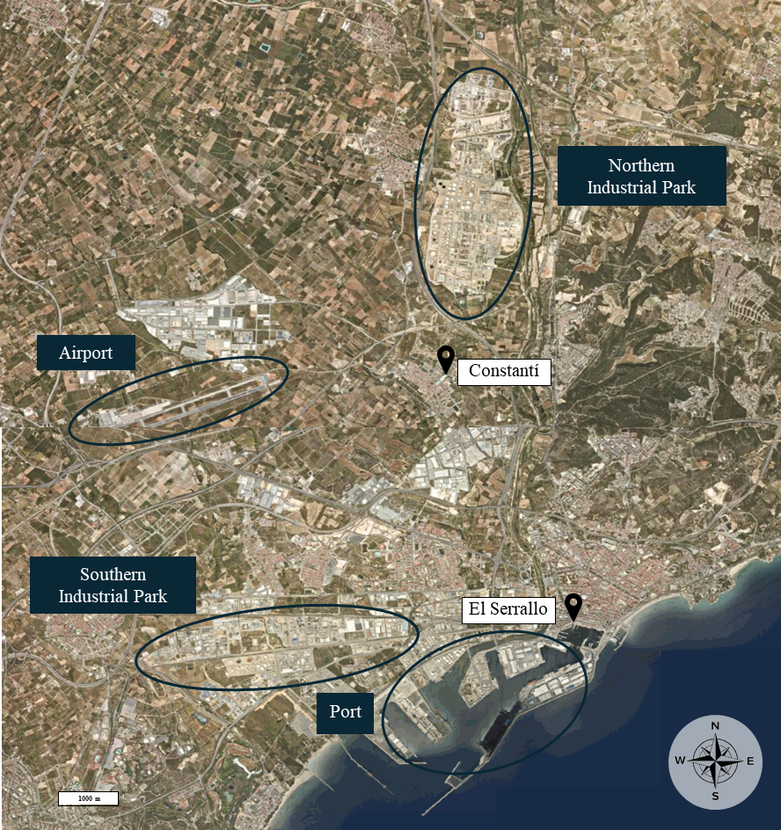

Figure 1S. Map of the study area showing the location of the two sampling sites (El Serrallo and Constantí), the two industrial parks in Tarragona, the port facilities, and the airport.

