Supplementary Material

Mapping and quantifying the spatial and temporal composition of waste piles in informal settlements of urban Malawi.
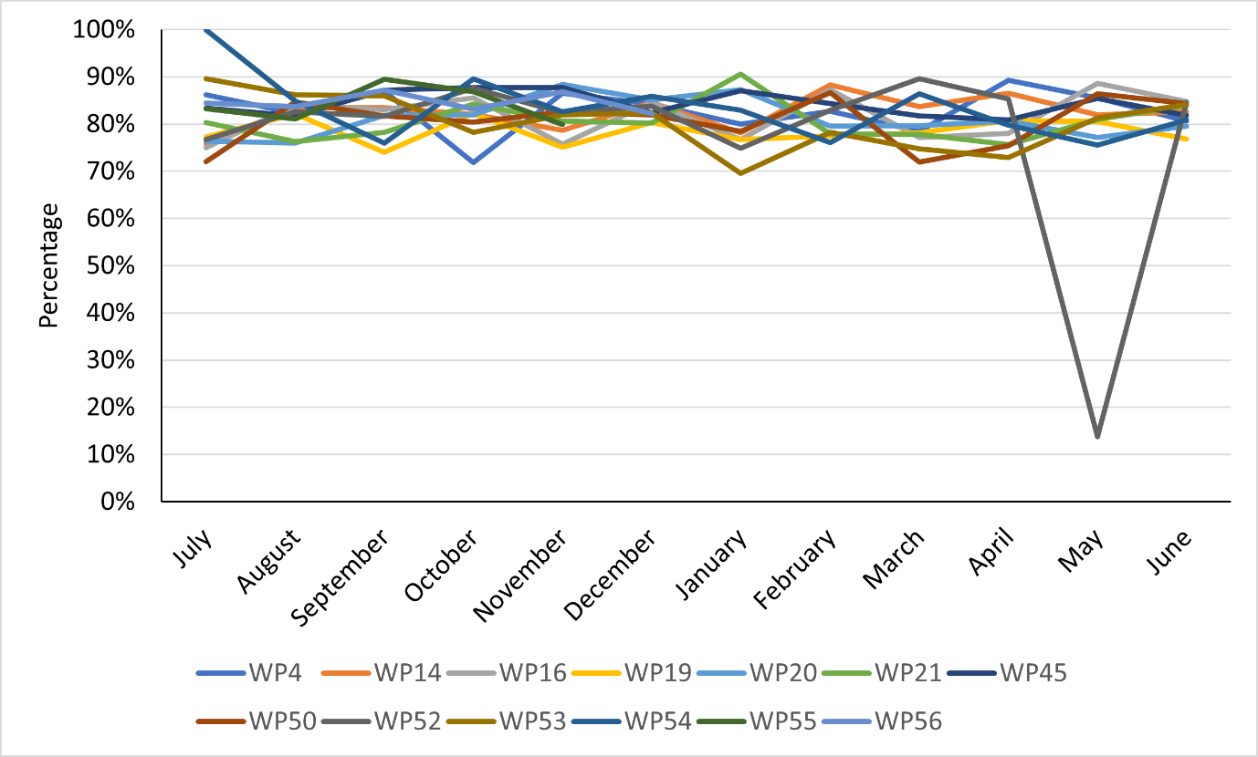
S9 Proportion of compacted samples made up of LDPE plastics across all waste piles by month.

