Figure S1. Correlation matrix showing the Pearson correlation coefficients of the air pollutant values from the different 9-month exposure periods: 9 months preconception; 9 months during pregnancy; and first 9 months after birth. Pearson correlation coefficients range from -1 to 1, with values closer to -1 indicating higher negative correlation, values closer to 0 indicating no correlation, and values closer to 1 indicating higher positive correlation.
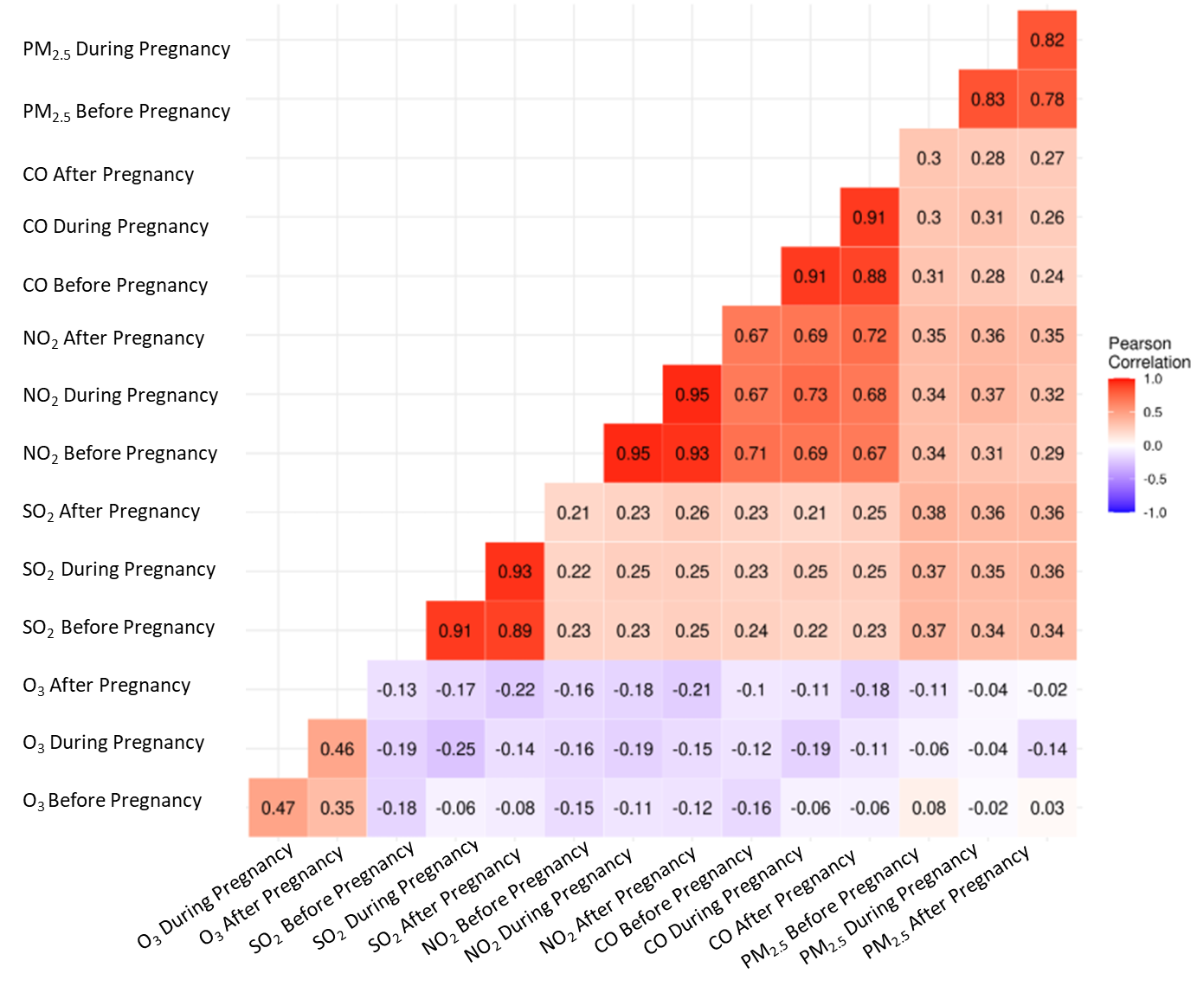

Table S1. Median and interquartile range (IQR) for each air pollutant before, during, and after pregnancy.
 | Before pregnancy | During pregnancy | After pregnancy
O₃ (ppm) | 0.02 (0.020, 0.027) | 0.02 (0.020, 0.027) | 0.02 (0.020, 0.027)
SO₂ (ppb) | 6.26 (3.544, 9.047) | 6.11 (3.425, 8.963) | 5.82 (3.298, 8.352)
NO₂ (ppb) | 18.97 (13.738, 24.271) | 19.06 (13.922, 23.784) | 18.99 (13.982, 23.312)
CO (ppm) | 0.91 (0.696, 1.222) | 0.88 (0.664, 1.181) | 0.84 (0.653, 1.135)
*Note: Values are indicated as median value (IQR).

Table S2. Odds ratios (OR) and 95% confidence intervals (CI) for the association between autism spectrum disorder (ASD) and an interquartile range (IQR) increase in the residentially-linked air pollutants. Effect estimates are shown for the full pregnancy and at potential periods of susceptibility, including 9 months preconception, 1st trimester, 2nd trimester, 3rd trimester, and 9 months post-birth. The associations for the periods of susceptibility were analyzed in separate exposure models and mutually adjusted exposure models.
Model | Mutually adjusted*
O₃ (N=1782; cases=250; controls=1532)
9 months preconception | 0.80 (0.59, 1.10)
Trimester 1 | 1.01 (0.79, 1.30)
Trimester 2 | 1.12 (0.95, 1.32)
Trimester 3 | 0.95 (0.76, 1.20)
9 months after birth | 1.08 (0.75, 1.57)
SO₂ (N=1770; cases=250; controls=1520)
9 months preconception | 2.92 (1.60, 5.33)
Trimester 1 | 0.84 (0.52, 1.35)
Trimester 2 | 0.79 (0.53, 1.18)
Trimester 3 | 0.64 (0.38, 1.05)
9 months after birth | 0.86 (0.40, 1.83)
NO₂ (N=1731; cases=244; controls=1487)
9 months preconception | 0.84 (0.48, 1.47)
Trimester 1 | 0.99 (0.58, 1.71)
Trimester 2 | 1.06 (0.67, 1.68)
Trimester 3 | 1.97 (1.11, 3.50)
9 months after birth | 0.75 (0.39, 1.45)
CO (N=1765; cases=249; controls=1516)
9 months preconception | 0.97 (0.59, 1.60)
Trimester 1 | 0.71 (0.45, 1.11)
Trimester 2 | 1.20 (0.86, 1.67)
Trimester 3 | 1.11 (0.69, 1.78)
9 months after birth | 1.49 (0.81, 2.75)
*Mutually adjusted for the other two exposure periods for the same air pollutants, as well as all other covariates (child sex, year of birth, month of birth, maternal age at birth, paternal age at birth, and census income.)
IQR: O₃ (0.007 ppm); SO₂ (5.54 ppb); NO₂ (9.86 ppb); CO (0.52 ppm)

Table S3. Odds ratios (OR) and 95% confidence intervals (CI) for the association between autism spectrum disorder (ASD) and an interquartile range (IQR) increase in the residentially-linked air pollutants. Effect estimates were shown for the full pregnancy and at potential periods of susceptibility, including 9 months and 3 months preconception, 9 months during pregnancy, 1st trimester, 2nd trimester, 3rd trimester, and 9 months and 3 months post-birth. The associations for the periods of susceptibility were analyzed in separate exposure models and mutually adjusted exposure models. The population was restricted to those with exposure datasets for the specific pollutant and PM_{2.5}.
 |  | O₃ (N=1762; cases=247; controls=1515) |  | SO₂ (N=1750; cases=247; controls=1503) |  | NO₂ (N=1712; cases=241; controls=1471) |  | CO (N=1746; cases=246; controls=1500)
Model |  | Adjusted* | Mutually adjusted** | Adjusted* | Mutually adjusted** | Adjusted* | Mutually adjusted** | Adjusted* | Mutually adjusted**
Before conception | 9 months | 0.73 (0.59, 0.91) | 0.76 (0.60, 0.95) | 1.13 (0.87, 1.47) | 1.12 (0.86, 1.46) | 0.99 (0.60, 1.64) | 1.25 (0.73, 2.14) | 0.99 (0.64, 1.54) | 1.05 (0.67, 1.64)
Before conception | 3 months | 0.97 (0.73, 1.29) | 0.98 (0.74, 1.31) | 1.53 (0.91, 2.60) | 1.44 (0.83, 2.52) | 0.89 (0.52, 1.52) | 0.92 (0.53, 1.59) | 0.90 (0.57, 1.43) | 0.88 (0.55, 1.40)
During pregnancy | whole pregnancy | 1.11 (0.83, 1.47) | 1.06 (0.79, 1.44) | 0.53 (0.26, 1.10) | 0.58 (0.28, 1.20) | 1.63 (0.86, 3.09) | 1.19 (0.61, 2.34) | 1.20 (0.70, 2.05) | 0.93 (0.53, 1.62)
During pregnancy | Trimester 1 | 0.98 (0.79, 1.22) | 0.98 (0.79, 1.23) | 0.71 (0.47, 1.06) | 0.63 (0.40, 1.01) | 0.93 (0.54, 1.61) | 0.90 (0.50, 1.60) | 0.79 (0.52, 1.19) | 0.82 (0.54, 1.26)
During pregnancy | Trimester 2 | 1.18 (0.94, 1.48) | 1.18 (0.94, 1.49) | 1.21 (0.80, 1.85) | 1.48 (0.90, 2.45) | 0.95 (0.54, 1.66) | 0.91 (0.50, 1.65) | 1.35 (0.89, 2.04) | 1.26 (0.82, 1.93)
During pregnancy | Trimester 3 | 0.75 (0.55, 1.02) | 0.75 (0.55, 1.03) | 0.74 (0.40, 1.38) | 0.58 (0.29, 1.17) | 2.01 (0.99, 4.11) | 1.83 (0.87, 3.82) | 0.92 (0.50, 1.71) | 0.81 (0.43, 1.54)
After birth | 9 months | 1.13 (0.87, 1.47) | 1.12 (0.86, 1.46) | 0.89 (0.45, 1.76) | 0.78 (0.39, 1.57) | 0.82 (0.45, 1.48) | 0.86 (0.45, 1.61) | 1.14 (0.67, 1.92) | 1.34 (0.77, 2.31)
After birth | 3 months | 1.18 (0.83, 1.68) | 1.20 (0.84, 1.71) | 1.10 (0.53, 2.31) | 1.30 (0.59, 2.84) | 0.83 (0.42, 1.64) | 0.94 (0.46, 1.90) | 1.50 (0.77, 2.93) | 1.73 (0.87, 3.47)
*ORs are adjusted for child sex, year of birth, month of birth, maternal age at birth, paternal age at birth, census income, and mutually adjusted for the other two exposure periods for the same air pollutants.
**Mutually adjusted for the other two exposure periods for the same air pollutants and PM_{2.5}, as well as all other covariates listed above.
IQR: O₃ (0.007 ppm); SO₂ (5.54 ppb); NO₂ (9.86 ppb); CO (0.52 ppm)

Table S4. Odds ratios (OR) and 95% confidence intervals (CI) for the association between autism spectrum disorder (ASD) and an interquartile range (IQR) increase in the residentially-linked air pollutants by different sex. Effect estimates are shown for the full pregnancy and at potential periods of susceptibility, including 9 months preconception, 9 months during pregnancy, and 9 months post-birth. The associations for the periods of susceptibility were analyzed in separate exposure models and mutually adjusted exposure models.
 | Male population |  |  | Female population
Model | Unadjusted | Adjusted* | Mutually adjusted** | Unadjusted | Adjusted* | Mutually adjusted**
 | O₃ (N=1005; cases=211; controls=794) |  |  | O₃ (N=777; cases=39; controls=738)
9 months before conception | 0.74 (0.60, 0.90) | 0.74 (0.61, 0.91) | 0.67 (0.53, 0.86) | 1.09 (0.71, 1.68) | 1.06 (0.69, 1.63) | 1.04 (0.64, 1.71)
Whole pregnancy | 0.95 (0.77, 1.16) | 0.98 (0.78, 1.24) | 1.11 (0.80, 1.52) | 1.00 (0.64, 1.56) | 1.08 (0.66, 1.76) | 1.10 (0.57, 2.14)
9 months after birth | 1.04 (0.84, 1.28) | 1.06 (0.84, 1.32) | 1.17 (0.88, 1.57) | 1.00 (0.61, 1.61) | 1.00 (0.61, 1.61) | 0.93 (0.51, 1.69)
 | SO₂ (N=997; cases=211; controls=786) |  |  | SO₂ (N=773; cases=39; controls=734)
9 months before conception | 1.24 (1.00, 1.54) | 1.25 (1.00, 1.57) | 2.47 (1.36, 4.47) | 0.97 (0.62, 1.52) | 0.98 (0.61, 1.58) | 0.79 (0.17, 3.72)
Whole pregnancy | 1.09 (0.88, 1.36) | 1.09 (0.87, 1.38) | 0.46 (0.20, 1.04) | 0.91 (0.58, 1.44) | 0.90 (0.55, 1.48) | 0.68 (0.16, 2.84)
9 months after birth | 1.12 (0.88, 1.42) | 1.13 (0.88, 1.45) | 1.01 (0.46, 2.21) | 0.82 (0.49, 1.36) | 0.86 (0.50, 1.49) | 1.61 (0.51, 5.10)
 | NO₂ (N=977; cases=206; controls=771) |  |  | NO₂ (N=754; cases=38; controls=716)
9 months before conception | 1.32 (1.12, 1.55) | 1.35 (1.13, 1.60) | 0.99 (0.57, 1.73) | 1.15 (0.80, 1.65) | 1.26 (0.86, 1.85) | 0.98 (0.28, 3.44)
Whole pregnancy | 1.34 (1.14, 1.58) | 1.37 (1.15, 1.63) | 1.63 (0.80, 3.31) | 1.19 (0.82, 1.75) | 1.32 (0.89, 1.96) | 2.00 (0.46, 8.71)
9 months after birth | 1.33 (1.12, 1.58) | 1.35 (1.12, 1.62) | 0.84 (0.44, 1.62) | 1.25 (0.83, 1.89) | 1.25 (0.83, 1.89) | 0.64 (0.16, 2.61)
 | CO (N=997; cases=210; controls=787) |  |  | CO (N=768; cases=39; controls=729)
9 months before conception | 1.23 (1.02, 1.49) | 1.30 (1.05, 1.62) | 1.20 (0.74, 1.95) | 1.17 (0.80, 1.73) | 1.41 (0.91, 2.18) | 0.68 (0.25, 1.81)
Whole pregnancy | 1.23 (1.02, 1.48) | 1.28 (1.03, 1.59) | 0.99 (0.54, 1.80) | 1.34 (0.91, 1.99) | 1.63 (1.04, 2.57) | 1.96 (0.63, 6.13)
9 months after birth | 1.24 (1.01, 1.51) | 1.31 (1.04, 1.65) | 1.12 (0.63, 2.01) | 1.26 (0.83, 1.92) | 1.61 (0.99, 2.61) | 1.23 (0.37, 4.13)
*ORs are adjusted for child sex, year of birth, month of birth, maternal age at birth, paternal age at birth, and census income.
**Mutually adjusted for the other two exposure periods for the same air pollutants, as well as all other covariates listed above.
IQR: O₃ (0.007 ppm); SO₂ (5.54 ppb); NO₂ (9.86 ppb); CO (0.52 ppm)

Table S5. Odds ratios (OR) and 95% confidence intervals (CI) for the association between autism spectrum disorder (ASD) and an interquartile range (IQR) increase in the residentially-linked air pollutants by different sex. Effect estimates are shown for the full pregnancy and at potential periods of susceptibility, including 3 months preconception, 1st trimester, 2nd trimester, 3rd trimester, and 3 months post-birth. The associations for the periods of susceptibility were analyzed in separate exposure models and mutually adjusted exposure models.
 | Male population |  |  | Female population
 | O₃ (N=1005; cases=211; controls=794) |  |  | O₃ (N=777; cases=39; controls=738)
3 months preconception | 0.95 (0.85, 1.07) | 0.89 (0.77, 1.04) | 0.95 (0.69, 1.31) | 1.21 (0.93, 1.57) | 1.08 (0.77, 1.51) | 1.04 (0.57, 1.90)
Trimester 1 | 1.13 (1.01, 1.28) | 1.15 (1.02, 1.31) | 0.95 (0.75, 1.21) | 1.08 (0.84, 1.39) | 0.96 (0.73, 1.27) | 1.03 (0.64, 1.68)
Trimester 2 | 1.01 (0.90, 1.13) | 1.07 (0.92, 1.24) | 1.23 (0.95, 1.58) | 0.93 (0.72, 1.21) | 1.05 (0.76, 1.46) | 1.07 (0.63, 1.83)
Trimester 3 | 0.81 (0.72, 0.92) | 0.81 (0.71, 0.92) | 0.68 (0.48, 0.96) | 1.02 (0.79, 1.32) | 1.10 (0.84, 1.45) | 1.12 (0.57, 2.21)
3 months after birth | 0.89 (0.79, 1.00) | 0.84 (0.73, 0.96) | 1.23 (0.82, 1.84) | 1.10 (0.85, 1.43) | 1.06 (0.80, 1.40) | 1.02 (0.47, 2.18)
 | SO₂ (N=997; cases=211; controls=786) |  |  | SO₂ (N=773; cases=39; controls=734)
3 months preconception | 1.18 (0.97, 1.43) | 1.23 (1.00, 1.52) | 1.60 (0.89, 2.87) | 0.95 (0.63, 1.44) | 1.03 (0.65, 1.61) | 1.90 (0.59, 6.14)
Trimester 1 | 1.05 (0.87, 1.27) | 1.06 (0.86, 1.29) | 0.75 (0.48, 1.15) | 0.83 (0.54, 1.26) | 0.88 (0.56, 1.39) | 0.70 (0.25, 1.99)
Trimester 2 | 1.08 (0.89, 1.31) | 1.07 (0.87, 1.32) | 1.21 (0.76, 1.91) | 0.96 (0.64, 1.42) | 0.92 (0.60, 1.42) | 0.98 (0.32, 3.00)
Trimester 3 | 1.12 (0.91, 1.37) | 1.10 (0.88, 1.36) | 0.72 (0.37, 1.41) | 0.96 (0.62, 1.51) | 0.95 (0.59, 1.53) | 0.96 (0.20, 4.67)
3 months after birth | 1.15 (0.93, 1.41) | 1.17 (0.94, 1.45) | 1.09 (0.49, 2.46) | 1.01 (0.65, 1.57) | 1.01 (0.63, 1.61) | 0.72 (0.13, 4.10)
 | NO₂ (N=977; cases=206; controls=771) |  |  | NO₂ (N=754; cases=38; controls=716)
3 months preconception | 1.27 (1.09, 1.49) | 1.30 (1.10, 1.53) | 0.91 (0.51, 1.65) | 1.03 (0.72, 1.47) | 1.17 (0.81, 1.70) | 0.74 (0.18, 2.96)
Trimester 1 | 1.25 (1.07, 1.46) | 1.26 (1.07, 1.48) | 0.97 (0.54, 1.75) | 1.12 (0.77, 1.62) | 1.25 (0.86, 1.84) | 0.85 (0.20, 3.68)
Trimester 2 | 1.30 (1.12, 1.51) | 1.32 (1.12, 1.56) | 0.87 (0.47, 1.61) | 1.22 (0.85, 1.74) | 1.31 (0.90, 1.91) | 1.58 (0.38, 6.54)
Trimester 3 | 1.39 (1.18, 1.64) | 1.43 (1.20, 1.70) | 2.51 (1.15, 5.49) | 1.08 (0.74, 1.58) | 1.21 (0.81, 1.81) | 0.62 (0.10, 3.86)
3 months after birth | 1.33 (1.12, 1.56) | 1.36 (1.14, 1.62) | 0.71 (0.34, 1.49) | 1.13 (0.78, 1.65) | 1.28 (0.87, 1.90) | 2.01 (0.39, 10.41)
 | CO (N=997; cases=210; controls=787) |  |  | CO (N=768; cases=39; controls=729)
3 months preconception | 1.15 (0.97, 1.36) | 1.22 (1.00, 1.48) | 1.15 (0.69, 1.89) | 0.99 (0.69, 1.43) | 1.24 (0.82, 1.88) | 0.47 (0.14, 1.55)
Trimester 1 | 1.11 (0.94, 1.31) | 1.11 (0.92, 1.34) | 0.72 (0.47, 1.12) | 1.14 (0.78, 1.65) | 1.40 (0.92, 2.13) | 1.45 (0.46, 4.55)
Trimester 2 | 1.22 (1.03, 1.43) | 1.25 (1.04, 1.50) | 1.42 (0.91, 2.21) | 1.33 (0.94, 1.87) | 1.52 (1.02, 2.27) | 0.92 (0.29, 2.95)
Trimester 3 | 1.25 (1.04, 1.49) | 1.30 (1.06, 1.59) | 0.89 (0.46, 1.72) | 1.29 (0.88, 1.90) | 1.55 (1.00, 2.40) | 1.25 (0.25, 6.22)
3 months after birth | 1.20 (1.00, 1.44) | 1.30 (1.05, 1.60) | 1.25 (0.60, 2.58) | 1.29 (0.88, 1.87) | 1.60 (1.04, 2.48) | 2.06 (0.41, 10.32)
*ORs are adjusted for child sex, year of birth, month of birth, maternal age at birth, paternal age at birth, and census income.
**Mutually adjusted for the other two exposure periods for the same air pollutants, as well as all other covariates listed above.
IQR: O₃ (0.007 ppm); SO₂ (5.54 ppb); NO₂ (9.86 ppb); CO (0.52 ppm)

Table S6. Odds ratios (OR) and 95% confidence intervals (CI) for the association between autism spectrum disorder (ASD) and an interquartile range (IQR) increase in the residentially-linked air pollutants. Effect estimates are shown for the full pregnancy and at potential periods of susceptibility, including 3 months preconception, 1st trimester, 2nd trimester, 3rd trimester, and 3 months post-birth. The associations for the periods of susceptibility were analyzed in separate exposure models and mutually adjusted exposure models. The population was restricted to the non-mover population only.
Model | Mutually adjusted* | Mutually adjusted for PM_{2.5}**
O₃ (N=1160; cases=165; controls=995)
3 months preconception | 0.96 (0.67, 1.38) | 0.97 (0.67, 1.40)
Trimester 1 | 1.02 (0.79, 1.33) | 1.06 (0.80, 1.39)
Trimester 2 | 1.09 (0.82, 1.44) | 1.04 (0.77, 1.39)
Trimester 3 | 0.83 (0.57, 1.21) | 0.83 (0.56, 1.22)
3 months after birth | 1.02 (0.65, 1.62) | 1.07 (0.67, 1.70)
SO₂ (N=1151; cases=165; controls=986)
3 months preconception | 2.00 (1.02, 3.89) | 1.63 (0.79, 3.35)
Trimester 1 | 0.83 (0.51, 1.35) | 0.66 (0.36, 1.19)
Trimester 2 | 0.87 (0.50, 1.52) | 1.19 (0.61, 2.33)
Trimester 3 | 0.82 (0.37, 1.80) | 0.60 (0.24, 1.50)
3 months after birth | 0.84 (0.32, 2.16) | 1.16 (0.42, 3.23)
NO₂ (N=1120; cases=161; controls=959)
3 months preconception | 1.10 (0.54, 2.24) | 1.13 (0.54, 2.35)
Trimester 1 | 0.91 (0.47, 1.77) | 0.88 (0.43, 1.81)
Trimester 2 | 0.82 (0.41, 1.64) | 0.79 (0.37, 1.67)
Trimester 3 | 3.71 (1.47, 9.35) | 3.00 (1.15, 7.83)
3 months after birth | 0.46 (0.19, 1.15) | 0.56 (0.22, 1.45)
CO (N=1145; cases=164; controls=981)
3 months preconception | 0.97 (0.54, 1.75) | 0.81 (0.44, 1.50)
Trimester 1 | 0.71 (0.43, 1.20) | 0.78 (0.44, 1.36)
Trimester 2 | 1.24 (0.75, 2.04) | 1.18 (0.69, 2.01)
Trimester 3 | 1.03 (0.47, 2.25) | 0.72 (0.31, 1.69)
3 months after birth | 1.52 (0.64, 3.61) | 2.35 (0.91, 6.05)
*Mutually adjusted for the other two exposure periods for the same air pollutants, as well as all other covariates (child sex, year of birth, month of birth, maternal age at birth, paternal age at birth, and census income).
**Mutually adjusted for the other two exposure periods for the same air pollutants and PM_{2.5}, as well as all other covariates listed above.
IQR: O₃ (0.007 ppm); SO₂ (5.54 ppb); NO₂ (9.86 ppb); CO (0.52 ppm)

