Dataset S1

AlphaFold predicted models
Structural predictions generated using AlphaFold 2.1, via ChimeraX version 1.8 (2024-06-10) and ColaFold, using default options and incorporating PDB templates for structure prediction (Goddard et al., 2018; Pettersen et al., 2021; Mirdita et al., 2022).

EfsHSP68 (triple-ACD)
Sequence and secondary structure
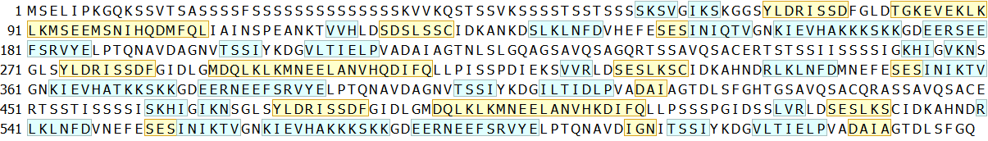

3D model
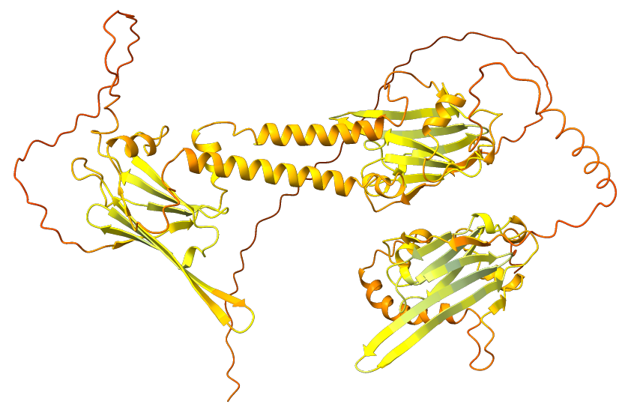 | 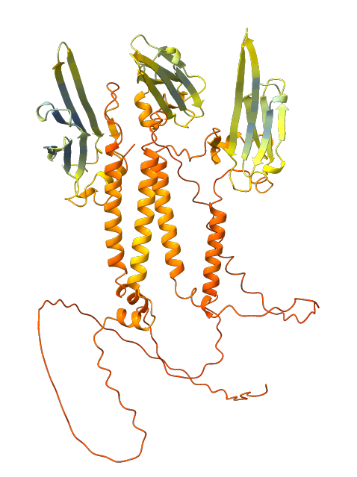
Best model: rank 01/05 | Rank 03/05

Per-residue model confidence score (pLDDT) between 0 and 100:
Very high (pLDDT > 90)
High (90 > pLDDT > 70)
Low (70 > pLDDT > 50)
Very low (pLDDT < 50)

PAE plots for AlphaFold’s five predicted models
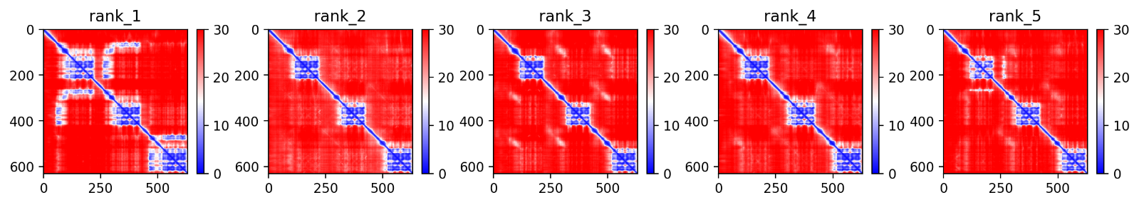

EfsHSP38.7.doubleACD (double-ACD)
Sequence and secondary structure

3D model
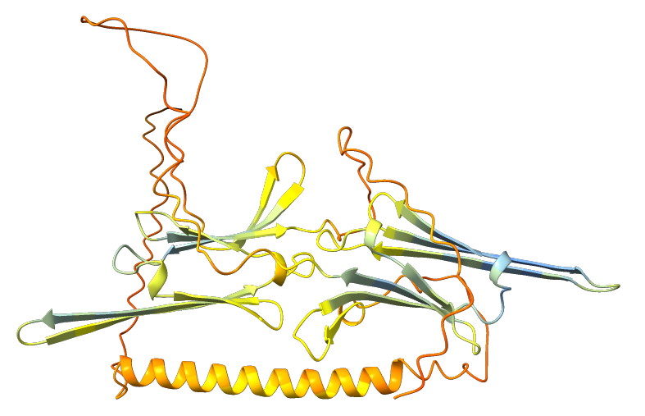 | 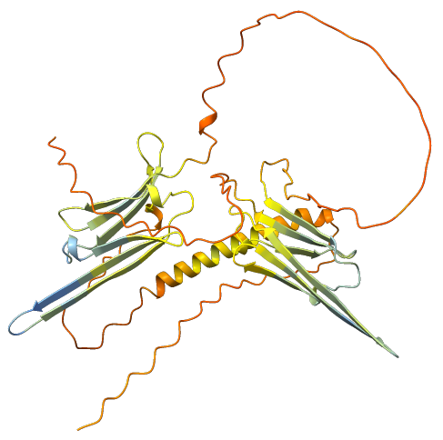
Best model: rank 01/05 | Rank 03/05

Per-residue model confidence score (pLDDT) between 0 and 100:
Very high (pLDDT > 90)
High (90 > pLDDT > 70)
Low (70 > pLDDT > 50)
Very low (pLDDT < 50)

PAE plots for AlphaFold’s five predicted models
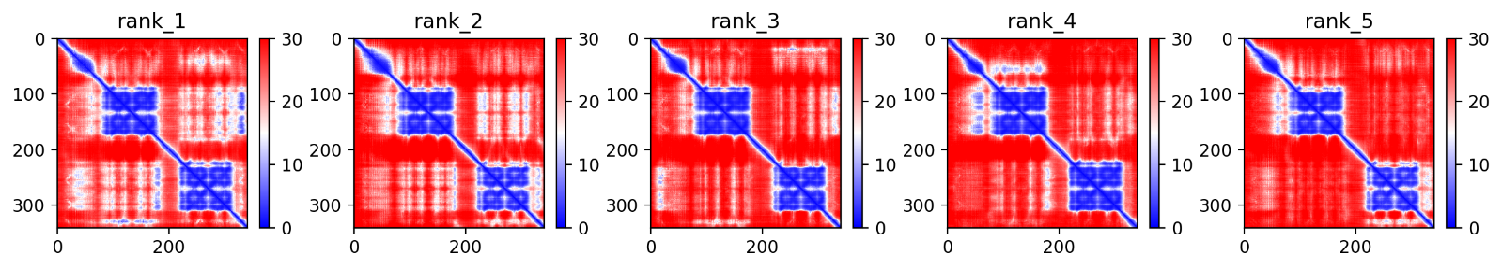

EfsHSP55.doubleACD (double-ACD)
Sequence and secondary structure
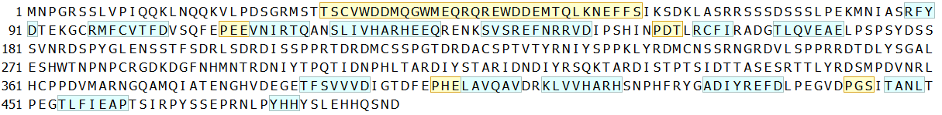

3D model
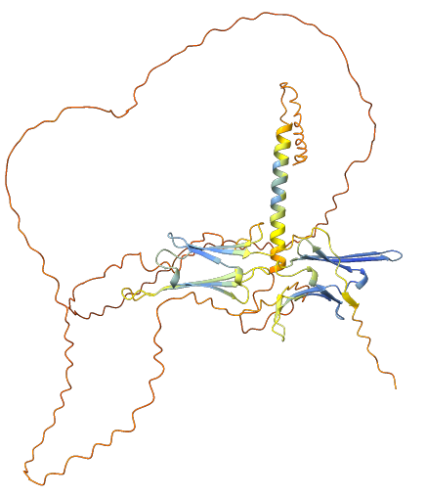 | 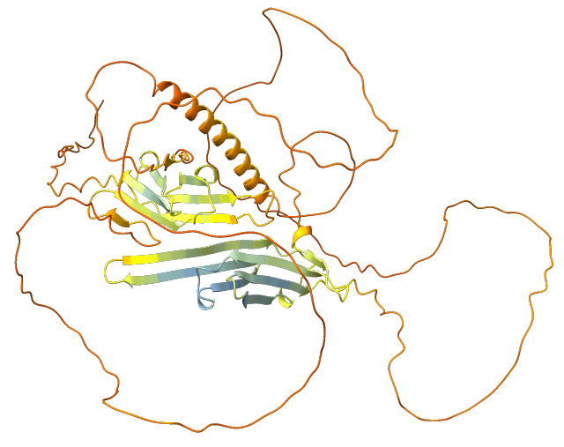
Best model: rank 01/05 | Rank 02/05

Per-residue model confidence score (pLDDT) between 0 and 100:
Very high (pLDDT > 90)
High (90 > pLDDT > 70)
Low (70 > pLDDT > 50)
Very low (pLDDT < 50)

PAE plots for AlphaFold’s five predicted models
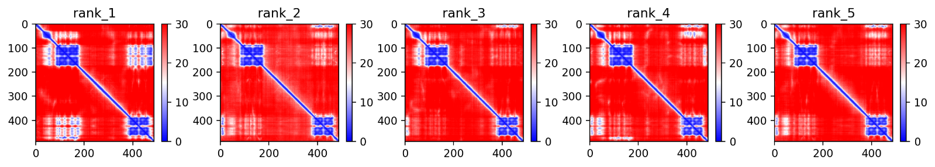

EfsHSP38.1.doubleACD (double-ACD)
Sequence and secondary structure

3D model
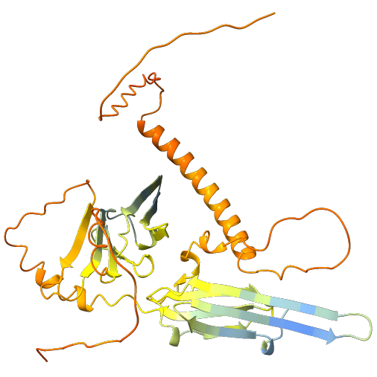 | 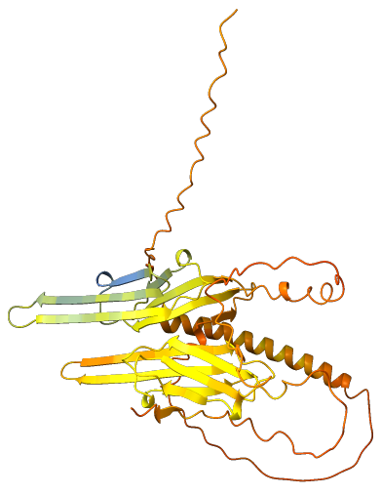
Best model: rank 01/05 | Rank 04/05

Per-residue model confidence score (pLDDT) between 0 and 100:
Very high (pLDDT > 90)
High (90 > pLDDT > 70)
Low (70 > pLDDT > 50)
Very low (pLDDT < 50)

PAE plots for AlphaFold’s five predicted models
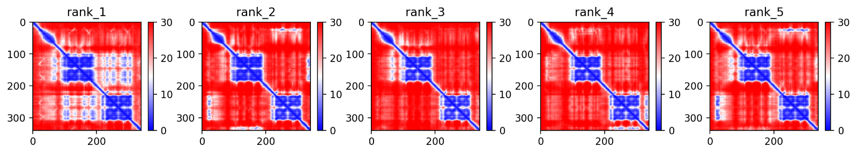

EfsHSP36.doubleACD (double-ACD)
Sequence and secondary structure

3D model
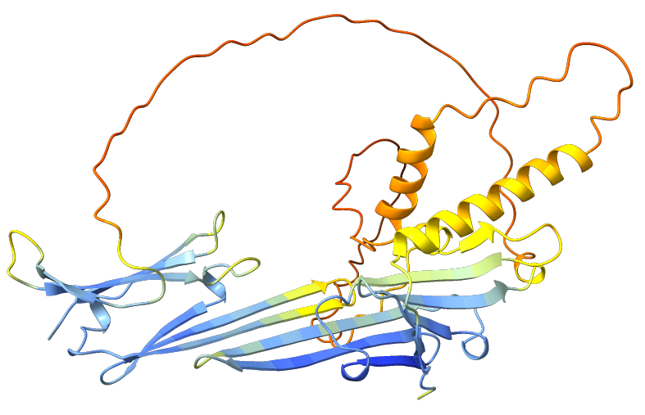 | 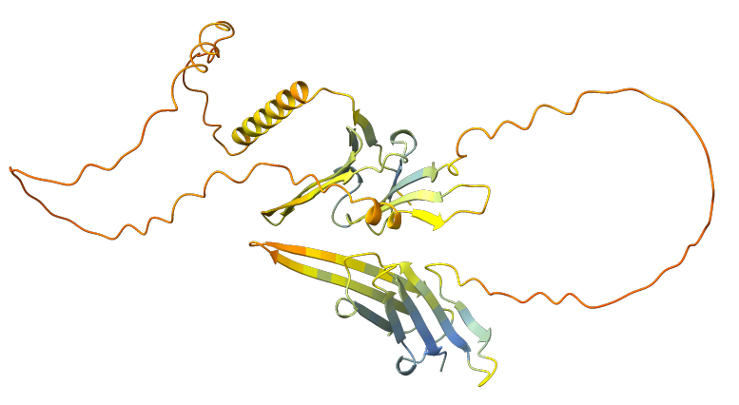
Best model: rank 01/05 | Rank 03/05

Per-residue model confidence score (pLDDT) between 0 and 100:
Very high (pLDDT > 90)
High (90 > pLDDT > 70)
Low (70 > pLDDT > 50)
Very low (pLDDT < 50)

PAE plots for AlphaFold’s five predicted models
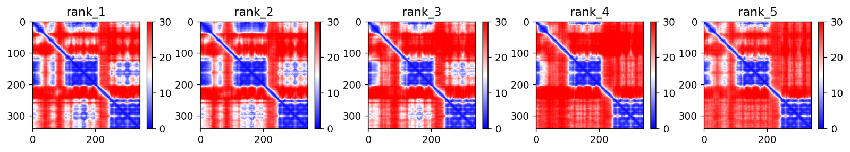

EfsHSP59.doubleACD (double-ACD)
THAP DOMAIN
Sequence and secondary structure
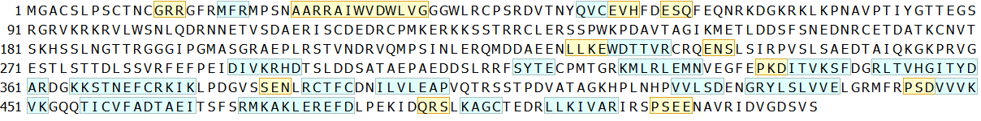

3D model
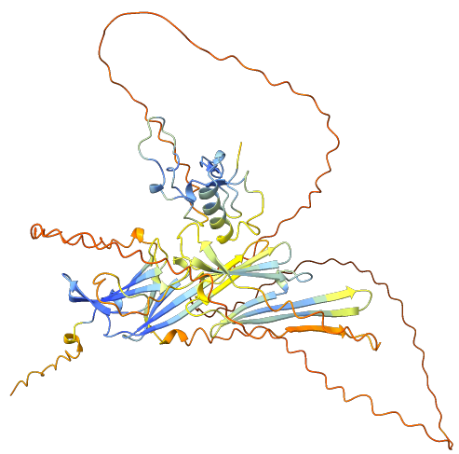 | 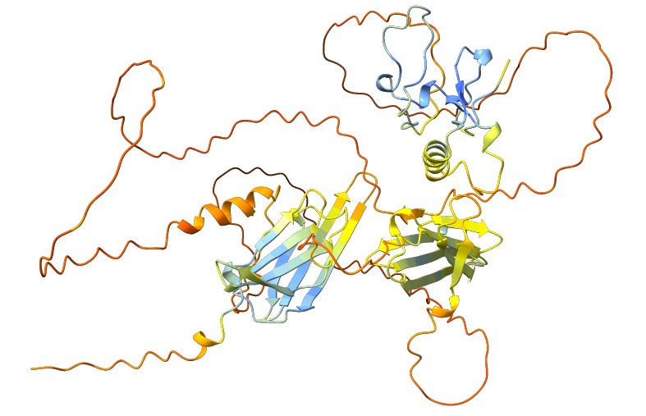
Best model: rank 01/05 | Rank 03/05

Per-residue model confidence score (pLDDT) between 0 and 100:
Very high (pLDDT > 90)
High (90 > pLDDT > 70)
Low (70 > pLDDT > 50)
Very low (pLDDT < 50)

PAE plots for AlphaFold’s five predicted models
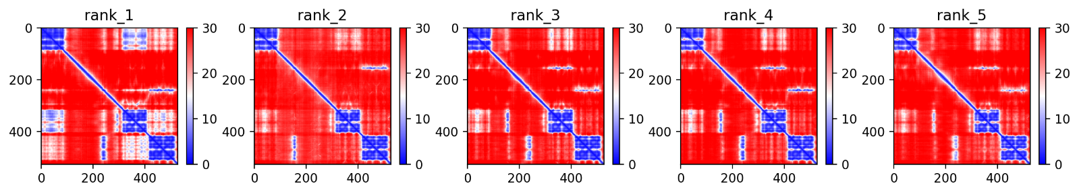

EfsHSP32.doubleACD (double-ACD)

Sequence and secondary structure

3D model
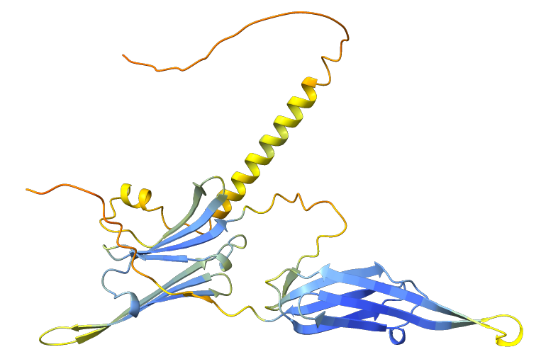
Best model: rank 01/05
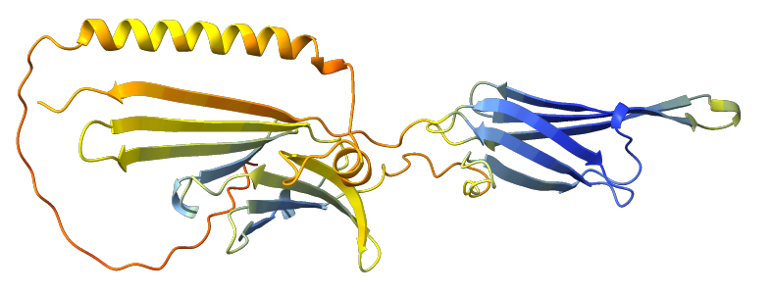
Rank 04/05

Per-residue model confidence score (pLDDT) between 0 and 100:
Very high (pLDDT > 90)
High (90 > pLDDT > 70)
Low (70 > pLDDT > 50)
Very low (pLDDT < 50)

PAE plots for AlphaFold’s five predicted models
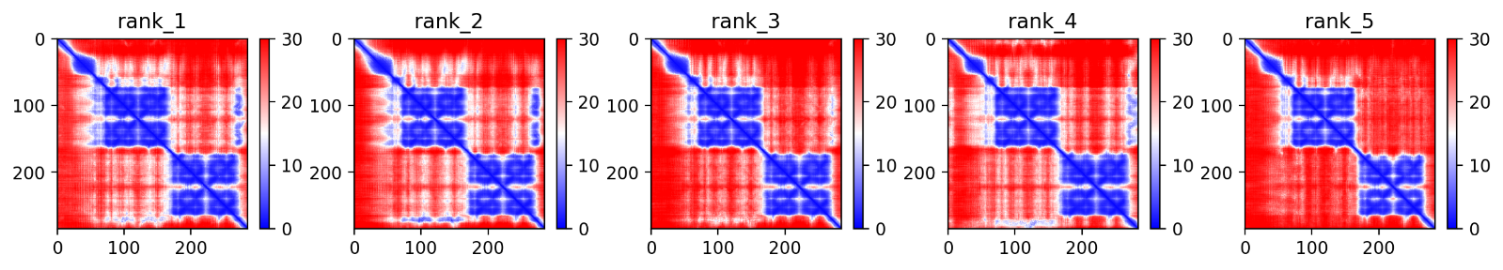

EfsHSP33.doubleACD (double-ACD)

Sequence and secondary structure

3D model
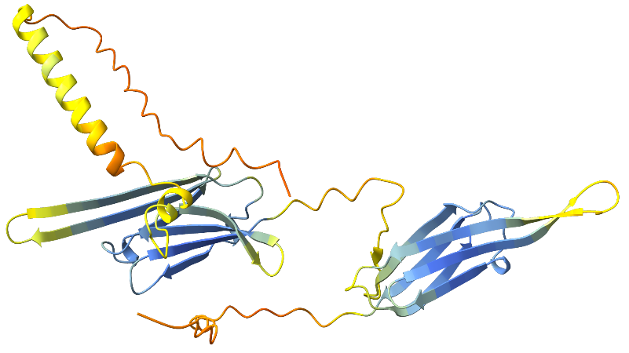 | 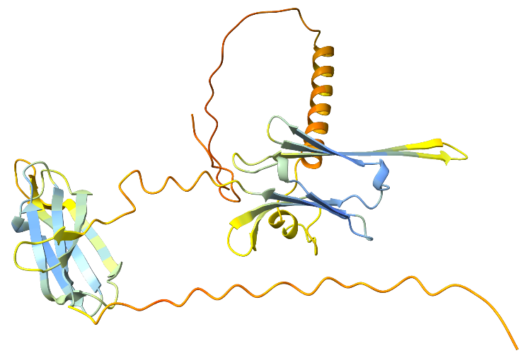
Best model: rank 01/05 | Rank 02/05

Per-residue model confidence score (pLDDT) between 0 and 100:
Very high (pLDDT > 90)
High (90 > pLDDT > 70)
Low (70 > pLDDT > 50)
Very low (pLDDT < 50)

PAE plots for AlphaFold’s five predicted models
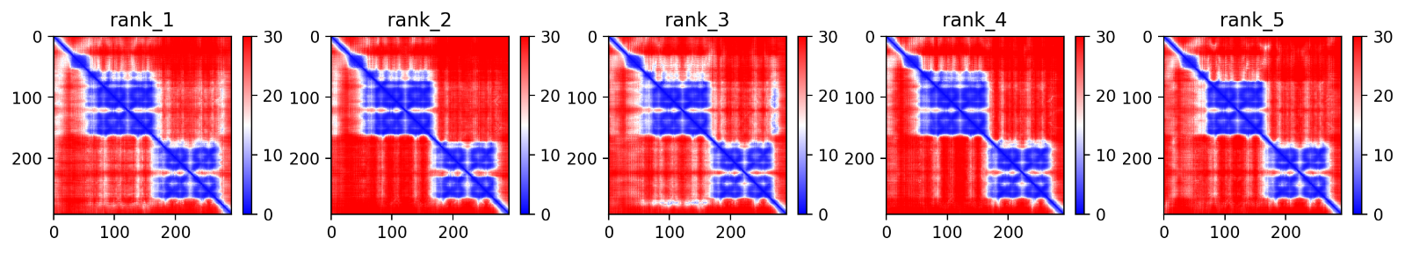

EfsHSP84.doubleACD (double-ACD)
Sequence and secondary structure
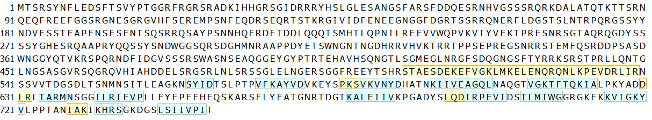

3D model
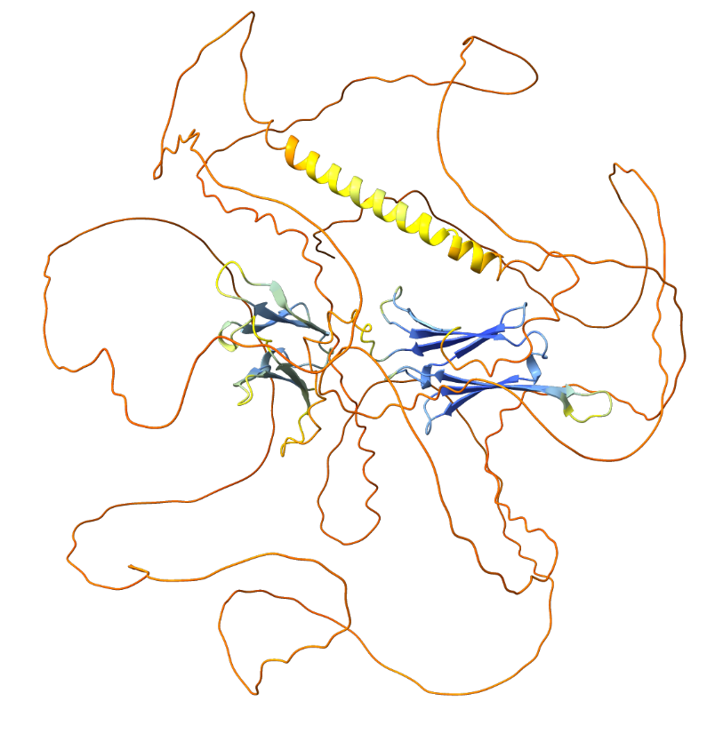 | 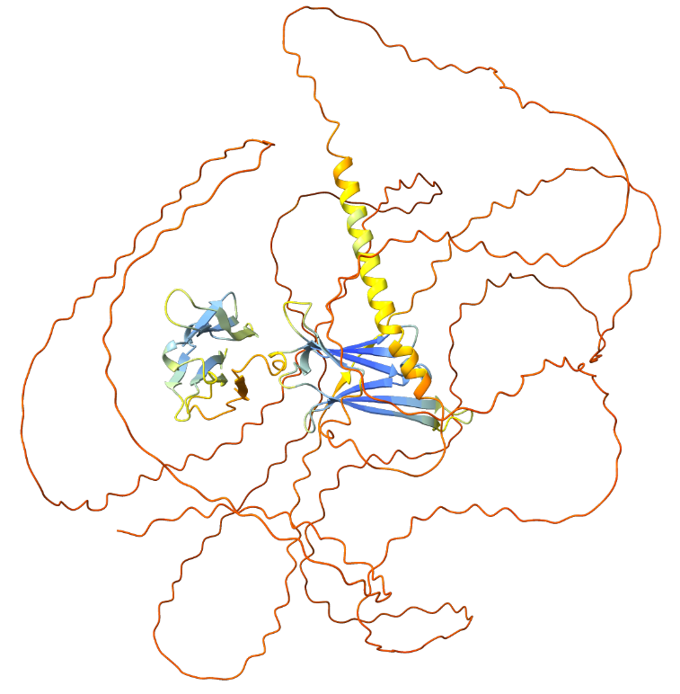
Best model: rank 01/05 | Rank 05/05

Per-residue model confidence score (pLDDT) between 0 and 100:
Very high (pLDDT > 90)
High (90 > pLDDT > 70)
Low (70 > pLDDT > 50)
Very low (pLDDT < 50)

PAE plots for AlphaFold’s five predicted models
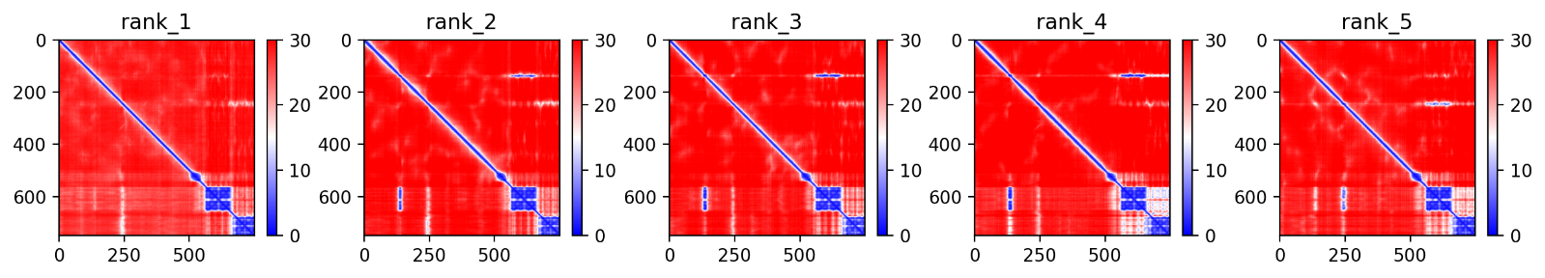

EfsHSP52.doubleACD (double-ACD)
Sequence and secondary structure
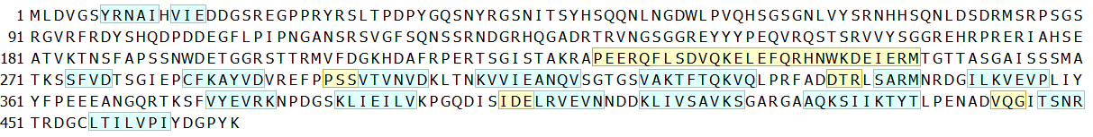

3D model
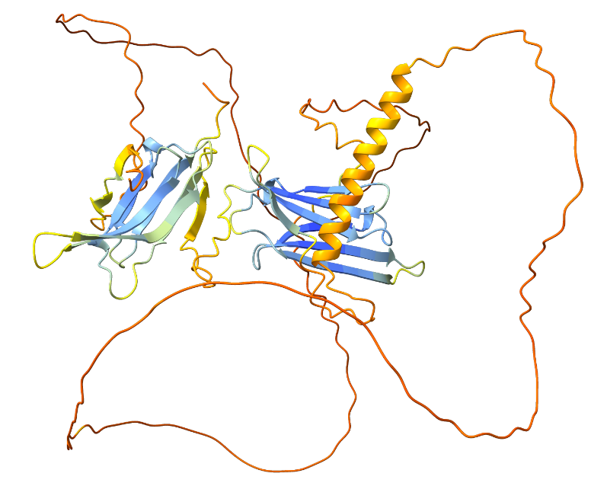 | 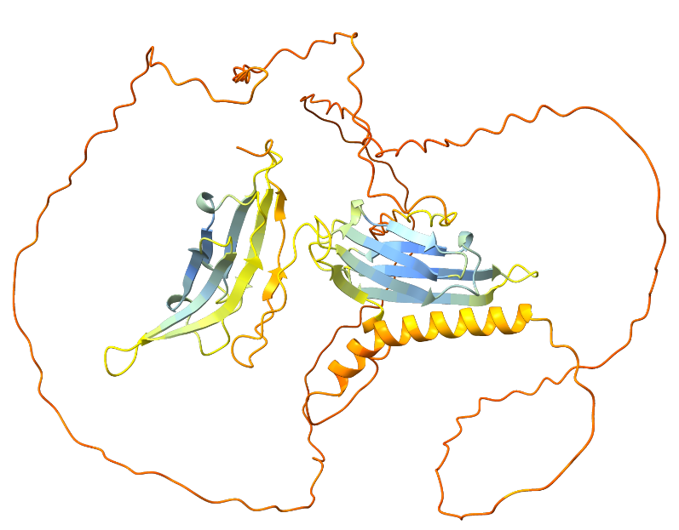
Best model: rank 01/05 | Rank 04/05

Per-residue model confidence score (pLDDT) between 0 and 100:
Very high (pLDDT > 90)
High (90 > pLDDT > 70)
Low (70 > pLDDT > 50)
Very low (pLDDT < 50)

PAE plots for AlphaFold’s five predicted models
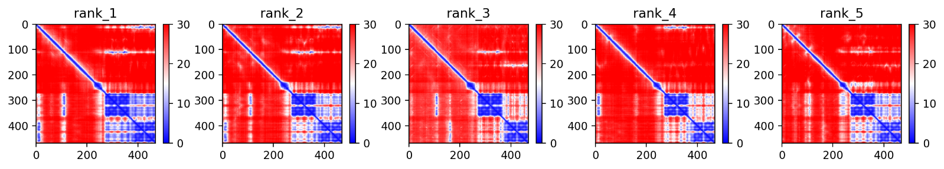

Structures of other homologous proteins
Structures of homologous proteins identified through SmartBLAST. These structure were obtained, via UniProt (The UniProt Consortium, 2023) from AlphaFold DB (Jumper et al., 2021; Varadi et al., 2022), and Protein Data Bank (PDBe) (Armstrong et al., 2020).

UniProtKB entry: P04792. Heat shock protein beta-1 (HSPB1). Homo sapiens
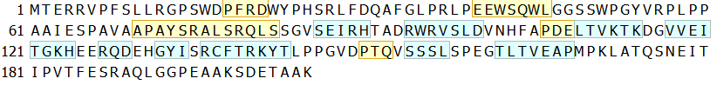  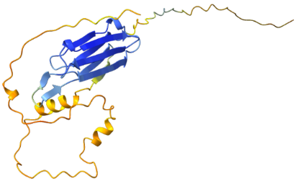  https://alphafold.ebi.ac.uk/entry/P04792 | HSPB1 dimers  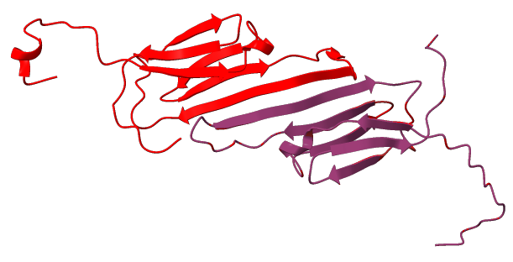  https://www.ebi.ac.uk/pdbe-srv/view/entry/2N3J
UniProtKB entry: O14558. Heat shock protein beta-6 (HSPB6). Homo sapiens
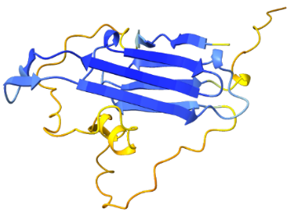  https://alphafold.ebi.ac.uk/entry/O14558 | HSPB6 dimers / tetramers  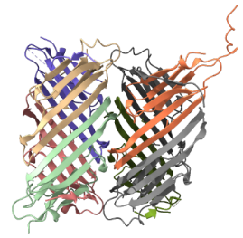  https://www.ebi.ac.uk/pdbe-srv/view/entry/4JUT
UniProtKB entry: Q16082  Heat shock protein beta-2 (HSPB2). Homo sapiens | UniProtKB entry: Q12988  Heat shock protein beta-3 (HSPB3). Homo sapiens
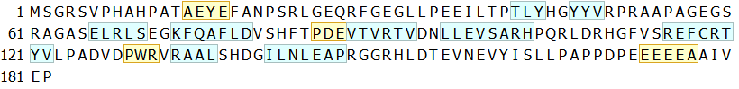  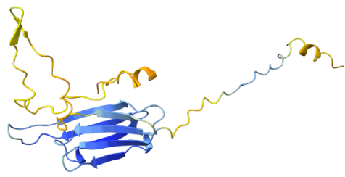  https://alphafold.ebi.ac.uk/entry/Q16082 | 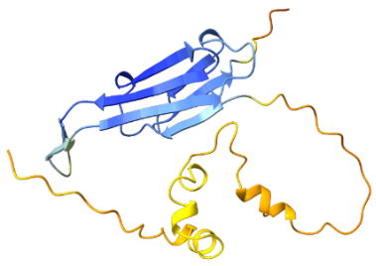  https://alphafold.ebi.ac.uk/entry/Q12988
UniProtKB entry: Q16082  Heterotetramen of HSPB3/HSPB2. Homo sapiens | UniProtKB entry: A0A024R3B9  Crystallin alpha B (CRYAB). Homo sapiens
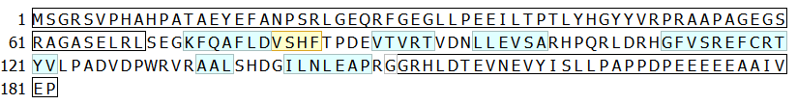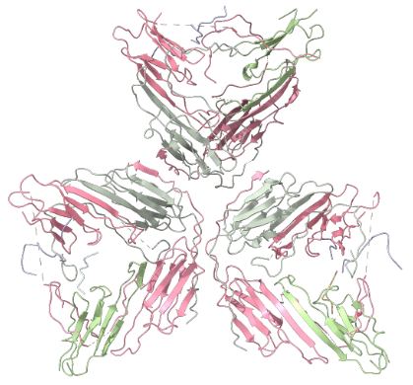  https://www.ebi.ac.uk/pdbe-srv/view/entry/6F2R | 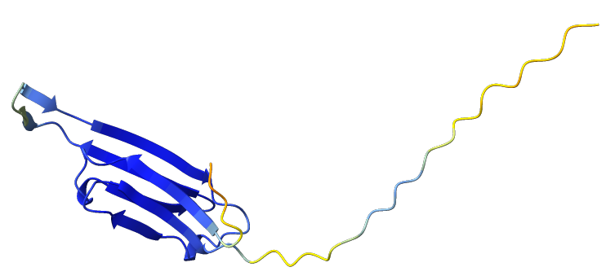  https://alphafold.ebi.ac.uk/entry/A0A024R3B9
UniProtKB entry: P34328  Heat shock protein Hsp-12.2. Caenorhabditis elegans | UniProtKB entry: G5EF99  SHSP domain-containing protein. C. elegans
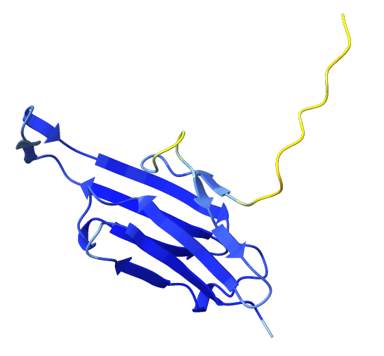  https://alphafold.ebi.ac.uk/entry/P34328 | 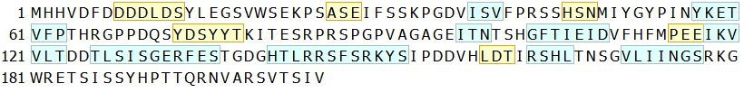  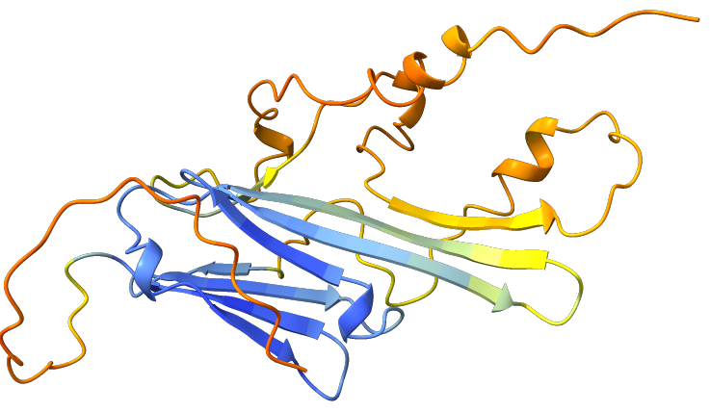https://alphafold.ebi.ac.uk/entry/G5EF99
UniProtKB entry: Q5H9M9  SHSP domain-containing protein (hsp-25)  Caenorhabditis elegans | UniProtKB entry: Q17849  SHSP domain-containing protein (hsp-25)  Caenorhabditis elegans
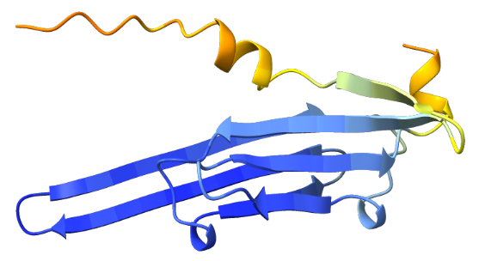  https://alphafold.ebi.ac.uk/entry/Q5H9M9 | 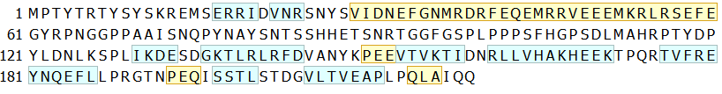  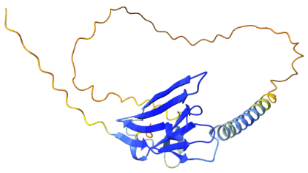  https://alphafold.ebi.ac.uk/entry/Q17849
UniProtKB entry: M9NHC5  Uncharacterized protein, isoform C (dHspB8)  Drosophila melanogaster | UniProtKB entry: Q9VSA9  Dmel\CG7409  Drosophila melanogaster
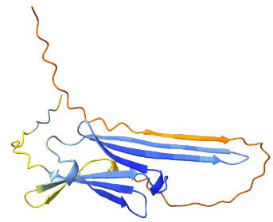  https://alphafold.ebi.ac.uk/entry/M9NHC5 | 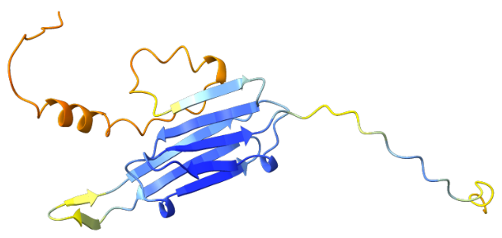  https://alphafold.ebi.ac.uk/entry/Q9VSA9
UniProtKB entry: P82147  Protein lethal(2)essential for life (l(2)efl)  Drosophila melanogaster | UniProtKB entry: Q9FHQ3_AtHSP15.7  15.7 kDa heat shock protein, peroxisomal (HSP15.7) Arabidopsis thaliana
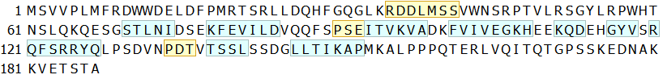  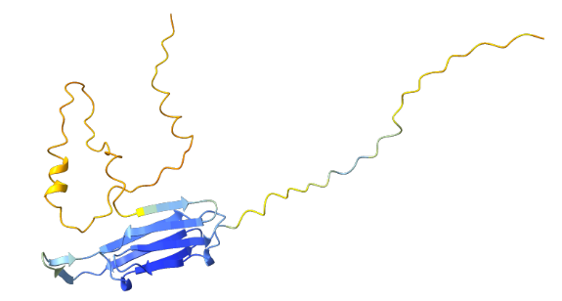  https://alphafold.ebi.ac.uk/entry/P82147 | 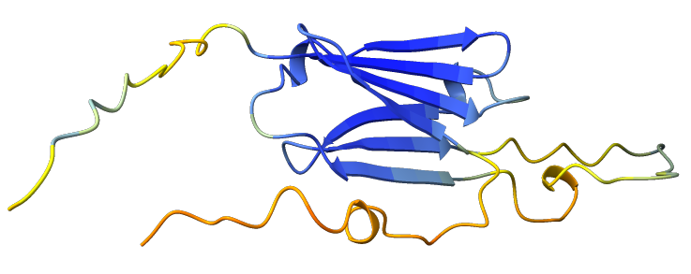  https://alphafold.ebi.ac.uk/entry/Q9FHQ3

Supplementary Figures
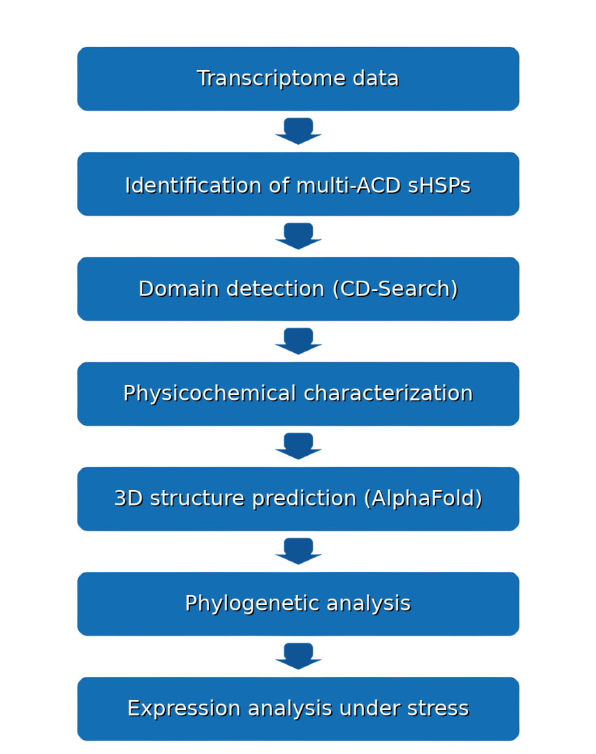

Figure S1. A schematic overview of the analytical workflow used for characterization of multi-ACD sHSPs.
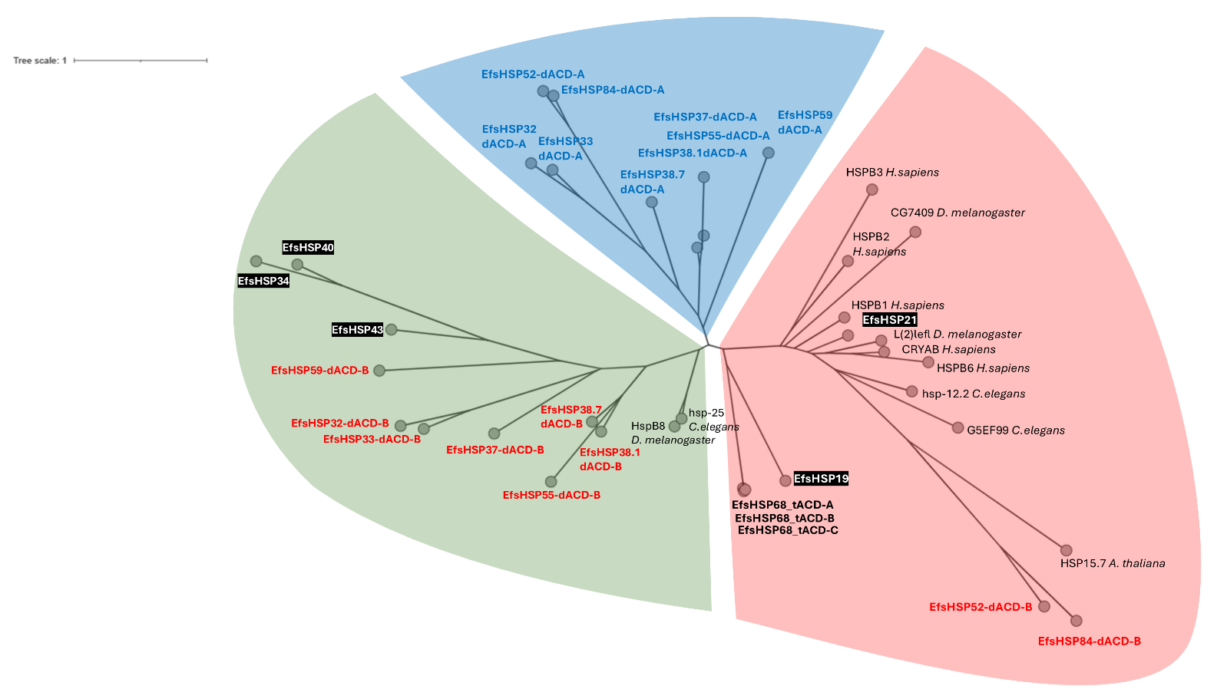
Figure S2. Maximum Likelihood (ML) tree constructed from the multiple sequence alignment of the alpha-crystallin domain (ACD) regions of small heat shock proteins (sHSPs) involved in the study, including sHSPs with dual ACD domain architecture, monomeric sHSPs (black background), triple ACD sHSPs (bold letters), and other well-characterized metazoan sHSPs. In sHSPs with double ACDs, the first ACD regions are represented in blue letters, and the second ACD regions in red letters. Clade colors correspond to those used in De la Fuente and Novo (2022).

