Supplementary Material
Occurrence of Per- and Polyfluoroalkyl Substances (PFAS) and Their Precursors in Biosolids Across 15 U.S. States
Xiayan Ye¹, Amith Maroli², Santhoshi Chitthaluri³, Erin M. Driver⁴, Rolf U. Halden⁴, Arjun K. Venkatesan³
¹ Cleveland Clinic Research, Cleveland Clinic, Cleveland, OH, 44195, USA
² Department of Environmental Medicine and Climate Science, Icahn School of Medicine at Mount Sinai, New York, NY, 10029, USA
³ Department of Civil and Environmental Engineering, New Jersey Institute of Technology, Newark, New Jersey, 07102, USA
⁴ Center for Environmental Health Engineering, The Biodesign Institute, Arizona State University, Tempe, AZ 85281, USA
*Corresponding author email: arjun.venkatesan@njit.edu; phone: +1 973-596-5884

Table SI-1: Information on sample and processing facilities
No. | State/ Location | Year | Population | Sample and Facility Information
1 | CA | 2015 | 130,000 | Biosolids.
 |  |  |  | Domestic, commercial and industrial inputs. The Discharger thickens primary sludge with gravity thickeners and waste-activated sludge through dissolved air flotation, treats the thickened sludge with anaerobic digestion, dewaters the digested sludge with a centrifuge.
2 | CA | 2015 | 50,000 | Dewatered Composite.
 |  |  |  | Domestic, commercial and industrial inputs. Sludge is anaerobically digested, dewatered using a belt filter press, and air dried.
3 | WA | 2020 | 38,000 | Biosolids.
 |  |  |  | Domestic, commercial and industrial inputs. One significant industrial user manufactures laser cutting equipment; activated sludge plant.
4 | CA | 2015 | 97,000 | Biosolids from Drying Beds.
 |  |  |  | Domestic, commercial and industrial input. Sludge is anaerobically digested, dewatered using a belt filter press, then air-dried to produce biosolids.
5 | CA | 2015 | 1,400,000 | Domestic, commercial and industrial inputs. Residential and main connections to businesses and industries: food service, automotive, metal finishing, photo processing, and manufacturing. Anaerobic digester tanks. After about 30 days, the sludge is transferred to open lagoons to dry.
6 | FL | 2016 | 2,300,000 | Class B Biosolids.
 |  |  |  | Domestic, commercial and industrial inputs. Anaerobically digested to meet Class B biosolids stabilization criteria, dewatered by centrifuges, and trucked to land application or landfill sites.
7 | CA | 2016 | 4,000,000 | Biosolids.
 |  |  |  | Domestic, commercial and industrial inputs. Solid fractions recovered from wastewater treatment processes include grit, primary screenings, primary sludge and skimming, thickened waste activated sludge, digested sludge screenings and digester cleaning solids. The fine solids (grit, primary screenings, digested sludge screenings, digester cleaning solids) that consist of primarily inorganic materials are hauled away to landfills. The remaining solid fractions (primary sludge and skimming, thickened waste activated sludge) are anaerobically digested. The digested solids are screened and dewatered using centrifuges. Thermophilic digestion is used to generate Class A “EQ” biosolids using anaerobic digesters.
8 | CO | 2015 | 211,000 | Biosolids.
 |  |  |  | Domestic, commercial and industrial inputs. 110,000 domestic + 101,000 employees in commercial and industrial businesses.
9 | MI | 2015 | 125,000 | Grab sample.
 |  |  |  | 72% domestic, 28% industrial inputs.
10 | CA | 2015 | 230,000 | Dewatered sludge cake.
 |  |  |  | Domestic (60%), commercial (30%) and industrial (10%) wastewater inputs.
11 | CA | 2015 | 740,000 | Biosolids.
 |  |  |  | Domestic, commercial and industrial inputs. Produces Class B biosolids using an anaerobic digestion process, during which the sludge is subjected to high temperatures (95°F to 131°F) for at least 15 days.
12 | CA | 2015 | 485,000 | Biosolids.
 |  |  |  | Domestic, commercial and industrial inputs.
13 | IL | 2015 | 2,200,000 | Biosolids.
 |  |  |  | Domestic, commercial and industrial inputs.
14 | NV | 2016 | 970,000 | Biosolids.
15 | CA | 2015 | 12,000 people (population equivalent) | Biosolids.
 |  |  |  | 35% industrial; Sanitary Plant includes a collection system and treats sanitary wastewater from airplanes and airport facilities, including terminal restrooms, hangars, restaurants, and shops. The Industrial Plant includes a separate collection system and treats industrial wastewater from maintenance shops and vehicle washing, as well as first-flush stormwater runoff from industrial areas. Process drains in the wastewater treatment plant area route to the Sanitary Plant, which may collect stormwater, overflow industrial wastewater from the equalization tank, and other incidental process wastewater.
16 | AZ | 2015 | 120,000 | Biosolids.
 |  |  |  | Domestic, commercial and industrial inputs. Sludge undergoes thickening for anaerobic digestion followed by dewatering and Class B pathogen reduction with a minimum of 38 percent reduction in volatile solids for land application.
17 | AZ | 2017 | 74,000 | Dewatered Sludge.
 |  |  |  | Domestic, commercial and industrial inputs. The solids from the primary and secondary systems are pumped to the anaerobic digester for final solids treatment. This process breaks down the organic material and generates natural gas (methane) which is used to produce electricity for the facility. The solids are then disposed of in the bio-solids disposal area.
18 | KY | 2020 | 751,000 | Primary sludge, waste activated sludge, and centrifuge cake samples.
19 | KY | 2020 | 751,000 | Domestic, commercial and industrial inputs. Processes biosolids from other KY treatment plants. Primary solids are anaerobically digested then combined with thickened waste-activated sludge for dewatering and drying. Digester gas provides much of the energy needed for drying, and waste heat from drying helps heat the digesters.
20 | KY | 2020 | 751,000
21 | IN | 2017 | 44,000 | Dewatered sludge.
 |  |  |  | 54% domestic, 28% industrial, 18% other; WAS storage and includes coarse bubble diffused aeration to prevent the WAS from becoming septic and keep the tanks well mixed before dewatering. WAS from the ASH tank is dewatered using a centrifuge process.
22 | KS | 2016 | 77,484 | Biosolids.
 |  |  |  | Domestic, commercial and industrial inputs.
23 | NY | 2015 | 53,000 | Sludge composite.
 |  |  |  | Domestic, commercial and industrial inputs.
24 | AZ | 2014 | 2,000,000 | Sludge sample.
25 | SC | 2020 | 100,000 | -
26 | AK | 2015 | 8,000 | Biosolids
 |  |  |  | No significant industrial users.
27 | ME | 2016 | 3,100 | Liquid Biosolids.
 |  |  |  | Class B land application was abundant in Maine in decades past but has been diminishing since the late 2000s. Class B biosolids are usually used at dairy farms for hay and feed corn crops. Lime stabilized biosolids.

Table SI-2. PFAS native compounds, surrogates, and internal standards used in this study
# | Compound name | Type | Abbreviation
n1 | Nonafluoro-3,6-dioxaheptanoic acid | native | NFDHA
n2 | Perfluorobutanoic acid | native | PFBA
n3 | Perfluoro-3-methoxypropanoic acid | native | PFMPA
n4 | 3-Perfluoropropyl propanoic acid | native | 3:3FTCA
n5 | Perfluoropentanoic acid | native | PFPeA
n6 | Perfluoro-4-methoxybutanoic acid | native | PFMBA
n7 | Hexafluoropropylene oxide dimer acid | native | HFPO-DA
n8 | Perfluorobutanesulfonic acid | native | PFBS
n9 | Perfluorohexanoic acid | native | PFHxA
n10 | Perfluoro(2-ethoxyethane)sulfonic acid | native | PFEESA
n11 | 1H,1H, 2H, 2H-Perfluorohexane sulfonic acid | native | 4:2FTS
n12 | 2H,2H,3H,3H-Perfluorooctanoic acid | native | 5:3FTCA
n13 | Perfluoropentanesulfonic acid | native | PFPeS
n14 | Perfluoroheptanoic acid | native | PFHpA
n15 | 4,8-dioxa-3H-perfluorononanoic acid | native | ADONA
n16 | Perfluorohexanesulfonic acid | native | PFHxS
n17 | Perfluorooctanoic acid | native | PFOA
n18 | 1H,1H, 2H, 2H-Perfluorooctane sulfonic acid | native | 6:2FTS
n19 | 3-Perfluoroheptyl propanoic acid | native | 7:3FTCA
n20 | Perfluoroheptanesulfonic acid | native | PFHpS
n21 | Perfluorononanoic acid | native | PFNA
n22 | Perfluorooctanesulfonamide | native | PFOSA
n23 | Perfluorooctanesulfonic acid | native | PFOS
n24 | N-methyl perfluorooctanesulfonamide | native | NMeFOSA
n25 | Perfluorodecanoic acid | native | PFDA
n26 | N-ethyl perfluorooctanesulfonamide | native | NEtFOSA
n27 | 1H,1H, 2H, 2H-Perfluorodecane sulfonic acid | native | 8:2FTS
n28 | 9-chlorohexadecafluoro-3-oxanone-1-sulfonic acid | native | 9Cl-PF3ONS
n29 | Perfluorononanesulfonic acid | native | PFNS
n30 | Perfluoroundecanoic acid | native | PFUnA
n31 | N-methyl perfluorooctanesulfonamidoacetic acid | native | NMeFOSAA
n32 | N-ethyl perfluorooctanesulfonamidoacetic acid | native | NEtFOSAA
n33 | Perfluorodecanesulfonic acid | native | PFDS
n34 | Perfluorododecanoic acid | native | PFDoA
n35 | N-methyl perfluorooctanesulfonamidoethanol | native | NMeFOSE
n36 | N-ethyl perfluorooctanesulfonamidoethanol | native | NEtFOSE
n37 | 11-chloroeicosafluoro-3-oxaundecane-1-sulfonic acid | native | 11Cl-PF3OUdS
n38 | Perfluorotridecanoic acid | native | PFTrDA
n39 | Perfluorododecanesulfonic acid | native | PFDoS
n40 | Perfluorotetradecanoic acid | native | PFTA / PFTeDA
s1 | Perfluoro-n-[1,2,3,4-¹³C₄]butanoic acid | SUR | MPFBA
s2 | Perfluoro-n-[1,2,3,4,5-¹³C5]pentanoic acid | SUR | M5PFPeA
s3 | 2,3,3,3-Tetrafluoro-2-(1,1,2,2,3,3,3-heptafluoropropoxy-¹³C₃-propanoic acid | SUR | M3HFPO-DA
s4 | Sodium perfluoro-1-[2,3,4-¹³C₃]butanesulfonate | SUR | M3PFBS
s5 | Perfluoro-n-[1,2,3,4,6-¹³C5]hexanoic acid | SUR | M5PFHxA
s6 | Sodium 1H,1H,2H,2H-perfluoro-1-[1,2-¹³C₂]hexane sulfonate | SUR | M2-4:2FTS
s7 | Perfluoro-n-[1,2,3,4-¹³C₄]heptanoic acid | SUR | M4PFHpA
s8 | Sodium perfluoro-1-[1,2,3-¹³C₃]hexanesulfonate | SUR | M3PFHxS
s9 | Perfluoro-n-[¹³C₈]octanoic acid | SUR | M8PFOA
s10 | Sodium 1H,1H,2H,2H-perfluoro-1-[1,2-¹³C₂]-octane sulfonate | SUR | M2-6:2FTS
s11 | Perfluoro-n-[¹³C₉]nonanoic acid | SUR | M9PFNA
s12 | Perfluoro-1-[¹³C₈]octanesulfonamide | SUR | M8FOSA
s13 | Sodium perfluoro-[¹³C₈]octanesulfonate | SUR | M8PFOS
s14 | N-methyl-d₃-perfluoro-1-octanesulfonamide | SUR | d3-N-MeFOSA
s15 | Perfluoro-n-[1,2,3,4,5,6-¹³C₆]decanoic acid | SUR | M6PFDA
s16 | Sodium 1H,1H,2H,2H-perfluoro-1-[1,2-¹³C₂]-decane sulfonate | SUR | M2-8:2FTS
s17 | N-ethyl-d₅-perfluoro-1-octanesulfonamide | SUR | d5-N-EtFOSA
s18 | Perfluoro-n-[1,2,3,4,5,6,7-¹³C₇]undecanoic acid | SUR | M7PFUnA
s19 | N-deuteriomethylperfluoro-1-octanesulfonamidoacetic acid | SUR | d3-N-MeFOSAA
s20 | N-deuterioethylperfluoro-1-octanesulfonamidoacetic acid | SUR | d5-N-EtFOSAA
s21 | Perfluoro-n-[1,2-¹³C₂]dodecanoic acid | SUR | MPFDoA
s22 | N-methyl-d₇-perfluorooctanesulfonamidoethanol | SUR | d7-N-MeFOSE
s23 | N-ethyl-d₉-perfluorooctanesulfonamidoethanol | SUR | d9-N-EtFOSE
s24 | Perfluoro-n-[1,2-¹³C₂]tetradecanoic acid | SUR | M2PFTeDA
i1 | Perfluoro-n-[2,3,4-¹³C₃]butanoic acid | IS | M3PFBA
i2 | Perfluoro-n-[1,2-¹³C₂]hexanoic acid | IS | MPFHxA
i3 | Perfluoro-1-hexane[¹⁸O₂]sulfonic acid | IS | MPFHxS
i4 | Perfluoro-n-[1,2,3,4-¹³C₄]octanoic acid | IS | MPFOA
i5 | Perfluoro-n-[1,2,3,4,5-¹³C₅] nonanoic acid | IS | MPFNA
i6 | Sodium perfluoro-1-[1,2,3,4-¹³C₄]octanesulfonate | IS | MPFOS
i7 | Perfluoro-n-[1,2-¹³C₂]decanoic acid | IS | MPFDA

Table SI-3. LC-MS/MS configuration and parameters
- LC parameters
LC parameter | Value
LC | Agilent G7120A 1290 Binary Pump
LC | Agilent G7116A 1260 Multicolumn Thermostat
LC | Agilent G7167A 1260 Multisampler
Analytical column | Agilent ZOBRAX Eclipse Plus C18  3.0 x 50 mm, 1.8 µm
Delayed column | Agilent ZOBRAX Eclipse Plus C18  4.6 x 50 mm, 3.5 µm
Column temperature | 50 °C
Injection volume | 5 µL
Mobile phase | A) 5 mM Ammonium acetate in water  B) 100% MeOH
Flow rate | 0.4 mL/min
Gradient | Time (min) %B
 | 0.0 10
 | 0.5 10
 | 2.0 30
 | 14.0 95
 | 14.5 100
Stop time | 16.5 minutes
Post time | 6 minutes
- MS parameters
MS Parameter |  | Value
MS | Agilent 6495 Triple Quadrupole MS/MS  Agilent Jet Stream ESI source
Gas Temperature | 175 °C
Gas flow | 17 L/min
Nebulizer | 20 psi
Sheath gas temperature | 275 °C
Sheath gas flow | 11 L/min
Capillary voltage (Neg) | 2500 V
Nozzle voltage (Neg) | 0 V
iFunnel  High pressure RF (Neg)  Low pressure RF (Neg) | 90 V  40 V

Table SI-4. SUR recoveries for each compound
 | Mean (%) |  |  | SD (%)
MPFBA |  | 133.12 |  | 24.61
M5PFPeA |  |  | 76.16 | 11.44
M3PFBS |  |  | 82.26 | 13.10
M5PFHxA |  |  | 78.06 | 13.19
M3PFHxS |  |  | 78.29 | 10.78
M4PFHpA |  |  | 80.45 | 12.77
M3-6-2FTS |  |  | 103.06 | 46.16
M8PFOA |  |  | 78.25 | 11.94
M8PFOS |  |  | 112.68 | 38.20
M9PFNA |  |  | 88.59 | 12.76
M5PFHxA |  |  | 78.06 | 13.19
M2-8-2FTS |  |  | 105.10 | 45.18
M6PFDA |  |  | 77.30 | 13.33
d3-N-MeFOSAA |  |  | 79.85 | 17.63
d5-N-EtFOSAA |  |  | 86.01 | 22.53
M7PFUnA |  |  | 74.25 | 15.90
M8FOSA |  |  | 62.68 | 16.69
M2PFDoA |  |  | 60.05 | 18.77
Average (M2PFDoA, M2PFTeDA) |  |  | 46.28 | 16.72
M2PFTeDA |  |  | 28.92 | 22.66
d7-N-MeFOSE |  |  | 30.25 | 18.11
d9-N-EtFOSE |  |  | 16.82 | 11.32

Table SI-5. Relative percent difference and spike recovery
 | RPD (%) |  |  | Spike recovery (%)
 | Mean | SD |  | Mean | SD
PFBA | 22.70 | 5.38 |  | 128.88 | 54.40
3-3FTCA | NA | NA |  | 99.14 | 26.96
PFPeA | 8.22 | 3.14 |  | 111.15 | 70.00
PFBS | 12.40 | 5.04 |  | 76.80 | 5.56
PFHxA | 11.80 | 8.79 |  | 88.70 | 1.85
PFHxS | 10.40 | 6.81 |  | 96.13 | 19.76
PFHpA | 28.00 | 11.60 |  | 91.77 | 5.92
5-3 FTCA | 10.50 | 0.10 |  | 85.86 | 33.71
6-2 FTS | 20.30 | 8.05 |  | 97.55 | 3.31
PFOA | 10.20 | 5.15 |  | 114.83 | 30.82
PFOS | 10.40 | 1.55 |  | 127.45 | 25.75
PFNA | 4.60 | 3.17 |  | 104.59 | 22.60
7-3 FTCA | 5.30 | 0.17 |  | 41.73 | 11.25
PFNS | 57.90 | 15.90 |  | 68.84 | 17.60
8-2 FTS | 6.80 | 5.32 |  | 70.17 | 2.90
PFDA | 7.88 | 7.68 |  | 67.97 | 72.38
NMeFOSAA | 28.10 | 6.28 |  | 128.24 | 13.70
NEtFOSAA | 15.20 | 9.45 |  | 100.76 | 33.56
PFDS | 15.70 | 22.20 |  | 132.61 | 21.79
PFUnA | 22.50 | 4.86 |  | 72.87 | 15.20
PFOSA | 10.20 | 4.41 |  | 86.34 | 20.18
PFDoA | 10.10 | 14.10 |  | 100.90 | 26.66
PFDoS | NA | NA |  | 106.29 | 30.12
PFTrDA | 16.00 | 13.80 |  | 93.75 | 6.89
PFTeDA | 7.10 | 10.10 |  | 88.78 | 12.63
NMeFOSE | 9.41 | 13.30 |  | 95.93 | 17.62
NEtFOSE | NA | NA |  | 94.95 | 15.55
Table SI-6: PFAS concentrations (ng/g dry wt) from each state
ng/g dry wt | CA | KY | AZ | WA | FL | CO | MI | IL | NV | IN | KS | NY | SC | ME | AK
PFBA | 6.68 | 4.06 | 3.12 | 3.42 | 5.03 | 2.64 | 1.04 | 3.45 | 4.09 | 9.40 | 3.81 | 3.76 | 3.24 | 1.75 | 0.32
3-3FTCA | 0.00 | 0.00 | 0.00 | 0.00 | 0.00 | 0.00 | 0.00 | 0.00 | 0.00 | 0.00 | 0.00 | 0.00 | 0.00 | 0.07 | 0.00
PFPeA | 9.37 | 3.03 | 6.87 | 8.19 | 2.10 | 3.72 | 2.10 | 7.19 | 7.90 | 9.74 | 0.00 | 5.37 | 6.30 | 0.00 | 0.00
PFBS | 16.17 | 1.35 | 8.70 | 0.51 | 1.14 | 1.35 | 0.46 | 7.62 | 1.03 | 0.95 | 0.76 | 1.05 | 1.61 | 0.03 | 0.04
PFHxA | 8.38 | 2.53 | 6.32 | 3.17 | 3.71 | 4.96 | 1.33 | 7.53 | 7.34 | 15.77 | 2.26 | 1.61 | 1.51 | 0.93 | 0.12
PFHxS-total | 3.05 | 1.09 | 1.17 | 1.34 | 0.75 | 0.72 | 0.69 | 1.71 | 2.11 | 1.45 | 1.10 | 3.36 | 0.72 | 0.48 | 0.03
PFHpA | 1.07 | 0.00 | 0.60 | 0.35 | 0.00 | 0.46 | 1.17 | 0.95 | 0.00 | 1.32 | 0.00 | 0.35 | 0.32 | 0.03 | 0.02
5-3FTCA | 61.84 | 45.06 | 113.70 | 41.57 | 140.16 | 161.85 | 0.01 | 407.77 | 32.56 | 19.30 | 35.12 | 6.18 | 6.39 | 0.07 | 0.65
6-2FTS | 4.32 | 3.36 | 3.87 | 1.58 | 6.83 | 2.57 | 1.34 | 3.81 | 8.18 | 4.49 | 3.32 | 7.92 | 2.05 | 0.12 | 0.01
PFOA | 10.43 | 1.85 | 5.75 | 5.27 | 3.26 | 4.63 | 14.63 | 7.72 | 3.60 | 15.78 | 3.11 | 3.17 | 2.20 | 0.11 | 0.16
PFHpS | 0.22 | 0.00 | 0.00 | 0.14 | 0.31 | 0.00 | 0.12 | 0.00 | 0.14 | 0.00 | 0.00 | 5.14 | 0.00 | 0.00 | 0.00
PFOS-total | 49.33 | 1.93 | 10.63 | 6.71 | 52.34 | 17.52 | 12.09 | 17.42 | 0.95 | 18.66 | 12.09 | 3.28 | 4.19 | 0.31 | 0.19
PFNA | 6.77 | 0.33 | 1.14 | 1.05 | 1.30 | 2.41 | 4.49 | 2.41 | 0.42 | 2.75 | 2.09 | 2.05 | 0.41 | 0.02 | 0.01
7-3FTCA | 21.03 | 6.23 | 28.63 | 15.45 | 38.35 | 28.03 | 0.79 | 239.85 | 8.24 | 15.16 | 9.37 | 0.95 | 2.98 | 0.02 | 0.15
PFNS | 0.20 | 0.02 | 0.23 | 0.05 | 0.71 | 0.18 | 0.01 | 0.08 | 0.07 | 0.46 | 0.08 | 0.23 | 0.14 | 0.00 | 0.00
8-2FTS | 3.95 | 0.35 | 3.28 | 1.00 | 5.67 | 2.93 | 2.47 | 3.30 | 1.47 | 1.74 | 4.09 | 1.15 | 0.02 | 0.06 | 0.02
PFDA | 8.29 | 1.40 | 8.54 | 21.23 | 6.36 | 9.70 | 8.39 | 23.32 | 3.55 | 17.16 | 6.97 | 0.68 | 1.46 | 0.04 | 0.06
NMeFOSAA-total | 21.28 | 4.81 | 16.45 | 14.93 | 14.61 | 23.47 | 17.00 | 14.56 | 3.28 | 20.62 | 19.81 | 1.35 | 4.33 | 0.02 | 0.06
NEtFOSAA-total | 38.78 | 3.06 | 9.12 | 5.76 | 12.46 | 11.24 | 7.47 | 11.74 | 3.98 | 32.86 | 8.91 | 3.90 | 2.44 | 0.06 | 0.05
PFDS | 3.88 | 0.12 | 1.20 | 0.35 | 2.10 | 0.73 | 2.79 | 1.00 | 0.34 | 1.99 | 0.72 | 0.08 | 0.24 | 0.09 | 0.01
PFUnA | 4.67 | 0.91 | 2.08 | 1.19 | 1.94 | 2.79 | 2.19 | 4.37 | 1.80 | 5.34 | 1.66 | 3.10 | 0.93 | 0.02 | 0.01
PFOSA | 2.00 | 0.18 | 0.98 | 1.92 | 0.58 | 4.34 | 9.26 | 0.97 | 0.39 | 0.63 | 5.18 | 0.17 | 0.60 | 0.00 | 0.02
PFDoA | 4.47 | 1.87 | 6.15 | 3.43 | 3.17 | 5.27 | 3.27 | 22.63 | 3.80 | 15.25 | 2.92 | 2.00 | 0.64 | 0.03 | 0.02
PFDoS | 0.00 | 0.00 | 0.00 | 0.00 | 0.00 | 0.00 | 0.00 | 0.00 | 0.00 | 0.00 | 0.00 | 0.00 | 0.00 | 0.70 | 0.00
PFTrDA | 2.03 | 0.56 | 0.43 | 0.00 | 0.00 | 1.02 | 1.00 | 4.74 | 0.00 | 5.12 | 0.25 | 0.99 | 0.19 | 0.00 | 0.00
PFTeDA | 3.17 | 0.97 | 2.39 | 0.48 | 0.60 | 3.91 | 0.96 | 4.30 | 1.18 | 5.53 | 0.42 | 0.42 | 0.00 | 0.00 | 0.00
N-MeFOSE | 18.00 | 6.55 | 12.51 | 4.66 | 10.02 | 16.41 | 2.67 | 4.23 | 5.19 | 4.24 | 10.40 | 15.70 | 1.31 | 0.00 | 0.00
N-EtFOSE | 5.93 | 4.36 | 3.98 | 1.63 | 0.68 | 25.87 | 1.69 | 4.79 | 8.13 | 4.48 | 1.59 | 23.52 | 1.12 | 0.00 | 0.00
Table SI-7: PFOA and PFOS concentrations over 25 years in U.S. biosolids.

Sampling period | No of WWTPs | PFOA (ng/g) * | PFOS (ng/g) * | Reference
2001 | 94 | 34±22 | 403±127 | (Venkatesan and Halden 2013)
2004 | 1 | <3 | 100 (81-160) | (Schultz et al. 2006)
2004-2005 | 1 | 144±63 | 37±17 | (Sinclair and Kannan 2006)
2004-2005 | 1 | 25±12 | 70±29 | (Sinclair and Kannan 2006)
2005 | 1 | 65.83±88.54 | 64.1±40.7 | (Loganathan et al. 2007)
2005 | 1 | 17.2±12.6 | 42.5±7.5 | (Loganathan et al. 2007)
2004-2007 | 1 | (8-68) | (80-219) | (Sepulvado et al. 2011)
2005-2013 | 1 | 23.5 (BDL-601) | 22.5 (BDL-68.1) | (Armstrong et al. 2016)
2015 | 1 | 0.44 | 12 | (Johnson 2022)
2018 | 4 | 4.34±5.64 | 8.37±4.69 | (Kim Lazcano et al. 2019)
2018 | 36 | (BDL-18) | (3-90) | (2020)
2019 | 6 | 3.03±1.63 | 14.64±6.03 | (Tavasoli 2020)
2020 | 1 | 0.211 | 9.4 | (Caniglia et al. 2022)
2020 | 4 | 12.75±9.86 | 107.5±147.46 | (Dorin Bogdan and Christopher Curran 2021)
2020 | 7 | 2.86±2.14 | 32.65±45.81 | (Schaefer et al. 2022)
2020 | 1 | 0.3±0 | 27.75±8.61 | (Pepper et al. 2021)
2021 | 8 | 8.5±0.3 | 16.1±1.2 | (Thompson et al. 2023)
2022 | 12 | 1.6±2.1 | 11.2±9.51 | (Oza et al. 2025)
2018-2021 | 190 | 4.8±11 | 40±179 | (Link et al. 2024)
2024 | 7 | 2.3 | 9.5 | (Rahman et al. 2025)
2014-2020 | 25 | 6.46 (0.11-47.8) | 22 (0.13-186) | This study
*Values presented either as mean ± standard deviation data or as range given as (min-max); BDL: Below Detection Limit

Table SI-8. PFAS concentrations from nine CA samples.
PFAS (ng/g dry wt) | Min | Max | Average | SD
PFBA | 1.48 | 27.13 | 6.68 | 7.91
PFPeA | 1.86 | 20.29 | 9.37 | 6.15
PFBS | 0.52 | 101.76 | 16.17 | 32.35
PFHxA | 3.79 | 13.25 | 8.38 | 3.17
PFHxS-total | 0.46 | 5.93 | 3.05 | 1.61
PFHpA | 0.00 | 4.11 | 1.07 | 1.27
5-3FTCA | 3.49 | 145.18 | 61.84 | 50.16
6-2FTS | 1.19 | 13.26 | 4.32 | 3.53
PFOA | 2.50 | 47.84 | 10.43 | 14.28
PFOS-total | 1.36 | 186.73 | 49.33 | 74.69
PFHpS | 0.00 | 0.78 | 0.22 | 0.26
PFNA | 0.23 | 25.34 | 6.77 | 8.71
7-3FTCA | 2.58 | 43.30 | 21.03 | 12.25
PFNS | 0.00 | 0.41 | 0.20 | 0.15
8-2FTS | 0.81 | 12.64 | 3.95 | 3.76
PFDA | 0.70 | 29.35 | 8.29 | 8.64
NMeFOSAA-total | 7.64 | 82.78 | 21.28 | 23.54
NEtFOSAA-total | 7.38 | 191.23 | 38.78 | 61.38
PFDS | 0.17 | 19.54 | 3.88 | 6.34
PFUnA | 0.54 | 13.34 | 4.67 | 4.33
PFOSA | 0.31 | 8.35 | 2.00 | 2.50
PFDoA | 1.51 | 14.94 | 4.47 | 4.30
PFTrDA | 0.00 | 11.01 | 2.03 | 3.57
PFTA | 0.30 | 17.23 | 3.19 | 5.36
N-MeFOSE | 0.00 | 50.38 | 17.40 | 19.02
N-EtFOSE | 0.00 | 17.06 | 4.48 | 7.25

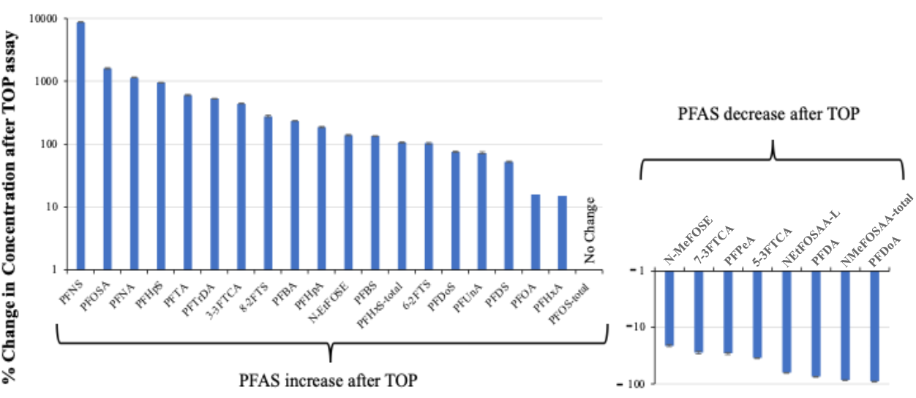
Figure SI-1. Average changes for each PFAS after the TOP assay. Error bar represents SD.
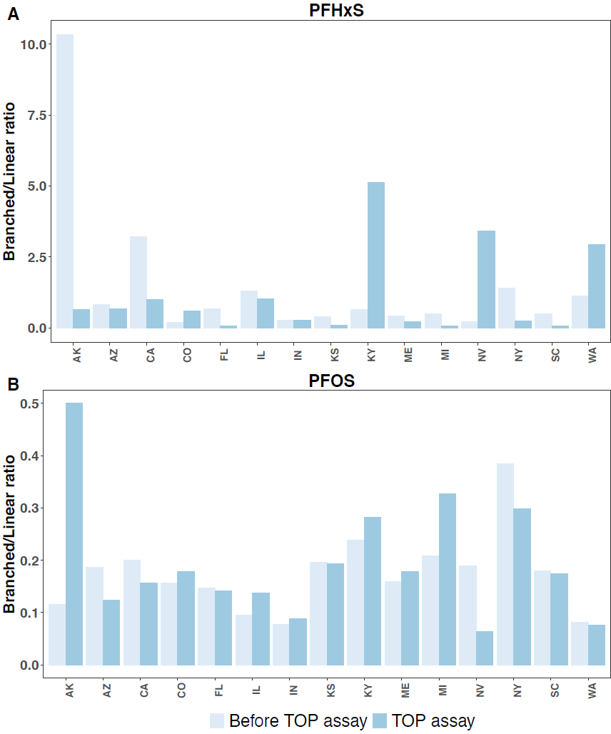
Figure SI-2. PFHxS and PFOS branched/linear ratios before and after the TOP assay shown by state.
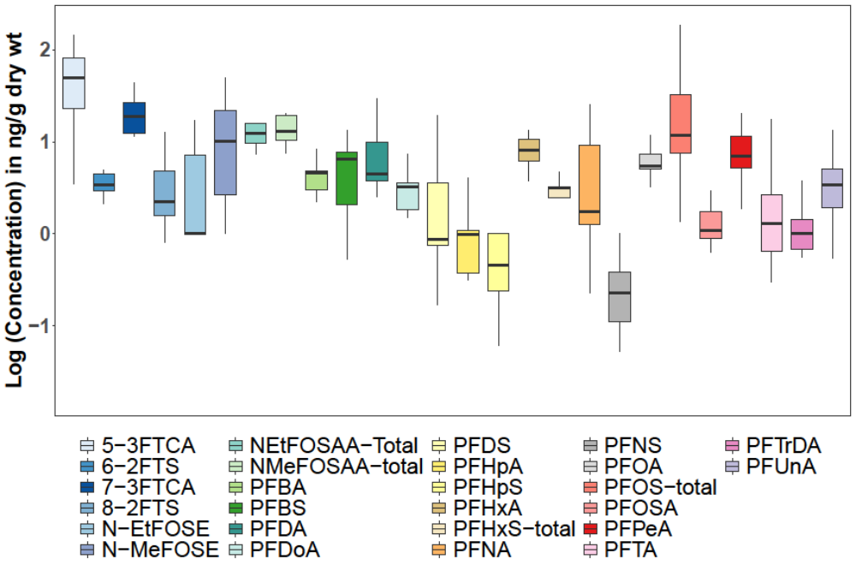
Figure SI-3. Variance in PFAS concentrations measured in nine biosolids samples collected from different locations across California.

References:

Armstrong DL, Lozano N, Rice CP, Ramirez M, Torrents A (2016) Temporal trends of perfluoroalkyl substances in limed biosolids from a large municipal water resource recovery facility. Journal of Environmental Management 165:88–95. https://doi.org/10.1016/j.jenvman.2015.09.023
Caniglia J, Snow DD, Messer T, Bartelt-Hunt S (2022) Extraction, analysis, and occurrence of per- and polyfluoroalkyl substances (PFAS) in wastewater and after municipal biosolids land application to determine agricultural loading. Front Water 4. https://doi.org/10.3389/frwa.2022.892451
Dorin Bogdan, Christopher Curran (2021) Evaluation of PFAS in wastewater treatment plants (WWTPs) across the United States. AECOM
Johnson GR (2022) PFAS in soil and groundwater following historical land application of biosolids. Water Research 211:118035. https://doi.org/10.1016/j.watres.2021.118035
Kim Lazcano R, de Perre C, Mashtare ML, Lee LS (2019) Per- and polyfluoroalkyl substances in commercially available biosolid-based products: The effect of treatment processes. Water Environment Research 91:1669–1677
Link GW, Reeves DM, Cassidy DP, Coffin ES (2024) Per- and polyfluoroalkyl substances (PFAS) in final treated solids (Biosolids) from 190 Michigan wastewater treatment plants. J Hazard Mater 463:132734. https://doi.org/10.1016/j.jhazmat.2023.132734
Loganathan BG, Sajwan KS, Sinclair E, Senthil Kumar K, Kannan K (2007) Perfluoroalkyl sulfonates and perfluorocarboxylates in two wastewater treatment facilities in Kentucky and Georgia. Water Research 41(20):4611–4620. https://doi.org/10.1016/j.watres.2007.06.045
Oza S, Bell KY, Xu Z, Wang Y, Wells MJM, Norton Jr. JW, Winchell LJ, Huang Q, Li H (2025) Surveillance of PFAS in sludge and biosolids at 12 water resource recovery facilities. Journal of Environmental Quality 54(1):6–19. https://doi.org/10.1002/jeq2.20595
Pepper IL, Brusseau ML, Prevatt FJ, Escobar BA (2021) Incidence of Pfas in soil following long-term application of class B biosolids. Science of The Total Environment 793:148449. https://doi.org/10.1016/j.scitotenv.2021.148449
Rahman A, Grieco S, Bahman B, Friedenthal A, White A, Williams T (2025) Understanding dynamics of PFAS in biosolids processed through composting, thermal drying and high temperature pyrolysis. Journal of Water Process Engineering 72:107508. https://doi.org/10.1016/j.jwpe.2025.107508
Schaefer CE, Hooper J, Modiri-Gharehveran M, Drennan DM, Beecher N, Lee L (2022) Release of poly- and perfluoroalkyl substances from finished biosolids in soil mesocosms. Water Res 217:118405. https://doi.org/10.1016/j.watres.2022.118405
Schultz MM, Higgins CP, Huset CA, Luthy RG, Barofsky DF, Field JA (2006) Fluorochemical Mass Flows in a Municipal Wastewater Treatment Facility. Environ Sci Technol 40(23):7350–7357. https://doi.org/10.1021/es061025m
Sepulvado JG, Blaine AC, Hundal LS, Higgins CP (2011) Occurrence and fate of perfluorochemicals in soil following the land application of municipal biosolids. Environ Sci Technol 45(19):8106–8112. https://doi.org/10.1021/es103903d
Sinclair E, Kannan K (2006) Mass Loading and Fate of Perfluoroalkyl Surfactants in Wastewater Treatment Plants. Environ Sci Technol 40(5):1408–1414. https://doi.org/10.1021/es051798v
Tavasoli E (2020) Distribution and Fate of Per- and Polyfluorinated Alkyl Substances (PFAS) in Wastewater Treatment Plants Discharging to Great Bay. Master’s Theses and Capstones
Thompson JT, Robey NM, Tolaymat TM, Bowden JA, Solo-Gabriele HM, Townsend TG (2023) Underestimation of Per- and Polyfluoroalkyl Substances in Biosolids: Precursor Transformation During Conventional Treatment. Environmental Science and Technology 57:3825–3832
Venkatesan AK, Halden RU (2013) National inventory of perfluoroalkyl substances in archived U.S. biosolids from the 2001 EPA National Sewage Sludge Survey. J Hazard Mater 0:413–418. https://doi.org/10.1016/j.jhazmat.2013.03.016
(2020) Initiatives to Evaluate the Presence of PFAS in Municipal Wastewater and Associated Residuals (Sludge/Biosolids) in Michigan. https://www.michigan.gov/-/media/Project/Websites/egle/Documents/Programs/WRD/IPP/pfas-initiatives-wastewater-sludge.pdf?rev=2f47b34f32804b349dcf219fec460ec5. Accessed 6 Oct 2025

