Supplementary data for
Synthesis of Metal Organic Framework-based Hydrogel for Microplastics Removal from Aquatic Environments
Thi Trang Luu^{1,2}, Shudi Mao¹, Dai Quyet Truong¹, Yihan Shi¹, Thi Ngoc Oanh Duon¹, Qiang Fu¹, Van Manh Do³, Saravanamuthu Vigneswaran¹, Tien Vinh Nguyen¹*
¹Faculty of Engineering and IT, University of Technology Sydney (UTS), Sydney, NSW 2007, Australia
²Faculty of Urban Infrastructure and Environment Engineering, Hanoi Architectural University, Hanoi, 100000, Vietnam
³Institute of Science and Technology for Energy and Environment, Vietnam Academy of Science and Technology (VAST), Hanoi, 100000, Vietnam
*Correspondence: tien.nguyen@uts.edu.au

Table
Table S1 Quantitative comparison of the most intense diffraction peak of ZIF-8.1 and ZIF-8.2.
Sample | Peak position (2Ɵ/ º) | Peak intensity (a.u.) | FWHM (º)
ZIF-8.1 | 17.66 | 18.38 | 0.18
ZIF-8.2 | 12.66 | 12.73 | 0.42

Table S2 Cost estimation for the lab-scale filtration column (Filtration rate: 1.7 m h⁻¹; Each hydrogel filter: used for 6 cycles, 4 hours/cycle before being replaced; Total volume of filtrated water/year:10.5 m³)
(1) Chemical cost for 40g product (1 year operation) | Price (AUD) |  | (2) Energy consumption for material fabrication (0.35AUD/kWh) |  | Price (AUD)
ZIF preparation | 0.80 |  | ZIF preparation |  | 0.01
10 wt% PVA solution | 0.66 |  | 10 wt% PVA solution |  | 0.01
PEGDA | 0.31 |  | Hydrogel mixture |  | 0.01
LAP | 0.01 |  | UV irradiation (for 365 pieces) |  | 1.28
Total (1) | 1.78 |  | Total (2) | 1.31
Treatment cost/annual: (1) + (2): 3.09 AUD
Treatment cost/m³ treated water: 0.3 AUD

Figure
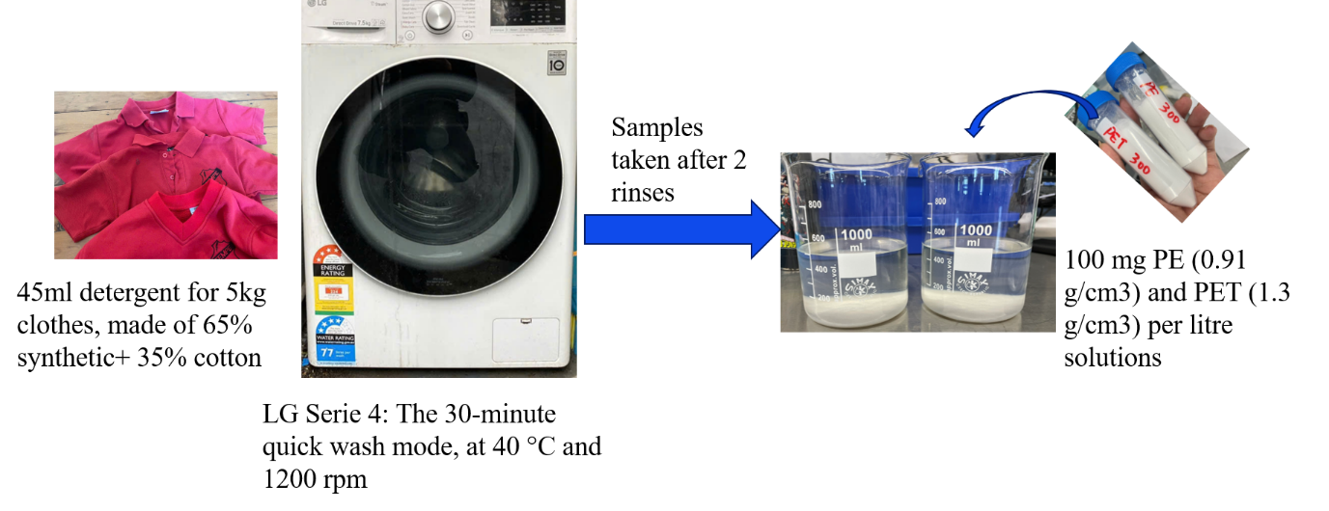
Fig. S1. Preparing the laundry wastewater with high strength MPs
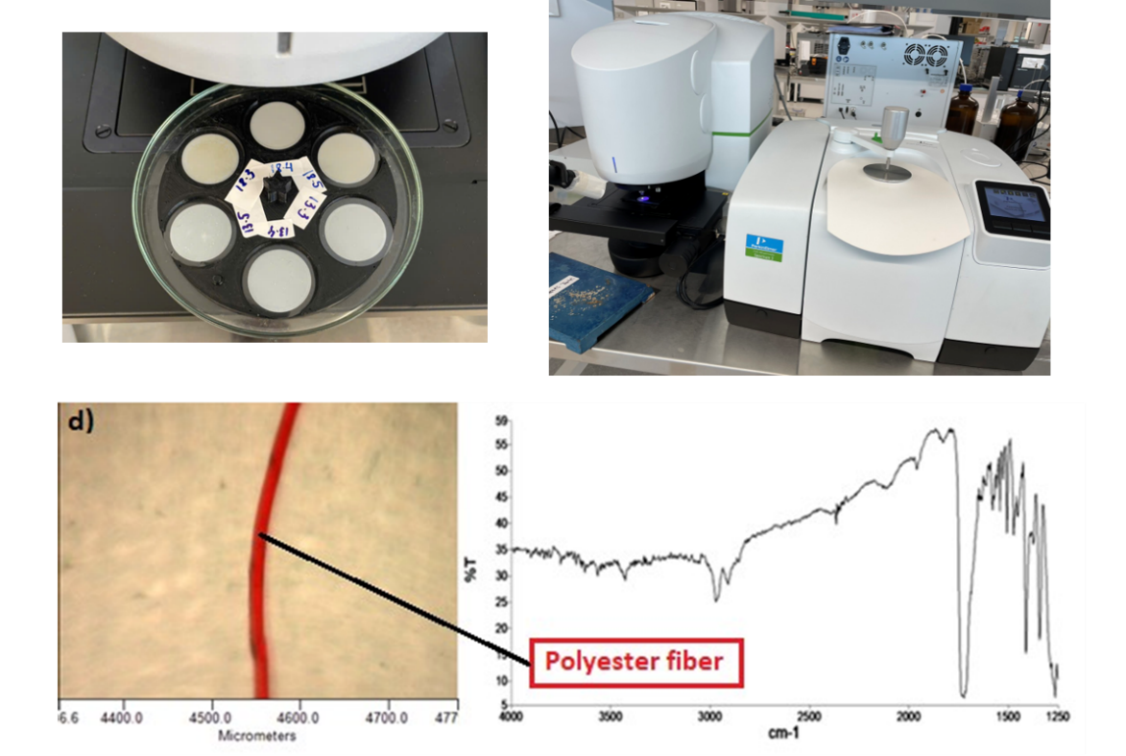
Fig. S2. Microplastics analysis using the PerkinElmer Spectrum 3 FTIR spectrometer equipped with a Spotlight 200i microscope (PerkinElmer, USA) ng
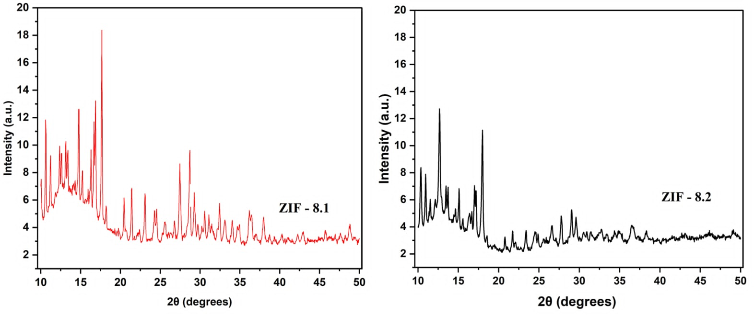

Fig. S3. XRD patterns of (a) ZIF-8.1 and (b) ZIF-8.2 synthesized under different HMIM:Zn molar ratios. The original diffraction patterns are presented separately for clarity, while the overlaid comparison is shown in Figure 1 of the main manuscript.

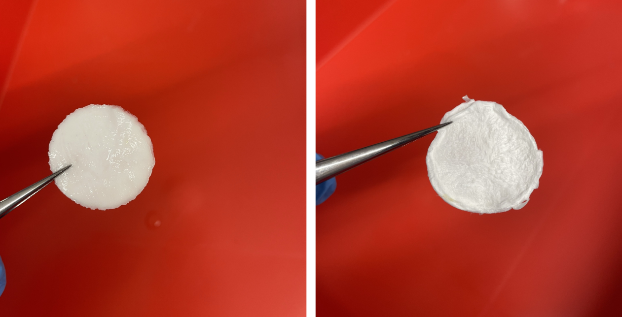
Fig. S4. Photographs of the ZIF-based hydrogel before and after freeze-drying. The freeze-dried material can be stored under ambient conditions without special preservation
.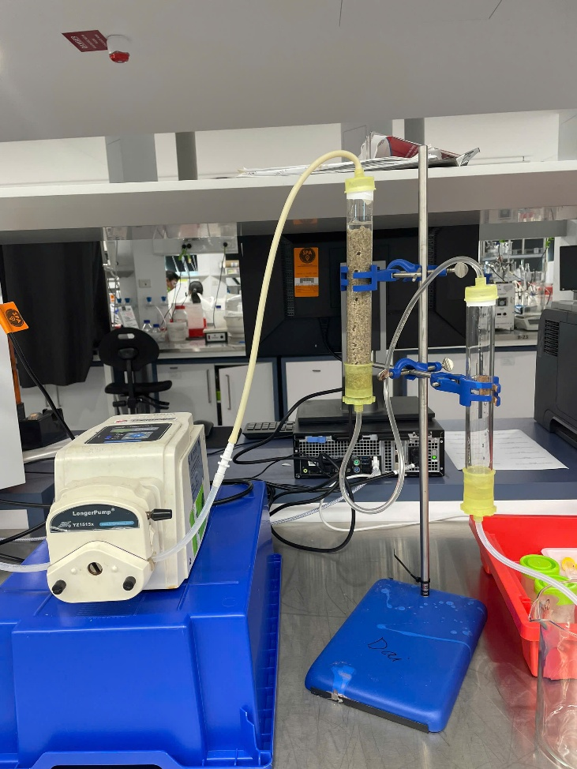
Fig. S5. Photograph of the laboratory-scale fixed-bed column setup employed to evaluate the microplastic removal performance of the ZIF-8/hydrogel composite under continuous-flow condition

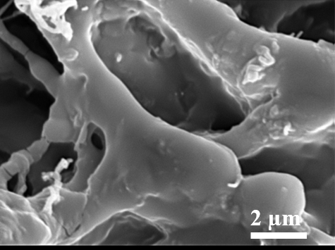
Fig. S6. SEM-EDS elemental mapping of ZIF-8.1@H6mg hydrogel composite, illustrating the spatial distribution of the primary elements carbon (C), oxygen (O), and zinc (Zn) within the material.

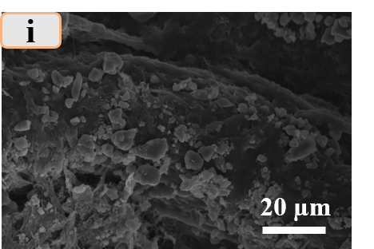
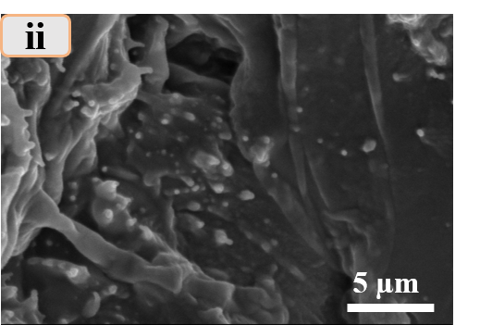

Fig. S7(i). SEM image of the ZIF-8.1@H6mg sample after the sixth filtration cycle, showing retained nanoscale microplastic particles on the hydrogel surface.

(ii). SEM image of ZIF-8.1@H6mg after the sixth filtration cycle and regeneration, showing the persistence of ZIF-8 nanocrystals on the hydrogel surface.

