Supplemental Data for: Brookes & Jimenez, “Metabolomics of aging
in primary fibroblasts from small and large breed dogs”

1 Table
2 Figures

Breed | Pure breed/Mix | Age | Size class | Age class
Alaskan Malamute mix | Mix | 15 y/o | Large | Old
Boxer | Pure breed | 13.5 y/o | Large | Old
Boxer/Shepherd | Mix | 13 y/o | Large | Old
Golden retriever | Pure breed | 11 and 13 y/o | Large | Old
Labrador mix | Mix | 14 y/o | Large | Old
Pitbull | Pure breed | 15 y/o | Large | Old
Australian Shepherd | Pure breed | 13 and 15.5 y/o | Large | Old
Rottweiler/Shepherd | Mix | 10 y/o | Large | Old
Siberian Husky | Pure breed | 6 and 11 y/o | Large | Old
Airdale terrier | Pure breed | 5 days old | Large | Young
Australian cattle dog | Pure breed | 3 days old | Large | Young
Doberman | Pure breed | 9 weeks old | Large | Young
German short-haired pointer | Pure breed | 2 days old | Large | Young
German wire-haired pointer | Pure breed | 2 days old | Large | Young
Labradoodle | Pure breed | 3 days old | Large | Young
Old English sheepdog | Pure breed | 3 days old | Large | Young
Rottweiler | Pure breed | 2 days old | Large | Young
Standard poodle | Pure breed | 4 days old | Large | Young
Bichon Frise | Pure breed | 12 y/o | Small | Old
Cocker Spaniel mix | Mix | 14 y/o | Small | Old
Jack Russell Terrier | Pure breed | 14 y/o | Small | Old
Shetland sheepdog | Pure breed | 14, 14, and 12 y/o | Small | Old
Shih Tzu | Pure breed | 14 y/o | Small | Old
Shih Tzu mix | Mix | 13 y/o | Small | Old
Yorkshire terrier | Pure breed | 17 y/o | Small | Old
Cavalier King Charles Spaniel | Pure breed | 4 days old | Small | Young
Corgi | Pure breed | 1 day old | Small | Young
Havenese | Pure breed | 4 days old | Small | Young
Soft coated wheaten terrier | Pure breed | 3 days old | Small | Young
Toy poodle | Pure breed | 3 days old | Small | Young
Yorkshire terrier | Pure breed | 3 days old | Small | Young

Table 1. Information about breeds, ages, size and age classes, and sample sizes for dogs included in this study.

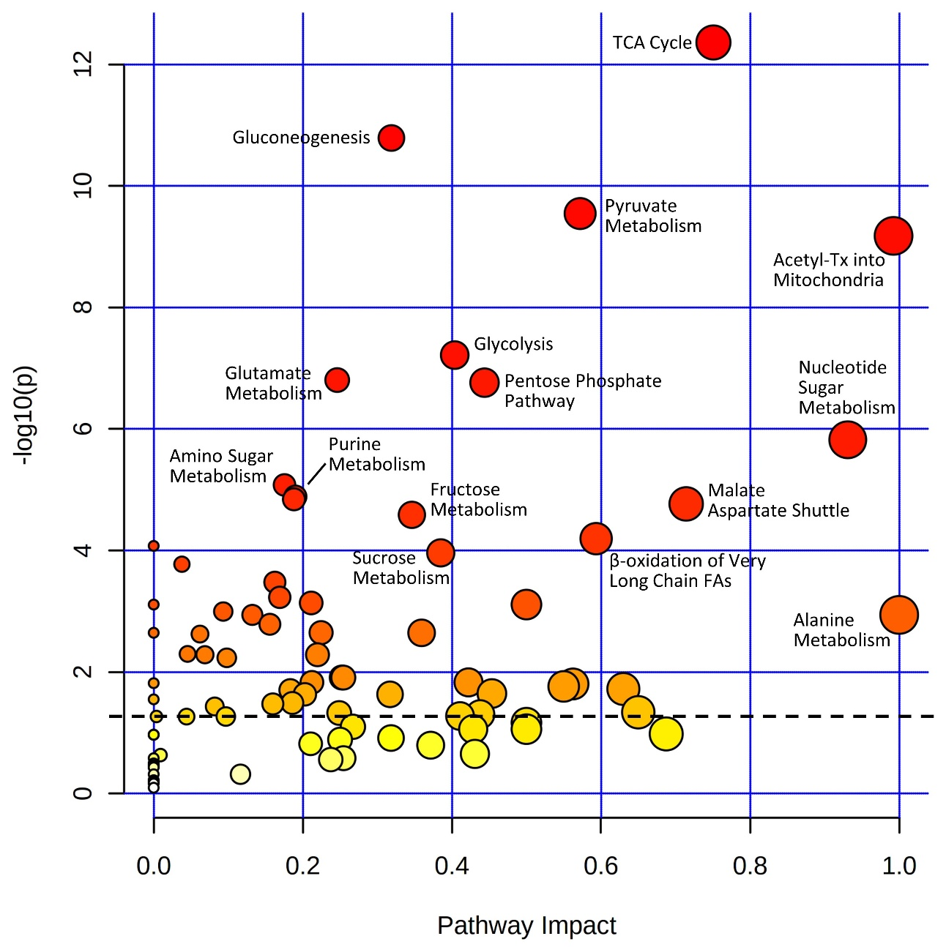
Supplemental Figure 1. Pathway analysis for the metabolomic data set. Pathway Analysis was prepared using free web-based Metaboanalyst software. Y-axis shows -Log₁₀ of p-values from the pathway enrichment analysis (Log10 of p=0.05 is 1.3, so pathways above the dashed line were considered to be significantly enriched in the analysis). X-axis shows pathway impact values from pathway topology analysis, indicating the degree of contiguous coverage within a pathway.

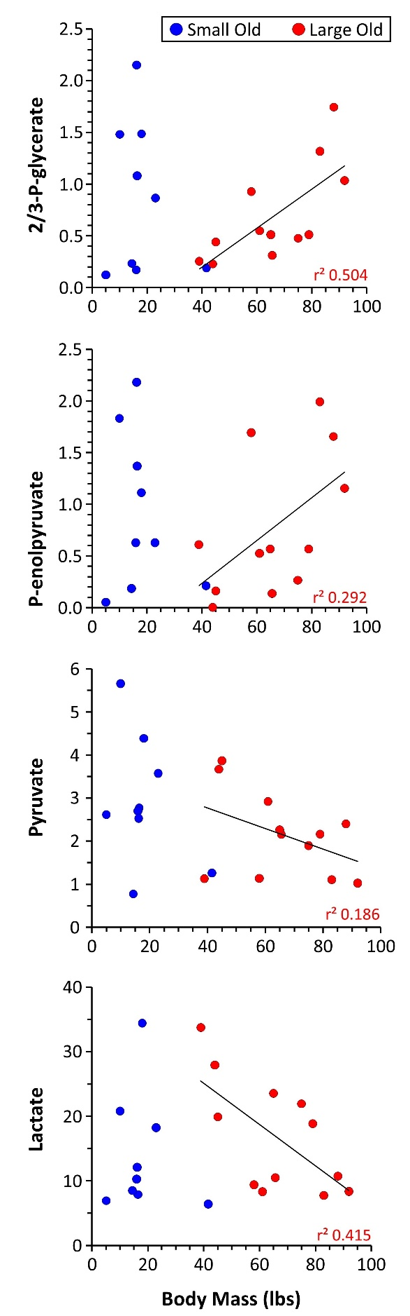

Supplementary Figure 2. Correlation of metabolites with body mass in old dogs. Correlations are shown between body mass and relative abundance (arbitrary units) of four glycolytic metabolites, in small and large old dogs. Due to insufficient variation in body mass, correlations were not calculable in young dogs of either breed size. Linear fit trendline and square of Pearson product moment correlation coefficient (r²) for the large old dog data set are shown on each graph.

