Supplementary Information

Supplementary Figure 1
A Spearman correlation between number of SA-β-Gal + cells and BMI (i) (r=0.020; p=0.938), HOMA-index (ii) (r=0.192, p=0.460) and Fasting insulin (iii) (r=0.211; p=0.417) in scWAT. Data are expressed as mean ± SD, *p≤0.05; **p≤0.01; ***p≤0.001. (JPG 181 KB)

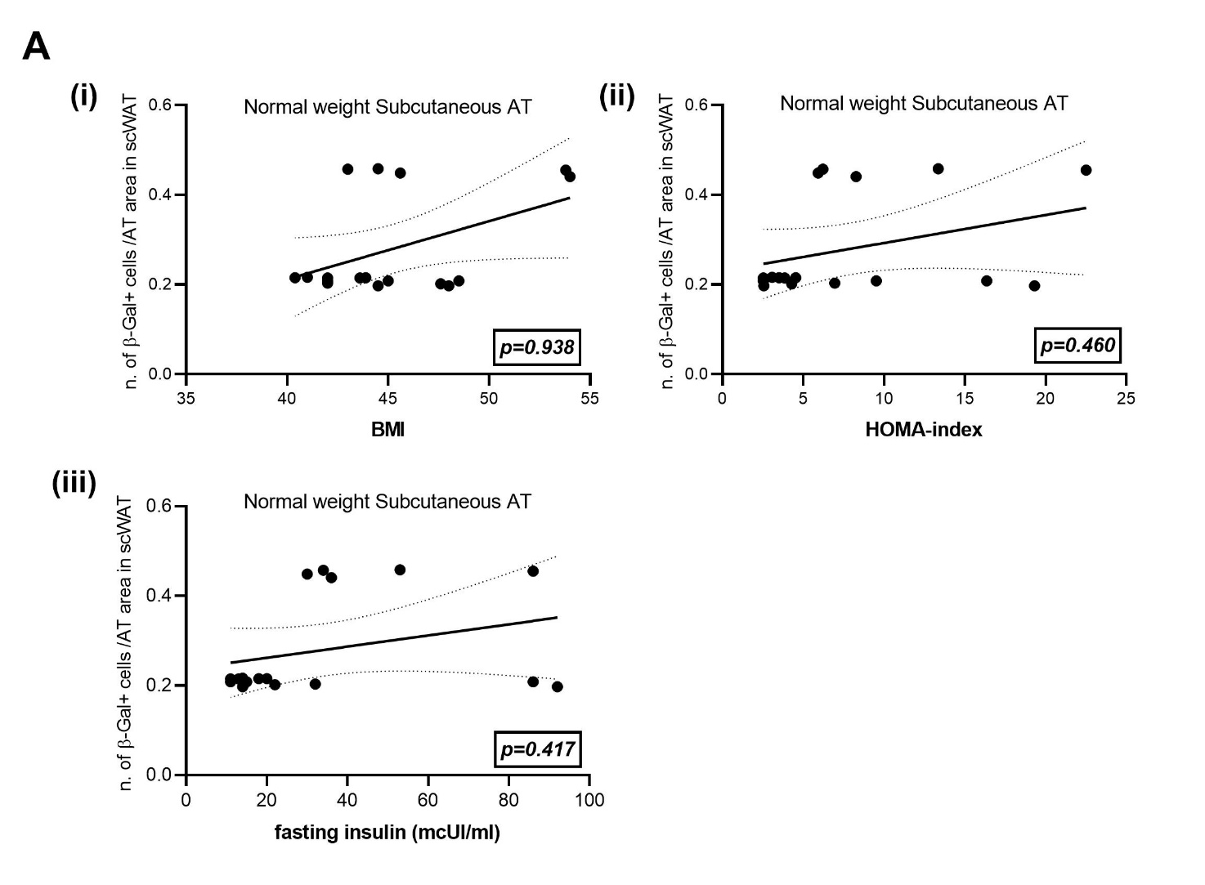

Supplementary Figure 2
Senescent macrophages in obese adipose tissue. Representative microscopy picture of a crown-like structure (CLS) in vWAT of obese subjects showing double positive (SA-β-Gal+/p16 +) cells (arrows). Bar =10 μm; Bar inset =5 μm.

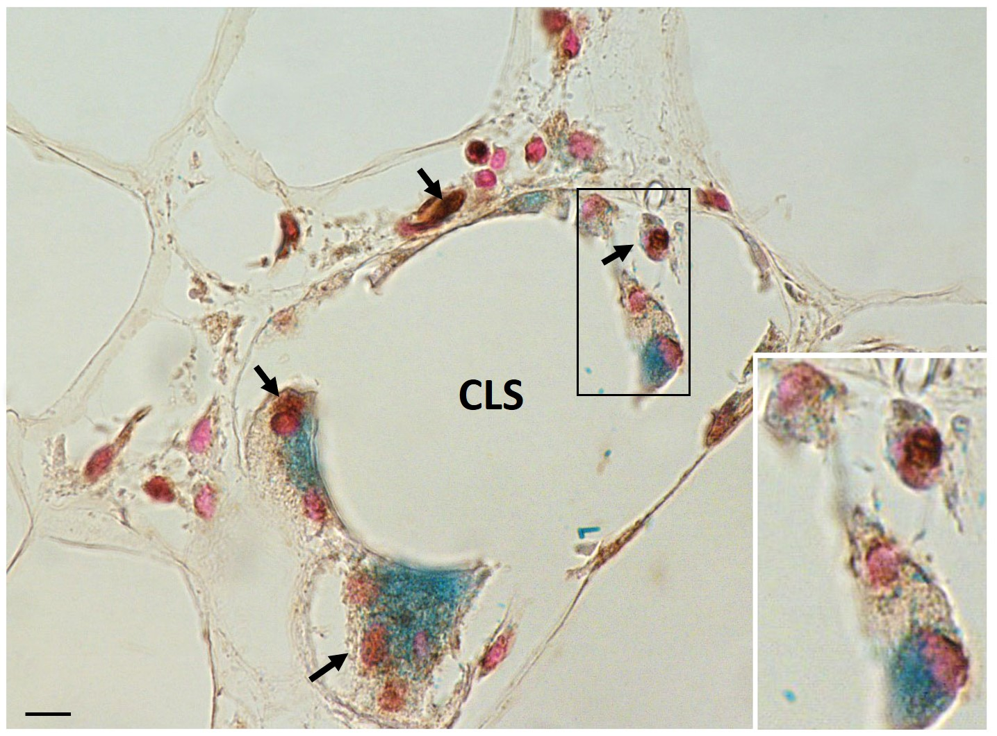

Supplementary Figure 3
A Representative pictures from Oil Red O-stained confluent hMADS cells (day 0, upper panel) and full differentiated adipocytes (day 13, bottom panel). B Transwell system for the co-culture experiment (THP-1 cells in the insert above; hMADS cells in the lower chamber). C qRT-PCR analysis of SIRT1 and NF-kB expression in hMADS adipocytes co-cultured with macrophages. Representative immunoblot and quantification of SIRT1 D and pJNK E in hMADS adipocytes co-cultured with macrophages. Data are expressed as mean ± SEM, *p≤0.05; **p≤0.01; ***p≤0.001; #p≤0.05; ##p≤0.01; ##p≤0.001. *vs M0; #vs hMADS.

