Supplementary figures
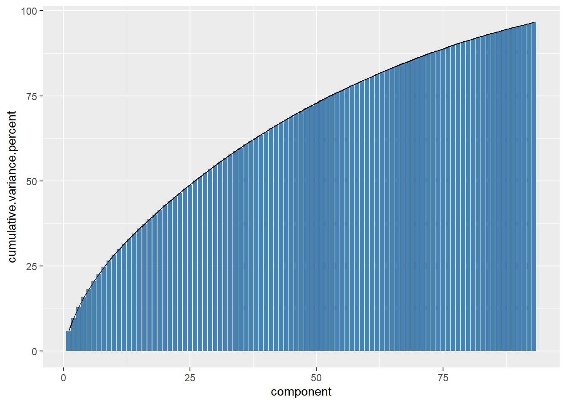
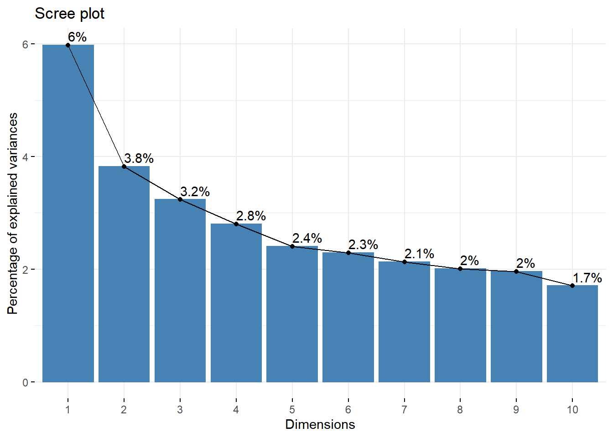

Supplementary Fig. 1 Cumulative explained variance and scree plot of factor analysis of mixed data (FAMD) principal components. Top row shows the cumulative explained variance of 93 principal components (PCs) from factor analysis of mixed data (FAMD) on 93 health deficit variables selected according to a standard procedure. Bottom row shows percentage of explained variance from the first 10 PCs (i.e., "Dimensions")

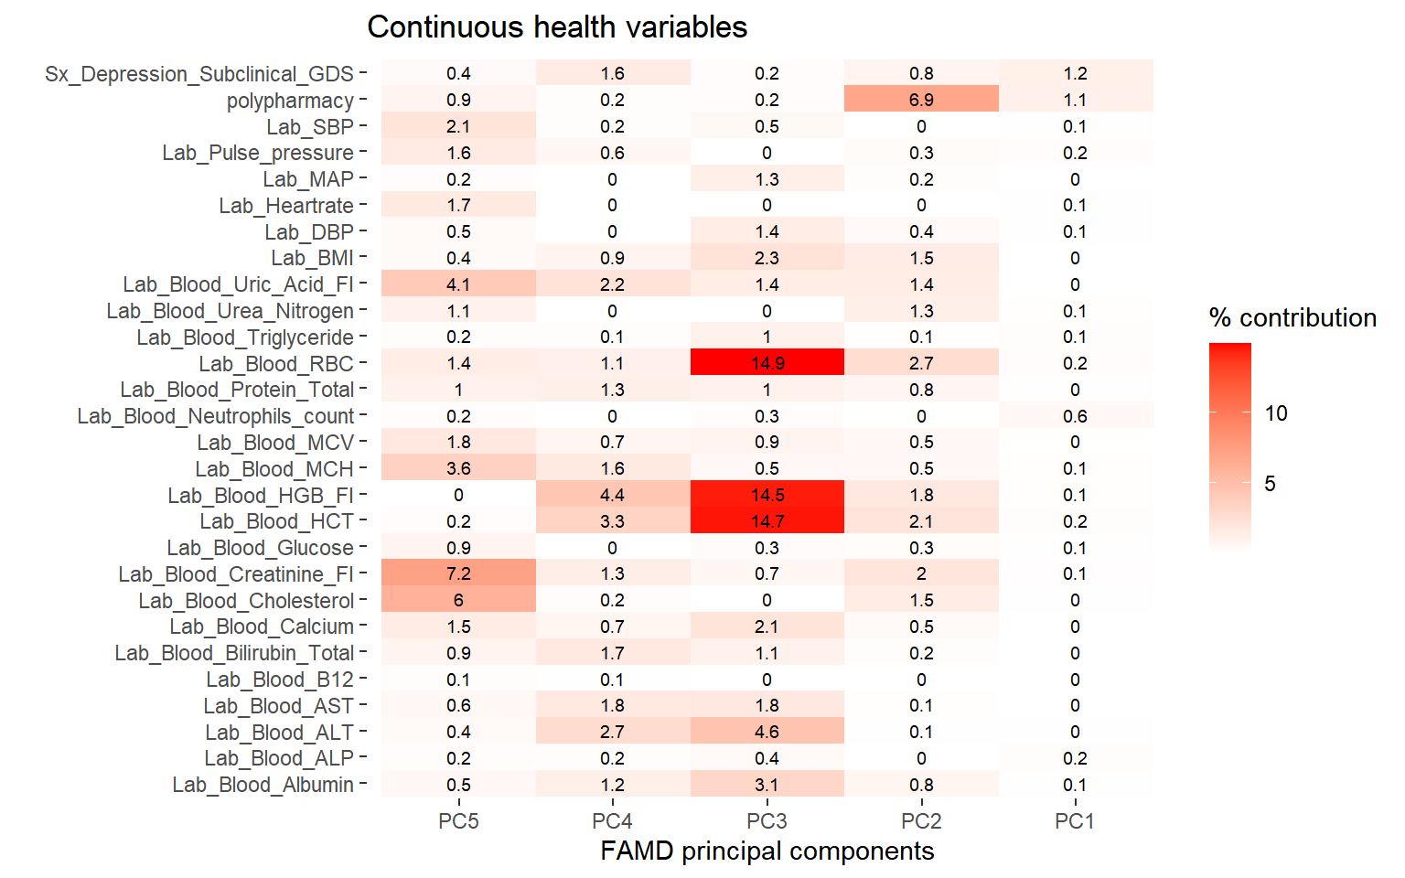Supplementary Fig. 2 Contribution of continuous health deficit variables to principal components 1 to 5. The figure shows the contribution of continuous health deficit variables to the first five principal components resulting from factor analysis of mixed data (FAMD) on 93 health deficit variables selected according to a standard procedure [1]

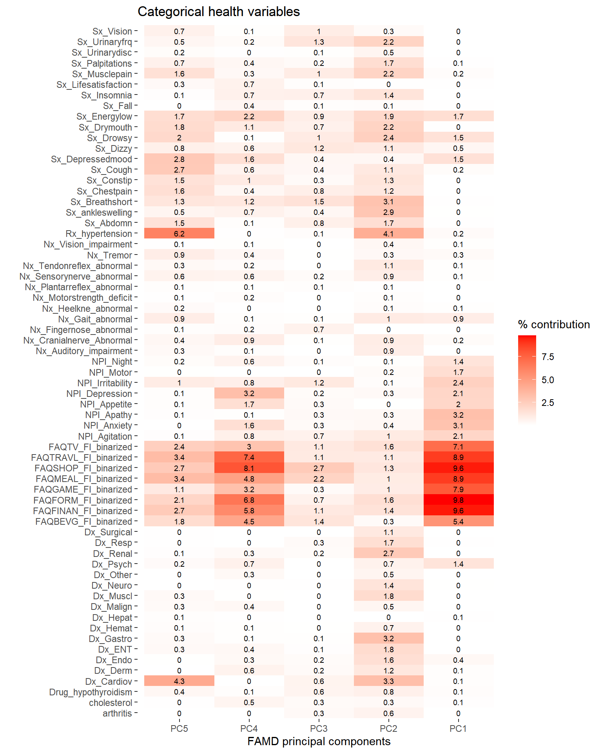
Supplementary Fig. 3 Contribution of categorical health deficit variables to principal components 1 to 5 resulting from factor analysis of mixed data (FAMD) on 93 health deficit variables selected according to a standard procedure [1]
Supplementary Fig. 4 Kaplan Meier curves illustrate survival probability during follow-up in sample tertiles for three different frailty indices (FI_{s}, FI_{r}, FI_{c}) for development (ADNI1) and validation cohorts (ADNI2+GO). FI_{s} = A 93-item FI created according to standard procedure by the authors. FI_{r} = A 26-item FI created by adding a data-driven supplement to the standard procedure. FI_{c} = A 40-item FI created according to standard procedure [1] by Canevelli, et al., [2]
Supplementary Fig. 5 Scatterplots with locally weighted smoothing lines illustrating the relationship between age and three different frailty indices (FI) in ADNI Development (ADNI1) and Validation samples (ADNI2+GO). r-values represent the Pearson correlation coefficient

Supplementary Fig. 6 The figure shows area under the time-dependent ROC-curves for prediction of future dementia conversion in subjects with mild cognitive impairment at baseline for three frailty indices (FIs). Mean AUC = solid line, 95% confidence interval and bands = dotted lines, bands are the outermost. FI_{s} = A 93-item frailty index (FI) created according to standard procedure by the authors. FI_{r} = A 26-item FI created by adding a data-driven supplement to the standard procedure. FI_{c} = A 40-item FI created according to standard procedure by Canevelli, et al., [2]. Plots are shown for both development (ADNI1) and validation (ADNI2 and ADNI GO) samples

Supplementary Fig. 7 The figure shows differences (mean = solid line, 95% confidence interval and bands = dotted lines, bands are the outermost) in AUC(t) between a data-driven frailty index (FI_{r}) and two FIs generated according to standard procedure (FI_{s},FI_{c}) for prediction of future dementia conversion in subjects with mild cognitive impairment at baseline. Plots are shown for development (ADNI1) and validation (ADNI2 and ADNI GO) samples and confirm greater AUC(t) for the data-driven FI_{r} over time compared with standard FIs

Supplementary tables
Supplementary Table 1: Categorical health deficit variables and thresholds used for dichotomization of deficits
 | Coded as
Categorical health deficit variables | 0 | 0.25 | 0.5 | 1
On medication for arthritis | No |  |  | Yes
On medication for elevated cholesterol | No |  |  | Yes
On medication for hypertension | No |  |  | Yes
On medication for hypothyroidism | No |  |  | Yes
History of cardiovascular disease | No |  |  | Yes
History of dermatologic-connective tissue disease | No |  |  | Yes
History of endocrine-metabolic disease | No |  |  | Yes
History of head, eyes, ears, nose, and throat diseases | No |  |  | Yes
History of gastrointestinal disease | No |  |  | Yes
History of hematopoietic-lymphatic disease | No |  |  | Yes
History of hepatic disease | No |  |  | Yes
History of malignancies | No |  |  | Yes
History of musculoskeletal disease | No |  |  | Yes
History of neurological (non-AD) disease | No |  |  | Yes
History of psychiatric disease | No |  |  | Yes
History of renal-genitourinary disease | No |  |  | Yes
History of respiratory disease | No |  |  | Yes
History of major surgical procedures | No |  |  | Yes
History of other diseases | No |  |  | Yes
FAQ, Writing checks, paying bills, or balancing checkbook | Independent /normal functioning (0) | Has difficulty, but does by self (1) | Requires assistance (2) | Dependent (3)
FAQ, Assembling tax records, business affairs, or other papers | Independent /normal functioning (0) | Has difficulty, but does by self (1) | Requires assistance (2) | Dependent (3)
FAQ, Heating water, making a cup of coffee | Independent /normal functioning (0) | Has difficulty, but does by self (1) | Requires assistance (2) | Dependent (3)
FAQ, Traveling out of the neighborhood) | Independent /normal functioning (0) | Has difficulty, but does by self (1) | Requires assistance (2) | Dependent (3)
FAQ, Preparing a balanced meal | Independent /normal functioning (0) | Has difficulty, but does by self (1) | Requires assistance (2) | Dependent (3)
FAQ, Paying attention to and understanding a TV program, book, or magazine | Independent /normal functioning (0) | Has difficulty, but does by self (1) | Requires assistance (2) | Dependent (3)
FAQ, Playing a game of skill such as bridge or chess | Independent /normal functioning (0) | Has difficulty, but does by self (1) | Requires assistance (2) | Dependent (3)
FAQ, Shopping alone for clothes, household | Independent /normal functioning (0) | Has difficulty, but does by self (1) | Requires assistance (2) | Dependent (3)
NPI, Agitation | No |  |  | Yes
NPI, Anxiety | No |  |  | Yes
NPI, Depression | No |  |  | Yes
NPI, Irritability | No |  |  | Yes
NPI, Sleep disturbance | No |  |  | Yes
NPI, Apathy | No |  |  | Yes
NPI, Aberrant motor behavior | No |  |  | Yes
NPI, Change in appetite or eating | No |  |  | Yes
Auditory impairment on physical exam | Absent |  |  | Present
Cranial nerve abnormality on physical exam | Normal |  |  | Abnormal
Finger to nose test | Normal |  |  | Abnormal
Heel-knee test | Normal |  |  | Abnormal
Gait on physical exam | Normal |  |  | Abnormal
Motor strength deficit on physical exam | Normal |  |  | Abnormal
Plantar reflex on physical exam | Normal |  |  | Abnormal
Tendon reflex test | Normal |  |  | Abnormal
Sensory nerve abnormality on physical exam | Normal |  |  | Abnormal
Tremor on physical exam | Absent |  |  | Present
Vision impairment on physical exam | Absent |  |  | Present
Symptoms from abdomen | Absent |  |  | Present
Self-reported ankle swelling | Absent |  |  | Present
Self-reported shortness of breath | Absent |  |  | Present
Self-reported chest pain | Absent |  |  | Present
Self-reported constipation | Absent |  |  | Present
Self-reported cough | Absent |  |  | Present
Self-reported depressed mood | Absent |  |  | Present
Self-reported dizziness | Absent |  |  | Present
Self-reported drowsiness | Absent |  |  | Present
Self-reported dry mouth | Absent |  |  | Present
Self-reported low energy | Absent |  |  | Present
Self-reported recent fall | Absent |  |  | Present
Self-reported insomnia | Absent |  |  | Present
Self-reported life satisfaction | Yes |  |  | No
Self-reported muscle pain | Absent |  |  | Present
Self-reported palpitations | Absent |  |  | Present
Self-reported urinary discomfort | Absent |  |  | Present
Self-reported urinary frequency | Absent |  |  | Present
Self-reported vision disturbance | Absent |  |  | Present
Categorical Health deficit variables. FAQ = Functional Assessment Questionnaire. NPI = Neuropsychiatric Inventory.

Supplementary Table 2: Quantitative health deficit variables and thresholds used for dichotomization of deficits
Health variable (quantitative) | Lower threshold | Upper threshold
Blood Albumin (g/dL) | Male (age < 69) = 3.3  Male (age 69 to 80) = 3.3  Male (age > 80) = 3.0  Female (age < 69) = 3.3  Female (age 69 to 80) = 3.3  Female (age > 80) = 3.0 | Male (age < 69) = 4.9  Male (age 69 to 80) = 4.6  Male (age > 80) = 4.6  Female (age < 69) = 4.9  Female (age 69 to 80) = 4.6  Female (age > 80) = 4.6
Blood Alkaline Phosphatase (ALP; U/L) | Any sex, any age = 35 | Male (age 50 to 60) = 131  Male (age 60 to 70) = 125  Male (age 70 to 80) = 130  Male (age > 80) = 125  Female (age 50 to 70) = 123  Female (age 70 to 90) = 135  Female (age > 90) = 140
Blood Alanine Aminotransferase (ALT; U/L) | Any sex, any age = 6 | Male (age < 69) = 43  Male (age ≥ 69 = 35  Female (age < 69) = 34  Female (age ≥ 69) = 32
Blood Aspartate aminotransferase (AST; U/L) | Male (any age) = 11  Female (any age) = 9 | Male (any age) = 36, Female (any age) = 34
Blood Vitamin B12 (pg/mL) | Any sex, any age = 180 | Any sex, any age = 914
Blood Total bilirubin (mg/dL) | Any sex, any age = 0.2 | Any sex, any age = 1.2
Blood Calcium (mg/dL) | Any sex, any age = 8.3 | Any sex, any age = 10.6
Blood Cholesterol (mg/dL) | Male (age < 60) = 170  Male (age 60 to 70) = 175  Male (age > 70) = 177  Female (age < 60) = 171  Female (age 60 to 70) = 188  Female (age > 70) = 207 | Male (age < 60) = 291  Male (age 60 to 70) = 298  Male (age > 70) = 300  Female (age < 60) = 291  Female (age 60 to 70) = 320  Female (age > 70) = 352
Blood Creatinine (mg/dL) | Male (any age) = 0.5  Female (any age) = 0.4 | Male (age 50 to 70) = 1.3  Male (age 70 to 80) = 1.5  Male (age > 80) = 1.6  Female (age 50 to 70) = 1.1  Female (age 70 to 80) = 1.2  Female (age > 80) = 1.4
Blood Glucose (mg/dL) | Any sex, any age = 70 | Any sex (age < 60) = 115  Any sex (age > 59) = 120
Blood Hematocrit (%) | Male (age < 60) = 39  Male (age > 59) = 37  Femal (any age) = 34 | Male (age < 60) = 54  Male (age > 59) = 51  Femal (any age) = 48
Blood Hemoglobin (g/dL) | Male (age < 60) = 12.7  Male (age > 59) = 12.5  Female (age < 60) = 11.6  Female (age > 59) = 11.5 | Male (age < 60) = 18.1  Male (age > 59) = 17.0  Female (age < 60) = 16.4  Female (age > 59) = 15.8
Blood Mean corpuscular hemoglobin (MCH; pg) | Any sex, any age = 26 | Any sex, any age = 34
Blood Mean corpuscular volume (MCV; fL) | Any sex (age < 60) = 79  Any sex (age > 59) = 80 | Male (age < 60) = 96  Female (age < 60) = 98  Any sex (age > 59) = 100
Blood Neutrophil count (10³/μl) | Any sex, any age = 1.96 | Any sex, any age = 7.23
Blood Total protein (g/dL) | Any sex (age < 60) = 6.1  Any sex (age > 59) = 6.0 | Any sex (age < 60) = 8.4  Any sex (age > 59) = 8.0
Blood Red Blood Cell Count (RBC; 10⁶/μl) | Male (age < 60) = 4.5  Male (age > 59) = 4.0  Female (age < 60) = 4.1  Female (age > 59) = 3.9 | Male (age < 60) = 6.4  Male (age > 59) = 5.8  Female (age < 60) = 5.6  Female (age > 59) = 5.5
Blood Triglycerides (mg/dL) | Male (any age) = 58  Female (age < 60) = 52  Female (age > 59) = 56 | Male (age < 60) = 320  Male (age > 59) = 260  Female (age < 60) = 262  Female (age > 59) = 240  Female (age < 60) =  Female (age > 59) =
Blood Urea nitrogen (BUN, mg/dL) | Any sex, any age = 4 | Any sex (age < 70) = 24  Any sex (age 70 to 80) = 29  Any sex (age > 80) = 34
Blood Uric acid (mg/dL) | Any sex, any age = 2.5 | Male (any age) = 8.3 Female (any age) = 7.5
Body mass index (BMI) | 18.5 | 30
Diastolic blood pressure (mmHg) | 60 | 89
Heart rate (count) | 60 | 99
Mean arterial pressure (mmHg) | 70 | 105
Pulse pressure (mmHg) | 30 | 65
Systolic blood pressure (mmHg) | 90 | 139
Number of medications (polypharmacy)* | No lower threshold | 5
Elevated Geriatric Depression Scale (GDS) score** | No lower threshold | 0
Quantitative health deficit variables that were dichotomized (0 and 1). The dichotomized variable was coded as “0” if the health deficit variable value was within threshold values, and “1” if outside. For blood test results, we used the age- and gender-specific (if applicable) reference ranges reported by the ADNI laboratory. * Number self-reported medications excluding supplements: More than 5 medications were considered polypharmacy. **In ADNI, a GDS-score threshold of 6 was used as an exclusion-criterium to rule out participants with clinical depression; here, we considered scores from 1 to 6 as subclinical depression and scored these as a deficit if present.

Supplementary Table 3: Binary classification in the development sample with class imbalance correction by undersampling
Classification / Performance measure | FI-variable
HC vs. AD | FI_{s} | FI_{r} | FI_{c}
Area under the curve | 0.75 (0.00) | 0.95 (0.00) | 0.81 (0.00)
Sensitivity | 0.71 (0.01) | 0.94 (0.00) | 0.75 (0.01)
Specificity | 0.67 (0.00) | 0.77 (0.00) | 0.70 (0.00)
PPV | 0.68 (0.00) | 0.81 (0.00) | 0.72 (0.00)
NPV | 0.70 (0.01) | 0.93 (0.00) | 0.74 (0.01)
F1-score | 0.69 (0.00) | 0.87 (0.00) | 0.73 (0.00)
MCI vs. AD | FI_{s} | FI_{r} | FI_{c}
Area under the curve | 0.68 (0.00) | 0.81 (0.00) | 0.72 (0.00)
Sensitivity | 0.71 (0.00) | 0.79 (0.00) | 0.72 (0.00)
Specificity | 0.62 (0.01) | 0.68 (0.00) | 0.64 (0.00)
PPV | 0.66 (0.01) | 0.72 (0.00) | 0.67 (0.01)
NPV | 0.69 (0.01) | 0.77 (0.01) | 0.70 (0.00)
F1-score | 0.68 (0.00) | 0.75 (0.00) | 0.69 (0.00)
HC vs. MCI | FI_{s} | FI_{r} | FI_{c}
Area under the curve | 0.59 (0.00) | 0.78 (0.00) | 0.61 (0.00)
Sensitivity | 0.60 (0.00) | 0.81 (0.00) | 0.63 (0.00)
Specificity | 0.54 (0.00) | 0.60 (0.00) | 0.52 (0.00)
PPV | 0.57 (0.00) | 0.67 (0.00) | 0.57 (0.00)
NPV | 0.58 (0.00) | 0.76 (0.00) | 0.59 (0.00)
F1-score | 0.58 (0.00) | 0.73 (0.00) | 0.60 (0.00)
The binary classification analyses are corrected for class imbalance by using undersampling of the majority class. AD = Alzheimer’s disease dementia. FI_{s} = A 93-item frailty index (FI) created according to standard procedure by the authors. FI_{r} = A 26-item FI created by adding a data-driven supplement to the standard procedure. FI_{c} = A 40-item FI created according to standard procedure by Canevelli, et al., [2]. HC = Healthy cognitively normal control. MCI = Mild cognitive impairment. NPV = negative predictive value. PPV = positive predictive value. SD = Standard deviation.

Supplementary table 4: Binary classification (HC versus AD) according to age and sex strata for three different FI-variables in the development sample

FI-variable: FI_{s} | Age and sex stratum
Performance measure | Young male | Old male | Young female | Old female
Area under the curve | 0.66 (0.02) | 0.79 (0.01) | 0.75 (0.02) | 0.78 (0.01)
Sensitivity | 0.97 (0.01) | 0.79 (0.01) | 0.83 (0.01) | 0.89 (0.01)
Specificity | 0.10 (0.02) | 0.71 (0.00) | 0.38 (0.02) | 0.42 (0.02)
PPV | 0.59 (0.01) | 0.75 (0.01) | 0.61 (0.01) | 0.67 (0.01)
NPV | 0.71 (0.02)§ | 0.78 (0.02) | 0.68 (0.05) | 0.79 (0.04)
F1-score | 0.73 (0.01) | 0.76 (0.01) | 0.70 (0.01) | 0.76 (0.01)
FI-variable: FI_{r} | Age and sex stratum
Performance measure | Young male | Old male | Young female | Old female
Area under the curve | 0.95 (0.01) | 0.94 (0.01) | 0.96 (0.01) | 0.97 (0.01)
Sensitivity | 0.96 (0.00) | 0.93 (0.00) | 0.90 (0.00) | 0.98 (0.00)
Specificity | 0.67 (0.01) | 0.73 (0.01) | 0.78 (0.02) | 0.82 (0.02)
PPV | 0.81 (0.01) | 0.80 (0.01) | 0.85 (0.01) | 0.89 (0.01)
NPV | 0.95 (0.01) | 0.92 (0.01) | 0.89 (0.01) | 0.98 (0.01)
F1-score | 0.89 (0.00) | 0.85 (0.00) | 0.86 (0.01) | 0.93 (0.01)
FI-variable: FI_{c} | Age and sex stratum
Performance measure | Young male | Old male | Young female | Old female
Area under the curve | 0.77 (0.02) | 0.80 (0.01) | 0.82 (0.02) | 0.85 (0.01)
Sensitivity | 0.90 (0.00) | 0.77 (0.01) | 0.84 (0.00) | 0.93 (0.00)
Specificity | 0.50 (0.02) | 0.66 (0.01) | 0.62 (0.02) | 0.63 (0.01)
PPV | 0.72 (0.01) | 0.71 (0.01) | 0.74 (0.01) | 0.78 (0.01)
NPV | 0.81 (0.03) | 0.75 (0.02) | 0.80 (0.03) | 0.90 (0.02)
F1-score | 0.79 (0.01) | 0.73 (0.01) | 0.78 (0.01) | 0.84 (0.00)
AD = Alzheimer's disease dementia. HC = Healthy cognitively normal control. "Young" designates subjects < 75 years, "Old" >= 75 years. FI_{s} = A 93-item frailty index (FI) created according to standard procedure by the authors. FI_{r} = A 26-item FI created by adding a data-driven supplement to the standard procedure. FI_{c} = A 40-item FI created according to standard procedure by Canevelli, et al., [2]. NPV = negative predictive value. PPV = positive predictive value. SD = Standard deviation. §Error margin is reported as standard error.

 | Sample
 | Development (ADNI1)
FI-variable | Model 1ª |  | Model 2^{b}
 | AHR (95% CI) | p-value | AHR (95% CI) | p-value
FI_{s} | 1.05 (1.02-1.09) | 0.002 | 1.03 (1.00-1.07) | 0.08
FI_{r} | 1.04 (1.02-1.06) | <0.001 | 1.02 (1.01-1.04) | 0.01
FI_{c} | 1.04 (1.02-1.06) | <0.001 | 1.02 (1.00-1.05) | 0.06
 | Validation (ADNI2+GO)
FI-variable | Model 1ª |  | Model 2^{b}
 | AHR (95% CI) | p-value | AHR (95% CI) | p-value
FI_{s} | 1.05 (1.01-1.09) | 0.008 | 1.03 (0.99-1.06) | 0.20
FI_{r} | 1.03 (1.01-1.04) | 0.001 | 1.01 (0.99-1.03) | 0.25
FI_{c} | 1.03 (1.01-1.06) | 0.01 | 1.01 (0.99-1.04) | 0.32
Supplementary table 5: Association between FI-variables and mortality risk

There were 86 deaths (11% of the total sample) during a median follow-up time of 1113 days in the development cohort, and 45 (6% of the total sample) during a median follow-up time of 1477 days in the validation cohort, respectively. Due to non-proportional hazards, we report average hazard ratios (AHRs) instead of standard HRs; AHRs were estimated using Prentice weights with censoring correction and robust variance estimation (see Methods). CI = confidence interval. FI_{s} = A 93-item frailty index (FI) created according to standard procedure by the authors. FI_{r} = A 26-item FI created by adding a data-driven supplement to the standard procedure. FI_{c} = A 40-item FI created according to standard procedure by Canevelli, et al., [2]. *All FI-variables were multiplied by 100 before entered into the models. ªModel 1 included age, sex and education as covariates. ^{b}Model 2 included age, sex, education and Mini-mental state examination (MMSE) score.

References
1. Searle SD, Mitnitski A, Gahbauer EA, Gill TM, Rockwood K: A standard procedure for creating a frailty index. BMC Geriatrics 2008, 8(1):24; https://doi.org/10.1186/1471-2318-8-24.
2. Canevelli M, Arisi I, Bacigalupo I, Arighi A, Galimberti D, Vanacore N, D’Onofrio M, Cesari M, Bruno G: Biomarkers and phenotypic expression in Alzheimer’s disease: exploring the contribution of frailty in the Alzheimer’s Disease Neuroimaging Initiative. GeroScience 2021, 43(2):1039-51; https://doi.org/10.1007/s11357-020-00293-y.

