Cardiovascular Correlates of Epigenetic Aging across the Adult Lifespan: A Population-based Study

Authors

Dan Liu, PhD¹, N. Ahmad Aziz, MD PhD^{1,2}, Gökhan Pehlivan MD¹, Monique M.B. Breteler, MD PhD^{1,3*}

*Corresponding Author:
Monique M.B. Breteler, MD PhD
Director of Population Health Sciences
German Center for Neurodegenerative diseases (DZNE)
Venusberg-Campus 1, Building 99
53127 Bonn
Germany
Tel +49 228 43302-929
Email: monique.breteler@dzne.de
ORCID: https://orcid.org/0000-0002-0626-9305

Supplemental Material
eFig 1. Correlation structure of cardiovascular factors
eFig 2. Relation between cardiovascular markers and AgeAcceGrim component variables
eFig 3. Assessment of interaction effects between sex and cardiovascular factors

eTable 1. Effects of classical cardiovascular risk factors on epigenetic age acceleration
eTable 2. Effects of markers of vascular function on epigenetic age acceleration
eTable 3. Sex-stratified analyses of the relation between cardiovascular factors and epigenetic age acceleration

eFig 1. Correlation structure of cardiovascular factors
Abbreviations: LDL, low-density lipoproteins; HDL, high-density lipoproteins; eGFR, estimated glomerular filtration rate; CRP, C-reactive protein; BMI, body mass index; HbA1c, glycated hemoglobin; CVD, cardiovascular diseases; DBP, diastolic blood pressure; SBP, systolic blood pressure; MAP, mean arterial pressure; PP, pulse pressure; TACI, total arterial compliance index; PWV, pulse wave velocity; ABI, ankle-brachial index; RSH, reactive skin hyperemia; CI, cardiac index; SVRI, systemic vascular resistance index; SI, stroke index.

eFig 2. Relation between cardiovascular markers and AgeAcceGrim component variables

a. classical cardiovascular risk factors
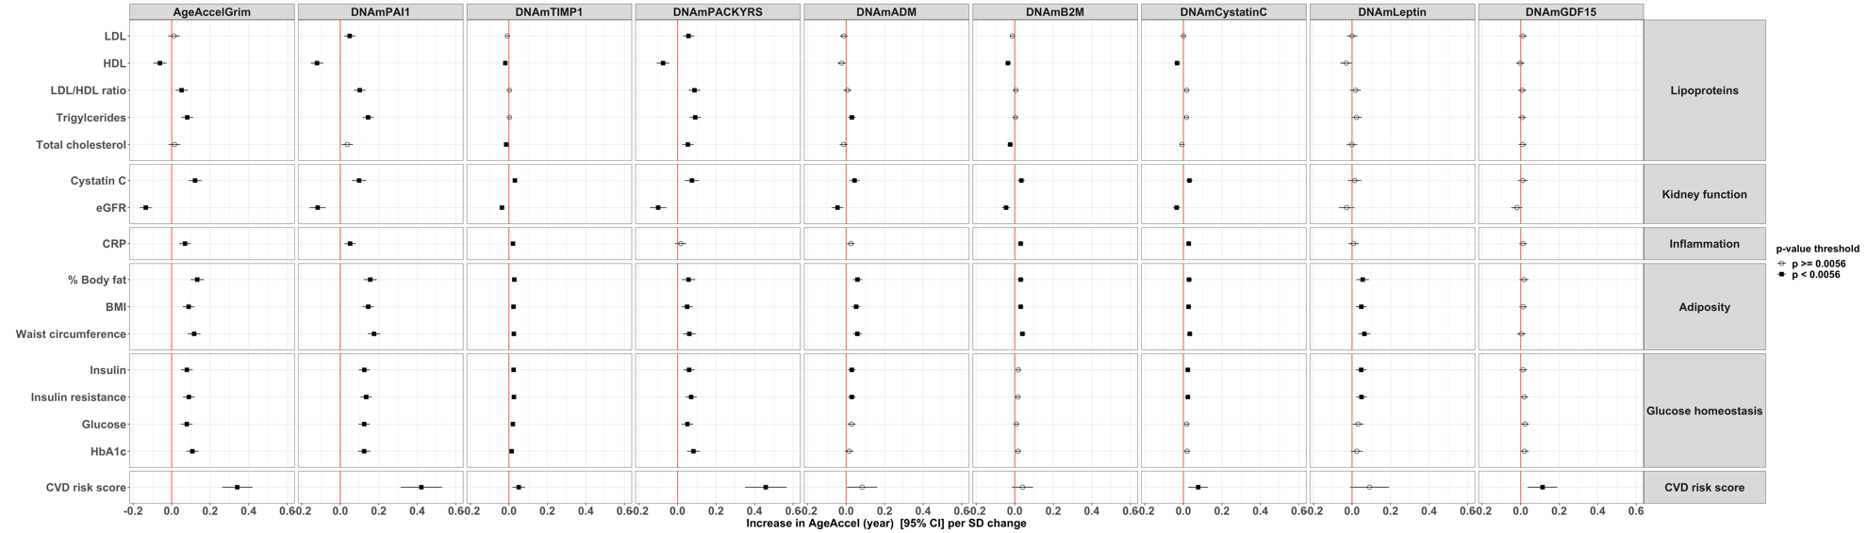

b. markers of vascular function
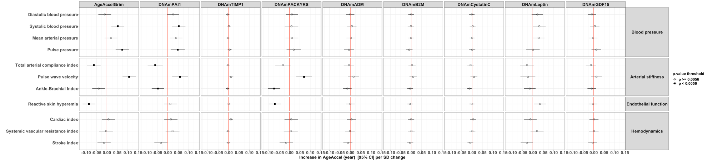

Abbreviations: DNAm: DNA methylation; ADM, adrenomedullin; B2M, beta‐2 microglobulin; GDF-15, growth differentiation factor 15; PAI-1, plasminogen activation inhibitor 1; TIMP-1, tissue inhibitor metalloproteinase 1; PACKYRS, smoking pack-years; LDL, low-density lipoproteins; HDL, high-density lipoproteins; eGFR, estimated glomerular filtration rate; CRP, C-reactive protein; BMI, body mass index; HbA1c, glycated hemoglobin; SD, standard deviation. Cardiovascular disease risk score included participants < 80 years old without cardiovascular diseases (n=3982).

eFig 3. Assessment of interaction effects between sex and cardiovascular factors on epigenetic age acceleration

Abbreviations: LDL, low-density lipoproteins; HDL, high-density lipoproteins; eGFR, estimated glomerular filtration rate; CRP, C-reactive protein; BMI, body mass index; HbA1c, glycated hemoglobin; CVD, cardiovascular diseases; DBP, diastolic blood pressure; SBP, systolic blood pressure; MAP, mean arterial pressure; PP, pulse pressure.

