Supplementary:

Fig 1: Example image and cell types and CD expressions of PBMC FACS analysis.
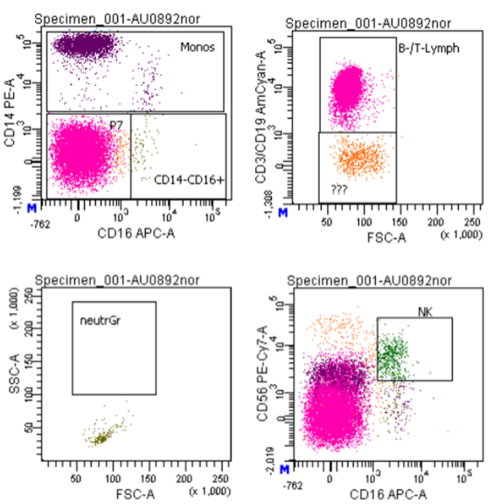
Tab S1:
Cell type | CD-Expression
NK-cells | CD56+, CD16+
monocytes | CD14+, CD16-
T-lymphocytes and B-lymphocytes | CD14-. CD16-, CD3+, CD19+
neutrophilic granulocytes | CD14+, CD16+
NK natural killer cells CD Cluster of differentiation.
Tab S2: Results of CERAD test (Z-values ± SEM)
Variables | z-value ± SEM
Semantic fluency (animals) | -0.03 ± 0.13
Boston Naming Test | 0.26 ± 0.12
Wordlist Learning Total | -0.38 ± 0.16
Retrieve word list | -0.23 ± 0.13
Saving Word list | -0.14 ± 0.11
Discriminability | 0.08 ± 0.13
Drawing figures | 0.25 ± 0.14
Retrieve figures | -0.05 ± 0.16
Saving figures | -0.08 ± 0.13
Phonematic fluency (S-words) | 0.79 ± 0.16
Trail Marking Test, Part A | 0.43 ± 0.16
Trail Marking Test, Part B | 0.45 ± 0.15
Trail Marking Test, B/A | 0.07 ± 0.17

Fig S2: Linear regression analysis was performed to analyse the correlation between blood- and brain ATP levels as well as brain energy metabolites tNAA, Cr, pCr (Fig. A-N).

