Supplemental Information: Figure 1: Effects of senotherapeutic treatment on the hippocampal SASP profile in C57BL/6 mice. mRNA expression levels of hippocampal SASP markers (a-f) were measured at time of euthanization after 10 treatments. Data are presented as means ± SEM (n = 8-12). A two-way ANOVA was used to determine P-values for the categorial variables (S = Sex and T = Treatment) and their interaction (S x T), which are shown for each bar graph. *p < 0.05, **p < 0.01, ***p<0.001 based on a two-tailed Student's t test.
Supplemental Information Figure 2: Senotherapeutic treatment altered plasma cytokine concentrations in C57BL/6 mice. Plasma concentrations of TNFα, MCP1, IL-6, and IL-10 (a-d) from time of euthanization after 10 senotherapeutic treatments. Data are represented as means ± SEM (n = 8). A two-way ANOVA was used to determine P-values for the categorial variables (S = Sex and T = Treatment) and their interaction (S x T), which are shown for each bar graph. *p < 0.05, **p < 0.01, ***p<0.001 based on a two-tailed Student's t test.
Supplemental Information Figure 3: Effects of senotherapeutic treatment on physical performance in C57BL/6 mice. MWM swimming speed during the training days and probe challenge (a-d) and forepaw grip strength (e). Data are presented as means ± SEM (n = 16-20). A two-way ANOVA was used to determine P-values for the categorial variables (S = Sex and T = Treatment) and their interaction (S x T), which are shown for each bar graph.
Supplemental Information Figure 4: Hippocampal mRNA expression of genes involved with synaptic plasticity were unaltered after senotherapeutic treatment. Hippocampal mRNA expression from time of euthanization after 10 senotherapeutic treatments in C57BL/6 mice. Data are represented as means ± SEM (n = 16-20). A two-way ANOVA was used to determine P-values for the categorial variables (S = Sex and T = Treatment) and their interaction (S x T), which are shown for each bar graph. **p < 0.01 based on a two-tailed Student's t test.
Supplemental Information Figure 5: Effects of aging on physical, metabolic, and cognitive parameters. Nontreated four-month-old C57BL/6 mice were compared to sex-matched control treated mice. Data are represented as means ± SEM (n = 16-20). A two-way ANOVA was used to determine P-values for the categorial variables (S = Sex and A = Age) and their interaction (S x A), which are shown for each bar graph. *p<0.05, **p < 0.01, ***p<0.001 based on a two-tailed Student's t test.
Supplemental Information Figure 6: Distance Traveled (centimeter) during acclimation day in open field of Novel Object Recognition (NOR) test. Data are presented as means ± SEM (n = 16-20). A two-way ANOVA was used to determine P-values for the categorial variables (S = Sex and T = Treatment) and their interaction (S x T), which are shown for each bar graph. **p < 0.01, ***p < 0.001 based on a two-tailed Student's t test.
Supplemental Information: Table 1: A list of forward and reverse primers used in this study.

Supplemental Information: Figure 1
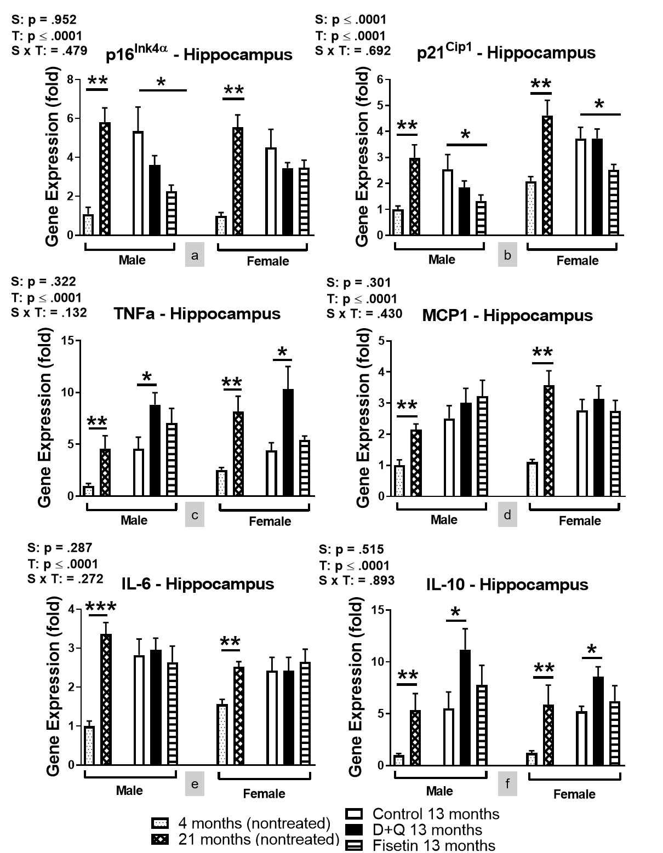

Supplemental Information: Figure 2
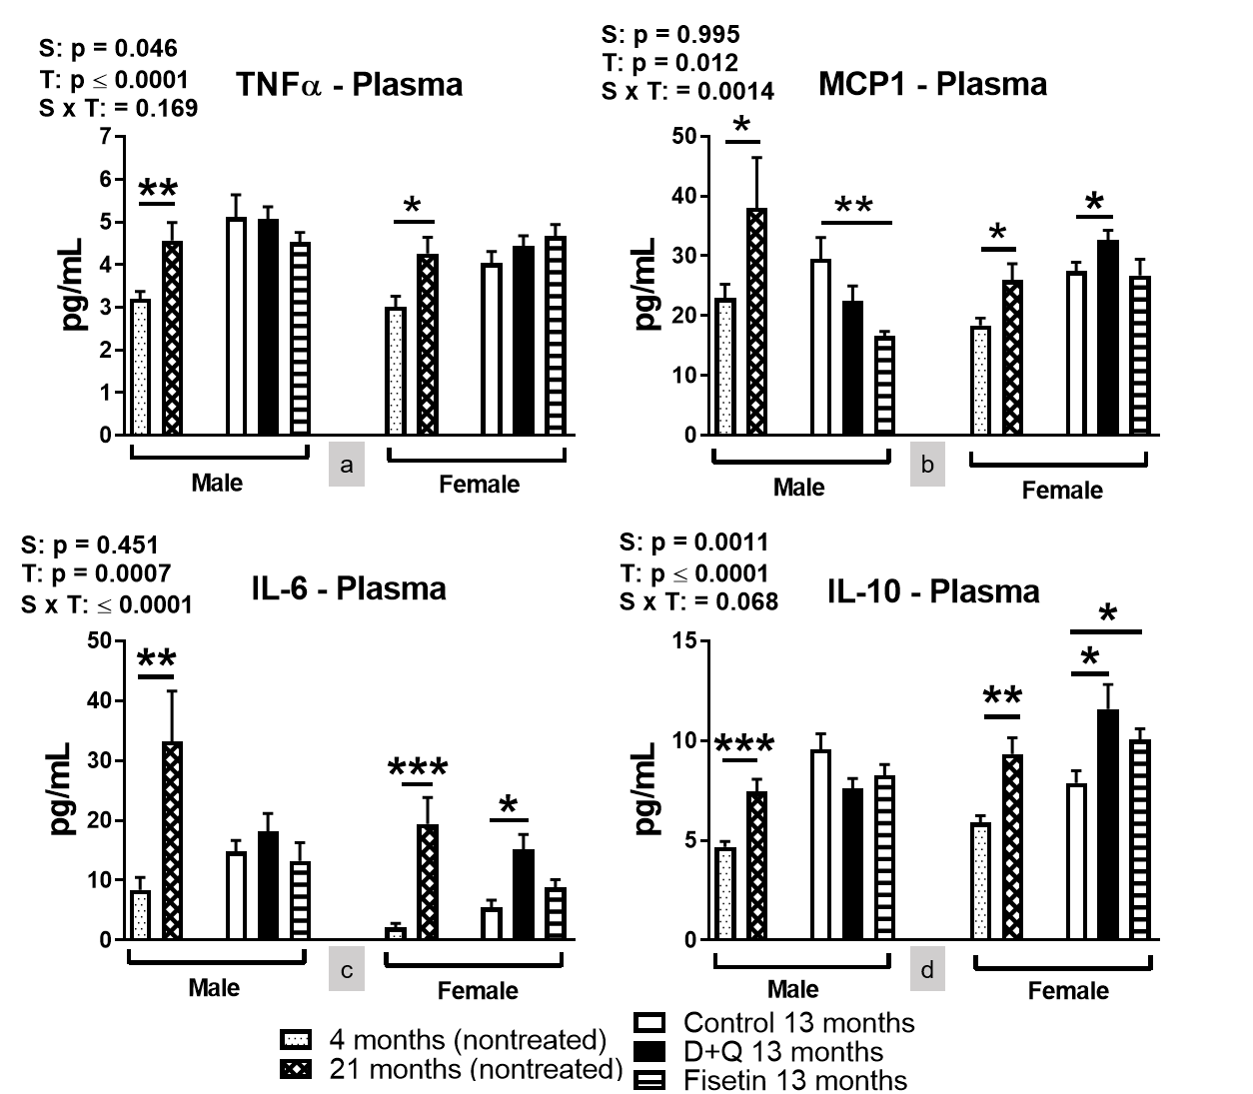

Supplemental Information: Figure 3
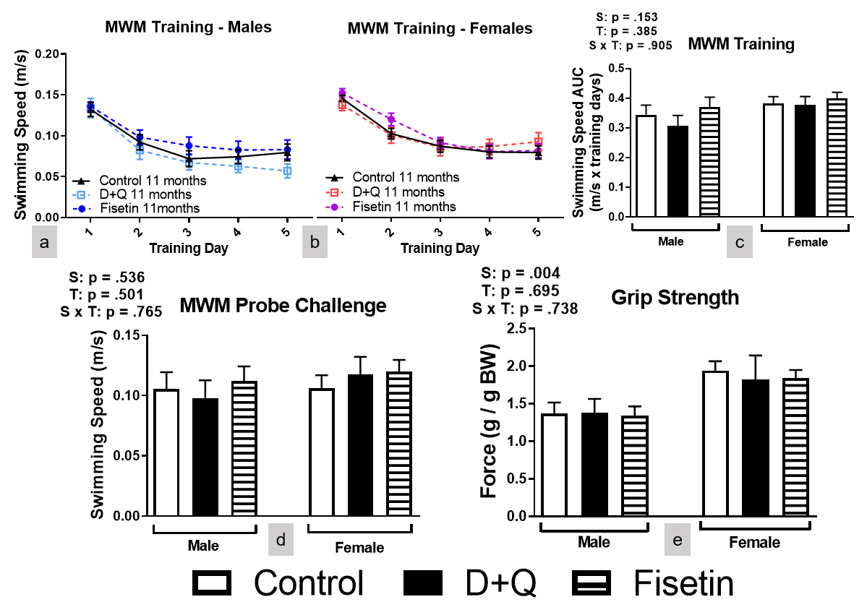

Supplemental Information: Figure 4
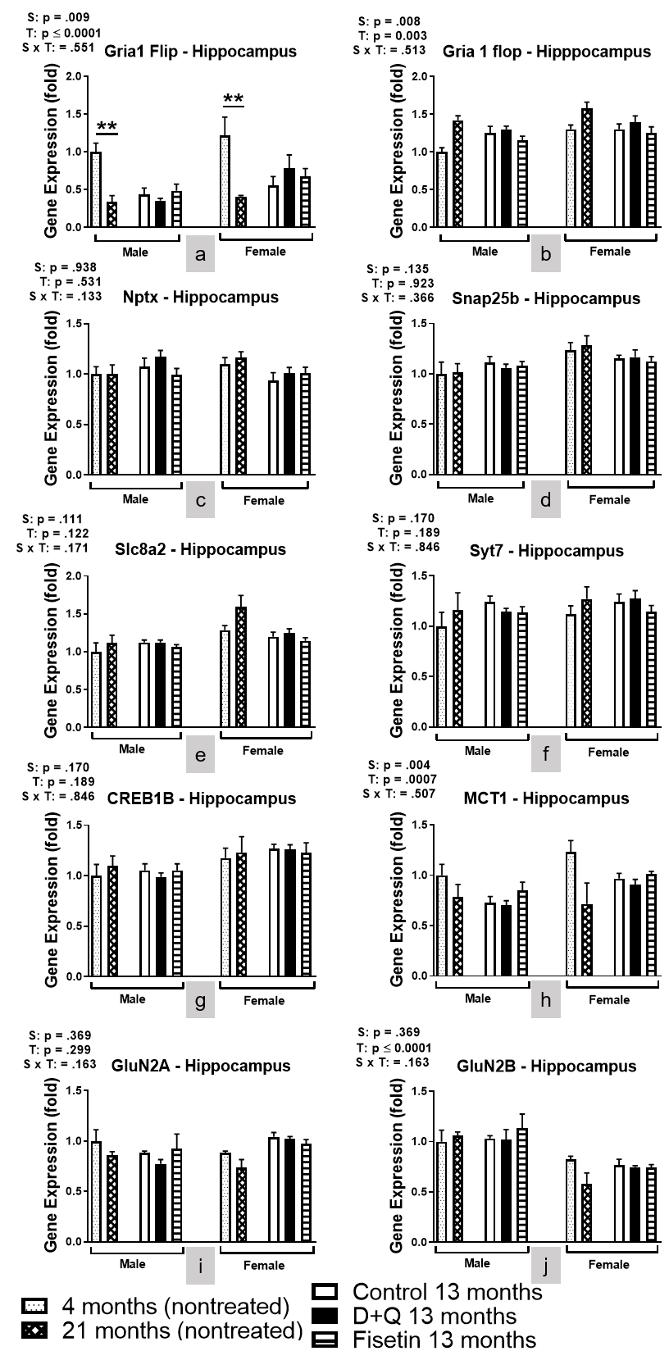
Supplemental Information: Figure 5
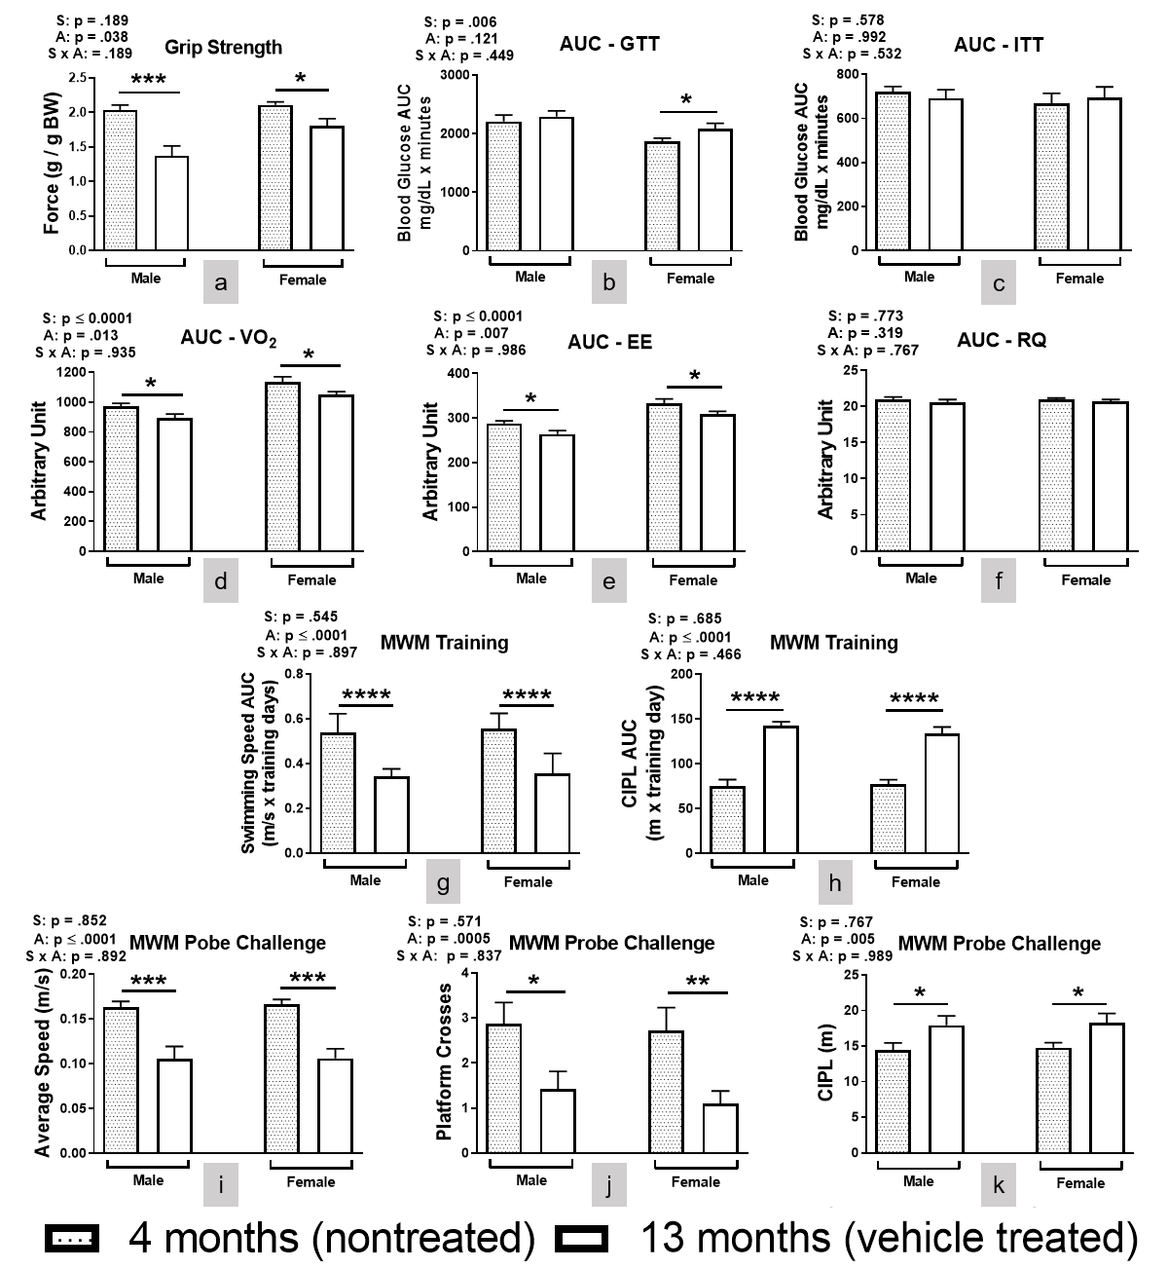

Supplemental Information: Figure 6

Supplemental Information: Table 1
 | Gene | Protein | Forward | Reverse
 | CDKN2A | p16^{Ink4α} | TACCCCGATTCAGGTGAT | TTGAGCAGAAGAGCTGCTACGT
 | CDKN1A | p21^{Cip1} | CCTGGTGATGTCCGACCTG | CCATGAGCGCATCGCAATC
 | TNFα | TNFα | GCCTCTTCTCATTCCTGCTTG | CTGATGAGAGGGAGGCCATT
 | CCL2 | MCP1 | CCACTCACCTGCTGCTACTCAT | TGGTGATCCTCTTGTAGCTCTCC
 | IL6 | IL-6 | TAGTCCTTCCTACCCCAATTTCC | TTGGTCCTTAGCCACTCCTTC
 | IL10 | IL-10 | GCTCTTACTGACTGGCATGAG | CGCAGCTCTAGGAGCATGTG
 | ACACA | ACC | ATGGGCGGAATGGTCTCTTTC | TGGGGACCTTGTCTTCATCAT
 | UCP1 | UCP1 | AGGCTTCCAGTACCATTAGGT | CTGAGTGAGGCAAAGCTGATTT
 | PPARG | PPARγ | ACCCCCTGCTCCAGGAGAT | TGCAATCAATAGAAGGAACACGT
 | NPTX | Nptx | ACACCATGAAAGTGGGAGGTAACT | ACTGGTCTTGTCCTTACTTCCGGA
 | SNAP25 | Snap25b | CTCATCGAGTGGGGCAACA | GTGATGCCATTTGCCATCGTT
 | Syt7 | Syt7 | ACTCCATCATCGTGAACATCATC | TATGTCGAAGGCGAAAGAC
 | Slc8a2 | Na⁺ / Ca⁺⁺ Exchanger, Member 2 | AACAGCACCTTCTACGTGG | GTCCTTCTGCGTCTCCC
 | GRIN2A | GluN2A | ACGTGACAGAACGCGAACTT | TCAGTGCGGTTCATCAATAACG
 | GRIN2B | GluN2B | CAGCAAAGCTCGTTCCCAAAA | GTCAGTCTCGTTCATGGCTAC
 | CREB1 | Creb1b | AGCAGCTCATGCAACATCATC | AGTCCTTACAGGAAGACTGAACT
 | SLC16A1 | MCT1 | TGTTAGTCGGAGCCTTCATTTC | CACTGGTCGTTGCACTGAATA
 | GRIA1 | Gria1 Flip | ACACCATGAAAGTGGGAGGTAACT | ACTGGTCTTGTCCTTACTTCCGGA
 | GRIA1 | Gria1 Flop | GTCCGCCCTGAGAAATCCA | GCACTCGCCCTTGTCGTA
 | SLC2A4 | Glut4 | ACACTGGTCCTAGCTGTATTCT | CCAGCCACGTTGCATTGTA
 | ADIPOR1 | AdipoR1 | ACGTTGGAGAGTCATCCCGTAT | CTCTGTGTGGATGCGGAAGAT
 | B2M | B2M | TTCTGGTGCTTGTCTCACTGA | CAGTATGTTCGGCTTCCCATTC

