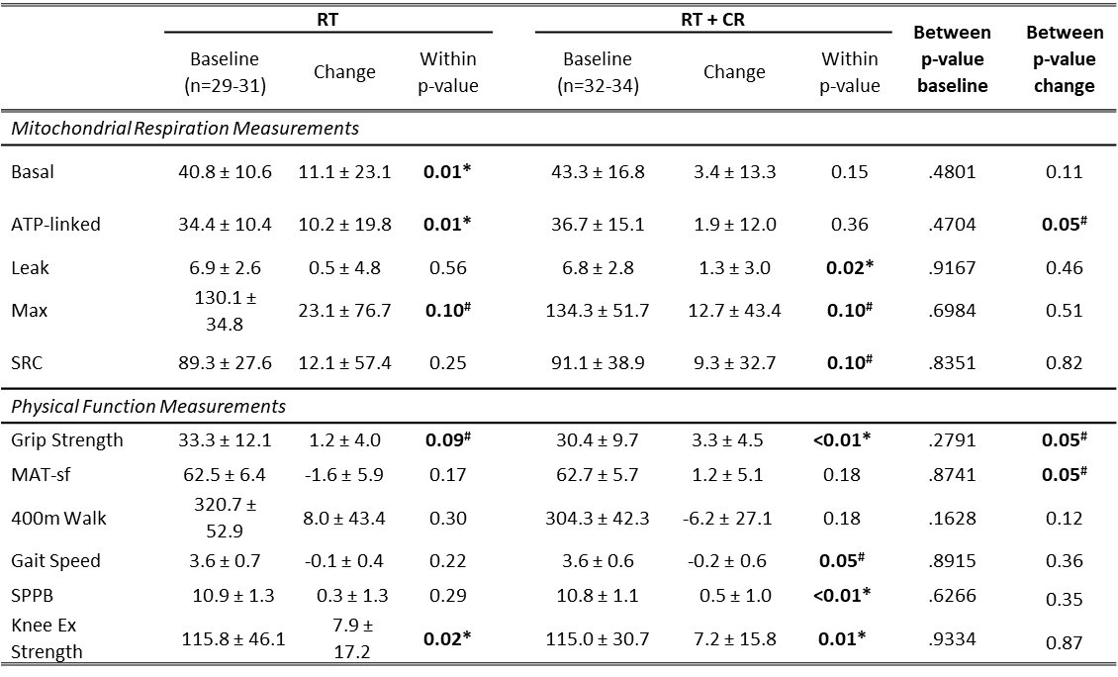
Supplemental Table 1. Unadjusted mitochondrial respiration and physical function measurements at baseline and changes with intervention (** < 0.01, * < 0.05, # < 0.10)

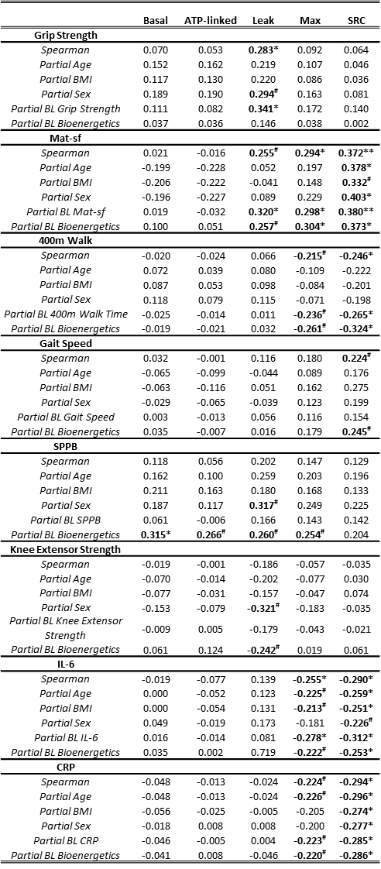
Supplemental Table 2. Correlations between change in mitochondrial respiration measurements and change in physical function and inflammatory cytokines. All participants (** < 0.01, * < 0.05, # < 0.10)

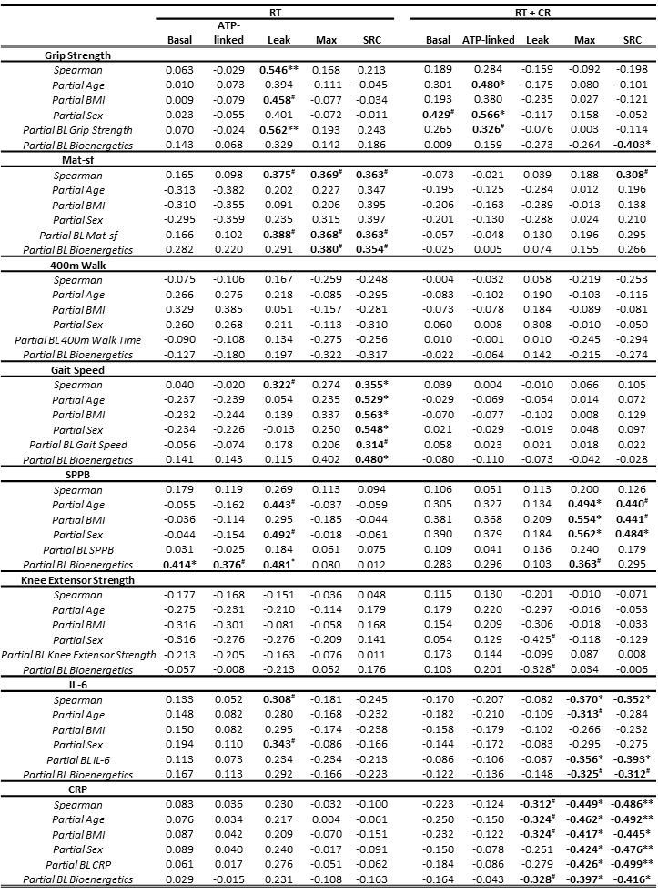
Supplemental Table 3. Spearman correlations between change in mitochondrial respiration measurements and change in physical function and inflammatory cytokines. Analysis by intervention group (** < 0.01, * < 0.05, # < 0.10)
Supplemental Table 4. Spearman correlations between change in mitochondrial respiration measurements and change in physical function and inflammatory cytokines. Analysis by sex (** < 0.01, * < 0.05, # < 0.10)
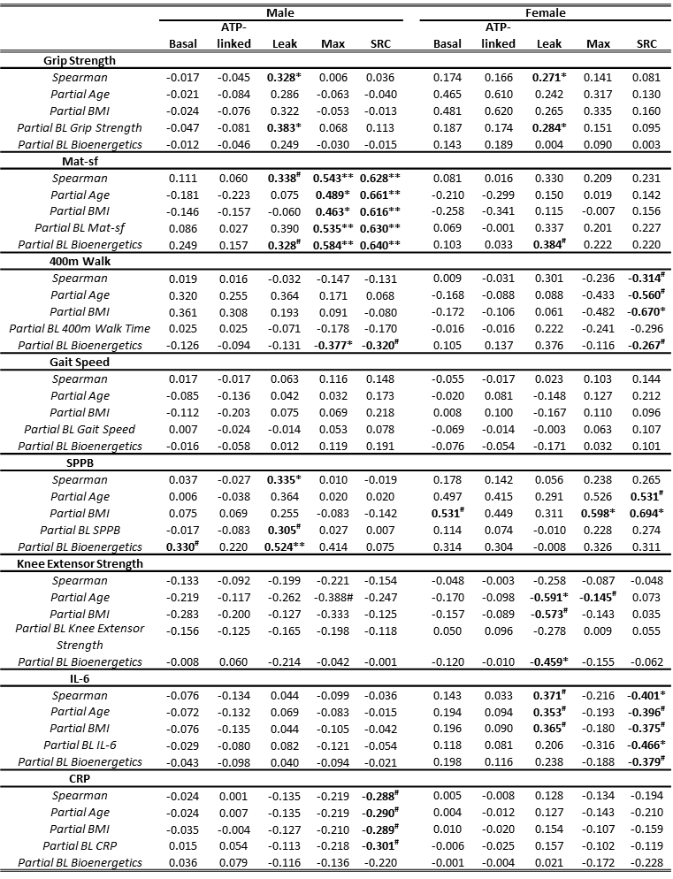
Supplemental Table 5. Parameters used for classification of responder status

Change Mean ± SD | RT | RT + CR | p-value for equality of variance | (RT ΔSD*1.15) | 75% CI of random change
Basal | 11.1 ± 23.1 | 3.4 ± 13.3 | 0.003 | 26.6 | -3.5, 49.7
ATP-linked | 10.2 ± 19.8 | 1.9 ± 12.0 | 0.006 | 22.8 | -3.0, 42.6
Leak | 0.5 ± 4.8 | 1.3 ± 3.0 | 0.008 | 5.5 | -0.7, 10.3
Max | 23.1 ± 76.7 | 12.7 ± 43.4 | 0.002 | 88.2 | -11.5, 164.9
SRC | 12.1 ± 57.4 | 9.3 ± 32.7 | 0.002 | 66.0 | -8.6, 123.4

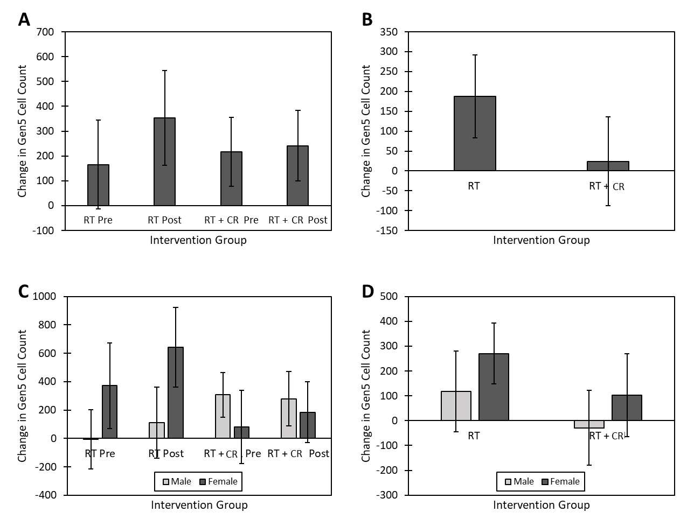
Supplemental Figure 1. Changes in cell count after serum treatment
- Change in cell count pre- and post-intervention after serum treatment.
- Change in cell count with intervention by intervention group (RT vs RT + CR).
- Change in cell count pre- and post-intervention after serum treatment in both treatment groups by sex.
- Change in cell count with intervention by intervention group and sex.

