Supplementary Figure 1
Supplementary Figure 2
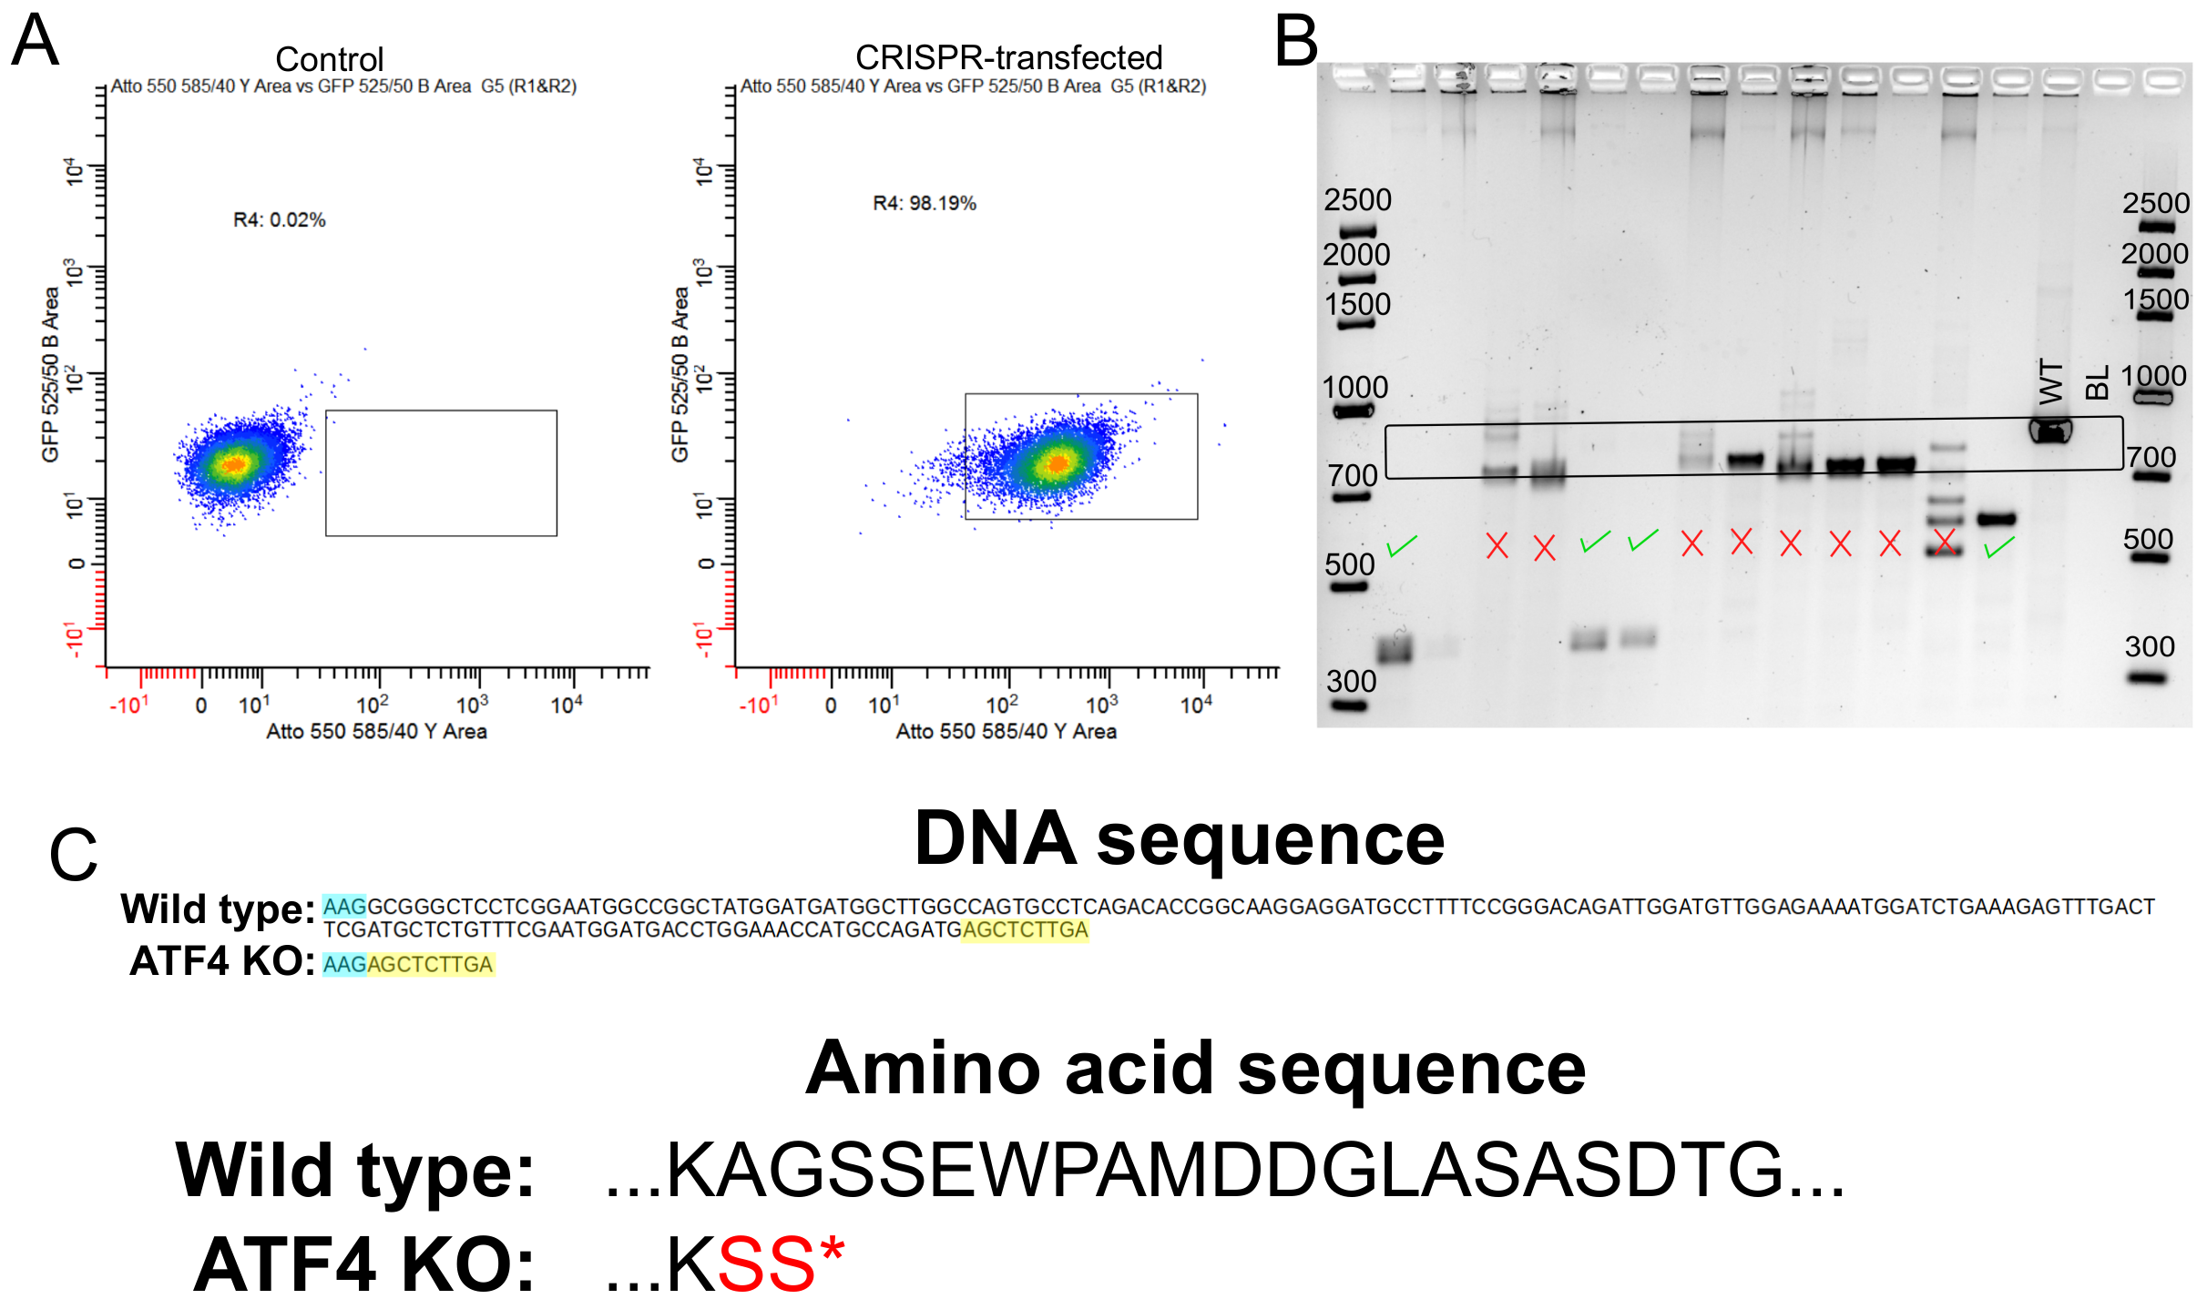
Supplementary Figure 3
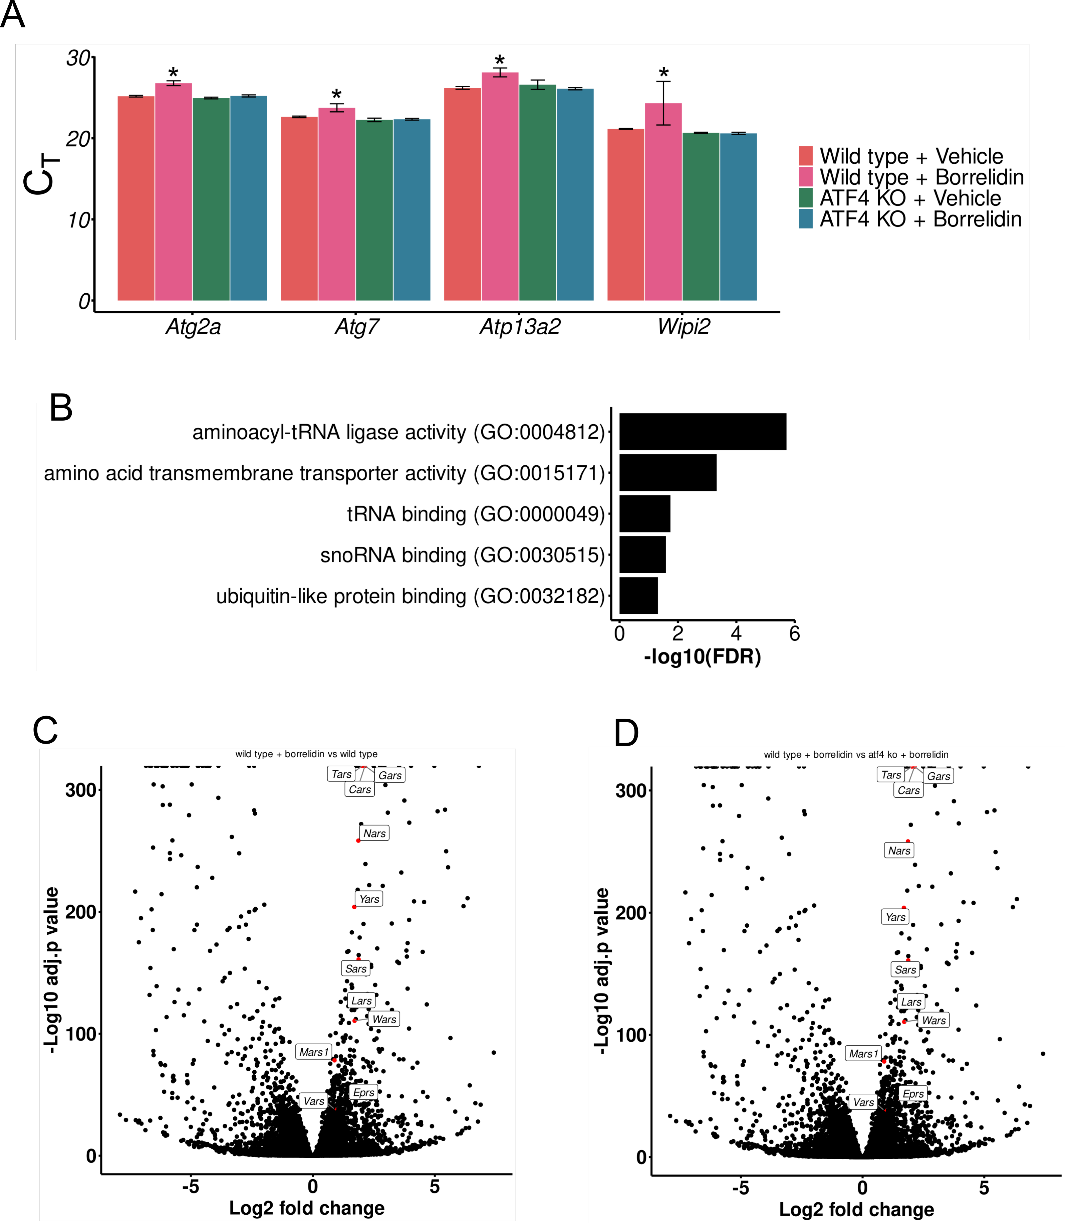
Supplementary Figure 4
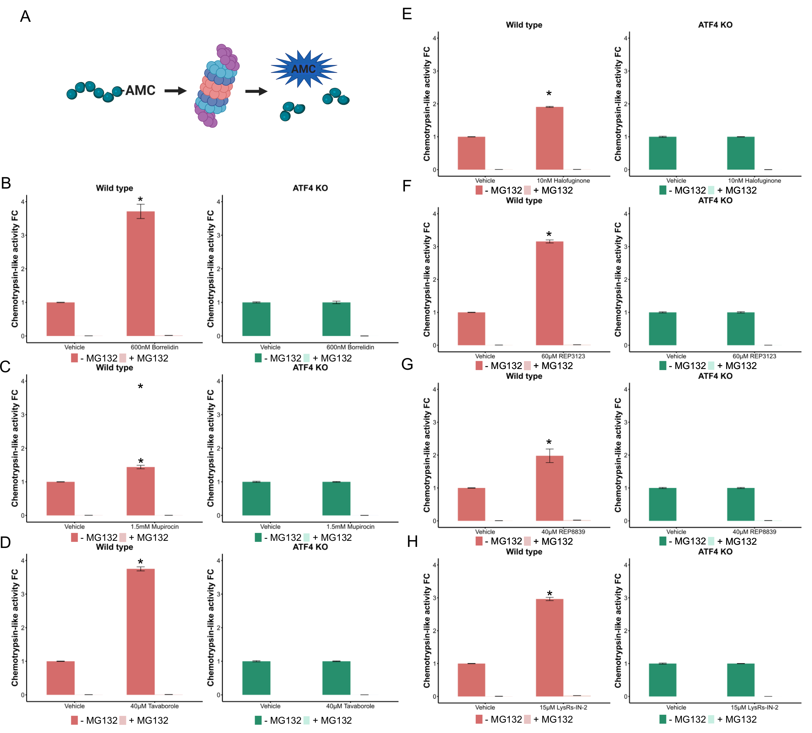
Supplementary Figure 5

