Appendix A. Supplementary Figures and Tables
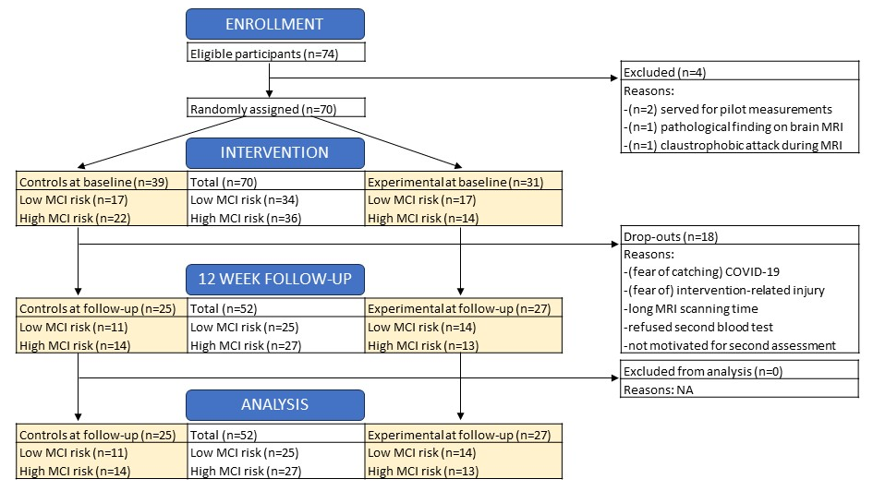
Supplementary Figure 1. Participant flow diagram
Abbreviations: MCI, mild cognitive impairment; MRI, magnetic resonance imaging; NA, not applicable.

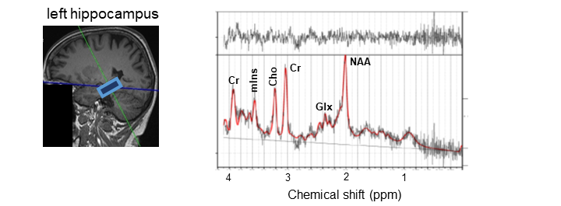
Supplementary Figure 2. ¹H-MRS voxel placement and example of a post-processed spectrum

Supplementary Table 1. Baseline participant characteristics and group differences
 | Missing | Control  (n = 25) | Experimental  (n = 27) | Total  (n=52) | p-value
Age | 0 | 69.0 (5.9) | 70.7 (5.6) | 69.9 (5.8) | 0.293
Sex:  - Male  - Female | 0 | 12 (48.0%)  13 (52.0%) | 12 (44.4%)  15 (55.6%) | 24 (46.2%)  28 (53.8%) | 0.797
Education:  - Higher  - Secondary  - Basic | 0 | 22 (88.0%)  1 (4.0%)  2 (8.0%) | 20 (74.1%)  7 (25.9%)  0 (0%) | 42 (80.8%)  8 (15.4%)  2 (3.8%) | 0.038*
Smoking status  - Smoker | 0 | 1 (4.0%) | 2 (7.4%) | 3 (5.8%) | 1.000
IPAQ-SF kcal/week | 0 | 5759.8 (4542.3) | 3296.7 (2711.3) | 4480.9 (3873.1) | 0.024*
IPAQ-SF PA level:  - sedentary  - moderately active  - highly active | 0 | 1 (4.0%)  8 (32.0%)  16 (64.0%) | 4 (14.8%)  13 (48.1%)  10 (37.0%) | 5 (9.6%)  21 (40.4%)  26 (50.0%) | 0.116
BMI (kg/m²) | 1 | 27.4 (3.3) | 28.4 (4.6) | 28.1 (5.0) | 0.385
Fat % | 1 | 31.1 (8.0) | 32.2 (9.6) | 31.5 (9.4) | 0.656
Right hand grip strength (kg) | 1 | 34.1 (11.6) | 32.3 (8.6) | 33.2 (10.1) | 0.536
MVC (Nm) | 21 | 158.1 (32.4) | 141.6 (38.5) | 149.0 (36.3) | 0.212
MoCA score | 0 | 24.5 (3.4) | 25.6 (2.5) | 25.0 (3.0) | 0.204
High MCI risk |  | 14 (56.0%) | 13 (48.1%) | 27 (51.9%) | 0.571
Continuous parameters are expressed as mean values (SD), p-values are derived from independent t-tests; categorical parameters are expressed as n (% of total), p-values are derived from Chi² tests or Fisher Exact tests. Significant p-values are marked *.
Abbreviations: BMI, body mass index; IPAQ-SF, International Physical Activity Questionnaire-Short Form; MCI, mild cognitive impairment; MoCA, Montreal Cognitive Assessment

Supplementary Table 2. Baseline participant characteristics and differences between older adults with low and high MCI risk
 | Low MCI risk  (n = 25) | High MCI risk  (n = 27) | Total  (n=52) | p-value
Age | 69.0 (5.7) | 70.7 (5.9) | 69.9 (5.8) | 0.293
Sex:  - Male  - Female | 10 (40.0%)  15 (60.0%) | 14 (51.9%)  13 (48.1%) | 24 (46.2%)  28 (53.8%) | 0.392
Education:  - Higher  - Secondary  - Basic | 21 (84.0%)  4 (16.0%)  0 (0.0%) | 21 (77.8%)  4 (14.8%)  2 (7.4%) | 42 (80.8%)  8 (15.4%)  2 (3.8%) | 0.382
Smoking status  - Smoker | 2 (8.0%) | 1 (3.7%) | 3 (5.8%) | 0.603
IPAQ-SF kcal/week | 4108.9 (3208.8) | 4825.3 (4434.5) | 4480.9 (3873.1) | 0.511
IPAQ-SF PA level:  - sedentary  - moderately active  - highly active | 1 (4.0%)  11 (44.0%)  13 (52.0%) | 4 (14.8%)  10 (37.0%)  13 (48.1%) | 5 (9.6%)  21 (40.4%)  26 (50.0%) | 0.412
BMI (kg/m²) | 28.1 (4.1) | 27.7 (3.9) | 28.1 (5.0) | 0.679
Fat % | 33.2 (7.5) | 30.3 (9.8) | 31.5 (9.4) | 0.242
Right hand grip strength (kg) | 32.9 (9.1) | 33.4 (11.1) | 33.2 (10.1) | 0.882
MVC (Nm) | 150.6 (35.0) | 145.2 (41.1) | 149.0 (36.3) | 0.712
IGF-1 | 114.1 (52.2) | 132.9 (58.5) | 116.2 (54.0) | 0.234
IL-6 | 9.6 (10.7) | 5.8 (4.8) | 8.1 (8.6) | 0.117
KYN | 1767.0 (848.0) | 1488.3 (742.2) | 1599.3 (724.8) | 0.217
Whole hippocampus | 3374.1 (298.1) | 3215.8 (392.7) | 3287.0 (358.0) | 0.167
CA1 | 638.3 (76.8) | 608.7 (89.8) | 622.0 (84.5) | 0.275
Subiculum | 437.2 (54.0) | 408.3 (52.4) | 421.3 (54.4) | 0.095
Presubiculum | 309.3 (34.7) | 286.3 (41.3) | 296.6 (39.7) | 0.068
CA4 | 236.1 (24.9) | 226.1 (29.7) | 230.6 (27.7) | 0.259
DG | 269.9 (29.6) | 256.7 (34.1) | 262.6 (32.4) | 0.203
tNAA/tCr | 1.17 (0.15) | 1.17 (0.11) | 1.17 (0.14) | 0.869
mIns/tCr | 1.09 (0.14) | 1.05 (0.23) | 1.07 (0.15) | 0.406
tNAA/mIns | 1.08 (0.14) | 1.16 (0.23) | 1.11 (0.15) | 0.198

Supplementary Table 3. Bivariate correlations between changes in blood biomarkers, hippocampus volume and neurometabolites for control group participants
 | ΔIL-6 | ΔKYN | ΔWhole hippocampus | ΔCA1 | ΔSubiculum | ΔPresubiculum | ΔCA4 | ΔDG | ΔtNAA/tCr left HPC | ΔmIns/tCr left HIPC | ΔtNAA/mIns left HPC
ΔIGF-1 | 0.018 | -0.015 | -0.346 | 0.165 | -0.681 | -0.593 | -0.022 | 0.214 | 0.098 | -0.455 | 0.364
ΔIL-6 |  | -0.300 | 0.421 | 0.341 | 0.082 | 0.559 | 0.159 | 0.062 | 0.191 | 0.200 | -0.045
ΔKYN |  |  | -0.051 | 0.073 | 0.030 | -0.092 | 0.022 | 0.201 | -0.343 | 0.210 | -0.357
ΔWhole hippocampus |  |  |  | 0.761 | 0.740 | 0.759 | 0.736 | 0.455 | -0.139 | 0.261 | -0.176
ΔCA1 |  |  |  |  | 0.389 | 0.366 | 0.686 | 0.695 | -0.406 | 0.467 | -0.455
ΔSubiculum |  |  |  |  |  | 0.645 | 0.366 | 0.160 | -0.079 | 0.091 | -0.103
ΔPresubiculum |  |  |  |  |  |  | 0.269 | -0.073 | 0.212 | 0.236 | -0.079
ΔCA4 |  |  |  |  |  |  |  | 0.602 | -0.576 | 0.103 | -0.200
ΔDG |  |  |  |  |  |  |  |  | -0.345 | 0.103 | -0.079
ΔtNAA/tCr left HPC |  |  |  |  |  |  |  |  |  | -0.253 | 0.588
ΔmIns/tCr left HPC |  |  |  |  |  |  |  |  |  |  | -0.874
Significant correlations are marked in bold (p < 0.05). Δ values were calculated by substracting the post-intervention value from the pre-intervention value. Spearman’s rho correlation values are presented.
Abbreviations: CA, cornu ammonis; DG, dentate gyrus; HPC, hippocampal cortex; IGF-1, insulin-like growth factor-1; IL-6, interleukin-6; KYN, kynurenine; mIns, myo-inositol; tCr, total creatine; tNAA, total N-acetylaspartate.

Supplementary Table 4. Bivariate correlations between changes in blood biomarkers, hippocampus volume and neurometabolites for all participants
 | ΔIL-6 | ΔKYN | ΔWhole hippocampus | ΔCA1 | ΔSubiculum | ΔPresubiculum | ΔCA4 | ΔDG | ΔtNAA/tCr left HPC | ΔmIns/tCr left HIPC | ΔtNAA/mIns left HPC
ΔIGF-1 | -0.148 | -0.018 | -0.198 | 0.039 | -0.333 | -0.295 | -0.027 | 0.009 | -0.019 | -0.241 | 0.188
ΔIL-6 |  | -0.063 | 0.176 | 0.165 | 0.041 | 0.314 | -0.041 | 0.093 | 0.096 | 0.133 | -0.083
ΔKYN |  |  | -0.199 | -0.081 | -0.064 | -0.069 | -0.152 | -0.226 | -0.033 | -0.062 | 0.022
ΔWhole hippocampus |  |  |  | 0.727 | 0.717 | 0.611 | 0.650 | 0.741 | -0.141 | 0.300 | -0.306
ΔCA1 |  |  |  |  | 0.446 | 0.352 | 0.404 | 0.577 | -0.279 | 0.437 | -0.546
ΔSubiculum |  |  |  |  |  | 0.434 | 0.211 | 0.298 | -0.007 | 0.320 | -0.275
ΔPresubiculum |  |  |  |  |  |  | 0.190 | 0.214 | 0.087 | 0.152 | -0.122
ΔCA4 |  |  |  |  |  |  |  | 0.903 | -0.331 | 0.033 | -0.072
ΔDG |  |  |  |  |  |  |  |  | -0.209 | 0.072 | -0.063
ΔtNAA/tCr left HPC |  |  |  |  |  |  |  |  |  | 0.232 | 0.416
ΔmIns/tCr left HPC |  |  |  |  |  |  |  |  |  |  | -0.704
Significant correlations are marked in bold (p < 0.05). Δ values were calculated by substracting the post-intervention value from the pre-intervention value. Spearman’s rho correlation values are presented.
Abbreviations: CA, cornu ammonis; DG, dentate gyrus; HPC, hippocampal cortex; IGF-1, insulin-like growth factor-1; IL-6, interleukin-6; KYN, kynurenine; mIns, myo-inositol; tCr, total creatine; tNAA, total N-acetylaspartate.

