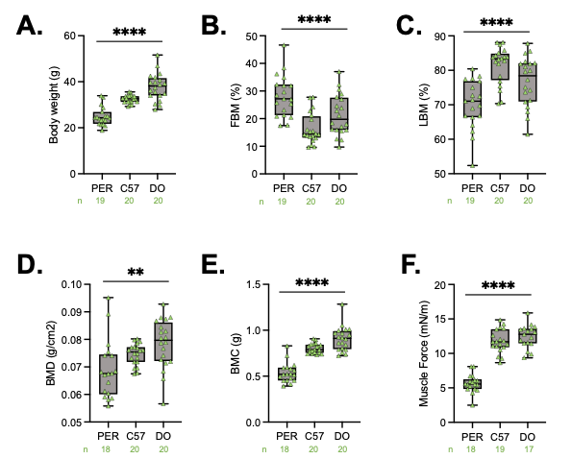
Supplemental Figure S1: Male Peromyscus leucopus demonstrate significantly altered body composition and skeletal muscle function compared to inbred and outbred male Mus musculus strains. A) total body weights of male Peromyscus leucopus (PER), C57BL6/J (C57), and diversity outbred (DO) mice, calculated by dual x-ray absorptiometry (DXA). B) DXA-determined fat body mass (FBM) percentages of all three strains. C) DXA-determined lean body mass (LBM) percentages of all three strains. D) DXA-determined bone mineral density (BMD) of all three strains E) DXA-determined bone mineral content (BMC) of all three strains. F) Recorded force (mN/m) of the Tibealis anterior of assayed animals following a stimulus of 125 Hz during Aurora Muscle Function Testing. FBM = fat body mass, LBM = lean body mass, BMD = bone mineral density, BMC = bone mineral content. Statistical analysis performed by one-way ANOVA analysis. Significance – ns p.> 0.05, * p < 0.05, ** p < 0.005, *** p < 0.0005, **** p < 0.0001

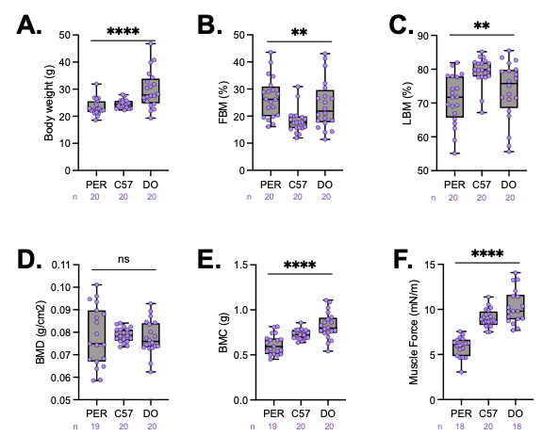
Supplemental Figure S2: Female Peromyscus leucopus demonstrate significantly altered body composition and skeletal muscle function compared to inbred and outbred female Mus musculus strains. A) total body weights of female Peromyscus leucopus (PER), C57BL6/J (C57), and diversity outbred (DO) mice, calculated by dual x-ray absorptiometry (DXA). B) DXA-determined fat body mass (FBM) percentages of all three strains. C) DXA-determined lean body mass (LBM) percentages of all three strains. D) DXA-determined bone mineral density (BMD) of all three strains E) DXA-determined bone mineral content (BMC) of all three strains. F) Recorded force (mN/m) of the Tibealis anterior of assayed animals following a stimulus of 125 Hz during Aurora Muscle Function Testing. FBM = fat body mass, LBM = lean body mass, BMD = bone mineral density, BMC = bone mineral content. Statistical analysis performed by one-way ANOVA analysis. Significance – ns p.> 0.05, * p < 0.05, ** p < 0.005, *** p < 0.0005, **** p < 0.0001

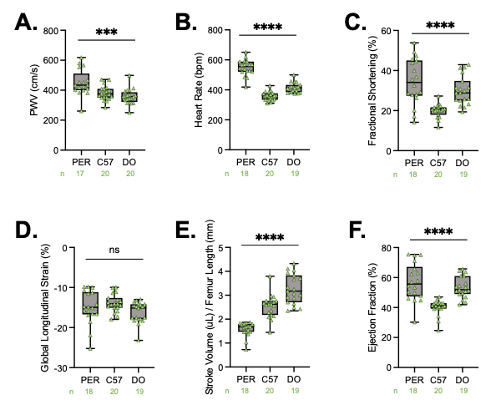
Supplemental Figure S3: Male Peromyscus leucopus demonstrate significantly altered cardiovascular parameters compared to inbred and outbred male Mus musculus strains. A) Pulse wave velocity (PWV) values of male Peromyscus leucopus (PER), C57BL6/J (C57), and diversity outbred (DO) mice, calculated from the distance between the thoracic and abdominal aorta. B) Heart rate (beats per minute, bpm) collected during echocardiography under 2.5% isoflurane anesthesia. C) Fractional shortening calculated during echocardiography along the peristernal long axis (B-mode). D) Global longitudinal strain (GLS) calculated during echocardiography along the peristernal long axis (B-mode). E) Stroke volume calculated during echocardiography along the peristernal long axis (B-mode), normalized to femur lengths collected during dual x-ray absorptiometry. F) Ejection fraction calculated during echocardiography along the peristernal long axis (B-mode). Statistical analysis performed by one-way ANOVA analysis. Significance – ns p.> 0.05, * p < 0.05, ** p < 0.005, *** p < 0.0005, **** p < 0.0001

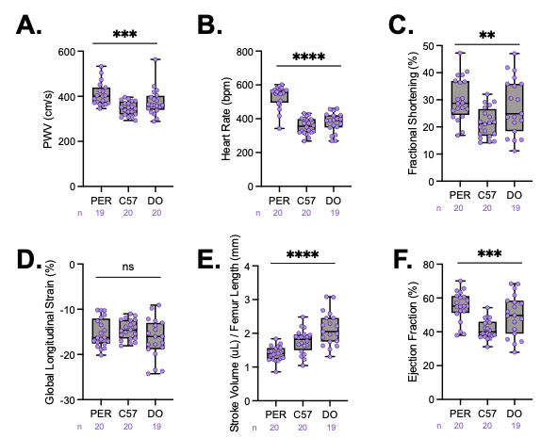
Supplemental Figure S4: Female Peromyscus leucopus demonstrate significantly altered cardiovascular parameters compared to inbred and outbred female Mus musculus strains. A) Pulse wave velocity (PWV) values of female Peromyscus leucopus (PER), C57BL6/J (C57), and diversity outbred (DO) mice, calculated from the distance between the thoracic and abdominal aorta. B) Heart rate (beats per minute, bpm) collected during echocardiography under 2.5% isoflurane anesthesia. C) Fractional shortening calculated during echocardiography along the peristernal long axis (B-mode). D) Global longitudinal strain (GLS) calculated during echocardiography along the peristernal long axis (B-mode). E) Stroke volume calculated during echocardiography along the peristernal long axis (B-mode), normalized to femur lengths collected during dual x-ray absorptiometry. F) Ejection fraction calculated during echocardiography along the peristernal long axis (B-mode). Statistical analysis performed by one-way ANOVA analysis. Significance – ns p.> 0.05, * p < 0.05, ** p < 0.005, *** p < 0.0005, **** p < 0.0001

